- Objective of activity and intended output (1-2 sentences)

Heat stress/high temperatures during flowering and pod development stages is a major constraint in chickpea production. Limited studies on chickpea heat tolerance mechanisms have been reported. With an objective of identifying genes and/or markers associated with heat tolerance, RNA-Seq based transcriptome profiling of heat stress responsive chickpea genotypes was performed. This study would reveal gene expression profiles and identification of heat stress responsive candidate genes for deployment in breeding programs.

- Materials and methods (very brief and succinct, 3 sentences at the most)

Six contrasting heat responsive (tolerant - ICCV 92944, ICC 1356, ICC 15614 and sensitive - ICC 5912, ICC 4567, ICC 10685) genotypes were selected for the study. Heat stress was imposed using growth chamber facility, vegetative (leaves and roots) and reproductive (leaves, roots and flowers) stage tissues (60 different samples) were collected. RNA-Seq was performed on these tissues and the sequence reads were analyzed for identification of heat stress responsive genes.

- Results and interpretation (again succinct, maximum of 250 words). Include data in the form of graphs, tables or pictures.

A total of 505 million reads were generated and and of these ~469 million reads were aligned to the chickpea genome assembly (Varshney et al. 2013, Nat Biotechnol 31:240–246). A total of 19, 938 genes were differentially expressed between tolerant and sensitive genotypes. In addition 2,942 novel genes were also found to be differentially expressed. Gene ontology analysis indicated the enrichments of 8,081 genes. A set of 56 genes belonging to APETALA2/Ethylene Responsive Factor (AP2/ERF) and Heat Shock Protein (HSP) 90 families were found to be significantly differentially expressed and are validated using quantitative real time PCR (Figure 1). Furthermore, single nucleotide polymorphisms (SNPs)/INDELs were identified by aligning the reads to the reference kabuli (CDC Frontier) genome and >22,456 SNPs/INDELs were identified across the parental genotypes of two mapping populations (ICC15614 × ICC 4567 and ICC 1356 × ICC 4567). This study provided valuable insights into heat stress response in chickpea and led to identification of the known and novel differentially expressed genes along with the marker resources. These resources will be useful for basic and applied research as well for accelerating heat tolerance breeding program in chickpea.

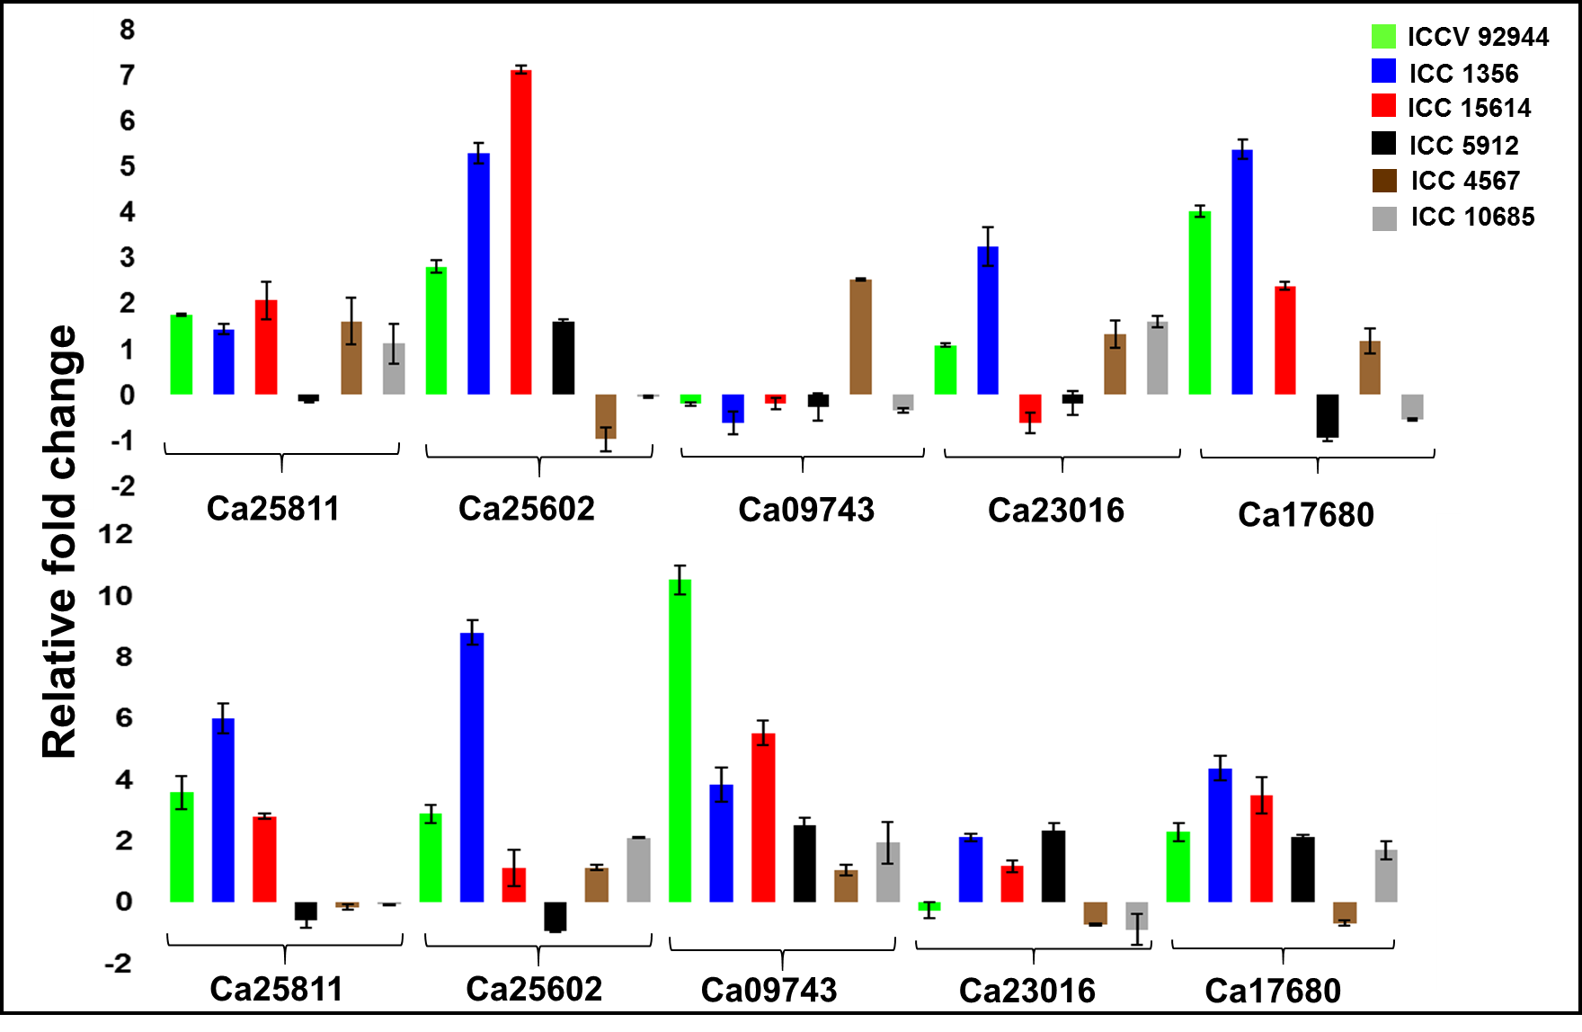

Figure 1: Validation of significantly differentially expressed genes using quantitative real time PCR (qRT-PCR)

- Next steps (1-2 sentences)

SNPs identified in the prioritized candidate genes would be mapped on to chickpea genetic map and the data would be analyzed for identification of common regions/genes for drought and heat stress response in chickpea.

