Product Line: PL6 – Extra-early maturing chickpea and lentil varieties
Activity title: Purification of secondary metabolites from 2 actinomycetes responsible for antagonistic activity against important fungal pathogens of chickpea and sorghum
Objective of the activity and intended output: In our previous study, a total of 137 actinomycetes, isolated from 25 different herbal vermi-composts, were characterized for their antagonistic potential against Macrophomina phaseolina (causes charcoal rot in sorghum and dry root rot in chickpea) by dual-culture assay. Of them, eight most promising isolates (CAI-17, CAI-21, CAI-26, CAI-68, CAI-78, KAI-26, KAI-27 and MMA-32) were demonstrated to have the potential for PGP and control of charcoal-rot disease in sorghum. These were also identified as Streptomyces but different species in the 16S rDNA analysis. In the present study, the most promising isolate Streptomyces sp. MMA-32 was further evaluated for its antagonistic activity against M. phaseolina and partial purification of the active metabolite was done.
Materials and methods: MMA-32 was characterized for the antagonistic activity against M. phaseolina (MP) by using dual culture assay and secondary metabolite production assay. MMA-32 was mass cultured, using starch casein broth and the supernatant collected and subjected to initial extraction by ethyl acetate and resultant organic and aqueous phases were evaluated against the pathogen. The active fraction was subjected to purification by thin layer chromatography (TLC) using hexane: ethyl acetate (6:4) as solvent system. The bands were scraped, the metabolites eluted and further tested for activity against the pathogen M. phaseolina. The active compound which inhibited the compound most effectively was subjected to HPLC for further purification.
Results and interpretation: It can be inferred from the present study that the secondary metabolites produced from the given Streptomyces sp., MMA-32 was effective against fungal pathogen M. phaseolina causative agent of charcoal rot in sorghum. The organic phase containing secondary metabolites were purified by TLC and HPLC. In the present study partial purification of secondary metabolite was done. By HPLC results it can be concluded that the compound needs further purification and characterization (Figs.1 and 2).
Name of the Scientists and organizations involved: S Gopalakrishnan, ICRISAT Patancheru.
Publication: Not yet published

Fig. 1. Dual culture assay- Streptomyces sp., MMA-32 inhibiting M. phaseolina

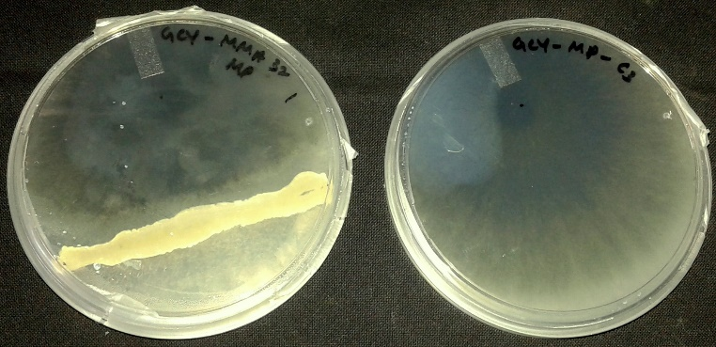

Fig. 2. Effect of organic phase of the culture filtrate of MMA-32 against M. phaseolina

Next steps: The active compound will be further purified in HPLC and checked for its antagonistic activity against M. phaseolina. The purified active compound will be sent to Dr Per Bruheim, NTNU, Norway for identification. The NMR and MS will be used for identification of the active compound.

