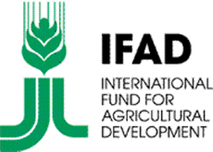
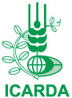


IFAD Grant Number: COFIN-ECG-56-ICARDA

Enhanced small-holder wheat-legume cropping systems to improve food security under changing climate in the Drylands of West Asia and North Africa

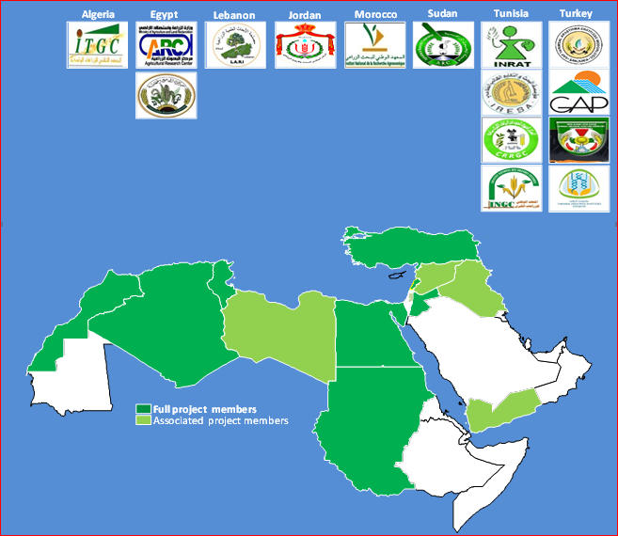
ANNUAL PROGRESS REPORT
2013/2014 Cropping Season

Table of Contents

Acknowledgements 3
Abbreviations Used 4
Executive Summary 5
I. BACKGROUND 8
II. IMPLEMENTATION PROGRESS 10
Component 1: Seed tasks 11
Component 2: Dissemination and scaling-up of superior technologies 13
Component 3: Capacity building 15
Component 4: Socio economic tasks. 16
Component 5: Back up research. 19
III. INNOVATIONS 25
IV. INTERNATIONAL PUBLIC GOODS 25
V. NUTRITION AND HEALTH 25
VI. GENDER ISSUES 26
VII. PARTNERSHIPS 27
VIII. CONCLUSIONS 27
Appendix 1: Tables and Figures 31
Appendix 2: Project partner’s workplans and budgets for cropping season 2014-15 32
Appendix 3: Project Photos 33
Annex 1: Results-based Logical Framework 44
Annex 2: International Public Goods 52

Acknowledgements
Funding for activities and achievements of the project reported in this document for period December 2013-January 2014 is from the European Union (EU), as part of the Commission’s (EC) support to the CGIAR and its International Centers under Grant COFIN-ECG-56-ICARDA EC IFAD 1276 with funds administered by the International Fund for Agricultural Development (IFAD), Rome Italy.
ICARDA and National Agricultural Research System (NARS) management of the project partner institutions are grateful to the European Union and the IFAD for the generous financial support and technical backstopping provided to this project.

ITGC (Institut Techniques des Grandes Cultures) Algeria
ARC (Agricultural Research Center), Egypt
NCARE (National Center for Agricultural Research and Extension), Jordan
LARI (Lebanese Agricultural Research Institute), Lebanon
INRA (Institut National Recherche Agronomique), Morocco
ARC (Agricultural Research Corporation), Sudan
INRAT (Institut National Recherche Agronomique de Tunisie), Tunisia
GAP ARI (Southeastern Anatolia Regional Agricultural Research Institute, Sanliurfa, TZARI Kahramanmaras and Eskechir), Turkey

Gratitude is also expressed to EU and IFAD by farming communities involved in the project, national coordinators, NARS scientists and support staff, management of ICARDA programs, units and scientists for the support to interactive working relations enabling the dissemination and production of decisive technologies that would impact livelihoods of small-holder farmers.

Disclaimer
The authors accept sole responsibility for the contents of this report. The report does not necessarily reflect the views of the EC or IFAD.

Abbreviations Used

CA Conservation Agriculture
CT Conventional Tillage
DD Direct Drill
EU European Union
EC European Commission
FFS Farm Field School
GIS Geographic Information Service
IPM Integrated Pest Management
MOA Memorandum of Agreement
MSPTU Mobile Seed Processing and Treatment Unit
NT No-till
PC Project Component
SC Steering Committee
SI Supplemental Irrigation
TDPs Technology Dissemination Platforms
VBSE Village-based Seed Enterprise
WANA West Asia and North Africa
ZT Zero Tillage

Executive Summary

Project “Enhanced small-holder wheat-legume cropping systems to improve food security under changing climate in the Drylands of West Asia and North Africa”

GOAL (Impact): Enhanced food and nutritional security, improved livelihoods of rural communities and agricultural sector growth in the countries of WANA in the face of increasing climatic variability and change.
PURPOSE (Outcome): Deliver pro-poor scientific and technological innovations to increase and stabilize the productivity of wheat and food legumes-based production systems in the dry areas of WANA.

PROJECT COMPONENTS (main outputs as refined with the evolution of project tasks)
PC1. Seed (-seed increase and supply as mean to promote new and superior and adapted varieties, -informal seed delivery system and enterprise development, -seed sector study and gap analysis, -capacity building and strengthening of national seed systems).
PC2. Dissemination of technologies (-on-farm technology dissemination platforms to popularize/promote superior and adapted wheat and food legume varieties, as well as more appropriate technology packages of integrated pest management(IPM), conservation agriculture and supplemental irrigation, -integrated technology dissemination platforms where new varieties and more appropriate crop production packages are combined).
PC3. Capacity building (-capacity building of farmers and field staff with Farmers Field Schools (FFS) classroom and field sessions, -technical fields days/harvesting days as approach and tools to strengthen knowledge and information sharing), -capacity building of technical staff, researchers and research support staff to upgrade knowledge, skills and capabilities to serve research for development and farming communities.
PC4. Socio-economic and gender backstopping studies (-baseline studies, policies, trends and gaps analysis, -economic feasibility, -adoption and impact studies, -gender analysis and mainstreaming studies as approaches to provide focused recommendations and avenues for gender balanced policies).
PC5. Back up and gap filling research (-adaptation of technologies better responding to farmers’ production environments and end-user requirements, -participatory development of new technologies and integrated technology packages, -establishment of processes and production decision-making tools and methods responding to climate variability).

Overview on main achievements during the reporting period
The project’s member countries increased their efforts and investments in the different tasks composing the project components. The following are an exhaustive list of important achievements:

Seed-early generation seed increase: important efforts were made (breeder, foundation seed basic seed production) to enhance the promotion of new varieties, especially in grain legumes faba bean, chickpea and lentil but also in wheat, especially durum wheat. ICARDA’s Seed Unit organized with project partners the production of 37 metric tons of faba bean, chickpea and lentil basic seed of new varieties. The 8 project partners project produced more than 760 metric tons of quality seed, the largest production portion of which was in chickpea (382 tons and bread wheat 259 tons). The project overall seed production of legumes was 62% of total production, clearly meeting the Rabat SC recommendations to boost promotion of food legume varieties. ICARDA also supplied numerous sets of superior potential genotypes of food legumes and wheat to all countries to implement on-farm participatory variety selection (PVS) activities.

Seed-strengthening NARS quality seed capabilities (particularly for food legumes): the project purchased and supplied five mobile seed processing and treatment units (MSPTU) to Algeria, Jordan, Morocco, Sudan and Tunisia and started initiating pilot informal seed enterprising. This activity represented a significant project investment of $250 000. Each country would be pursuing a local path to achieve informal community/village-based seed enterprises (VBSEs) and the project would be monitoring progress and constraints (especially policy aspects) and providing backstopping and recommendations that would lead to establish them. Preliminary backstopping steps were engaged through capacity building of NARS seed staff and MSPTUs beneficiaries in the use and maintenance of the units and seed business planning.

Dissemination of technologies-On-farm technology dissemination platforms (TDP): impressive efforts and investments were made to implement a total of 424 technology dissemination fields, (project farmer-to-farmer interaction platforms) involving popularization of better adapted and yield potential varieties. Seed is provided to farmers to grow large fields allowing visits and interactions with farmers. The same is done for crop management technology packages of IPM, conservation agriculture (CA in its no-till/direct drill and bed planting components), supplemental irrigation (SI) and their combinations with varieties. Technology dissemination fields of food legumes were dominant (63.4% of the total) with 110 faba bean fields (25.9% of the total) confined to only three countries Egypt, Tunisia and Sudan and 90 chickpea fields (21.2% of the total) in all countries except Egypt and Jordan. The TDP realizations of 2014 were twice those of 2013 and fully reflect the recommendations of the project steering committee (SC). This is the way the project would enhance food legumes promotion via the adoption by TDP host farmers of new/better potential varieties and continue their cultivation, encourage demand for seed from other farmers and stimulate famer-to-farmer seed exchange in food legumes, sector lagging well behind that of cereals in most countries.

Capacity building-Farmers: main activities were to get farmers exposed to technologies and enable interactions. 24 FFS were held with 115 training sessions benefiting 2400 direct participants while 390 field days were organized and allowed more than 6000 participants to be exposed and informed about the technologies proposed.
Capacity building-Extension agents, field support staff and young farmers: 445 participants (12% women) benefited from 19 in-country training courses that . Overall the number of direct capacity building beneficiaries was the double of season 2012-13 with 50% less and better focused activities.
Capacity building-Researchers and research support staff: 6 regional training courses benefited 53 project member participants. 19 participants (36%) were women..

Socio economics: baseline surveys were done in all 8 countries, 2 pilot adoption and impact studies on adoption of wheat and faba bean varieties were done in Morocco (1300 surveyed farmers and stakeholders) and faba bean in Egypt (700 surveyed farmers and stakeholders) and concurrently a pilot seed sector and policy analysis study and analysis of the wheat value chain were also engaged in Morocco. Final reports and presentations of results are due in 2015. Cost benefits studies on certain proposed technologies have been done in all countries.

Backup and gap filling research: Research topics and tasks aimed at fine-tuning and completing the production of technologies were pursued related to the variability of climate and climate change. Two pilot research actions used remote sensing/GIS to monitor crop prevalence, crop performance and identify and manage stress spots in representative zones of wheat-legumes cropping systems of Tunisia (Fernana region) and Morocco (Romani region). Activities started in 2014, completion of both research actions and documentation of results are due in 2015. Another interesting pilot research activity has been developed to address modeling in supplemental irrigation. This is a study carried out by ICARDA scientists in Jordan and engaging a graduate student. Its completion and documentation is due in 2015.

Innovations
Innovations are major considerations in the project and strongly advocated and encouraged. Few examples, in sequence, are: -the use of on-farm TDPs as platforms to enhance the build-up of seed availability, famer-to-farmer seed exchange and cultivation of food legumes as well as platforms of interaction and capacity building of farmers and field staff. This approach is a prelude for more integration of other stakeholders to start building up and organizing innovations platforms, -the use of participatory variety selection to allow farmers decide which varieties to adopt and promote, -the initiation of informal community-based seed enterprises targeting more food legumes as neglected seed sector, -the use of GIS as monitoring and decision making tool to crop management under climate variability and consequent changes in biotic and abiotic stresses, -the use of modeling in the management of supplemental irrigation in semi-arid environments.

International public goods
New varieties of food legumes and wheat were the dominant public good beside publications (peer reviewed, manuals and theses of graduate students). 70 varieties released during period 2010-14 (food legumes 29 and wheat 41) were used by the project and additional 4 faba bean, 6 chickpea and 4 lentils varieties were newly submitted for release in food legumes as advocated by the project SC . The project produced a manual on Conservation Agriculture (CA) “Practical Guide to Conservation Agriculture in West Asia and North Africa (to be translated in French and Arabic). Other publications produced by the project teams are indicated in Annex 2.

Gender
A pilot study was conducted in Morocco on understanding the links enabling the adoption and/or adaptation of innovations related to wheat and food legumes and their implications on gender role and distribution of benefits. This study is part of a global study with over 56 cases, entitled “Innovation and Development through Transformation of Gender Norms in Agriculture and Natural Resource Management”. Completion of the study and documentation of results are due in 2015.
In capacity building and gender empowerment, priority was provided to females in degree and non-degree trainings and their participation is strongly encouraged in other activities (FFS, technical field days, demonstration days, information days) despite the prevailing serious socio-cultural limitations in all project member countries, particularly in rural areas. There are however niches where gender can have the leading role and this has to do with uses, value addition, access to markets and enterprising initiatives. These aspects would be addressed as components in a next phase or another project.

Partnerships
The project has established collaborative links and joint activities with the project “Enhancing food security in Arab countries” jointly funded by AFSED and the Kuwait Fund. Joint on-farms and capacity building activities are carried out by both projects in several countries (Algeria, Tunisia, Jordan, Egypt and Sudan). The project has also established collaboration with four of the CGIAR Collaborative Research Program (CRPs), Dryland Systems, Grain legumes, Wheat and Climate Change as well as the African Development Bank funded project SARD-DC (wheat in Africa). Also, recommendations of contacts and linkages with on-going IFAD-countries bilateral projects have been set and Sudan is an example where linkage is operational.

MAIN REPORT:

Project Title: Enhanced small-holder wheat-legume cropping systems to improve food security under changing climate in the drylands of West Asia and North Africa

- BACKGROUND
Cereals (durum and bread wheat) and food legumes (faba bean, chickpea, and lentil) are the most important, basic annual crops grown in West Asia and North Africa (WANA) region where most of the countries are high consumers (particularly in rural areas) and net importers of these commodities, addressed by the project. These crops, grown in rainfed areas, are often prone to climatic variability and change. Consequently, the project countries need to improve their productivity and production to contribute to better livelihoods of households, especially in rural areas where dependence on crop production and indirectly livestock, when they can afford it, is high.
Each country has important niches where productivity is still low for varying reasons and can be boosted with readily available technologies and technology packages not yet disseminated and adopted by small poor farmers. ICARDA and its project partners have committed themselves to producing more appropriate technologies and their dissemination to impact productivity, production and livelihoods of small farmers. The project aims to progressively build up impact at individual farms, villages, regions and set the path for adapted policies impacting small famers and the value chain of the targeted crops, especially food legumes, still lagging behind cereals in most countries
Food legumes cropping is an important component to sustainable wheat cropping, reduction of production costs (contribution of fixed nitrogen, breakage of diseases/pests cycle and reduction of weed proliferation) and to natural resources potential stabilization if not improvement. Soil fertility is a prime cropping parameter in the dry areas and is maintained/increased only with legumes in wheat based production systems. Rainwater productivity is also better with wheat legumes-rotation and positively affects grain yields, but also biomass resulting in production of important quantities of crop residues that represent valuable feed and could pave the pace to integration of livestock in the farming systems of the dry areas where livestock is an important asset to survival of small farmers and an important risk mitigation factor of climate variability and change. To enhance food legumes production it is vital to strengthen seed availability and therefore the need to strengthen this seed section still lagging behind in most countries. The approach to advocate and organize informal quality seed production is a strategy that the project has stated to implement hoping that this would bring significant changes at the production and marketing level but also at policy levels. It is nowadays well admitted that “seed security” is “food security”. The use of supplemental irrigation is, in this respect, a way to secure quality seed production. Inherent irrigation costs would be, depending on productivity levels, more or less covered by the value addition linked to selling prices of quality seed. This technology is also advocated and disseminated by the project where irrigation availability is present.
Also, this is mounting evidence that conservation agriculture improves rainwater productivity besides reducing cost of production and improving soil physical properties and can contribute to stabilizing crop productivity levels in a cereal-legume production system. This is also an avenue where the project is investing.

The potential impact of the project would be great with successfully organized dissemination of technologies and high adoption by farmers and this is what the project has set as major goal with appropriate specific objectives.

Project goal: The overall goal of the project is to contribute to food security in the WANA region in an environment of increasing climate variability by improving the productivity and production of wheat-legume based cropping systems.

Project objectives:
The main project objectives are to enhance food and nutritional security, contribute to the improvement of rural community’s livelihoods, and contribute to the promotion and growth of the wheat-grain legumes sector in countries of the WANA region in the face of increasing climatic variability and change.
Two specific objectives have been set:
Specific Objective 1: Promotion of proven and tested technologies for wheat-legume rotation systems by scaling out existing improved wheat and food legume varieties and their associated production technologies [supplemental irrigation (SI), introduction of new conservation agriculture (CA) technologies in wheat-legume rotation systems, and improved seed delivery systems]. Concurrently, appropriate new technologies to sustainably improve productivity and production are being identified and tested.
Specific Objective 2: In response to new challenges and constraints, such as climate change, further development and demonstration of new varieties, which are higher yielding and adapted to both biotic and abiotic stresses, are required. The use of these new varieties will be combined with integrated pest/disease management (IPM/IDM) for key diseases, insect pests, and parasitic weeds that have a wide range of hosts in farmers’ fields. Improved crop and soil water management, including the use of supplemental irrigation, GIS, and geo-statistics, will be used for a spatial analysis of the distribution of diseases and pests. The economic impacts of diseases will be evaluated.

Project Outputs as set in the project logframe (Annex 1)
Outputs addressing Specific Objective 1
- High yielding and stress tolerant wheat and food legume germplasm and associated technologies tested and adapted to farmers’ production environments and end-user requirements
- Preferred genotypes identified in participatory varietal selection trials and submitted by the national programs for varietal release in targeted production areas
- New and emerging constraints to adoption by farmers of identified improved technologies and the feedback provided on the technology development and adaptive research program
- National and seed systems strengthened through technical training and advisory services
- Financially viable community or farm-based seed production enterprises, capable of producing quality-assured seed, established on pilot sites
- New conservation agriculture-based wheat-legume rotation systems developed and tested in farmers’ fields
- Integrated supplemental irrigation and crop management packages that conserve water and maximize crop productivity developed and tested in the target areas
- Gender analysis, including differentiating the constraints that men and women face in accessing technologies, information, and markets and communicating this to relevant stakeholders, including research, extension development organizations and policy decision makers
- Analysis of productivity trends and gaps in wheat and food legume based systems made available to relevant institutions and policy decision makers
- Research capacity of national programs enhanced through training and networking
Outputs addressing Specific Objective 2
- New wheat and food legume genotype, better adapted to climate variability and change
- Sustainable wheat-legume rotation system established at the farm level
- IPM options for key diseases, insect pests and parasitic weeds with wide effectiveness demonstrated in farmers’ fields
- GIS spatial analysis of dry area farming systems and geo-statistics of crop adaptation and disease/pest prevalence to help target technology interventions
- Tools for determining new supplemental irrigation schedules and packages for better adaptation of wheat-legume systems to climate change
- Ex-ante assessments of the potential impacts of improved wheat legume varieties and associated technologies on crop productivity, household income, and food supply documented for selected countries
- The impacts of selected crop diseases evaluated and farmers’ perceptions and practices in managing plant diseases analyzed.
Progress achievements for these outputs are documented in Annex 1 (project logframe).

- IMPLEMENTATION PROGRESS

- Project expenditure by year
The actual project expenditures for three years will be reported in a separately-attached certified financial statement.
- Brief comments on expenditure

- Physical progress by Components/output
Growing season 2013-14 is considered the true second year of the project. Strong recommendations were provided by the steering committee to address the project logframe outlined outputs putting more efforts into early seed increase, organization of the dissemination and scaling up technologies and technology packages, popularization of new high potential varieties with increased interactions with farmers around the advocated technologies and specific efforts on food legumes crops. In physical terms, compared to growing season 2012-13, important progress was achieved and this is documented by output in the project logframe presented in Annex 1.

D. Progress by Components
During cropping season 2013-14, activities were greatly amplified in three main components: seed activities, on-farm- technology dissemination platforms and capacity building of farmers. This was a strong recommendation by the project steering committee during its Rabat meeting (October 30). Growing season climatic conditions were also favorable and greatly helped project partners in all 8 countries to specifically and positively impact these components.

Component 1: Seed tasks
1.1 Early Seed increase by project countries. Planned activities for the 8 countries were to put more efforts into early seed increase of all promising genotypes and varieties wanted by farmers and needing promotion. A total of 105 promising genotypes (undergoing the process of registration and release) and commercial varieties were increased at breeder, foundation, pre-basic and basic seed levels. The number of increased genotypes per crop species and the amount of seed produced in metric tons (MT) are reported in Table 1 Appendix 1.

- 105 promising genotypes and varieties of wheat (durum and bread wheat) and food legumes (faba bean, chickpea and lentil) were used.
- 761 MT of raw seed were produced of which 475 MT (62.4%) were food legumes and 286 MT wheat.
- The largest portion of food legumes was in chickpea with 382 MT (59 %) and the largest portion in wheat was in bread wheat genotypes and varieties with 258.9 MT (33.9%).
- The enthusiasm for chickpea (an important food commodity in all countries) reflects the efforts of most countries to develop chickpea production. Algeria, Jordan Lebanon Morocco, Tunisia and Sudan are specifically targeting chickpea increased cultivation while Turkey has made important progress with this crop.
- The biggest effort in lentil seed production was made by Egypt which is having a consistent program of lentil promotion besides the usual program on faba bean.
- Sudan is promoting 4 excellent chickpea genotypes in El Gezira State, Turkey has successfully engaged scaling up of Cakir variety and Tunisia is promoting and has submitted cultivar “Rebha” for registration.

1.2 Backstopping with source seed. This is an important complementary activity of production and supply of source seed to project partners.
- Production of source seed of promising genotypes to benefit the project countries in the promotion of superior genotypes was as follows: durum wheat 3.6 MT, bread wheat 4 MT, Faba bean 4.7 MT, Chickpea 4.3 MT and lentil 3.7 MT.
- Supply of source seed and technical backstopping of small farmers (57) in Morocco, Tunisia and Sudan to be acquainted with principles and guidelines of food legumes quality seed production. This activity was managed as an example to strengthen the approach to village based seed enterprise with smallholders taking into consideration that the faith of food legumes production and marketing is greatly linked to small farmers.
1.3 Development of informal seed sector. This task involves several concurrent activities that should lead to the mobilization and empowerment of farmers to establish VBSEs (Village-Based Seed Enterprise). Major achievements in 2014 were at different levels:
- An investment of $250 000 was made to provide five (05) mobile seed processing units (Figure 1, Appendix 1) to strengthen the informal seed delivery capabilities of five countries: Algeria, Jordan, Morocco, Sudan and Tunisia; emphasis should be on food legumes seed. Because of the regulatory and legal hurdles, each country has set a transitory pathway to achieve the ultimate goal of establishing VBSEs. In Morocco, the mobile seed processing unit is presently hosted at Marchouch INRA station and would be transferred (when a legal way is worked out) to Cooperative Al Hillal (Marchouch village). The project has already engaged quality seed production backstopping with this cooperative (36 farmers and 483 ha useable area) and Al-Wided Cooperative (11 farmers and 261ha useable area) to service to farmers and markets of the Marchouch-Romani region. In Tunisia, the mobile seed unit is temporarily hosted by the “Institut National des Grandes Cultures” (INGC) and will be transferred to one of the recently created Farmers’ Associations involved in food legume development to mainly serve farmers of Boussalem, Fernana, and Amdoun area. In Sudan, the mobile seed unit is hosted at the Hudeiba Research Station of the Agricultural Research Corporation and would be under the supervision of the Nile Valley Governorate Farmer’s Organization to service the dissemination of new varieties of faba bean (Eddamer, Shendi, Merowe), chickpea and lentil and processing services to farmers of the Governorate. In Jordan, the mobile seed unit is hosted at NCARE, Maru research station under the supervision of an association of farmers to service small farmers of northern Jordan. It is question to seek the assistance of an NGO to backstop the organization of seriously interested farmers into a business group committed to the development of food legume seeds. In Algeria, the mobile seed unit has been transitionally provided to a recognized leading small farmer exemplary in quality seed production until a business oriented food legume seed association emerges. This farmer will be under the full backstopping from El-Khroub Farm for Demonstration and Seed Production of the “Institut Technique des Grandes Cultures” (ITGC). The hosting farmer is formally committed to service other farmers of Constantine Governorate involved in the local initiative of food legumes development, particularly chickpea and lentil. The seed processing units are operational and the beneficiaries have been receiving training for use and maintenance. A specific training course is planned in May 2015 to provide the operators and beneficiaries with the necessary skills to optimize the outputs from these units.
1.4 Mobilization and empowerment of farmers for Village-Based Seed Enterprises. A pilot activity was implemented in Morocco with 15 farmers of cooperative “El Hilal”. Farmers were provided with basic seed: 1 MT of chickpea, 0.3 MT of faba bean minor and 0.6 MT of lentil to produce quality declared seed for marketing within their community. They were provided full capacity building backstopping to apprehend the different steps of VBSE establishment, from production techniques to seed processing, business planning, profitability and marketing. Their seed production was about 20 MT of quality seed, enough to allow cultivation of 200 ha with the three grain legumes next cropping season.
1.5 Capacity building. Three (3) technicians and one (1) community-based seed producer benefited from a regional course on variety maintenance and community-based seed production and marketing held in Rabat during April 2014. Twenty three (23) participants attended a seed production course organized in Tunisia (October 2014). The breakdown of the participation is as follows: 13 technicians (7 females and 6 males), 7 Extension agents (5 females and 2 males) and 3 students (2 females and 1 male). Eight (8) support staff (all males) helped in the organization of the course.
1.6 Seed sector study.A thorough pilot seed study was jointly implemented with the socio-economic team on wheat and faba bean seed system in, respectively, Morocco. Aspects addressed were seed policies, variety release, seed market and quality. More details are highlighted under project “Component: Socio-economic studies”

Component 2: Dissemination and scaling-up of superior technologies
2.1 Technology dissemination platforms. Impressive progress was achieved in popularization of new varieties as key factor to improvement of productivity and varieties combined with better production technologies packages (IPM, CA and SI); all organized and implemented as on-farm technology dissemination platforms (TDPs) where leader farmers were hosts of TDPs and other neighboring farmers were organized to be exposed and have participatory interactions on the proposed technologies. Types and numbers of TDPs implemented by each country and the number of associated host farmers, land area used and quantities of seed mobilized for their implementation during growing season 2014 are indicated in Table 2, Appendix 1. The following are important achievements to point out:
- A total of 424 technology dissemination platforms (TDPs) were implemented by the 8 countries. This was almost more than the double of TDPs implemented in 2013. Major efforts were from Egypt (94 TDPs) and Tunisia (93 TDPs). Egypt invested more in faba bean and lentil varieties combined with CA and IPM packages while Tunisia invested its efforts on popularization of chickpea, faba bean (small) and durum wheat varieties.
- 278 farmers (leaders) hosted the TDPs
- Land area used was almost 266 hectares
- Quantities of seed mobilized and provided to farmers for realization of the TDPs was 33.633 metric tons.

2.2 Breakdown of TDPs by technology components and crops targeted. The summary situation for all 8 countries is shown in Table 3, hereafter.
Data breakdown for crops shows that the project invested important efforts on food legumes as recommended by the project SC.
- 269 TDPs was the total for food legumes (faba bean 110), chickpea 90 and lentil 69) and this represents 63.4% of total implemented TDPs in 2014, almost 3 times what was implemented in 2013.
- In wheat, most investments were put on durum wheat with 125 TDPs (29.5% of total).

Data breakdown for TDPs shows that:
- 228 TDPs (53.8%) were on variety demonstration and popularization. The number of high potential varieties used was the following:
  - faba bean 6 varieties (Egypt 3 and Sudan 2, Tunisia 1),
  - Chickpea 18 varieties (Algeria 4, Sudan 4, Lebanon 3, Tunisia 3, Morocco 2, Turkey 2),
  - Lentil 6 varieties (Turkey 2, Algeria 2, Lebanon 1 and Tunisia 1),
  - Durum wheat 23 varieties (Algeria 8, Egypt 2, Lebanon 6, Morocco 2, and Turkey 5)
  - Bread wheat 17 varieties (Algeria 7, Egypt 3, Lebanon 2, Morocco 2 and Turkey 3).
- 125 TDPs (29.5%) were on conservation agriculture (CA) with its sub components: raised bed in irrigated agriculture (case of Egypt,) and direct drill of zero-tillage in the other countries. A large number of CA TDPs were implemented on faba bean (24) and lentil (30) in Egypt. Another country where CA TDPs were important is Lebanon (9 on chickpea and 16 on durum wheat). The reason behind this is that the Lebanese team invested in the purchase of small direct drill planter well adapted to implementation of demonstration platforms.
- 51 TDPs were on IPM packages with a large number (30) on IPM of faba bean in Egypt.
As expected, because of the limitations in the availability of irrigation water, the number of SI TDPs was the lowest with only 20 TDPs and most of them were on durum wheat, a vital crop for many small farmers in WANA

Table 3. Breakdown of the technology dissemination platforms (TDPs) by project targeted technologies and crops for all 8 countries and their relative importance during growing season 2014.
  - Achievements and future prospects. The scaling up of all these technology components would be advocated by the project next cropping season with more focused actions such as supply of seed, increased farmer-to-farmer interactions, working initiatives with organized community groups. There are achievements but also challenges that the project will face and these are briefly summarized below:

- From variety popularization TDPs, several varieties were liked and desired by farmers who expressed their wish to be provided with seed, particularly for food legumes. Thorough surveys on seed demand have not been implemented and the project recommendation is to go ahead with food legumes seed supply to farmers, when available, as this action is tolerated by national programs despite the existing stiff seed regulations in every country that are more specific to cereals but are also enforced for food legumes.

- In CA TDPs (raised bed in irrigated cropping and direct drill in rainfed cropping), a serious effort needs to be still deployed to take advantages of the substantial benefits in reduction of production costs and stability if not increase in crop productivity. Raised beds are vital to increased cropping of lentil in Egypt and important in weed management of faba bean and chickpea and increases of wheat productivity in both Egypt and Sudan. In rainfed agriculture, the impact of CA is still linked to the availability of appropriate no-till seeders which are so costly for the best ones. There are cheap planters that have been tried and advocated but their efficiency is questioned by farmers. For the good ones, we know that national agricultural research and development institutions and few big farmers are providing services to other farmers (case of the Maghreb countries). The project has not invested in planters that could be used on a service provider’s basis because it had to invest first in seed processing units. Investing in CA planters to particularly benefit small farmers in rainfed areas is a good avenue, particularly if this is organized with community enterprises.

- In IPM TDPs, more efficient pesticides (particularly seed dressing), to control biotic stresses in food legumes have been demonstrated and the issue of impact is highly linked to their availability in the market and their affordability to small farmers.

- In SI TDPs, the impact of wheat and food legume biological productivity (grain and residues) is clear. The effects on physical and chemical quality also have been demonstrated to farmers. Better quality grain is always rewarded by the market and this represents added value and more secure marketing, especially if the produce is seed. Because of the limited water resources in semi-arid environments and the inherent investment in irrigation equipment, the project is advocating the use SI to benefit quality seed production as seed is vital input not only to increased productivity but for small farmers, seed security is food security.

Component 3: Capacity building
3.1 Capacity building of farmers, extension and local field support staff
To fulfill the overall objective of dissemination technologies and technology packages to smallholder farmers, the project recommended the use of prevailing and innovative community dissemination approaches/mechanisms. The following were used:
- Farmer Field Schools (FFS)
- On-farm demonstrations and technology transfer fields
- Field days/harvest days and field and classroom information, awareness and technology popularization sessions.
- Farmer-to-farmer transfer of information and knowledge on improved technologies where lead farmers are prepared to service “satellite farmers."
- On-farm field and classroom workshops with organized farmer interest groups such as associations and cooperatives.
- On-station information, awareness and interaction workshops on constraints and upgraded technologies.
- Field and classroom capacity building of farmers, extension agents and young farmers
- In country and regional training course primarily targeting researchers and research support staff.
The combined use of all approaches/mechanisms was the case in several countries where conditions for implementation existed. The following are major achievements implemented by all 8 project partner countries:
- 24 FFS were organized and had 115 training sessions reaching 2400 direct beneficiaries.
- 390 field/harvest days were organized and involved 6100 beneficiaries, mostly farmers.
- 12 participatory variety selection (PVS) days were organized on on-farm verification and specific PVS trials of wheat and food legumes and initiated more than 300 farmers to practice PVS, discuss results and point out varieties they liked mostly and would like to participate in their promotion in seed of the varieties they liked is provided to them .
The overall exposed participants to activities implemented around the TDPs were close to 9000 and this number represents a sharp increase accomplished with better focused activities and expresses more efficient use of resources.

3.2 Capacity building of research and technical support staff. Significant achievements were accomplished through the following planned activities:
- In-country training courses
- Regional training course
- Individual trainings
- Support to graduate students
- Participation of researchers to national and International scientific events (workshop, symposiums)
The overall achievements are indicated in Table 4, Appendix 1 and here is a summary:
- 445 extension agents, research support staff and young farmers benefited from 21 implemented in-country courses.
- 42 research and research support staff (13 females and 29 males) benefited from 5 ICARDA organized regional training courses.
- 8 young research scientists (5 females and 3 males) individually benefited from training of 3 to 5 weeks on topics of interest to the project and to them on focused topics important to their research and sometimes to research in relation to their graduate studies.
- 7 research scientists (2 females and 5 males) benefited from the support of the project to participate to the 3 following international events: -2nd International Wheat Stripe Rust Symposium, -21st Biennial International Workshop on Plant Resistance to Insects, -6th International Food Legumes Research Conference & 7th International Conference on Legume Genetics and Genomics.

Component 4: Socio economic tasks.
The main achievements are the completion of countries baseline surveys, and the implementation of a pilot socio economic study on faba bean in Egypt and of a pilot multiple-components investigation study in Morocco. Topics covered by this investigation include: -adoption and impact of wheat and faba bean varieties, -analysis of the whole seed value chain with specific emphasis on analysis of seed policies, -implications of technologies on gender roles and distribution of benefits, -wheat value chain analysis. Most of these aspects are in the final completion of reporting and a comprehensive analysis for improving the performance of the wheat sector in Morocco is planned in 2015.

4.1 Countries baseline surveys. Data about the characterization of the project targeted areas in each country has been organized, main constraints to crop production and technology dissemination, main technologies needed by smallholder farmers as well as several incentives and policies avenues that could contribute to the promotion of wheat and food legumes productivity and production. Other significant results, not in all countries, are the determination of production costs and the cost benefits analysis of advocated technologies, including the cost-benefit analysis of wheat and food legumes seed, made as a pilot study only in Morocco but with 3 participants from the other project member countries. Synthesis of what could be common problems, challenges and assets have not yet been apprehended but would surely be addressed by the project.

4.2 Socio economic study on faba bean in Egypt. The study was combined with the committed baseline study to address the following aspects: -practices of farmers and faba bean production constraints, -economic feasibility of the recommended technology package and -monitoring and evaluation of the on-farm demonstration and technology dissemination platforms. Main results from statistical data show that:
- There was a sharp decline in faba cropping and the country’s self-sufficiency went from 96% in the late eighties to 31% in 2012 (Table 5, Appendix 1).
- While faba bean area decreased, the area of wheat increased; this is mainly due to strong incentive policies for wheat (Figure 2, Appendix 1).

4.2.1 Survey data on a random sample of 695 farmers from the five governorates of Kafer el-Sheikh, Sharkia and Al-Mansura (old cropping lands), Nubaria (new cropping lands) and Asyut (Upper Egypt) show that:
- Average area planted by faba bean was about 0.7 ha per farm. Some farmers in the new land (20%) grow faba beans as intercrop between fruit trees.
- Faba bean yields obtained by farmers average 3643 kg/ha with variation between regions (3786 Kg/ha in old cropping land, 3607 kg/ha in new land, and 3286 kg/ha in Upper Egypt.
- Farmers’ perception on the main reasons of faba bean area decline are, respectively,
  - Orobanche and the spread of weeds as the most important constraints (this was reported by 57% of surveyed farmers).
  - Lack of qualified labor and rising of wages (13%),
  - Spread of aphids (9%),
  - High price and unavailability of seed (6%),
  - Lack and high prices of fertilizers and other inputs (5%),
  - Shortage of water quantity and the lack of availability of needed irrigation time (4%),
  - Low selling price of faba beans and
  - Rising cost of cultivation in some areas (3%), and low productivity and chocolate spot and rust diseases in some areas (3%).
Many of these constraints are addressed by the project, particularly the most important ones related to orobanche and weeds. The technology package comprising tolerant varieties to orobanche and other foliar diseases (Table 6, Appendix 1), chemical control of orobanche and weeds, delayed sowing, early maturing and bed planting as indirect way of increased irrigation efficiency.

4.2.2 Economic feasibility study. It showed that the recommended technology package can increase farmers’ grain yield by 256 kg/ha and reduce production costs by 2670 LE/ha and the end result is an increase in net revenue by 3852 LE/ha (equivalent to about 550 USD/ha)
4.2.3 Monitoring and impact evaluation of technology dissemination. Results showed that from the 695 farmers surveyed only 94 farmers (13.5%) have been exposed to the technology package (efforts from the project in 2014), thus many more have to be reached. Out of the project 94 farmers, 43 have expressed full satisfaction towards the proposed technology package and declared that they will continue using it. It is obvious that more efforts are to be done to expose famers to the technology package and this has been a recommendation from the project to our Egyptian colleagues.

4.3 Adoption and impact of wheat varieties in Morocco. A national survey was conducted on a target sample of 21 major wheat/food legumes producing provinces (covering more than 75% of national wheat/food legumes production) comprising 1230 households and 83 commercial seed growers. The main results from this multi-components socio economic study are described in the following paragraphs.

4.3.1 Preliminary survey results
- Adoption of improved wheat varieties released in the last 5, 10 and even 20 years is very low (0%, 15% and 41% respectively).
- Only 10 varieties cover more than 92% of total area (cultivated by more than 91% of farmers) and all 10 varieties are at least 28 years old showing that old varieties dominate the wheat production system in Morocco.
- Achtar, Marchouch, Amal, Rajae (bread wheat) and Karim(durum wheat) are the top 5 wheat varieties (in order of their area coverage) with a combined total area coverage of over 78%.
- Main family source of income is from agricultural activities for 93% of the surveyed sample and it is 83 % for grain growers and only 77%.
- Number of released food legume varieties is negligible as well as their use.

4.3.2 Preliminary results on whole seed value chain. The results cover aspects such as varietal development, release, and acquisition of rights, -seed quality assurance and licensing, -seed production and marketing and aspects related to past and current modus operandi, actors, and trends identified the opportunities, challenges and provide recommendations. The following is a summary of findings in the seed sector.
4.3.2.1 Achievements
- Number of varieties released has increased recently
- Seed supply increased from 0.9 million to 2 million quintals in six years (2007-2013).
- The seed distribution networks have also increased from 380 sell point to about 500
- Certified seed use increased from 0.7 million quintals before 2007 to 1.2 million quintals in 2013.
- Certified cereal seeds marketed by the private seed companies increased from 30 to 150,000 quintals.
- More recent varieties have entered the informal sector
- Inter-professional organization (FNIS) established

4.3.2.2 Major challenges
- Reduced flow of registered varieties of national origin
- None of the INRA-Morocco varieties recently registered has entered the production and commercialization lines.
- No noticeable achievements in production and commercialization of seed for forge and legume crops
- Lack of state support for certified seed of food legumes and forage crops, low demand & supply.
- Limited private sector participation in cereal seed production and commercialization.

Recommendations
- Strengthening the national breeding program (e.g. take advantage of the physical presence of ICARDA’s in Morocco);
- Revision of the terms of concession for INRA
- Establishing a full-fledged variety maintenance and pre-basic seed production unit in INRA
- Establish mechanisms for domestic production of pre-basic and basic seed of foreign varieties
- Improve extension through active involvement of seed companies in promotion of certified seed and varieties
- Include the seed sector in long-term government support

4.3.3 Seed policy
A preliminary report was produced on seed policies and regulations and achieved the following outputs:
- Description of the legal seed policy framework in Morocco
- Identification of available policy and regulatory incentives
- Implications of seed policy on international trade

4.3.4 Wheat value chain analysis
This effort has been reduced to only wheat seed value chain analysis. First inferences are that:
- Market demand signals for quality are not transmitted to producers because a quality grading system does not exist in the country. This undermines the role of high quality seed in securing high expected performance of improved varieties. Interviews with grain traders showed that:
- They buy domestic wheat of different qualities and varieties and mix them with imported wheat to meet certain minimum quality standard (often set by themselves and at times set by specific millers).
- Formal bread wheat market is regulated by the Ministry of Agriculture. Purchase prices are officially set and published during sowing time so that producers and millers are aware and decide how to get organized with this commodity. On the other hand prices are not regulated for durum wheat and food legume crops.

    - Comprehensive analysis to improve the performance of the wheat sector in Morocco
This is an activity planned for 2015 and expected to report on the combination of all the results from: -household survey (adoption and impact), -seed value chain analysis, -wheat value chain analysis, seed policy analysis, and gender related issues. It is also expected to provide critical evaluation on the constraints and opportunities and set the necessary recommendations to a better performance wheat seed sector.

Component 5: Back up research. Activities in this component are linked to the general research agenda of ICARDA, but with more project focused support activities dedicated to fine tuning of technologies, their final completion and also the implementation of pilot research initiatives that would lead to produce cross cutting tools, approaches, methodologies that would serve this project to achieve its objectives but also to produce working references to be scaled out to other projects.
5.1 GIS and remote sensing. Two pilot activities (in Tunisia and Morocco) with the following aims: -monitoring crop performance, -mapping stress zones (biotic stresses related to rust, foliar diseases, and insect pests and abiotic stresses more related to drought), -assessing the impact of stresses outbreaks on wheat and food legumes production and -establishing an early warning system were continued in 2014 and led to the following outputs:
- Mapping and monitoring of the cereal-legume cropping systems in Seriana (Tunisia) and Marchouch (Morocco) pilot sites.
- Development of the electronic field data collection kit.
- Collection of extensive ground truth data for remote sensing classification.
- Mapping the land use and land cover types at high spatial scales.
- Quantification of the cropping systems, condition and distribution pattern.
- Estimation of the legume and cereal biomass.
- Development of the inputs layers for pests and disease risk mapping.
These activities are planned to be completed in 2015.

5.2 Modeling and implementation tools in supplemental irrigation. This research activity started last year and has two components. The first one, started in 2013 and dealing with modeling of supplemental irrigation in semi-arid environments using environmental parameters (rainfall temperature, soil moisture and varieties of wheat) to identify the most appropriate growth stage where a given quantity of irrigation water is supplied to lead to the highest water productivity (kg of grain yield produced by 1 mm of water supplied), is in completion (publication under review). The second one, started in 2014 (with an MSc student in Jordan) has similar objectives (that would lead to technical recommendations and not modeling) using drip irrigation, a more efficient and water saving supplemental irrigation technique. This study would be completed next year.

5.3 IPM activities. These activities are important support ones to the project as the dimension of diseases and pest is necessary to monitor in view of the effects of climate variability and change that are greatly influencing shifts and drifts in biotic stresses.

5.3.1. Insects

5.3.1.1 Food legumes
Survey
A survey was conducted in Morocco to monitor insect pests of food legumes in the country for the last three years, 2012, 13 and 14. This year’s survey, which was conducted in four provinces, Abda, Doukala, Sais and Taza confirmed the last two years results in showing that the Leaf Miner is the most important pest of chickpea across all the chickpea producing areas of the country. High infestation levels of Sitona on faba bean were also found in the all the surveyed areas, mainly in Abda and Doukkala. The faba bean stem borer was found in high numbers in the more favourable zones (Sais region). These data were very useful in establishing hotspots for screening for resistance to the key insect pests of food legumes in Morocco. Also, these survey data will be used to generate risk maps for the different pests in the whole Morocco.

Host Plant Resistance
275 chickpea accessions from the ICARDA gene bank, selected using the Focus Identification of Germplasm Strategy (FIGS), were evaluated for resistance to leaf miner under field conditions at Marchouch station. 86 accessions showed low level of infestation, 3 in the scale of 1-9 visual damage score. These lines are being re-screened for confirmation in a replicated trial in three stations in Morocco (Marchouch, JemaaShaim and Allal Tazi). If confirmed these would be the first sources of resistance to Leaf miner identified through the FIGS approach.
408 chickpea single plants selected last season from crosses with Leaf miner resistance sources were evaluated in progeny rows at Marchouch station for Leaf miner resistance and agronomic characters, and at Sidi Allal Tazi station for resistance to Ascochyta blight. Several lines showed good level of resistance to Leaf miner (3 in the 1-9 visual damage score), but unfortunately all the lines were susceptible to Ascochyta blight disease. Combing resistance to these two biotic stresses (Ascochyta and Leaf miner) has become a priority of chickpea breeding program at ICARDA.
375 Kabuli chickpea accessions, selected from the ICARDA genebank, using FIGS were evaluated in the field at Annoceur (off season) for resistance to Pod borer. 34 accessions were selected with low level of pod damage (1-5%). These accessions are being re-screened this season for confirmation at three stations in Morocco (Annoceur, Allal Tazi and Machouch), using late planting date. The 375 FIGS selected accessions are also being evaluated in Ethiopia for resistance to Pod borer. Screening results from the three stations in Morocco and Ethiopia should provide us with solid data on resistance to Pod borer in Kabuli chickpea.
135 faba bean accessions from ICARDA faba bean breeding program and 12 other accessions from the ICARDA virology lab were evaluated for resistance to stem borer (Lixus). The evaluation was made at Douyet station in Morocco. Out of the 135 accessions tested, 8 showed no infestation to Lixus. One accession out the 12 accessions from the virology lab tested also showed no infestation to this pest. These promising faba bean accessions are being rescreened for confirmation this season at Douyet station. If this resistance is confirmed, this would be the first report of resistance in faba bean to Lixus.

Integrated Pest Management
A liquid formulation of the seed dressing insecticide Celest ®Top (a.i. Difenoconazole + Fludioxonil+ Thiamethoxam) was tested for the control of the pea aphid on lentil and the stem borer of faba bean. Three doses (1.5 cc, 2 cc, 2.5 cc) were tested, in addition to untreated check. The results showed that the high doses did reduce significantly pea aphid infestation on lentil and Lixus infestation on faba bean. The number of Pea aphid/10 lentil plants dropped from 16 for the control to only 5 aphids for the 2.5cc treatment. Also, the % faba bean infested plants by Stem borer dropped from 75% for the control to 30% for the 2.5 cc treatment. Experiments to confirm these results are being re-conducted at Douyet station for Stem borer and at Marchouch for Pea aphid. Seed dressing pesticides should be adopted faster by farmers as they could be easily applied. Celest ®Top has been registered in 2014 as a seed dressing pesticide for the control of cereal and food legume pests in Morocco.

      - Wheat
Survey
A survey was conducted in Morocco to monitor insect pests of wheat in the country. This monitoring was conducted in four provinces, Abda, Doukala, Sais and Taza. The results showed that the Hessian fly is the most important insect of wheat in all regions surveyed. Medium infestation levels of Wheat stem saw fly were recorded in all the provinces. Low Russian wheat aphid infestations were found in the middle atlas of Morocco. It was interesting to see low numbers of Sunn pest in Romani region. Wheat in this region used to suffer from Sunn pest infestations in the 1980’s. There should be close monitoring of this pest in the country and be prepared with some management options in case of the pest’s outbreak in Romani region and other regions as well.

Host Plant Resistance
11 Bread wheat and 13 durum wheat accessions from the ICARDA genebank selected through FIGS confirmed their high level of resistance to Sunn pest at vegetative stage the second year of testing at Terbol Station.
6 durum wheat lines from the International durum wheat collection (270 lines) showed a high level of resistance to Sunn pest feeding the first year of testing at Terbol station. These lines will be re-tested in 2014/15 season for confirmation.

Integrated Pest Management
The seed dressing insecticide Celest® Top (a.i. Difenoconazole + Fludioxonil+ Thiamethoxam) was tested for the control of Wheat stem saw fly at Marchouch station. Three doses (1.5 cc, 2 cc, 2.5 cc) were tested, in addition to untreated check. The results showed that high doses reduced significantly the presence of Wheat stem saw fly. If confirmed this season for its efficacy against Wheat stem saw fly and other wheat insects such as the Russian wheat aphid and the Hessian fly, this seed dressing option could be a good and easy IPM component to use and disseminate for the control of these pests.

    - Diseases
Survey of Fungal and viral diseases of chickpea and faba bean in the Sudan
Disease surveys were done on chickpea and faba bean in the Sudan during 2013/14 cropping season covering many fields in Gezira Scheme, River Nile State, and Northern State. The major chickpea diseases in all surveyed areas are Chickpea stunt (Chlorotic dwarf virus - CpCDV), Fusarium wilt and root rot complex. The major pathogens associated with Fusarium wilt and root rot complex were Fusarium oxysporumf.sp.ciceris and Macrophomina phaseolina. It is worth mentioning that, due to wilt and root rot complex diseases, many farmers abandoned the cultivation of chickpea in the River Nile State. On faba bean all fields were affected by virus; roots rots caused by M. phaseolinaand F. solani.

Survey on the distribution of parasitic weed affecting faba bean in Northern Sudan
Orobanche spp are becoming problematic on food legumes in Mediterranean countries and are now expanding their ecologies in Sudan and Ethiopia. Orobanche infestation in faba bean fields in Sudan was first reported in 2001 localized in Eddebaiba area, in Northern State (150 ha.). In 2002/03, the parasite moved to new areas including Saggai (4.2 ha.), Abu Dom (10.7 ha.), Fetna (17.8 ha.) Abu Rannat (63.2 ha.) and Mahrosa Island. In 2013/14 cropping season, the parasitic weed expanded its range and recorded in many areas of the northern and Nile River States like Selaim basin and Artigasha Island with moderate infestation and Kaptoad, Mengalag, and Jartoad with high infestation. Magasir Island showed low levels of infestation. Since the parasitic weed is expanding is coverage, integrated parasitic weed management options should be started soon.

Wheat rust surveillance and database development
In the 2013 -14 cropping season, wheat rust surveillance (yellow and stem rusts) was conducted/ coordinated in Turkey, Morocco, Algeria, Sudan, and Egypt. Yellow and stem rust samples were collected and sent to the Global Rust reference center at Aarhus University, Denmark for race analysis from Lebanon, , Turkey, Sudan, and other countries to develop distribution map of wheat rust using the Wheat Rust Tool Box:
(http://130.226.173.136/ProjectNET/WheatRustToolbox/Menu/01_Home/Home.aspx) and Rust Tracker (http://rusttracker.cimmyt.org) online databases hosted by Aarhus university and CIMMYT, respectively. For biological rust monitoring, seeds of all available sources of rust genes at ICARDA including the north American stem rust differential set (20 entries), stem rust monogenic lines (45), Australian stem, leaf and yellow rust differentials and Avocet Near Isogenic lines (104 entries), leaf rust differential genotypes (17 genotypes), leaf rust Thatcher monogenic lines (40 genotypes), GRRC Yellow rust differential set and Yellow rust differential set from INRA-France (91 entries were multiplied and distributed to NARS to be used to monitor wheat rusts.

Sources of resistance to wheat rusts
Adult plant resistance is a key approach to manage frequent hot resistance breakdown to rust in wheat. In 2014, more than 15,000 wheat genotypes from IWWIP, ICARDA and the national wheat breeding programs in Turkey were evaluated against stripe, leaf, and stem rust under artificial inoculations. Selected materials with adult-plant resistance were further tested at seedling stage using the same races as were used for field inoculations. Genetic analysis of resistance to stripe rust pathogens in three F3 population of cross between three genotypes Yr27resistant gene with the universal susceptible cultivar Avocet S indicated involvement of 3-4 genes to confer resistance to yellow rust.

Screening of faba bean lines for their resistance to foliar diseases
Out of 61 faba bean lines evaluated for flora diseases, three breeding lines were selected for Ascochyta blight resistance; and 20 lines were selected for their resistance to chocolate spot. These lines were shared to NARS in 2014/15 cropping season through ICARDA International Nurseries platform.

Screening of chickpea lines for their resistance to foliar and soil-borne diseases
A total of 681 breeding lines were evaluated for their resistance to Ascochyta blight at Terbol ICARDA research Station. A total of 60 breeding lines were selected based on their resistance to Ascochtyta blight and agronomic traits. The lines are shared with NARS breeding programs. For developing Fusarium wilt resistance 341 breeding lines were evaluated during summer at Terbol ICARDA station and 85 breeding lines were selected for further evaluations.

Effects of seed dressing pesticides on the spread of Faba bean necrotic yellows virus in faba bean and Barley yellow dwarf virus-PAV in barley and oat crop
The usefulness of treating seeds of faba bean, barley and oat with Celest top (25 g/L difenoconazole + 25 g/L fludioxonil + 262.5 g/L thiamethoxam) and Apron Star45 WS (200 g/kg thiamethoxam, 200 g/kg mefenoxam, 20 g/kg difenoconazole) in reducing the spread of aphid-transmitted Faba bean necrotic yellows virus (FBNYV) and Barley yellow dwarf virus-PAV (BYDV-PAV) was investigated under field conditions at Mornag Research Station, Tunisia, during 2013/2014 growing season, using artificial virus inoculation. Two faba bean (Bachar&Badii), two barley (Rihan& Manal) and two oat (Bizantha&Meliane) Tunisian cultivars were used for the investigation. Seeds were treated before sowing with Celest top at three rates (0.75, 1.5, 3.0 cc/kg of seeds) and with Apron Star 45 WS at three rates (1.25, 2.5, 5 g/kg of seeds) and compared with untreated seeds (control). The experiments were carried out in a randomized complete block design with two replicates for each treatment. Four weeks after sowing, all faba bean plants were artificially inoculated with FBNYV using the aphid vector Acyrthosiphonpisum, whereas barley and oat plants were inoculated with BYDV-PAV using the cereal aphid vector Rhopalosiphumpadi. Aphid populations were observed for 48 h after inoculation to investigate the effect of seed treatment on the viruliferous aphids. Virus infection was recorded visually 4-5 weeks after inoculation based characteristic symptoms of the two viruses. Yield loss was determined after harvest of infected and healthy plants. Results showed that spread of both viruses and yield loss were significantly decreased in treated plots compared with untreated plots (Figures 5 and 6). Based on the results obtained, seed treatment with Celest top and Apron Star can effectively reduce the incidence of two persistently transmitted aphid-borne viruses, BYDV-PAV and FBNYV, affecting cereal and legume crops, respectively. Additional viruses (such as Beet western yellows virus and Chickpea chlorotic stunt virus) on faba bean and chickpea will be evaluated during the coming growing season.
Based on the good results of the seed-treatment with the Celest top (25 g/L difenoconazole + 25 g/L fludioxonil + 262.5 g/L thiamethoxam) on the spread of persistently transmitted aphid-borne viruses, the seed-treatment technology was transferred to few farmers in Tunisia. Farmers’ seeds (1 ha/crop/farmer) were treated with the Celest top at rate of 300 cc/kg of legume seeds (faba bean and chickpea), and at 150 cc/kg of cereal seeds (wheat, barley and oat) and compared with 1 ha untreated field/crop/farmer (control). Seed treatment with Celest top effectively reduced the incidence of the main insects and diseases observed during 2013/2014 growing season, such as powdery mildew incidence on barley (reduced from 100% in untreated fields to 0-5% in treated fields),Sitona infestation on faba bean (reduced from 80% in untreated fields to 5-10% in treated fields), septoria incidence on wheat (reduced from 50-70% in untreated to 10% in treated fields), aphids infestation was reduced on both legumes and cereals treated fields compared with untreated fields, Barley yellow dwarf virus (BYDV) on oat and barley was reduced from 35-50% in untreated fields to 0-1% in treated fields, Faba bean necrotic yellows virus (FBNYV) was reduced from 20-50% in untreated fields to 1-5% in treated fields. In addition, good management for Ascochyta blight was observed on chickpea fields treated with Celest top compared with untreated fields. Based on the data collected from few farmers, the grain yield was increased 20-35% (faba bean, mean for 3 fields in Grombalia, MenzelTemime, Mateur)), 30% (durum wheat in Grombalia), 29% (barley in Mateur) and 53% (chickpea in Mateur) in treated fields compared to untreated fields. This study will be repeated during the coming growing season in both regions to confirm the results and invite more farmers and organize field days in both regions.

5.4 Breeding and germplasm enhancement activities. In 2014, only activities related to increase of promising advanced genotypes proposed by breeders to increase and dispatch as trials to project partners were partially supported by the project. It is necessary for partners to continue evaluating germplasm to progressively identify better adapted and more productive genotypes. This is a continuous activity as it takes years to come out with potential genotypes useful to farmers. The following are data of trials dispatched to project partners:
- 30 sets of durum wheat trials to Algeria, Egypt, Iraq, Jordan, Libya, Sudan, Tunisia, Turkey, Lebanon, Syria and Morocco.
- 18 sets of bread wheat trials to Algeria, Egypt, Iraq, Libya, Sudan, Tunisia, Turkey, Syria, and Morocco.
- 27 sets of faba bean trials to Egypt, Iraq, Jordan, Libya, Morocco, Tunisia, Turkey, Yemen, Lebanon and Syria.
- 29 sets of chickpea trials to Algeria, Egypt, Iraq, Jordan, Libya, Morocco, Sudan, Tunisia, Turkey and Syria.
- 29 sets of lentil trials to Algeria, Egypt, Iraq, Jordan, Libya, Tunisia, Turkey, Yemen, and Syria.

It is to be noted that Iraq, Libya, Syria, and Yemen are also full benefit members of the project in germplasm evaluation and capacity building (of researchers and support staff) activities.
These germplasm enhancement activities have imposed to ICARDA’s Seed Unit the technical effort to implement increases on small plots on a total area of 10 hectares. The production per crop species was as follows:

- 3.5 metric tons of bread wheat genotypes on 672 small seed increase plots
- 6.1metric tons of durum wheat genotypes on 177 small seed increase plots
- 4.3 metric tons of chickpea genotypes on 675 small seed increase plots
- 3.3 metric tons of faba bean genotypes on 374 small seed increase plots
- 6.5 metric tons of lentil genotypes on 1493 small seed increase plots

- Difficulties encountered and measures taken to resolve problems
Difficulties were at different levels with different seriousness degrees. The most significant were in delays in transfer of funds from ICARDA to project member countries due to the fact that ICARDA is associated with Syria which was under international embargo. All ICARDA is suffering from this situation and not only the present project. Despite timely application by ICARDA to an OFAC (Office of Foreign Assets Control) license, bureaucratic hurdles were there and delays in fund transfer were there. All countries reacted positively to these delays and found local solutions pending the return to normal. The different ICARDA regional and country offices played a key role in assisting and securing the normal implementation of this project as apriority one allocating resources available to them for a wide range of activities first to this project.

III. INNOVATIONS
The most significant innovation in term of interactions with farmers was the progress to carry activities as organized technology dissemination platforms, a step further in building up innovation platforms. In project tasks, the following innovations are worthy to be reported:
- Serious efforts to implement Participatory Variety Selection where farmers were the ultimate deciders on varieties to select and promote.
- Significant efforts to promote conservation agriculture (CA) despite the limited availability of adapted planters. A practical conservation guide was produced in English pending its translation into French (Moroccan contribution) and Arabic (Jordanian contribution).
- The most important asset to informal seed delivery systems that is mobile seed processing units was secured for 5 counties (Algeria, Jordan, Morocco, Sudan and Tunisia). With this asset and capacity building of beneficiaries, the prospects for the development of an informal food legumes seed sector would be great.
- Investigations to set GIS/remote sensing as a tool to monitor wheat-food legumes cropping systems in their evolution as cultivated crops and also and as an early warning tool to manage the evolution of the biotic and abiotic stresses induced by climatic variability and change.

IV. INTERNATIONAL PUBLIC GOODS
IPGs from this project have much to deal with varieties as a major components but also publications under their various forms (scientific articles in journals, thesis, brochures, CD and DVDs and reports, project and country specific).
The number of varieties and publications are listed inAnnex.2

V. NUTRITION AND HEALTH
Wheat and food legumes are the most basic food commodities in all countries of the project, particularly in rural areas. Increasing cultivation of food legumes and improving productivity of the wheat food legumes cropping systems is vital and the project is dedicating significant efforts to these objectives. Nutritional value of food legumes is known to contribute high quality proteins to the daily diet of populations. Faba been and to a lesser degree lentil are important food items for millions of Egyptians. Chickpea is largely used food commodity to populations of most countries. Any progress made in the availability of these commodities at affordable market prices will improve the daily diet and would positively impact heath of populations that cannot afford animal proteins. The visible efforts of the project to boost food legumes production would surely impact nutrition and health of consumers. This can be demonstrated in Egypt and Sudan with faba bean as well as with chickpea in countries like Jordan, Lebanon, and Turkey where daily consumption is practiced. As a first step the project is to focus on increased cultivation and production of food legumes and wheat and this would indirectly impact nutrition and health of populations as both commodities, when combined, are known to be an excellent daily diet that is maintaining good health of millions of persons across the WANA region.

VI. GENDER ISSUES
The socio-cultural makeup of the project member countries puts the obligation on them to seek better ways and means to address gender issues and explore all possible avenues for gender empowerment and income equity. This is the strategy of the project but it is not an easy task. In the baseline study we have seen that the percentage of women headed farms or any related important role in the value chain of wheat and food legumes are limited. This picture was also well evidenced in the wheat and faba bean value chain surveys implemented with highly representative samples of actors (1300 wheat farmers, seed producers and others stakeholders in Morocco and 700 faba bean farmers and other stakeholders in Egypt).
A specific pilot gender study was also engaged in Morocco and most indicators are showing that there is a lack of gender income equity and mainstreaming. This is however common to every project member country with different causes and effects. Avenues to better gender conditions appear to be more open in countries of North Africa compared to those of West Asia and the Nile Valley regions.
At the level of empowerment, the project has invested and cumulated significant results in capacity building, especially in terms of access to knowledge of researchers and research support staff as well as technical field staff and extension agent. More is to be done for women farmers and women of farming households and other value chain stakeholders in the area of enterprising in trade, processing and marketing.
At the research level the project is linking to a global initiative involving 56 case studies, entitled “Innovation and Development through Transformation of Gender Norms in Agriculture and Natural Resource Management”. Preliminary investigations using the norms and innovations of this initiative have been implemented in Morocco in Betit, AinJomaa, and Sidi Slimane, action sites that differ in gender norms, economic, and biophysical dynamics and ensuring diversified sampling to allow serious identification of gender constraints in different contexts.
To start the study, the project invested in training INRAM (Institut National de la Recherche Agronomique du Maroc) team, also comprising graduate students, on collecting qualitative research data using the innovative study methodology. The findings of this study will provide insight on how scientific and institutional interventions (related to wheat legume crop rotations, women cooperatives, conservation agriculture, and new seeds varieties) in different contexts are affecting and in turn affected by gender norms and agency, as well as the role of innovations in moving households out of poverty. Fieldwork in the three sites has been complete and currently the translation of notes into English is also almost complete. The study assesses the gender impacts and opportunities (the gender-responsiveness) of innovations through interviews and focus group discussions (with elders (key informants), men and women farmer innovators, middle class, poor class, and households who were able to get out of poverty, are trapped in poverty, or representative of poverty in the villages). These considerations are important for increasing the wealth and wellbeing of households, equitable distribution and management of resources, empowerment of women, increasing the capacity of communities to innovate. A workshop will be held with breeders, other related scientists, development agencies and policy makers to deliver key learning and co-plan subsequent research and interventions.
For partnership building, discussions were initiated with the American University of Beirut’s graduate program RCODE (Rural Community Development) to gain joint supervision on theses, especially through ICARDA’s Scholarship Grants, for further exploring the role of gender in wheat and legume innovations. Another partnership was initiated with management of the International Center for Women’s Leadership at St. Francis Xavier University in Nova Scotia, Canada. The center expressed interest in offering leadership training for women farmers in the region.
It is the aim of the project to continue putting more efforts to address gender issues as there are more acute in countries members of this project.

- PARTNERSHIPS
The project has established collaborative links and joint activities with the co-funded project “Enhancing food security in Arab countries” jointly funded by AFSED and the Kuwait Fund. Joint on-farms and capacity building activities are carried out by both projects in several countries (Algeria, Tunisia, Jordan, Egypt and Sudan). The project has also established collaboration with four of the CGIAR Collaborative Research Program (CRPs), Dryland Systems, Grain legumes, Wheat and Climate Change as well as the African Development Bank funded project SARD-DC (wheat in Africa). Also, recommendations of contacts and linkages with on-going IFAD-countries bilateral projects have been set and Sudan is an example where linkage is operational.

- CONCLUSIONS
- Lessons learned. The most important ones are as follows:
- Promoting technologies is a task highly linked to on-farm activities and effective participation of farmers and extension.
- The promotion of simple technology packages such as new varieties is easier to organize than the promotion of composite integrated technology packages.
- Wheat technologies are easier to promote because they benefit from well-established backing policies and better organized markets and post-harvest processing.
- Food legume development need more effort and need the full backstopping of the value chain stakeholders. Realistic and strong policies are decisive elements and would influence the whole research-for-development process. Numerous research results on food legumes have not benefited farmers and thus the contribution to food security and better nutrition of rural populations.
- Seed issues are also important as is market regulation. Seed delivery systems and regulations of all countries are not adapted to food legume production and market incentives are not there to stimulate more investment in inputs to allow substantial improvement in productivity and consequently better financial benefits. The lack of adapted mechanization and availability of small scale machinery are other constraints to steady production of food legumes.
- A constraint where policy could make the difference is competition from imports. Most project partner countries have open economies and the private sector is for the moment more attracted by imports rather than promoting local production.

The following are principle recommendations that were advocated to project partners:
- Working with individual, pilot, grassroots community groups is, for the moment, the only way to get around the many limitations affecting food legumes.
- Emphasizing seed issues such as the advocacy and the recognition of informal seed delivery system, better varieties and production packages to limit the negative effect of biotic and abiotic stresses, mechanization and post-harvest technologies would greatly enhance the development of food legumes.
- An important consideration is to see international cooperation and funding agencies pushing and requiring the integration of food legume development as a must-have component, especially expressing their contribution to sustainable cereals production but also their contribution to soil fertility, reduction of production cost (nitrogen is supplied free), breakage of disease and pest cycles and their role in the contribution to preservation of natural resources (land and water) and clean environment.
- There are fewer staff working in research and development of food legumes and thus providing staff and offering priority capacity building opportunities to young food legumes scientists, extension staff and farmers should be advocated at all levels.
- Regional interactions are beneficial to research and knowledge sharing, especially if these interactions are also organized to allow farmers from different countries to share experiences and knowledge and learn from each other. A special effort can also be made at the regional level for policy and market issues.

- Workplans and budgets.
- First a summary of the overall operational budget is presented (Figure 3). It provides the breakdown of budget allocations as discussed and approved both by the TC (technical committee composed of all the national coordinators and the project coordinator) and the SC (steering committee composed of the directors of the national institutions, the representative of IFAD and the representative of ICARDA management).
Figure 3. Breakdown of the SC and TC approved project operational budget by project components for growing season 2014-15.
From the figure, we can see that:
- The upmost priority was given to project component: dissemination/upscaling of technologies which is 43. 3% of the total budget (615 000 USD).
- When we combine budget lines of the dissemination component with the component capacity building of farmers and field staff the investment of the project in interactions with farmers becomes 384 650 USD representing 62.5% of the mobilized budget.
- The breakdown of technology dissemination/up scaling platforms planned by the different countries and the expected numbers of farmers to be exposed to these platforms are shown in Table 1, Appendix 2.
- The project expects to reach 15 000 farmers with platforms organized around demonstration/popularization of food legumes and wheat varieties associated with combination of technologies comprising CA+ Varieties, IPM + varieties, SI + varieties platforms and capacity build activities involving FFS training sessions and field/harvest days.
This was a strong recommendation of the SC to favor dissemination/scaling up activities

- Allocated budget per country. It is indicated in Table 2, Appendix 2 and comprises two sections: the operational budget which is under the responsibility of partners to implement planned activities and an allocation of 15 000 USD/country for capacity building of researchers and research support staff put under the responsibility of the project coordinator. The aim is to use efficiently this pulled budget line of 120 000 USD (15000 USD x country) based on priorities and gaps to fill.
The breakdown of the operational budget share for each country is indicated in the table as well as the tentative country budget breakdown for each project component. This latter is a summary extracted from the official budget and workplan tables that are included in the official, signed, MOAs between ICARDA and the 8 partner countries. The workplan and budget tables per country are indicated in Tables 3 to 10, Appendix 2.

Appendix 1: Tables and Figures

Table 1. Number of genotypes and high potential varieties subjected to early seed increase and the corresponding seed quantities produced in 2014 by the project per countries and crops.

Table 2. Type and number of technology dissemination platforms (TDPs) implemented by the project partner countries with indications on the number of host farmers associated, land area used and quantities of seed mobilized for their implementation during growing season 2014.

Table 3. Breakdown of the technology dissemination platforms (TDPs) implemented by the project partner countries in 2014 by type of TDP and crops.

Table 4. Capacity building activities implemented by the project in 2014 to benefit researchers, research support staff and graduate students.

Table 5. Evolution of faba area, productivity, production and level of self-sufficiency in Egypt over period 1987-2012.
Table 6. Varieties of faba bean available for cultivation to Egyptian farmers and their main characteristics with regards to biotic stresses.

Figure 1. Model of mobile seed processing unit purchased by the project in 2014 to strengthen to national seed sector and contribute to the emergence of informal community based quality seed production, especially of food legume crops. Five countries: Algeria, Jordan, Morocco, Sudan and Tunisia beneficiated from this project investment.

Figure 2. Evolution of the area of faba bean compared, dry beans, to rice and wheat in Egypt during period 1996- 2013.

Appendix 2: Project partner’s workplans and budgets for cropping season 2014-15

Table 1. Number of farmers planned to be exposed to project technology platforms in 2015.

Table 2. Country allocated operational budget and its breakdown per project component planned to be implemented during cropping season 2014-15.

Table 3. Algeria’s operational budget and breakdown per project components and tasks.

Table 4. Egypt’s operational budget and breakdown per project components and tasks.

Table 5. Jordan’s operational budget and breakdown per project components and tasks.

Table 6. Lebanon’s operational budget and breakdown per project components and tasks.

Table 7. Morocco’s operational budget and breakdown per project components and tasks.

Table 8.Sudan’s operational budget and breakdown per project components and tasks.

Table 9.Tunisia’s operational budget and breakdown per project components and tasks.

Table 10.Turkey’s operational budget and breakdown per project components and tasks.

Appendix 3: Project Photos

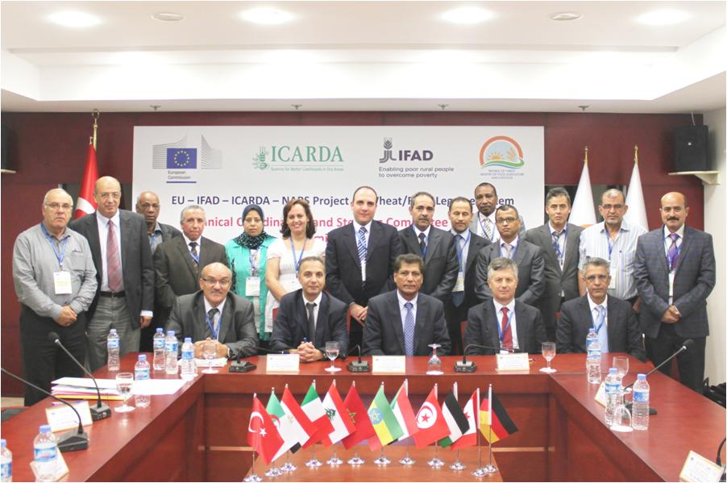
Technical and Steering Committees meeting. Izmir, October 2014

Durum wheat and chickpea:
Major interest crop for Algeria, Tunisia, Jordan, Lebanon, Morocco and Turkey
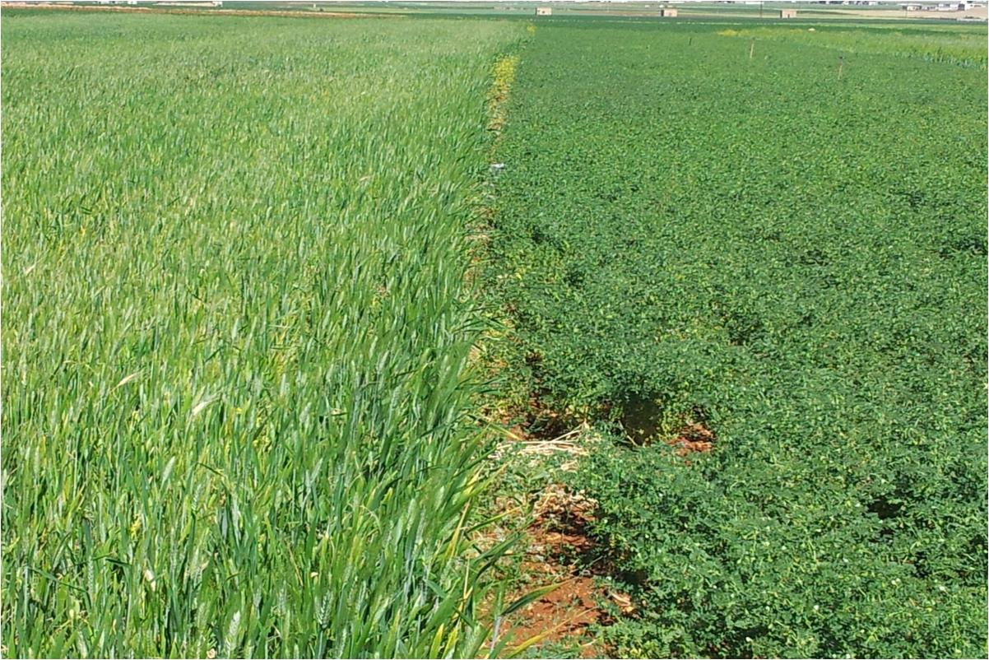

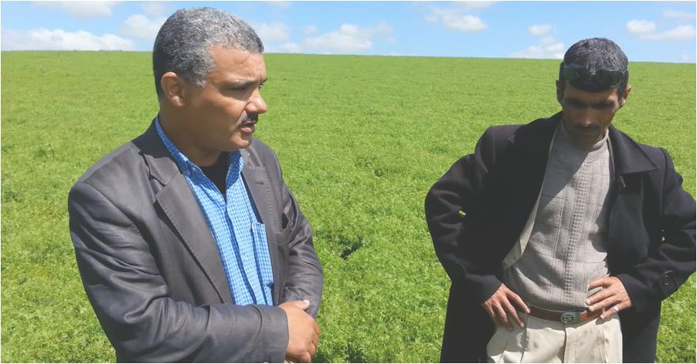
Promotion of Lentil in Western Algeria
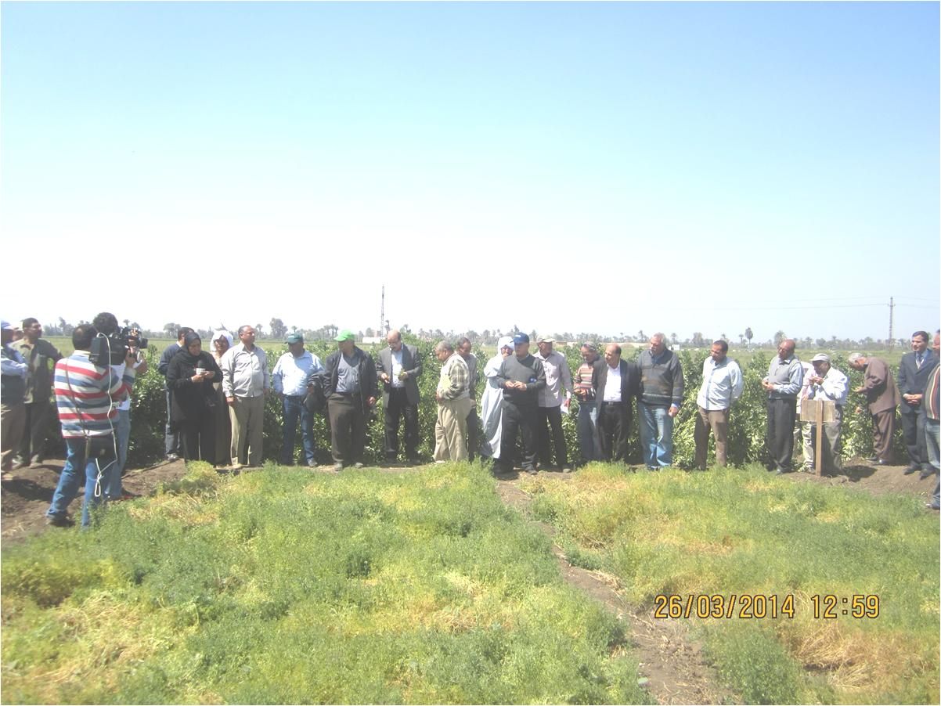
Lentil demonstration day in Egypt
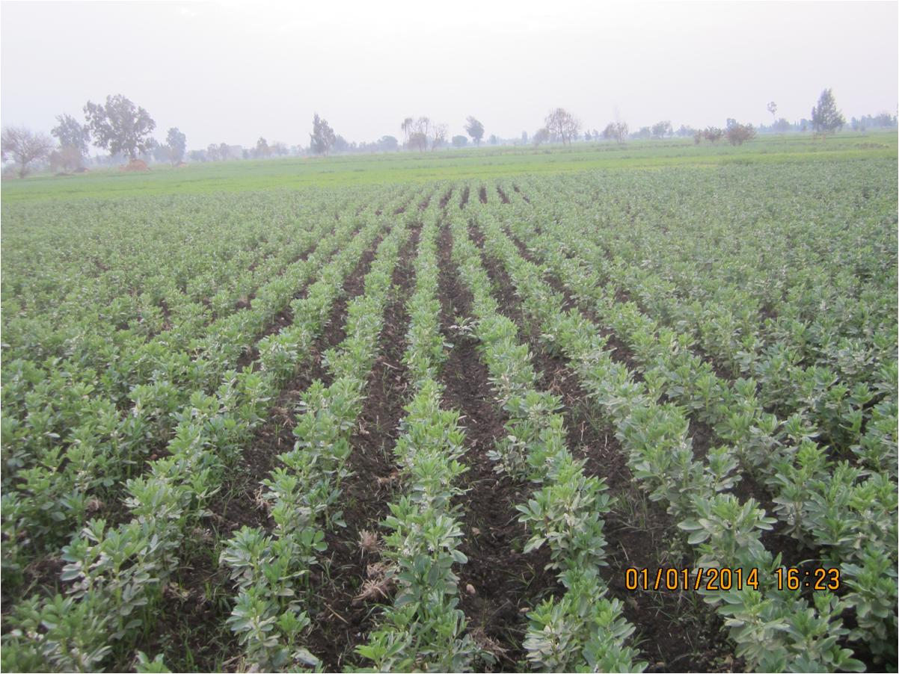
Faba bean Misr 3: a high yielding and Orobanche tolerant variety
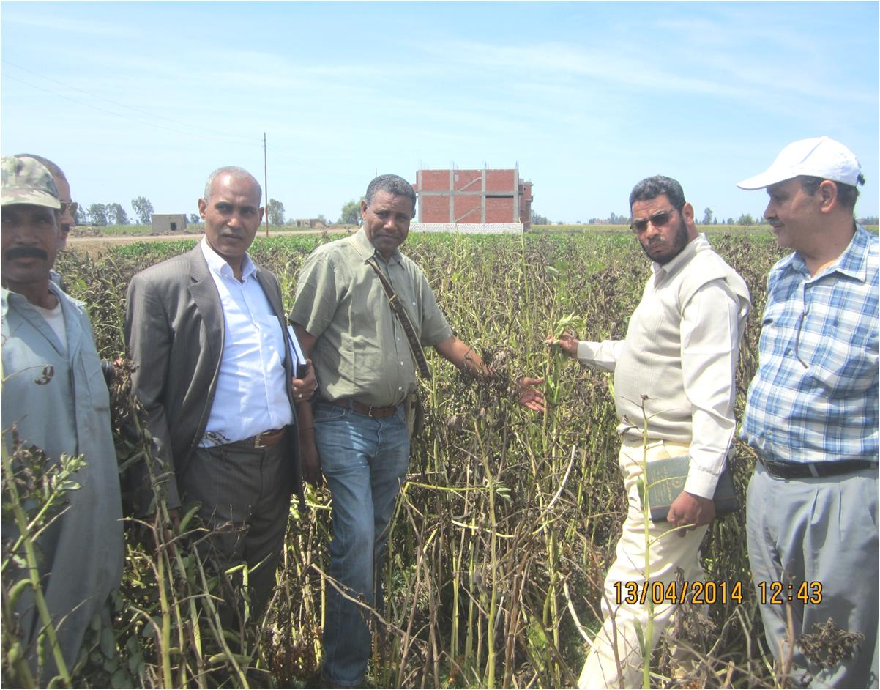
Seed increase field of Faba bean in Egypt
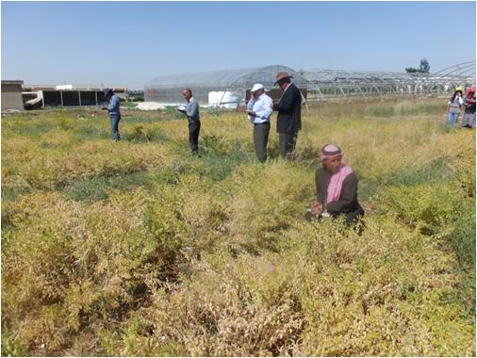
Madaba, Jordan: Chickpea participatory selection
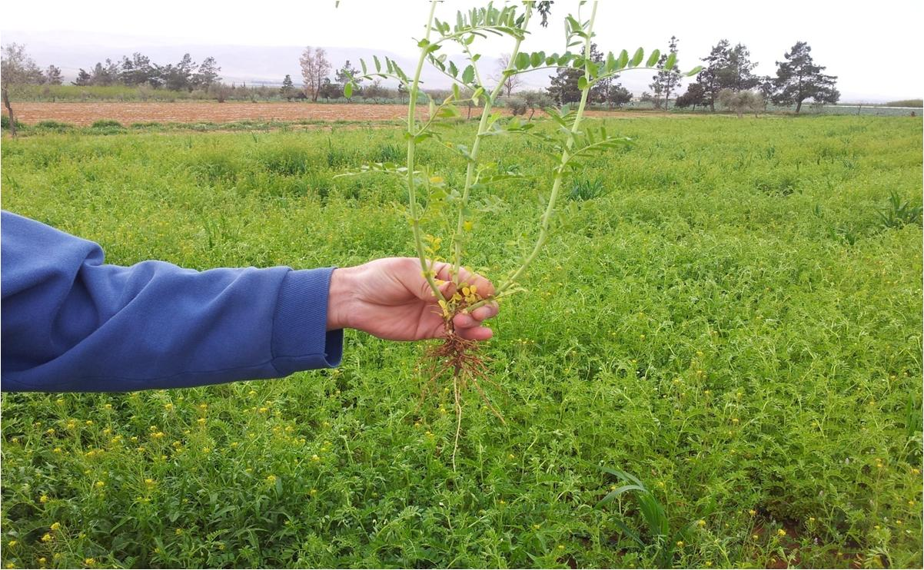
Winter chickpea increase field
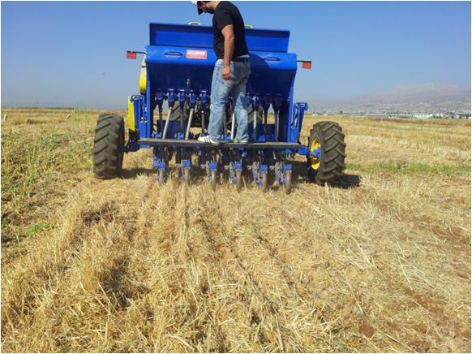
Direct drill planter that fits with needs of small farmers in Lebanon.
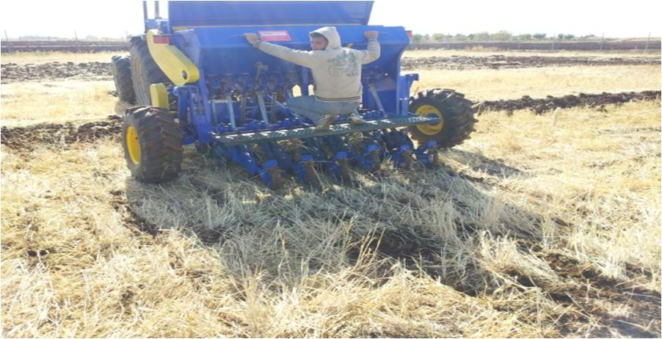
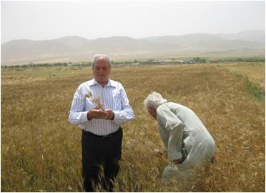
Mikki 3 : a durum variety liked and promoted by farmers in Lebanon.
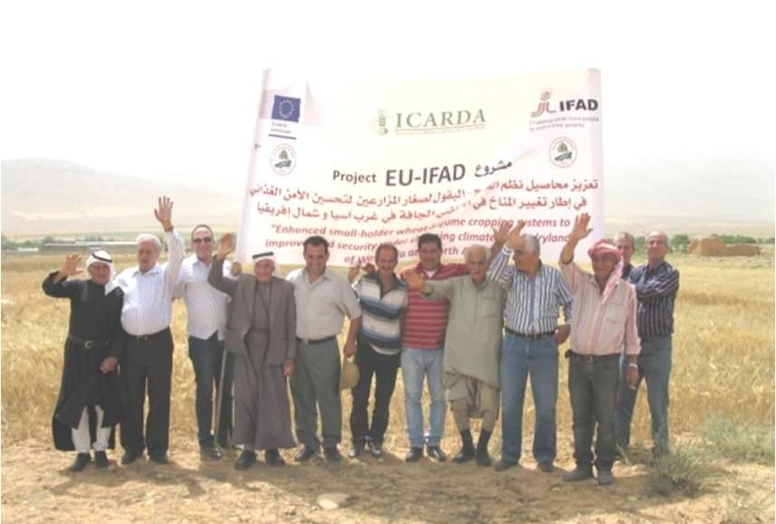

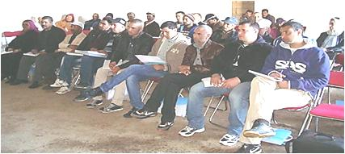
Capacity building of young farmers and interactions with Cooperatives: Morocco
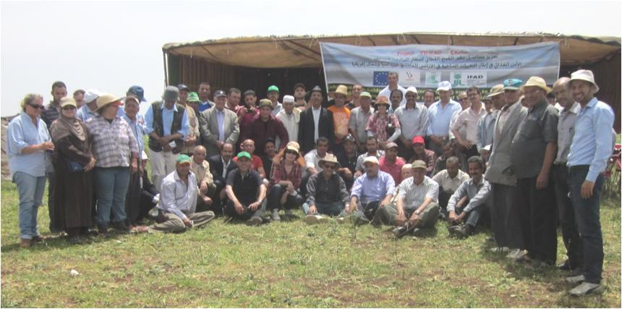

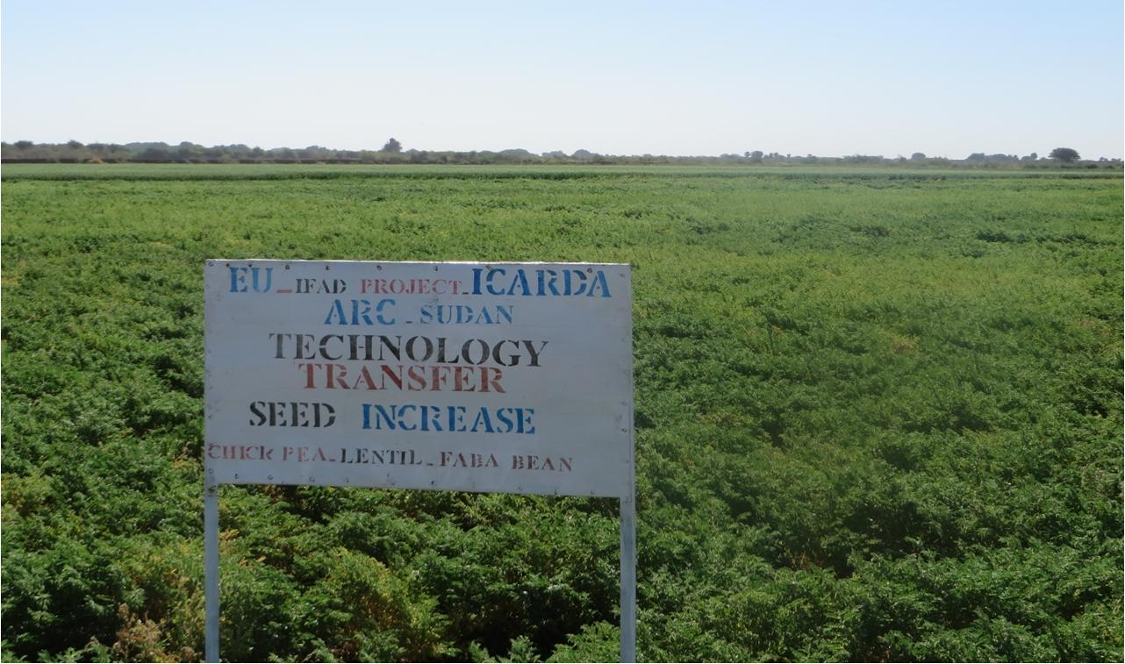
Promotion of chickpea varieties: Sudan
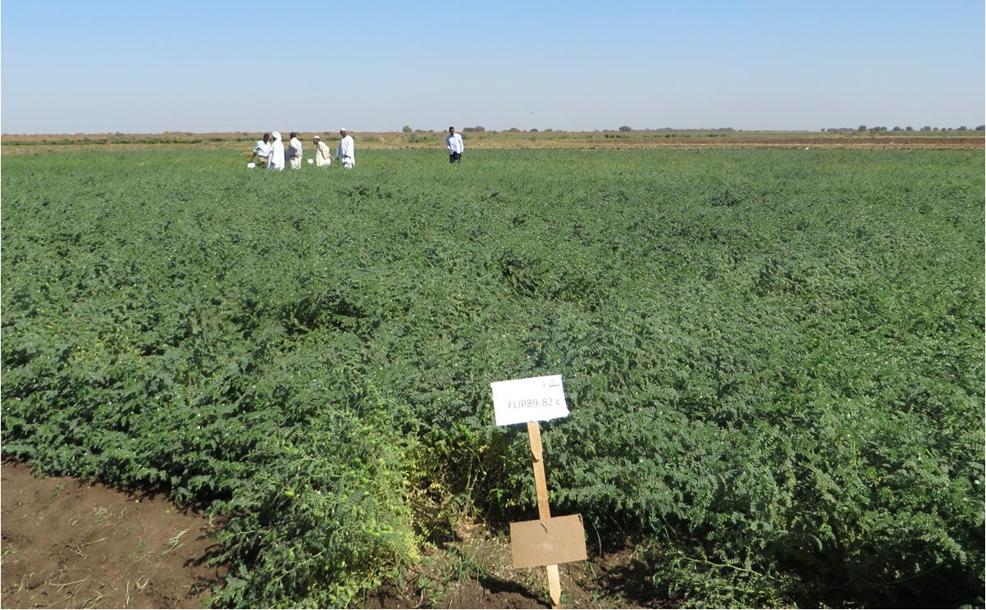
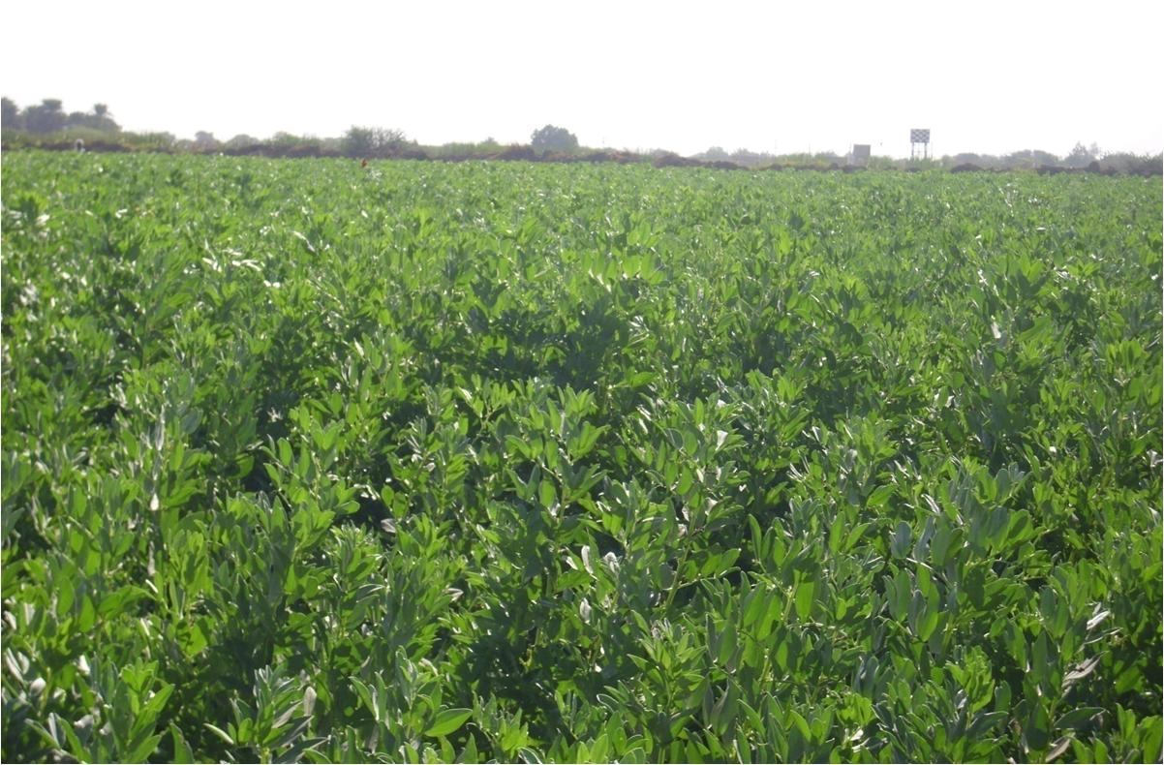
Promotion of Faba bean varieties: Sudan
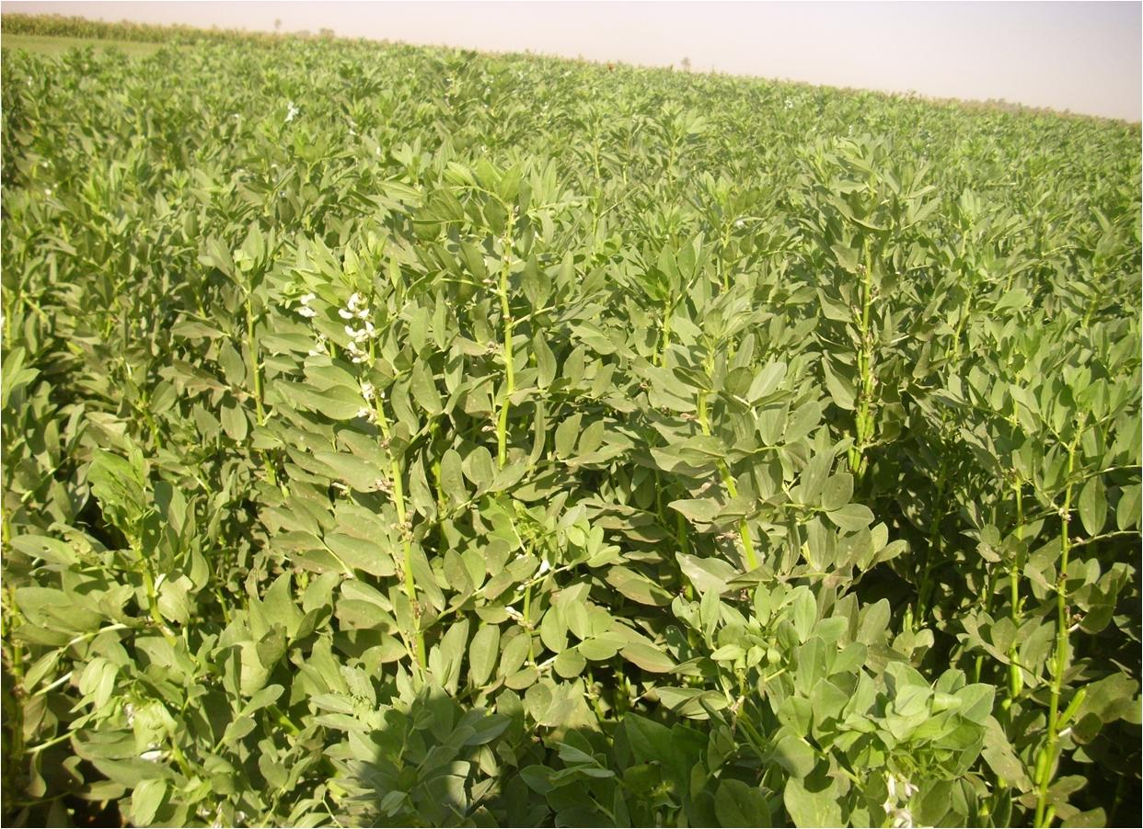

Promotion of wheat, chickpea and faba bean small in Tunisia:
Varieties and informal quality seed production and delivery

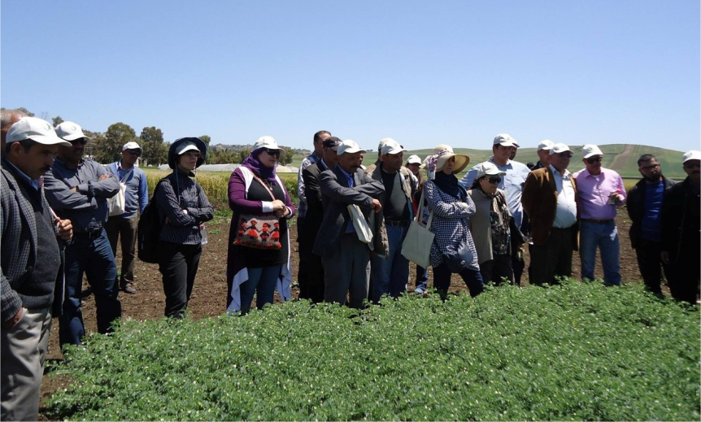

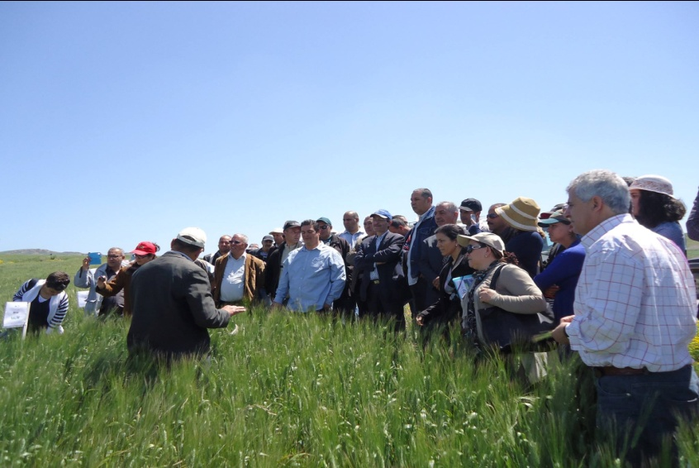

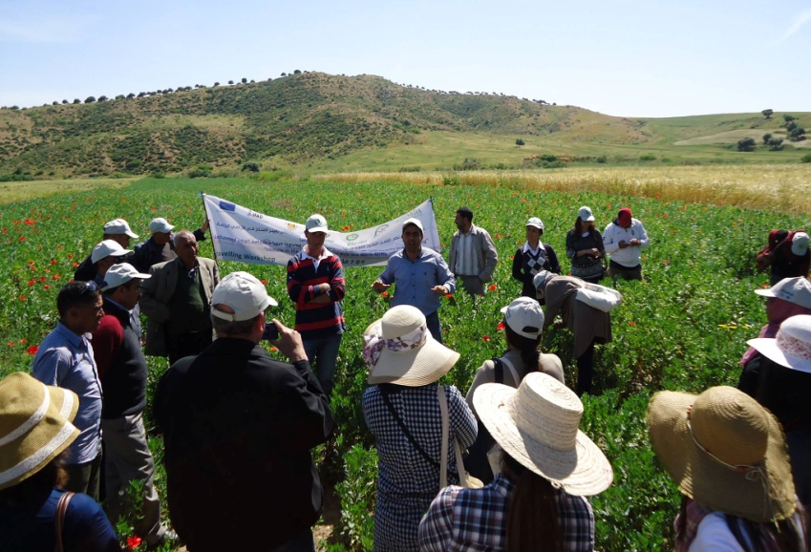

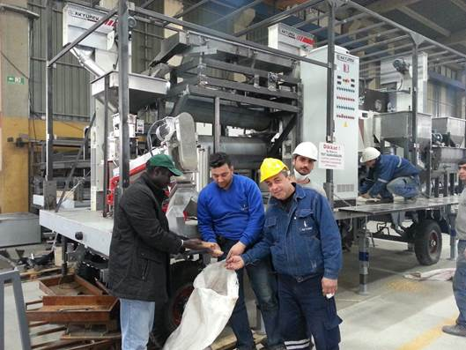

Annex 1: Results-based Logical Framework

Results-based logical framework
December 31th, 2014

Project: Enhanced small-holder wheat-legume cropping systems to improve food security under changing climate in the drylands of West Asia and North Africa
Objectives | Indicators | Means of Verification | Achievements
GOAL (Impact): Enhanced food and nutritional security, improved livelihoods of rural communities and agricultural sector growth in the countries of West Asia and North Africa (WANA) in the face of increasing climatic variability and change | - Increased national food and nutritional security.  - Reduced vulnerability of farm families whose livelihood depends on income from wheat-food legume based farming systems.  - Improved agricultural productivity, better quality of wheat and food legume products and more sustainable utilization of natural resources.  - Risk for disease/pest epidemics reduced | National economic statistics  National income statistics  National food trade statistics | Achievements to be indicated after the end of the project (end of 2015)
PURPOSE (Outcome): To deliver pro-poor scientific and technological innovations to increase and stabilize the productivity of wheat and food legume based production systems in the dry areas of WANA. | - Improved varieties released and adopted by farmers  - Improved production technologies and crop management practices adopted by farmers.  - Measurable increase in productivity in farmers’ fields  - Reduced losses from diseases/pests and increased stability of wheat-grain legume yields.  - Enhanced professional capacity of NARS and increased research efficiency and exchange of knowledge | National agricultural production statistics  Adoption and impact studies  NARS annual work programs and reports | Achievements to be indicated after the end of the project (end of 2015)

Specific Objective 1: Promotion of proven and tested technologies for wheat-legume rotation systems, by scaling out existing improved wheat and food legume varieties and associated production technologies, while concurrently identifying and testing appropriate new technologies to sustainably improve productivity and production.
Outputs | Indicators | Means of Verification | Achievements in 2014
- High yielding and stress tolerant wheat and food legume germplasm and associated technologies tested and adapted to farmers’ production environments and end-user requirements | - Number of farmers in target areas adopting new germplasm and associated technologies  - Increased yields in farmers’ fields  - Reduced costs and increased returns of production in farmers’ fields | Countries reports, Project reports & field records | -424 On-farm technology dissemination platforms (TDPs)were implemented in 2014 comprising demonstration/popularisation of superior wheat and food legumes varieties and many of these varieties combined with IPM, CA and SI technology components.  -Number of farmers exposed to these dissemination platforms reached more than 6000 and represent potential adopters. High potential adopters are the 278 leader farmers who hosted the TDPs.  -Technologies demonstrated provided farmers with the opportunity to see by themselves yield increases as well as reduction of production cost and measured increased returns particularly when varieties were combined with the full technology packages. This was an extensive well organized campaign on faba bean in Egypt. This was also the case in the other countries with faba bean and chickpea in Sudan, durum wheat in Jordan, durum and bread wheat and lentil in Algeria, Faba bean and chickpea in Tunisia, durum wheat and chickpea in Lebanon, wheat and chickpea in Turkey, durum wheat, lentil and chickpea in Morocco for normal and seed production.  - A great margin of progress is expected in 2015 where the number of TDPs is going to sharply increase and would target exposure of technologies to an estimated number of 15 000 farmers.
- Preferred genotypes identified in participatory varietal selection trials, submitted by national programs for varietal release in targeted production areas | - Number of varieties submitted for national release | Countries reports, Records of national variety release programs | -Farmers selected 2 varieties of faba bean : Merowe and Shendi and released by Sudanese National Variety Release Committee2013.  -Farmers selected 1 chickpea variety (cv. Rebha) in Tunisia, which has been proposed for registration in the Official Catalogue of Plant Variety in 2013.  -Farmers have selected the best wheat varieties in 3 research stations in Jordan from macro-plot (6 lines) and micro-plot (5) trials.  -On-farm and on-station final evaluation trials installed for participatory variety selection in several countries.  - This is an on-going activity and further progress in expected.
- New and emerging constraints to the adoption by farmers of improved technologies identified and feedback provided to technology development and adaptive research program. | - Further adaptive research to address emerging constraints  - Recommended policy and institutional options for relieving constraints | Countries reports, baseline surveys,  Farmer surveys & constraints analyses  Countries work plans  Project reports | -Different surveys done on diseases, insect pests, plant parasites in Tunisia, Morocco and Sudan, allowed to identify major problems: pod borer infestation on faba bean in North Africa; virus diseases on faba bean and chickpea in Sudan and Tunisia; FW/Root rot diseases on chickpea, lentil and wheat in several countries.  Research activities are implemented to find durable solutions (IPM).  -Efficient pesticides have been tested and recommended.
- National seed systems strengthened through technical training and advisory services | - National seed systems staff trained in seed technology, seed marketing and seed enterprise development | Countries and Project reports (ICARDA Seed Unit)  Training programs & Seed Unit reports  National seed systems business plans | -Regional and in-country seed training courses were held in most countries on variety maintenance, quality seed production, seed enterprising and seed business planning. Pilot seed sector studies were implemented on wheat seed sector in Morocco and faba bean in Egypt. Final recommendations are in the process.  -Training course were held in most countries since 2013; Jordan, Lebanon, Turkey, Sudan, Morocco and Tunisia.
- Financially viable community- or farm-based seed production enterprises, capable of producing quality-assured seed, established in pilot sites | - Number of community- or farm-based seed production enterprises established in target areas  - Quantity of seed produced | Countries and Project reports (ICARDA Seed Unit  Seed enterprise business plans and records  Seed unit purchase and supply documents. | - 5 mobile seed units ordered in 2013 (October 2013-December 2013), were provided (the last one in September 2014) to Algeria, Jordan, Morocco, Sudan, Tunisia. Beneficiaries are identified and were trained on their use and maintenance. Each country would be having a proper strategy to use these seed unit with the final objective to promote informal seed delivery systems that would benefit food legumes on a priority basis.  -Business plan developed in Morocco for seed production of legumes:  30 ha of 5 food legume preferred varieties were sown in17 farmers ‘fields in cooperative El-Hilal at Marchouch. It is expected to produce 50 T that can satisfy all farmers of cooperatives El-Hilaland El-Wided next season (2014/15).  - Technical backstopping would be provided to beneficiaries of the other 4 countries in 2015 due to the late arrival and clearance from customs of the seed units.  -All 5 seed processing units are expected to serve quality seed delivery systems development starting from 2015.

Specific Objective 1 (continued)
Outputs | Indicators | Means of Verification | Achievements in 2014
- New conservation agriculture-based wheat-legume rotation systems developed and tested in farmers’ fields | - Number of farmers in target areas adopting conservation agriculture systems  - Yields in farmers’ fields  - Costs and returns of production in farmers’ fields | Countries and Project reports & field records | -125 on-farm conservation agriculture platforms were implemented in 2013/14 (86 were on food legumes and 39 on wheat). 5 countries (Morocco, Lebanon, Algeria, Jordan and turkey dealt with direct drill (DD) of both crops and Egypt dealt with raised bed technology in faba bean). Significant yield increases of faba bean, chickpea and lentil were observed under CA, and reduction of production cost is a significant parameter understood by all farmers.  -Increasing number of farmers adopting the technology and asking to adopt technology; but the lack of low cost efficient direct drill is a constraint to progress. Some countries like Algeria and Morocco have invested in DD planters both at formal and private initiatives and services are provided, unfortunately, now mostly to big farmers.
- Integrated supplemental irrigation and crop management packages that conserve water and maximize crop productivity developed and tested in the target areas | - Number of farmers in target areas adopting supplemental irrigation and crop management packages  - Yields in farmers’ fields, and water productivity  - Costs and returns of production in farmers’ fields | Countries and Project reports & field records | -Supplemental irrigation has been demonstrated and is used by farmers for wheat Algeria, Lebanon, Tunisia, Jordan and Turkey. For food legumes the project has initiated activities and is advocating its use in food legumes for increased seed production, the most important way to balance the induced cost of irrigation. For the moment progress is seen only on chickpea in countries such as Algeria, Turkey and Lebanon.  - Fine tuning of the technology is still studied on chickpea and lentils and the project would be testing and evaluating cost and returns of drip irrigation on these crops.
- Results from wheat and food legumes baseline and variety adoption surveys and constraints analysis communicated to users including research, extension, development agencies and policy decision-makers | - Data base of baseline production and varietal adoption  - List and ranking of major constraints to adoption of modern varieties  - Recommendations to address constrains to technology adoption | Countries and research reports,  Farm surveys, policy briefs, seminar presentations  Meetings with decision-makers | -Initiated in Morocco (in collaboration with CGIAR Research Program on wheat)  - farmers surveyed in Morocco in 2013  - faba bean farmers surveyed in 2013 in Egypt.  -Data have been analyzed in 2014 and final finding would be documented, published and discussed with policy makers and interested national and international parties in 2015.

Specific Objective 1 (continued)
Outputs | Indicators | Means of Verification | Achievements in 2014
- Gender analysis including the differentiation of the constraints that men and women face in accessing technologies, information and markets communicated to relevant stakeholders including to research, extension development organizations and policy decision-makers | - Institutional and policy options the remove gender inequity delivered to and discussed with decision-makers | Countries and Project reports ICARDA Gender team) & country baseline studies field records  Publications  Specific initiatives | -Gender analysis in progress in Morocco needs to be addressed in other countries where data is available from baseline study.  -Fine research is needed as the Gender issue is complex in the socio-cultural context of the project countries.  - A linkage to a global initiative involving 56 case studies, entitled “Innovation and Development Through Transformation of Gender Norms in Agriculture and Natural Resource Management” would bring more insight to gender issues in this project.
- Analysis of productivity trends and gaps on wheat and food legume based systems made available to relevant institutions and policy decision-makers | - Data base, productivity gap estimates | Project reports &Reports of ICARDA Socioeconomic Unit | The Wheat value chain and its seed value chain have been studied on a pilot basis in Morocco and results are expected to be out in 2015. For food legumes another pilot study was implemented on faba bean in Egypt and here also results are expected to surface in 2015.  -Trends and gaps for both types in a system-based logic need more attention from the project.
- Research capacity of national programs enhanced through training and networking | - NARS researches, research support staff, extension and field support staff trained in technology dissemination  - Degree training organized for research and research support staff trained in regional and in-country training courses.  - Individual training based on competitive opportunities to support specific demand training and support training to graduate students to complete their degree research.  - trained in new techniques such as double haploid breeding, marker-assisted selection and transformation  - Full support to graduate students. | Project report, Training programs (CDU team), and country reports.  Graduate student theses | -445 extension agents, research support staff and young farmers benefited from 21 implemented in-country courses.  -43 research and research support staff (13 females and 29 males) benefited from 5 ICARDA organized regional training courses.  8 young research scientists (5 females and 3 males) individually benefited from training of 3 to 5 weeks on topics of interest to the project and to them on focused topics important to their research and sometimes to research in relation to their graduate studies.  -7 research scientists (2 females and 5 males) benefited from the support of the project to participate to the 3 following international events: -2nd International Wheat Stripe Rust Symposium, -21st Biennial International Workshop on Plant Resistance to Insects, -6th International Food Legumes Research Conference & 7th International Conference on Legume Genetics and Genomics  -1 MSc (Jordan) and 1 PhD (Morocco) graduate students are directly supported by the project.

Specific Objective 2: Development of new germplasm and production technologies to cope with climate change.
Outputs | Indicators | Means of Verification | Achievement in 2014
- New wheat and food legume genotypes, better adapted to climate variability and change | - Number of new genotypes with required resistance and end use quality | - Countries & Project reports, lab records  - Record on nurseries and trials distributed to partners countries  - Results of national breeding programs | - Trial sets were supplied by ICARDA to project countries: 30 trial sets of durum, 18 trial sets of bread, 27 trial sets of faba bean, 29 trial sets of chickpea and 29 trials sets of lentil.  - High-yielding and stress tolerant varieties of faba bean, chickpea, lentil, durum and bread wheat were selected and advanced by national programs.
- Sustainable wheat-legume rotation system established at farm level. | - Number of farmers in target areas adopting wheat-legume rotation systems  - Cropping systems productivity in farmers’ fields | - Countries and Project reports & field records | -Pilot crop rotation including food legume established in several countries to study the long term effect of CA on the performance of both crops.  -More time is needed and it is a difficult task for the scope of the project dealing more with technology dissemination and having a limited live time of 3 years.
- IPM options for key diseases, insect pests and parasitic weeds with wide effectiveness demonstrated on farmers’ fields. | - Farmers in target areas adopt IPM options  - Strategies for further dissemination of IPM practices | - Countries and Project reports (ICARDA IPM team & field records | -Genotypes resistant to pests and diseases identified and advanced in wheat and food legumes; Recommended IPM packages used on faba bean.  - A number of 275 farmers participated in14 Farm Field Schools (FFS) to improve their knowledge of IPM practices.  -New elements (herbicide control, plant parasite control in faba bean, fungicide control, seed dressing with new chemicals have been integrated in IPM packages and tested in farmers’ fields.  - Best impact with IPM package recorded in faba bean in Egypt.
- GIS spatial analysis of dry area farming systems and geo-statistics of crop adaptation and disease/pest prevalence to help target technology interventions. | - Mapping and Monitoring of the Cereal-Legume Cropping Systems in the Marchouch Pilot Site, Morocco and Fernana Pilot site in Tunisia | - Project reports (ICARDA GIS team) databases and maps  - NARS work agendas and reports | -Development of the electronic field data collection kit done.  -Collection of extensive ground truth data for remote sensing classification done. The outputs expected in 2015 are:  - Quantification of the cropping systems, condition and distribution pattern  - Mapping the land use and land cover types at high spatial scales. .  - Estimation of the legume and cereal biomass. Development of the inputs layers of pests and diseases risk mapping.

Specific Objective 2 (continued)
Outputs | Indicators | Means of Verification | Achievement in 2014
- Tools for determining new supplemental irrigation schedules and packages for better adaptation of wheat-legume systems to climate change | - NARS use a validated model for simulating the effect of climate change on rain-fed wheat-legumes areas and develop adaptation strategies using supplemental irrigation and other water management option  - NARS use spatial maps for identifying areas to apply supplemental irrigation | Project reports, Report of pilot study  NARS work agendas and reports  Progress report on the activities of the ICARDA sponsored student from Jordan. | -NARS are testing deficit irrigation to improve wheat yield (Algeria, Tunisia, Jordan) and food legume (Tunisia, Turkey).  -Training course on supplemental irrigation for NARS scientists and engineers (9 participants) in Amman in 2013.  A model for supplemental irrigation is being elaborated in Jordan to benefit semi-arid areas .  -An MSc student is completing his second research year. A research work in collaboration between ICARDA (IWLM program) and the Jordanian University of Sciences and Technologies (JUST).
- Ex-ante assessments of the potential impact of improved wheat-legume varieties and associated technologies on crop productivity, household income and food supply documented in selected countries | - Ex-ante assessments of the potential impact of new technologies delivered to, and discussed with, decision-makers | Project report (ICARDA Socioeconomic team)  Survey results  Impact briefs  Seminar presentations | -Final reports for Morocco and Egypt pilot studies are in the finalization stage and due in 2015. Results of the Morocco wheat sector study will be presented during the Meknes International Agriculture Fair (end of April 2015)
- The impacts of selected crop diseases evaluated and farmers’ perceptions and practices in managing plant diseases analyzed | - Estimates of costs of major crop disease communicated to stakeholders | Project report (ICARDA IPM team)  Survey results  Impact briefs  Seminar presentations | -Cost benefit IPM package on seeds dressing to control viral diseases on faba bean and chickpea and full package to control of Orobanche were evaluated with farmers in Tunisia and Egypt (with a large number of farmers in 4 governorates).  -Impact measured on faba bean and advocated to policy makers for support in the national faba bean rehabilitation program.

Annex 2: International Public Goods

Publications

Ahmed, S., M. Abang and M. Imtiaz. 2014. Integrated management of Fusarium wilt and its effect on disease development and yield of chickpea in Syria. Archives of Agronomy and Soil Science. (Accepted-ISI).

Bayaa, B, S. Ahmed, M. Baum, and N. Hussien. 2014. Pathogenicity and Genetic Diversity of Fusariumoxysporumf.sp. lentis, the Causal Organism of Lentil Vascular Wilt in Syria. Aleppo University Research Journal (Accepted).

Bayaa, B., M. Abu Shaer , S. Ahmed and M. Baum 2014. In -vitro Antagonistic Effect of different Isolates of Trichodermaspp from Syrian Soils AgainstFusariumoxysporumf.sp. lentis, the Causal Organism of Lentil Vascular Wilt. Aleppo University Research Journal. (Accepted).

Hussien, N.H., B. Bayaa, S. Ahmed, M. Baum and M.M. Yabraq. 2014. New method to screen Fusariumoxysporumf.sp. lentis isolates for pathogenicity. Arab Journal of Plant Protection, 32(2): 131-139.

Omyma Elmahi Mohamed, Aladdin Hamwieh, Seid Ahmed and NafisaElmahi Ahmed. 2014. Genetic variability of Fusariumoxysporum f. sp. cicerispopulation affecting chickpea in the Sudan. Journal of Pythopathology. (Accepted).

Kher, S.V., L. M. Dosdall, H. A. Cárcamo, and M. El-Bouhssini.- - 2014.Antixenosis Resistance to Oulemamelanopus (Coleoptera: Chrysomelidae) in Central Asian Wheat Germplasm. Journal of Economic Entomology 107: 410-416.

Ravi Yandamuri, RanjeetaGautam, Charles Darkoh, VanithaDareddy, Mustapha El-Bouhssini, Beatrice Clack. 2014. Cloning, Expression, Sequence Analysis and Homology Modeling of the ProlylEndoprotease from EurygasterintegricepsPuton. Insects, 5: 762-782; doi: 10.3390/insects 5040762.

Papers presented at workshops/conferences
Ahmed, S., Karrou, M.and Shiv, A. Kumar. 2014. Effects of supplementary irrigation on Fusarium wilt epidemics and yield of lentil in northern Syria. Poster presented in joint conference of the 6th International Food Legumes Research Conference (IFLRC VI) and 7th International Conference on Legume Genetics and Genomics (ICLGG VII), Saskatoon, Canada. July 7-11, 2014.

Kumari, S.G., A. Ekzayez and A. Najar. 2014. Effects of seed dressing pesticides on the spread of Faba bean necrotic yellows virus on faba bean and Barley yellow dwarf virus-PAV on barley and oat. 14th Mediterranean Phytopathological Union & International Society of Mycotoxicology, 25-29 August 2014, Istanbul, Turkey.

Kumari, S.G., A. Ekzayez and A. Najar. 2014. Effects of seed dressing pesticides on the spread of Faba bean necrotic yellows virus on faba bean and Barley yellow dwarf virus-PAV on barley and oat. Joint International Congress, 14th Congress of Mediterranean Phytopathological Union, International Society of Mycotoxicology (Mediterranean Branch), 25-29 August, Istanbul, Turkey, Page 103.

M. El-Bouhssini, M. Nachit, A. Amri, M. Mosaad, O. Abdallah, S. Grando, S. Ceccarelli, R. Malotra, A. Sarker, M. Imtiaz, S. Agrawal, S Lhaloui, N. Nsarellah, M. Jlibene, A. Ammar, F.C. Ogbonnaya, W. Tadesse, K. Street, M. Keser and A. Bari. 2014. Status of host plant resistance to insect pests of cereals and food legumes in West and Central Asia and North Africa. International Plant Resistance to Insects Workshop, Marrakech, Morocco, 14-16 April, 2014.
Lhaloui, S., M. El Bouhssini, H. Ramdani, S. Krimi Bencheqroun, S. Kemal, S. Kumari, F. Gamba and H. Bahaddou. 2014. Status of insect pests of cereals and food legumes in Morocco. 11th Arab Congress of Plant Protection, Amman, Jordan, November 9-13, 2014.

Amri, M.ElBouhssini, N. Nsarellah, M. Nachit, O.Abdallahh, S. Lhaloui, M. Jlibene, M. Mergoum, J. El Haddoury, M. ElHaila, B.Gill, S. Cox and J. Hatchett. 2014. Results of collaborative germplasm enhancement for resistance to Hessian fly of wheat in Morocco. International Plant Resistance to Insects Workshop, Marrakech, Morocco, 14-16 April, 2014.

N. Nsarellah, M. Nachit, S.Lhaloui, A. Amri, M. El Bouhssini. 2014. Recent durum wheat variety release with Hessian fly resistance from inter specific crosses in Morocco. International Plant Resistance to Insects Workshop, Marrakech, Morocco, 14-16 April, 2014.

W. Tadesse, O. Abdella, F.C. Ogbonnaya, M. El Bouhssini, S. Lhaloui and A. Ammar. Identification and development of elite bread wheat genotypes with high yield potential and Hessian fly resistance. International Plant Resistance to Insects Workshop, Marrakech, Morocco, 14-16 April, 2014.

Lhaloui, M. El Bouhssini, H. Ouabbou, F. Ogbanaya, M. Parry, S. Udupa,N. Nsarellah, J. El Haddouri and K. El Fakhouri. 2014. New sources of resistance to the Moroccan populations of Hessian fly identified in primary synthetic and reverse genetic strategy-induced point mutation bread wheat lines. International Plant Resistance to Insects Workshop, Marrakech, Morocco, 14-16 April, 2014.

A. Cherif , M. El Bouhssini , H. Glida , M.S. Gharbi and J. Mediouni Ben Jemâa. 2014. Potential of genes H22, H18, H13 and H11 for durum wheat resistance to Mayetiola destructor field populations from North Tunisia. International Plant Resistance to Insects Workshop, Marrakech, Morocco, 14-16 April, 2014.

Varieties used and promoted by the project member countries

The most relevant in this context is the number of food legume varieties that have been subjected to early seed increase, promotion and demonstration to farmers. Release regulations, as we said before, are stiff and not favorable to food legumes. The varieties promoted are usually accepted and considered as “temporary releases”, especially when they are used by farmers and occupy significant cultivation areas.
The following is a list of varieties with significant superior potential and well accepted, cultivated and often very requested by farmers. For cereals they are official releases and for food legumes they are temporary releases. Both are to be considered as IPGs. The following table (see next page) indicates the varieties of faba bean, chickpea, lentil, and durum and bread wheat used promoted by project partners

Food legumes and wheat varieties increased, demonstrated and promoted by the project partners during growing season 2013-14.
Countries | Faba bean | Chickpea | Lentil | Durum wheat | Bread wheat | Total
Algeria | - | - | 2  Ebla 1  Idlib 2 | 6  Setifis, Megress, Wahbi, Saoura, Mansoura, Massinissa | 7  El Wifak, R’mada, Djanet, Djemila, Tidis, Akhamokh, Massine | 15
Egypt | 4  Nubaria 2 Nubaria 3 Sakha 4 Misr 3 | - | 1  Flip 95-67L | 2  Benysuif 5, Benysuif 6 | 3  Gemmiza 11 Sids 12 Sohag 1 | 10
Jordan | - | 1  Jubeiha 3 | - | 2  ASCAD1187 ACSAD1275 | - | 3
Lebanon | - | 3  Ghab5,  FLIP97-7C  FLIP97-706C | 1  Idleb2 (ILL5883) | 6  Tal Amara1, Miki 3, Icarasha2 : Ghzael, Azeghar 2: Lahn3 | 2  Tal Amara2, MR1009 | 12
Morocco | - | 1  Arifi | 1  Chakkouf | 2  Louiza  Faraj | 2  Kharrouba, HI50 | 6
Sudan | 4  Shendi, Merowe  Eddamer  Basabeer | 3  Hawata  Burgeig  Salawa | 3  Aribo  Rubatab  Nedi | - | - | 10
Tunisia | - | 1  Nour | 1  Boulifa: (FLIP05-19L) | - | - | 2
Turkey | - | 11  Azkan, Hisar, Cakır,  Aksu, Diyar,  Arda ( FLIP97-90C)  Hassanbey  (FLIP98- 55C)  Seckin (FLIP98-63C)  Akça, Yazici,  Agsakalli | 4  Gumrah: ILL7938,  Karagul: (ILL10091,)  Ankaraye: (ILL8634),  Bozok) | 5  Alibaba, Gundas, Icajoudy, Saribasak, Edessa) | 3  Mufitbey,  Nacibey, Mesut | 23
Total | 8 | 20 | 13 | 23 | 17 | 81

Appendix 1. Tables and Figures

Table 1. Number of genotypes and high potential varieties subjected to early seed increase and the corresponding seed quantities producedin 2014by the project per countries and crops.
Countries | Durum | Bread wheat | Chickpea | Lentil | Faba bean | Seed produced (MT)
Algeria | 4 | 4 | 5 | 7 |  | 20
Egypt |  |  |  | 14 | 5 | 19
Jordan | 2 | 1 | 1 | 1 |  | 5
Lebanon | 1 |  | 1 |  |  | 2
Morocco | 3 | 2 | 4 | 2 |  | 11
Sudan |  |  | 5 | 2 | 7 | 14
Tunisia | 2 |  | 5 | 4 | 6 | 17
Turkey | 5 | 6 | 4 | 2 |  | 17
Variety number | 17 | 13 | 25 | 32 | 18 | 105
Total seed produced (MT) | 27.7 | 258.9 | 382 | 19.4 | 73.7 | 761.7
MT= Metric tons of raw seed (non processed)

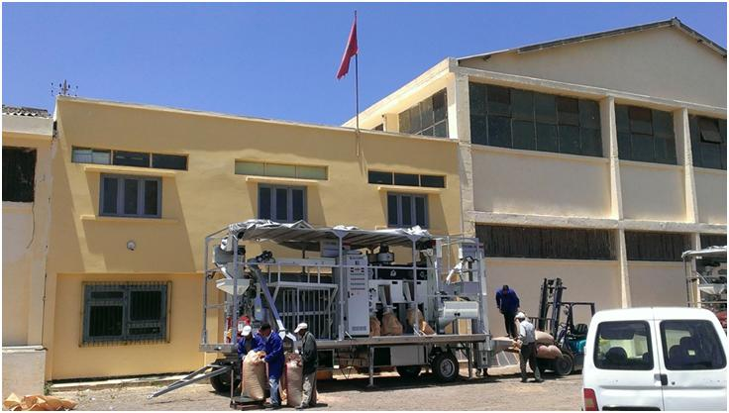
Figure 1.Model of mobile seed processing unit purchased by the project in 2014 to strengthen to national seed sector and contribute to the emergence of informal community based quality seed production, especially of food legume crops. Five countries: Algeria, Jordan, Morocco, Sudan and Tunisia beneficiated from this project investment.

Table 2. Type and number of technology dissemination platforms (TDPs) implemented by the project partner countries with indications on the number of host farmers associated, land area usedand quantities of seed mobilized for their implementation during growing season 2014.

Table3. Breakdown of the technology dissemination platforms (TDPs) implemented by the project partner countries in 2014 by type of TDP and crops.

Table 4.Capacity building activities implemented by the project in 2014 to benefit researchers, research support staff and graduate students.
Individual trainings
Direct support to graduate studies
2 MSc students in jordan and Morocco?

Table 5.Evolution of faba area, productivity, production and level of self sufficiency in Egypt over period 1987-2012.
% Self-sufficiency | Total Production (1000 MT) | Productivity (tons/hectares) | Cultivated area  (1000 hectares) | Period/Cropping Seasons
81 | 329 | 2.4 | 140 | 1987/88- 1991/92
91 | 377 | 2.9 | 131 | 1992/93-1996/97
96 | 405 | 3 | 135 | 1997/98- 2001/02
80 | 337 | 3.17 | 106 | 2002/03
79 | 331 | 3.27 | 100 | 2003/04
67 | 282 | 3.38 | 83 | 2004/05
59 | 248 | 3.36 | 74 | 2005/06
65 | 304 | 3.39 | 89 | 2006/07
58 | 244 | 3.42 | 72 | 2007/08
70 | 295 | 3.41 | 87 | 2008/09
55 | 232 | 3.01 | 77 | 2009/10
45 | 192 | 3.15 | 61 | 2010/11
31 | 138 | 3.38 | 41 | 2011/12

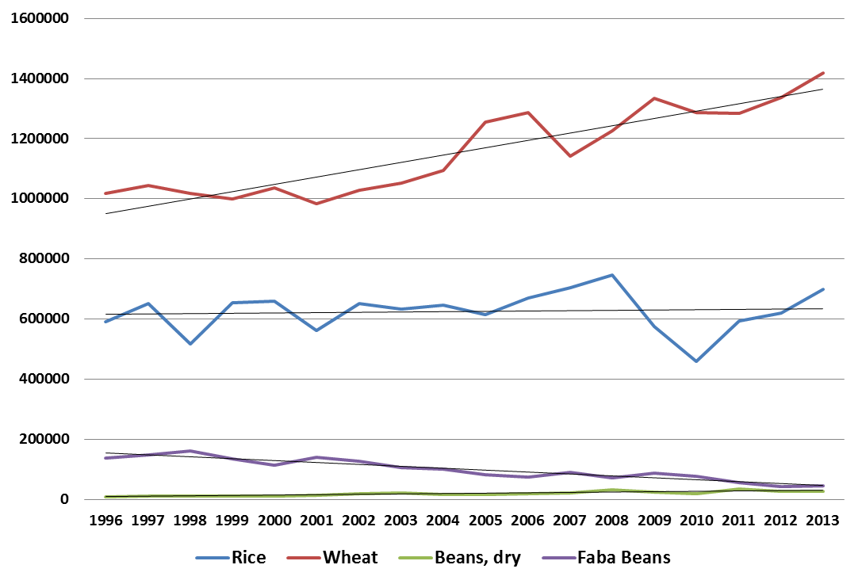
Figure 2.Evolution of the area of faba bean compared, dry beans, to rice and wheat in Egypt during period 1996 2013.

Table 6.Varieties of faba bean available for cultivation to Egyptian farmers and their main characteristics with regards to biotic stresses.
Period | Registeredvarieties | Characteristics
2010-2013 | Misr 3  Giza 843 | Tolerant to Orobanche and resistant to Foliar diseases
2010-2013 | Nubaria 2  Nubaria 3 | Adapted to low water requirements and early maturing
2010-2013 | Sakha 4  Giza 716  Giza 3 | Resistant to Foliar diseases and adapted to early planting
2014-2015 | Sakha 1 | Early mature and resistant to Foliar diseases
2014-2015 | Nubaria 1 | Recommend to newly reclaimed soils and Resistant to Foliar diseases
2014-2015 | Misr 1 | Tolerant to Orobanche

Appendix 2. Project partners workplans and budgets for cropping season 2014-15.
Table 1. Number farmers planned to be exposed to project technologies in 2015
** FFS sessions and field days to be set later
Table 2. Country allocated operational budget and its breakdown per project component planned to be implemented during cropping season 2014-15.

Table 3.Algeria’s operational budget and breakdown per project components and tasks.
PROJECT TASK  COMPONENTS | ALGERIA PLANNED ACTIVITIES  Growing Season 2014-2015 | Percent of SC approved budget | TENTATIVE  BUDGET. USD | OBSERVATION
TASK 1 | Seed Activities (breeder and pre-basic seed increase, seed processing machine activities) | 15 | 9 750
TASK 2 | Popularization of Varieties (Demonstrations) | 45 | 29 250 | With recommended package
TASK 3 | IPM Demonstrations | 45 | 29 250 | Implemented previously
TASK 4 | Conservation Agriculture (CA) Demonstrations | 45 | 29 250 | with some sites of CA in AinDefla and Setif
TASK 5 | SI Demonstrations | 45 | 29 250
Tentative Budget subtotal for Tasks 1 to 5 |  |  | 39 000 | Main budget Investment
TASK 6 | Capacity Building of Farmers | 20 | 13 000 | Important task investment
TASK 7 | Capacity Building of NARS Staff* |  | 15 000 | Centralized task
Tentative Budget subtotal for Tasks 6 and 7 |  |  | 28 000 | As recommended  by EC
TASK 8 | Back up Research |  |  | Under NARS funding
TASK 9 | PVS activities | 5 | 3250
TASK 10 | ICARDA Trials |  |  | Under NARS funding
TASK 11 | Socio economics activities | 5 | 3250 | a quick survey of impact of 100 samples is in progress
TASK 12 | painting and publication | 10 | 6500
Tentative Budget subtotal for Tasks 8 to 12 |  |  | 13 000
Tentative Country Allocated Operational Budget (all tasks except task 7) for growing Season 2014-2015 |  | 100% | 65 000 | As approved  by the SC

Table 4.Egypt’s operational budget and breakdown per project components and tasks.
PROJECT TASK  COMPONENTS | EGYPTPLANNED ACTIVITIES  Growing Season 2014-2015 | TENTATIVE  BUDGET. USD | OBSERVATION
TASK 1 | Seed Activities (breeder and pre-basic seed increase, seed processing machine activities) | x
TASK 2 | Popularization of Varieties (Demonstrations) | xxxxx | Main task investment
TASK 3 | IPM Demonstrations | x | Included in the demonstrations as component of full Technology Package
TASK 4 | Conservation Agriculture (CA) Demonstrations | x
TASK 5 | SI Demonstrations | x
Tentative Budget subtotal for Tasks 1 to 5 |  | 50 000 | Main budget Investment
TASK 6 | Capacity Building of Farmers | 15 000 | Important task investment
TASK 7 | Capacity Building of NARS Staff* | 15 000* | Centralized task
Tentative Budget subtotal for Tasks 6 and 7 |  | 30 000 | As recommended  by EC
TASK 8 | Back up Research | xx
TASK 9 | PVS activities | x
TASK 10 | ICARDA Trials | x
TASK 11 | Socio economics activities | / | Done previously
Tentative Budget subtotal for Tasks 8 to 11 |  | 10 000 | Reduced as recommended by the EC
Tentative Country Allocated Operational Budget(all tasks except task 7) for growing Season 2014-2015 |  | 75 000 | As approved  by the SC
Note:
x = There are activities implemented in this given Task
/ = No activities are implemented this season or activities are implemented with
= local financial resources
xxxx = High volume of activities are centered and implemented in this task

Table 5.Jordan’s operational budget and breakdown per project components and tasks.
PROJECT TASK  COMPONENTS | JORDANPLANNED ACTIVITIES  Growing Season 2014-2015 | TENTATIVE  BUDGET. USD | OBSERVATION
TASK 1 | Seed Activities (breeder and pre-basic seed increase, seed processing machine activities) | xx | Important investment in these tasks  IPM and SI Included as component of full Technology Package
TASK 2 | Popularization of Varieties (Demonstrations) | xxxxxx
TASK 3 | IPM Demonstrations | x
TASK 4 | Conservation Agriculture (CA) Demonstrations | xxxxxx
TASK 5 | SI Demonstrations | x
Tentative Budget subtotal for Tasks 1 to 5 |  | 28 200 | Main budget Investment
TASK 6 | Capacity Building of Farmers | 9 400 | Important task investment
TASK 7 | Capacity Building of NARS Staff* | 15 000 | Centralized task
Tentative Budget subtotal for Tasks 6 and 7 |  | 52 600 | As recommended  by EC
TASK 8 | Back up Research | 2350 | Budget reduced for these tasks as recommended by the EC
TASK 9 | PVS activities | 2350 | Budget reduced for these tasks as recommended by the EC
TASK 10 | ICARDA Trials | 2350 | Budget reduced for these tasks as recommended by the EC
TASK 11 | Socioeconomic activities | 2350 | Budget reduced for these tasks as recommended by the EC
Tentative Budget subtotal for Tasks 8 to 11 |  | 9 400 | Budget reduced for these tasks as recommended by the EC
Tentative Country Allocated Operational Budget (all tasks except task 7) for growing Season 2014-2015 |  | 47 000 | As approved  by the SC
Note:
x = There are activities implemented in this given Task
/ = No activities are implemented this season or activities are implemented with
= local financial resources
xxxx = High volume of activities are centered and implemented in this task

Table 6.Lebanon’s operational budget and breakdown per project components and tasks.
PROJECT TASK  COMPONENTS | LEBANON PLANNED ACTIVITIES  Growing Season 2014-2015 | TENTATIVE  BUDGET. USD | OBSERVATION
TASK 1 | Seed Activities (breeder and pre-basic seed increase, seed processing machine activities) | 7 000 | Important task investment
TASK 2 | Popularization of Varieties (Demonstrations) | 18 000 | Main task investment
TASK 3 | IPM Demonstrations | / | Already Implemented
TASK 4 | Conservation Agriculture (CA) Demonstrations | 4 000 | Included in the demonstrations as component of full Technology Package
TASK 5 | SI Demonstrations | 5 000
Tentative Budget subtotal for Tasks 1 to 5 |  | 34 000 | Main budget Investment
TASK 6 | Capacity Building of Farmers | 6 000 | Important task jointly coordinated with Task 2
TASK 7 | Capacity Building of NARS Staff* | 15 000* | Centralized task
Tentative Budget subtotal for Tasks 6 and 7 |  | 21 000 | As recommended  by EC
TASK 8 | Back up Research | 3 500
TASK 9 | PVS activities | / | Done previously
TASK 10 | ICARDA Trials | / | Local funding
TASK 11 | Socio economics activities | 3 500
Tentative Budget subtotal for Tasks 8 to 11 |  | 7 000 | Reduced as recommended by the EC
Tentative Country Allocated Operational Budget (all tasks except task 7) for growing Season 2014-2015 |  | 47 000 | As approved  by the SC
Note:
/ = No activities are implemented this season or activities are implemented with

Table 7.Morocco’s operational budget and breakdown per project components and tasks.
PROJECT TASK  COMPONENTS | MOROCCOPLANNED ACTIVITIES  Growing Season 2014-2015 | TENTATIVE  BUDGET. USD | OBSERVATION
TASK 1 | Seed Activities (breeder and pre-basic seed increase, seed processing machine activities) | 2 000 | Progress previously achieved in seed increase
TASK 2 | Popularization of Varieties (Demonstrations) | 1000 | Linked to IPM and CA activities
TASK 3 | IPM Demonstrations | 22 000 | important investment in these two tasks
TASK 4 | Conservation Agriculture (CA) Demonstrations | 14 000 | important investment in these two tasks
TASK 5 | SI Demonstrations | / | No activities
Tentative Budget subtotal for Tasks 1 to 5 |  | 39 000 | Main budget Investment
TASK 6 | Capacity Building of Farmers | 20 000 | Important task investment
TASK 7 | Capacity Building of NARS Staff* | 15 000 | Centralized task
Tentative Budget subtotal for Tasks 6 and 7 |  | 35 000 | As recommended  by EC
TASK 8 | Back up Research | 4 000
TASK 9 | PVS activities | / | Under NARS funding
TASK 10 | ICARDA Trials | / | Under NARS funding
TASK 11 | Socio economics activities | 4 000
Tentative Budget subtotal for Tasks 8 to 11 |  | 8 000
Tentative Country Allocated Operational Budget (all tasks except task 7) for growing Season 2014-2015 |  | 67 000 | As approved  by the SC
Note:
/ = No activities are implemented this season or activities are implemented with

Table 8.Sudan’s operational budget and breakdown per project components and tasks.
PROJECT TASK  COMPONENTS | SUDANPLANNED ACTIVITIES  Growing Season 2014-2015 | TENTATIVE  BUDGET. USD | OBSERVATION
TASK 1 | Seed Activities (breeder and pre-basic seed increase, seed processing machine activities) | 3 000
TASK 2 | Popularization of Varieties (Demonstrations) | 34 000 | Main task investment
TASK 3 | IPM Demonstrations | 4 000
TASK 4 | Conservation Agriculture (CA) Demonstrations | x | Included in the demonstrations as component of full Technology Package
TASK 5 | SI Demonstrations | x
Tentative Budget subtotal for Tasks 1 to 5 |  | 41 000 | Main budget Investment
TASK 6 | Capacity Building of Farmers | 20 000 | Important task investment
TASK 7 | Capacity Building of NARS Staff* | 15 000* | Centralized task
Tentative Budget subtotal for Tasks 6 and 7 |  | 35 000 | As recommended  by EC
TASK 8 | Back up Research | 4 000
TASK 9 | PVS activities | /
TASK 10 | ICARDA Trials | 2 000
TASK 11 | Socio economics activities | 3 000 | Done previously
Tentative Budget subtotal for Tasks 8 to 11 |  | 9 000 | Reduced as recommended by the EC
Tentative Country Allocated Operational Budget (all tasks except task 7) for growing Season 2014-2015 |  | 70 000 | As approved  by the SC

Table 9.Tunisia’s operational budget and breakdown per project components and tasks.
PROJECT TASK  COMPONENTS | TUNISIAPLANNED ACTIVITIES  Growing Season 2014-2015 | TENTATIVE  BUDGET. USD | OBSERVATION
TASK 1 | Seed Activities (breeder and pre-basic seed increase, seed processing machine activities) | 7 600 | Progress previously achieved in seed increase
TASK 2 | Popularization of Varieties (Demonstrations) | 29 500 | important investment in these two tasks
TASK 3 | IPM Demonstrations | 4 000 | Linked to Task 2
TASK 4 | Conservation Agriculture (CA) Demonstrations | / | Linked to Task 2
TASK 5 | SI Demonstrations | 3 000
Tentative Budget subtotal for Tasks 1 to 5 |  | 44 100 | Main Investment
TASK 6 | Capacity Building of Farmers | 8 000 | Important task investment
TASK 7 | Capacity Building of NARS Staff* | 15 000 | Centralized task
Tentative Budget subtotal for Tasks 6 and 7 |  | 23 000 | As recommended  by EC
TASK 8 | Back up Research | 4 000
TASK 9 | PVS activities | 1 500
TASK 10 | ICARDA Trials | 4 000
TASK 11 | Socio economics activities | 5 400
Tentative Budget subtotal for Tasks 8 to 11 |  | 14 900 | Acceptable investment
Tentative Country Allocated Operational Budget (all tasks except task 7) for growing Season 2014-2015 |  | 67 000 | As approved  by the SC

Table 10.Turkey’s operational budget and breakdown per project components and tasks.
PROJECT TASK  COMPONENTS | TURKEYPLANNED ACTIVITIES  Growing Season 2014-2015 | TENTATIVE  BUDGET. USD | OBSERVATION
TASK 1 | Seed Activities (breeder and pre-basic seed increase, seed processing machine activities) | x
TASK 2 | Popularization of Varieties (Demonstrations) | xxxxxx | Important task investment
TASK 3 | IPM Demonstrations | x | Included in the demonstrations as component of full Technology Package
TASK 4 | Conservation Agriculture (CA) Demonstrations | x
TASK 5 | SI Demonstrations | x
Tentative Budget subtotal for Tasks 1 to 5 |  | 30 000 | Main budget Investment
TASK 6 | Capacity Building of Farmers | 27 000 | Important task investment
TASK 7 | Capacity Building of NARS Staff* | 15 000 | Centralized task
Tentative Budget subtotal for Tasks 6 and 7 |  | 42 000 | As recommended  by EC
TASK 8 | Back up Research | x | Fully under funding by the National program  as recommended by the EC
TASK 9 | PVS activities | x
TASK 10 | ICARDA Trials | x
TASK 11 | Socio economics activities | x
Tentative Budget subtotal for Tasks 8 to 11 |  | //
Tentative Country Allocated Operational Budget (all tasks except task 7) for growing Season 2014-2015 |  | 57 000 | As approved  by the SC
Note:
x = There are activities implemented in this given Task
/ = No activities are implemented this season or activities are implemented with
= local financial resources
xxxx = High volume of activities are centered and implemented in this task

