CRP: Dryland Systems (DS)

Center: ICARDA

Flagship: NAWA
Action Site: Béni Khedache-Sidi Bouzid (Tunisia)
Activity Full Title: In collaboration with decision makers and users develop a national pastoral code and assess and promote needed policies

Activity co-leaders: Mounir Louhaichi & Jutta Werner

Key national partner(s): Ministry of Agriculture (DGF, IRESA, IRA, OEP, CRDA Medenine); Ministry of Environment, Ministry of Interior, civil society, etc.

Objective: To develop sound policies that will enable implementation of governance of rangelands (collective action for sustainable pastoralism)

Research question: Can pastoral codes be effective way of managing common rangelands and what policies are needed to implement them?

Code number: 005

Outputs:
- Publish one blog on “Speaking Common Rangeland Truth to Power”
- Bibliography related to the development of pastoral code for Tunisia (Rangeland Governance)
- 1 multi-stakeholders and decision makers (15 person) workshop on developing pastoral code for governing communal rangelands in Tunisia with emphasis on woman’s role organized (report)

Speaking Common Rangeland Truth to Power
Submitted by Jutta Werner and Mounir Louhaichi on July 7, 2015
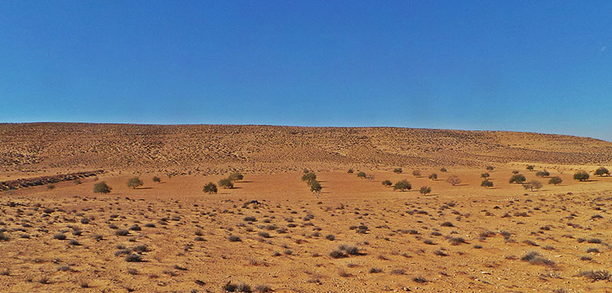Degraded rangeland in Southern Tunisia. Olive trees visible at distance have been planted by land users in areas not suitable for orchards in order to appropriate land (Photo: ICARDA)
Rangelands in Tunisia cover 5.5 million hectares, about 34% of the country’s total landmass, the majority of which encompasses arid areas. For centuries, sheep, goat and camel herders have relied on mobility and common use of rangelands as an effective adaptation strategy for coping with drought affected areas and conserving precious limited resources. However, Tunisia’s legal system does not effectively support or reflect the needs of these dryland communities that rely on mobility and common rangelands for their livelihoods and survival. Unfortunately, this is often the case in most dryland countries.
For example, Tunisia’s current Code on Forests reflects a top down approach from a sedentary agrarian perspective predicated on the concept of rainfed agriculture, when indeed these rangelands are suitable for rainfed agriculture. Furthermore, the code’s legal principles deal with aspects of land ownership, which are not relevant to the traditional practices of land use.
Current legislation has also been responsible for the disappearance of the traditional common rangelands governance system, which defined rangeland resting periods and access for entitled user groups in order to preserve resources. The traditional system has now been replaced it by a de facto “free for all situation,” where access to rangelands cannot be managed or controlled, and thus resulting in overstocking, overgrazing, and land and resource degradation.
After the 2011 Tunisian “Arab Spring,” the new constitution outlined a process of decentralization that gave local communities, amongst other things, a greater say in how natural resources are managed. While this is a positive step in the right direction, there is an urgent need to determine the legal status of common rangelands, and amend the existing legislation in order to ensure sustainable rangeland management.
Under the framework of the CGIAR Research Program on Dryland Systems, a group of researchers at the International Center for Agricultural Research in the Dry Areas (ICARDA) are scientifically advising the Tunisian Ministry of Agriculture in this regard and working closely with local partners and stakeholders to ensure an open and participatory process that reflects the concerns of dryland communities in the ground and will bring concrete outcomes with positive impact in their lives.
“There is a high cost of doing nothing. Common rangelands continue to degrade at an alarming rate. These ecosystems are reaching pointy of no-return which means desertification, ” said, Mr Youssef Saadani, Director General of Forestry Department, Ministry of Agriculture, Tunisia.
Tunisia’s policy makers are not only listening to what scientists and local stakeholders have to say; they are embracing whole new way of doing things together and spearheading a process to define a shared vision and plan of action for managing common rangelands.
On June 16, 2015 a multi-stakeholders workshop was organized with the aim of developing a new pastoral code on the basis of: ​
- analyzing issues related to the present legal situation of common rangelands
- sharing lessons learned about pastoral laws in other countries, and
- defining a shared vision of common rangelands among all stakeholders.
One of the workshop participants observed:
“We need to move away from the narrow vision of considering rangelands as a source of feeding for livestock and wildlife. We must broaden our perspective and treat rangelands as a multifunctional environment, considering also aspects of eco-tourism and carbon sequestration.”
Mr Youssef Saadani, Director General of the Forestry Department who presided over the workshop, highlighted that a new forthcoming study has revealed the cost of land degradation in Tunisia is estimated at about 80 million Tunisian Dinars (equivalent to 40 million USD). The lively discussions amongst the participants led to the following conclusions:
The issue of managing common rangelands is not technical issues; rather the bottlenecks to solving it are closely related to social and institutional factors. There is a major conflict between the de-facto users and the traditionally entitled users. De-facto users are in much higher numbers than the entitled users and this is contributing to severe degradation.
The participants also observed that land users are planting olive trees in areas that are not suitable for orchards as a means to appropriate land. This alarming “free for all situation,” is further exacerbated by complex and confusing legislation that negatively fuels competition for land.
For example, there are at least 26 decrees in place at the current moment; some of them are not enforced or implemented, while others are partially outdated. The land tenure regime is not clear, especially for those rangelands that are not under the forest authority. Subsidized regimes also appear to be inequitable, with many of the participants raising questions as to why the Tunisia governments affords subsidies to private rangelands and not to common rangelands.
It is clear that the effective and sustainable governance of common rangelands in Tunisia will not be an easy task. It will require patience, determination, political will and the full and active participation of several stakeholders, including the Ministry of Interior, Ministry of Environment, Ministry of Planning and representatives of the civil society in order to define and enforce an appropriate law that will ultimately benefit local dryland communities in Tunisia and ensure preservation of precious natural resources and prevent further land degradation.
But the future looks promising as Tunisia’s policymakers work hand in hand local with our researchers and to undertake an assessment and analysis of the existing laws and gather information of the application and practicability of those laws. A working group with representation from different line ministries is being established to steer the process in the right direction.
All relevant stakeholders and partner will gather again in the fall during a national level seminar to discuss findings and determine next steps for ensuring sustainable natural resources management at local level, with particular emphasis on common rangelands in the country’s dry areas.
This research is being conducted in the framework of the CGIAR Research Program on Dryland Systems under the North Africa and West Asia Flagship and supported by the CGIAR Fund Donors.
About the authors
Jutta Werner is a Scientist for Rangeland Management and Rangeland Ecosystem Services and Mounir Louhaichi is a Senior Rangeland Scientist at the International Center for Agricultural Research in Dry Areas.
About the editor
Tana Lala-Pritchard is the global Communications Program Coordinator for CGIAR Research Program on Dryland Systems.
References
Nefzaoui, A., El Mourid, M. and Louhaichi, M. 2014: The Tribe. Platform of Participatory Local Development and Management of Communal Rangeland Resources. In: Journal of Arid Land Studies 24(1): 57-60.
Louhaichi, M. 2011. ICARDA’s Research Strategy for Rangeland Ecology and Management in Non-Tropical Dry Areas. Rangelands 33(4): 64-70
Ngaido, T. and Kirk, M. 2000: Collective Action, Property Rights, and Devolution of Rangeland Management: Selected Examples from Africa and Asia. ICARDA.

Tags:
- Tunisia
- common rangelands
- land degradation
- climate change

Flagship:
- North Africa and West Asia
- See more at: http://drylandsystems.cgiar.org/news-opinions/speaking-common-rangelands-truth-power#sthash.u2SpFING.dpuf

Authors/Collaborators:
Dr. Jutta Werner. Scientist for Rangeland Management and Rangeland Ecosystem Services at the International Center for Agricultural Research in Dry Areas (ICARDA), Amman, Jordan. J.Werner@cgiar.org
Dr. Mounir Louhaichi. Senior Rangeland Scientist at the International Center for Agricultural Research in Dry Areas (ICARDA), Amman, Jordan. M.Louhaichi@cgiar.org
Mr. Youssef Saadani. Directeur Direction Generale des Forets, Ministry of Agriculture (Tunisia). ysaadani04@yahoo.fr
Dr. Ali Nefzaoui. Consultant at the International Center for Agricultural Research in Dry Areas (ICARDA), Amman, Jordan. A.Nefzaoui@cgiar.org

