
ICARDA

Baseline Analysis of the Production and Livelihood Systems of

Meknes-Saies Region of Morocco

Abdalla Laamari, Ahmed Mazid and Aden Aw-Hassan

Table of Contents

Summary 3
I. Introduction 5
II. Objectives 5
III. Methodology 6
Description of the Study Area 6
Ain Jemaa location 7
Bitit location 8
Sidi Slimane Location 10
Questionnaire development 12
Sample strategy for the baseline survey 12
IV. Results of Baseline Characterization 14
Socioeconomic characteristics of households in Meknes action site 14
Background on household head 14
Demographic characteristics of the household 15
Household assets 19
Household gross income, share of agriculture in total income and contribution of women 26
Land tenure and land use 31
Farmer’s annual and perennial crop practices 40
System vulnerability and local coping mechanisms used by households 58

Summary
This report is a baseline study providing a description and analysis of the production system in three sites in the Meknes-Saies region of Morocco. The study is based on randomly selected sample of 508 farming households selected form three sites in the two provinces of Elhajeb and Meknes. The selected sites represent geographically diverse landscapes: plains and mountains; and production systems: rainfed and irrigated; and intensive and extensive.
The region is mainly rainfed systems but with increasing irrigation where ground water is accessible. The government to Morocco is undertaking an ambitious program of supporting agricultural intensification (The Moroccan Green Plan) and this region because of its relatively better endowments (rainfall about 500 mm) is an important focus of this program. However, the issue of concern to agricultural research and development is the long term sustainability of that intensification. This study, therefore, provides understanding of current production and livelihood systems for policy making and baseline data and analysis that could be used as future reference for assessing the impact of research and development outcomes. This descriptive baseline report provides information on key indicators, which are briefly stated in this brief. Illiteracy: high level of no schooling leading to illiteracy was recorded about 37-40% of the surveyed household and that was higher among women. Demography: The household size was about 7 persons per household with 3-5 below 14 years old. Land fragmentation: overall average land holding was 8.9 ha with only 1.5 ha irrigated, and land is mostly privately owned land, mainly by men, with only 6% of the women land ownership reported. There are also military land (guich) and state land leased to farmers. The main problem is land fragmentation with plots being continuously split for siblings through inheritance. One third of the surveyed households have 2 hectares or less. These are the most vulnerable households which need specific attention in rural development programs. The Moroccan Government realizes this problem and is implementing a program of aggregation encouraging some kind of collective action to take advantage of the economy of scale. Land use: Overall land is mainly dominated by cereals (mainly wheat) and food legumes, but there has been marked increase in fruit trees, onions and potatoes. The increase of these high value crops coincides with the expansion of irrigation and government programs promoting high value crops. This is something that should be further investigated to measure the economics of these high value corps against the natural resources so that sustainable intensification options can be identified. Income: Agriculture is the main income source with a share of 33-60% of the household income, depending on the agricultural resources base and availability of irrigation. Agricultural income comes from rainfed crops 34%, irrigated crops 33% and livestock 18%. Off farm income contribute on the whole at 12% of the income. However, these shares depend on the household type with small holder farms who depend more off-farm income. On the whole 42% of the households reported to have at least one person (mainly male) working and earning off-farm work, only 4% of the households reported female working off-farm which could be under-reporting due to cultural reasons. Poverty: The data show that 22.5% of the households earn USD 1 or less per person per day, 45% earn USD2 or less per person per day. Assuming a poverty line of USD1.2 per person per day, we estimate that 27.4% of the households have income levels that fall below that poverty line. Vulnerability: The four most important sources of vulnerability identified by surveyed farmers are climate related: drought (53%), hail storms (27%), temperature fluctuation with unexpected heat or cold (20%), untimely rains (12%), also crop failure (16%) which may be related to climate factors and animal diseases (11%). Adaptation: However, farmers reported adaptation measures against these shocks were not very informative with the majority of farmers doing nothing (55% when they face drought, while some reported selling livestock (20) and few shifting to nonfarm employment. These strategies were distinct for larger farms over 20 hectares that opted for selling part of their land or livestock as adaptation strategy while smallholders below 2 hectares opted for selling livestock or shifting to nonfarm employment. This indicates that climate change will lead to exodus from agriculture accelerating rural-urban migration. This is a critical linkage between the agricultural sector and the wider economy. However, from the survey farmers’ awareness on adaptation strategies to climate change seems low. More research and communication is needed to make farmers awareness of adaptation options. Gender: Three main points related to gender inequality are reported: 1. illiteracy was higher in women household heads than male, 2. women land ownership was reported to be low with only 6% of the holdings owned by women; and 3. Women’s off farm work was reported to be low, this could be due to either underreporting because of cultural sensitivity or hard conditions for women to seek and work off farm jobs. All these cases need gender specific policies to target rural women.

Introduction
This report is focusing on baseline survey analysis in Meknes-Saies (Morocco) action site. Where agriculture in Morocco is key sector for the socio-economic development and it plays a significant role in the Moroccan national economy, comprising about 15.1% of gross domestic product (GDP). Agriculture employs more Moroccan than any other sector where about 44.6% of the labor force is working in the agricultural sector. Barley, wheat, vegetables, citrus fruits, grapes, olives; and livestock are the most important agricultural commodities in Morocco.

Arable land and permanent crops represent 12% (9,200,000 ha) of the total land area in Morocco, of which 1,200,000 ha are irrigated, 12.5 percent (5,800,000 ha) is forest, and 52,900,000 ha are rangelands and unproductive lands. Of the total cereal area, which covers 80 percent of arable land, 50 percent is sown to barley, 40 percent to bread and durum wheat and 9 percent to maize. Four percent of the arable land is sown to pulses, mainly fava bean, chickpeas, lentils and peas. The area under weedy fallow varies between 1,600,000 and 2,600,000 hectares and is more prevalent in the drier zones.

Vulnerability refers to the degree to which a system or societies are susceptible to, and unable to cope with, adverse effects of climate change, including climate variability and extremes. Vulnerability is a function of the character, magnitude and rate of climate change and other shocks to which a system is exposed, its sensitivity and its adaptive capacity (IPCC, 2007). Since agriculture depends on environmental conditions, it’s extremely vulnerable to climate, and these changes will significantly affect the agricultural sector in most countries, with the greatest risks borne by those in the dry areas.

Despite the high contribution of agriculture to the overall economy, this sector is challenged by climate change. A study on climate change impact on agricultural production coordinate by FAO with INRA and DMN in 2009 indicated that Climate projections on Morocco show gradually increasing aridity because of reduced rainfall and higher temperatures. It is necessary to keep in mind that climate models best predict averages rather than extreme values. This means that if aridity increases, on average, as predicted, there can nonetheless be certain years, sporadically, that will be very rainy. Increased aridity will thus have negative effects on agricultural yields, especially from 2030 onwards. All crops will not be equally vulnerable to climate change. In Figure III, one can note that rainfed crops (non-irrigated) will be particularly affected by climate change.

Objectives
This report is describing and analyzing the current farming systems in three selected benchmark sites located at Sais region of Morocco for production system characterization and system vulnerability. These sites represented the topographic gradient, where Ain Jemaa community represents the plain, the mountain represented by Bitit community, and an intermediary zone was represented by Sidi Slimane site. The study provides baseline information on key indicators that late can be used to monitor and assess the outcomes of development interventions and their impacts. Specific objectives of this study include:
- Detailed descriptions of current farming systems and land use,
- Descriptions of the livelihood systems from different sources including remittances.
- Assessment of the level of technology use for all crops and livestock
- Determining the gender role in the production systems
- Identifying production constraints
- Determining the causes of vulnerable households and resilient livelihoods
- Identifying access to credit and perceptions to agricultural policies

Methodology
The study adopted stratified random survey of three distinct sites representing different agro-ecologies, land use systems and production domains in the Meknes-Saies region. The characteristics of the study sites, sampling procedure, and the survey design and implementation are described below.

Description of the Study Area
The Meknes-Saiss Action Site covers an area of about 1694 km2 in the north of Morocco (Figure 1), and total population of the site in 2004 was 714 thousand where percentage of rural population of site is 20%. This action site has a semi-arid to sub-humid moisture regime, as determined by the balance between precipitation and potential evapotranspiration.
The average annual precipitation is for a dryland area relatively high, ranging from 500 to 800 mm across the site. Most of the site attains a level of 500-600 mm. The precipitation is higher over the hills, on average 600-700 mm over the western hill range and 600-800 mm in the eastern hill range. The inter-annual precipitation variability is moderate, with a coefficient of variation of 24%. Nevertheless, risk of drought remains high, particularly in the early part and the middle of the growing season. The precipitation pattern is typically winter-rainfall, distributed over one long season, with on average 90% of all precipitation occurring during the period between November and April.
Figure1. Location of the Morocco Action Site

Most of the site is used for agriculture. The land still under natural forest are bare rock is very small. The dominant land use at the site is rainfed cropping. Based on the local topography two classes are distinguished: rainfed crops on land with slopes not exceeding 8%, and rainfed crops on slopes exceeding 8% and thus being exposed to considerable risk of erosion. Orchards are a very important component of the land use pattern and are mainly concentrated along the eastern hills, where they may also occur in mixtures with remnants of the natural forest. In the northwestern plain the dominant land use pattern is a mixture of rainfed and irrigated crops, fed by groundwater.
According to the dominant land use patterns, three main agricultural regions can be differentiated:
- the northwestern plain with a mixture of rainfed and ground-water irrigated crops;
- the orchard-dominated hills in the east
- the undulating to rolling plains and low hills with rainfed crops in most of the area

The rainfed mixed system is the dominant system of the Action Site. The crops in this system are primarily rainfed, although in some areas supplementary irrigation on wheat and full irrigation for summer cash crops are developing rapidly. There are tree crops (olives and fruit trees) and grapes. Common crops are wheat, chickpeas, lentils, faba bean and fodder crops. Many farms are intensively capitalized with a high level of inputs, and farmers are very sensitive to market opportunities. There are a number of specialized dairy and poultry systems within this ecological zone. These may also include summer crops grown following winter fallow or with some supplementary irrigation. Major production constraints are poor access to quality land by increasing numbers of small farmers, soil erosion on slopes during rainstorms, and erosion by wind on light, over-cultivated, exposed soils. However, the urban agglomeration of Meknes occupies a large part of the Action Site.
Three representative locations of the three main agricultural regions have been selected to carry out the baseline survey where Ain Jemaa, Sidi Slimane, and Bitit locations were selected. These sites were different in term of population, area, resources, villages and density as shown in Table 1.

Table 1: Poverty, social and human parameters of Ain Jemaa, Sidi Slimane, and Bitit locations
Location | Poverty index | Vulnerability index | Severity index | Inequity index | CHDI (*) | CSDI (**)
Ain Jemaa | 29.58 | 30.00 | 3.56 | 38.39 | 0.498 | 0.309
Sidi Slimane | 15.31 | 20.97 | 1.82 | 41.43 | 0.631 | 0.735
Bitit | 34.38 | 25.34 | 4.99 | 42.58 | 0.553 | 0.643
(*) community human development index - Source: HCP, December 2005, (**) community social development index

Ain Jemaa location
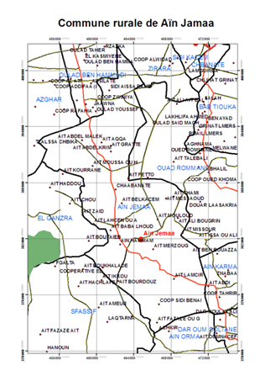
Figure 2 represented the Map of Ain Jamaa area which includes 29 villages, 23 districts for elections, 4 machyakhas (tribes) and 11 moqadems. The total land area about 20647 ha, of which 19300 ha is cultivated by 2100 farmers. About 64 % of the farmers own less than 5 ha each, which represents 15.5 % of the total cropped area. While one percent of the farmers own more than 50 ha each that represents 26 % of the total cropped area. The land tenure is mostly private (about 85 %).
Average annual rainfall in this location is about 550 mm. Thus, agriculture in the Ain Jamaa is dominated by the rainfed farming system. Only less than 100 ha of cultivated land were irrigated for growing crop because the lack of water sources.

Agricultural production system in this location is similar to the Mediterranean type with a cereal /fallow rotation. Fallow land, stubble and the uncultivated hilly land used for grazing by sheep and cattle. This system would undergo a substantial change under the pressure of crop mechanization which allows for cultivation more land area. Thus fallow land area has drastically decreased. Livestock production was forced to adapt to the new situation.

Crop production system in Ain Jemaa
The cultivated crops are cereals (Soft wheat (SW), durum wheat (DW) and barley), food legumes (faba bean, chick pea and peas), forages (oat), industrial crops (sunflower), olive tree and some vegetables. Thus, the crop production system is dominated by cereals (50% of cultivated land area), with SW, DW and barley in that order of importance. SW represents more than 70% of cereal land area. All of these crops are mechanized on the flat lands and farmers seem to master the cropping technical operations. On sloppy lands, draft animals are used for plowing and harvesting is then manual.
Figure 2: Map of Ain Jamaa area

Food Legumes (faba bean and chickpea) come in second place and occupy almost half (40%) of the cultivated land area in crop rotation with wheat.
The olive tree production was introduced, aided by the technical services of the Ministry of Agriculture, in 1993 through the distribution of subsidized seedlings, and is becoming increasingly important due to the Green morocco strategy.
After harvest, most of the wheat production is sold on the field. Reputable traders dominate this trading where farmers seem to find their account. In fact, the urgent cash needs force farmers to sell their harvest even sacrificing some profits. However, most of DW and some SW grain harvests are used for household human consumption. Most of the produced barley grain is used for livestock feeding.

Livestock production system in Ain Jemaa
Ruminant production (sheep and cattle) is practiced by about 80% of the farms. Livestock production system has undergone substantial changes with respect to animal population and breeds. Herders have introduced some improved breeds of cattle and have adopted the artificial insemination technique to improve the productivity of the local breeds, while reducing the number of raised animals to cut on production costs. The average population of cattle by household is about 2 to 3 heads. Some relatively large herds (20 heads or more) can be found throughout the rural commune. Cattle are mainly raised for meat production. Commercial milk production is mostly operated by large herd owners. Tentative organization of small milk producers into cooperatives has failed so far. Sheep population is dominated by the Sardi breed followed by the Timahdite one. Flock population ranges from 10 to 30 heads. Over the years, technical management of the flock has known a lot of changes. Fattening activity has been adopted by more and more livestock producers. Thus, calves born on the farm are raised, fattened and sold around the age of 18 months. While calves bought from the local or neighboring weekly markets are fattened for about six months and sold. Lambs are commonly fattened for about 3 to 6 months for the Muslim feast of Aid Al-adha.

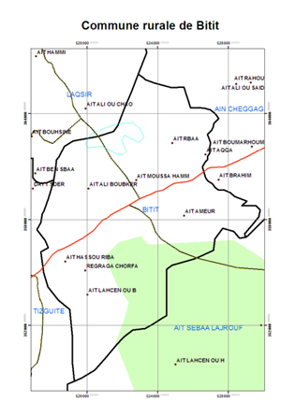
Forage crops, dominated by oats as hay, represent about 6% of the cropped land area. Grazed barley is practiced by few farmers as it coincides with the lambing and early lamb-growing periods. Due to the absence of rangelands, as well as all the potentially cultivated land is cropped, animals usually graze on the roadsides and stubble after grain harvest. When farm feeding resources (grain barley, faba bean, forage peas, oat hay, cereal straw, ..) are exhausted or not enough for appropriate feeding of the raised animals, farmers turn to the local weekly markets to buy some feed such as con silage, sugar beet dry pulp, wheat bran, and commercial feed.

Bitit location
The Bitit location is in the district of Meknes governorate, under the administrative area of the Agricultural Directorate of El Hajeb and the “CT” (local administration) of Taoujdadte (Figur 3).
Figure 3: Map of Bitit Area

The total area of the Bitit location is 7400 ha where 5000 ha represent the cropped area and 2400 ha include the pasture and non-cropped area. All the cropped area is under direct owner-ship land tenure status. The area is well provided with the social and economic infrastructures such as roads, electricity, schools and hospital.
The rural population in Bitit location is represented by eight Douars (villages), 1.822 households, 1.047 farmers, including 9% of women and around 10.552 inhabitants. Average household size is 7.4 inhabitants/ household, it is substantially higher than the national average of 5.8 inhabitants / household. Human assets consist of household members aged between 15 and 64 years, represents 59.9 % of the population. Among the population of household heads, there is one woman, who is responsible for the home.

The level of education of household members reflects a high illiteracy rate approaching 50 %. This proportion is higher than the national average in rural areas: according to data from the last national survey on literacy conducted in 2006, the rate is 38.5 % for the whole country and 54.4 % in rural areas. For the female population, the situation is even worse, with over 75 % illiteracy rate. The level of education of household heads is 48.2 %. The migration rate reached 40 % in Bitit area. Given the households affected by migration, the rate is a little over two emigrants per household. The majority of migrants are male, but the proportion of the female population appears remarkably high, it is almost 44 %. This can be explained by the fact that the towns of Saïs, located between two major urban centers (Fez and Meknes) basins are recruiting women domestic workers for urban households. Moreover, migrants are usually the children of the family in 76%. Migration is mainly related to the job search, including 35 % of cases and only 15% for schooling. Migration to the city is 58% and 13% abroad the rest is done in adjacent municipalities.

Farmers practice in their great majority agriculture as main activity. But, relatively a high proportion of them practice another activity beside the agriculture, especially in trade and services (grocery, butcher, small trade in fruits, vegetables, spices, hardware, fast food... in short trades from the weekly market). It has to be noted that nearly 20% of farmers are resident outside the rural area. Livestock are well integrated in the production system. The herds are diversified including cattle for meat and milk production and sheep and goat for meat production. The main sources of feed and fodder are pastures, forage crops produced at the farm level, crop residues and the concentrates from the local market. However, pastures undergo significant degradation and limitation in the region. Therefore, size of small ruminant herds became smaller. The climate in this area is a Mediterranean type, semi-arid with cool winter. The long term average annual rainfall is 550 mm and the average temperature is around 20°C, and the annual evapotranspiration is estimated at 1.400 mm a year.

The soils are a calcixerol, moderately to deep type. They offer good opportunity to irrigation and the intensification of crop production. However, rocky blocs are very frequent over 3000 ha of the total area and needs a serious de-stoning. Water resources are very important and are represented by three main streams crossing the area and providing the area with an average water flow of 800 liters/second. Underground water is another water source, and there are around 50 individual wells with 40 to 50 meters depth, providing a total water flow of 300 liters/second.

Many projects have been launched in Bitit area, even before the “Plan Maroc Vert” and within the plan. The first project was related to land rehabilitation and started 1996. The physical component of different project was targeted to irrigation network rehabilitation, land reclamation and conservation, and creation of five units for onion storage and conservation.

Sidi Slimane Location
Sidi Slimane is one of the surrounding communities of Meknes (Figure 4). The community is under the authority of CT 23-01 Dkhissa and includes 20 Douars (villages). It has a total population of 11627 inhabitants, 988 of whom are farmers, accounting for 8.5% of the total population. According to this figures, agriculture is not the main economic activity of the household.
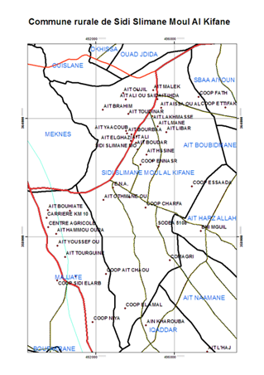
It is a humid site with an annual average of 500 mm and temperatures are below 10 °C in winter temperatures and exceed 30 °C in summer. Water resources are dominated by groundwater and surface water. Oued Islane, which flow is decreasing due to climate changes and other reasons that affecting that region since 1981. Between 1995 and 1996, more than 460 ha were irrigated from this source. Since 1981 the number of wells has increased dramatically. Currently more than 447 wells are drilled in the area but only 1/3 that are functional. Source Kherrouba which previously constituted an important source of irrigation for 1500 ha in the region regrouping Mejjat, Haj Keddour and Sidi Slimane, it is currently not operational and the water has been diverted to other farms in the rural town of Mejjat. Note that the number of wells has increased since the distribution of state land in 2005 but also transaction among land reform beneficiaries has increased and new land owners have emerged from other regions.

The entire community is located in a plain area and is considered as a transition zone between Ain Jemaa and Bitit sites. The soil is fertile and offers multiple cropping opportunities for diversification. For the total cropped area 6691 ha, the soil Hamri (Red) is dominating and represents 60% of soil types.

The main property right in Sidi Slimane location is the agrarian reform. All farmers have beneficiated from this status since 1971. The transfer of this land from the state to farmers was initiated in 2005 and currently melk (private) status is representing 51 % of total operated area. The gulch status is about 33% of total cropped area and the area represents only 14%. The distribution of land is unequal among owners. Farms less than 5 hectares represent 79.71 % and those over 100 ha represent only 1 %. So 1 % of farmers hold 36% of the cropped area and nearly 79.71 % hold 27% of area. This unequal distribution has an impact on the use of resources as well as the adoption of new technologies, production and market integration of agricultural products.
Figure 4: Map of Sidi Slimane Location
m

Farmers in this location have developed profound transformations on the crops grown and technologies used. Prior to 1985, the cropping system was dominated by soft wheat, durum wheat, barley, vetch, and fruit trees. The most irrigated vegetables are carrots, onions and artichoke. Kherouba was the main source of irrigation water. The gravity irrigation system was the most practiced. Among cereals, wheat was the most practiced and occupies nearly 42% of the total area. Legumes occupy second place with nearly 14% of the agricultural land. Forages in third place followed by industrial crops.
The Production technology which was used was old and dominated by the heritage of the French colons. The use of certified seed was very low and use of fertilizer was very low and even not used by small farmers. Since 2005, the production system has changed completely. Two key factors explain this change, the ownership of agrarian reform land and the pressure of climate change. The first factor has contributed to introduction of new crops by new land owners. The use of irrigation is not a new practice in the region but it was intensified since 1981 as an adaptation mechanism to climate change and has become a necessary practice for the producing onion, potato and other irrigated crops. Bean was quite present until 90s but removed from the system due Orobanche problems. In 2012 many farmers have reintroduced this crop in the system, they were able to use appropriate weed control treatments. Industrial crops has disappeared from the region, sunflower which was cropped under contract with oil companies was rejected by farmers for profitability reasons. Prices and production costs were the most reasons for not continuing producing sunflower. Some farmers have started introducing tobacco. The current trend is crop diversification with a specific interest to onion, potato grape fruit using Spanish technology (Pergola), almonds and peaches.

Animal production system has changed completely during last 20 years. From transhumant to sedentary system with dominance of sheep production, livestock is now dominated by cattle production for meat and milk. Sheep flock size has reduced according to available grazing area. Before 1990, the average sheep flock size was about 200 ewes and only local cattle breed was dominating. Actually, all farms are cattle production oriented with a dependence to feed market. Sheep fattening is limited to a short period in order to satisfy sacrifice Eid. The agricultural development fund grants have encouraged farmers to develop more cattle production.

The region is poor in term of local organization and cooperatives. The only existing form is the agrarian reform cooperatives. They were introduced in the region in 1971. The number of these cooperatives is eight. These cooperatives were created after land expropriated from foreigners and distributed to farmers. Moroccan land reform in the region brought fundamental structural changes on a large scale. The State had strong influence of the cooperatives through well designed cropping system and use of appropriate technologies. So the situation of the cooperatives of agrarian reform remains dependent on the intervention of public authorities. After 2005, the State has decided to sell land distributed to beneficiaries. This operation has contributed to strengthen private property right and animate land market in the whole region. The role and power of the cooperative has been reduced to few activities such as purchase seeds. General assembly and regular meeting are no longer taken place. Foreigners have settled in the region and land prices rose. More than 40% of farmers quite the region and large farmers are the new land owners and agricultural investors. This situation has contributed to the development of modern agriculture and reduced the number of active persons in agriculture. Even the region has several agricultural training institution and research center; farmers are not well supervised and agricultural extension services are not very active.

Questionnaire development
Conducting household baseline survey in the target areas for site characterization as well as socioeconomic characteristics of households and identify system vulnerability and local coping mechanisms used by households in the study areas are the major objectives for this study.
Through coordination between ICARDA and the socio-economic team of the Project in Morocco, a baseline survey in the three target locations was considered.
Before the survey implementation, a rapid rural appraisal was carried out in the study areas. The questionnaire was designed and developed by the socioeconomics at ICARDA and the National team; it was also discussed with the field staff and modified according to local conditions. The final format of questionnaire included the following major topics:
- Respondent and household head’s background
- Demographic characteristics of the household
- Financial, physical, natural and social capitals
- Household gross income
- Agricultural production
- Farmers’ practices and input used
- Utilization of farm production
- Access and management of water resources
- Livestock production and management
- Food security
- Borrowing and access to credit
- System vulnerability and local coping mechanisms used by households

Before launching the survey, the questionnaire was tested in the three target areas. Pre-testing of the questionnaire provided an opportunity to make some modification on the questionnaire before adopt and use it in the field and an improved version of the questionnaire was used in the survey.

A training workshop on the enumerators was organized. The target group of this training was the enumerators and supervisors who collected the data and supervised and verify field data collection in the three-benchmark sites. The main objectives of this training workshop were to acquaint the field staff with the questionnaire format and train them on collecting and recording the data.
The questionnaire was used to collect the data through personal interview. The data collected was reviewed and verified twice; the first revision was after collecting the data from the farms, the central staff checked and verified that the questionnaires, and consistent whereas, the second revision was after data entry into the computer, the central staff reviewed and verified the different data on the computer files.
Data entry and editing began while interviewers were still in the field. Then, data was coded, entered and edited in the computer. Microsoft Excel and Statistical Package for Social Sciences (SPSS) were used for the analysis.

Sample strategy for the baseline survey
The project area is part of the Meknes-Tafilalet region and the CRP1.1 DS is located in two provinces Meknes and Elhajeb. The respective sites occupy a total agricultural area of 149,520and 146,000 hectares. The administrative structure of the study area is represented in table 2. We have at least 4 to 6 rural communities by district.

Table 2: Administrative structure
Administrative units | Elhajeb | Meknes
Districts | 3 | 3
Rural commune | 12 | 17
Municipalities | 4 | 6
Number of farmers | 18,800 | 19,860

In both Elhajeb and Meknes provinces cereal and food legume productions are important and represent around 70% of total cropped area, with a possibility of irrigating 6% of this area in Elhajeb. Cereals and food legumes are both under rainfed system in Meknes province.
However, the CRP DS system project is much diversified geographically and represents different ecosystems: plain and mountain, rainfed and irrigated, intensive and extensive agriculture. As we are conducting a baseline study, it is important to capture this diversity in order to identify complementarities and farmers’ strategies in coping with risk, market dynamics and climate changes.
Given the size of the questionnaire and the complexity of the questions and considering the budget constraints and time limitation for the survey; a random sample of 508 households (1.4% of the total population) was selected in the two provinces focusing on three locations. The sampling strategy was based on the spatial distribution of villages and the representativeness of household’s situations. This distribution was approached by distances from the district. A multi-stage random sample technique was used. Villages was selected randomly using topographic maps. To draw a random sample of villages, a number will be attributed to each village. A subgroup of 28 villages is selected randomly, which represents 49% of total villages in the three locations. Distribution of the selected villages was as follow: 14 villages in Ain Jemaa from a total of 29; 10 villages for Sidi Slimane from a total of 20, and 4 villages from Bitit from a total of 8 villages.
However, Table 3 summarized the sample distribution by locations, sex and holding categories.

Table 3: Sample distribution by land types
 | Location |  |  | Total
 | Ain Jemaa | Sidi Slimane | Bitit
Sample Size | 229 | 137 | 142 | 508
Governorate | Meknes | Meknes | Hajeb
No. of Selected Villages | 14 | 10 | 4 | 28
Sex of the household head
- Males | 205 | 120 | 137 | 462
- Females | 1 | 3 | 0 | 4
Holding Categories
- <= 2 ha | 15.4% | 32.4% | 54.6% | 31.0%
- 2 – 5 ha | 25.6% | 38.2% | 24.8% | 28.8%
- 5 – 10 ha | 26.9% | 25.0% | 13.5% | 22.6%
- 10 – 20 ha | 18.9% | 4.4% | 3.5% | 10.7%
- > 20 ha | 13.2% | 32.4% | 3.5% | 6.9%
Average farm Size (ha) | 13.6 | 3.9 | 6.2 | 8.9
Average family size | 6 | 7 | 6 | 6

Results of Baseline Characterization

Socioeconomic characteristics of households in Meknes action site
Survey results related to socioeconomic characteristics of the households in sample are summarized as the following:

Background on household head
Age structure of the interviewed heads of the household in the sample is presented in Figure (6-1) where the age ranged from 22 to 95 years and average age of the household head was 52 years with standard deviation 15 years. However, the data indicated disturbances in the generation flow since about 50% of the interviewed farmers were of ages older than 50.

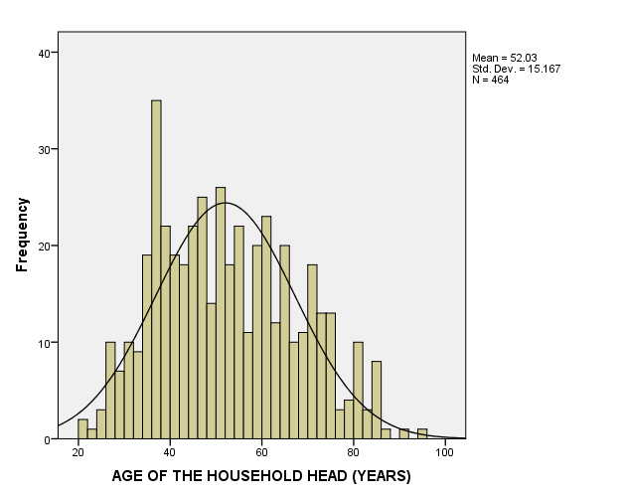
Figure 6-1: Distribution age of the household heads in the sample

Average age of the households was different between the three locations where was 60 years in Sidi Sliman, 50 years in Ain Jemaa, and was 48 years in Betit; these differences were significant at <0.01.

The household heads had, on average, 31 years as experience in agriculture, but the majority (42%) did not had any educational degree (Table 6-1), 30% completed the elementary school, 22.5% had the secondary degree and only 2.5% from the interviewed farmers had a university degree and no significant differences between the household heads by locations and education levels Table (6-1-1).

Table 6-1-1 Education level of the household head by locations
Education Level | Location |  |  | Total sample
Education Level | Ain Jemaa | Betit | Sidi Sliman | Total sample
No Level | 44.70% | 37.40% | 40.90% | 41.50%
Elementary | 24.30% | 33.80% | 36.20% | 30.30%
Secondary | 25.20% | 21.60% | 18.90% | 22.50%
University | 2.40% | 3.60% | 1.60% | 2.50%
Quranic School | 3.40% | 3.60% | 2.40% | 3.20%
Total | 100.00% | 100.00% | 100.00% | 100.00%

Only 4 women in the sample were household head, the majority (91.5%) of the interviewed farmers were household heads residence in their villages. 42 farmers were not available for the interviewed and the information was obtained from their representatives in the village. Only 12 farmers in the sample (2.4%) were living outside the village.

Demographic characteristics of the household
The household size in the sample ranged from 1 to 26 persons with an average 6.6 and standard deviation 3.5 persons and the majority (59%) has a family size ranged 4-7 persons (Figure 6-2). About 53% of household members were males and female members constituted 47%. The average household size in Sidi Sliman was 7.1 persons while was 6.5 in Ain Jemma and 6.3 persons in Betit and these differences was statistically not significant.
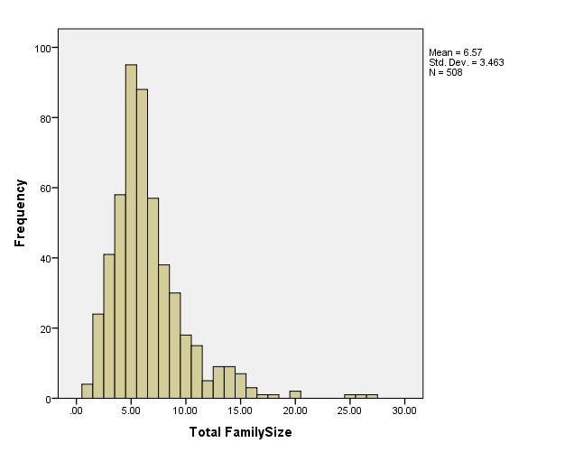

Figure 6-2: Distribution the household by family size in the sample
The households in the sample were asked to classify their family members by age groups and sex. Not all household had members in all age groups but the majority (more than 90%) they had member or more in the group 25-65 years (Table 6-1-2). The average number of active people in the household (25-65 years) was 1.9 persons for male and 1.7 persons for female (Table 6-1-3) and the total 3.5 persons per household.

Table 6-1-2 Percentage of households responded positively to the family classification by age groups
 | Total | ≤7 years old | 8-14 years | 15-24 years | 25 – 65 years | >65years old
Male | 99% | 30% | 31% | 36% | 94% | 29%
Female | 99% | 28% | 28% | 35% | 91% | 25%

Table 6-1-3 Average No. of family members by age group and sex for household responded positively
 | Total | ≤7 years old | 8-14 years | 15-24 years | 25 – 65 years | >65years old
Male | 3.46 | 1.39 | 1.28 | 1.51 | 1.90 | 1.04
Female | 3.11 | 1.31 | 1.31 | 1.49 | 1.71 | 1.02

The level of education is high importance to identify the ability of a society to use and adopt new agricultural technologies and to determine the degree and type of communication channels required. Data analysis in this study indicated that about 49% of the households had a male member or more had no education, and this percentage increased to 69% for female. However, Table 6-1-4 presented percentages of households in the study areas by locations and education level of their members, the statistical analysis shows there is scientific differences at <0.05 level between locations for the case no education for both male and female.

Table 6-1-4 Percentages of households by education level of their members.
Sex | Location | Household With a Member Had No Education | Household With a Member Had Quranic Education | Household With a Member Had Elementary Education | Household With a Member Had Secondary Education | Household With a Member Had University Education
Male | AIN JEMAA | 53% | 3% | 55% | 49% | 12%
Male | BETIT | 46% | 1% | 55% | 44% | 10%
Male | SIDI SLIMAN | 43% | 2% | 71% | 51% | 8%
Male | Total | 49% | 2% | 59% | 48% | 10%
Female | AIN JEMAA | 72% | 0% | 43% | 28% | 4%
Female | BETIT | 52% | 1% | 39% | 35% | 8%
Female | SIDI SLIMAN | 81% | 1% | 39% | 32% | 3%
Female | Total | 69% | 1% | 41% | 31% | 5%

The survey data indicated that about 83% of the households in the target area had a male member or more is working full or part time in the family farm, this percentage was much lower (10%) for the female. There were variation between the three locations as illustrated in Tables 6-1-5 and 6-1-6 but the differences were not significant.

Table 6-1-5 Household percent who had members working on their family farm by locations
Location | Male | Female
AIN JEMAA | 83.8% | 10.9%
BETIT | 77.5% | 5.6%
SIDI SLIMAN | 87.6% | 13.9%
Total | 83.1% | 10.2%

Table 6-1-6 Average number of household members working on family farm by location
LOCATION |  | Average number of household members working on family farm
 |  | Male | Female
AIN JEMAA | Mean | 1.98 | 1.92
AIN JEMAA | N | 192 | 25
AIN JEMAA | Std. Deviation | 1.306 | 1.077
BETIT | Mean | 1.71 | 1.13
BETIT | N | 110 | 8
BETIT | Std. Deviation | 1.168 | .354
SIDI SLIMAN | Mean | 1.94 | 1.89
SIDI SLIMAN | N | 120 | 19
SIDI SLIMAN | Std. Deviation | 1.110 | .937
Total | Mean | 1.90 | 1.79
Total | N | 422 | 52
Total | Std. Deviation | 1.220 | .977

About 42% of the household had some male members who earn income from off farm activities, this percentage was higher in Sidi Sliman (52.6%) compared to Ain Jemaa (30.6%). This percentage declined to 4.1% for the females (Table 6-1-7). The number of household who earn income from off farm activities was, in the average, 1.6 persons (Table 6-1-8) and no significant differences between the averages by location and sex.

Table 6-1-7 Percentage of households who had some members earn off farm income by location and sex
 | Male | Female
AIN JEMAA | 30.6% | 3.9%
BETIT | 49.3% | 4.2%
SIDI SLIMAN | 52.6% | 4.4%
Total | 41.7% | 4.1%

Table 6-1-8 Average number of household members who earn off farm income by location and sex
LOCATION |  | Average Number of household members who earn income from off farm
 |  | Male | Female
AIN JEMAA | Mean | 1.60 | 2.22
AIN JEMAA | Std. Deviation | .984 | 1.302
BETIT | Mean | 1.51 | 1.50
BETIT | Std. Deviation | .913 | 1.225
SIDI SLIMAN | Mean | 1.61 | 1.17
SIDI SLIMAN | Std. Deviation | 1.157 | .408
Total | Mean | 1.58 | 1.71
Total | Std. Deviation | 1.021 | 1.146

For the labor force in the household at the study area, the hypothesis is household members ranged from 15 to 65 years old are the available labor force in the household. Data analysis indicated that the highest percentage (22%) in the sample had 2 members as a labor force in the household, but cumulative percent of labor force distribution shown that 84% of the households in the sample had less than 7 members as labor force. Distribution labor force by sex indicated that 35% of the households in the sample had one male member as labor force and 38.6% of the households had one female member (Table 6-1-9 and figure 6-3).

Table 6-1-9 Number of available labor force in the household by sex
Labor force (#) | Male |  | Female |  | Total
Labor force (#) | Frequency | Percent | Frequency | Percent | Frequency | Percent
1 | 172 | 33.9 | 186 | 36.6 | 13 | 2.6
2 | 131 | 25.8 | 147 | 28.9 | 113 | 22.2
3 | 90 | 17.7 | 83 | 16.3 | 85 | 16.7
4 | 49 | 9.6 | 35 | 6.9 | 85 | 16.7
5 | 28 | 5.5 | 16 | 3.1 | 69 | 13.6
6 | 10 | 2 | 4 | 0.8 | 54 | 10.6
7 | 6 | 1.2 | 5 | 1 | 29 | 5.7
8 | 3 | 0.6 | 4 | 0.8 | 20 | 3.9
9 | 1 | 0.2 |  |  | 8 | 1.6
10 |  |  |  |  | 6 | 1.2
11 |  |  | 1 | 0.2 | 7 | 1.4
12 | 1 | 0.2 | 1 | 0.2 | 4 | 0.8
13 |  |  |  |  | 3 | 0.6
15 |  |  |  |  | 3 | 0.6
19 |  |  |  |  | 1 | 0.2
24 |  |  |  |  | 1 | 0.2
Missing | 17 | 3.3 | 26 | 5.1 | 7 | 1.4
Total | 508 | 100 | 508 | 100 | 508 | 100

Availability of labor force in the household was not the same in the three locations, Table 6-1-10 illustrated distribution of labor force by locations and it is clear that there were differences between locations but these differences were not significant. On other hand, availability of labor force in the household does not mean these labor are working in the family farm and we mentioned earlier that 83% of the sampled household had one male member working in the family farm and the percentage was 10% for female.

Table 6-1-10 Number of available labor force in the household by locations
Labor force (#) | Locations |  |  | Total
Labor force (#) | AIN JEMAA | BETIT | SIDI SLIMAN | Total
1 | 3.1% | 2.1% | 2.3% | 2.6%
2 | 22.4% | 27.9% | 17.3% | 22.6%
3 | 13.6% | 16.4% | 23.3% | 17.0%
4 | 16.2% | 16.4% | 18.8% | 17.0%
5 | 15.4% | 14.3% | 10.5% | 13.8%
6 | 15.4% | 7.9% | 6.0% | 10.8%
7 | 5.7% | 4.3% | 7.5% | 5.8%
8 | 3.9% | 3.6% | 4.5% | 4.0%
9 | 1.3% | 2.1% | 1.5% | 1.6%
10 | 0.9% | 0.7% | 2.3% | 1.2%
More than 10 | 2.2% | 4.2% | 6.1% | 3.8%
Total | 100.0% | 100.0% | 100.0% | 100.0%

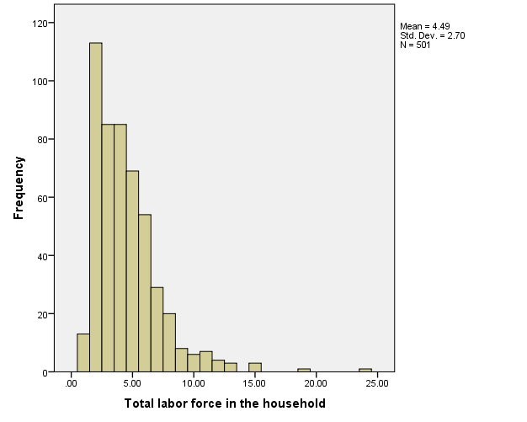
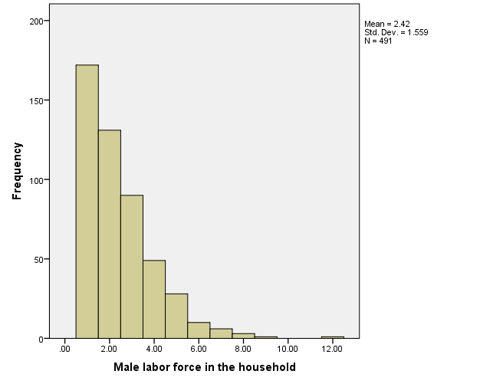
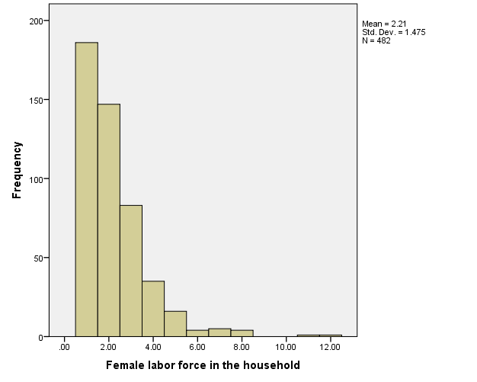
Figure 6-3 Distribution of labor force in the households by sex in the study area

Household assets
Household characteristics are based on the main house-hold assets. Households usually use a variety of resources as inputs into their production. These can be classified into human, financial, physical, natural and social capital, as has been popularized in the sustainable livelihoods approach (Carney, 1998), and these have been used here to ensure that all the components of livelihood assets were addressed.

Financial capital
Financial capital is the availability of money or equivalents that enables people to adopt different livelihood strategies. Available stock and savings may not be cash, and is sometimes livestock in dry areas. Livestock are considered a stand-by asset as part of a strategy to reduce vulnerability, and alternative sources of income, especially from non-farm activities, also have poverty reducing effect. Facilitating finance to farmers and intermediary agencies is important in improving livelihoods in rural areas, by improving the delivery of inputs to farmers and introducing liquidity into output marketing. Moreover, delivery of credit can be linked to savings as the other important element in rural finance.
Households in the sample were asked about the estimated their annual income from crop and livestock. The estimated average household annual income from both crop and livestock was 74457 Dirham (around USD 7635 at exchange rate US$ = 9.75 Dirham). The income from crops was more than double than the livestock (Table 6-1-11). The estimated average annual household income from crops and livestock was difference among the location as shown in table 6-1-11 and these differences were significant at <0.05.

Table 6-1-11 Estimated average annual household income from crops and livestock by locations
Location |  | Share of agriculture in total family income (%) | Estimated annual total income from crops (Dirham) | Share of livestock in total family income (%) | Estimated annual total income from livestock (Dirham) | Estimated income from crop and livestock (Dirham)
Ain Jemaa | Mean | 59 | 56464 | 30 | 25483 | 81748
Ain Jemaa | Std. Deviation | 30 | 118898 | 28 | 42293 | 144534
Betit | Mean | 68 | 86124 | 21 | 12314 | 98438
Betit | Std. Deviation | 33 | 365330 | 31 | 32864 | 368020
Sidi Sliman | Mean | 62 | 18932 | 34 | 14675 | 33602
Sidi Sliman | Std. Deviation | 33 | 30730 | 31 | 38566 | 61539
Total | Mean | 63 | 55624 | 28 | 18925 | 74457
Total | Std. Deviation | 32 | 214243 | 30 | 39205 | 224191
As was mentioned earlier, livestock in the dry area may consider as financial assets; Table 6-1-12 summarized percentage of households who had each type of livestock as well as minimum, maximum, and mean numbers of livestock.

Table 6-1-12 Average number of livestock
Livestock Type | % of households | Min | Max | Mean | Std. Deviation
MILK COWS | 61% | 1 | 20 | 2.8 | 2.4
CALVES | 5% | 1 | 10 | 2.2 | 2.0
Ox | 47% | 1 | 11 | 2.5 | 1.8
Buffalo | 6% | 1 | 12 | 1.9 | 2.3
Camels | 0% | 450 | 450 | 450.0 | .
EWES | 34% | 1 | 250 | 22.9 | 28.9
RAMS | 16% | 1 | 40 | 3.0 | 6.8
LAMBS MORE THAN 8 MONTHS | 18% | 1 | 150 | 9.0 | 17.6
LAMBS LESS THAN 8 MONTHS | 22% | 1 | 75 | 11.6 | 13.8
GOATS | 2% | 1 | 20 | 4.3 | 6.5
EQUINES | 16% | 1 | 8 | 1.5 | 1.0
BEE HIVES | 1% | 1 | 12 | 4.4 | 4.7

Facilitating finance to farmers is an important component of financial capital for the rural households; about 40% of the households in the sample indicated that they had reliable sources for borrowing money at the time of needed and this percentage was the same in the three locations. Other 22% said they had access to other sources of funding. However, Table 6-1-13 illustrated the sources of cash loan received by the households in the study area where neighbors rank as the first source and bank as the second.

Table 6-1-13 Sources of cash loan received by the households in the study area
Source | N | % of households to the total sample | % of households to those received loan
Bank | 71 | 14% | 36%
Private sector | 12 | 2% | 6%
Neighbors | 77 | 15% | 39%
Relatives | 23 | 5% | 12%
Neighbors & Relatives | 9 | 2% | 5%
Association/ NGO | 8 | 2% | 4%
Total | 200 | 39%

Physical capital
Physical capital plays a vital role, as it comprises basic infrastructure and producer goods supporting livelihoods. Many assessments have found that a lack of certain infrastructure is a core dimension of poverty. Without adequate access to public services such as water and energy, human health deteriorates and long periods are spent in non-productive activities (DFID, 2001). Tractors and other equipment ownership all affect households’ welfare.
Number of households who owned agricultural equipment is relatively low only 19% of the households in the sample owned tractor and 10% owned pick-up. Household owned tools for the house were much better than agricultural equipment where more than 90% of the household owned TV, Mobil Phone, and Refrigerator. Table 6-1-14 summarized the average number of equipment and tools owned by the household in the sample and the estimated average value of equipment and tools.

Table 6-1-14 Equipment and tools owned by households
Items | % of household owned | Number |  |  | Value (Dirham/Unit)
Items | % of household owned | Min. | Max. | Mean | Estimated average value | Std. Deviation
Equipment
Owned Tractors | 19% | 1 | 5 | 1.2 | 159478 | 298173
Harvester Combine | 3% | 1 | 2 | 1.1 | 232308 | 138694
Water pump combine | 22% | 1 | 4 | 1.1 | 30273 | 54301
Owned Automobile | 16% | 1 | 3 | 1.1 | 90613 | 90241
Owned pick-ups | 10% | 1 | 2 | 1 | 60167 | 46449
Owned trucks | 2% | 1 | 3 | 1.2 | 81375 | 56094
Grain storage structures | 31% | 1 | 3 | 1.1 | 66354 | 70257
Tools for the house
TV | 98% | 1 | 15 | 1.3 | 1305 | 1121
Satellite | 82% | 1 | 7 | 1.2 | 352 | 291
Radio Cassette Or Cd | 42% | 1 | 3 | 1.1 | 158 | 110
Mobile Phone | 94% | 1 | 8 | 2.2 | 444 | 673
Land line phone | 6% | 1 | 3 | 1.3 | 219 | 122
Refrigerator | 92% | 1 | 3 | 1.1 | 2109 | 1475
Washing Machine | 44% | 1 | 3 | 1.1 | 1278 | 959
Gold Value | 5% | 1000 | 100000 | 12911.5 | 12912 | 22181
Other Assets | 2% | 1 | 4 | 1.6 | 29500 | 34271

Table 6-1-15 summarized percentage of households and the average number of equipment and tools owned by the household in the sample by locations in the target area. It is noticeable that there were differences between locations regarding percentage of owners related to agricultural equipment, but there are no differences for house tools.

Table 6-1-15 Equipment and tools owned by households by locations
Location | AIN JEMAA |  | BETIT |  | SIDI SLIMAN
Item | % of household owned | Average Number | % of household owned | Average Number | % of household owned | Average Number
Equipment
Owned Tractors | 25% | 1.2 | 15% | 1.3 | 14% | 1
Harvester Combine | 6% | 1.2 | 1% | 1 | 1% | 1
Water pump combine | 10% | 1.1 | 14% | 1.4 | 50% | 1.1
Owned Automobile | 10% | 1.2 | 17% | 1.3 | 26% | 1.1
Owned pick-ups | 10% | 1 | 10% | 1.1 | 9% | 1
Owned trucks | 3% | 1 | 2% | 1 | 1% | 2
Grain storage structures | 50% | 1.1 | 15% | 1 | 13% | 1
Tools for the house
TV | 96% | 1.4 | 99% | 1.3 | 99% | 1.1
Satellite | 86% | 1.3 | 80% | 1.1 | 76% | 1
Radio Cassette Or Cd | 50% | 1.1 | 39% | 1.1 | 32% | 1.1
Mobile Phone | 94% | 2.3 | 98% | 2 | 91% | 2.3
Land line phone | 3% | 1.9 | 4% | 1.3 | 12% | 1.1
Refrigerator | 92% | 1.1 | 87% | 1.1 | 97% | 1
Washing Machine | 37% | 1.1 | 44% | 1.1 | 55% | 1
Gold Value | 0% | 0 | 1% | 5000 | 18% | 13228
Other Assets | 2% | 1.8 | 1% | 1.5 | 1% | 1.5

According to many studies which supposed that livestock ownership has to be part of physical assets for the household, Table 6-1-16 summarized the status of livestock in the three locations where about two third of the households owned milk cows with average 3 heads and about one third owned of households owned ewes with average 23 heads.

Table 6-1-16 Average number of livestock owned by household
LOCATION | AIN JEMAA |  |  | BETIT |  |  | SIDI SLIMAN |  |  | Total
Item | Average Number | % of household owned | Std. Dev | Average Number | % of household owned | Std. Dev | Average Number | % of household owned | Std. Dev | Average Number | % of household owned | Std. Dev
NUMBER OF MILK COWS | 3 | 68% | 3 | 2 | 51% | 2 | 3 | 59% | 2 | 3 | 61% | 2
NUMBER OF CALVES | 3 | 3% | 3 | 2 | 9% | 1 | 3 | 6% | 2 | 2 | 5% | 2
NUMBER OF OX | 3 | 58% | 2 | 2 | 26% | 2 | 2 | 51% | 2 | 2 | 47% | 2
NUMBERS OF BUFFALO | 2 | 8% | 1 | 3 | 4% | 4 | 2 | 2% | 1 | 2 | 6% | 2
NUMBER OF CAMELS | 450 | 0% | . |  | 0% |  |  | 0% |  | 450 | 0% | .
NUMBER OF EWES | 28 | 42% | 25 | 19 | 36% | 38 | 12 | 18% | 12 | 23 | 34% | 29
NUMBERS OF RAMS | 3 | 23% | 7 | 2 | 13% | 3 | 4 | 9% | 10 | 3 | 16% | 7
NUMBERS OF LAMBS MORE 8 MONTHS | 8 | 23% | 10 | 12 | 15% | 32 | 7 | 12% | 9 | 9 | 18% | 18
NUMBERS OF LAMBS LESS 8 MONTHS | 12 | 31% | 13 | 6 | 15% | 9 | 15 | 12% | 19 | 12 | 22% | 14
NUMBER OF GOATS | 3 | 1% | 2 | 8 | 2% | 11 | 1 | 1% | 0 | 4 | 2% | 6
NUMBER OF EQUINS | 2 | 19% | 1 | 2 | 8% | 1 | 1 | 20% | 0 | 1 | 16% | 1
NUMBER OF BEE HIVES | 5 | 1% | 6 | 6 | 1% | 6 | 3 | 1% | 1 | 4 | 1% | 5

Almost all households in the sample were resident in houses included 4 rooms in the average, the estimated average value of the house is 217 thousand Dirham (equivalent to USD 22850 at the exchange rate 9.75 Dirham for 1 USD). Table 6-1-17 illustrated average number of rooms in the household and estimated average value of the house by location, statistical analysis indicated that there was significant differences between location for average number of rooms at P <0.1 but no differences for estimated average value of the house.

Table 6-1-17 Average number of rooms in the household and estimated value of the house by locations
LOCATION |  | AVERAGE NUMBER OF ROOMS IN THE HOUSEHOLD | ESTIMATED VALUE OF THE HOUSE (Dirham)
AIN JEMAA | Mean | 4.0 | 176200
AIN JEMAA | N | 221 | 155
AIN JEMAA | Std. Dev. | 1.6 | 288001
BETIT | Mean | 3.6 | 222780
BETIT | N | 137 | 118
BETIT | Std. Dev. | 1.3 | 483649
SIDI SLIMAN | Mean | 4.2 | 266545
SIDI SLIMAN | N | 133 | 112
SIDI SLIMAN | Std. Dev. | 1.3 | 448726
Total | Mean | 3.9 | 216758
Total | N | 491 | 385
Total | Std. Dev. | 1.5 | 405139

Natural capital
Natural capital is very important for rural communities because they derive all or part of their livelihoods from resource-based activities. Farm size is a major determinant of the financial status of farmers, plays an important role in family labor employment and income, and may influence production per unit area. Mean farm size in the target areas was 8.9 hectares, with a range from 0 to 210 ha, but most households in the sample were small farmers where about 54% of those samples had less than 4 ha. Mean farm size varies between the three locations, being 13.6 ha in Ain Jemaa, 6 ha in Betit, and 3.96 in Sidi Sliman (Table 6-1-18) and this differences is significant at P<0.01. Irrigated land represents on average 22% of survey farmland, being only 9% in Ain Jemaa, 31% Sidi Sliman, but was 68% in Betit (Figure 6-4 and Table 6-1-19).

Table 6-1-18 Total cropped area by location (ha)
Location | Mean | N | Std. Deviation
Ain Jemaa | 13.56 | 229 | 22.39
Betit | 6.02 | 142 | 19.12623
Sidi Sliman | 3.96 | 135 | 3.11226
Total | 8.89 | 506 | 18.70342
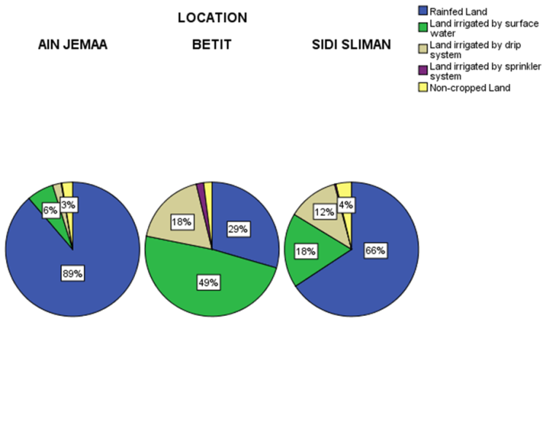

Figure 6-4 Farmland by irrigation regimes and locations

Table 6-1-19 Total cropped area by irrigation regime and location
Location | Rainfed Land | Irrigated Land |  |  |  | Non-cropped Land
Location | Rainfed Land | Irrigated land by surface water | Irrigated land by drip system | Irrigated land by sprinkler system | Total irrigated land | Non-cropped Land
Ain Jemaa | 12.9 | 0.9 | 0.3 | 0.0 | 1.3 | 0.4
Betit | 1.8 | 2.9 | 1.1 | 0.1 | 4.1 | 0.1
Sidi Sliman | 2.8 | 0.8 | 0.5 | 0.0 | 1.3 | 0.2
Total | 7.1 | 1.5 | 0.6 | 0.0 | 2.1 | 0.2
Significant difference between means of rainfed land and Irrigated land by surface water at P<0.01

Farmers owned, in average, 83% of farmland, 11% was state land and 6% was common land. These percentages were vary among the location as shown in Figure 6-5 where the owned land represent 63% in Sidi Sliman and was 87% in Ain Jemaa location.
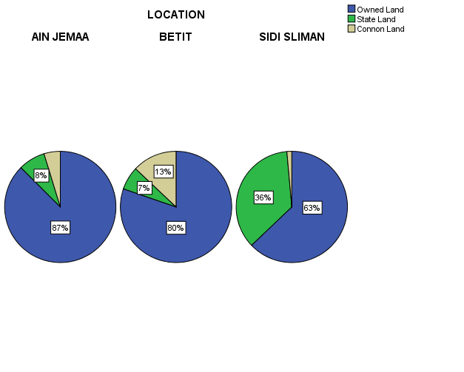
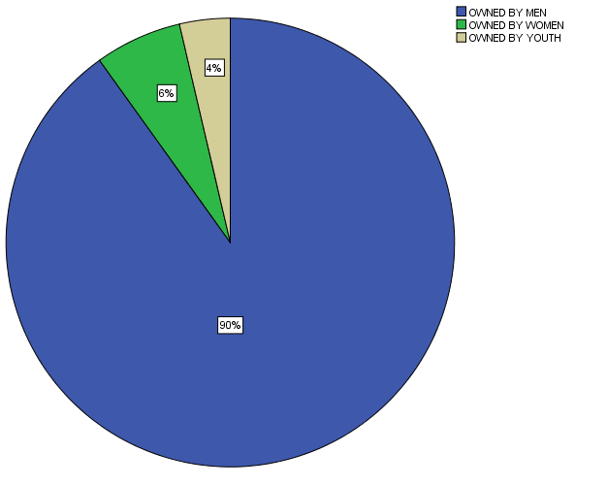

Figure 6-5 Land Distribution by ownership type and by gender

For the owned land, 90% of this land was owned by men, 6% by women and 4% by youth (Figure 6-6) and no significant difference related to this issue was found by locations.

Farmers in the sample were asked to estimate the value of their rainfed and irrigated land. Table 6-1-18 summarized the average value of the land by the three locations where the estimated average value of irrigated land was 360 thousand Dirham and rainfed land was 216 thousand Dirham and the difference represent 70%. There were significant differences at P<0.01 between the estimated land values for both irrigated and rainfed land by locations, the lowest values was in Ain Jemaa location and the highest was at Betit for irrigated land and at Sidi Silman for rainfed land (Table 6-1-20).

Table 6-1-20 Estimated values of irrigated and rainfed land by location
Location |  | Average Value For Irrigated Land (Dirham/ha) | Average Value For Rainfed Land (Dirham/ha)
Ain Jemaa | Mean | 279675 | 146462
Ain Jemaa | N | 80 | 184
Ain Jemaa | Std. Deviation | 222462 | 298480
Betit | Mean | 406996 | 250797
Betit | N | 112 | 86
Betit | Std. Deviation | 203781 | 288475
Sidi Sliman | Mean | 404574 | 358389
Sidi Sliman | N | 74 | 70
Sidi Sliman | Std. Deviation | 212014 | 224864
Total | Mean | 368030 | 216485
Total | N | 266 | 340
Total | Std. Deviation | 218864 | 293886

Social Capital
The social capital of any society is very important, as mutual trust and connectedness helps to cope with shocks and vulnerability, particularly for the poor. Availability of agricultural community organizations, farmers had the potential to cooperate in commonly beneficial development schemes. There is a strong need to develop mutual trust and organization of the community to develop and utilize available resources for sustainable livelihoods. However, in this study, household in the sample were asked many questions related this subject such as if any member of the household have community leadership role; is there any member of the household a member in any community organization; and if the household can rely on government support if the crop fails. Table 6-1-21 summarized the response of farmers on this questions where only 12% of the households had a member in a community organization most of this organizations is agricultural cooperative, 4% indicated that they had community leadership role, and only 10% of the household in the sample can rely on government support if their crop fails.

Table 6-1-21 Farmers’ responses to questions on community organizations
Item | Location |  |  | Total
Item | Ain Jemaa | Betit | Sidi Sliman | Total
A Member of the HH have community leadership role | 3% | 7% | 3% | 4%
A Member of the HH is a member in any community organization | 12% | 11% | 13% | 12%
Type of organization
Association | 36% | 85% | 20% | 44%
Cooperative | 60% | 15% | 80% | 54%
Syndicate | 4% | 0% | 0% | 2%
HH relationship with the member
Brother | 56% | 44% | 0% | 33%
Son | 31% | 11% | 14% | 21%
Father | 13% | 0% | 21% | 13%
HH head | 0% | 44% | 64% | 33%
Can rely on government support if the crop fails | 10% | 15% | 4% | 10%

Household gross income, share of agriculture in total income and contribution of women
Household farmers in the target areas had many activities as part of their livelihoods and they had many income sources. One of the most established characteristics of rural households in developing countries is that they obtain their incomes from many different sources (Reardon 1997, Davis et al. 2010). Household income diversification is the norm in rural societies, and specialization in a single activity is the exception. The literature has identified a variety of factors that may explain income diversification such as risk reduction strategies, responses to household shocks, and asset accumulation strategies that originate from movement into nonfarm activities and migration to cities.

Households in the sample were asked to identify the main source of their income, 83.8% reported from on-farm, 0.8% government salaries, 5.8% off-farm, 0.8% of responders indicated to on-farm and government salaries, and 8.7% said that on-farm and off-farm were the main source. These percentages were vary between locations as shown in Figure 6-6 where the contribution from on-farm income in Ain Jamaa and Betit was higher compared to Sidi Sliman location. Also there were differences between contributions of income sources according to farm size (Figure 6-7) where contribution on-farm income was 69% for small farmers who hold less than 2 hectare and reach to 100% for the farmers who hold more than 50 ha.

Figure 6-6 Main source income percent for household by locations

Figure 6-7 Main source income percent for household by farm size

Based on the survey data, annual household income in the study area ranged from 2,000 to 4,000,000 Dirham but 50% of the sample received annually less than 45000 Dirham (Figure 6-8). Average annual household income was estimated at around 100 thousand Dirham (around 10300 USD at the exchange rate equal 9.75). It was higher in Ain Jemaa and Betit compared to Sidi Sliman (Table 6-1-22) but the difference statistically was not significant.

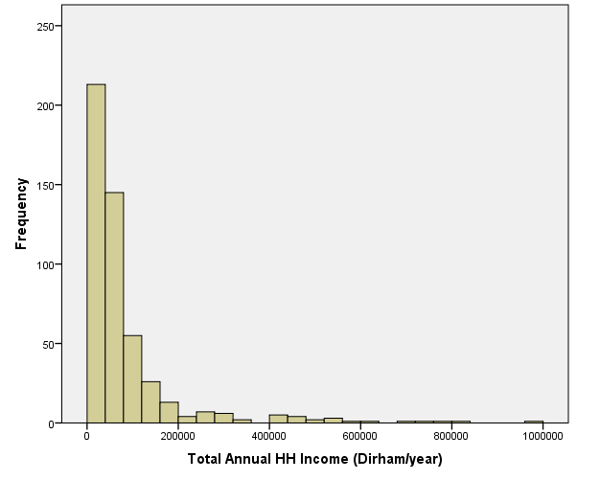
Figure 6-8 Household distribution by estimated annual income

Table 6-1-22 Estimated average annual household income by locations (Dirham/year)
Location | Mean | N | Std. Deviation
Ain Jemaa | 114905 | 220 | 264842
Betit | 114208 | 138 | 354547
Sidi Sliman | 63084 | 137 | 77160
Average | 100369 | 495 | 261014

There is a large variation in the annual household income in the sample according to the farm sizes as shown in Table 6-1-23 and this differences was statistically significant. Average annual household income was about 6000 USD for the small scale farmers compared to about 95000 USD for the farmers hold more than 50 hectare.

Table 6-1-23 Estimated average annual household income by farm size category
Farm size category | Estimated average annual income |  | N | Std. Deviation
Farm size category | Dirham | US$ | N | Std. Deviation
LE 2 ha | 42511 | 4360 | 154 | 50848
2-5 ha | 58596 | 6010 | 143 | 70873
5-10 ha | 88194 | 9046 | 108 | 82790
10-20 ha | 137942 | 14148 | 53 | 181754
20 -50 ha | 252316 | 25879 | 19 | 216557
GT 50 ha | 929786 | 95363 | 14 | 1186569
Total | 100369 | 10294 | 491 | 261014

As what was indicated earlier, household farmers in the target areas had many activities to make their livelihoods and they had many income sources. Table 6-1-24 illustrated the estimated average annual household income by the details sources; it is clear that income from crops both rainfed and irrigated is the main source for household income.

Table 6-1-24 Estimated average annual HH income in Meknes action side (Morocco) –Dirham/year
Income source | % of responders | Mean | Std. Deviation | % contribution
Income Of Rainfed Crops | 59% | 24880 | 74720 | 30%
Income From Irrigated Crops | 39% | 25257 | 66822 | 30%
Farm Work Income | 15% | 1347 | 5261 | 2%
Non-Farm Work Income | 21% | 5935 | 28836 | 7%
Milk Production Income | 17% | 3345 | 18900 | 4%
Income From Selling Animals | 48% | 14183 | 32258 | 17%
Income From Selling Plant Products | 10% | 1274 | 8701 | 2%
Income From Selling Water For Agriculture Purpose | 1% | 105 | 1340 | 0%
Income From Selling Honey | 0% | 16 | 255 | 0%
Income From Selling Handicrafts | 1% | 37 | 519 | 0%
Income From Hiring Out Tractor and Equipment | 3% | 573 | 5077 | 1%
Income From Rent Land | 3% | 303 | 2304 | 0%
Income From Business | 2% | 1774 | 21206 | 2%
Income From Regular Salaried Jobs | 8% | 1269 | 7213 | 2%
Income From Out Migration | 1% | 35 | 478 | 0%
Income From Remittances | 7% | 1176 | 7741 | 1%
Income From Cash And Kind Gifts | 1% | 153 | 2072 | 0%
Income From Pension From Emplyer | 2% | 554 | 7064 | 1%
Income From Other Sources | 1% | 706 | 9647 | 1%

Income sources were grouped in five categories included Income from Rainfed Crops, Income from Irrigated Crops, Income from Livestock, Income from Off-Farm, and Income from Other sources. Figure 6-9 shows the contribution of each category in the HH income at the total sample level. Income from rainfed and irrigated crops was contributed by two third of the total HH income while the income from livestock contributed by 18, 12% from of farm, and 3% from other sources. These contributions were varied according to the locations as well as farm size categories as shown in Figure 6-10. The income from rainfed crop was the most important source for the HH in Ain Jamaa; in Betit was irrigated crop, while rainfed and irrigated crops in addition to off-farm income are the most important sources for HH in Sidi Sliman.

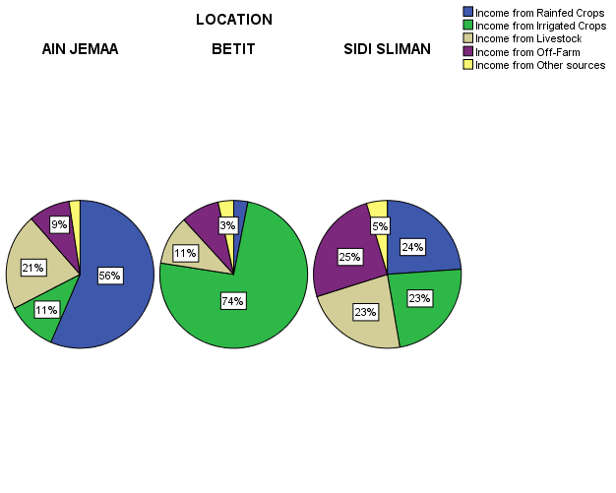
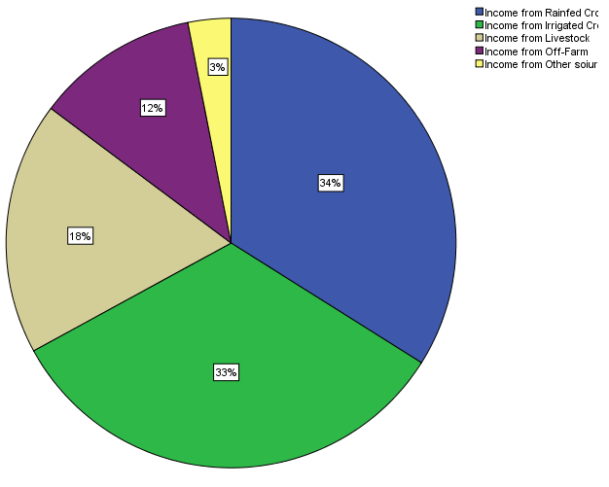

Figure 6-9 Household income by sources at the sample level

Figure 6-10 Household income by sources, locations and farm size categories

Farmers in the sample were asked about who is managing the household income from each source by gender. Table 6-1-25 summarized replies of households in the sample regarding this question and it is very clear from the answers that men are responsible essentially for managing all the HH income and the women had important role in managing the income from handicrafts and some role in managing the income from remittances.

Table 6-1-25 Managing the household income by source and gender (%)
Income Source | % Responders | Gender (%)
Income Source | % Responders | Men | women | Joint
Rainfed Crops | 52.0 | 97.3 | 1.9 | 0.8
Irrigated Crops | 27.0 | 96.4 | 0.7 | 2.9
Farm Work | 11.8 | 95.0 | 3.3 | 1.7
Non-Farm Work | 16.7 | 98.8 | 0.0 | 1.2
Milk Production | 12.8 | 90.8 | 7.7 | 1.5
Selling Animals | 37.8 | 96.4 | 1.0 | 2.6
Selling Plant Products | 7.5 | 97.4 | 2.6 | 0.0
Selling Water | 0.4 | 100.0 | 0.0 | 0.0
Selling Honey | 0.2 | 100.0 | 0.0 | 0.0
Handicrafts | 0.8 | 50.0 | 50.0 | 0.0
Hiring Out Tractor, Equipment | 1.8 | 88.9 | 0.0 | 11.1
Rent Land | 1.8 | 88.9 | 0.0 | 11.1
Business | 1.4 | 100.0 | 0.0 | 0.0
Regular Salaried Jobs | 2.4 | 100.0 | 0.0 | 0.0
Income From Out Migration | 1.0 | 100.0 | 0.0 | 0.0
Remittances | 5.5 | 71.4 | 17.9 | 10.7
Cash And Kind Gifts | 0.6 | 100.0 | 0.0 | 0.0
Pension Employer | 1.4 | 71.4 | 14.3 | 14.3
Other Source | 1.4 | 100.0 | 0.0 | 0.0
Per capita income (person/day) was calculated based on the data collected through baseline survey in this study. The calculation of per capita was done by dividing the total household income to number of family size to year days. Figure 6-11 shown household distribution by per capita income where 22.5% of the household received 1 USD or less per person/day and 45% received 2 USD or less per person/day.
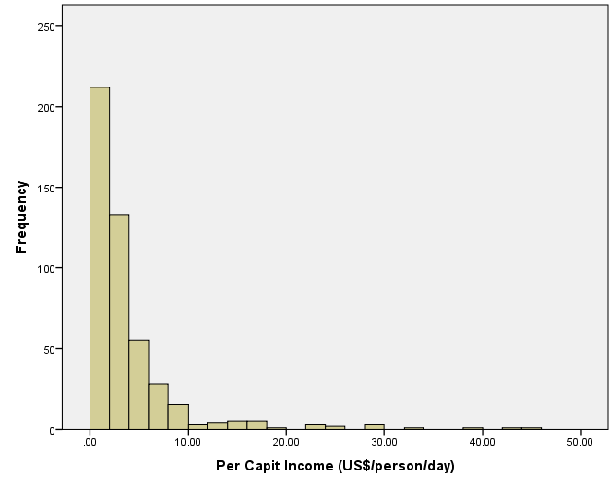
By assumption that the poverty line, which is used in many studies, equal 1.2 USD per person/day; it was estimated that 27.4% of the study area are below poverty line and this percentage was higher at Sidi Saliman location compared to other locations and between small scale farmers compared to medium and large farmers (Table 6-1-26).

Figure 6-11 Household distribution by per capita income

Table 6-1-26 Poverty in the study area
 | Below Poverty Line | Above Poverty Line
Location
AIN JEMAA | 20.80% | 79.20%
BETIT | 26.20% | 73.80%
SIDI SLIMAN | 39.30% | 60.70%
Farm size category
LE 2 ha | 39.50% | 60.50%
2-5 ha | 32.10% | 67.90%
5-10 ha | 18.10% | 81.90%
10-20 ha | 13.20% | 86.80%
20 -50 ha | 5.90% | 94.10%
GT 50 ha |  | 100.00%
At Sample Level | 27.50% | 72.50%

Land tenure and land use
According to table 6-2-1 the average cropped area is 3.90, 6.55 and 14.6 ha respectively in Sidi Sliman, Betit and Ain Jemaa. Farms attain operational size primarily through the share cropping and have recourse to renting and collective land. It’s important to notice that in Ain Jemaa women control 10% of private land.

Table 6-2-1: Farm size and gendered distribution of private land
 |  | Land status |  |  |  | Part of private land
Sites | Average | Private | State | Military | Collective | % for Men | % for Women | % for youth
Ain Jemaa | 14.60 | 9.28 | 2.60 | 0.00 | 2.72 | 66 | 10 | 24
Betit | 6.55 | 5.08 | 0.36 | 0.04 | 1.07 | 100 | 0 | 0
Sidi Sliman | 4.00 | 2.34 | 0.00 | 1.60 | 0.00 | 92 | 8 | 0

a. Ain Jemaa b. Betit c. Sidi Sliman
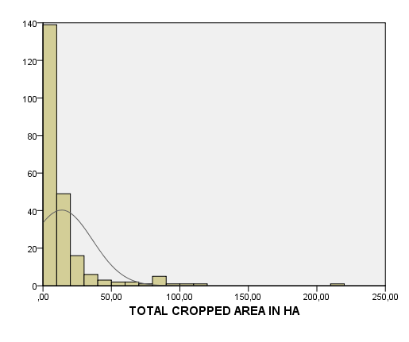  Figure 6.12: Cropped area distribution among farmers | 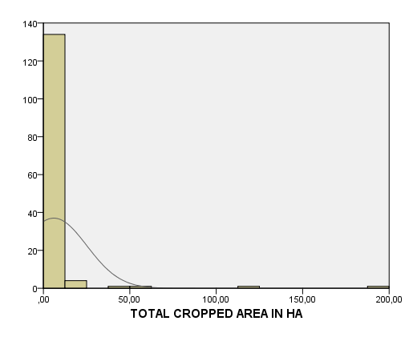 | 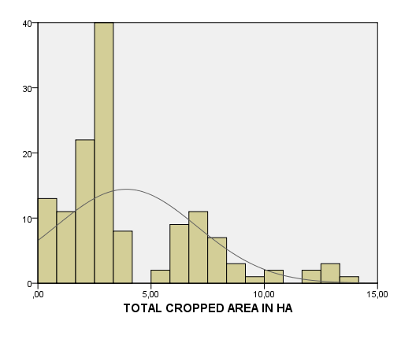

Land distribution among farmers differs from site to site. At Sidi Sliman the cropped area distribution seems to be more equitable than the other sites. At Betit site most farmers are operating small areas.

Land use
The cropping system is well diversified in the tree sites. At Ain Jemaa witch is 100%rainfed site, most farmers are operating less than 10 ha. Cereals and food legumes are dominating. According to the survey 99% of farmers are cropping durum and bred wheat. The area allocated to bread wheat is higher than for durum. Barley crop has regressed during the last 15 years and only 41% of total surveyed farmers are allocating less than one hectare to barley for grain production mainly. Food legumes such as faba bean and chickpeas are practiced respectively, by 56 and 21% of total farmers. Sunflower, the standard crop used to be practiced since 1988. Farmers have reported that they have problems in negotiating the output price with oil companies. In addition the income generated by this crop covers only input costs. Economically, it’s not a profitable crop even it’s considered as a cash crop. Onion and potato are practiced by few farmers (14%) who have access to water. In general more than 2/3 of the area is allocated to cereals.

In the case of Sidi Sliman, farmers have the opportunity to use water for irrigation but farm size and land tenure are the main constraints for developing agriculture. In average farmers are operating less than 4 ha. The guich (military) land status is dominating in the surveyed area. Sidi Sliman community is part of the urban area of Meknes and most of the land used in agriculture was under state or guich status. Some farmers have beneficiated from the land reform launched by Morocco in 1972. Arable land was distributed among cooperatives. Beneficiaries have received more than 14 ha each. Other farmers who were involved in the wars conducted by the Sultans (King) have beneficiated about 2.5 ha as a counterpart of their participation. The guich status is similar to the private one because all families have a tittle and transaction can be done through contract (mainly renting). However the problem of this status is the heritage. At the beginning each family has received 2.5 ha, but when the owner died, the descendant share the land according to the ‘‘chariaa’’and we can create new farm with only 0.5 ha or less. This situation is dominating and concerns the best soils in the region. In our sample, we have tried to consider this group of farms because they are dominant and they are the main source of labor within and the outside the region. However the main problem faced for developing agriculture is not the technology but the legislation. More efforts are needed to review the rules and laws governing the property right. This issue needs a special research involving lawyers and rural sociologists.

The major crops as reported by surveyed farmers are wheat, corn, barley, faba bean, onion, potato, olives, fruit trees and oat. Wheat, mainly soft wheat is practiced by 84% of farmers. Onion, barley, corn and faba are practiced, respectively by 24, 14, 10 and 6% of total surveyed farmers. In the cooperative farms we have also olives and potato.

For Betit, water is available and the average cropped area is about 6.55 ha. In average 2.25 ha are irrigated which represents more than 34% of total area. By the adoption of the drip irrigation this area will double next five years. An important water saving program is launched in the site with incentives (100% of total cost) for adopting drip irrigation instead of flood irrigation. Onion is dominating in the region and more than 66% of farmers are practicing it. Wheat and barley represent respectively 30 and 6% of total surveyed farms. With more than 27% of total producers, potato is becoming an important cash crop. Finally, faba is the most dominant food legume in the region and more than 14% of farmers are allocating at leas 0.5 ha to faba. We can find a mosaic of crops such as fruit trees, olives and other vegetables at large farms that have more access to water and land. The region is very dynamic and well served by the private sector for all inputs.

Land tenure and biophysical characteristics of crop land
In Betit, private status is representing more than 73% and renting in and out are common practices. Crop sharing is not a familiar practice. This practice can be explained by water availability. So the renting amount is around 4500 dh/ha and some farmers are preferring to rent out their land. More than 59% of farmers have more than two plots.

Figure 6.14: Plots distribution among Betit farmers in %

Table 6-2-2-1: Frequent uses of the large plots at Betit
 | PLOT 1 |  | PLOT 2 |  | PLOT 3
Crops/trees | Farmers | % Farmers | Farmers | % Farmers | Farmers | % Farmers
Wheat | 48 | 33,80 | 20 | 23,81 | 14 | 30,43
Vegetables | 1 | 0,70 | 0 | 0,00 | 0 | 0,00
Olives | 4 | 2,82 | 6 | 7,14 | 4 | 8,70
Barley/oat | 5 | 3,52 | 4 | 4,76 | 3 | 6,52
Forages | 3 | 2,11 | 2 | 2,38 | 0 | 0,00
Lentil | 0 | 0,00 | 0 | 0,00 | 1 | 2,17
Faba | 19 | 13,38 | 6 | 7,14 | 3 | 6,52
Corn | 1 | 0,70 | 7 | 8,33 | 1 | 2,17
Tobacco | 7 | 4,93 | 7 | 8,33 | 2 | 4,35
Onion | 40 | 28,17 | 19 | 22,62 | 8 | 17,39
Potato | 14 | 9,86 | 13 | 15,48 | 10 | 21,74
Total | 142 | 100,00 | 84 | 100,00 | 46 | 100,00

Up to farmers’ opinion, more than 75% of the soils are good and around 52% of them have deep soils. Even if the site is located in the Middle Atlas, more than 67% of the plots’ slop is flat. This situation explains the importance of mechanization and the use of tractor. For soil conservation, more than 34% of farmers are practicing crop rotations. Food legumes after cereals and corn after wheat are dominating rotations. Fallow was important 15 years ago but not now, the intensification and water have contributed to the adoption of new crop management practices. More than 62% are not practicing any soil conservation technology.
Land status b. Soil depth
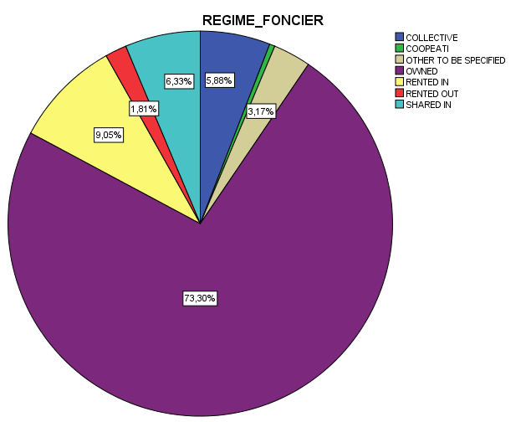

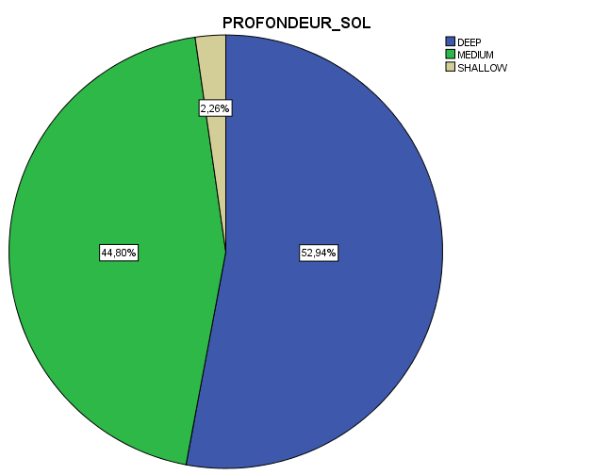

- The average slope of the plot d. Soil fertility
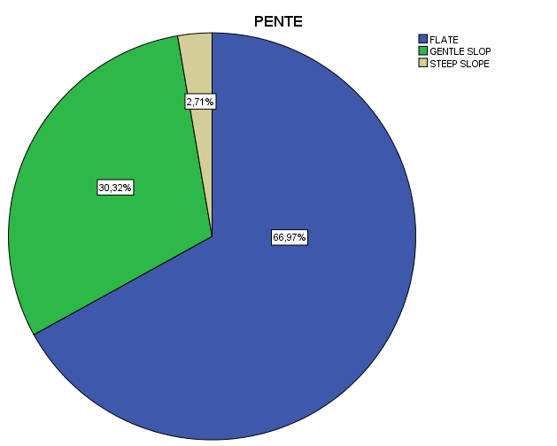

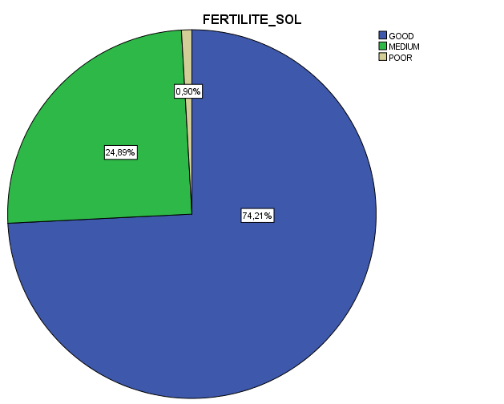

e. Soil conservation technics
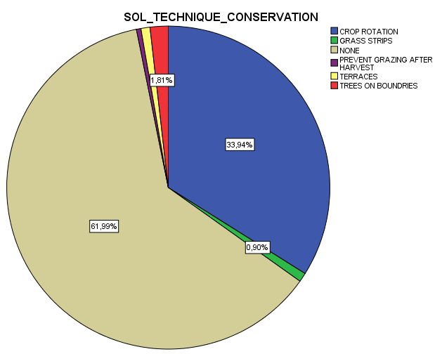

Figure 6.15: Plot characteristics in Betit

In the case of Ain Jemaa the average frequent number of plots by farm is around tree (52% of farms) but we can find more than that. According to figure 62.3, we have 100% of farmers with only 1 plot, this indicate that we have a less fragmented farms. This situation can facilitate the management and the adoption of improved technologies.

Figure 6.16: Plots distribution among Ain Jemaa farmers in %

Table 6-2-2-2: Frequent uses of the large plots at Ain Jemaa
 | PLOT 1 |  | PLOT 2 |  | PLOT 3
Crops/trees | Farmers | % Farmers | Farmers | % Farmers | Farmers | % Farmers
Wheat | 120 | 50,66 | 67 | 35,83 | 44 | 37,29
Vegetables | 4 | 1,75 | 10 | 5,35 | 11 | 9,32
Olives | 19 | 8,30 | 13 | 6,95 | 1 | 0,85
Barley/oat | 10 | 4,37 | 27 | 14,44 | 17 | 14,41
Lentil | 7 | 3,06 | 6 | 3,21 | 1 | 0,85
Chickpea | 12 | 5,24 | 10 | 5,35 | 5 | 4,24
Faba bean | 36 | 15,72 | 40 | 21,39 | 23 | 19,49
Corn | 2 | 0,87 | 0 | 0,00 | 1 | 0,85
Tobacco | 4 | 1,75 | 4 | 2,14 | 0 | 0,00
Sunflower | 1 | 0,44 | 2 | 1,07 | 3 | 2,54
Potato | 14 | 6,11 | 8 | 4,28 | 12 | 10,17
Total | 229 | 100,00 | 187 | 100,00 | 118 | 100,00

a. Land status b. Soil depth
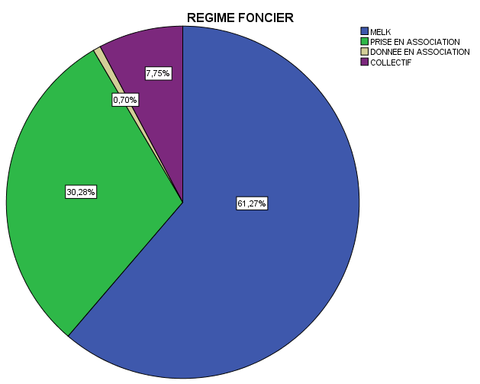
No answer
Deep
Medium
Shallow

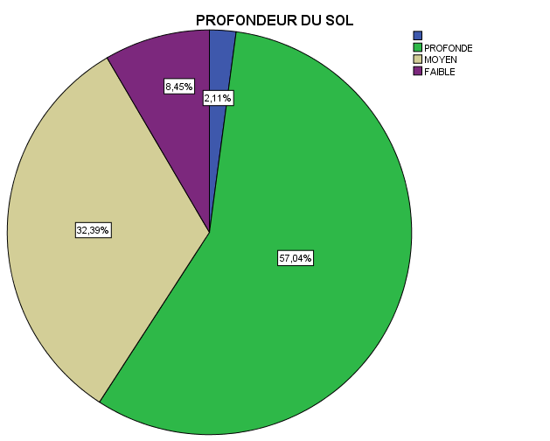
Melk
Association in
Association out
collective
c. Soil fertility d. Average slope of the plot
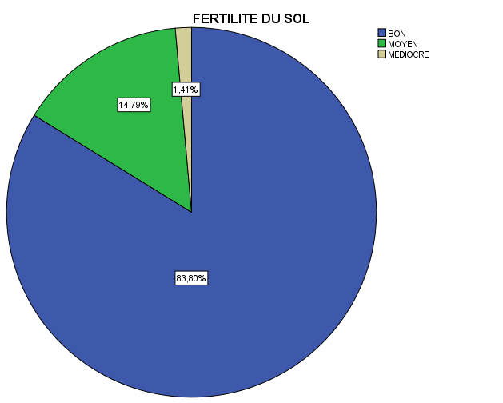

No answer
Flat
Gentile slope
Sleep slope
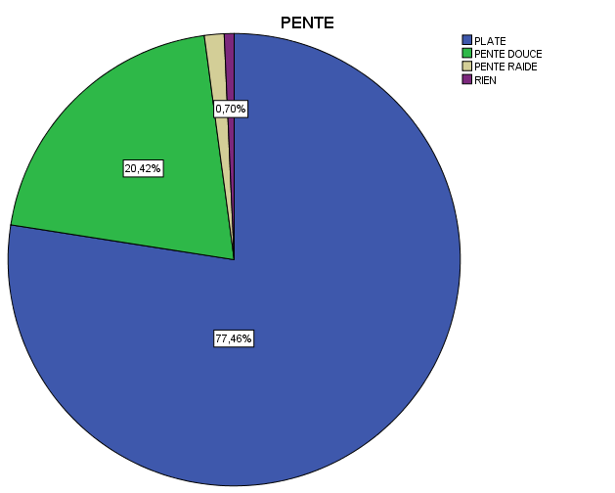

GOOD
MEDIUM
BAD

e. Water conservation technics
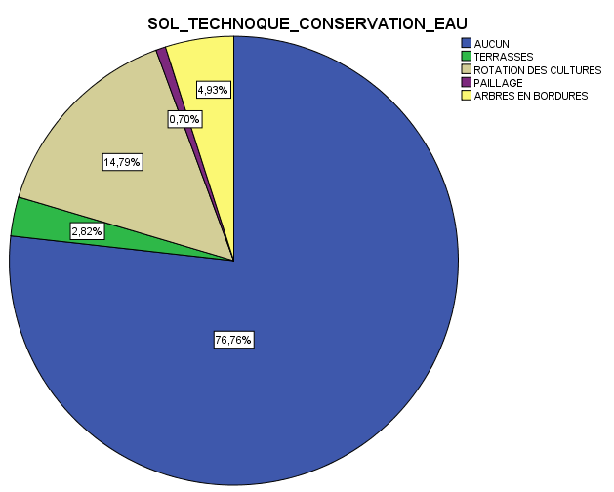

Figure 6.16: Plot characteristics in Ain Jemaa

In the case of Sidi Sliman land status and legal regime of land the private status is dominating by 62% followed by Guich or military regime. Direct tenure is dominating and irrigation opportunities are important. More than 57% of soils are considered as good and have plate slop. No water conservation technics were recorded. Cereals are more dominating. It’s important to notice that the site is geographically located around INRA research center and the National School for Agriculture (ENAM). Some farmers have contributed to the training of the students or have participated to the experiments conducted by INRA researchers.

Most of farmers have less than 3 ha, particularly those operating land under Military status. For this group continuous wheat is frequent. Each farmer has at least one plot (92%), but few farmers have more than tree plots (figure 6.16). in general we have a maximum of five plots by farm (large). The cropping system is diversified but dominated by wheat, olive trees, forage crops and potato.

Figure 6.17: Plots distribution among Sidi Sliman farmers in %

Table 6-2-2-3: Frequent uses of the large plots in Sidi Sliman
 | PLOT 1 |  | PLOT 2 |  | PLOT 3
Crops/trees | Farmers | % Farmers | Farmers | % Farmers | Farmers | % Farmers
Wheat | 100 | 80.00 | 13 | 27.00 | 11 | 33.33
Vegetables | 4 | 3.20 | 1 | 2.05 | 0 | 0
Olives | 0 | 0 | 10 | 20.80 | 1 | 3.00
Barley/oat | 7 | 5.60 | 8 | 16.70 | 3 | 9.10
Lentil | 2 | 1.60 | 0 | 0 | 0 | 0
Faba | 0 | 0 | 0 | 0 | 2 | 6.10
Forages | 7 | 5.60 | 5 | 10.40 | 6 | 18.20
Corn | 0 | 0 | 1 | 2.05 | 1 | 3.00
Potato | 3 | 2.40 | 10 | 21.00 | 7 | 21.21
Fallow | 0 | 0 | 0 | 0 | 2 | 6.06
Total | 125 | 100,00 | 48 | 100,00 | 33 | 100,00

a. Land status b. Soil depth
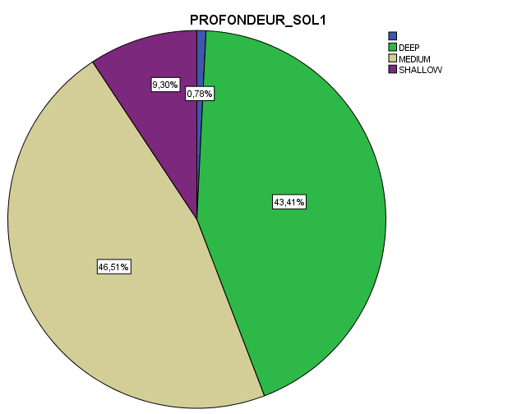

c. Soil fertility d. Average slope of the plot
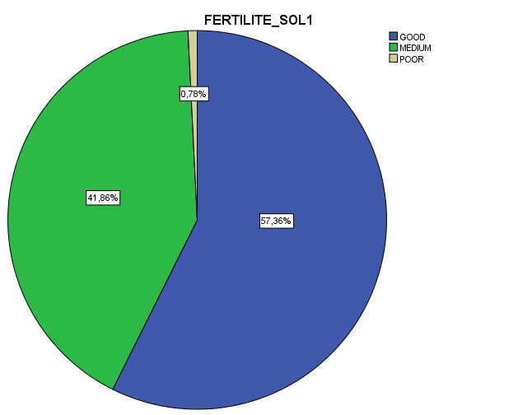
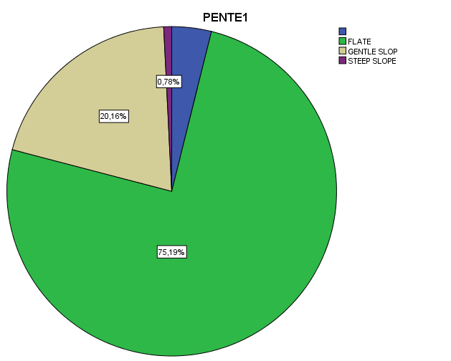

e. Water conservation technics
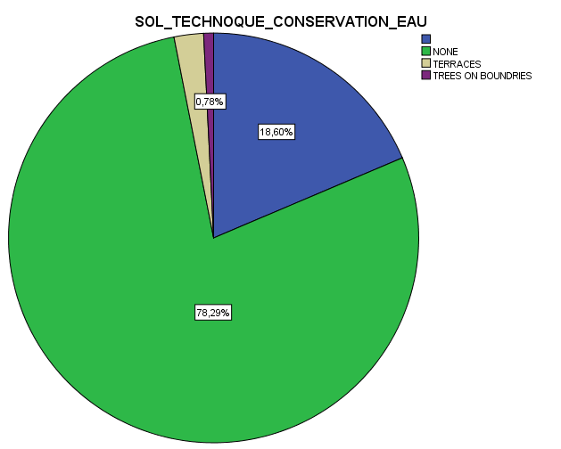

Figure 6.18: Plot characteristics at Sidi Sliman

Farmer’s annual and perennial crop practices

Cropping patterns
The term cropping system refers to the crops and crop sequences and the management techniques used on a particular field over a period of years.The cropping system at CRP-DS action site is quite diversified and reflects production conditions variability from site to site (table 6-2-3-1). With the presence of water in Betit we can find several crops but onion is dominating. At Sidi Sliman irrigation opportunities exist but not generalized. In general we have cereals, legumes, olives, onion and potato. The region of Ain Jemaa is completely different. With limited water sources, cereals and legumes are dominating. Oat and barley are important in Ain Jemaa more than the other sites. Fruit trees such as plumb, apple, olives, and grapes are mainly cropped by large farms at Sidi Sliman and Betit.
Table 6-2-3-1: Major crops practiced in % of farmers
Crops | Betit (%) | Ain Jemaa (%) | Sidi Sliman (%)
Wheat | 30 | 99 | 84
Faba | 14 | 56 | 6
Onion | 66 | 14 | 24
Potato | 27 | 7 | 10
Barley/Oat | 5 | 41 | 14
Chickpeas | - | 21 | -
Corn | 6 | - | 10

Crop management
Moroccan agriculture is divided between a modern industrial sector that primarily produces food for export, and smallholdings that produce food mainly for local markets and farmers’ own subsistence. The geographical diversity of the site results in varied agriculture, with crops ranging from cereals and vegetables to fruits. Wheat, onion, faba bean, potato, corn and olives are major products in Saiss. This diversity has contributed significantly towards food security and has generated labor opportunity and the development of the agro-industry sector in the region.

According to that intensification and the development of the agriculture was based on the introduction of the mechanization, the use of fertilizer and certified seeds and the adoption of modern practices for fruit trees. The survey has target medium and small farms where the cropping system is dominated by wheat, barley, food legumes and onion. Major crops used are labor intensive, particularly in Betit and Sidi Sliman.

a. Wheat
In the case of Ain Jemaa the tillage sequences adopted are based on the preceding crop, the soil texture and slope. In majority, the first tillage is deeper in all sites but frequencies vary from site to site. Firs tillage is concentrated between august and September. The second tillage for seedbed preparation is conducted between the last week of November and the second week of December. The sowing practice is concentrated in November, particularly during the third week of this month. However, tillage and sowing date are depending on the availability of the tractor and the seed drill.

Table 6-2-3-2: Crop practices for wheat at Ain Jemaa site
Sequences | 05 | 06 | 07 | 08 | 09 | 10 | 11 | 12 | 01 | 02 | 03 | 04
Tillage |  |  | 12% | 36% | 28% | 15% | 9%
Sowing |  |  |  |  |  | 6% | 92% | 2%
Top Dressed Fertilizer |  |  |  |  |  |  | 7% | 8% | 24% | 29% | 32%
Weed control |  |  |  |  |  |  |  |  |  | 80%
Irrigation
Harvesting |  | 8% | 83% | 9%

Not all wheat producers are practicing weed control. Only 80% of interviewed farmers are controlling weed using chemical product. Weed control period is between the second week of February and the first week of March. July is the appropriate harvesting period for most of 83% of the farmers in the sample.

For the Sidi Sliman site (table 6233), crop management is quite similar to Ain Jemaa except weed control. Most farmers apply chemical weed control products between February and March (78% of farmers). It’s important to investigate this issue because some farmers extend this use beyond March. More than 90% of farmers start harvesting wheat in June (the last week). Perhaps 2013-2014 cropping season is an exception because harvest period is around July (1st and 2nd weeks).

Table 6-2-3-3: Crop practices for wheat at Sidi Sliman site
Sequences | 05 | 06 | 07 | 08 | 09 | 10 | 11 | 12 | 01 | 02 | 03 | 04
Tillage |  | 4% | 25% | 10% | 19% | 24% | 16%
Sowing |  |  |  |  |  | 2% | 97% | 1%
Top Dressed Fertilizer |  |  |  |  |  |  | 3% | 2% | 13% | 60% | 22%
Weed control | 3% |  |  |  |  |  |  |  | 13% | 41% | 37% | 4%
Irrigation
Harvesting | 5% | 90% | 5%

In the case of Betit we notice the importance of irrigation. Even wheat is not an important crop but more than 44%of wheat producers use water for irrigation. Irrigation frequency depends on climate condition, this season is an exception and more than 58% of farmers irrigate tree times. The optimum period for irrigation is March and April.
During this season farmers have harvested wheat early than in normal year. More than 71% of farmers have harvested wheat by the end of June and early July.
Table 6-2-3-4: Crop practices for wheat in Betit
Sequences | 05 | 06 | 07 | 08 | 09 | 10 | 11 | 12 | 01 | 02 | 03 | 04
Tillage |  |  | 17% | 39% | 13% | 11% | 20%
Sowing |  |  |  |  |  |  | 91% | 9%
Top Dressed Fertilizer |  |  |  |  |  |  | 10% | 4% | 7% | 28% | 44% | 7%
Weed control | 8% |  |  |  |  |  |  | 5% | 10% | 18% | 51% | 8%
Irrigation | 18% |  |  |  |  |  | 6% | 6% |  | 12% | 27% | 31%
Harvesting |  | 71% | 29%

Rotation systems
Farmers in Sais acting site try to maintain between cereals and other crops but it's not the possible for some farmers; particularly those with limited farm size. It appears that rotations have changed since the extended drought in 1980s and the irrigation in Sidi Sliman and Betit. Ain Jemaa farmers’ cereal/cereal rotation is very limited, only 6% of total farmers use it. It's similar for Betit but not the case in Sidi Sliman where more than 33% farmers practice continuous cereals. With about 66% of farmers, food legume/wheat seems to be the most practiced rotation in Ain Jemaa. Cereal/fallow rotation is still important in Sidi Sliman. Onion and potato can be practiced as previous crops for wheat. The pressure towards maximizing crop production has apparently not only discouraged the use of fallow or food legume. The continuous cropping of wheat reflects some of the economic pressures on the farmers. Sometimes weather conditions can affect the continuous planting wheat because it's generally accepted that this practice is effective if there is sufficient rainfall. Farmers are much more willing to take such risks with bred wheat more than durum wheat.

Figure 6.19: Rotation systems
- Ain Jemaa b. Betit c. Sidi Sliman
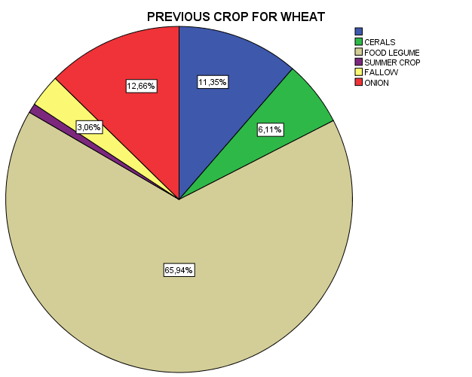 | 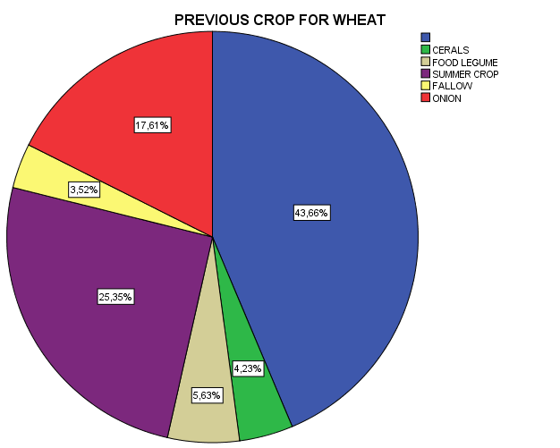 | 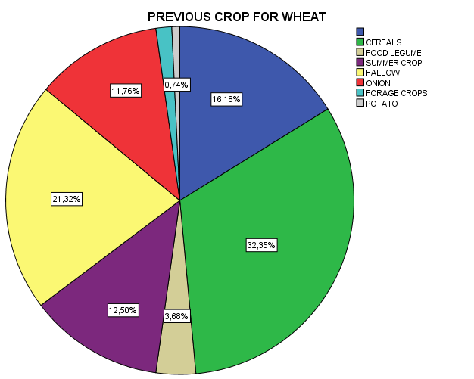

Land preparation of wheat
Tillage operation represents a crucial component, in the minds of the producers, of the cropping system. Farmers emphasize that in order to get a good crop the land must be tilled. They strive to till their plots as much as possible; they face several constraints in doing so. These constraints force them to adopt a relatively wide range of tillage sequences. Over the 229 surveyed farmers of Ain Jemaa more than 52% are using stubble plow for the primary tillage. Deep tillage is an important practice and represents around 70% of total farmers (stubble plow and tree discs). Animal traction is still a practice for onion, potato, food legume and corn producers. Previous crop and available machinery are the main factors affecting the nature of tillage. The role of agrarian reform cooperatives in facilitating this activity for members has decreased.

Figure 6.20: Tillage material used by Ain Jemaa farmers
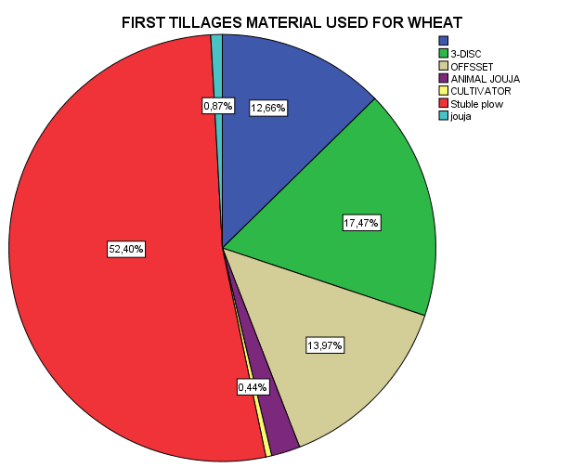 | 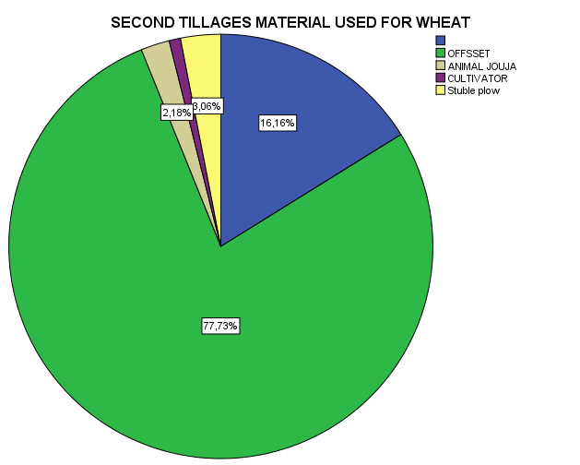

Animal traction is regressing but still less than 1% of farmers are still using it. The second tillage material used is the offset and represents 78% of farmers. The primary tillage cost is about 310 dirham/ha (32.36 $US/ha) and the second tillage cost is about 210 dirham/ha (22.11 $US/ha). Paradoxically, the utilization of tractors has served to increase somewhat the temporary demand for hired labor.
In the case of Betit, more than 53% of farmers are using 3-disc material for the first tillage. For
Figure 6.21: Tillage material used by Betit farmers
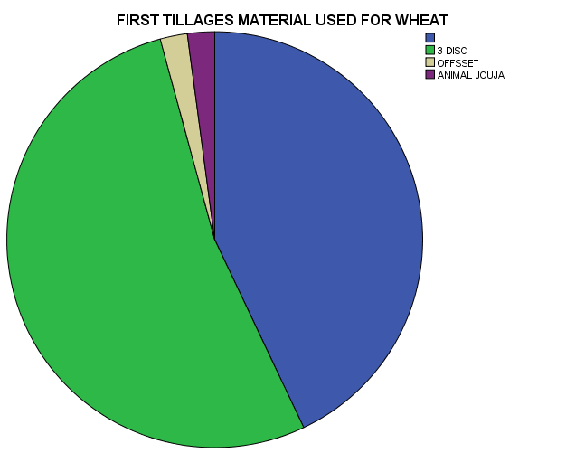 | 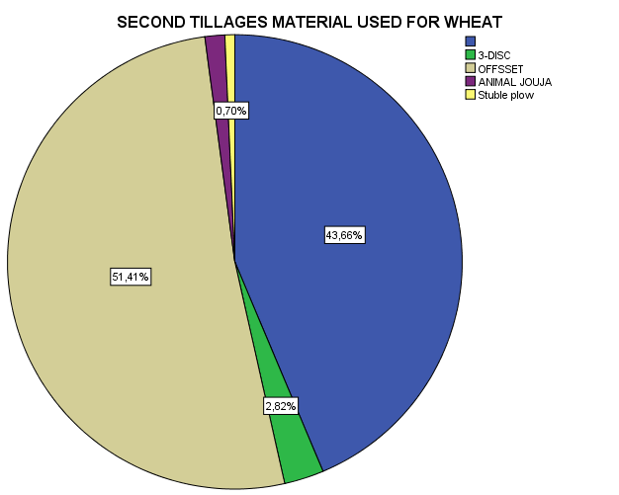
the second tillage offset disc is used by 51% of farmers. This difference between the sites can be explained by the topography and the slope. But, in general the mechanization is a common practice in Betit. However the tillage cost is very high in comparison to standard situation, the respective tractor rent amount is about 503 (55 $US/ha) and 304 dirham/ha (52 $US/ha) for the first and second tillage.
For Sidi Sliman, more than 80% of farmers use 3-disc material for the first wheat tillage. Offset material is the most material used for the second tillage (82%). The respective renting cost for the 3-disc and the offset is about 380 (40 $US/ha) and 220 dirham/ha (23.15 $US/ha).

Figure 6.22: Tillage material used by Sidi Sliman farmers
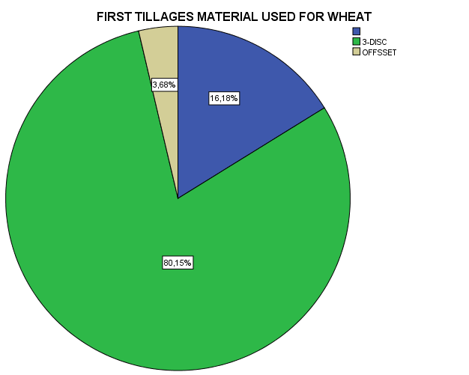 | 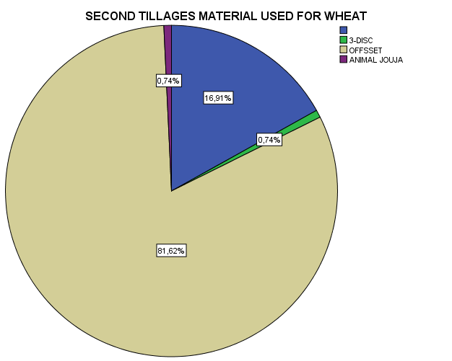

Fertilizer use for wheat
The use of chemical fertilizers is one of the main factors of crop intensification. For all crops, especially wheat, fertilization plays an important role in increasing yields. Their use by farmers remains dependent on the market prices and their applications. Today, there is a wide range of chemical fertilizer available in the tree regions which offers farmers a range of choices. According to the survey farmers try to apply high fertilizer rates and quite varied products. The entire quantity of phosphate and potassium fertilizer units is a made before sowing, while the overall amount of nitrogen is divided among development stages of wheat. About 15 to 20% of nitrogen is used at planting time as a compound fertilizer (TSP). More than 45 and 50% of nitrogen are used respectively at tillering and between bolting and flowering period. However, these amounts can be adjusted according to the distribution and volume of rainfall (in case of absence of irrigation). Di-Ammonium phosphate fertilizer (DAP) is the most used fertilizer in the tree sites. This use is respectively 100, 99 and 69% of farmers in Sidi Sliman, Ain Jemaa and Betit. Other fertilizer such as mono ammonium phosphate and compound fertilizer (NPK) are used mainly in Betit. The quantities used vary from 115 to 145 kg/ha. Farmers try to use limited quantities of fertilizers due to prices (more than 300 dh/ql).

In general, the use of top dressed fertilizer, we found more than three types. This diversification is justified by the awareness of the farmers of the importance of these types and also climate conditions. In addition OCP caravan has created an awareness of the farmers of the importance of these fertilizers and also the existence of several types that can be used instead of using urea 46% as usual. It seems that urea 33% is the most used one in the tree sites. But still prices and fertilization uses are the major constraint of using rationally top dressed fertilizer. Sources of fertilizer are well diversified. It’s important to notice that in Ain Jemaa, the private sector play an important role in providing farmers with fertilizer (figure 6.23).

Figure 6.23: Top dressed fertilizer used
- Betit b. Ain Jemaa c. Sidi Sliman
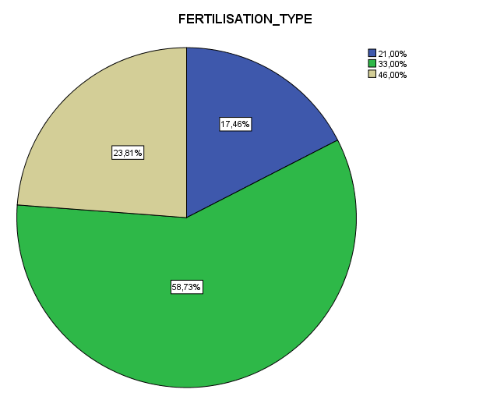  [Tapez une citation prise dans le document, ou la synthèse d’un passage intéressant. Vous pouvez placer la zone de texte n’importe où dans le document et modifier sa mise en forme à l’aide de l’onglet Outils de dessin.] | 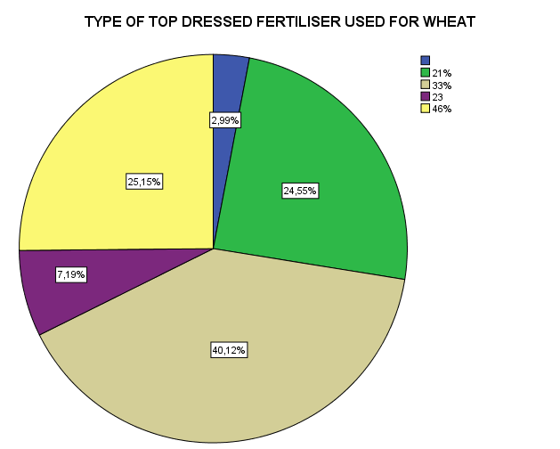 | 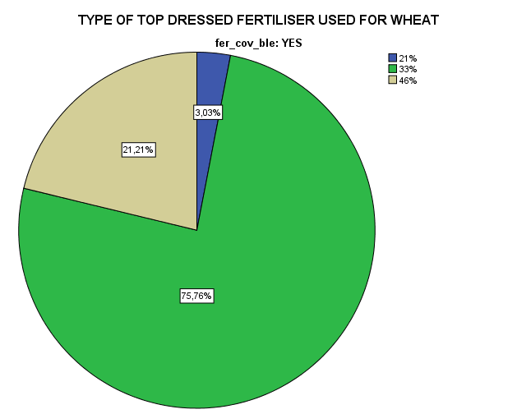  [Tapez une citation prise dans le document, ou la synthèse d’un passage intéressant. Vous pouvez placer la zone de texte n’importe où dans le document et modifier sa mise en forme à l’aide de l’onglet Outils de dessin.]

Figure 6.24: Top dressed fertilizer sources
- Betit b. Ain Jemaa c. Sidi Sliman
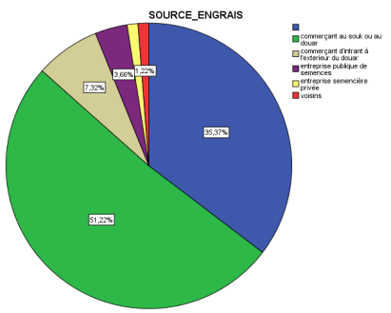  [Tapez une citation prise dans le document, ou la synthèse d’un passage intéressant. Vous pouvez placer la zone de texte n’importe où dans le document et modifier sa mise en forme à l’aide de l’onglet Outils de dessin.] | 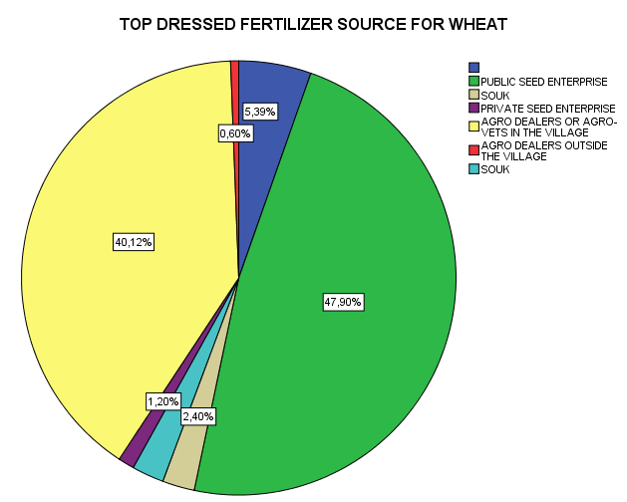 | 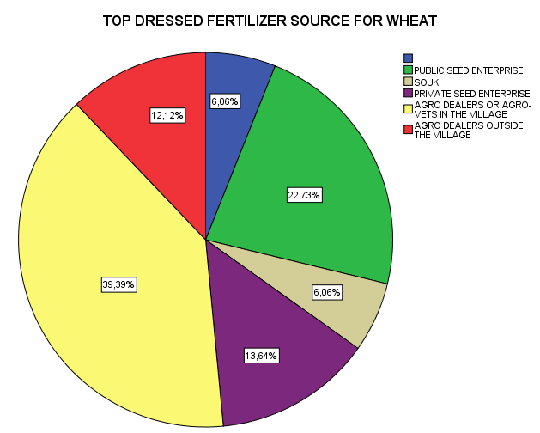  [Tapez une citation prise dans le document, ou la synthèse d’un passage intéressant. Vous pouvez placer la zone de texte n’importe où dans le document et modifier sa mise en forme à l’aide de l’onglet Outils de dessin.]

Planting (sowing)
The majority of farmers are planting between November and December. The real time depends on weather conditions and the seeder for those who are using machines. In Sidi Sliman, still 48% of farmers are planting manually. This situation can be explained by the importance of the area allocated to wheat. Most of the farmers are poor and the use of the seeder is not justified. At Ain Jemaa only 20% of the farmers use manual broadcasting. In Betit site most of farmers are planting manually. More than 95% of farmers use manual broadcasting and this situation can be explained by the importance of wheat, the topography and the cost.

It’s important to notice that farmers are using a wide range of varieties. For durum wheat most of improved varieties are obsolete. Les varieties 27-77, Marzak and Karim were released, respectively in 1982, 1984 and 1985. For bread wheat, the most used varieties are Amal, Marchouch, Arrihane and Achtar. They are released in between 1984 and 1996 but others such as Faiza, Salama and Radia are new improved varieties and released between 2004 and 2010. Maarchouch is the most appreciated variety but it’s not usually available in the market. So, still farmers are using old improved varieties. Up to figure 6.24 the main source of seed is SONACOS

Table 6-2-3-5: Wheat varieties used by farmers
 | Betit |  | Ain Jemaa |  | Sidi Sliman
VARIETIES | Nb. Farmers | % farmers | Nb. Farmers | % farmers | Nb. Farmers | % farmers
ACHTAR (BW) | 12 | 15,19 | 20 | 10,00 | 16 | 14,81
AMAL (BW) | 19 | 24,05 | 87 | 43,50 | 15 | 13,89
AMRIA (BW) | 1 | 1,27 | 0 | 0,00 | 0 | 0,00
FAIZA (BW) | 1 | 1,27 | 10 | 5,00 | 3 | 2,78
KARIM (DW) | 9 | 11,39 | 14 | 7,00 | 3 | 2,78
KENZ (BW) | 2 | 2,53 | 0 | 0,00 | 6 | 5,56
MARCHOUCH (BW) | 18 | 22,79 | 11 | 5,50 | 36 | 33,33
NESMA (BW) | 2 | 2,53 | 3 | 1,50 | 2 | 1,85
RAJAE (BW) | 0 | 0,00 | 1 | 0,50 | 3 | 2,78
RADIA (BW) | 1 | 1,27 | 24 | 12,00 | 4 | 3,70
ARREHANE (BW) | 10 | 12,66 | 8 | 4,00 | 15 | 13,89
TIGRE (BW) | 2 | 2,53 | 4 | 2,00 | 0 | 0,00
WISSAM (BW) | 2 | 2,53 | 10 | 5,00 | 1 | 0,93
VITRON (DW) | 0 | 0,00 | 1 | 0,50 | 0 | 0,00
WAFIA (BW) | 0 | 0,00 | 4 | 2,00 | 0 | 0,00
JAOUDA (BW) | 0 | 0,00 | 1 | 0,50 | 0 | 0,00
SALAMA (BW) | 0 | 0,00 | 2 | 1,00 | 0 | 0,00
2777 / MARZAK (DW) | 0 | 0,00 | 0 | 0,00 | 3 | 2,78
SEBOU (DW) | 0 | 0.00 | 0 | 0,00 | 1 | 0,93
TOTAL | 79 | 100 | 200 | 100,00 | 108 | 100,00
(BW): bread wheat
(DW): durum wheat

Figure 6.25: Seed sources in % farmers
- Betit b. Ain Jemaa c. Sidi Sliman
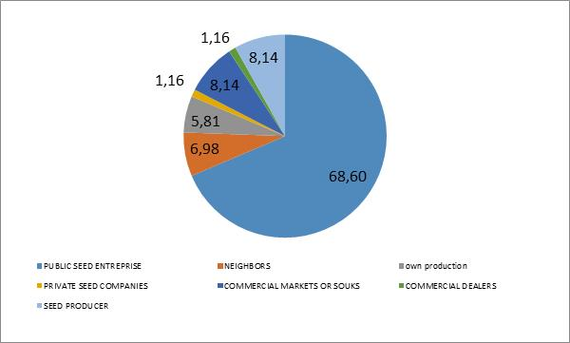 | 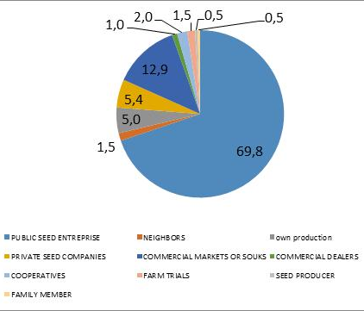 | 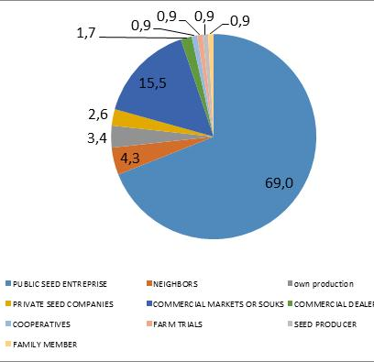

(public enterprise) and represents, respectively 68.6, 69.0 and 69.8% in Betit, Sidi Sliman and Ain Jemaa. The seed price depends on the source and it ranges from 300 to 550 dh/ql. In average the seed price is about 345, 340 and 338 dh/ql, respectively in Ain Jemaa, Betit and Sidi Sliman.

The seeding rate is very high in comparison to what recommended in these sites. More than 70% of farmers use 200 kg/ha but in average we found a range from 210 to 236 kg/ha. The high seed rate can be explained by the use of manual broadcasting.

Other practices
Chemical weed control is a not a common practice in the tree sites. With 82% of farmers, this practice is frequent at Ain Jemaa. In the other sites we have only 50% of farmers are controlling weeds in Betit and 72% of farmers in Sidi Sliman.

Irrigation of wheat is more frequent in Betit. More than 44% of farmers irrigate wheat. Flood irrigation system is practiced by more than 94% of farmers. Sprinkler irrigation is used by only 6% of total farmers.

Farmers in the sample strive to maintain a rotation between cereals and corn, onion and food legumes. At Sidi Sliman, with a majority of small farmers the practiced rotation is wheat/wheat. Farmers are aware about the importance of crop rotations but limited resources and economic pressure have contributed to the disturbance of the rotation system practiced.

Harvesting
The frequent harvest period is around July, except this cropping season with the bad weather conditions. It was not a normal year, so in the estimation of the production cots we have used the yield of the normal year. The combine is used by all farmers.

Wheat enterprise budget
The enterprise budget is a convenient means of summarizing enterprise cost and return for each crop. The preparation of enterprise budgets requires a working data on production technical coefficients, prices, labor and equipment. The enterprise budget is based on the system of production that identifies the specific outputs to be produced, the sequence of operation, the approximate labor used by operation, and the inputs required.

Table 6-2-3-6: Production cost for wheat production in dirham per ha
 | a. BETIT
 | Quantity/ha | Price dh/Unit | Value in dh/ha
Gross Margin in Dh/ha
Yield q/ha NY (normal year) | 45 | 260 | 11700
Yield q/ha (2014) | 38 | 260 | 9880
Operational costs
Tillage |  |  | 862
First Material | 1 | 503 | 503
Second Material | 1 | 310 | 310
Family labor | 4 |  | 0
Hired labor | 7 | 7 | 49
Planting/Sowing |  |  | 1094
Seed Rate_KG/HA | 234 | 4 | 824
Machinery |  | 270 | 270
Seed Covering |  |  | 343
Material |  | 292 | 292
Family labor | 3 |  | 0
Hired labor | 7 | 7 | 51
Organic Fertilizer |  |  | 1074
Machinery | 1 | 855 | 855
Family labor | 19 |  | 0
Hired labor | 31 | 7 | 219
Chemical Fertilizer |  |  | 813
Quantity DAP in ql | 1.4 | 338 | 473
Quantity of STP in ql | 0.4 | 350 | 137
Machinery | 1 | 155 | 155
Family labor | 5 |  | 0
Hired labor | 7 | 7 | 49
Top dressed fertilizer |  |  | 730
Quantity of Urea in ql/ha | 1.5 | 280 | 420
Price |  | 240 | 240
Family labor | 8 |  | 0
Hired labor | 10 | 7 | 70
Weed control |  |  | 897
Nb. Of application | 2 | 266 | 533
Family labor | 50 |  | 0
Hired labor | 52 | 7 | 364
Irrigation |  |  | 665
Nbr. Of irrigation | 3 | 679 | 240
Family labor | 39 |  | 0
Hired labor | 61 | 7 | 425
Harvesting & Transportation |  |  | 790
Machinery | 1 | 300 | 300
Family labor | 28
Hired labor | 70 | 7 | 490
Total cost in dh/ha |  |  | 7268
Advantage 2013/2014 |  |  | 2612
Advantage NY |  |  | 4432
b. Sidi Sliman

 | Quantity/ha | Price dh/Unit | Value in dh/ha
Gross Margin in Dh/ha
Yield q/ha NY (normal year) | 41 | 260 | 10660
Yield q/ha (2014) | 28 | 260 | 7280
Operational costs
Tillage |  |  | 656
First Material | 1 | 380 | 380
Second Material | 1 | 220 | 220
Family labor | 6 |  | 0
Hired labor | 8 | 7 | 56
Planting/Sowing |  |  | 933
Seed Rate_KG/HA | 239 | 3 | 813
Machinery |  | 120 | 120
Seed Covering |  |  | 292
Material |  | 180 | 292
Family labor | 28 |  | 0
Hired labor | 72 |  | 0
Organic Fertilizer |  |  | 1029
Machinery | 1 | 560 | 560
Family labor | 33 | 0 | 0
Hired labor | 67 | 7 | 469
Chemical Fertilizer |  |  | 685
Quantity DAP in ql | 1.7 | 300 | 510
Quantity of STP in ql/ha | 0.2 | 350 | 70
Machinery | 0.3 | 140 | 35
Family labor | 15.0 | 0 | 0
Hired labor | 10 | 7 | 70
Top dressed fertilizer |  |  | 660
Quantity of Urea in ql | 1,30 | 280 | 280
Price | 1 | 320 | 320
Family labor | 7 |  | 0
Hired labor | 9 | 7 | 60
Weed control |  |  | 1655
Nb. Of application | 3 | 480 | 1440
Family labor | 55 | 0 | 89
Hired labor | 18 | 7 | 126
Irrigation |  |  | 550
Nbr. Of irrigation | 1 | 550 | 550
Family labor | 16 |  | 0
Hired labor | 0 |  | 0
Harvesting & Transportation |  |  | 370
Machinery | 1 | 300 | 300
Family labor | 37 | 0 | 0
Hired labor | 10 | 7 | 70
Total cost in dh/ha |  |  | 6829
Advantage 2013/2014 |  |  | 451
Advantage NY |  |  | 3831

 | Aïn Jemâa
 | Quantity/ha | Price dh/Unit | Value in dh/ha
Gross Margin in Dh/ha
Yield q/ha NY (normal year) | 35 | 260 | 9100
Yield q/ha (2014) | 30 | 260 | 7800
Operational costs
Tillage |  |  | 551
First Material | 1 | 310 | 310
Second Material | 1 | 210 | 210
Family labor | 6 |  | 0
Hired labor | 4 | 7 | 31
Planting/Sowing |  |  | 870
Seed Rate_KG/HA | 210 | 4 | 735
Machinery | 1 | 135 | 135
Seed Covering |  |  | 218
Material | 1 | 190 | 190
Family labor | 28 |  | 0
Hired labor | 4 | 7 | 28
Organic Fertilizer |  |  | 189
Machinery |  | 168 | 168
Family labor | 20 |  | 0
Hired labor | 3 | 7 | 21
Chemical Fertilizer |  |  | 963
Quantity DAP in ql | 1,9 | 300 | 570
Quantity of STP in ql | 1,0 | 340 | 340
Machinery | 0,1 | 280 | 39
Family labor | 4,0 |  | 0
Hired labor | 2 | 7 | 14
Top dressed fertilizer |  |  | 499
Quantity of Urea in ql/ha | 1,30 | 280 | 364
Price |  | 100 | 100
Family labor | 20 | 280 | 0
Hired labor | 5 | 7 | 35
Weed control |  |  | 488
Nb. Of application | 2 | 230 | 460
Family labor | 50 |  | 0
Hired labor | 4 | 7 | 28
IRRIGATION |  |  | 200
NBRE_IRRIGUATION | 0 | 0 | 0
Family labor |  |  | 200
Hired labor | 0 |  | 0
Harvesting & Transportation |  |  | 421
Machinery | 1 | 400 | 400
Family labor | 10 |  | 0
Hired labor | 3 | 7 | 21
Total cost in dh/ha |  |  | 4399
Advantage 2013/2014 |  |  | 3401
Advantage NY |  |  | 4701

B. Onions
Onions are among the most widely adapted vegetable crops. They can be grown from the tropics to sub arctic regions. This adaptation is primarily due to differing response to day length. Unlike most other species, day length influences bulbing in onions as opposed to flowering. Onion bulbs are placed into three groups based on their response to hours of day length. The short-day bulb varieties with day lengths of 11-12 hours while intermediate bulb varieties with day lengths of 13-14 hours and are found in the mid-temperate regions of this country; finally, the long-day varieties are adapted to the most northern climes of the United States as well as Canada and bulb with day lengths of 16 hours or greater.

According to FAO, the crop is usually sown in the nursery and transplanted after 30 to 35 days. Direct seeding in the field is also practiced. The crop is usually planted in rows or on raised beds, with two or more rows in a bed, with spacing of 0.3 to 0.5 x 0.05 to 0.1 m. Optimum soil temperature for germination is 15 to 25°C. For bulb production the plant should not flower since flowering adversely affects yields. Bulbs are harvested when the tops fall: For initiation of flowering, low temperatures (lower than 14 to 16°C) and low humidity are required. Flowering is, however, little affected by day length. The short day onion is the dominant type grown in the site (Betit and Sidi Slimane). The crop can be grown from both seed and transplants, but the majority is grown from transplants. Farmer perceive that onion is labor and input consuming; however, it is clearly attractive activity that pays of that inputs provided that market prices do not drop due to oversupply.

In Betit and Sidi Slimane the crop is usually sown in the nursery between April and May for more than 78% of farmers. It's the optimum period for labor the availability and soil humidity. The transplant production begins after 30 to 35 days with land preparation. Women labor force is appreciated for seed preparation (cleaning and drying), sowing and transplanting. Up to agronomist fertilizer requirements are normally 60 to 100 kg/ha N, 25 to 45 kg/ha P and 45 to 80 kg/ha K.

Different varieties exists in Morocco. Their uses are site specific. We have the white onion used mainly in the High Atlas and planted in autumn and harvested in spring. Red onions are used in the Chaouia and Gharb region. They are very strong and can be stored for a long period. They are planted in spring and harvested in summer. In Betit and Sidi Slimane, the yellow onions are the most common. They are planted in spring and harvested in summer. When they are well dried, they can be conserved for a long period. They are more appreciated than the other for specific cooking recipes. The production cycle of onion is about 9 stages, since seeding to bulbs development. According to their water content 89%, they are sensitive to diseases. Technical coefficients and production cost are summarized in Table 6-2-3-7.

Table 6-2-3-7: Technical coefficient and production cost for onion in dh/ha for 2014
 | Betit |  |  | Sidi Slimane |  |  | Ain Jemma
Items | Quantity | Price dh/unit | Cost dh/ha | Quantity | Price dh/unit | Cost dh/ha | Quantity | Price dh/unit | Cost dh/ha
Gross Margin in |  |  | 39600 |  |  | 48000 |  |  | 43400
Production q/ha | 330 | 120 | 39600 | 400 | 120 | 48000 | 310 | 140 | 43400
Operational cost
Land preparation |  |  | 840 |  |  | 650 |  |  | 850
Machinery 1 | 1 | 500 | 500 | 1 | 400 | 400 | 1 | 500 | 500
Machinery 2 | 1 | 340 | 340 | 1 | 250 | 250 | 1 | 350 | 350
Labor in % of total | 87 |  | 0 | 70 |  | 0 | 80 |  | 0
Organic and chemical fertilizer |  |  | 1750 |  |  | 1750 |  |  | 1400
Quantity (kg/ha) | 500 | 3,5 | 1750 | 500 | 3,5 | 1750 | 400 | 3,5 | 1400
Family labor in %of total | 50 |  | 0 | 75 |  | 0 | 20 |  | 0
Hired labor in% of total | 50 |  | 0 | 25 |  | 0 | 80 |  | 0
Planting |  |  | 6600 |  |  | 7750 |  |  | 9220
Seed rate (kg/ha) | 8 | 150 | 1200 | 7 | 250 | 1750 | 9 | 280 | 2520
Seeding cost |  |  | 1600 |  |  | 0 | 1 | 3700 | 3700
Family labor in %of total | 25 |  | 0 | 1 |  | 0 | 0 |  | 0
Hired labor in% of total | 75 |  | 3800 | 99 |  | 6000 | 100 | 1800 | 3000
Top dressed fertilizer |  |  | 1640 |  |  | 1080 |  |  | 1340
Fertilizer (hg/ha) | 410 | 4 | 1640 | 270 | 4 | 1080 | 335 | 4 | 1340
Family labor in %of total | 50 |  | 0 | 50 |  | 0 |  |  | 0
Hired labor in% of total | 50 |  | 0 | 50 |  | 0 |  |  | 0
Irrigation cost | 17 | 120 | 4930 | 22 | 140 | 8140 | 15 | 150 | 1440
Cost | 17 | 170 | 2890 | 22 | 230 | 5060 | 15 | 55 | 825
Family labor in %of total | 50 |  |  | 45 |  |  | 30
Hired labor in% of total | 50 |  |  | 55 |  |  | 70 |  | 160
Crop maintenance |  |  | 1100 |  |  | 700 |  |  | 600
Quantity in l/ha or kg/ha | 8 | 100 | 800 | 5 | 100 | 500 | 2 | 225 | 450
Family labor in %of total | 52 |  | 0 | 40 |  | 0 | 30 |  | 0
Hired labor in% of total | 48 |  | 300 | 60 |  | 200 | 70 |  | 110
Harvest |  |  | 2300 |  |  | 4100 |  |  | 4000
Family labor in %of total | 10 |  | 0 | 8 |  | 0 | 1 |  | 0
Hired labor in% of total | 90 |  | 2300 | 92 |  | 4100 | 40 | 100 | 4000
Total cost in dh/ha |  |  | 19160 |  |  | 24170 |  |  | 17410
Net income in dh/ha |  |  | 20440 |  |  | 23830 |  |  | 25990

C. Potato
Potato (Solanum tuberosum) is a perenial plant native to South America and belongs to the botanical family of Solanaceae. Potato has a high nutritional value. In Morocco, potato is the most cropped vegetable area. The main varieties used in Morocco are Nicola (white flesh); Spunta (white flesh); Desiree (red meat) and others (Timate, Roseval, Diamond, ect..). The amount of seed required for ha is of the order of 4 tons. The plantation is direct; no nursery is needed. The growing season is February-March for June production. In reality, the season starts in May with production in autumn. The planting density is generally around 45,000 to 50,000 plants per ha. Before planting it's important to carry a deep tillage and use manure (up to 25 tone/ha). Nitrogen, phosphorus and potassium are required. Technical coefficients and production cost are summarized in Table 6-2-3-8.

Table 6-2-3-8: Technical coefficient and production cost for potato in dh/ha for 2014
 | Betit |  |  | Sidi Slimane |  |  | Ain jemma
Items | Quantity | Price dh/unit | Cost dh/ha | Quantity | Price dh/unit | Cost dh/ha | Quantity | Price dh/unit | Cost dh/ha
Gross Margin in |  |  | 45300 |  |  | 60000 |  |  | 40250
Production q/ha | 302 | 150 | 45300 | 400 | 150 | 60000 | 230 | 175 | 40250
Operational cost
Land preparation |  |  | 800 |  |  | 500
Machinery 1 | 1 | 500 | 500 | 1 | 300 | 300 | 1 | 500 | 500
Machinery 2 | 1 | 300 | 300 | 1 | 200 | 200 | 1 | 300 | 300
Labor in % of total | 65 |  | 0 | 36 |  | 0 | 50 |  | 0
Organic and chemical fertilizer |  |  | 3150 |  |  | 1120 |  |  | 3150
Quantity (kg/ha) | 900 | 3,5 | 3150 | 320 | 3,5 | 1120 | 900 | 3,5 | 3150
Family labor in %of total | 30 |  | 0 | 80 |  | 0 | 20 |  | 0
Hired labor in% of total | 70 |  | 0 | 20 |  | 0 | 80 |  | 0
Planting |  |  | 7320 |  |  | 17550 |  |  | 6820
Seed rate (kg/ha) | 2600 | 1,2 | 3120 | 4300 | 1,5 | 6450 | 1100 | 1,2 | 1320
Seeding cost | 1 | 2200 | 2200 | 1 | 9100 | 9100 | 1 | 3700 | 3700
Family labor in %of total | 10 |  | 0 | 20 |  | 0 | 0 |  | 0
Hired labor in% of total | 90 |  | 2000 | 80 |  | 2000 | 100 | 1800 | 1800
Top dressed fertilizer |  |  | 1800 |  |  | 760 |  |  | 1340
Fertilizer (hg/ha) | 450 | 4 | 1800 | 190 | 4 | 760 | 335 | 4 | 1340
Family labor in %of total | 20 |  | 0 | 65 |  | 0 |  |  | 0
Hired labor in% of total | 80 |  | 0 | 35 |  | 0 |  |  | 0
Irrigation cost |  |  | 2208 |  |  | 2700 |  |  | 1440
Cost | 16 | 138 | 2208 | 9 | 300 | 2700 | 8 | 160 | 1280
Family labor in %of total | 30 |  |  | 30 |  |  | 13
Hired labor in% of total | 70 |  |  | 70 |  |  | 87 |  | 160
Crop maintenance |  |  | 720 |  |  | 552 |  |  | 600
Quantity in l/ha or kg/ha | 6 | 120 | 720 | 2 | 276 | 552 | 2 | 250 | 500
Family labor in %of total | 40 |  | 0 | 33 |  | 0 | 20 |  | 0
Hired labor in% of total | 60 |  | 0 | 67 |  | 0 | 80 |  | 110
Harvest |  |  | 2000 |  |  | 1600 |  |  | 2300
Family labor in %of total | 5 |  | 0 | 16 |  | 0 | 1 |  | 0
Hired labor in% of total | 20 | 100 | 2000 | 16 | 100 | 1600 | 23 | 100 | 2300
Total cost in dh/ha |  |  | 17998 |  |  | 24782 |  |  | 14210
Net income in dh/ha |  |  | 27302 |  |  | 35218 |  |  | 26040

D. Faba
It is important to note that food legumes are cultivated in Morocco for a long time and considered as the second important crops after cereals. They are mainly cultivated under rainfed conditions. At the favourable rainfed region food legumes occupy a share of 90.4, 71.4 and 62% of the total area of ​​chickpeas, beans and lentils. This is particularly observed for total production of the three crops with a dominance of faba. The yield of chickpea is significantly important in the favourable rainfed zone. However, it should be noted that the variability in area, production and yield is observed in favourable rainfed, intermediate and arid regions. Faba yield is more stable in arid south than in the other sites. But this stability is encountered for chickpea in the Eastern arid and favourable zones. Finally, yield stability is high in for chickpeas in arid zone. In general, yields are low compared to the potential of the regions and the research progress.

Table 6-2-3-9: Importance of faba bean by zone (1978-2006)
Zones | Area in 1000 ha |  |  | Production in 1000 qx |  |  | Yield in ql/hq
Zones | Mean | S-d | CV % | Mean | S-d | CV % | Mean | S-d | CV %
Rainfed | 113.6 | 29.9 | 26.4 | 751.0 | 513.2 | 68.3 | 6.3 | 3.4 | 53.9
Intermediate rainfed | 15.8 | 6.2 | 39.2 | 99.1 | 69.7 | 70.4 | 6.1 | 3.4 | 55.5
Arid south | 20.7 | 7.7 | 37.2 | 148.7 | 84.8 | 57.0 | 7.3 | 3.1 | 42.8
Arid Eastern | 3.9 | 1.5 | 37.1 | 21.7 | 11.8 | 53.8 | 5.7 | 2.6 | 45.8
Mountain | 2.6 | 2.8 | 107.2 | 18.1 | 19.1 | 105.6 | 7.0 | 4.1 | 58.0
Sahara | 2.5 | 2.3 | 91.0 | 25.7 | 29.9 | 116.3 | 9.8 | 6.7 | 68.7

Table 6-2-3-10: Technical coefficient and production cost for potato in dh/ha for 2014

 | Betit |  |  | Sidi Slimane |  |  | Ain Jemaa
Items | Quantity | Price dh/unit | Cost dh/ha | Quantity | Price dh/unit | Cost dh/ha | Quantity | Price dh/unit | Cost dh/ha
Gross Margin in |  |  | 7980 |  |  | 6000 |  |  | 6600
Production q/ha | 19 | 420 | 7980 | 15 | 400 | 6000 | 15 | 440 | 6600
Operational cost
Land preparation |  |  | 750 |  |  | 700 |  |  | 500
Machinery 1 | 1 | 450 | 450 | 1 | 450 | 450 | 1 | 300 | 300
Machinery 2 | 1 | 300 | 300 | 1 | 250 | 250 | 1 | 200 | 200
Labor in % of total | 1 | 0 | 0 | 53 |  | 0 |  |  | 0
Organic and chemical fertilizer |  |  | 1050 |  |  | 525 |  |  | 875
Quantity (kg/ha) | 300 | 3,5 | 1050 | 150 | 3,5 | 525 | 250 | 3,5 | 875
Family labor in %of total | 46 |  | 0 | 46 |  | 0 | 50 |  | 0
Hired labor in% of total | 54 |  | 0 | 54 |  | 0 | 50 |  | 0
Planting |  |  | 840 |  |  | 7060 |  |  | 3730
Seed rate (kg/ha) | 120 | 4,5 | 540 | 180 | 4,5 | 810 | 120 | 4 | 480
Seeding cost | 1 | 300 | 300 | 1 | 250 | 250 | 1 | 250 | 250
Family labor in %of total | 22 |  | 0 | 0 |  | 0 | 30 |  | 0
Hired labor in% of total | 78 |  | 0 | 100 |  | 6000 | 70 |  | 3000
Top dressed fertilizer |  |  | 980 |  |  | 200 |  |  | 300
Fertilizer (hg/ha) | 280 | 3,5 | 980 | 50 | 4 | 200 | 75 | 4 | 300
Family labor in %of total | 53 |  | 0 | 60 |  | 0 | 50 |  | 0
Hired labor in% of total | 47 |  | 0 | 40 |  | 0 | 50 |  | 0
Irrigation cost | 6 | 270 | 2700 | 0 |  | 0 | , |  | 1440
Cost | 6 | 180 | 1080 | 0 |  | 0 |  |  | 0
Family labor in %of total | 4
Hired labor in% of total | 60 |  |  |  |  |  |  |  | 160
Crop maintenance |  |  | 432 |  |  | 700 |  |  | 600
Quantity in l/ha or kg/ha | 2 | 216 | 432 | 2 | 350 | 700 | 2 | 200 | 400
Family labor in %of total | 52 |  | 0 | 50 |  | 0 | 40 |  | 0
Hired labor in% of total | 48 |  | 0 | 50 |  | 0 | 60 |  | 0
Harvest |  |  | 800 |  |  | 450 |  |  | 800
Family labor in %of total | 10 |  | 0 | 20 |  | 0 | 10 |  | 0
Hired labor in% of total | 90 |  | 800 | 80 |  | 450 | 90 |  | 800
Total cost in dh/ha |  |  | 7552 |  |  | 9635 |  |  | 6805
Net income in dh/ha |  |  | 428 |  |  | -3635 |  |  | -205

live trees
In Morocco olive trees occupy more than 560,000 ha with 220,000 ha in irrigated area, 200,000 ha in mountains, 100,000 ha in the favorable areas (Sefrou, El Hajeb, Fes, Meknes, SidiKacem, Gharb, Loukkos and Benslimane) and 40,000 ha in the other regions such as Settat, Safi, Khemisset and Khouribga. Olive production is about 560,000 tone and create more than 11 million working days.
In the CRP11 site olive production is important and well developed. The available oil processing industry has contributed to the development of olive production mainly in Ain Jemaa and Betit Slimane. Picholine variety is the most dominant one. It's a dual purpose variety; oil and fruit. Other varieties exist such as Dehbia and Meslasa, but still farmers are using old improved varieties. Uo to farmers it's hard to adopt improved varieties but we can use new management technologies (grafting, fertilizer, etc.). According to the production cycle, the march-June period is crucial and nutritional and water needs are very high. Grafting is the most applied technology for olive plantation extension and the private sector is largely contributing to the production of rootstock.

Deep, highly fertile soils are not desirable for olives since they tend to produce excessively vigorous trees. The best production comes from trees of moderate vigor. As with climate, however, the ability of olives to tolerate lean soil conditions does not mean they are entirely invincible. The fastest way to kill an olive tree (short, perhaps, of setting it on fire) is to plant it in poorly drained soil. This is the case in Ain Jemaa. Up to table 6-2-3-11, olive production is not profitable for farmers in Betit. The negative profit is due to the olive fruit price. In the local market, olive price is in average about 8 dirhams/kg (1 $US/kg).

Table 6-2-3-11: Technical coefficient and production cost for olives in dh/ha for 2014

 | Betit |  |  | Ain Jemaa
Items | Quantity | Price dh/unit | Cost dh/ha | Quantity | Price dh/unit | Cost dh/ha
Gross Margin in |  |  | 13500 |  |  | 11250
Production q/ha | 30 | 450 | 13500 | 25 | 450 | 11250
Operational cost
Land preparation |  |  | 580 |  |  | 350
Machinery 1 | 1 | 600 | 400 | 1 | 200 | 200
Machinery 2 | 1 | 180 | 180 | 1 | 150 | 150
Labor in % of total | 100 |  | 0 | 100 |  | 0
Organic and chemical fertilizer |  |  | 0 |  |  | 350
Quantity (kg/ha) | 0 |  | 0 | 100 | 3,5 | 350
Family labor in %of total | 0% |  | 0 | 100 |  | 0
Hired labor in% of total | 0% |  | 0 | 0 |  | 0
Planting |  |  | 4200 |  |  | 3700
Seed rate (kg/ha) | 600 | 4 | 2400 | 550 | 6 | 3300
Seeding cost | 1 | 1800 | 1800 | 1 | 400 | 400
Family labor in %of total | 50% |  | 0 | 50 |  | 0
Hired labor in% of total | 50% |  | 0 | 50
Top dressed fertilizer |  |  | 0 |  |  | 0
Fertilizer (hg/ha) | 0 |  | 0 | 0 |  | 0
Family labor in %of total | 0% |  | 0 | 0 |  | 0
Hired labor in% of total | 0% |  | 0 | 0 |  | 0
Irrigation cost | 12 | 200 | 3240 |  |  | 1440
Cost | 12 | 70 | 840 | 0 |  | 0
Family labor in %of total | 50 |  |  | 0 |  | 0
Hired labor in% of total | 50 |  |  | 0 |  | 160
Crop maintenance |  |  | 2500 |  |  | 600
Quantity in l/ha or kg/ha | 5 | 500 | 2500 | 2 | 150 | 300
Family labor in %of total | 50 |  | 0 | 50 |  | 0
Hired labor in% of total | 50 |  | 0 | 50 |  | 0
Harvest |  |  | 4000 |  |  | 3600
Family labor in %of total | 50 |  | 0 |  |  | 0
Hired labor in% of total | 50 |  | 4000 |  |  | 3600
Total cost in dh/ha |  |  | 2100 |  |  | 950
Net income in dh/ha | 1 | 1500 | 1500 | 1 | 950 | 950
Coût de griffage | 1 | 600 | 600 | 0
MOF | 1 |  |  | 0
MOS | 1 |  |  | 0
Coût total dh/ha |  |  | 16620 |  |  | 9550
Avantage net dh/ha |  |  | -3120 |  |  | 1700

System vulnerability and local coping mechanisms used by households

The households in the sample were asked to respond on questions related to the major shocks observed over the past ten years and the average times they faced it during the last 10 years. Table 9-1 illustrate percentage of households in the sample by the major shocks they faced and frequencies times of the shocks in the last 10 years. It is clear from the table 6-9-1 that drought was ranked as the first major shocks faced by households (50.8%) and came in average every 3 years. Hailstorm was ranked as the second major shocks encountered by household (25%) with frequencies in average 2.4 years follow by crop failure (15.9%).

Table 6-9-1 Major shocks encountered by households during over the past 10 years
Shock type | % household replied positively | Frequencies (Average times in the last 10 years)
Drought | 50.8% | 3.2
Hailstorm | 25.0% | 2.4
Crop failure | 15.9% | 3.3
High temperature fluctuation | 12.0% | 2.5
Untimely rains | 10.6% | 2.5
Irregular weather ( dry spell) | 10.4% | 3
Yield losses | 10.4% | 2.5
Animal disease | 10.0% | 3
Temperature fluctuation low | 8.9% | 2
Death of livestock | 5.9% | 1.9
Decline in health | 5.9% | 1.7
Major changes in crop pattern | 5.4% | 1.7
Illness of family member due to extreme weather | 4.9% | 4
Major changes in livestock asset | 4.7% | 1.6
Flood | 3.7% | 1.8
Other shocks | 1.8% | 1.8
Loss of income | 1.8% | 4.9
Decline in consumption | 1.0% | 2.4
Change in soil salinity and decrease/increase in soil moisture | 0.4% | 1.4
Depletion of groundwater | 0.4% | 1.6
Loss of assets | 0.2% | 2.3
Major changes in farm investment (capital formation) | 0.0% | 1.6
Food insecurity/shortage | 0.0% | 1

Table 6-9-2 summarized the answer of households on a question related to how many times during the last ten years they faced a specific shocks. Loss of income, illness of family member due to extreme weather, crop failure, and drought were more frequencies encountered by households compared to other shocks.

6-9-2 Frequencies of time during the last 10 years faced household for specific shocks
Major shocks | No. of responds | Frequencies (Average times in the last 10 years)
Major shocks | No. of responds | Min | Max | Mean | Std. Deviation
Food insecurity/shortage | 2 | 0 | 2 | 1 | 1.4
Change in soil salinity and decrease/increase in soil moisture | 7 | 0 | 2 | 1.4 | 0.8
Major changes in livestock asset | 26 | 0 | 5 | 1.6 | 1.1
Major changes in farm investment (capital formation) | 5 | 0 | 2 | 1.6 | 0.9
Depletion of groundwater | 8 | 0 | 3 | 1.6 | 0.9
Major changes in crop pattern | 33 | 0 | 4 | 1.7 | 1.0
Decline in health | 31 | 0 | 6 | 1.7 | 1.5
Flood | 30 | 0 | 10 | 1.8 | 2.5
Any others 1 specify | 14 | 0 | 6 | 1.8 | 1.4
Death of livestock | 34 | 0 | 5 | 1.9 | 1.0
Temperature fluctuation low | 46 | 0 | 6 | 2 | 1.4
Loss of assets | 3 | 0 | 5 | 2.3 | 2.5
Hailstorm | 133 | 0 | 10 | 2.4 | 2.3
Decline in consumption | 7 | 0 | 5 | 2.4 | 1.5
Untimely rains | 58 | 0 | 10 | 2.5 | 2.2
Temperature fluctuation high | 60 | 0 | 10 | 2.5 | 1.9
Yield losses | 51 | 0 | 10 | 2.5 | 1.9
Animal disease | 57 | 0 | 10 | 3 | 2.7
Irregular weather ( dry spell) | 54 | 0 | 7 | 3 | 1.9
Drought | 266 | 0 | 10 | 3.2 | 2.1
Crop failure | 79 | 1 | 10 | 3.3 | 2.0
Illness of family member due to extreme weather | 25 | 0 | 10 | 4 | 3.3
Loss of income | 11 | 0 | 15 | 4.9 | 4.2

Households in the sample was asked on the adaptation strategies that they used to reduce the negative effect of shocks; most of the household answered that they did nothing. Table 6-9-3 summarized the reply of households on this question for drought, hailstorm, crop failure, and changes in livestock. For drought, most of household did nothing (55%), 20% sold livestock, 5% shifted to non -farm employment and only 4% providing supplemental irrigation for their crops.

Table 6-9-3 Adaptation strategies used by household for most important shocks
 | Drought |  | Hailstorm |  | Crop Failure |  | Changes in Livestock
 | Freq. | % | Freq. | % | Freq. | % | Freq. | %
Did Nothing | 126 | 55% | 74 | 64% | 49 | 75% | 2 | 10%
Left Land Fallow | 2 | 1% | 6 | 5% | 4 | 6% | 4 | 19%
Sold Part Of The Land | 1 | 0% |  | 0% |  | 0% |  | 0%
Leased Out Part Of The Land | 3 | 1% |  | 0% |  | 0% |  | 0%
Sold Livestock | 47 | 20% | 13 | 11% | 3 | 5% | 6 | 29%
Provided Supplemental Irrigation | 10 | 4% | 3 | 3% |  | 0% |  | 0%
Change In Cropping Pattern | 8 | 3% | 2 | 2% | 1 | 2% |  | 0%
Followed Improved Crop Production Patterns | 1 | 0% | 1 | 1% |  | 0% | 1 | 5%
Any Other Adaptation | 2 | 1% | 3 | 3% | 2 | 3% | 1 | 5%
Adopt Drought Tolerant Varieties | 1 | 0% |  | 0% |  | 0% |  | 0%
Changed Composition Of My Livestock | 1 | 0% |  | 0% |  | 0% | 4 | 19%
Borrowed Money From Relatives Or Others | 8 | 3% | 2 | 2% | 3 | 5% |  | 0%
Relying On Assistance From Government Or Ngo | 1 | 0% | 1 | 1% |  | 0% |  | 0%
Less Food Consumption Or Changed Food Habits | 2 | 1% |  | 0% |  | 0% |  | 0%
Shifted to Non -Farm Employment | 12 | 5% | 4 | 3% | 1 | 2% | 1 | 5%
Migration | 2 | 1% | 4 | 3% | 1 | 2% | 2 | 10%
Other | 3 | 1% | 2 | 2% | 1 | 2%
Total | 230 | 100% | 115 | 100% | 65 | 100% | 21 | 100%

Adaptation strategies used by the households in the sample were vary according to farm size. Table 6-9-4 illustrate the responds of households on adaptation strategies for the drought shocks by holding categories as an example. The analysis show that there were difference strategies used for each holding categories where most small holders did nothing (65%) compared to large holders (37.5%). The responds of small holder were sold livestock (12.7%), less food consumption (3.2%) and shifted to non-farm employment (9.5%); while large holders answered sold livestock (37.5%), sold part of the land (12.5%), borrowed money from relatives or others (12.5%). The differences between adaptation strategies used by households were statistically significant at p> 0.01).

Table 6-9-4 Adaptation strategies used by household for drought by holding categories
Shock Type | Holding Categories |  |  |  |  | Total
Shock Type | LE 2 ha | 2-5 ha | 5-10 ha | 10-20 ha | GT 20 ha | Total
Did nothing | 65.1% | 61.4% | 39.3% | 53.6% | 37.5% | 54.8%
Left Land Fallow | 0.0% | 1.4% | 1.6% | 0.0% | 0.0% | 0.9%
Sold part of the land | 0.0% | 0.0% | 0.0% | 0.0% | 12.5% | 0.4%
Leased out part of the land | 1.6% | 1.4% | 1.6% | 0.0% | 0.0% | 1.3%
Sold livestock | 12.7% | 20.0% | 23.0% | 28.6% | 37.5% | 20.4%
Provided supplemental irrigation | 1.6% | 4.3% | 9.8% | 0.0% | 0.0% | 4.3%
Change in cropping pattern | 0.0% | 1.4% | 11.5% | 0.0% | 0.0% | 3.5%
Followed improved crop production patterns | 0.0% | 0.0% | 0.0% | 3.6% | 0.0% | 0.4%
Adopt drought tolerant varieties | 0.0% | 1.4% | 0.0% | 0.0% | 0.0% | 0.4%
Borrowed money from relatives or others | 3.2% | 1.4% | 3.3% | 7.1% | 12.5% | 3.5%
Relying on assistance from government or NGO | 0.0% | 0.0% | 0.0% | 3.6% | 0.0% | 0.4%
Less food consumption or changed food habits | 3.2% | 0.0% | 0.0% | 0.0% | 0.0% | 0.9%
Shifted to non-farm employment | 9.5% | 2.9% | 4.9% | 3.6% | 0.0% | 5.2%
Migration | 0.0% | 1.4% | 1.6% | 0.0% | 0.0% | 0.9%
Any other adaptation | 3.2% | 1.4% | 3.2% | 0.0% | 0.0% | 2.1%
Total | 100.00% | 100.00% | 100.00% | 100.00% | 100.00% | 100.00%
No of observations | 63 | 70 | 61 | 28 | 8 | 230
Chi-Square = 99.082 and significant at p<0.01.



