6-month’s report for CRP 1.1 (2015)
Cluster: System productivity improvement
Sub-Cluster: Establish a seed system platform compatible with existing agro-ecological environments to supply farmers with high quality seed and planting materials so as to improve livelihoods, food security and incomes of smallholders
2.4 Production of quality planting material of local fruit tree varieties by the farmers
Activity: Support to farmers' production of quality planting material in Central Asia
6-month’s output: 30 Farmers (10 women and 20 men) selected for production of quality planting material of local fruit trees varieties (report).
Findings of survey mission on assessment of existing fruit trees planting material production system and identification linkages planting material suppliers and fruits producers in Fergana Province in Uzbekistan conducted by Uzbek Research Institute of Horticulture, Viticulture and Wine-making on 28 August -13 September 2014 demonstrated the following constrains in the system:
- Farmers' lack of knowledge on planting material demand in horticulture sector of Uzbekistan.
- Farmers' lack of awareness of new fruit trees varieties, developed by formal breeding system.
- Lack of certified planting material ensuring quality planting material.

To fill in these gaps in seed system of fruit trees and supplying small holder famers with quality planting material it was agreed with national partners to strengthen the existing seed system through trainings of farmers on technologies of fruit trees multiplication, linking farmers – nursery keepers with mother plantations of research institutes and matrix orchards of farmers for improving their access to grafting material of fruit trees diversity, linking planting material suppliers with production farmers.
Due to the budget cut the selected number of farmers for production of planting material of local varieties of fruit trees was reduced from 30 farmers to 10 in the project sites. The main criteria applied in the selection of farmers were: 1) willingness of farmers to use their nurseries as demonstration sites for trainings in production of planting material; 2) knowledge and skills of farmers in multiplication of fruit trees; 3) readiness to broaden portfolio of fruit trees varieties and crops multiplied in their nurseries; 4) willingness of farmers to learn and apply technologies and skills ensuring quality planting material. 10 farmers – nursery keepers were selected in Fergana Province of Uzbekistan to produce planting material of local varieties of apple, apricot, pomegranate and grape.
Guidelines on producing quality planting material of apple, apricot and pomegranate are drafted in local language to be used for training farmers which are planned for end of July-August 2015.

Appendix 1
Photos
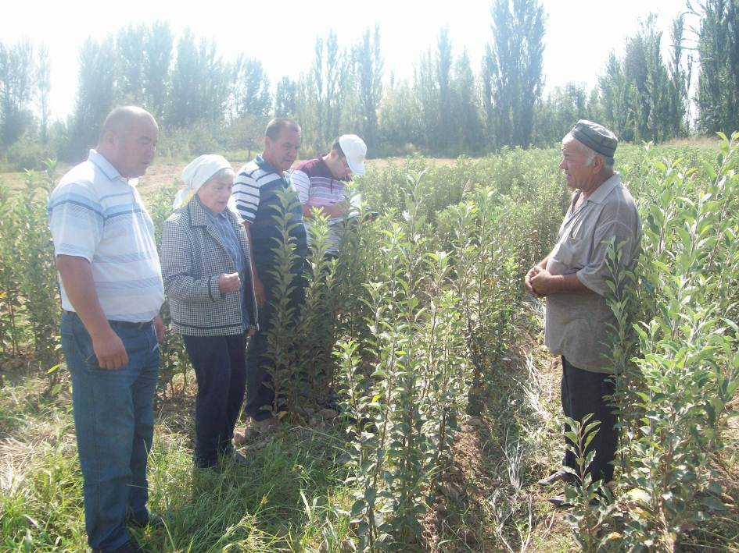

Fig. 1. Tree nursery of farmer Mr. Ilhomjon Egamberdiev who grows planting material of apple varieties – Rene Simirenko, Namangan olma and Eshon olma.

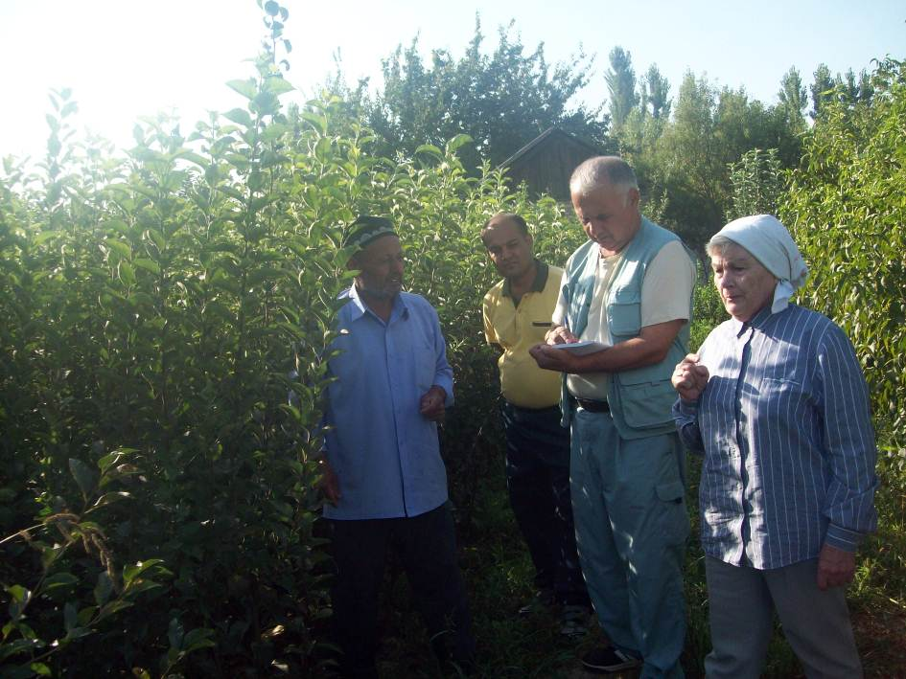

Fig. 2. Tree nursery of farmer Mr. Habibullo Boydadaev who grows saplings of apple varieties – Kizil olma, Eshom olma, Namangan kirmizi, Kandil sinap and apricot varieties – Subhoni, Ruhi Juvanon, Kandak.

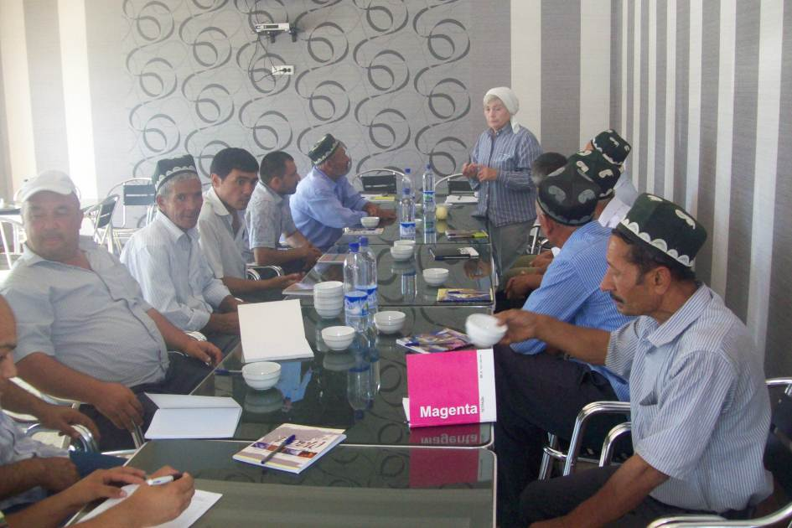

Fig. 6. Round table discussion with farmers.

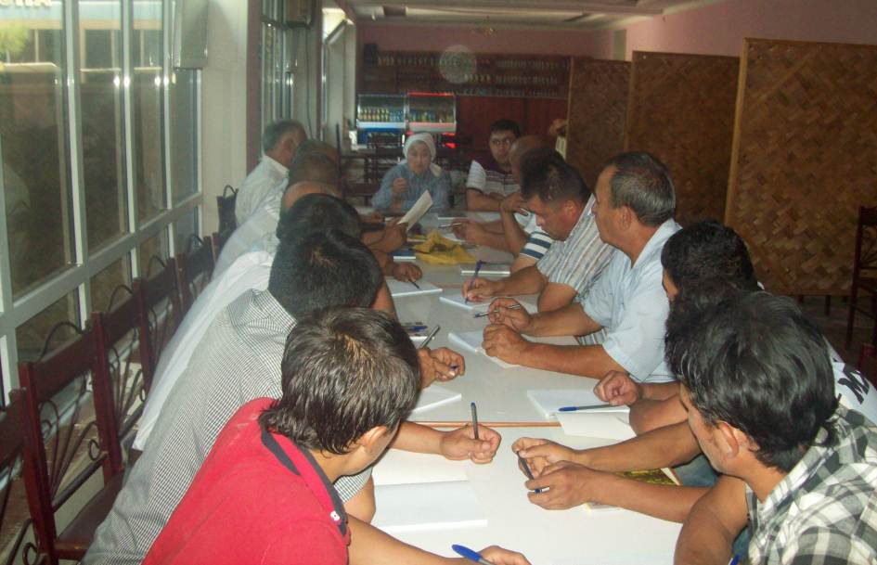

Fig. 7. Round table discussion with farmers.

