Baseline survey: A baseline study was conducted from 3 to 9 February, 2015 jointly by Central Potato Research Institute and CIP to characterize the farming systems, resources and environments. Randomized, Sex-disaggregated information of total 120 household was collected from Maan Sagar village in Jodhpur district a common site of all CGIAR centers to ascertain possibilities of growing potato in dry land system of Maan Sagar. The socio-economic strengths, weakness, opportunities and threats of potato cultivation at project site were studied. The study came out with interesting findings in the form of huge enthusiasm of farmers of the area to go for potato cultivation. In addition to it, the environmental conditions such as temperature, humidity and sunshine were found favorable for a successful cultivation of potato crop in the area. The weekly temperature (both maximum and minimum), humidity, sunshine and rainfall profile were analyzed for five years. However, limited and costly underground water for irrigation and no availability of quality potato seed locally and lack of information on agronomic practices have been identified some important challenges and threats. Study came out with a comprehensive action plan for introduction of potato in cropping system. A working paper will be written and documented in next six monthly report.

Paper published: Rajesh K. Rana, S. Arya, Sanjay Kumar, B. P. Singh, G. Adinarayana, Shalander Kumar and M. S. Kadian. 2015. Analysis of pre-requisites and framework for introducing potato crop in non-traditional Anantapuramu district of Andhra Pradesh. Indian Journal of Tropical Agriculture. Vol. 33, No. 2, April-June 2015.

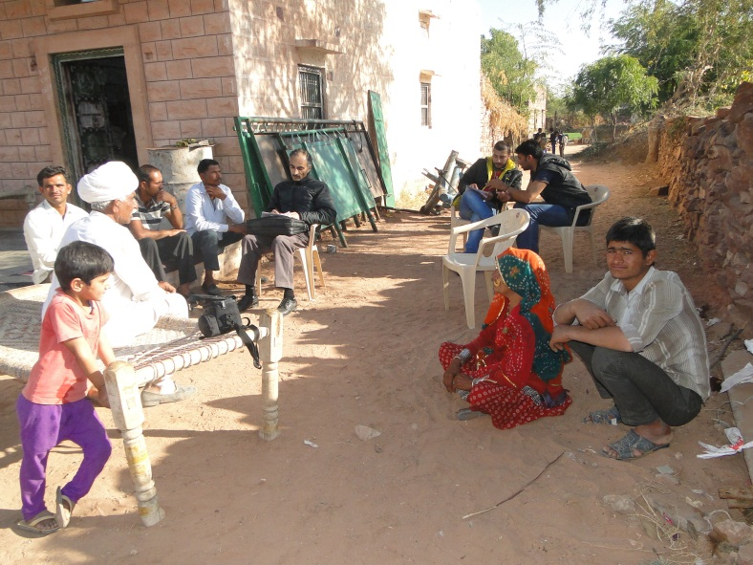
Fig.1. Gathering information for baseline study

