F4: Grain Legumes Seed Systems: Annual Report Oct 2015-Dec 2016

1. Introduction
ICARDA is implementing bilateral projects in Ethiopia, Iran and selected countries in West Asia and North Africa region with financial support from USAID, Government of Islamic Republic of Iran and EU-IFAD support, respectively. In Ethiopia, two projects on faba bean and chickpea entitled ‘Deployment of malt barley and faba bean varieties and technologies for sustainable food and nutritional security and market opportunities in the highlands of Ethiopia’ and Better livelihoods for small holder farmers through knowledge based technology interventions in the highlands of Ethiopia: Increasing the productivity of chickpea in wheat-based cropping system were implemented in four major fab bean and chickpea growing areas of the country with financial support from USAID. In Iran under the project Increasing the Productivity of Cereal-based Systems to Enhance Food Security was started in 2016-17 with financial support from the Government of Islamic Republic of Iran with focus in rianfed areas of four provinces i.e East Azerbaijan, Kermanshah, Kurdistan and Lorestan provinces. The EU-IFAD project, entitled Enhanced small-holder wheat-legume cropping systems to improve food security under changing climate in the drylands of West Asia and North Africa, NARS was implemented in selected target countries from West Asia and North Africa Region (Algeria, Egypt, Morocco, Tunisia and Egypt).

Under the bilateral projects, NARS partners and key stakeholders of target countries together with national seed suppliers, agricultural extension services and farmer groups were involved in the several variety and seed related activities including popularization and demonstration of integrated crop management to create awareness and demand for new legume technologies and engaged in early generation seed multiplication (breeder, pre-basic and basic) as well as certified/quality seed production through formal or farmer-based seed production schemes and small seed pack distribution for scaling-up legume technologies. For example, in Ethiopia, the project partnered with federal and regional NARS; federal and regional seed enterprises; seed producer cooperatives and Bureaus of Agriculture of target districts in four major faba bean and chickpea growing regions in Amhara, Oromia, Southern Nations, Nationalities and Peoples (SNNPR) and Tigray. For faba bean the project was implemented in 62 districts of 21 zones of four major regions working with 28 licensed and 7 non-licensed seed producer cooperatives. For chickpea, the project was implemented in 42 districts of 14 zones of four major regions working with 20 licensed and one non-licensed seed producer cooperatives.

The following key areas were covered primarily under bilateral projects of USAID, EU-IFAD, and ICARDA-Iran projects:
- Faba bean seed system study jointly with CRP-DS (including DNA finger printing) to analyze varietal adoption, farmer’s perception, seed sources, etc to understand systemic constraints and recommend solutions in Ethiopia
- Accelerated early generation seed production (breeder (G₀), pre-basic (G₁-G₃) and basic/elite (G₄) seed) by NARS and farmer seed producer cooperatives particularly for basic seed in Ethiopia during the main season and off-season using irrigation
- Small seed pack distribution for on-farm quality seed production and scaling-out of grain legume technologies through revolving seed scheme in Ethiopia
- Popularization and demonstration of new grain legume technologies like new improved varieties and integrated crop management technologies including bio-fertilizers in Ethiopia
- Strengthening capacity of NARS partners, stakeholders and farmers for acquiring knowledge and skills for effective project implementation and provision of facilities where feasible
- Characterizations of farm households to establish benchmarks and measure the impact of the project on adoption and impact on food and nutritional security.
- Forging an effective partnership existing public, private and farmer-based actors for effective project implementation.

2. Grain legumes seed production by NARS and partners
In WANA and Ethiopia, NARS and other key stakeholders were engaged in early generation seed multiplication (breeder, pre-basic and basic) as well as certified/quality seed production through formal or community seed production schemes and small seed pack distribution for scaling-up legume technologies.

2.1 Early generation seed multiplication
About 357.151 ha of early generation seed of different seed classes were planted and 794.693 t of seed was produced in 2015/16 crop season. In Ethiopia breeder, pre-basic and basic seed of faba bean and chickpea were multiplied by NARS (EIAR and RARIs) in 2015/165 crop season (Table 1). In total about 333.3 ha was planted and 722.23 t of different seed classes of faba bean and chickpea were produced by USAID projects. Some of the basic seed production was carried out with farmer seed producer’s cooperatives/groups under the supervision of NARS. In Iran breeder seed 1-3 were planted on 15.4 ha with anticipated seed production of 26.18 t of seed with NARS in Kurdistan, Marageh and Sararood agricultural research centers for further multiplication in the coming years

Under EU-IFAD project early generation seed multiplication was also carried out in Algeria, Egypt, Morocco, Sudan and Tunisia. A total of 46.183 t of different seed classes of faba bean , chickpea and lentil seed was produced primarily with NARS partners. However, in Morocco, all seed production activities failed because of the drought in 2016.

Table 1. Early generation seed multiplication by NARS during 2015/16 crop season
Country | Crop | Seed class | Area (ha) | Seed produced (t) | Remarks
Ethiopia | Faba bean | Breeder | 10.64 | 26.60
Ethiopia |  | Pre-basic | 15.74 | 39.35
Ethiopia |  | Basic | 84.8 | 211.98 | 45.8 ha with estimated production of 114.6 was with seed producer’s cooperatives involving 125 (24 female) farmers
Ethiopia |  |  | 111.2 | 277.93
Ethiopia | Chickpea | Breeder | 8.4 | 16.8
Ethiopia |  | Pre-basic | 49.9 | 99.8
Ethiopia |  | Basic | 163.9 | 327.7 | 104 ha with estimated production of 208 t was with seed producer’s cooperatives involving 348 (67 female) farmers
Ethiopia |  |  | 222.1 | 444.3
Ethiopia | Total USAID |  | 333.3 | 722.33
Iran | Chickpea | Breeder 1 | 4.6 | 3.08
 |  | Breeder 2 | 8.5 | 6.05
 |  | Breeder 3 | 2.3 | 17.05
 | Total Iran |  | 15.4 | 26.18
Egypt |  | Breeder | 0.2 | 0.378 | Progeny rows of two promising varieties (Giza 1557 and Giza 1813)
Sudan | Faba bean | Breeder | 2 | 4.4
 |  | Foundation |  | 5.0
 |  | Certified |  | 27.4 | Produced by ARC
 |  |  | 2+ | 36.8
 | Chickpea | Breeder | 1 | 1.48 | Including pre-release seed multiplication
 |  | Foundation |  | 1.03
 |  | Certified seed |  | 4.30 | Produced by ARC
 |  |  | 1+ | 6.81
 |  |  | 3+ | 43.61
Tunisia | Faba bean | G₂ | 0.4 | 0.417
 | Chickpea | G₂ | 0.525 | 0.436
 | Lentil | G₂ | 1.126 | 1.342
 |  |  | 2.051 | 2.195
 | Total-EU-IFAD |  | 5.251 | 46.183
 | Grand total |  | 357.151 | 794.693
Note: Algeria (report pending) and Morocco (no report due to crop failure)

2.2 On-farm seed production
Farmers from the seed producer cooperatives or groups are identified, trained and provided with seed to produce and market the seed as a group through formal and/or informal channels and return the seed in kind. Farmers took the responsibility to produce and sell through formal channels (seed enterprsies or unions) or sell or exchange seed with other farmers within their vicinity and beyond. District BoA experts and development agents and research staff were also trained to supervise and monitor seed production.

In Ethiopia, the faba bean project is working in 21 zones and 62 districts with 28 licensed and 7 non-licensed seed producer cooperatives with total membership of 6644 farmers (721 female farmers,10.9%). The chickpea project is working in 14 zones and 46 districts with 20 licensed and 1 non-licensed seed producer cooperatives with total membership of 11472 farmers (1577 female farmers, 13.7%), Small seed packs were distributed to farmer groups in the form of revolving seed fund for on-farm seed production of quality seed and scaling up/out activities. Farmers pay back the amount of seed received so that it can be used to reach new farmers in the community during the second year. Farmers are supervised by BoA and inspected by the regional seed certification offices to produce certified/quality seed for marketing through formal sector or informal sector for own use, exchange or sell to other farmers within or beyond their villages.

NARS partners mobilized the available faba bean and chickpea seed and distributed it to the seed producer farmers. About 2842 farmers (365 female farmers, 12.84%) were provided with 155 t of small seed pack of improved faba bean and chickpea varieties as part of technology out-scaling for on-farm seed multiplication and revolving seed fund scheme (Table 2). About 1026.8 ha was planted with anticipated production of 2249.5 t of seed as part of on-farm seed multiplication with seed producer’s cooperatives i.e.979,5 t of faba bean (from 391.8 ha) and 1270 t of chickpea (from 635 ha). The faba bean seed produced will be sufficient to plant 5,597.1 ha (reaching 50,883 farmers @0.11 ha) and producing 16, 791 t of seed/grain the following year. Similarly, the chickpea seed produced will be sufficient to plant 12700 ha (reaching 57,727 farmers @0.22 ha) producing 37,100 t seed/grain the following year crop cycle.

Moreover, 45.3 t of faba bean seed was exchanged through farmer-to-farmer reaching 714 farmers (48 female farmers, 8.79%) and planted on 239.3 ha which will produce 718 t of seed/grain sufficient to plant 4102 ha producing 12,306 t grain in the next crop cycle. Likewise, 60.7 t of chickpea seed was exchanged through farmer-to-farmer reaching 1618 farmers (204 female farmers, 12.61%) and planted on 488 ha which will produce 1464 t of seed/grain sufficient to plant 14640 ha producing 12,306 t grain in the next crop cycle. NGOs and other partners also purchased and distributed 1.2 t and planted 6 ha with expected production of 15 t of seed/grain (if used as seed could plant 150 ha and produce 450 t grain the next crop cycle).

Table 2. On -farm seed production of faba bean and chickpea in Ethiopia during 2015/16 crop season
Crop and seed class | Seed provided (t) | Area planted (ha) | Expected production (t) | Number of farmers |  |  | Remarks
 |  |  |  | Male | Female | Total
Faba bean
Certified/quality seed (small pack) | 73.4 | 275.8 | 689.45 | 700 | 142 | 842 | NARS-on-farm
Quality seed (revolving seed) | 2.3 | 116 | 290.00 | 295 | 35 | 330 | NARS-on-farm
Farmer-to-farmer seed exchange | 45.3 | 239.3 | 598.23 | 666 | 48 | 714 | Seed/grain
NGOS/other actors | 1.2 | 6 | 15.00 | 36 | 5 | 41 | Seed/grain
Subtotal | 122.2 | 637.1 | 1592.68 | 1697 | 230 | 1927
Chickpea
Certified/quality seed (small pack) | 68.9 | 552.5 | 1105.0 | 1310 | 145 | 1455 | NARS-on-farm
Quality seed (revolving seed) | 10.4 | 82.5 | 165.0 | 172 | 43 | 215 | NARS-on-farm
Farmer-to-farmer seed exchange | 60.7 | 488.3 | 976.6 | 1618 | 204 | 1822 | Seed/grain
Subtotal | 140 | 1123.3 | 2246.6 | 3100 | 392 | 3492
Total | 262.2 | 1760.4 | 3839.28 | 4797 | 622 | 5419

In Tunisia, during the 2015-2016 cropping season 27 male farmers and 23 female farmers in two communities participated in seed production of improved faba bean and chickpea varieties. In Hamronia, 9 and 26 farmers, respectively planted 8 and 20 ha of faba bean and chickpea and produced 12.6 t and 31 t seed in the same order. In Neber, 13 farmers planed chickpea on 13 ha and produced 4.55 t of seed mainly because of the very bad crop establishment.

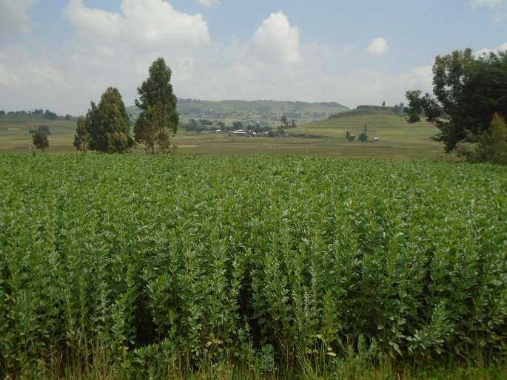 | 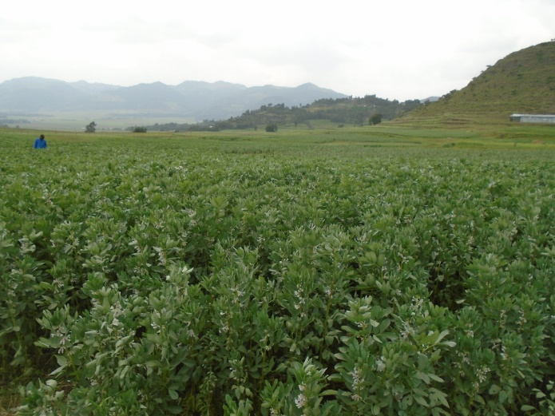
Early generation seed production of faba bean by Debre Biran ARC (left: breeder seed of var Walki ) and Alamata ARC (right: pre-basic seed of var. Hashenge)
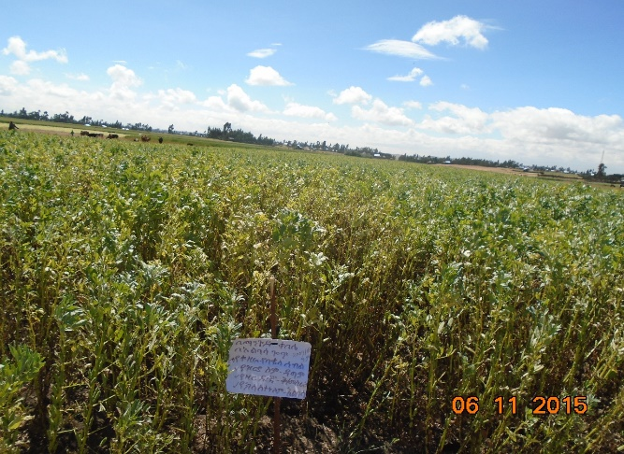 | 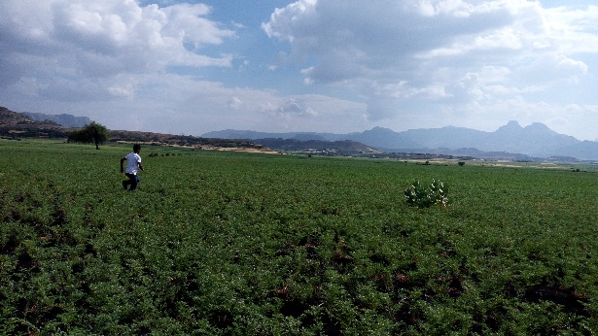
On-farm seed production of faba bean by DBARC (left : var Dagem) and by Gonder ARC (right)
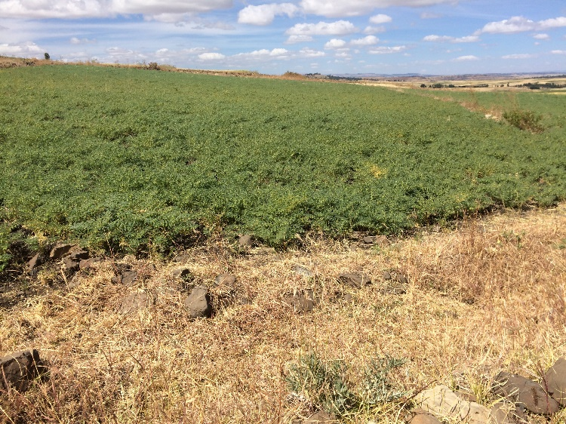 | 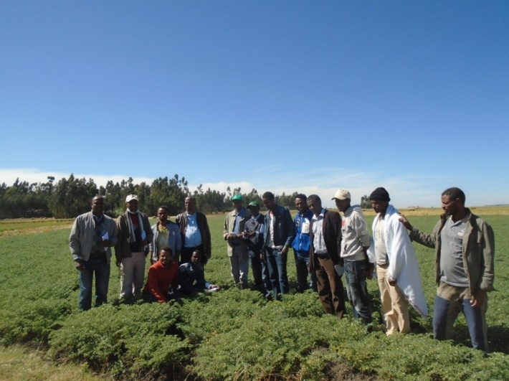
On-farm seed production of chickpea by Adet ARC at Shbel Berenta (left) and by DBARC at Jihur (right: var. Arerti)

