Technical Report PK-CRP DS/BARI-06/2015

INVOLVEMENT OF RURAL WOMEN IN FIELD ACTIVITIES
(CRP 1.1 DRYLAND SYSTEMS)

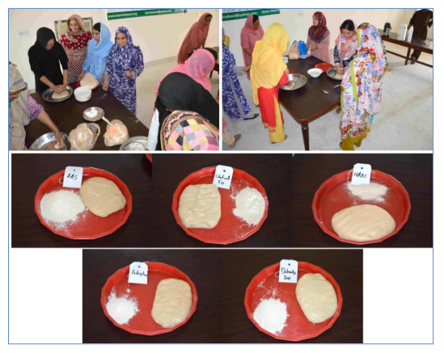
Dr. M. Ramzan Anser
Dr. A. Sarkar
Dr. Muhammad Tariq

Barani Agricultural Research Institute
Chakwal, Pakistan
December 2015

- INTRODUCTION
Women are an actively involved component of rural life in dryland areas. They play key role in various agricultural operations such as harvesting of fodder and it’s feeding to livestock, milking of animals, making farm yard manure cakes for using as fuel, harvesting of wheat etc. However, their services are hardly recognized. They are rarely provided any opportunity to share their experiences and capabilities. Realizing the need, CRP Dryland Systems therefore, provided them an opportunity to evaluate cooking quality of various promising wheat cultivars that were evaluated at farmers fields under the project.
- ACTIVITY
Consumer preferences for wheat cooking quality were checked by making different groups of women at BARI. Flour of five wheat varieties was given to them without mentioning the name of variety. Women (48 women farmers) carried out all the process like doughing (Fig.1), Making loaves and cooking the loaves to make bread (Fig 2).
Fig 1: Rural women making flour of different wheat cultivars

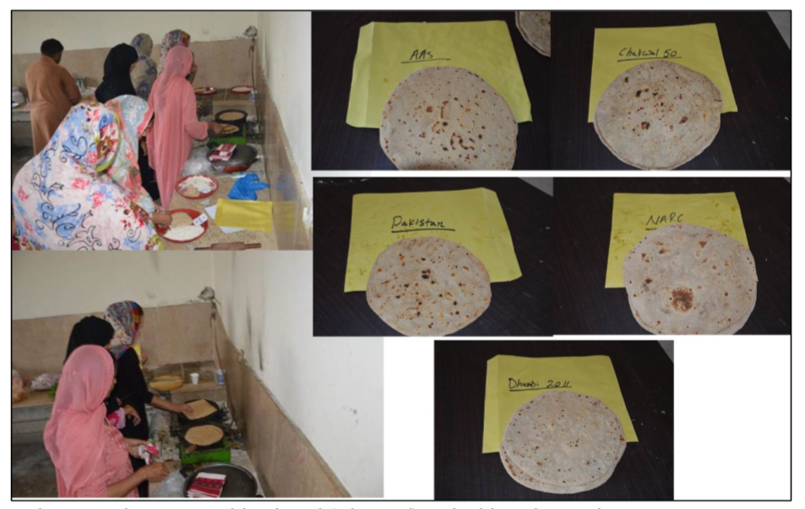
Fig 2: Rural women making Rural women making bread (Chapaati) and taking observations
- OUTPUT
The unique opportunity provided to rural women farmers in varietal selection process was very much appreciated and is expected to serve as precedent for active participation of females in field activities in future projects

