Activity: Study of expression pattern of defence genes in chickpea and pathogenicity causing genes in FOC through qPCR in resistant and susceptible cultivars grown under elevated CO₂

Objective: To quantify defence and pathogenicity causing gene(s) in compatible and incompatible interaction under elevated CO₂

Materials and methods: Total RNA was extracted from root tissues of wilt infected and control chickpea seedlings of susceptible cv. JG 62 and resistant cv. WR 315 grown under ambient and elevated CO₂ condition. cDNA was synthesized from total RNA. Specific primers for the defence related genes in chickpea and pathogenicity causing genes in Foc were designed and the expression profiling was determined by real-time PCR.

Results and interpretation: β-1, 3- glucanase, a PR 2 family protein was found to be highly up-regulated in JG 62 at early stage of infection irrespective of CO₂ level, but down-regulated latter, whereas in WR 315, the maximum expression of this gene was found in late stage of infection.
On the other hand, four SIX genes of Foc, SIX 5, SIX 8, SIX 11 and SIX 13 were were found to be highly up-regulated at early stage of infection (7-14 dpi). In JG 62, all genes were more induced than WR 315 indicating their role in pathogenicity. SIX 8 gene was found to be most important secreted effector gene as it was highly up-regulated than others.

Next steps: Detailed analysis of the expression data is in progress.

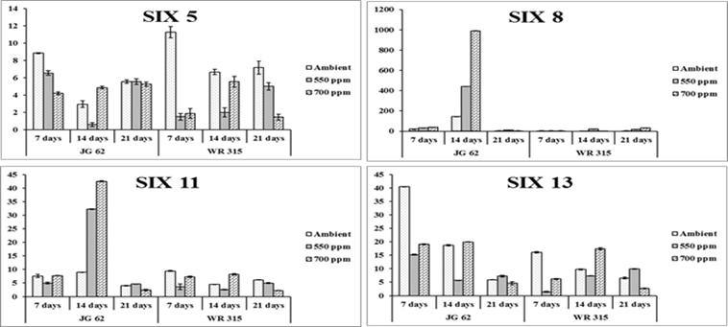
Figure: Expression profile of pathogenicity causing SIX genes in Foc x chickpea interaction.

