6 MONTHLY PROGRESS REPORT
FOR THE YEAR 2015 (Jan - June)
Barani Agricultural Research Institute, Chakwal

CRP 1.1: Dry Land Systems

CRP Activity Title: Improving Water and Land Productivity in Rain fed Systems Using Community- based Water and Agronomic Management Approaches.

Sub-Activity Title: Decision making and planning in agriculture by calibrating, validating and scenario simulating the crop model (DSSAT) according to rainfed climate

KEY MESSAGES:
Climate Change is a rapidly unfolding challenge of catastrophic global, regional and national proportions. Pakistan will be affected by the impacts far more seriously than is generally recognized by the policy makers and opinion leaders. Pakistan has continuously witnessed history’s worst disasters since 2001. According to the IPCC’s fifth Assessment Report (AR5), global surface temperature increase exceed 1.5°C and keep rising beyond 2100 in all scenarios except the lowest-emission scenario, in which actions are taken to nearly eliminate CO2 emissions in the second half of the 21st century. In scenarios with higher rates of emissions, warming is likely to exceed 2°C by 2100 and could even exceed 4°C. The temperature increases in both summer and winter are reported higher in northern Pakistan than in southern. Despite the fact that Pakistan has witnessed a number of natural disasters in recent past, the need to study severity and impact of the natural disasters was felt after the devastating flood in 2010 (Yu, Winston et. al., 2013). The flood in 2010 had a devastating effect on the lives and livelihoods of millions in the country. The cost of recovery was estimated at USD8.74 to 10.85 billion (ADB, WB, and GOP, 2010).
Agriculture is extremely vulnerable to climate change. Climate change is both an opportunity and potential threat for future agriculture and livestock globally and in Pakistan particularly. Pakistan is most likely one of the worst hit countries due to adverse effects of climate change that could have far reaching implications for agriculture, livestock production and in turn for human beings.
To measure the climate change effect and impacts it is necessary to assess climate changes and adoptive measures for these changes. In scientific community there is no other tool/practice to check the climate change effect on agriculture expect crop models. Decision makers need a risk analysis to identify and prioritize effective adaption and mitigation strategies. Climatic variations, continuously increasing population pressure and market infrastructures are driven forces to reduce agricultural productivity. New management options and appropriate genotypes are need of the day to be considered for sustainable production.
Crop simulation models have the potential to help understanding the impact of climate change and climate variability and agronomic practices on plant growth and development as the models integrate the soil-plant-atmosphere complex. The Decision Support System for Agro-technology Transfer (DSSAT) (Hoogenboom et al. 2004) is a comprehensive decision support system (DSS) for assessing management options. The cropping system simulation model (CSM) included in DSSAT v4.5 (Jones et al. 2003; Hoogenboom et al. 2004), is process-oriented, dynamic and simulates growth, development and yield for more than 25 different crops.
The model is parameterized using different agronomic parameters (phonological development, dry matter accumulation, leaf area index, physiological indices and grain yield) and climatic data. Efficiency of the model will be tested using model validation skill scores including d-stat, RMSE and R2.
Objectives of the study:
The specific objective of the study is:
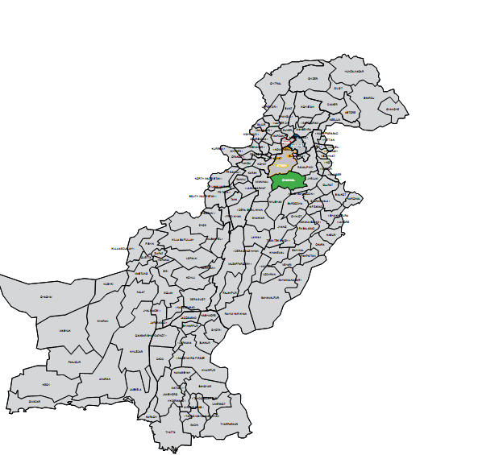
To develop crop model for wheat and barley for supporting in planning for improved resilience and sustainably stabilize yields and productivity
2. METHODOLOGY:
2.1. Study Area
The study was conducted at Barani Agricultural Research Institute (BARI) located within 72° longitude, 32° latitude and 575 m altitude in the district Chakwal, Pakistan. The climate of Chakwal is semi-arid subtropical and the annual rainfall varies from 500-1000 mm most of which falls during monsoon (Fig.1) in the form of high intensity showers. The area also receives winter showers of lesser intensity during December to February.
Fig.1. Study area
The map shows the location of the experimental area. Experimental site is located in Chakwal district and the total area of the district is 660,119 hectares; 785,795 hectares is under cultivation and 39,783 hectares area is covered by the forests. About 8% of the total cultivated land is irrigated by canals, wells and tube wells (Government of Punjab 2013). About 70% of the population is related to farming or farm related activities. Groundnut and wheat are the main crops of the district. Sorghum, mustard, millet and gram are also grown by the farmers. Vegetables grown in the district include turnip, cauliflower, tomato, okra, onion and carrot. The fruits are citrus and guava (Government of Punjab, 2009b). Percentage of major winter crops is shown in Figure. 2.
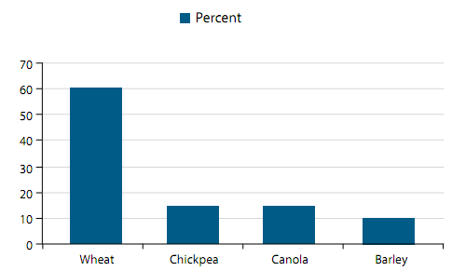
Figure. 2: Winter cropping pattern for major crops in Chakwal
(Source: Akmal, M et al, 2014)
In this study two crops were selected (Wheat and Barley) for modeling. Wheat and Barley varieties of chakwal-50 and Joo-83 were used for model calibration respectively. Previous three years (2010, 2012 and 2013) data for wheat and two year (2012 and 2013) data for barley were collected from the experimental site (BARI) including Parameters shown in Table 1.
Table 1. Crop data required for DSSAT
Planting date | Row spacing (cm)
Emergence date | Anthesis date
Planting depth (cm) | Plant height (cm)
Planting method | Maturity date
Plant population at seeding (plants/m2) | Harvesting date
Plant population at emergence (plants/m2) | Yield (kg/ha)
Crop simulation models are complementary tools in field. In this perspective, one crop growth model DSSAT (Decision Support System for Agro-technology Transfer) will be calibrated and validated to predict cropping pattern (shifting sowing date), growth and yield of wheat and Barley under rainfed conditions for Pothwar region of Pakistan.
The input data required to run the DSSAT models include daily weather data (maximum and minimum air temperature, rainfall, and solar radiation); soil characterization data (physical, chemical, and morphological properties for each layer); a set of cultivar-specific coefficients characterizing the cultivar being grown in terms of plant development and grain biomass; and crop management information, such as plant population, row spacing, seeding depth, and application of fertilizer and irrigation. The soil water balance is simulated to evaluate potential yield reduction caused by soil water deficits. The soil water balance is determined on a daily basis as a function of precipitation, irrigation, transpiration, soil evaporation, runoff, and drainage from the bottom of the profile. The main components and module structure are shown in Figure.3.
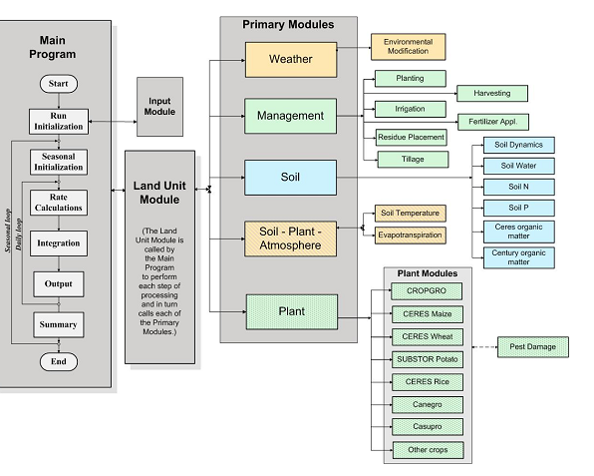
Figure.3. Overview of the components and modular structure of DSSAT v.4.5.0.0
2.2. Meteorological Data:
The climate data, maximum and minimum temperature (°C), Rainfall (mm) and solar radiation (MJ m-² d⁻¹), of last 31 years (1984-2015) was obtained from Soil and Water Conservation Research Institute (SAWCRI), Chakwal. Data of the years (1984-2000) was in the raw form and contained missing data. The raw data was compiled in excel sheets and missing data gaps were filled by using some climate software and were again converted to the format of DSSAT (Figure.4).
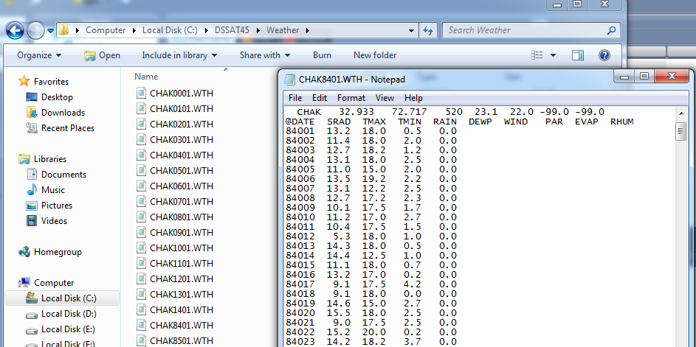
Figure.4. Climate data files and format in DSSAT
2.3. Soil Properties:
For the purpose of soil analysis soil pit at a depth of 100 cm was dug and the data of soil was calculated as shown in Table 2.
Table 2: Soil properties of experimental site (BARI)
Soil depth (cm | Lower limit | Drained upper limit | Saturation | Root growth factor | Saturated hydraulic conductivity cm/h | Bulk density (g/cm3) | Organic carbon (%) | Clay (%) | Silt (%) | Nitrogen (%) | pH in water
18 | 0.06 | 0.2 | 0.42 | 1 | 0.75 | 1.52 | 0.45 | 6 | 16 | 0.04 | 9.1
61 | 0.065 | 0.18 | 0.39 | 1 | 0.6 | 1.7 | 0.35 | 14 | 8 | 0.02 | 9.1
98 | 0.07 | 0.17 | 0.35 | 1 | 0.8 | 1.6 | 0.2 | 6 | 20 | 0.02 | 8.9
151 | 0.06 | 0.17 | 0.38 | 1 | 0.83 | 1.39 | 0.02 | 8 | 22 | 0.02 | 8.9
198 | 0.06 | 0.18 | 0.32 | 1 | 0.8 | 1.42 | 0.02 | 10 | 6 | 0.02 | 8.9

2.4. Model Calibration for Wheat and Barley:
Model calibration is the adjustment of parameters so that simulated values compare well with observed data. The so-called 'genetic coefficients' that influence the occurrence of developmental stages in the DSSAT can be derived iteratively by manipulating the relevant coefficients to achieve the exactly match between the simulated and observed number of days to phenological events (Table 4). CERES Wheat and Barley models were used. For these CERES models, the plant life cycle is divided into several phases, which are similar among the crops (Table 3).

Table 3: Growth stages simulated by DSSAT CERES
Wheat and Barley
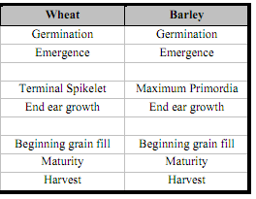
Table 4: Cultivar coefficients for the DSSAT CERES Wheat and Barley
Cultivar coeff | Definition
P1V | Days, optimum vernalizing temperature, required for vernalization
P1D | Photoperiod sensitivity coefficient (% reduction in rate/ h near threshold)
P5 | Grain ﬁlling (excluding lag) period duration (°C d)
G1 | Kernel number per unit canopy weight at anthesis (#/g)
G2 | Standard kernel size under optimum conditions (mg)
G3 | Standard , non-stressed mature tiller weight (including grain) (g dwt)
PHINT | Thermal time between the appearance of leaf tips (°C d)
3. RESULTS AND DISCUSSIONS
3.1. Calibration of Wheat:
Wheat variety of Chakwal-50 was selected for model calibration, because it is a high yielding, drought tolerant and disease resistant wheat cultivar for rainfed areas of Punjab, Pakistan. First of all cultivar coefficients were adjusted for the variety chakwal-50 as shown in Table 5.
Table 5: Cultivar coefficients fitted for chakwal-50
(Wheat variety)
Cultivar coefficients
P1V | 40
P1D | 55
P5 | 550
G1 | 24
G2 | 26
G3 | 1.3
PHINT | 70

The GENCALC software (Hunt and Pararajasingham, 1994) does this type of adjustment automatically and therefore uses the observations of phenological events from one or several experiments from a range of environments. We choose the manual approach because there were relatively few experimental data per cultivar, impeding the identification of optimal parameter values by such a mathematical algorithm. Godwin et al. (1989) suggested that such a manual, iterative approach usually reaches reasonable estimates of the genetic coefficients.
The DSSAT model was calibrated by using the crop data of 2010, 2012 and 2013 (Table 6).
Table 6: Wheat crop data used for DSSAT calibration
Parameters | Years
Parameters | 2010-2011 | 2012-13 | 2013-14
Planting date | 10-Nov-10 | 01-Nov-12 | 05-Nov-13
Emergence date | 16-Nov-10 | 09-Nov-12 | 12-Nov-13
Planting depth (cm) | 10 | 10.00 | 10
Planting method | dry seed | Dry seed | Dry seed
Plant population at seeding (plants/m2) | 400 | 400 | 400
Plant population at emergence (plants/m2) | 200 | 200 | 200
Row spacing (cm) | 22.5 | 22.5 | 22.5
Anthesis date | 15-Mar-11 | 11-Mar-13 | 14-Mar-14
Plant height (cm) |  | 97.8
Maturity date | 19-Apr-11 | 10-Apr-13 | 14-Apr-14
Harvesting date | 30-Apr-11 | 24-Apr-13 | 28-Nov-14
Yield (kg/ha) | 4209 | 4329 | 4046

3.1(a). Initial conditions
The most important part of running any crop model is the initial soil moisture contents. It shows the level or conditions of moisture contents present in the soil before sowing, because by these moisture contents any model can predict yield exactly. Initial moisture contents for wheat for three years (2010, 2012 and 2013) are shown in Table 7.
Table 7: Initial soil moisture conditions
YEAR | DATE | DEPTH OF SAMPLING | Moisture content (cm3/cm3)
2010 | 09-11-2010 | 15 | 0.10
2010 | 09-11-2010 | 35 | 0.10
2010 | 09-11-2010 | 55 | 0.10
2010 | 09-11-2010 | 75 | 0.10
2010 | 09-11-2010 | 95 | 0.11
2010 | 09-11-2010 | 115 | 0.12
2012 | 30-10-2012 | 15 | 0.14
2012 | 30-10-2012 | 35 | 0.13
2012 | 30-10-2012 | 55 | 0.12
2012 | 30-10-2012 | 75 | 0.13
2012 | 30-10-2012 | 95 | 0.12
2012 | 30-10-2012 | 115 | 0.13
2013 | 04-11-2013 | 15 | 0.15
2013 | 04-11-2013 | 35 | 0.14
2013 | 04-11-2013 | 55 | 0.14
2013 | 04-11-2013 | 75 | 0.15
2013 | 04-11-2013 | 95 | 0.13
2013 | 04-11-2013 | 115 | 0.13

3.1 (b). Fertilizer Application:
Table 8: Fertilizer application in wheat
Date | Fertilizer material | Depth (cm) | N (kg/ha) | P (kg/ha) | K(kg/ha)
10-Nov-10 | Urea | 20.00 | 120 | 100 | 60
1-Nov-12 | Urea | 20.00 | 120 | 100 | 60
5-Nov-13 | Urea | 20.00 | 120 | 100 | 60

The above mentioned data was entered in the DSSAT crop management data file and it is our X-file, then we made the A-file for the DSSAT.
Table 9: A-file parameter for wheat
TRNO | ADAT | MDAT | HWAM
2010 | 11074 | 11109 | 4209
2012 | 13070 | 13100 | 4329
2013 | 14070 | 14104 | 4046
ADAT = Anthesis date (YrDoY)
MDAT = Physiological maturity data (YrDoY)
HWAM = Yield at harvest maturity (kg/{dm}ha)

3.1(c). Performance evaluation of DSSAT
The performance of the DSSAT model after calibration of wheat was evaluated. The variables tested included the key phenological dates (anthesis and harvest maturity) and the final yield. In general, the model gave good predictions of crop development and final grain yields, and for the cultivar chakwal-50 (Table 10). For calibration, the simulated dates of anthesis and physiological maturity as well as yield were compared with the observed data (Table 10).
Different statistic indices were employed, including Coefficient of Determination (r-square), absolute and normalized Root Mean Square Error (RMSE and NRMSE) and index of agreement (d-index). Normalized RMSE gives a measure (%) of the relative difference of simulated versus observed data. The simulation is considered excellent with a normalized RMSE is less than 10%, good if the normalized RMSE is greater than 10% and less than 20%, fair if normalized RMSE is greater than 20 and less than 30%, and poor if the normalized RMSE is greater than 30% (Jamieson et al.,1991). The index of agreement (d) proposed by Willmott et al.(1985), according to the d-statistic, the closer the index value is to one, the better the agreement between the two variables that are being compared and vice versa.
The good thing of DSSAT is that it itself performed the statistical analysis of the observed and simulated values of the experiments in the Evaluate.out file.
Table 10: Statistical indices of evaluating the performance of CERES-Wheat model in predicting phenological dates and simulating grain yield.
Cropping years | Anthesis (DAP) |  | Physiological Maturity (DAP) |  | Grain yield (kg/ha)
 | Simulated | Measured | Simulated | Measured | Simulated | Measured
2010-2011 | 127 | 125 | 163 | 160 | 4478 | 4209
2012-13 | 130 | 128 | 167 | 165 | 4445 | 4329
2013-14 | 136 | 132 | 173 | 170 | 4112 | 4046
Index
RMSE (day)ª | 2.8 |  | 2.7 |  | 173
NRMSE (%)^{b} | 2 |  | 2 |  | 4
d-stat^{c} | 0.84 |  | 0.90 |  | 0.68
r-square^{d} | 0.98 |  | 0.98 |  | 0.75
ª RMSE | Root mean square error
^{b} NRMSE | Normalized root mean square error
^{c} d-stat | Wilmot's index of agreement
^{d} r-square | Coefficient of determination
The model was able to predict the anthesis date well as shown in Table 10, and Figure. 5. The values for RMSE, normalized RMSE, index of agreement (d) and r2 for anthesis date were 2.8 d (days), 2%, 0.84 and 0.98, respectively. There was, also, a close match between predict and observed physiological maturity dates. The values for RMSE, normalized RMSE, index of agreement (d) and r2 for physiological maturity date were 2.7 d (days), 2%, 0.90 and 0.98, respectively.

Figure 5. Comparison of predicted and measured days from sowing to anthesis (a) and to maturity (b).
All of the indices imply that there was a good agreement between simulated and measured durations (days, d) from sowing to anthesis and from sowing to physiological maturity stages. Based on these results it can be concluded that the model was very robust in predicting the critical phonological growth stages.
Grain yield was very well simulated by the CERES-Wheat model. (Fig. 6; Table 9). The RMSE, normalized RMSE, d-index, and r2 were 173 kg ha⁻¹, 4 %, 0.68 and 0.75, respectively. Aforementioned indexes imply the robustness of the model in simulating wheat grain yield.

Fig. 6: Comparison between simulated and measured grain yield (kg/ha)
3.2. Calibration of DSSAT for Barley:
In the soils where wheat, maize, rice and sugarcane cannot be cultivated easily, we can cultivate barley (Joo - جو) because it is a tolerant crop and can resist harsh environments. Not only barley gives good yields with lesser agriculture inputs but it can also replenish the damaged soils. Barley, like all other crops is affected by the saline soils, but due to its high resistance it can give better yields than other crops. Barley is adapted to a wide range of soils such as less fertile, fertile, sandy or soils. Barley variety Joo-83 was selected for the model calibration.
Table 11: Cultivar coefficients fitted for Joo-83
(Barley variety)
Cultivar coefficients
P1V | 12
P1D | 30
P5 | 625
G1 | 13
G2 | 20
G3 | 3
PHINT | 70

Calibration of barley was done under stressed conditions. The DSSAT model was calibrated by using the Barley crop data of 2012 and 2013 (Table 12).
Table 12: Crop data for Barley crop
Parameters | Years
Parameters | 2012-13 | 2013-14
Planting date | 22-Oct-12 | 29-Oct-13
Planting depth (cm) | 10 | 10
Emergence date | 27-Oct-12 | 04-Nov-13
Plant population at seedling (plants/m2) | 330 | 330
Plant population at emergence(plants/m2) | 200 | 200
Planting method | Dry seed | Dry seed
Row spacing (cm) | 30 | 30
Anthesis date | 01-Feb-13 | 05-Feb-14
Plant height (cm) | 73.2 | 81.4
Tillage date | 06-Oct-12 | 06-Oct-13
Tillage implement | Cultivator | Cultivator
Tillage depth (inch) | 8 to 12 | 8 to 12
Maturity date | 22-03-13 | 30-03-2014
Harvesting date | 25-Apr-13 | 28-Apr-14
Yield (kg/ha) | 1166 | 1266

3.2 (a). Initial conditions:
The most important part of running any crop model is the initial soil moisture contents.
Table 13: Initial conditions for Barley
YEAR | DATE | Depth of sampling (cm) | Moisture content (cm3/cm3)
2012 | 21-10-2012 | 15 | 0.14
2012 | 21-10-2012 | 35 | 0.12
2012 | 21-10-2012 | 55 | 0.11
2012 | 21-10-2012 | 75 | 0.12
2012 | 21-10-2012 | 95 | 0.15
2013 | 28-10-2013 | 15 | 0.14
2013 | 28-10-2013 | 35 | 0.13
2013 | 28-10-2013 | 55 | 0.15
2013 | 28-10-2013 | 75 | 0.11
2013 | 28-10-2013 | 95 | 0.11
3.2 (b). Fertilizer Application:
Table 14: Fertilizer application in Barley
Date | Fertilizer material | N (kg/ha) | P (kg/ha)
22-10-2012 | Urea | 110 | 40
29-10-2013 | Urea | 110 | 40

3.2 (c). Performance evaluation of DSSAT for Barley:
The performance of the DSSAT model after calibration of Barley was evaluated. The variables tested included the key phenological dates (anthesis and harvest maturity) and the final yield. In general, the model gave good predictions of crop development and final grain yields, and for the cultivar Joo-83 (Table 12). For calibration, the simulated dates of anthesis and physiological maturity as well as yield were compared with the observed data (Table 15).
Different statistic indices were employed, including Coefficient of Determination (r-square), absolute and normalized Root Mean Square Error (RMSE and NRMSE) and index of agreement (d-index). Normalized RMSE gives a measure (%) of the relative difference of simulated versus observed data. The simulation is considered excellent with a normalized RMSE is less than 10%, good if the normalized RMSE is greater than 10% and less than 20%, fair if normalized RMSE is greater than 20 and less than 30%, and poor if the normalized RMSE is greater than 30% (Jamieson et al.,1991). The index of agreement (d) proposed by Willmott et al.(1985), according to the d-statistic, the closer the index value is to one, the better the agreement between the two variables that are being compared and vice versa.
Table 15: Statistical indices of evaluating the performance of CERES-Barley model in predicting phenological dates and simulating grain yield.
Cropping years | Anthesis (DAP) |  | Physiological Maturity (DAP) |  | Grain yield (kg/ha)
 | Simulated | Measured | Simulated | Measured | Simulated | Measured
2012-13 | 100 | 102 | 154 | 151 | 1225 | 1166
2013-14 | 99 | 100 | 158 | 153 | 1297 | 1266
Index
RMSE (day)ª | 1.58 |  | 4.12 |  | 47.12
NRMSE (%)^{b} | 2 |  | 3 |  | 4
d-stat^{c} | 0.61 |  | 0.41 |  | 0.78
r-square^{d} | 1 |  | 1 |  | 1
ª RMSE | Root mean square error
^{b} NRMSE | Normalized root mean square error
^{c} d-stat | Wilmot's index of agreement
^{d} r-square | Coefficient of determination

The spring barley was calibrated in the same way. The difference between the simulated and observed anthesis as well as physiological maturity varied between 2 and 4 d; the simulated yield was within 20 % of the measured values for each year (R² = 1; RMSE = 47.12 kg ha–1).
As shown in the Table 15, model is under predicting the anthesis day

Figure 7: Comparison of simulated and measured anthesis day (a), maturity day (b) and yield (c) of Barley.
All of the indices imply that there was a good agreement between simulated and measured durations (days, d) from sowing to anthesis and from sowing to physiological maturity stages. Based on these results it can be concluded that the model was very robust in predicting the critical phenological growth stages.
3.3. Validation of DSSAT for wheat:
The experiment for DSSAT validation for wheat variety chakwal-50 was performed at Barani Agricultural Research Institute, Chakwal in 2014-2015 (Figure 8). Experimental conditions and results obtained (Table 15) from the field trial (2014-2015) were used for validation/evaluation of CERES-Wheat model through DSSAT 4.5 software to simulate and predict wheat yield. The comparison between actual data and predicted data (comparing between predicted and observed data) and run the DSSAT model provides validation of the crop models that allows users to compare simulated outcomes with observed results. Necessary files were prepared as required.
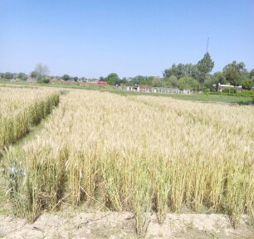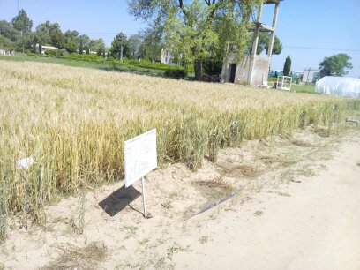
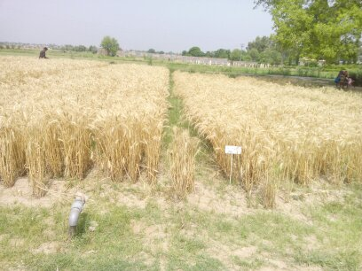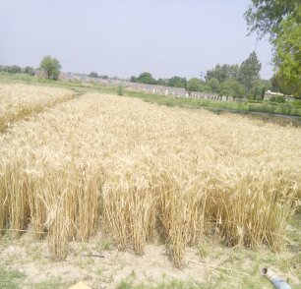
Figure 8: Field experiment for evaluation of DSSAT for wheat (Chakwal-50)
3.3 (a). Crop data:
Crop data for wheat variety Chakwal 50 for DSSAT validation was taken from the experiment conducted in the field (2014-15) as shown in Table 16.

Table 16: Wheat crop data for validation of DSSAT
Parameters | 2014-15
Planting date | 14-Nov-14
Emergence date | 20-Nov-14
Planting depth (cm) | 10
Planting method | Dry seed
Plant population at seeding (plants/m2) | 400
Plant population at emergence (plants/m2) | 200
Row spcing (cm) | 22.5
Anthesis date | 20-Mar-15
Plant height (cm) | 95
Maturity date | 22-Apr-14
Harvesting date | 07-May-15
Yield (kg/ha) | 4100

3.3(b). Initial conditions:
Initial moisture contents were recorded before the sowing of wheat crop from 6 different depths (15, 35, 55, 75, 95, 115 cm). It is important to take this data because with these initial conditions model predict the yield and yield components.
Table 17: Initial moisture contents
Year | Date | Sampling depth (cm) | Moisture contents (cm3/cm3)
2014-15 | 04-11-2014 | 15 | 0.2
2014-15 | 04-11-2014 | 35 | 0.2
2014-15 | 04-11-2014 | 55 | 0.18
2014-15 | 04-11-2014 | 75 | 0.2
2014-15 | 04-11-2014 | 95 | 0.18
2014-15 | 04-11-2014 | 115 | 0.18

For DSSAT validation for wheat we add only one year data set in the model. DSSAT run and gave the satisfactory results (Table 18), which shows our calibration was good. With one year data set it is impossible for the DSSAT to calculate R2 and d-stat factor. But DSSAT calculated RMSE and NRMSE which were in the range.

Table 18: Statistical indices of evaluating the performance of DSSAT model in predicting phenological dates and simulating grain yield for evaluation (validation).
Cropping years | Anthesis (DAP) |  | Physiological Maturity (DAP) |  | Grain yield (kg/ha)
 | Simulated | Measured | Simulated | Measured | Simulated | Measured
2014-15 | 128 | 126 | 161 | 159 | 4295 | 4100
Index
RMSE (day)ª | 2 |  | 2 |  | 195
NRMSE (%)^{b} | 2 |  | 1 |  | 5
ª RMSE | Root mean square error
^{b} NRMSE | Normalized root mean square error
Overall results indicated that the model performance indicators have closer agreement between observed and simulated wheat anthesis day, physiological maturity and grain yield data for the variety chakwal-50.
CONCLUSIONS:
Based on above results, following conclusions were drawn:
- The CERES-Wheat model showed close agreement between observed and simulated wheat parameters (anthesis day, physiological maturity day and grain yield data) with RMSE, NRMSE, d-stat and R² indicators within permissible limits
- The CERES-Wheat model in DSSAT is well calibrated and validated for Chakwal-50 variety
- The CERES-Barley model calibration with two year dataset shows the model is well calibrated for anthesis day, physiological maturity and yield. All the statistical parameters; RMSE, NRMSE, d-stat and R² were in the reasonablerange.

REFERENCES:
ADB, WB and GoP (2010). Pakistan Floods Damage and Need Assessment. Islamabad, Pakistan. Asian Development Bank, World Bank, and Government of Pakistan.
Akmal, M., et al. (2014). Climate Change and Adaptation– Farmers’ Experiences from Rainfed areas of Pakistan. Study conducted by Climate Change Centre, The Agricultural University Peshawar.
Godwin DC, Ritchie JT, Singh U, Hunt L (1989). A user’s guide to CERES-Wheat v2. p. 10.
Government of Punjab (2009b). Pre-Investment study on Chakwal District 2009. Directorate of Industries Government of Punjab, Lahore, Pakistan.
Government of Punjab (2013). Punjab Development Statistics 2013, Bureau of Statistics, Government of Punjab. Lahore.
Hoogenboom, G., Jones, J.W., Wilkens, P.W., Porter, C. H., Batchelor, W. D., Hunt, L. A., Boote, K. J., Singh, U., Uryasev, O., Bowen, W.T., Gijsman, A. J., Du Toit, A., White, J.W. & Tsuji, G.Y. (2004). Decision Support System for Agrotechnology Transfer Version 4.0 (CD-ROM). Honolulu, HI: University of Hawaii.
Hunt LA, Pararajasingham S (1994). Genotype coefficient calculator. In: IBSNAT (International Benchmark Sites Network for Agrotechnology Transfer) (eds.), DSSAT Manual Version 3, vol. 3, pp. 201-223.
Jamieson, P.D., Porter, J.R., Wilson, D.R., 1991. A test of computer simulation model ARC- WHEAT1 on wheat crops grown in New Zealand. Field Crops. Res. 27, 337–350.
Jones, J.W., Hoogenboom, G., Porter, C. H., Boote, K. J., Batchelor, W. D., Hunt, L. A., Wilkens, P.W., Singh, U., Gijsman, A.J. & Ritchie, J. T. (2003). DSSAT cropping system model. European Journal of Agronomy 18, 235–265.
Willmott, C.J., Akleson, G.S., Davis, R.E., Feddema, J.J., Klink, K.M., Legates, D.R., Odonnell, J., Rowe, C.M., 1985. Statistic for the evaluation and comparison of models. J. Geophys. Res. 90, 8995–9005.
Yu, Winston et.al. (2013). The Impacts of Climate Risks on Water and Agriculture. The Indus Basin of Pakistan. World Bank Washington DC.

