

Intensifying common bean cropping within maize based farming systems using ISFM framework

Mid-year progress report,
CIAT, Lilongwe, Malawi

Introduction
Sustainable intensification, which generally aims to produce more without necessarily expanding the size of land, is the core goal of this project. This contribution will employ integrated soil fertility management framework to test and adapt intensification strategies (improved bean and maize varieties using a combination of inorganic and organic fertilizers)) in various socio-ecological conditions in the action villages.

Farmers in the region have been intercropping beans and maize as a major cropping system but yields have been generally low (<0.5 Mg ha⁻¹ for beans and <2 Mg ha⁻¹ for maize against potential yields of 2.5-4 and 6-12 Mg ha⁻¹, respectively. Several improvements have been done in maize and reports show an increasing and stable trends in yields for most improved varieties compared to local ones (Tamene et al. 2015). However, most farmers still use local varieties despite the benefits observed for improved varieties under research. Even those that use improved varieties, yields are stagnating and mostly very low. In this study, one of the widely grown maize variety was selected to test its performance when integrated with beans of different growth habits and varieties. Beans are among some of the crops that are adapted to relatively hilly areas and grow better on less fertile soils. Climbing bean varieties, despite offering 2-3 times higher yield compared to the bush beans, have not been released in Malawi but can be appropriate to support the increasing population against small landholdings thereby necessitating intensification. Beans, especially climbing ones could also yield more biomass to provide supplemental livestock forage and improve soil fertility, promoting biological nitrogen fixation as well as improved human nutrition.
Intensification in terms of input use have generally been promoted for usage of inorganic fertilizers that provide quick returns. However, commercial fertilizers are expensive to the reach of most small scale farmers. As such farmers apply minimal amounts leading to nutrient mining and eventual decline in soil fertility. Locally available organic sources could be affordable but their usage has been quite minimal due to limited promotion and experimentation by farmers. Moreover under the ISFM framework, studies show that combined usage of organic and inorganic fertilizers synergistically improves the agronomic use efficiency of the applied nutrients but also improves the soil health in the long run especially for non-responsive marginal soils. Based on this background, transdisciplinary team led by CIAT Malawi (both Soils and Beans departments) in close collaboration with Bunda college, ICRAF and Michigan State University (MSU) are conducting demonstration trials for three seasons (2013 – 2016), involving climbing and bush beans under different soils fertility management regimes and cropping systems. The main objective of the trials is to enhance the productivity and adoptability of climbing and dwarf beans through introducing improved high yield varieties, management practices and staking options. Specifically the demonstration trials are aimed at:
- Scaling-out number of participating farmers by increasing the number of mother and baby trials;
- Narrowing yield gap of maize-legume farming system by promoting use of best fit ISFM practices;
- Assess the impacts of variety, environment, and management practices on maize-bean productivity;
- Assessing the profitability of different bean/maize growing practices under sole and intercrop systems to demonstrate the effect of different management options (manure and fertilizer use, intercropping, staking options) on climbing and dwarf beans yield in different agro-ecological zones;

The last objective will be handled over longer seasons (2014-2016).

Methodology

Feedback and awareness meetings
The study sites are Linthipe and Kandeu in Dedza and Ntcheu respectively. During the farming recess period (between 23 and 27 October, 2014), a aimed at providing feedback on the trials conducted in the season 2013/2014, provide awareness and plan on continuation of the trails for 2014/2015 . This involved mobilization of the continuing as well as engaging new participants for the 2014/2015 growing season. In each site the first day focused on explaining genetic traits of the promising beans over the ones they already have, and advantages of adopting use of ISFM technologies in bean production (Figure 1). The second day concentrated on identification of mother plot owners and their associated members (Appendix 1 shows the schedule used). Attendance was overwhelming in both sites; Mbidzi and Mkuwazi registered a total of 137 farmers, of which 84.7% were female, Ungwe had 95 farmers (82.0 % female), while Kandeu had 95 farmers of whom 83.3 % were female. In Linthipe, in attendance were thirteen traditional leaders and four extension officers, while in Kandeu, four traditional leaders and four extension officers attended the meeting.

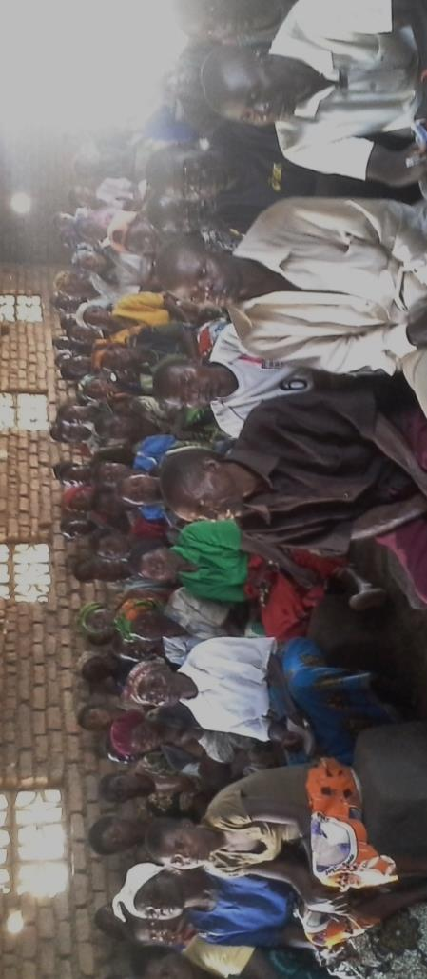
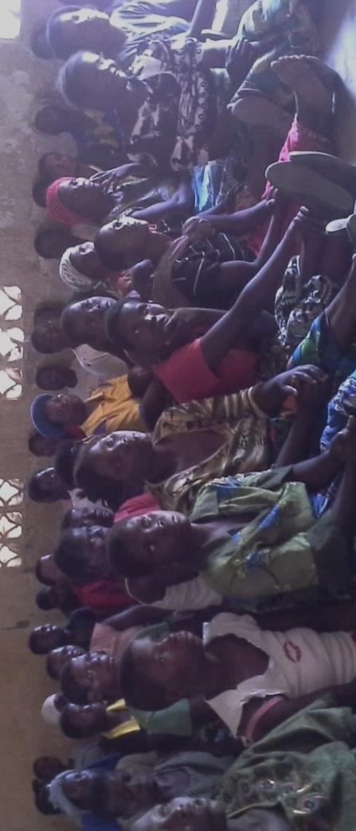
Figure 1: Farmer feedback and mobilization meetings in Linthipe (top) and Kandeu (bottom)

Products of these meetings were twelve famers with mother trials and 197 baby trial plots as indicated in Table 1 in the methods section. Each mother trial formed a club that had a leader and a secretary to document activities and observations on the mother trial.

Increase in number of participating farmers from 2013-2015
During the 2013/14 forty six farmers from three villages participated in the trials. In the current season (2014/15) the trials were scaled out to cover six villages and 209 farmers (Table 1). Participating farmers formed a club and co-managed the trials with technical backstopping by local extension agents and CIAT researchers.

Table 1 Farmers participation between 2013 - 2015
 | Linthipe |  |  |  |  |  | Kandeu |  |  |  | Total
 | Baby |  | Mother |  |  |  | Baby |  | Mother
 | Female | male | Female | male |  |  | Female | male | Female | Male | Female | Male
2014-15 | 89 | 19 | 6 | 0 |  |  | 73 | 16 | 5 | 1 | 173 | 36
2013-14 | 28 | 4 | 3 | 0 |  |  | 7 | 2 | 1 | 1 | 39 | 7
Change (%) | 218 | 375 | 100 |  |  |  | 943 | 700 | 400 | 0

Trial design
The basic design of the trials follows Mother – Baby formulation (Snapp et al., 2002; Badu-Aparaku et al., 2012), with nearby fields as control for placebo. Mother trials were laid out in split-plot design, with two promising each bean variety (bush and climbing) acting as whole plots, while management options were split plots. The promising two climbing bean varieties were MBC 33 and DC86-263, whereas the bush bean seed varieties were SER45 and SER83. Maize seed (DK8033) was used in bean- maize intercrop option. Management options included mono-cropping, intercropping with maize, use of manure, fertilizer, a combination of manure and fertilizer for dwarf and climbing bean fields, as well as different staking options for climbing bean fields. The staking options include stick stakes, and maize. The treatments were randomized in three replicates taking into account farmers existing farming systems but ensuring that ridges were approximately 0.75m and 4m long. Table 2 shows the treatments for the current season (2014/15) and the last season (2013/14).

Table 2: Trial treatments in the 2013/14 and 2014/15 growing seasons
DWARF |  | CLIMBER
2013-14 | 2014-15 | 2013-14 | 2014-15
Bean | Bean | Bean + Stick stakes | Bean + Stick stakes
Bean + Manure | Bean + Manure | Bean + Manure + Stick stakes | Bean + Manure + Stick stakes
Bean + Maize + Fertilizer | Bean + Manure + Fertilizer | Bean + Maize + Fertilizer | Bean + Manure + Fertilizer + Stick stakes
Bean + maize + Manure | Bean + Maize | Bean + maize + Manure | Bean + Maize
Bean + Maize + Manure + Fertilizer | Bean + maize + Manure | Bean + Maize + Manure + Fertilizer | Bean + maize + Manure
Bean + Maize | Maize + Manure + Fertilizer | Bean + Maize | Maize + Manure + Fertilizer
 | Bean + Maize + Manure + Fertilizer | Maize + Sesbania sesban | Bean + Maize + Manure + Fertilizer
 | Bean + Maize + Fertilizer | Bean + Pigeon peas | Bean + Maize + Fertilizer

Each plot had 5 ridges and a dead row left in between the plots to act as path. Fertilizer was applied at the rate of 100 kg ha⁻¹ for basal dressing with 23:21:0 +4 S, and topl dressing with Urea (46% N). Manure was applied before planting at the rate of 17 Mg ha⁻¹ for bush beans and 8.5 Mg ha⁻¹ for climbing. Appendix 2 shows the procedure for manure application. The net plots for the harvesting procedure were defined by the middle three ridges, 2m x 3 middle rows, discarding 1m from each end. In maize-bean intercrop, beans were planted 25 cm apart, one seed per station while in sole crop bush beans and climbing beans were planted 10 cm and 20cm apart, respectively. Maize was planted at 25cm between plants, one seed per station (Appendix 3). In intercrops, the spatial arrangement included planting on the same station with maize, and in between (Appendix 3).
For baby trials a subset of technologies used on the mother trials were selected by farmers and replicated on their plots. Farmers were provided with package of promising bean seed varieties (MBC 33, DC86-263, SER45 and SER83), maize seed (DK8033) and fertilizer equivalent to two plots (both top and basal dressing).

Trainings and plot demonstrations through participatory approaches
To improve the capacity of the personnel and participating farmers, trainings on activities to be done in the trials were conducted. During the delivery of input and materials, extension officers were given documents (See Appendices 2, 3, and 4) to be used in the field and were also briefed and demonstrated upon to ensure accurate implementing.
During fertilizer application, a demonstration aimed at both extension officers and farmers was undertaken on the trial plots. Figure 2 below shows farmers learning how to apply fertilizer in Linthipe. Basal dressing was done a day after emergence, while top dressing followed after three weeks from the planting date. Beans had only 23:21:0 +4S applied. The method of application for sole beans involved making a groove on the shoulders of a ridge (10 cm away from bean plants) where fertilizer was evenly spread at a rate of 30 kg/ha and covered with soil. For maize a hole of about 5 – 7 cm was made between the two planting stations (12.5 cm for each maize plant) and a bottle top full of fertilizer was applied. Top dressing for maize followed the same methodology.

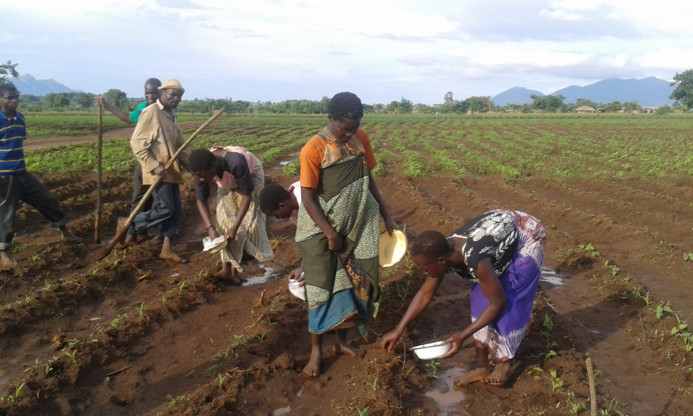
Figure 2: Farmers learning how to apply fertilizer through participation

Four extension workers and twelve lead famers (2 female) were trained in methods of collecting data on germination counts, phenology, labour, and weed rate, while eight extension officers (one female) and 209 famers were trained in harvesting procedures. A protocol guide with data collection sheets was given to extension officers to aid in data collection.

Field day and participatory technology selection
Field day was conducted on 14/03/15 in Linthipe. Participants included the DADO for Dedza district, eight extension officers for the Extension Planning Area (EPA), traditional leaders from the surrounding areas, participating and non-participating farmers. Patronage was dominated by feminine gender. Participants were exposed to the various trials to evaluate the performances of the different technologies. During the visit participants expressed sentiments of admiration of the beans, especially the bush ones, which produced relatively more pods (over 100 pods per plant), as opposed to the existing varieties (about 30 pods per plant). This observation against the prolonged drought showed evidence for the varieties resilience to drought. Famers also learnt the effects of ISFM technologies on reducing signs of water stress, as crops in plots with manure showed little signs of water stress despite the drought. The demonstrated technologies showed evidences of being climate smart to the farmers. Based on the observed performances of the varieties under the existing challenging condition, some clients asked for the varieties. However, it was disclosed that the varieties need to be released by DRAS first before distributing to end users.
To increase awareness of the activities in the trial sites, the field day was covered by Zodiak radio station. The radio interviewed project members to explain about the treatments, management practices and performances of the different varieties.
To evaluate the treatments, a participatory technology selection was conducted where participating and non-participating farmers (117 women and 42 men) visited the trials and ranked for the best three technologies. One of the key observations the farmers made was the possibility of intercropping at the same planting station with maize and between the two beans (Appendix 4).

Workshop presentations (see attachments)
Outputs of some of the work done were presented at two international conferences. These are:

- Chataika B., Ndengu G., Mponela P., Magreta R., Tamene L., Chirwa R., and Chikowo R. (2015). “Participatory yield assessment of climbing and bush beans under different management options in Malawi” presented at the International Conference on Integrated Systems, Abuja, Nigeria.
- Chataika B., Mponela P., Ndengu G., Tamene L., Chirwa R. (2015). “Drought tolerant bean varieties offer hope to smallholder farmers in Malawi” presented at the International Conference on “Beating Famine – Southern Africa”, Lilongwe, Malawi.
The second presentation which showcased the potential answer of using suitable technologies to tackle the impact of climate change attracted a great deal of interest from workshop participants as a result of which exclusive field visit was requested by a Journalist from Zambia and the other from East Africa (Clifford Gikunda (Contacts: cngikunda@gmail.com). A field visit was organized to see the performances of bush bean varieties under the very serious drought stressed conditions in the region and talk to local farmers. The clips will be shared with Anna Phiri from Zambia, Grassroots Trust, (Contacts: Anna Phiri; annaphiri@gmail.com; +260967781898) and Daisy Ouya, Communications Specialist for World Agroforestry Centre- Nairobi (d.ouya@cgiar.org) who were also interested in bean story.

Appendix 1: PREPARATION FOR 2014/15 SEASON

No | ACTIVITY | TIME FRAME | TARGET
1 | Research Feed Back Sessions:  - Overview of 2013/14 Participatory Research activities  - Results of the 2013/14 research activities  - Baseline survey results  - Baby trials and control plots  - Mother trials  - Participatory technology evaluation  - Lessons learnt from 2013/14 trials  - Strategies for overcoming the shortfalls  (Included discussion on factors influencing bean+maize production) | 09:00 -09:30 AM  09:30 – 12:00  13:30 – 14:30  14:30 – 15:30 | Three Groups at Linthipe  One group at Kandeu  Village leaders from the study areas  AEDOs from project sections (and potential new section??)  AEDIC from each EPA  DADOs (optional)
2 | Sensitization and Mobilization of Farmers for 2014/15 Participatory Research:  - Sensitization meeting:  - Farmer and field Identification:  - Farmer participation criteria  - Roles of CIAT/AR  - Roles of Extension officers  - Roles of participating farmers  - Assigning plots to research: what should be considered?  - Group dynamics (working in groups)  - Overcoming the obstacles to participatory research: experienced from 2013/14 season. | New farmers: 1 full day  Continuing farmers:  Half Day per site | 100 farmers (10 groups) per District broken down as follows:  Linthipe:  5 Mothers (Climbing bean)  5 Mothers (Bush bean)  100 + Babies  Kandeu:  5 Mothers (Climbing bean)  5 Mothers (Bush bean)  100 + Babies
3 | Mother trials Identification and Mapping: | One day per district

APPENDIX 2: PROCEDURE FOR APPLYINGPOULTLY MANURE

We have ten 50Kg bags per mother. The mode of application shall be as follows:

- Make a basin of about 15cm deep on the ridge on a planting station, using the given spacing (you could split the ridge should need arise);
- Apply one handful (0.5 kg) of manure per planting station;
- Mix the soil thoroughly with soils;

Note: there should be some homogeneity between soils and manure in the planting station to avoid overproviding our plants with nutrient which may eventually burn our crop.

APPENDIX 3: PLANTING PROCEDURES

2014-2015 Season

This document is supposed to be used in conjunction with the plot trial layout given.

- CLIMBING BEANS
In this trial, climbing beans will be intercropped with maize and pigeon peas, the following procedures need to be followed when planting.
- Maize will be planted 25cm apart, one seed per planting station.
- Climbing beans intercropped with maize will be planted at a spacing of 25cm (i.e. same spacing as maize, and the maize plant will act as the live stake).
- Sole climbing beans will be planted 20cm apart, stick stakes will used for each bean plant (2m high, stakes to be sourced before beans are planted).
Note: On the first day of planting, only maize will be planted. Climbing beans will follow two weeks after.

- DWARF BEANS
Dwarfs will be intercropped with maize, and the following have to be done during planting:
- Maize will be planted 25cm apart, one seed per planting station.
- When intercropped with maize, bean seeds planted 12.5 cm apart (that is one will be planted on the same station as that of maize, while other one will be between the two maize planting stations).
- Sole dwarf beans will be planted 10cm apart.

Note: In the dwarf trial both beans and maize can be planted at the same time.

APPENDIX 4: SPATIAL ARRANGEMENT OF DWARF BEANS IN MIXED/INTERCROP (KADZALIDWE KA NYEMBA ZATHU): A PICTORIAL PRESENTATION

- Dwarfs will be planted as shown in the Figure below (Nyemba zosayanga tidzale chonchi)

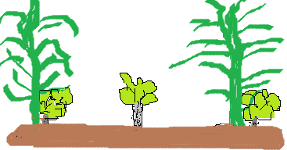
12.5 cm 12.5 cm

b. Climbing bean must be planted as below (Nyemba zoyanga tidzale chonchi)

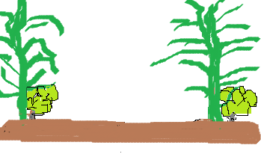
25cm

