Technical Report PK-CRP DS/SSRI-08/2015

AN ASSESMENT OF FARMER FIELD DAY ON CACTUS PROMOTION AT CHAKWAL SITE OF CRP-DS IN PAKISTAN

(Organized by Rangeland Research Institute (NARC) under CRP-DS in collaboration with ICARDA, Pakistan on May 29, 2015)

By

Hassnain Shah and Waqas Farooq

Social Sciences Research Institute - National Agricultural Research Centre

Islamabad

&

Boubaker Dhehibi
Social, Economic and Policy Research Program (SEPRP)
International Center for Agricultural Research in the Dry Areas (ICARDA)
Amman - Jordan

Draft report

June 2015
Contents

Introduction 3
Objective of the study 4
Methodology 4
Results and discussions 4
Project visibility 4
Program and activities of field day 5
Introduction of Experts 5
Recording Feedback and Assessment 6
Developing Ownership 6
Awareness and views of farmers about cactus 7
Response of Feeding Demo for Goats 9
Conclusion and Recommendations 10
References 11

Introduction
Rangelands ecosystems of Pakistan are diverse and provide various direct and indirect services. Pakistan has an area of 87.98 million hectare (mha), out of which 45.2 million ha, which is about 51.4 percent of the land surface of the country, consists of rangelands (FAO, 2013). In arid and semi-arid areas rangelands are the major free grazing areas for livestock round the year (Ahmad and Islam, 2011; Mirza et al., 2006). However, doubling every 5 decades, population of grazing and browsing animals is expanding in similar ratio as human population (Mohammad, 1989). Therefore, grazing lands are degraded at the rates that are at least proportional to the difference between carrying capacity and grazing/browsing animal population. Moreover, drought also occurs in Pothwar, especially in the rangelands of district Chakwal and worsens the overgrazing effects. It results in permanent and complete loss of some species of vegetation. The situation is further aggravated during the dry period, combined with drought years, causes heavy losses of livestock each year (Grainger, 1990; PARC, 1998). At present, productivity of Pakistan rangelands is about 10 to 50% of their potential (Quraishi et al., 1993).

Keeping in view this situation, rangeland rehabilitation activities were included at this site under CRP DS. Among these activities, introduction and promotion of cactus through validation trials followed by dissemination activities that include farmers’ field days were also incorporated in the work plan. To further help and facilitate this process by incorporating the community concerns and end user feedback into the technical activities, social sciences role was incorporated. The current report is prepared with this background by the Social Sciences Component of the project to help the technical partners to move further along the adoption and impact pathway. In a follow up of the Farmer’s field day (FFD) organized by Rangeland Research Institute (RRI) of National Agricultural Research Center (NARC) under “CRP Dry land System” on 29th May, 2015 at Latifal activity cluster in the Chakwal site for promotion of cactus the current report is prepared by the the Social Sciences Research Institute (SSRI). SSRI, NARC is also an implementing partner of the project which is supposed to facilitate the project technical partners and by providing feedback on issues and concerns of target communities in relation to social acceptability, economic viability and compatibility of the intervention and activities with target communities/farmers resources and farming system. The socioeconomic feedback and observations on the technology dissemination process and its impact on farmer society, recommendation based on famers’ feedback would help in out scaling project interventions. The suggested recommendations would help the implementing partners to successfully conduct their activities and in this regard, current study was done by team of SSRI to provide feedback with following objectives:

Objective of the study
- To assess and evaluate effectiveness of farmers’ field day on Cactus.
- Document perception of farming community regarding technologies introduced in the area through CRP project.
- Suggestion for further improvement in dissemination process of the project

Methodology
To provide feedback on FFD a short questionnaire was developed and interviews were conducted from the participants to acquire the information on a) pre and post field day knowledge of participants about technology, b) their perception about the cactus and adoption intension c) usage of cactus intervention and impact they perceive. Some questions on basic information about the participants like age, gender, farming experience, and education etc., were also included to assess the selection of the participants with respect to the objective of field day. Due to scarcity of time only 15 participants were randomly interviewed after the field day for getting feedback on field day. In addition to that, SSRI team had a group discussion with famers of the area to explore other aspects of the technology, discussion was carried with the group of farmers about the scope and adoption potential. Observation method was also used through participation of social sciences team in the whole process of field day. Descriptive analysis was performed on gathered data.

Results and discussions
The targeted area falls in high rainfall zone of Chakwal receiving 600 mm annual rainfall. Majority of the farmers of the area have uncultivated waste land. There is huge potential for cactus and other rangeland intervention at site.

Project visibility
Proper introduction of the project and the collaborating partners was highlighted by the implementing partner in charge at the start of the formal discussion of the FFD. Beside it proper display of banner was also done. The scope of work and objective of the project were also shared with the participants.
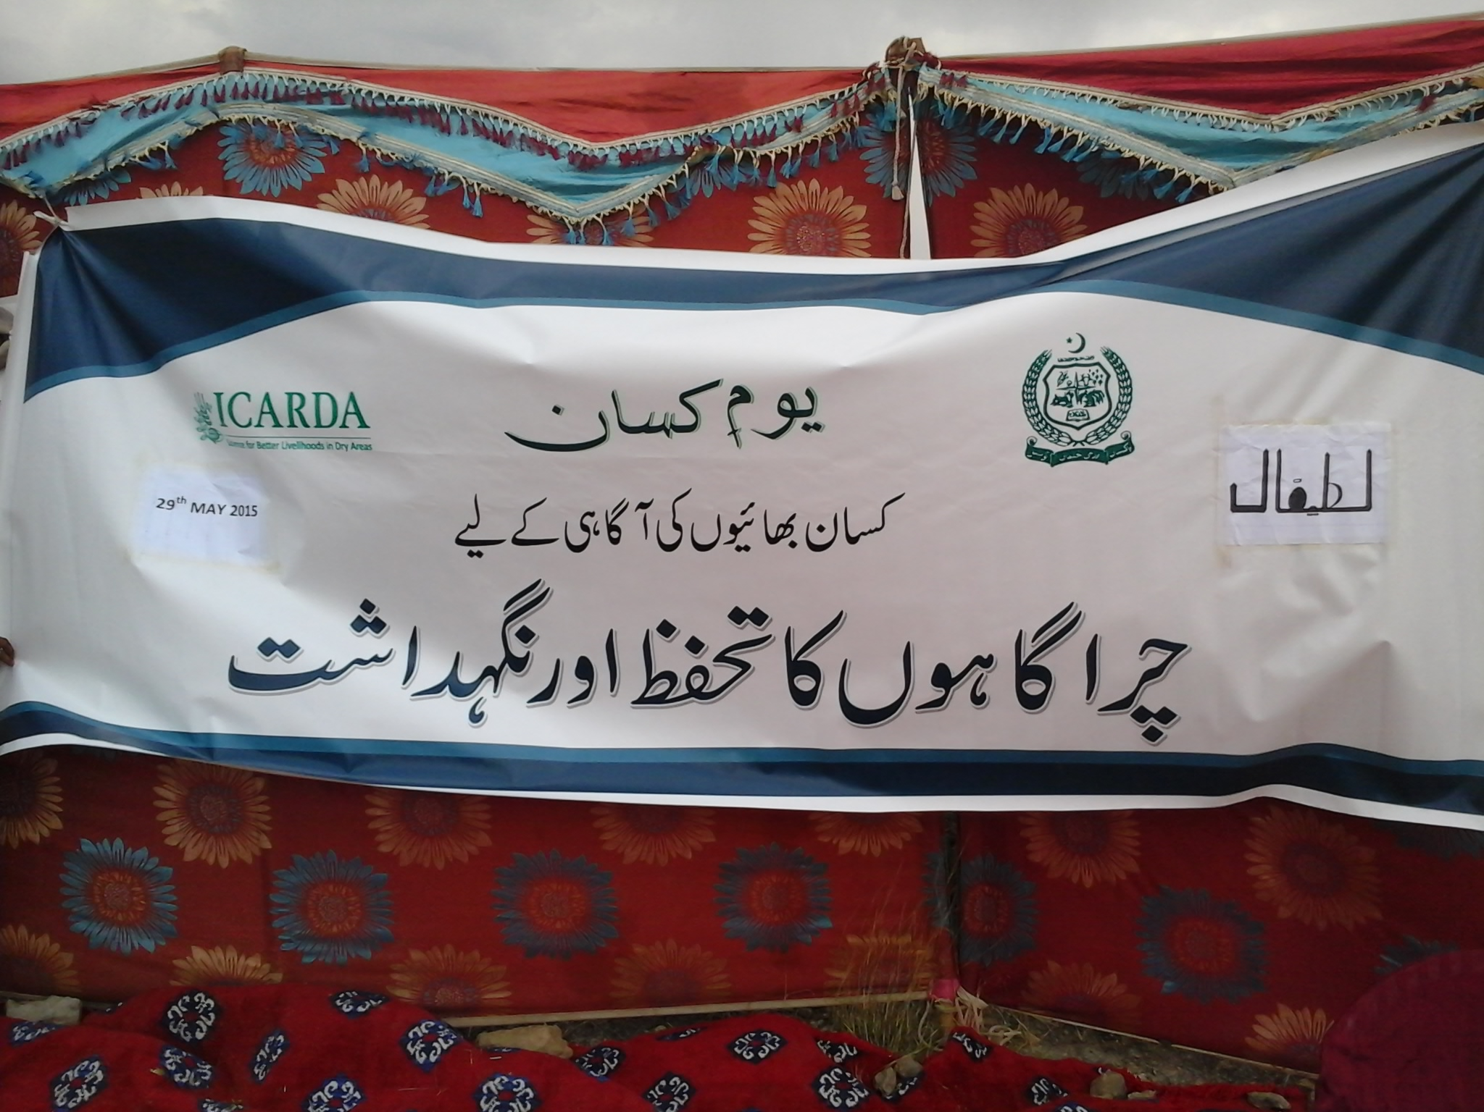

Program and activities of field day
The program was organized in systematic way. Program was formally started with the recitation of Holy Quran, followed by a brief introduction of the project, its concept, practical implication, specific objective of the field day, and an overview of the rangeland technologies introduced in the area that can increase the carrying capacity of rangeland. Importance of cooperation of the community was also highlighted to foster the adoption of cactus at their own farm. Information was extended on overall situation of the rangelands in the country and that area, over time decrease in the rangelands and how to cope up with such scarcity. Function was well organized in term of number of participants, there were mixture of small, medium, large and tenants as well. Diverse participation was observed in FFD in term of no, farm size and village. Participating farmers were from the Latifal, Mangwal, Karahi , sakriala villages. Some of farmers were new visited, first time to the demonstration trial. Proper sitting arrangements were made

Introduction of Experts
Session stared with in by various briefing by different resource persons. These briefings were nicely arranged and presented keeping in view the diversity of participants. Imtiaz Director RRI, explained about the importance of rangeland and their role in livestock management and livelihood. Dr Sarfraz Ahmed Project Director (RADP) also highlighted the importance of rangelands and overtime change in the rangeland especially its degrading aspect. He also explained about the cactus and its usefulness keeping in view the cyclical feed availability in the area. Later on Mr. Hassnain Shah from SSRI explained about the significance of demonstration site and the benefits through dissemination and adoption of technology, he also highlighted the importance of technical partner working with community.
After the formal technical discussion by the experts from NARC, farmers also acknowledged the efforts of technical partner and thanked them. Farmer were of the view that after the initiation of CRP1.1, they were provided opportunity to interact with experts from agriculture related institutes and that helped to improve their awareness about the new varieties, new technologies and new commodities like cactus.

Recording Feedback and Assessment
Demonstration of different technologies/innovations through farmers field days have gained popularity and are being organized in many developing countries. The farmers’ field days try to raise awareness of farmers about non-traditional technological options on the one hand and provide feedback on farmers, interests, choices and issues on the other hand.
The objective of this exercise was to document some of the observations on different aspects of the field days, to provide some feedback and to suggest some improvements the field day activity is discussed within the context of technology transfer and project orientation. For this purpose discussion of SSRI team was done in group before start of the activities, reached well in time, had enough time to interact with participants arrived and coming. After completion of the activity formal questionnaire was used and some important findings are given as under. Focus of the field day was on cactus intervention with objective to demonstrate cactus to the community and give them awareness about the cactus as fodder. A diversified group of the farmers were invited in terms of farming practices, age of the farmers, education level etc. Number of the participant was reasonably good.
Figure No: 1 Figure No: 2
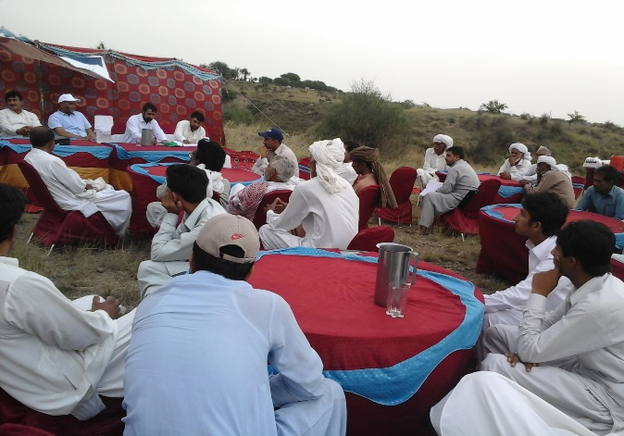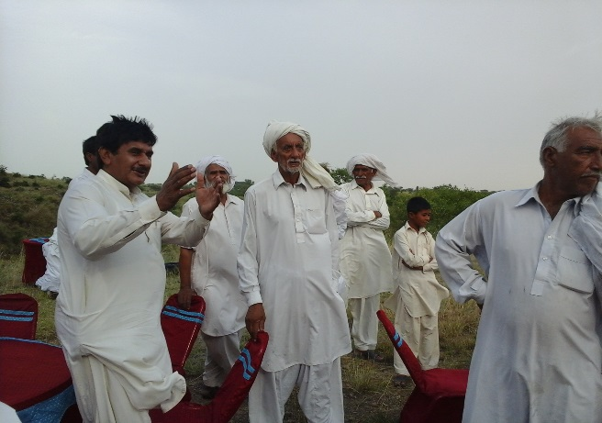

Developing Ownership
To develop more ownership of the message and to motivate farmers towards adoption of the target intervention, it is suggested to increase involvement of the participants in discussion. During the FFD, sharing experiences by the host farmer may further help to increase ownership and interest of the farmers. Speaking in same language by the host farmer may help to convey the message more clearly and also technical experts can evaluate how their message has been delivered and taken up by the participating host farmer.

Awareness and views of farmers about cactus
Farmers even were not well aware about different technologies and new practices being adopted by fellow farmers in the same community. Therefore, such field days help to improve knowledge both from farmer to farmer and farmer to researcher and vice versa. Furthermore the discussion on practices and problems of the farming community provide an opportunity to make an entry point for new innovations. It justifies that why, what and how farmer should move further for better farm income and livelihood.
Level of awareness about the cactus, its usage and importance was very low Majority of farmers (80 percent) were unaware about the cactus before coming to the FFD and demonstration. They were considering it useless. The local specie of cactus having needles are only used for the boundaries and there is no productive use of it. Farmers reported that they have not seen such type of cactus before participating this FFD. They supported that that it is a useful intervention as this cactus specie can be used as fodder for the livestock. Participants were also of the view that if it remains green and juicy around the year it would be very good intervention. This can be helpful especially during fodder deficient month’s e.g May- June and in winter also.
Figure No -3 Figure No -4
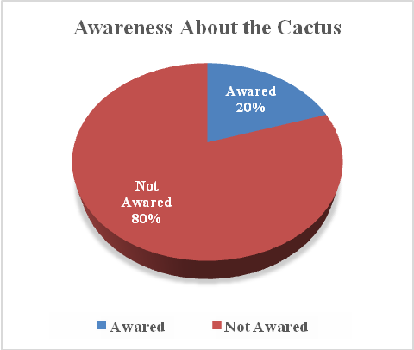
Above mentioned graph 3 shows the awareness level about the cactus and figure 4 explains the views and perception of farmers about the cactus before participating in this FFD. Result showed that only 20 percent of the participants were aware about the cactus intervention. These were mainly neighboring farmers who visit and saw the cactus. Although they were aware about the cactus but objective of cactus demonstration trial were not clear to them. FFD provide an excellent opportunity for farmer and research to come together and share experiences and objective of demonstration site. SSRI team held a discussion to get insight farmer report that although we saw cactus plantation here from last year and consulted with the host farmer about the cactus but we were quite confused and mixed minded that how it can be used for fodder . It was further reported by few farmers that we try to keep away our animal from this plantation that it might cause some damage to animal. In this field day we get confidence after hearing the expert’s views. This FFD had helped to change the mind set as presented in Figure 4 where most of the farmer were only aware of cactus with spines and consider this a useless and harmful specie.
Due to little awareness and experience about the spineless cactus the adoption intension was quite low. However, the farmer who have shown intention to adopt were those who have already participated in the FFD about Cactus held at NARC Islamabad. The new farmers earlier perceived that cactus was useless and harmful thing. Therefore, they initially will go for evaluation and will decide their mind set after observation the results of this trail. FFD changed their thinking and perception about the cactus. Now they consider it potential fodder and rangeland intervention in that area. Overall the program was well organized and team deserves the appreciation.
Figure No-5

Response of Feeding Demo for Goats
At the end of the FFD a feeding demonstration was arranged. The mature cactus pads from NARC were cut and taken to do a feeding demo in the FFD. The goats selected for this feeding and palatability tes were well fed and were not hungry at all as were coming back after grazing in the evening. However, all the three Goats ate at the cactus. The mix feed was prepared using some concentrate. However, to check the possibility of direct feeding, only cactus was offered first. Unexpectedly all the goats ate the cactus pads very eagerly. It was concluded by the farmers that there was no issue of un-palatability. It was also reported by farmers that both small and large ruminants like cactus equally as it was difficult to protect the trail from grazing animals.
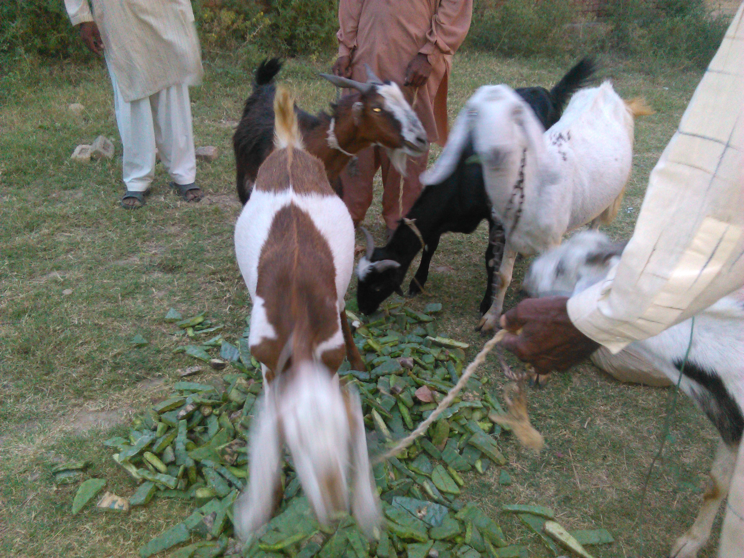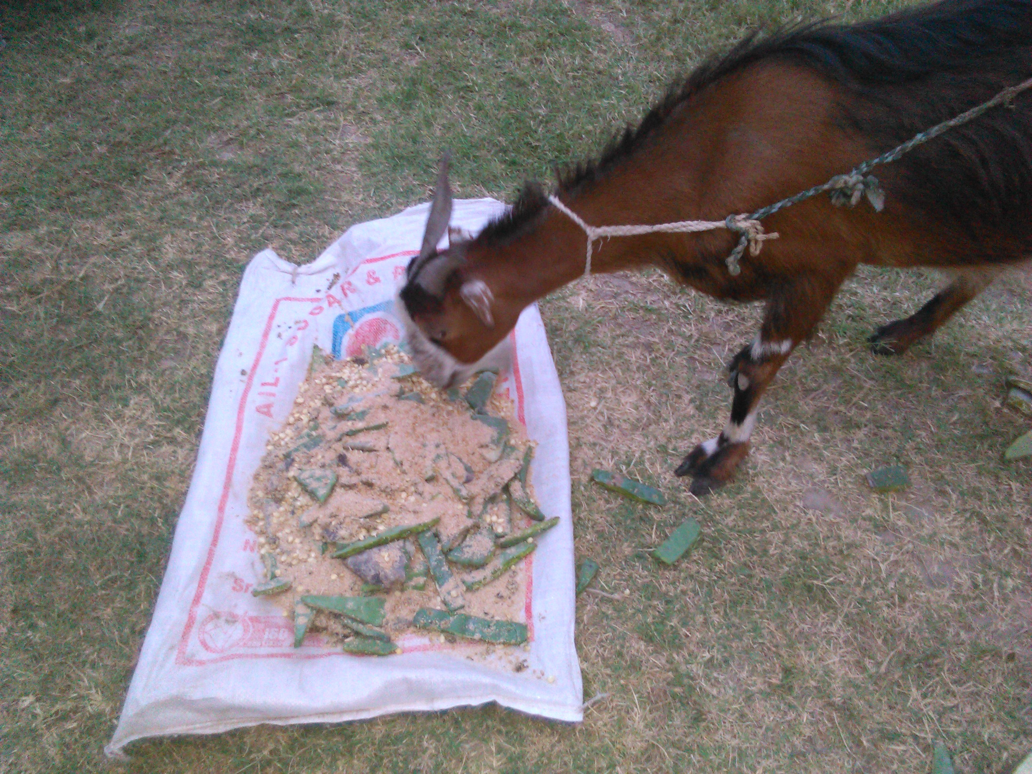

Conclusion and Recommendations
Overall activity was well organized. Farmers considered all the activities very useful. The trees and shrubs were considered as long term investment due to long gestation period. However cactus was found very promising as it was highly palatable. However, farmers were mainly looking at the activity and were found in the mode of evaluation as very few reported to adopt at this stage. Some gaps were observed that if addressed may improve the effectiveness of such FFDs. Visit to demonstration site was made individually by farmers. If it could be done as a group along with experts to brief about the activity and production packages may help to disseminate knowledge of the production package. The host farmer could not participate due to some personal engagements. His presence and briefing may be helpful to convey the message. The practical for feeding the cactus to animals was arranged separately and most of farmers went away. That need to be arranged at spot:
- Targeted awareness specially for farmer having excessive non cultivated land
- Participation of early adopters if ant in FFD
- Timing of FFD should be conveyed a week before FFD to increase participation
- Host farmer should be invited to share his experience with farmer

References
Ahmad, S. And M. Islam. 2011. Rangeland productivity and improvement potential in highlands of Balochistan, Pakistan. Biomass - Detection, Production and Usage, Darko Matovic (Ed.), ISBN: 978-953-307-492-4, In Tech, pp. 289-304
Grainger, A. 1990. The Threatening Desert. Earthscan Publication Ltd. London. pp. 121- 143.
FAO, 2013. http://fao.org.pk/Projects/TCP/PAK/3402/TCP-PAK-3402.pdf
Mirza, S.N., S. Ahmad and M. Islam. 2006. The vagaries of drought in Balochistan and strategies to reduce economic losses. Bal. J. Agri. Res., 3(1): 39-42
Mohammad, N. 1989. Rangeland Management in Pakistan. International Centre for Integrated Mountain Development, Kathmandu, Nepal. pp. 32-46.
PARC, 1998. National Forage and Fodder Research Programme. Natural Resources Division, Pakistan Agricultural Research Council, Islamabad. pp.12-24.
Quraishi, M. A. A., S. K. Ghulam and S. M. Mian. 1993. Range Management in Pakistan. Department of Forestry, University of Agriculture, Faisalabad. 229 p

