Implementation report on

“Climate variability risk analysis, WUE and NUE for cropping systems based on historical as well as future climate change scenarios”

Anthony M. Whitbread and V. Nageswara Rao

June 2015
Introduction
Water is the most crucial input for agricultural production. Globally, agriculture accounts for more than 80% of all freshwater used by humans, most of that is for crop production. Currently most of the water used to grow crops is derived from rainfed soil moisture, with non-irrigated agriculture accounting for about 60% of production in developing countries. Monsoon rainfall variability and declining water table due to over exploitation resulted in shortage of fresh water supplies for agricultural use in India, which calls for an efficient use of this resource. Water-use efficiency (WUE) and nitrogen-use efficiency (NUE) are important measures that can affect the productivity of cropping systems in different Agroeco-systems. Strategies for efficient management of water and nitrogen for agricultural use involves conservation and judicious use of water; optimal application to enhance of nitrogen use efficiency for crop productivity is of paramount importance especially in rainfed systems.
This activity has been pursued with an objective of identify suitable dryland cropping systems for efficient use of water and nutrients under climate variability and change situations in future in the state Rajasthan, India. The study area encompasses action sites of CRP1.1: Dryland Systems in the state, which are listed as follows:
Eight villages: 1. Govindapur, 2. Mansagar villages in Osiean mandal, Jodhpur district; 3.Dedha, 4. Damodhara villages in Jaisalmer mandal, 5. Sankaria, 6. Didhu villages in Nachana mandal, Jaisalmer district; 7. Dhok and 8. Dhirasar villages in Chohtan mandal of Barmer district in the state of Rajasthan, India.
Table 1. Daily Weather data sets collected for Jodhpur, Jaisalmer and Barmer districts of Rajasthan, Source: Various governmental sources, Rajasthan
District/state | Stations/Data source | Variables collected | Time series (period)
Jodhpur/ Rajasthan | Central Arid Zone Research Institute (CAZRI), Jodhpur | Rainfall, min. &max. temperatures, Sunshine hours | 1969-2013
Jaisalmer/ Rajasthan | Directorate of Economics and Statistics, Rajasthan | Daily rainfall | 1957-2012
Barmer/ Rajasthan | Directorate of Economics and Statistics, Rajasthan | Daily rainfall | 1957-2012

Data collection
Weather data collection
Weather data collected from three districts of Rajasthan
Historical weather datasets consisting of daily rainfall, minimum and maximum temperature and solar radiation are collected for crop modelling, and daily rainfall from individual mandals is collected for rainfall analysis from meteorological observatories for several locations in each of the three districts in Rajasthan where action sites of CRP1.1: Dryland Systems are located in India, and the details of weather data sets collected are given in table 1.
Soils in selected districts
The districts of Jaisalmer, Barmer and Jodhpur are in the western part of Rajasthan encompassing the plains characterised by strong south westerly winds during summer, which causes frequent sandstorm and sand movements.
The sandy arid plains (Marusthali) are mainly derived from the aeolian sands. These soils are medium to fine textured soils (60% of area) either associated with dunes or interdunal plains are deep, excessively drained, calcareous or non-calcareous and sandy in nature.
Semi-arid transitional plains area extended from the northern foothills of the Aravallis to the sandy arid plains in the west. The soils are medium to heavy textured soils (28% of the area) mainly derived through the alluvium brought down by Ghaggar River from the Shivalik hills and Luni River from the Aravalli hills. The dominant soils are deep to very deep, calcareous or non-calcareous, sandy in nature occupying gently sloping plains.
Representative soil profiles textural characters, profile depths, layer-wise hydrological parameters including plant available water holding capacity, infiltration and drainage, physico-chemical properties are gathered from various research organizations/review of literature. The profile characteristics of some typical soils in the district are arranged as soil templates for use in APSIM model soil databases for the district. We are making efforts to collect the soil profile characteristics from selected districts of Rajasthan.
Major Cropping systems in study districts
To sustain the system resilience, efficient use of water and nitrogen, a suitable shorter duration drought tolerant crops need to be introduced to intensify the cropping systems and asses the system efficiency in terms of Water and Nitrogen use needs assessment.
In Barmer, Jodhpur and Jaisalmer districts of Rajasthan, the major traditional cropping systems are Bajra and cluster bean systems. In these areas, short season cereals (pearl millet, wheat and barley), legumes (cluster bean, green gram, cowpea, chickpea and moth bean) are preferred cropping options, those would be explored using APSIM, a cropping systems model and expert opinions for resource use efficiency, risk assessment against traditional cropping systems. New crop cultivars phenology and growth (ex.HHB-67 of pearl millet and RGC-1017 of cluster bean) is to be fetched from national partner from their field experimentation data.
Table 2. Major traditional and improved cropping systems planned to assess resource use efficiency and productivity in Barmer,Jodhpur and Jaisalmer, Rajasthan
District | Major traditional cropping systems | Major Improved cropping systems | Soil type
Jodhapur, Jaisalmer, Balmer | Sole pearl millet | Cowpea / pearl millet,  Moth bean/pearl millet intercrops | medium to fine textured sandy soils
Jodhapur, Jaisalmer, Balmer | Sole cluster bean | Intercropping of cluster bean (or) mung bean/ SD pigeonpea | medium to fine textured sandy soils
Jodhapur, Jaisalmer, Balmer | Sole cowpea, mung bean, moth bean | Pearl millet/short duration pigeonpea intercropping | medium to heavy textured soils
During recent years in Rajasthan, sole pigeonpea has gained popularity and acceptance of farmers in the region with efforts of ICRISAT to popularize drought tolerant pigeonpea. Since pigeonpea is initially slow growing crop, potential intensification options like inclusion of popular short season crops in the region like pearl millet, cluster bean, mung bean and moth bean as intercrops needs to be explored within pigeonpea system for resource use efficiency (WUE, NUE) to sustain the enhanced productivity with crop intensification.
Results
- Based on our preliminary analysis of seasonal rainfall in Barmar and chohtan mandals of Barmer district in Rajasthan, it is observed that there is a significant variability in inter-annual rainfall, which occurs mainly during SW monsoon (Figure 1) effected by ENSO phase (Figure 2) as seen from Chohtan rainfall. Understanding of these patterns of rainfall in response to ENSO phase and other ocean and atmospheric interactions provides an opportunity to make appropriate choice of better crop management decisions to improved productivity by considering the seasonal rainfall variability in response ENSO phase.
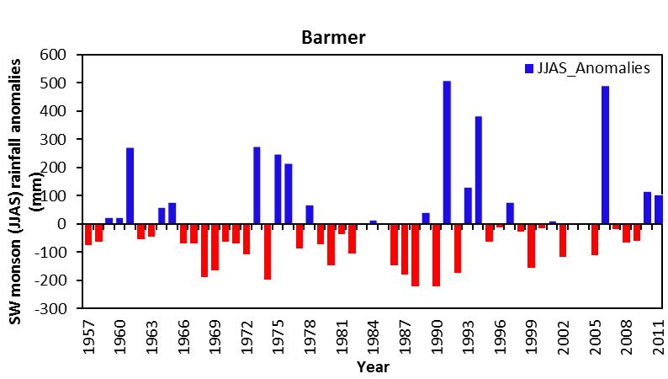
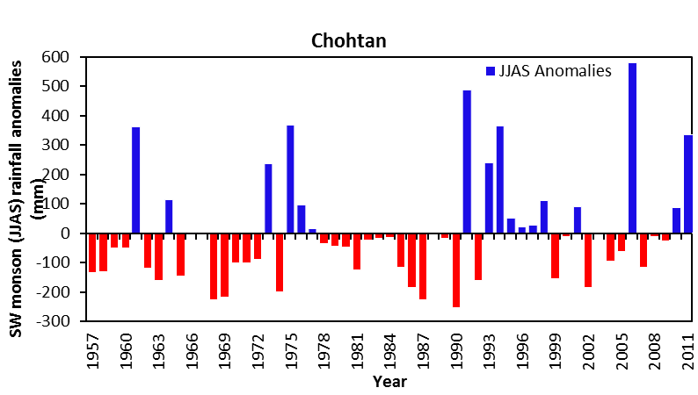
Figure 1. Inter-annual variability of (SW monsoon) rainfall in Barmer and Chohtan mandals of Barmer district in western Rajasthan during 1957 to 2011.

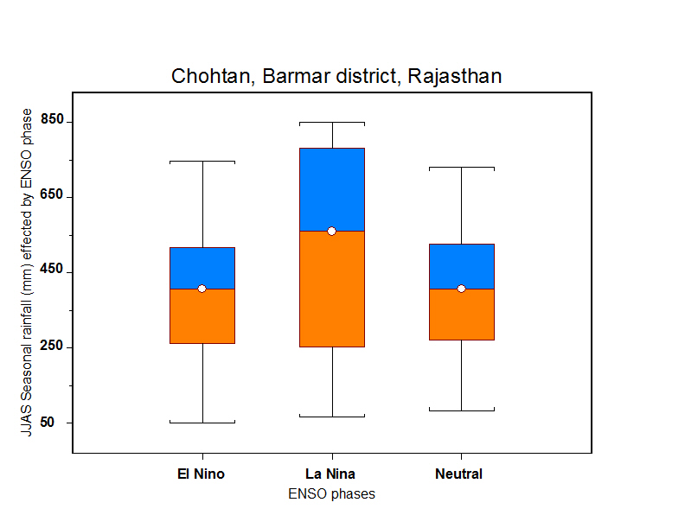
Figure 2. Effect of ENSO phase on South West monsoon seasonal rainfall (JJAS months) in Chohtan mandal, Barmar district, Rajasthan during 1961-2011.

