Integrated Pest management in food legumes in rotation with cereals in a crop system. West Asia and North Africa. CRP-DS IPM NAWA. Case Meknes - Sais

December 2015

Integrated Pest management in food legumes in rotation with cereals in a crop system. West Asia and North Africa. CRP-DS IPM NAWA. Case Meknes - Sais
Responsible: Hamal Abdelhamid
Introduction
Integrated pest management of insects, diseases, viruses and weeds affecting food legumes in rotation with cereals was studied in two rural districts of Meknes site (Sais) during the 2014-2015 cropping season. The objective of the on-farm action research was to promote the adoption of integrated pest management (IPM) of key biotic constraints for cereal and food legumes and human capacity building.
Methodology
The research was done at rural areas in two platforms of the rural commune of Ain Jemaa and Sidi Slimane. Two varieties of wheat (Arrihane and Amal) were sown (200 kg / ha) on 20 and 23 November 2014 in one hectare of land. Two hundred kg of DAP (18-46) was applied at sowing with asymmetrical harrow. At tillering stage of wheat, 34 kg of nitrogen as ammonium nitrate was applied. Wheat plots were treated with Cossack herbicide at a dose of 0.8 l per ha in 200 liters of water. At heading stage, fungicide as Ogam (Epoxiconazole 12.5%+ Krysoxime-methyl 12.5% ) was applied to control Septoria leaf blotch and brown rust of wheat. For food legume technology, large seed faba bean variety De Fez and small seeded faba bean variety Alfia- 5 were planted each in 0.5ha of land. Gallant super herbicide (Haloxyfop-R Methyl Ester= a.i. 108g/L) at the rate of 0.5 l / ha was applied at two leaf stages of the two legume crops. Weeding practices were: one hoeing, two hoeing with a herbicide applications and un-weeded control. Annual precipitation was more than 457 mm during the cropping season. Control of broomrape in the food legumes plots was done by applying 167 ml /ha of glyphosate at mid flowering stages in 200 liters of water.
Results and discussion
The results showed that maximum grain yield was obtained by adopting two hoeing combined with herbicide applications at 4 two leaf stages of legume crops in the Ain Jemaa for large and small seeded faba bean varieties as compared with one hoeing and the check (Fig.1). At Sidi Slimane, similar result was observed where two hoeing and herbicide application has increased seed yield (Fig. 2)

Figure 1. Effects of weed control practices on large and small seeded faba bean varieties in Ain Jemaa Site

Figure 2. Effects of weed control practices on large and small seeded faba bean varieties in Sidi Slimane Site

In the management of wheat diseases, this impact of amelioration of grain yield due to package technologies adopted by the project CRP IPM to the farmers in both of the site. The respect of intervention of agricultural activities (control weeds, fertilizer, control of disease, insect etc...), in order to place all in the same package to increase and stabilized grain yield of farmers (Table 2).

Figure 3. Effects of IPM on yield of bread wheat, Ain Jemma site

Figure 4. Effects of IPM on yield of bread wheat, Sidi Slimane site
The gain of grain yield of bread wheat at Ain Jemaa was 3 t/ha for Amal, and 2.4t/ha for Arrihane (Fig. 3). At Sidi Slimane, the grain yield gain was 3.5 t/ha for Amal and 3.2 t/ha for Arrihane (Fig. 4). For this site the impact of new technologies take the results of increasing yield for two consecutive seasons resulting four fold of yield increased. The number of farmers and technologies implemented in 2014 and 15 cropping season as presented in Table 1.
Table 1: Summary of IPM platform activities in 2013/14 and 2014/15 cropping season.
Activities | IPM Platform
Activities | Ain Jemaa |  | Sidi Slimane Moule El Kifane
Activities | 2014 | 2015 | 2014 | 2015
Number of farmers who used the technology package | 2 | 15 | 2 | 10
Area covered by tested technologies (ha) | 4 | 20 | 2 | 12
Number of farmers trained | 35 | 25 | 30 | 20
Communications Missions and FM Radio Medina Meknès | 2 |  | 3
Missions Televised | 2 |  | 1

Back up research
1. Test of efficacy of herbicides to control weeds in food legumes applied post-emergence
This experiment was conducted in the domain of experimental at Douyet with the obectives to identfiy new herbicide to control weeds in food legumes (Faba bean, chickpea, lentil and field pea).
Results
The post-emergence herbicide Bentazone (480 g a.i./l) controlled weeds with an efficiency of 95% on chickpea, 80% on small grain (Fevrole); 90% on early pea and 70% on lentil with 30%. The herbicide showed phytotoxicity only on lentil (Table 2). The herbicide glyphosate ( 0.5 L pc/ha) showed efficacy of 80% con controling dicot weedsin chickpea ; 60% on lentil and 80% on early pea plots. It showed toxicity (60% )on bean
Table 2. Efficacy of herbicides to control weeds in food legumes applied 30 days after crop -emergence
Food Legumes/weeds | Active ingredient | Bentazone 480 g/l | Linuron+ Glyphosate sous sel Isopropylamine | Glyphosate sous sel Isopropyla | Untreated control | Linuron | Linuron+Glyphosate sous sel Isopropyla | Linuron+Glyphosate sous sel Isopropyla
Food Legumes/weeds | Commercial Product | Basagran | Afalon+Guardien | Guardien | Untreated control | Afalon | Afalon+Guardien | Afalon+Guardien
Food Legumes/weeds | Doses p.c/ha | 1,5L | 1,5+1,5l | 0,5 L |  | 0,5 LITRES | 0 ,5+0 ,5 LITRES | 1+1 LITRE
Chickpea | Efficacité | 95 | 100 | 80 | - | 40 | 90 | 100
Chickpea | Toxicité | 5 | 100 | 5 | - | 5 | 90 | 100
Faba bean (small seeded) | Efficacité | 80 | 90 | 80 | - | 10 | 20 | 0
Faba bean (small seeded) | Toxicité | 10 | 95 | 60 | - | 70 | 50 | 10
Lentil | Efficacité | 70 | 70 | 60 | - | 85 | 60 | 0
Lentil | Toxicité | 30 | 30 | 5 | - | 5 | 15 | 100
Field pea | Efficacité | 90 | 100 | 80 | - | 80 | 90 | 90
Field pea | Toxicité | 5 | 100 | 15 | - | 60 | 100 | 100
Weeds | Dicotyledone | 95 | 50 | 60 | - | 60 | 70 | 80
Weeds | Monocots | 10 | 60 | 95 | - | 10 | 15 | 95

The herbicides controlled more monocots (95%) than dicots (60%) (Table 2). The result showed that the herbicide Linuron at 0.5 L/ha controlled weeds at 40% and 85%, respectively on chickpea and Lentil with 5% of toxicity. Linuron herbicide has an efficacy more on dicotyledonous (60%) than Monocots (10%). Combinations of Linuron+Glyphosate of forme sel Isopropyla was toxic except on lentil with 60% of efficacy and 15 % of toxicity at dose 1+1 l/ha and 70% of efficacity and 30% of toxicity at the doses 1.5+1.5 l/ha (Table 2).

Activities and Farmers Fields School during the 2014 -2015
CRP DS IPM project in Sidi Slimane and Ain Jemaa Meknes
1. Food Legume Technologies
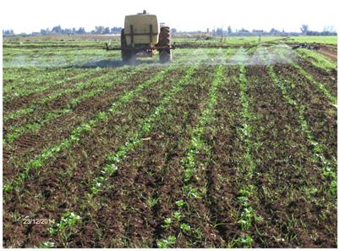 | 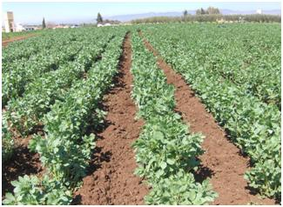
Control of weeds in faba bean at sidi slimane. | First Control of orobanche crenata in faba bean at sidi slimane and plowing the field in 28 FEB 2015
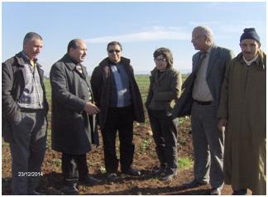 | 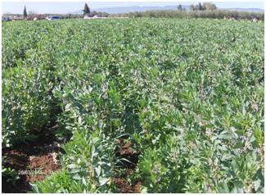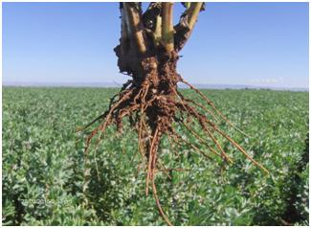
Visit of Farmers of Ain jemaa and ONCA to the site of Sidi slimane and discussion. | Fields of faba bean at the site of sidi slimane and control of Orobanche crenata on 28 march2015

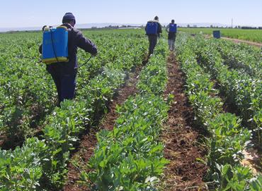
Control of Orobanche crenata on the bean with glyphosate 60+60 g i.a/ha

2. Bread wheat technologies
Ain Jemaa site |  |  | Sidi Slimane Moule Elkifane site
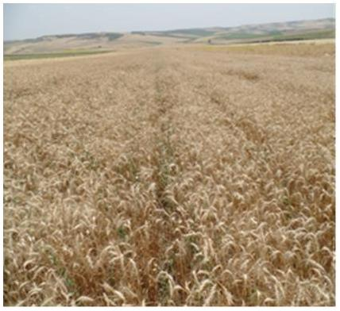 |  |  | 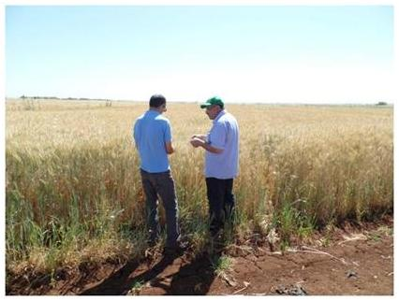
Arrihane |  | Amal | Arrihane |  | Amal
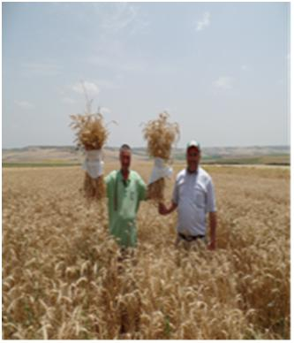 |  |  | 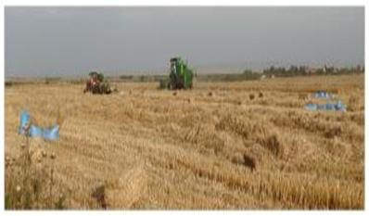
Arrihane | AMAL |  | Arrihane | AMAL

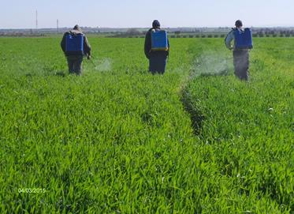
Application of fungicide Ogam at 0.8 l/ha to control diseases (Septoria and Rust)

Field days

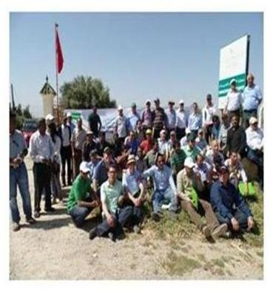 | 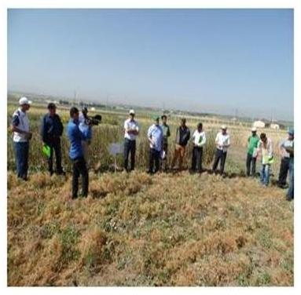
Photo of the participants in the tour day backups research trials legumes experimental field Doyet | Visit the Indian delegation the inspection tests of broomrape at Doyet
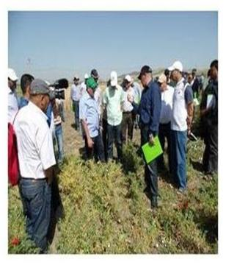

Acknowledgement and disclaimer:

This work was undertaken as part of, and funded by, the CGIAR Research Program on Dryland Systems led by the International Center for Agricultural Research in the Dry Areas (ICARDA). The opinions expressed here belong to the authors, and do not necessarily refl ect those of Dryland Systems, ICARDA, or CGIAR.

