Technical Report PK-CRP DS/BARI-05/2015

ESTABLISHMENT OF SEED INCREASE PLOTS BY PARTICIPATORY FARMERS-SEED ENTREPRENEURS
(CRP 1.1 DRYLAND SYSTEMS)

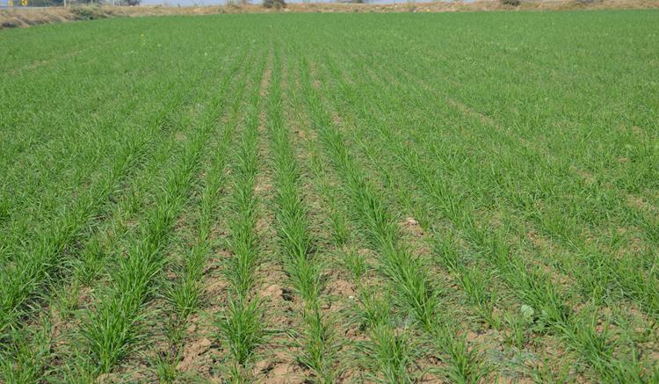

Dr. M. Ramzan Anser
M. Azeem Tariq
Dr. A. Sarkar
Dr. Muhammad Tariq

Barani Agricultural Research Institute
Chakwal, Pakistan
November 2015

SUMMARY
Wheat and lentil are important crops to ensure food and nutritional security in dryland region. However, yield of these crops is quite low. Farmers plant local varieties using their own unimproved seeds. Low crop yield affects livelihood of these low income group farming communities majority of who have limited livelihood beyond agriculture. Increasing population and shrinking land and other resources indicate that crop yields in barani areas will have to increase per unit area on a sustainable basis to ensure food and nutritional security.
Improved crop cultivars have been developed by NARS and were selected by farmers for their ecologies during the last season. However, their adoption would depend on availability of quality seed. After training of partner farmers in seed processing and training, the farmers were provided assistance in establishing seed increase plots of most promising cultivar of wheat and lentil in their ecologies under CRP Dryland Systems to enable farmers to work as seed entrepreneurs in dryland areas.
The seed entrepreneurs planted wheat cultivar “Dharabi-11) on six acres and lentil cultivar “Markaz-09” on two acres. During the process, farmers learned various skills to avoid mixing of other varieties seed which are usually present in seed drills. Moreover, selection of the fields with low weed infestation would also help them to produce quality seed. The assistance and support provided under the project is expected to help rural farming communities to produce quality seed in their own areas not only for themselves but also for the nearby communities and is expected to help them increase crop yields, resilience and farmers income.

INTRODUCTION:
The barani areas of Punjab contribute substantially to cropped area in Punjab, Pakistan (Fig. 1).

Fig.1 Percent contribution of dryland areas to cropped area in Punjab
Wheat and lentil are important crops to ensure food and nutritional security in dryland region. However, yield of these are low. The last ten years statistics of dryland areas show average wheat grain yield ranged from 483 to 987 kg ha⁻¹; average chickpea yield varied between 213-764 kg ha⁻¹ while for lentil it was in the range of 475-592 kg ha⁻¹ in Punjab (Punjab Development Statistics, 2014).
Farmers plant local varieties using their own unimproved seeds. Low crop yield affects livelihood of these low income group farming communities majority of who have limited livelihood beyond agriculture. Increasing population and shrinking land and other resources indicate that crop yields in barani areas will have to increase per unit area on a sustainable basis to ensure food and nutritional security. Improved crop cultivars have been developed by NARS and were selected by farmers for their ecologies during the last year. However, their adoption would depend on availability of quality seed. The situation is even worse in the dryland belt areas as authentic seed companies including Punjab Seed Corporation (PSC) are not supplying certified seed of even main cash crops in the area (GoP, 2010). The frequent climatic variations in the areas discourage the seed companies to manufacture and market quality seed to farmers in the rainfed areas. The farmers are consequently using poor quality old low yielding varieties seed produced locally. Due to non-availability of improved seed in rainfed tract substantial area remains devoid of agriculture crops that result in exposure of soil to erosion and leads to soil degradation and desertification. It was, therefore, essentially required to explore mechanism for availability of certified seed of improved varieties to farmers in the rainfed areas to prevent further expansion of land degradation and desertification process.
Healthy and pure seed source have been found to give better seed germination and good crop stand which enabled the plants to withstand abiotic stress especially drought during the crop season and was found to produce higher yield (Tariq et al., 2012). Therefore, it was planned under CRP DS to develop the capacity of selected farmers in informal seed production. The trained farmers are expected to work as seed entrepreneur.

ACTIVITY & METHODOLOGY
The seed entrepreneurs (05) with project support planted seed plots involving wheat cultivar “Dharabi-11) on six acres and lentil cultivar “Markaz-09” on two acres in Chakwal.
List of seed entrepreneur with area of seed increase plots with dates of sowing:
Sr. No. | Name of the seed entrepreneur | Village name | Mobile # | Area under wheat | Area under lentil
 | Ghulam Shabbir | Saghar | 0331-5977933 | - acres  (15.11.2015) | 0.5 acres  (15.11.2015)
 | Haji Zafar | Akwal | 0332-5344897 | 1.5 acres  (11.11.2015) | -
 | Malik M. Taj | Saghar |  | - | 0.5 acre  (02.11.2015)
 | Master M. Javed | Sakryala | 0347-5080930 | 1.5 acres  (13.11.2015) | 1 acre  (13.11.2015)
 | Dr. Fakhr-ul-Hassan | Latifaal | 0313-5692628 | 1.5 acres  (16.11.2015) | -

The supervised sowing was carried out which involved:
- Ensuring with seed entrepreneurs that the planter they use is clean:
One of the major mistake farmers make that the planters they use contain seeds of the previous crops, this invites mixing (Fig 1).

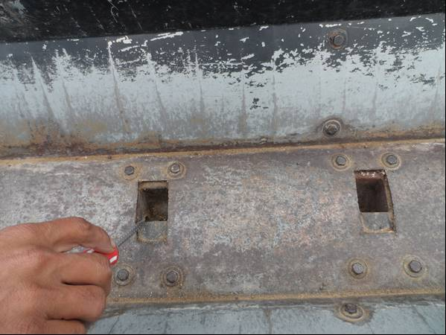
Fig 1. A planter containing wheat seeds from previous season.

During sowing of seed increase plots, the farmers were requested to clean their planters so that the purity of the promising crop cultivars is ensured from the very beginning.

The discussion with farmers revealed that most of the farmers did not calibrate their drills or check how much quantity of seed their drill is delivering. Farmers usually observe this when after sowing an acre (say), they still have seed saved in the drill, while they had put in the drill seed for one acre. Therefore, the seed calibration process was also demonstrated to the farmers before sowing of seed plots (Fig 2).

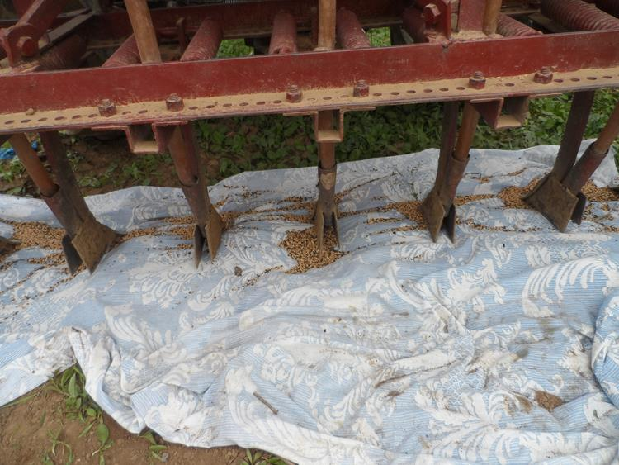
Fig 2. Static planter/drill calibration at farmers’ fields.

The project would end in December, 2015, but Barani Agricultural Research Institute, Chakwal shall manage to continue helping seed entrepreneurs to maintain purity of seed through:
- Control of weeds
- Removal of off-type plants (at heading)
- Separate harvesting and threshing of seed crop
- Seed grading.
The institute shall also help facilitate seed entrepreneurs in establishing an informal seed system whereby they would be able to exchange/sale seed to the other farmers in their ecology so that availability of quality seed gradually increases in the dryland area leading to higher productivity and profitability of farmers with improved resilience.
The seed entrepreneurs mostly planted their seed plots themselves (Fig 3-4):
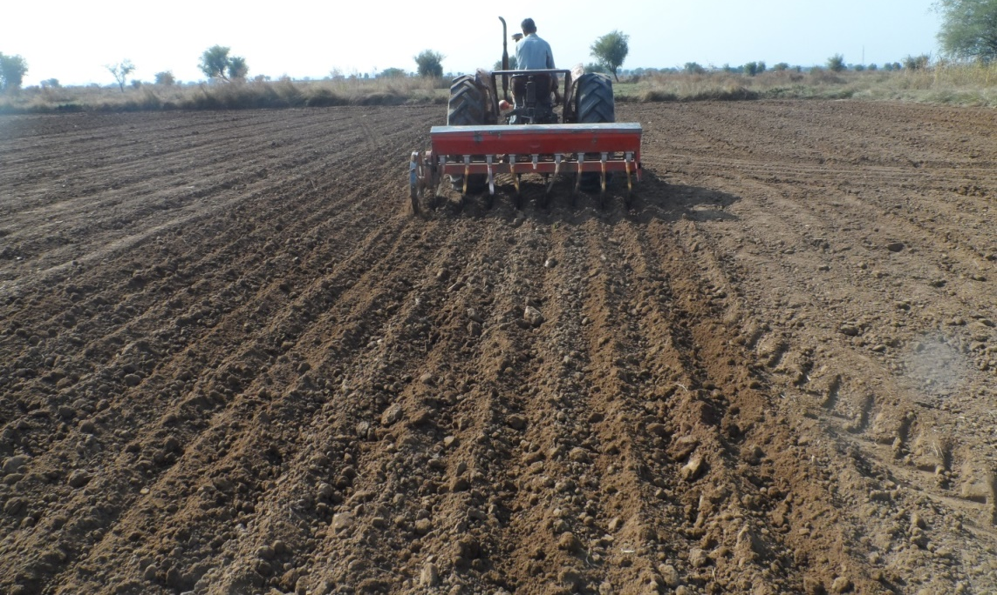
Fig 3 : Planting of wheat seed plot by Mr. M. Javaid- a seed entrepreneur of village Sakriala, Chakwal
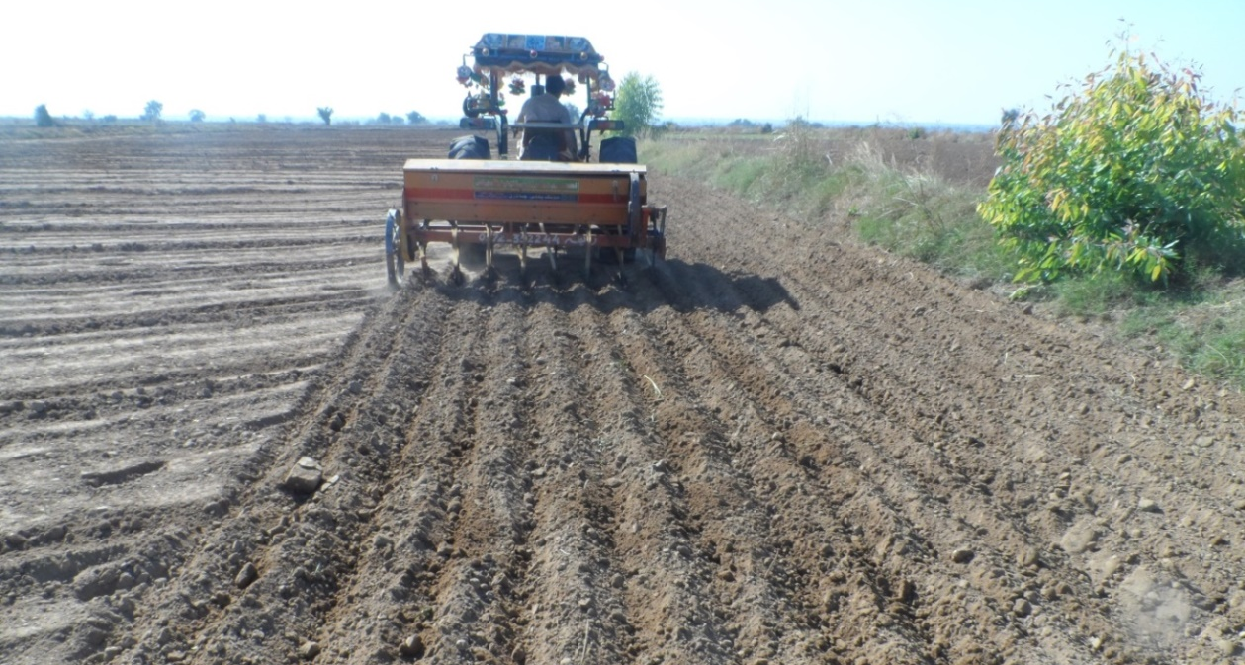
Fig 4: Planting of wheat seed plot by Mr. Ghulam Shabbir- a seed entrepreneur of village Saghar, Chakwal
Better emergence was observed in all seed plots (Fig 5,6):
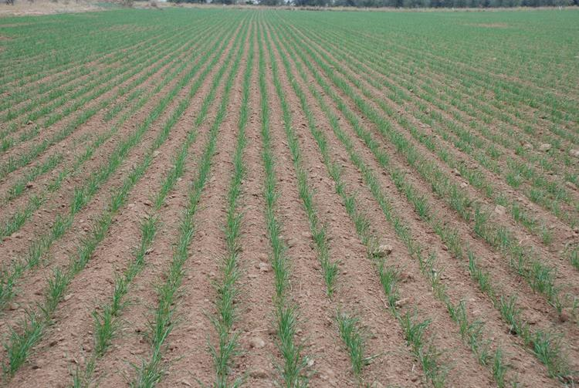
Fig 5. Emergence of wheat cultivar “Dharabi-11) at saghar, Chakwal
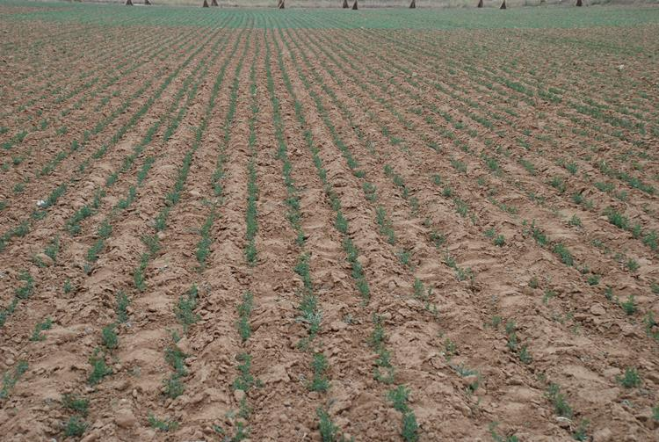
Fig 6. Emergence of lentil cultivar “Marka-09) at latifal, Chakwal

OUTPUT
Establishment of an informal seed system in dryland area as business activity whereby farmers have easy access to quality seed of promising varieties of wheat and lentil in their region which can lead to higher productivity and profitability of farmers with improved resilience & better use of marginal lands.

LITERATURE CITED
GOP. 2010. Agricultural Statistics of Pakistan, Ministry of Food and Agriculture and Cooperative, (Planning Unit), Government of Pakistan, Islamabad. Punjab.
Punjab Development Statistics. 2015. Bureau of Statistics, Government of Punjab, Lahore. http://bos2.pitb.gov.pk/system/files/Dev-2014.pdf
Tariq, M., R. M. Omer, M. A. Mian, O. Rehman, A. T. Virk and K. Abbass. 2012. Promoting certified seed availability of wheat (Triticum aestivum L.) through public-private partnership and its impact on yield in rainfed areas

