Activity: Commercial hybrid cultivation production promoted in at least 100,000 ha
- Objective of activity and intended output:
To popularize the hybrid pigeonpea by making the availability of hybrid seeds on large scale and to enhance the productivity of small holder farmers cultivating pigeonpea in SAT regions.
- Materials and methods:
Standardization of seed production technology for different agro ecologies.
Capacitating public and private sector, NGOS, progressive farmers and NARS on hybrid pigeonpea seed production.
- Results and interpretation:
In 2016, a quantity of 705 tons of hybrid pigeonpea seeds were produced by all the stake holders Which was sufficient to cover 140000 has of area with hybrid pigeonpea seeds. An area of 680 has is under seed production by public, private, NGOS, progressive farmers and NARS which is expected to produce more than 800 Tons of hybrid seeds for 2017 season.
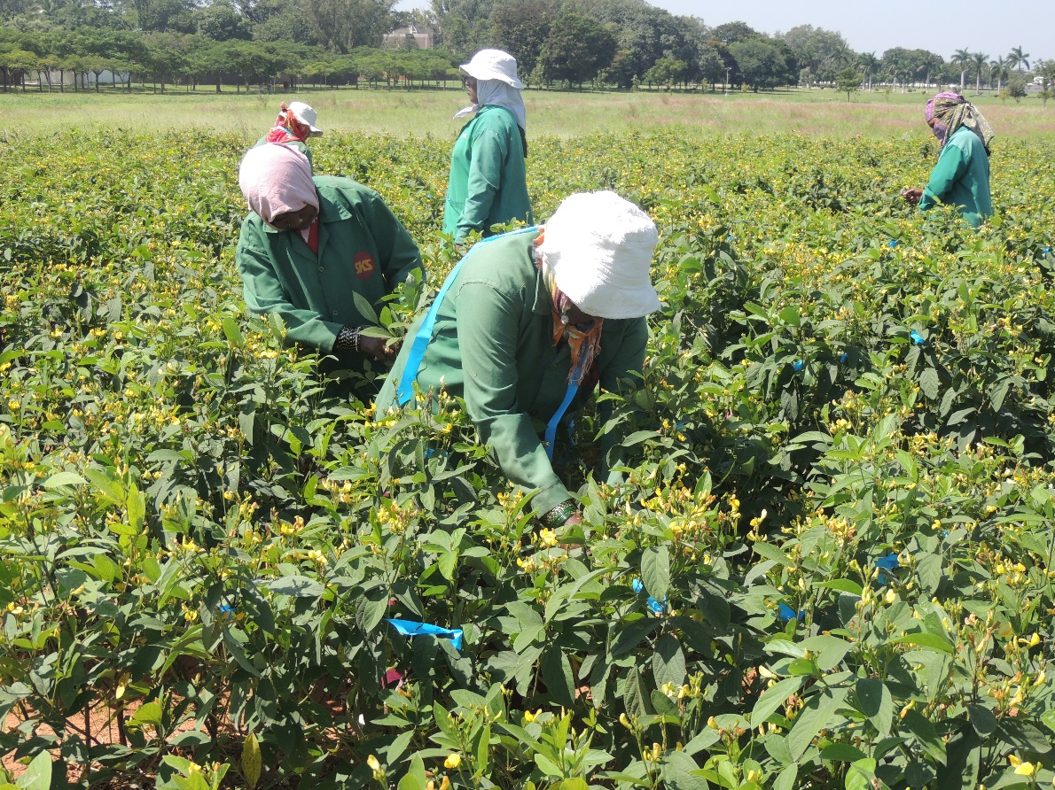
Nucleus seed production of hybrid parental lines at ICRISAT

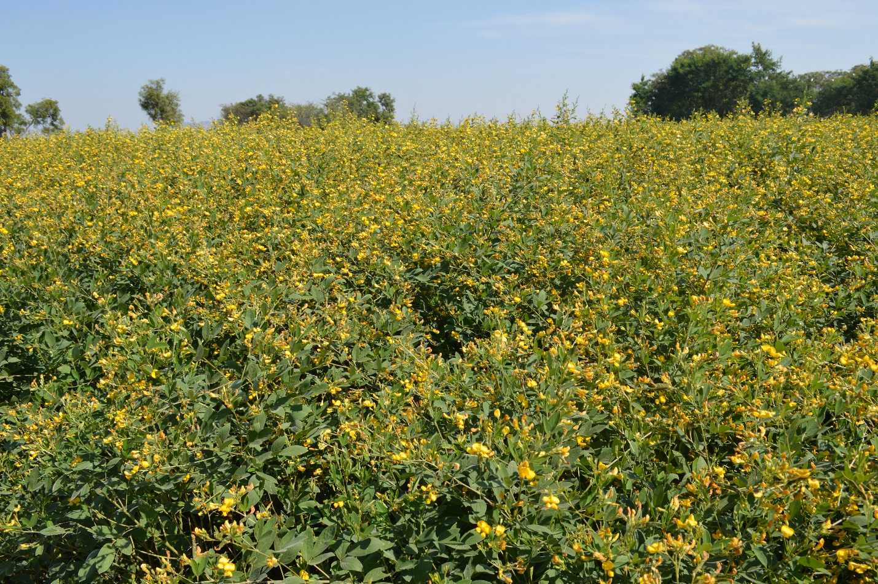
Certified seed production of Hybrid by National Seeds Corporation
- Next steps:
There is a continued need to capacitate the stake holders for increasing the availability of hybrid pigeonpea to the small holder farmers.

