High-yield Soybean and cowpea genotypes identified
In 2016, three soybean genotypes; one early (TGx 1835-10E), one medium (TGx-1904-6F) and one late (TGx-1951-3F) maturing were evaluated for high yield and drought tolerance in three agro-ecologies in Mozambique: Ruace, (15.2355º S, 36.6886º E), Zambezia province, Ntengo Umodzi (14.5458º S, 34.1863º E), Tete province and Muriaze (15.2729º S, 39.3173º E), Nampula province. These genotypes were selected from a larger study that consisted of 30 genotypes in 2014 and subsequently from a subset of six best performing genotypes evaluated in 2015. The seeds were planted on six different dates starting from 16 Dec 2015 to 5 March 2016 at 14-day intervals corresponding to early to late planting to expose the plants to late season drought. In the three agro-ecologies, rainfall typically starts in December reaching its peak in January and begins a gradual decrease in February terminating in April. Thus, late season drought is the overriding factor that affects soybean performance in these environments. Soybean yields and yield components include number of pods per plant and seed size declined as planting delayed across locations from the first planting to the last planting date. The decline was more pronounced in the medium and late maturing genotypes due to the shortened the growing cycle. At Ruace where rainfall was relatively high and stable during the early part of the season, grain yields for the first and the second planting dates which occurred in December were not different for the early and medium maturing genotypes; however, grain yields dropped by 34 and 56% when planting of the early and medium genotypes, respectively, occurred in January. For the late genotype at Ruace, yield declined 32% when planting delayed 14 days after mid Dec and another 50% decline when planting was done in January. Severe drought spells after January at Ntengo Umodzi severely affected crop establishment, growth and yield; hence yields for all genotypes declined by more than 65% when planting occurred after December. At Muriaze where the ecology is relatively dry, soybean yields for the first three planting dates for the early genotype were not different; however, yields for medium and late genotypes planted in the third week of January decreased by 636 kg (24%) and 883 kg (41%), respectively, compared with yields for those planted 14 or 28 days earlier. Yields after January were too low due to severe terminal drought. The medium maturing genotype performed better than the early and late maturing genotypes in the three agro-ecologies where drought occurs frequently.
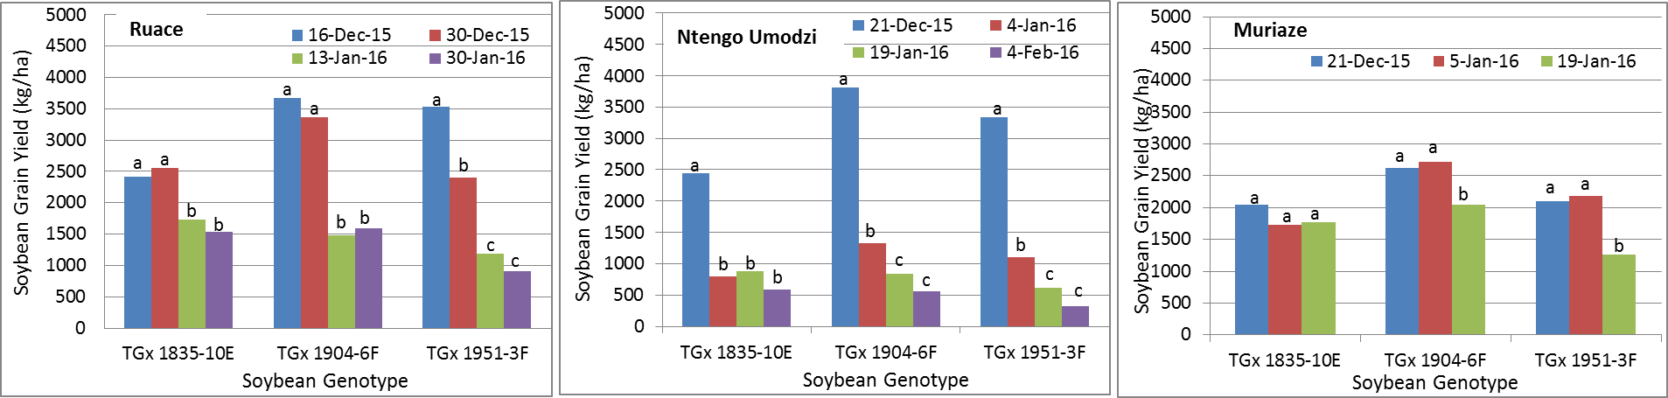
Fig. 1. Effect of planting date on soybean grain yield across three ecologies in Mozambique

For, cowpea, six genotypes: IT-16, IT-18, IT-1069, IT-1263, IT97K-390-2 and IT04K-227-4 were selected from 20 genotypes tested in 2015 for evaluation in 2016 at Ruace and Muriaze using four different planting dates. The decrease in yield and yield components in cowpea with planting dates followed a similar trend as in soybean at Muriaze where rainfall is relatively low and short in duration. However, cowpea yields at Ruace increased as planting delayed from the third week of January to mid-February since rainfall at that period of the growing season was too high for cowpea, although there were no significant differences among the first three planting dates within the genotypes due to high variability in the data. High rainfall encourages high disease incidence, and attracts more insect pests leading to low yields. IT-16 and IT-18 appeared to be the best two genotypes at Ruace under terminal drought but no conclusion could be drawn for Muriaze.
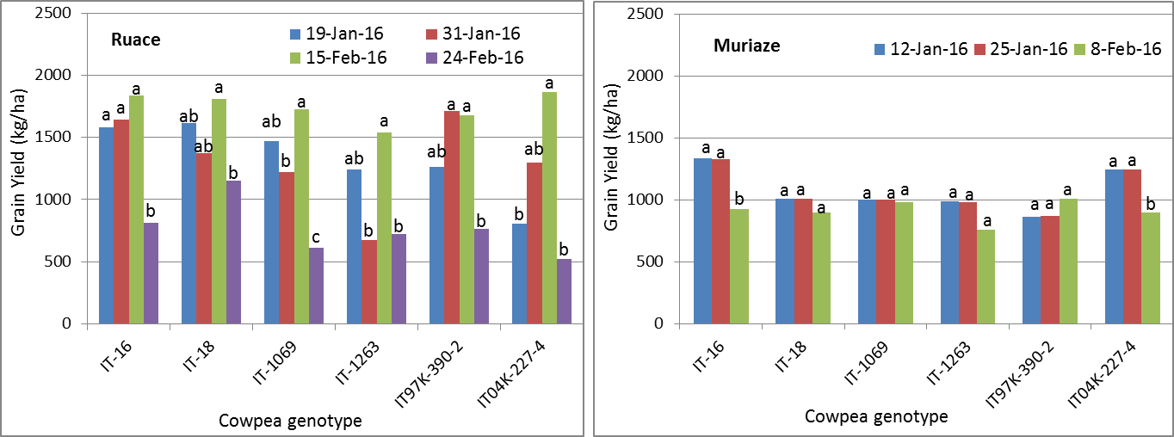
Fig. 2. Effect of planting date on cowpea grain yield across two ecologies in Mozambique

