December 2015

GENDERED LAND TENURE AND WATER INFRASTRUCTURE IN THE CHINYANJA TRIANGLE: THE CASE OF CHAULUKA AND KAMWAZA VILLAGES IN KANDEU, NTCHEU, MALAWI

Food security and better livelihoods

for rural dryland communities

A report by Wapulumuka Oliver Mulwafu, University of Malawi.

Submitted to IWMI under the Dryland Systems: Integrated agricultural production systems for the poor and vulnerable in dry areas

1.0 INTRODUCTION
According to the Malawi Land Act of 1965, three categories of land tenure exist in the country. These are private, public and customary land. Private land is all land held under a freehold title, a leasehold title or land registered under the Registered Land Act of 1967. Public land is all land occupied by the government while customary land is all land held, occupied or used under customary law (Peters & Kambewa, 2007; Kishindo, 1994:57). Customary land, whose custodians are the chiefs, is very important for food production by small scale farmers since it accounts for 67% of the total land available in the country. Therefore ownership of land is crucial in food production and investments. In Malawi, land tenure is related to marriage systems of matrilineal and patrilineal nature. In the matrilineal system, inheritance and succession run through the female line while in patrilineal it runs in the male line. This entails that land tenure is gendered. It can either be held by a male or a female member of the family. This report sheds more light on the link that exists between gendered land tenure and investments in water infrastructure for multiple purposes in the Ntcheu district of the Chinyanja Triangle.
2.0 LITERATURE REVIEW
Gendered land tenure exists following marriage systems of patrilineality and matrilineality. In many parts of the world, land is generally owned by men but efforts are being made to reform land tenure policies so that women’s rights to land should improve. In Africa, the premise is that women’s land rights under customary tenure are fragile and threatened (Peters, 2010:179; Kishindo, 2004; Kaarhus, 2010). There is need for women to hold land rights because they are responsible for production of about 60-80 % food. From what was established at the Beijing Platform for Action, women own only one percent of the world’s property. Yet it is estimated that one third of the world’s households are female headed, either temporarily or permanently due to divorce or death. In developing nations the rate is even higher. As such there is need for women to be empowered and be in control of the means of production. Esther Boserup also argued along the same lines that women play an important role in agriculture as food providers in many parts of the world, mainly in Africa. Therefore she describes as ‘dubious’ the generalisation that men are the food providers (Boserup, 1970: 15).
Within the Chinyanja Triangle, studies have documented the gendered manner in which resources are used for development related activities. Amede, et al. (2014) have shown that dryland agriculture is a predominant source of livelihoods for over 90% of the rural population. Chileshe (2005) explores how land and natural resources in rural communities are accessed, used and managed to support livelihoods. The study shows that social differences, traditional institutions and government policy are central in determining access, use and control of land and natural resources in rural livelihoods. In this regard, rather than being replaced, customary land tenure and traditional and administration structures in rural Zambia should be adapted to current social and economic realities in which individuals and households create their multiple livelihoods. Writing more broadly, Ruth Meinzen, Dick and Margreet Zwarteveen, (1998) have argued that the widespread trend to transfer irrigation management responsibility from the state to communities or local user groups has by and large ignored the implication of intra-community power differences for the effectiveness and equity of water management. Gender is a recurrent source of such difference. Despite the rhetoric on women’s participation, a review of evidence from south from south Asia shows that female participation is minimal in water user’s organizations. One reason for this is that the formal and informal membership criterion excludes women. Berge et.al. have argued that the primary concern for any land tenure system is security of tenure for the people actually working on the land. Land users must be convinced that investments in the form of labour and capital will provide returns both in the short and long term perspective. Both matrilineal and patrilineal systems discriminate systematically between male and female children. In patrilineal land holding systems land devolves on male heirs while daughters are assumed to be married to men who inherit land. In matrilineal systems the opposite case applies where sons will not need to inherit land. It is assumed that they will get land from their wives.
The New Land Policy in Malawi, once implemented, will ensure rights to inherit land for all children irrespective of sex (Peters, 2010:191, Kishindo, 2004; Kaarhus, 2010). However, it should be noted that for matrilineal societies, this land policy will reduce the women’s existing rights as owners of the land. This is due to the fact that in matrilineal societies, daughters inherit land while sons move to their wives’ home and cultivate in their wives’ field. But the policy will allow sons to inherit land from their mothers in the same way that daughters do.
3.0 OBJECTIVES OF THE STUDY
The study sought to establish a link between gendered land tenure and water infrastructure development for multiple purposes. There are two components with related outputs:
a) the basis is an in-depth analysis of matrilineal and patrilineal land tenure and trends/transitional forms, and how this is related to, and embedded in land tenure and marriage patterns and other relevant factors, including the gendered division of livelihood strategies and gendered division of tasks, especially for cropping, and domestic tasks, including water fetching.
b) to study the impacts of matri-/patrilineal land tenure on gendered long-term investments in land-bound water infrastructure, both public and private investments and for both productive and domestic water uses (e.g., one village with public investments in irrigation, also describing private investments in farming; one village with many private investments, e.g. groundwater pumps, and one 'remote' site with minimal investments)

4.0 METHODOLOGY
The study sought to find out the link between gendered land tenure and investments in water infrastructure in selected villages in Ntcheu district. Two case studies were selected which also have irrigation schemes, with one fully developed and the other one still under construction. The study also investigated the issues of marriage pattern, land tenure, irrigation and decision making in water infrastructure development.
The case studies were conducted in T/A Njolomole’s area in Ntcheu district between October and December 2014. Ntcheu falls within the Chinyanja Triangle and shares a boundary with Mozambique to the western part of the district. The study was carried out in two villages, namely Kamwaza and Chauluka under Kandeu Extension Planning Area (EPA). These villages were selected for two reasons. First, both villages have recently experienced investments in the water infrastructure which are transforming the gender roles and livelihoods of the members. Second, matrilocal and patrilocal systems of marriage residence are practiced in the two villages. In addition, the study compliments the on-going larger Drylands Research Project in the Chinyanja Triangle being implemented by IWMI in Kandeu EPA. A total of 40 respondents were sampled from the two villages with 20 respondents from Chauluka village (8 males and 12 females), and another 20 from Kamwaza (9 males and 11 females). A second round of data collection involved 10 in-depth interviews with scheme committee members (5 from each village), and also 2 follow up interviews that needed clarification from some men and women in the two villages, one female in Chauluka and one male in Kamwaza. Of these 16 were males and 24 were females from different households. Interviews were conducted independently with individual respondents who are also small-scale farmers and thereafter focus group discussions (FGDs) were done to source information from the management committees of the irrigation schemes. All the responses from the respondents were documented in notebooks for analysis.
Map of the Chinyanja Triangle
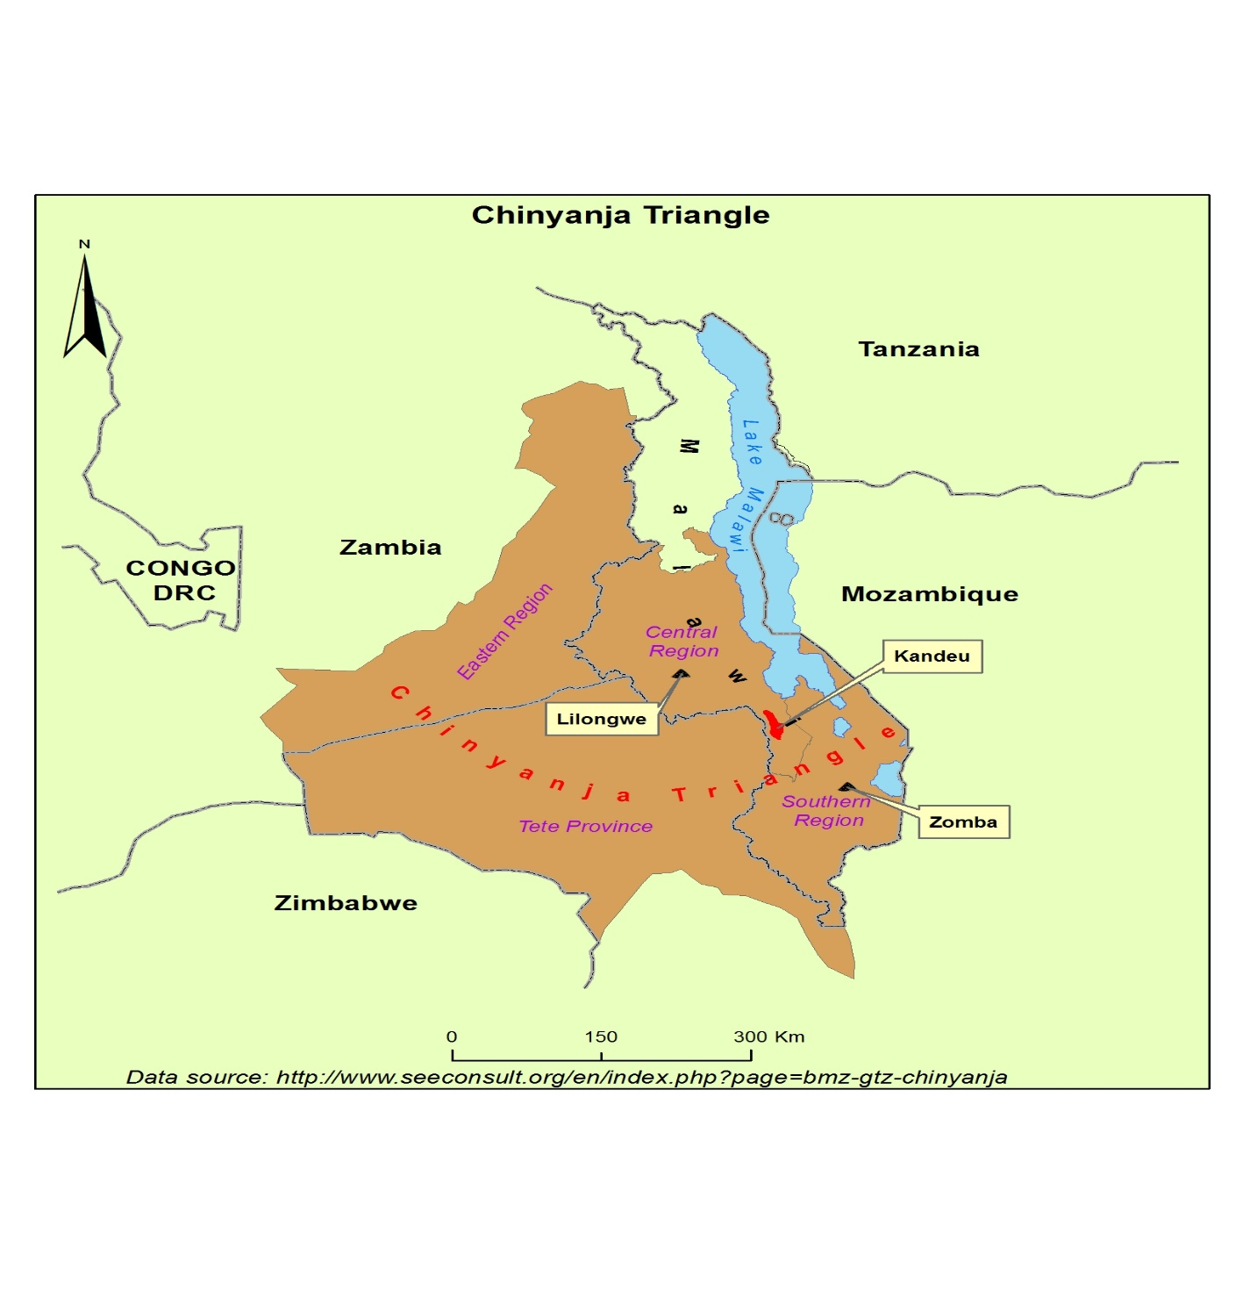
Chauluka and Kamwaza villages are 15 km away from Ntcheu Boma. They are both under Muwalo Group Village Head of TA Njolomole. Most of the people in this community belong to the Ngoni ethnic group and the area is known to have that Ngoni dominance setting. The study discusses matters relating to marriage patterns, land tenure, division of livelihood, water investment, impacts of matrilineal/patrilineal land tenure on gendered investments in land-bound water infrastructure. The discussion below presents findings from the two villages, starting with Chauluka and then Kamwaza.

5.0 RESULTS OF THE STUDY
The study has revealed a number of issues relating to marriage patterns, land tenure, gendered division of livelihood strategies, investments in farming and water infrastructure. The discussion below presents findings from the case studies of Chauluka and Kamwaza villages.
The study has found that land is held under customary law in the area. Village chiefs, who can be either male or female, must themselves trace their inheritance through matrilineal lineage, and serve as the trustees of the land on behalf of their people. Village chiefs are part of the local government system but follow traditions and practices of particular areas of their jurisdiction. Allocation to new members in the village is done by the village head. For those who are already members of the village, land becomes de facto family property; it is passed from parents to children. In the past when virgin land was abundant, men and women in the village would open up new areas (mphanje) either for settlement or farming, but after consultation with the chief, men get through their wives. Ideally, land is not supposed to be sold but can be rented out on a short term basis. Average farm sizes are relatively small, ranging from 0.1 ha to 5 ha per family. These plots are not consolidated in one area; they are often fragmented and found in different places. While most parts of the country are increasingly experiencing land shortage problems the situation in Kandeu EPA is not very acute. Residents are still able to find some land if they wanted to increase hectarage. The only problem is that such land is likely to be of marginal quality. Most of the farmers we interviewed indicated that they use family labour in order to produce crops. This is due to the fact that they produce primarily for home consumption and only a little for sale. Expanding production for commercial purposes would require inputs and resources which residents do not have.
In terms of marriage, the matrilineal and matrilocal systems are followed. Under the matrilineal system, which is dominant in the area, descent is through the line of the mother. Its contrasting system is that of patrilineality where descent and inheritance are through the father’s line. However, in terms of residence after marriage, uxorilocal/matrilocal system, where a man goes to live at the wife’s village, is commonly practiced. Virilocality/patrilocality is a system where a woman goes to live at her husband’s home after marriage. Although patrilocality is practiced in some cases, the area is largely matrilineal in terms of inheritance. The children are owned by the mother through whom lineage and inheritance are traced. There are very few cases of the tradition of lobola (bridewealth) as practiced in some cultures. Those who do are immigrants into the area. As such patrilocality is also described as “kubwereka” (to borrow a wife), meaning that a husband borrows a wife to live with at his home but knowing clearly that she and the kids belong to the wife’s home. Married couple are expected to make investments in the wife’s home area. In recent times, the tradition is changing whereby some couples opt to invest in towns and other neutral places.
The matrilineal system puts the woman and the children born in the family in a secure position in case of death or divorce. This is due to the fact that the children belong to the woman and therefore their socially sanctioned home is their mothers. As such, some women indicated that they like the system of getting married to a man who will leave his home and stay at the wife’s place so that they can build a home together. On their part, men said that they follow the system which is commonly practiced in the village. The land on which they establish a home belongs to the wife and a man is also shown a piece of land for farming which belongs to the wife. In theory, both men and women make decisions on investments in the woman’s land such as crops to produce, harvesting and marketing. In practice, the men make decisions on the wife’s land. A wife’s plot is different and cannot be farmed by other members of her maternal family. But depending on the character of the couple, power dynamics play a role in determining division of labour. According to one respondent, matrilocality gives women a peace of mind knowing that even if the marriage breaks, she and the children will be safe. On the other hand, men who live at their wives’ village are also at a risk of losing land once the marriage breaks. Men are still expected to make long term investments in water infrastructure as part of the efforts to consolidate their marriages. In the words of Kishindo “men normatively acquire rights to land through marriage, their enjoyment of these rights is directly dependent upon the longevity of the union” (Kishindo, 2006:62). And when these men go back to their villages, they face land problems since their married sisters would have shared the land among themselves. According to one farmer, the option is to buy land in a neutral place: “I don’t want to be stranded in future when my marriage breaks because my sisters have taken all the land with their husbands. As such I have bought a piece of land in Mozambique”. However, this was the opinion of one respondent and does not represent a common trend in the area as few men have enough resources to invest in land while anticipating marriage break ups. But it illustrates the dilemma some men face in a village setting when marriages do not work.
One of the respondents observed that nowadays men have become clever when choosing where to settle after they get married. Giving his own example, he noted that, “I have settled at my wife’s place because it was the only alternative out of land scarcity problems. I can’t take her to my village because there is no land for me there. So this system has saved me”. Though this is the case for some men in the village, others feel uncomfortable with the practice to the extent that they acquire land in far off places so that they should not be stranded if the wife dies or in case of divorce. They go to places where they can easily find land. This is an emerging trend particularly among the younger men as land in their villages is becoming scarcer.
As mentioned earlier, land tenure is directly related to marriage patterns. In the village men do acquire land through marriage. However, it is not all men that move to their wives’ homes, some do marry and stay with their wives in their own villages. This is possible only if there is enough land at the man’s home, as the culture demands that men move to their wives’ home. According to one female informant, a woman who goes to live at her husband’s place takes a huge risk. If the husband dies, she might be sent packing. “My husband and I were living at his home when we just got married. We built a house there. After observing how other women were being treated after the death of their husbands, my husband thought of moving from his home to my home. So we built a house and settled here. This was done to make sure that even if he dies, the kids and I will be safe here in my village”. For residents in the village, the perception is that matrilineal and matrilocal patterns of marriage work better for families. However, it is also important to know that it is not always the case that the wife would be chased away after the death of the husband. The behaviour of the widow also determines whether she will stay or not. But with land shortage problems facing most of the families, it is becoming increasingly common for the widow in a patrilocal marriage to be sent to her own home so that the husband’s relations take over the land left by the deceased man. The common trend is for women to have matrilocal marriages.
The major sources of water in the area are rivers, boreholes, wells and rainfall. Most of the rivers originate in the mountains and flow down to the low lying areas where population tends to be concentrated. For a long time residents have been relying on rivers and rainfall for production. Crops grown in upland areas use mostly rainfall while dry season farming uses water from rivers. Boreholes are a relatively new source of water but have been widely adopted across the country. Partly due to deforestation taking place in the highland areas, water is becoming scarcer so that some streams which used to be perennial now dry up in the dry season months of September and October. This has forced some farmers to dig their own wells around their homes. Many respondents indicated that both men and women take the initiative in the design and site selection of private wells. The actual digging is done by men and boys. Once the well is operational, women are the main users of the facility.
Water is essential in everyday life. It is used for a variety of domestic as well as for productive activities. Domestically, it is used for cleaning, washing, preparation of food and also drinking among others. It is women and children who are responsible for using water in this manner. These are roles socially assigned to women and it is rare to find men performing these tasks openly. Water can also have multiple productive uses such as in the making of bricks, and watering of crops and livestock. Men tend to dominate this kind of water use. Different water infrastructure can be put in place to facilitate the multiple uses of water. In the study area there are two notable water infrastructural developments. These are boreholes and the irrigation schemes. Boreholes provide water largely for domestic purposes while irrigation schemes use water productively for watering crops grown during the dry season. For married couples, both men and women provide labour for managing plots on the irrigation scheme. Respondents also reported that they use proceeds from sale of crops together as a family. They plan together on how to use the proceeds such as purchase of food, payment for children’s education and household items. However, there are reported cases of individual men who take most of the money and use it on their own activities like beer drinking and womanising. When this happens it can become a source of family conflicts and may sometimes end up in marriage break ups.
There are 16 small scale irrigation schemes under Kandeu EPA, but the study has focused on only two namely: Chauluka and Kamwaza Irrigation Schemes (see Table 1 below). The schemes have been established under different circumstances, with initiatives coming from within or outside interventions, and the majority use gravity to channel the water to the irrigation plots. These schemes were established as part of the effort to deal with hunger in the society as well as increase farmers’ incomes. As in the words of Esther Boserup, ‘necessity is the mother of invention’. Irrigation has turned out to be a solution to the problem of insufficient food supplies. A number of Non Governmental Organisations have made investments in the water sector with the aim of improving the livelihoods of the communities. Among these include Care Malawi, IRLAD and Total Land Care. Their support is mainly in the form of hardware such as construction of the irrigation schemes while government provides extension services on agriculture, forestry and aquaculture. Details about site selection, design of the scheme and gendered roles are provided in the discussion under each case study. Men and women in the villages provide local construction materials such as river sand and stones. Promotion of irrigated agriculture is a continuation of efforts that were initiated in the country immediately after independence in 1964 with support from the Chinese Agricultural Technical Mission (Makato, 1984; Ferguson and Mulwafu, 2007). The main aim of these schemes was to promote agricultural intensification particularly through the production of cash crops by peasants which would contribute to the general improvement of the overall standards of living of the rural poor.
Land on which irrigation schemes in this area have been established does not belong to any individual farmer; it is land that was given to the scheme by the village head. However, individual farmers own the plots which would have been allocated by the scheme committee. The oldest scheme in the area is Chauluka while the newest is Michi, currently under construction. Crops grown include maize, potatoes, beans, tomatoes, and onions. Training in scheme management is done at the beginning of the scheme and also each time there is change in the leadership of scheme management.
Table 1: List of Irrigation Schemes in Kandeu EPA, Ntcheu District
Serial No | Name of Scheme | Sponsor
 | Namale | NGO/Local initiative
 | Chauya | NGO/Local initiative
 | Tilime nawo | Government
 | Chauluka | NGO/Local initiative
 | Kamwaza | NGO/Local initiative
 | Daudi/Chimbiya | Government
 | Chamgomo | Government
 | Michi/ Kadziputa | Government
 | Khomba | NGO/Local initiative
 | Likumbo | NGO/Local initiative
 | Tipindule | NGO/Local initiative
 | Kanjuzu | NGO/Local initiative
 | Thondoya | NGO/Local initiative
 | Liwadzi | NGO/Local initiative
 | Ntendezi | Government
 | Nazing’ombe | Government

Most respondents indicated that men and women share most of the agricultural responsibilities although women tend to shoulder many of the domestic chores. During the dry season for example when crops would have been harvested from the fields, most men tend to relax while women continue to work on their domestic chores such as child care, fetching water, and cooking. During the rainy season, both men and women work together in the fields performing a variety of tasks such as land preparation, planting maize seeds, weeding and harvesting. Land preparation is generally considered a male task but the other tasks like planting, weeding and harvesting are jointly performed by both men and women. On the other hand, men are largely responsible for house construction on land belonging to the wife. The man has to procure materials for building such as cement, iron sheets and bricks. In fact, under the matrilineal system, it is a tradition that a man builds a house at the wife’s home where they can stay together as a family. In case of divorce, the man leaves behind the house and moves out either to his original home or to another place where he has married. Here again, the man would be expected to build another house for the new wife. Nowadays, men tend to be responsible for payment of children’s education. In the past, however, men were responsible for the education of their sister’s children as (mwini mbumba). These tasks also depend on the nature of the family because some men can be very irresponsible and would leave all the work to the wife and children while they go out drinking beer.
Apart from domestic tasks, women also perform most of the livelihood activities. In fact, women are responsible for household tasks of food preparation, cleaning and child care, and work which in the rural setting involve carrying water and fetching firewood. Men take part in some of these activities to support their families especially when women are sick or have gone away. Most literature shows that women do most, if not all, of the domestic work and even the farm work. According to Malawi’s 2008 census, more than 80% of the population lived in rural areas, but only 50% of the economically active men worked full time on their own farms.
This is in line with what is happening at Kandeu. While women dominate the agricultural sector the performance of specific farming tasks is very much gendered. In the irrigation schemes, women tend to outnumber the men yet women work together with the men throughout the processes of crop production. Looking at the composition of farmers at the two schemes, it is clear that women dominate: there are 68 females against 37 males, and 42 against 11 in Kamwaza and Chauluka schemes respectively. According to several respondents, this can be attributed to the fact that the society is matrilineal, therefore most of the land is owned by the women. Customary law recognises women as the owners of land and men can access land through their wives. In terms of long term investments, men can invest in their plots since security of tenure lies with the scheme committee. It is the scheme management committee that allocates land to both men and women regardless of the marriage system. Apart from this, the culture of the area allows for women to take full responsibility of the children because even if the marriage breaks up, the children stay with the mother. As such the women try all means possible to provide for the family, especially the children. Recently, there have also been campaigns by some organisations encouraging women to venture into production of crops that can increase their income levels. From what has been gathered in the study, there was an observation that most of the men in this area tend to migrate to South Africa to seek greener pastures, thereby leaving the women and children to fend for themselves. This has also increased female involvement in irrigation farming. The situation is not unique to matrilineal societies; similar trends are taking place in patrilineal societies where the numbers of young men migrating to South Africa has been increasing in recent years.
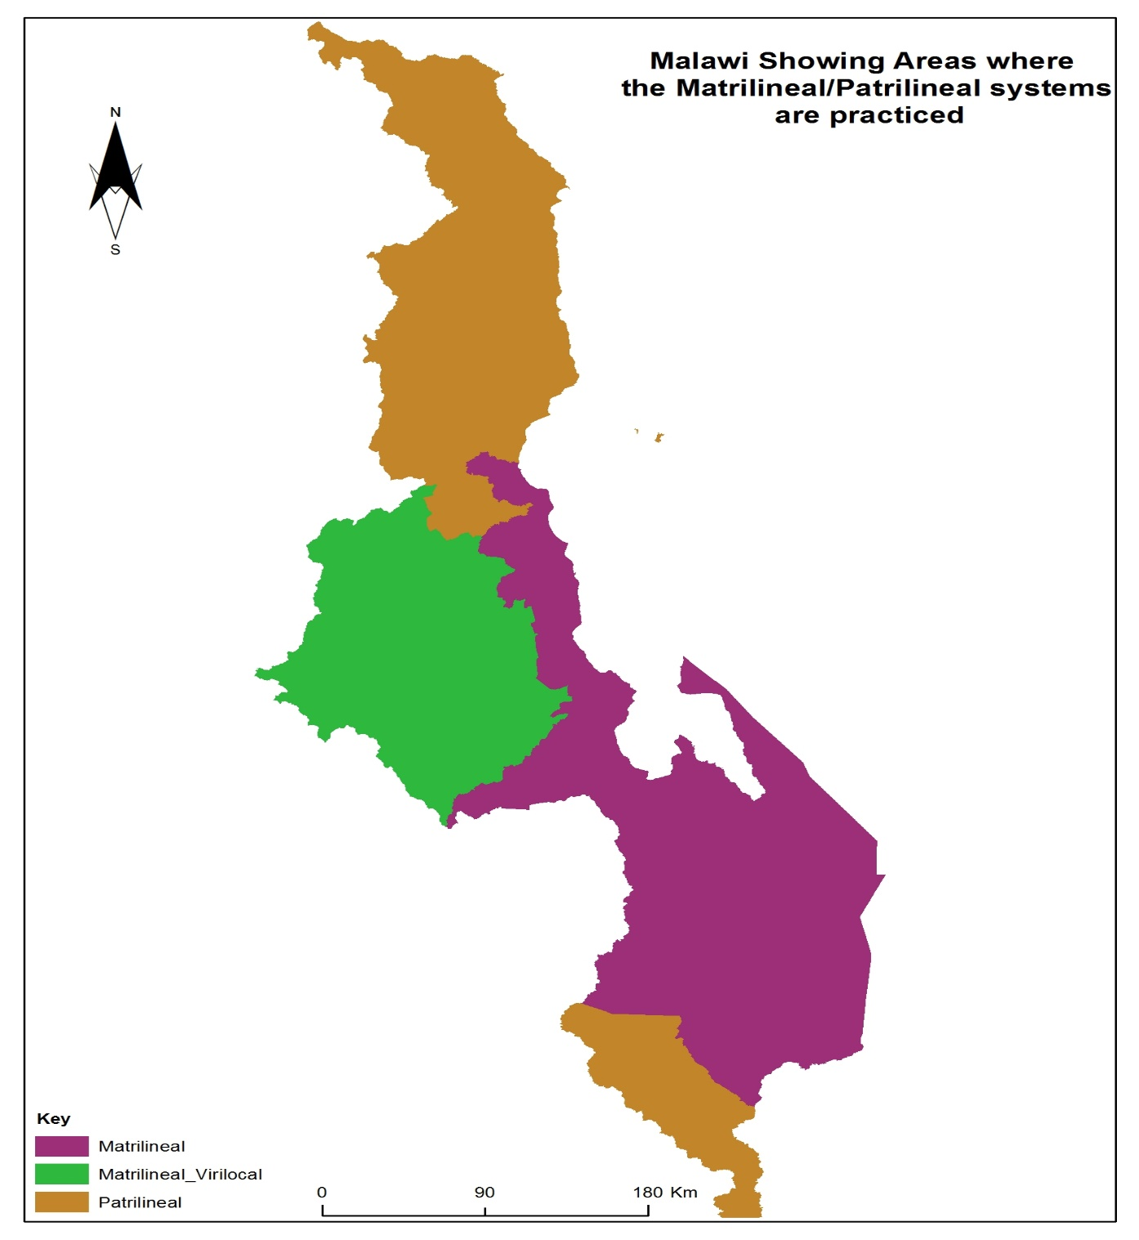
THE CASE OF CHAULUKA VILLAGE
Both Chauluka and Kamwaza villages are located to the south west of Kandeu EPA. The two villages have some investments in water in the form of boreholes, irrigation schemes and private wells. There are three boreholes that are being used by residents in Kamwaza and Chauluka Villages. This is because, according to tradition, the two villages were one in the past but separated afterwards. The boreholes provide water for domestic purposes such as cleaning, cooking and washing. They also provide water for brick making and watering seedlings and vegetables gardens near the homes. Water from the boreholes is mostly drawn and used by women. As in the words of one of the respondents, “boreholes are for women only. If you happen to see a man on the queue there, just know that he is either a widower or one who is shy to propose”. Boreholes are run by committees, comprising mostly women, which have been set up in both Chauluka and Kamwaza villages to facilitate the effective performance of the water sources. Small amounts of money are collected from water users for maintenance work. For married couples, both men and women discuss the amounts and when to make payments to the committee. In the case of single and widowed families, the head of the household makes such decisions. Water users are also advised not to pump water during the night to avoid creating a loophole for vandalism.
Chauluka irrigation scheme was established in the year 2000 as one of the small scale schemes being promoted by the Malawi Government. The scheme began with 17 members, almost all of them men, who wanted to see an improvement in their lives by growing crops at least twice a year (see list in Table 3 below). These individuals conceived the idea after observing what was happening in other areas. The number of members has grown to 105. Of these, 68 are female members while 37 are males. Membership in the scheme is done at family level so that if a male member registers, the female member is also considered to be part of the scheme. Two members from the same family are not allowed to get more than one plot. This is done to allow participation of more people in the village. At first, the scheme at Chauluka had membership of farmers from both Chauluka and Kamwaza villages because by then there was no irrigation scheme at Kamwaza. However, the situation changed in 2006 when residents of Kamwaza decided to establish their own irrigation scheme. In fact, farmers from Kamwaza Village were asked to leave Chauluka Scheme and encouraged to build their own scheme. Chauluka Irrigation Scheme gets its water from the Mponda River. Crops grown include maize, beans, vegetables and sweet potatoes. Since Kamwaza scheme is still under construction, on average a farmer cultivates about 0.5 acres of land. Proceeds from irrigation farming help farmers to be food secure and also to buy farm inputs for the rain fed farming season.
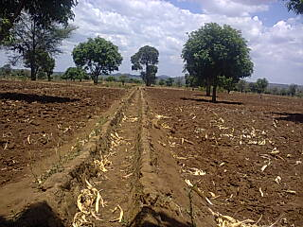
Part of the canal under construction at Chauluka irrigation scheme
  - Marriage pattern
The study has revealed that there are two common patterns of marriage being practiced in Chauluka village: “chitengwa” or patrilocal and “chikamwini” or matrilocal systems. Under patrilocal marriage pattern, a woman follows the husband when they get married and in matrilocal, the man is the one that follows the wife to stay at her mother’s home. In both patterns the process is that a man expresses his intention to marry a woman to his uncles who are the ones that consult the woman’s uncles and then the woman’s uncles set a date for the ceremony. Whatever system is chosen there are requirements that a man must follow. The man’s family is supposed to pay a little something to the family of the woman which is like a token of appreciation and this money is given to the uncles represented as “ankhoswe” or counsellors, to the parents and also to the village head from the woman’s side. In both settings, if there is a gift of children, the children are said to belong to the woman. The area is dominated by matrilocal marriages and there are no reported cases of “lobola” in the area.
1.2. Land tenure
According to the findings of this study, land in the area is guided by traditional law which starts from the village heads as the custodians on behalf of the people in the area. Land has been passing from the village head to the parent which in the end becomes family land. Children inherit land from their parents; this family land is usually overseen by the brother of a woman: the uncle called “amalume”. If in need of more land or in case of new members, the parents are supposed to ask from the village head to help with the allocation of communal land left, this is usually virgin land called “tchire” or “mphanje”. At the moment, there is very little mphanje left in the village.
People may also gain land through buying which is becoming rare these days because there is no more land to sell. The respondents stated that there is already high demand for land so that people do not think it wise to sell their land. Instead, there is a growing trend of land renting whereby people pay money according to the size of the land. Rented land is done per season with prices determined by the owner. For example, from the respondents interviewed the price of 1 acre ranged from K3000 to K6000 per season (exchange rate of 1 USD = MK 450).
  - Relationship between land tenure and marriage pattern
It was found that in both patrilineal and matrilineal settings, land tenure still passes from the parents to their children. In the matrilineal system, the husband follows the wife to her mother’s home where the parents of the woman’s are responsible to sharing with the couple land to settle and cultivate on. The land is recognized by the husband’s name but, in reality, the wife is the true custodian of the land. This means that in terms of disputes about the land, the wife is the one who can be present at the court “pabwalo” to discuss land matters. On the other hand, under the patrilineal system, the man’s parents give land to their son to cultivate on; the land is identified by the man’s name and belongs to him as well. As vividly put by one respondent: “mphamvu zimakhala kwa munthu yemwe walondoledwa”, meaning that the power/ownership over land in the two marriage patterns lies in the hands of the one who was followed between a man and a woman even though in both settings land is identified by the man’s name. The argument for land being identified by a man is that he is the head of the family and so everything should be recognized in his name. Just as land is said to belong to the woman in matrilineal setting, the children also belong to a woman. Thus when a man dies, the woman and the children stay at the woman’s home but if they were staying at the husband’s home, they are sent back to the mother’s home, where they have to be given land to settle.
In the matrilineal system, children, even in the absence of the mother or their mother’s uncle, have more power over land than their father. But, in a patrilineal setting, the father is the only one with power over land so that if he father dies, the children and the widow may be allowed to stay at their father’s home or may be sent back to the mother’s home. One of the respondents, a man in a matrilineal setting gave the example of his own family arguing that if his wife died, he could not be in charge of the land but his children, whether male or female, are the ones that can do so. In some of the interviews it was pointed out that this is due to the fact that in their culture they believe in respecting ownership of land and inheritance. As one of the respondents put it “kunena kwa Chingoni timati, kwa eni kulibe mkuwo” to mean one is supposed to be humble when visiting, in this case whether the men are under matrilineal marriage or the women are under patrilineal marriage, they are visitors and must respect the culture of the areas they have been married into.
This however brought in diverse opinions from different respondents, to begin with a 57 year old man who is married in a matrilocal setting observed that most of the times when a woman is married in a patrilocal setting it is risky for her because there is a possibility of her share of family land being given to others at her home and, to make matters worse, when the husband dies, she may have problems when she is sent back home. Another respondent, who is a woman, observed that from her experience she does not support the patrilocal system at all because according to her it is also a huge risk “ndi chinthu choopsa kukhala ku chitengwa”. She shared her experience of living in a patrilineal setting when her husband was usually away at work in South Africa leaving her and the children home and the treatment she got from her in-laws gave her a picture of how it would be if the husband were to die. After some time they decided to change the marriage pattern to matrilocal so that she and her husband moved to her mother’s home. She feels there is no peace in a patrilocal setting as compared to matrilocal. Although land is truly owned by the woman in a matrilineal setting, men have a say and are treated with respect by the community whilst in a patrilineal or even patrilocal setting a woman is constantly reminded that she is a visitor.
The woman respondent further stated that she has also observed how other women are treated in patrilocal settings. In case of death of a husband, she has seen women and the children being sent back to their homes, sometimes barely two weeks after burial. If that happens during the rainy season, they are still told to go and only come to check on their crops while operating from their mother’s home.
Another story, recounted by a man in a matrilocal setting, noted that if a woman dies, the choice to stay lies with the widower himself, if he chooses to stay with the children, he is welcomed to do so. The only time he has to move out is when he desires to get married again, and in that case, the new wife cannot stay in the house. It was also argued that most men who follow matrilocal pattern also run a risk of losing land at their mother’s home. One woman clearly put it that if she were to get divorced with the husband, the husband would need to remarry to acquire himself a place to stay and land to cultivate. Marriage is a means through which men access land in a matrineal setting.
  - Divorce rate in the area
Findings from the study show that there are no reported cases of marriages that end in divorce in this area. The few that do are usually those that involve the younger couples of 16 to 30 years, and this is for a number of reasons. The most common reason was that with the growing number of men going to South Africa for business or work, women are left vulnerable so that some end up falling for other men in the area thereby leading to infidelity. And some of them are so young that they do not respect marriage institution. Respondents observed that being married at a younger age leads to a situation where the couples get tired of each other too early and that when they experience too many arguments in such marriages they cannot accommodate each other. On the issue of gender based violence, many respondents noted that there are few such cases reported in the area partly because of the police presence and the village head’s involvement. It is a common trend in the area that if a man mistreats a wife, he is punished severely when reported to the police.
  - Changes in the land tenure systems over time
There have been changes on issues to do with land tenure in this area. Most of them attributed the change to growing population against the same size of land. Respondents observed that there is more quest for land now compared to the past, the argument being that with growing population, there is no more trust as their parents used to do. In the past it was easy for people to acquire land apart from getting it from their family members and village head. People just shared land free of charge which is not the case now, and one respondent stated that “kale malo amapita ndi mowa” to mean that people could exchange land with beer. But he noted that children are becoming cleverer now, as they don’t let go of their family land that easily.
A few examples were given to explain the growing quest for land, like children grabbing land from those old folks who obtained land freely in the past. One clearly noted that “munthu wolemera ndi amene ali ndi malo” meaning that a wealthy person now is the one with more land, showing that people now value land a lot more than it used to be the case in the past.
They also pointed out that in the past marriage patterns and land tenure requirement applied so much but now it is the law that applies more. Although theoretically in a patrilineal/patrilocal setting children and the mother could be sent back to the mother’s home in case the father dies, in reality this is not common these days. The trend now is that people are using a legal framework that determines how land and other property should be shared among the children. This tendency is encouraging many men to build good houses even in a matrilineal/matrilocal setting, knowing that as much as it is not their original home, it is their children’s home; “pano kunalowa chizungu, anthu amaganizira ana awo” meaning that in the modern world the trend is that men are more concerned with their children and not culture.
  - Gendered division of livelihood strategies
This issue was discussed under three categories, cropping, domestic chores and fetching water. Most respondents pointed out that men and women share much of the cropping activities starting from clearing of the fields to harvesting. But prior to harvesting most of the work to do with the crops is done by the women, including activities like “kutonola maize” (shelling) and collecting crops from the granary. Most of them indicated that seeing men in the granary is considered a taboo in the area, and they further noted that the granary is a woman’s territory “kunkhokwe ndi kwa mzimayi” since they are the ones that are responsible for food security, that is, knowing how much food is left in stores. Some also added that there are some crops that are being gendered female, crops like “mawere”. One respondent dared to say that “mawere” are grown by women in this area, and that a man would not be found doing “mawere” production. Another respondent added that during the rainy season it is the women who also fetch vegetables like pumpkin leaves from the fields, and that no man is found fetching vegetables in fields.
Under the domestic tasks, the discussion shows that most of the tasks are performed by women but in some cases men can help with tasks like cooking, and fetching firewood. Most of the respondents indicated that men can help with cooking usually when the wife is not home or sick but under normal circumstances it is a woman’s responsibility. With firewood fetching, respondents noted that this is becoming a balanced task for both men and women, pointing out that indeed in the past women were solely responsible for firewood fetching but now it is involving both sexes. On other tasks like taking care of children, most respondents said that it is considered a woman’s job to bath and feed them, with men taking much responsibility for payment of school fees, clothing and other household needs. In addition, it was also discussed whether men take responsibility of their sister’s children. Many said it used to happen in the past but now men are increasingly taking care of their children only. Women also do the washing and cleaning in the homes and in some minor cases the men can help with the cleaning but it is mostly the women.
Under water fetching, most respondents stated that it is a woman’s job to fetch water and some men jokingly argued that the man’s head was not meant to carry a water bucket as it hurts. For water used for domestic activities, it is usually women who do that and even with construction water, it is mostly women who do the fetching. House construction and roof making is considered a man’s task with women acting as helpers in some cases by passing the mud or the grass to the men as they are constructing. It was argued that it is considered a taboo in their area for a woman to be found on top the house making a roof, some said if such were to be the case the men in the woman’s family would be questioned on why they would let a woman go up the roof; “ndikutitukwana pa Chingoni mzimayi kukwera padenga” meaning it is an insult in a Ngoni setting for a woman to go up the roof.
Impacts of matrilineal or patrilineal land tenure on gendered investments in land bound water infrastructure
    - Water investment infrastructures
Borehole
There are land bound water infrastructures in the community. There are four boreholes, one well and one irrigation scheme with canals. All respondents claimed that new developments go through the village head since nothing can be done in the area without the knowledge of the village head. Both government and Non Governmental Organizations go through the village head who works together with community members. The boreholes are publicly owned and everyone around facility has access to the water. The site selection is mostly determined after the survey by donors to find potential water points but the final decision is made by the village head and some community members. However there are some members in the area who wield great influence and their opinions are taken seriously by the village head. For example, there is one borehole in the community given by the Government but the location was highly influenced by one of the community members who chose a place closer to his home and as the survey was done, the water point was fortunately found around the area. The borehole at the school’s location was chosen by MASAF, who after building the school blocks, felt they needed to provide water for the school. With the RIEP borehole it was after the work at the scheme, when the NGO had promised to build a hospital but failed due to limited time that they decided to leave the community with another tangible development. The village head was consulted and he chose a site near the court because it is the middle point of the village which meant that everyone would access it. The borehole near the school was put there to cater for the people who are far away from any borehole on their side of the village.
Each of these boreholes has a committee which is responsible for management of the borehole, for instance maintenance and ensuring hygiene. Everyone can access the water except at night for fear of thieves taking advantage. Even strangers can access the water but the maintenance fee or expenses are covered by men and women around the borehole with the committee being responsible for fee collection. Both men and women in the committee are trained on how to fix the boreholes even though the men are the ones that dominate. Table 2 below illustrates details of the four boreholes.
Table 2
Borehole | NGO/Donor | Year | Location
BH1 | MASAF | 2008 | At Chileka Primary school
BH2 | RIEP | 2000 | In the middle of Chauluka village, closer to the traditional court “bwalo” and close to the irrigation scheme
BH3 | Government | 2014 | Near Davis Chambo’s house
BH4 | Government | In 1980s | Near Chileka primary school

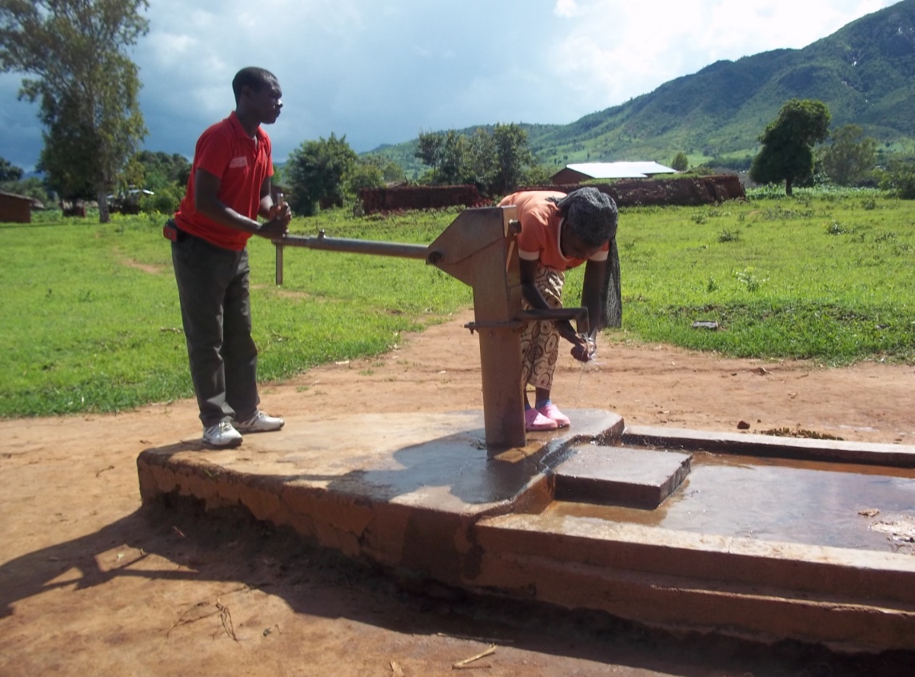
BH1 at Chileka primary school

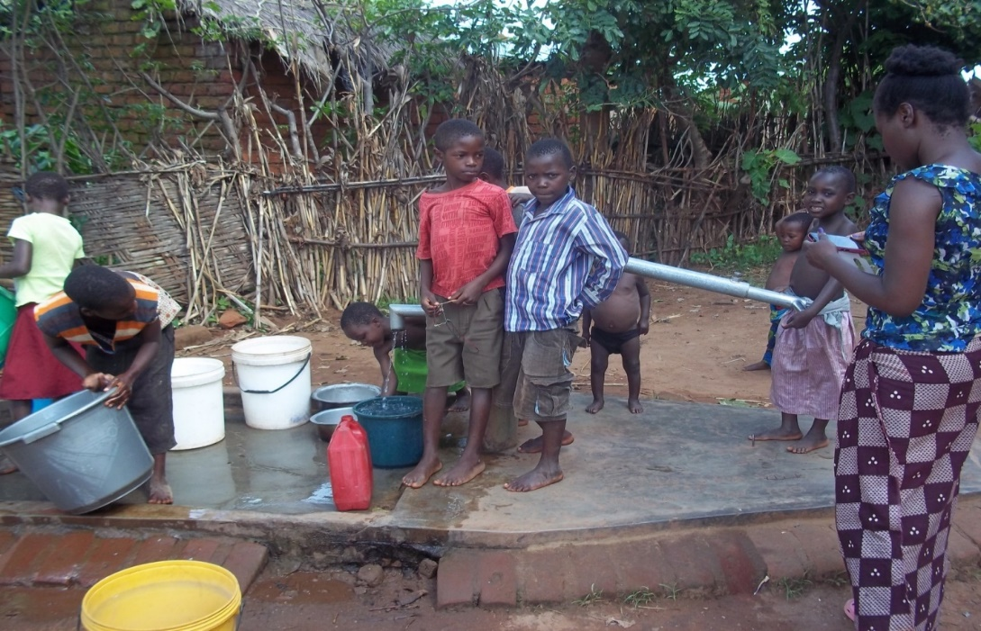
BH2 Near traditional court and close to Chauluka irrigation scheme
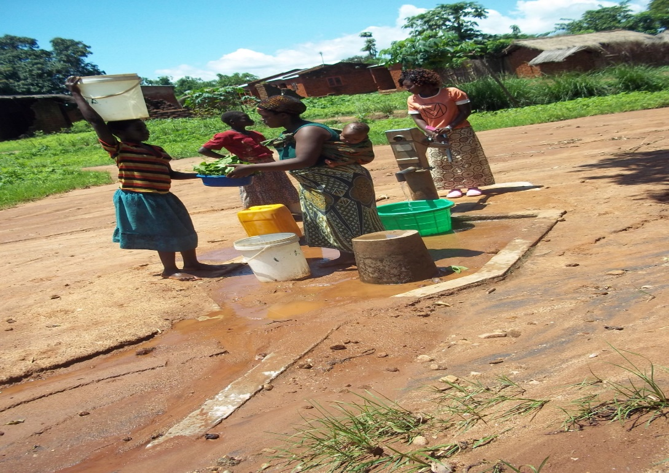
BH3 Near Mr. Davis Chambo’s house
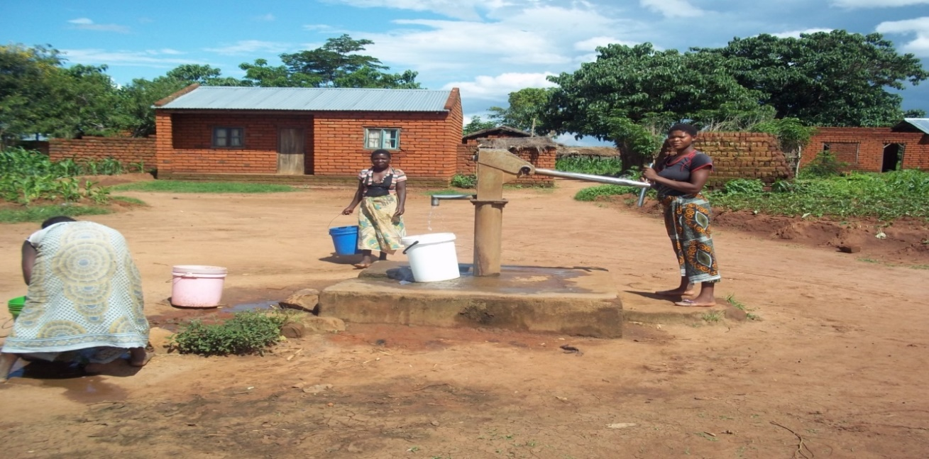
BH4: Near Chileka primary school
The well
The well is privately owned and belongs to one Mr Nyambo from the village. It was dug in 1987. The decision to dig the well was made seeing how scarce water was. He uses the water mostly for domestic activities. Men and women from nearby houses can access the well occasionally but not on a regular basis.

Irrigation scheme
The scheme was initially developed by some 17 men and women who took over the idea from 6 initiators headed by Mr Lazaro Baziwero. Mr. Baziwero had lived in Mozambique for a long time and upon coming back home in the 1990s, he and some 5 friends came up with idea of starting irrigation farming as he had seen how productive it was in Mozambique. The first group was supported by DANIDA, even though its history was not clearly explained. Respondents mentioned that DANIDA only brought the treadle pump technology. When other community members saw this they expressed interest to join. But they were not allowed. This made other community members, a group of 17 men, to come together and start digging canals right from the source of the river. They chose an area that was closer to the one that had been earmarked by the group of six men. This move brought conflicts amongst the two groups so that the issue went to the village head’s court but when it failed to be resolved, they went next to the Group Village Head. Here, it did not work either and the issue was referred to TA Njolomole’s court where, with help from the District Commissioner, a judgment was passed that the two had to join and be one group and that they had to choose a name to call their scheme. One of the leading members, Mr Davis Chambo, suggested “Tedzani Irrigation scheme” but the TA rejected for there was already a scheme by that name. He then suggested “Chauluka” for the two groups working together.
Out of anger, some members in the first group protested and quit scheme. Meanwhile, scheme construction continued with support from DANIDA up to 2006 when RIEP took over in the same year. RIEP worked with the scheme up to 2002 when CARE Malawi took over. With the passage of time, the number of members grew to the current 105 members (consisting of 37 men and 68 women). Despite having no women in the initiating group, currently there are more women than men in the scheme. One respondent observed that at the beginning the scheme seemed to be a man’s venture and women were reluctant to fully participate. The first group of women joined after water had been diverted from the main river. After almost four years, some of the 6 initiators rejoined the scheme.
The scheme has a committee of 10 (that is, 5 men and 5 women) who are the administrators of the scheme. They are responsible for enforcing rules and regulations under which the scheme operates. For instance, the rules include payment of membership fee of K500, water fee of K200 per season (but new members are required to pay K3000). The amount of K3000 is supposed to cover the work that the other members have so far done already. Membership to the scheme is free; anyone in GVH Muwalo is free to join. One needs to express their intention to join to the committee who explain the rules and if applicants agree, they are free to join.
There is fair distribution of water and plots in the scheme. The committee has divided the scheme into four groups recognized by blocks: A, B, C and D where they also choose leaders responsible for water distribution. The leaders are paired and alternate between men and women. Most of the respondents felt that water distribution is fair as there is a schedule that makes sure everyone in the block have access to water. Those with large plots are still accommodated in the same way as everyone else. However, when members with large plots or those who need more water present a request, they are allowed to irrigate at night. On plot allocation, respondents mentioned that every member is supposed to get no more than half an acre since demand is high. Those that do not have plots on the scheme find land by renting from those with plots there. Rental charges range from K2000 to K3000 an acre and, in some cases, plot holders simply agree to paying through labour, that they will prepare the land after the season is over.
Night irrigation has some rules that must be followed. For instance, men are free to go out to the scheme but there are limitations for women. Single women “mbeta” are not allowed to irrigate at night but married women can do that while accompanied by their spouses. The reason is that they do not want the scheme to be associated with rumours like single women having love relationships with men in the scheme. In exceptional cases, a single woman can be allowed to irrigate at night if she communicates to the committee and goes with her children but not alone.
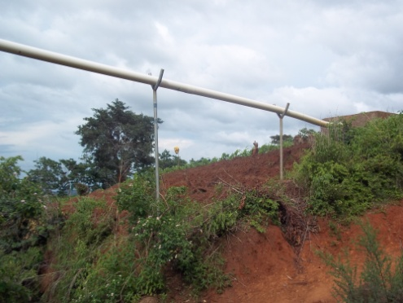
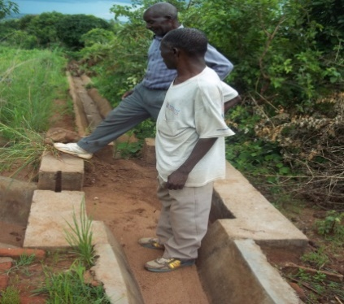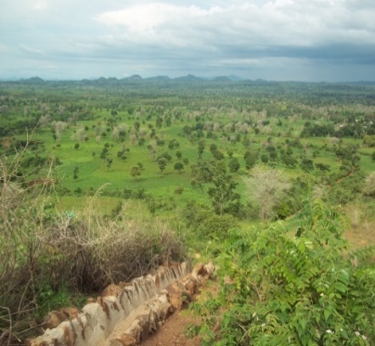
Chauluka irrigation scheme
Table 3 below shows the list of initiators of Chauluka scheme (2 groups)
Serial No | First Group | Sex | Second Group | Sex
1 | Lazaro Baziwelo | M | Davis Chambo | M
2 | Standford Soules | M | Rasford Chikafa | M
3 | Kilioti Witness | M | Weckson Fulagombe | M
4 | Keneyas Witnes | M | Howard Saulosi | M
5 | Watson Njoka (deceased) | M | Nelson Ngowe | M
6 | Rasford Mbirimtengerenji | M | Friday Chauluka | M
7 |  |  | Patrick Bonya | M
8 |  |  | Edward Noah | M
9 |  |  | Mackford Chawo | M
10 |  |  | Harold Majamanda | M
11 |  |  | John Chawo | M
12 |  |  | Wilson Kamwaza | M
13 |  |  | Samson Kanyemba | M
14 |  |  | Aaron Noah | M
15 |  |  | Kazembe Belias | M
16 |  |  | Daulosi Belias | M
17 |  |  | Hector Semu | M

Table 4: Names of plot holders at Chauluka Scheme
Serial No | Name | Sex
1 | Gilbert Joji | M
2 | Clifton Goziwa | M
3 | Lasford Mbirimtengenji | M
4 | Winfred Majamanda | M
5 | Lloyd Chagona | M
6 | Samudi Lanjesi | M
7 | Elemeleki Biniwell | M
8 | Mackford Chawo | M
9 | John Chawo | M
10 | Mackson Gonthi | M
11 | Nelson Ngowe | M
12 | Kazembe Beliasi | M
13 | Livison Kamba | M
14 | Symon Ching'amba | M
15 | Ganizani Ngowe | M
16 | Ronald Kakhobwe | M
17 | Davis Chambo | M
18 | Lazalo Bazwell | M
19 | Friday Chauluka | M
20 | Fickson Mkambeni | M
21 | Kenneth Ganiza | M
22 | Stanford Saulosi | M
23 | Mose Gada | M
24 | Frackson Chibweya | M
25 | Mateyu Friday | M
26 | Ronald Chikafa | M
27 | Chikondi Amosi | M
28 | Luka Friday | M
29 | Elemiya Chimangeni | M
30 | John Njati | M
31 | Kiliyoti Witinesi | M
32 | Clement Chakoma | M
33 | Felasi Kacheya | M
34 | Clifton Geoffrey | M
35 | Jalison Matiyasi | M
36 | Yosefe Gozwa | M
37 | Leckson Chilingulo | M
38 | Teleza Kachiwala | F
39 | Eliza Majamanda | F
40 | Assa Kamenya | F
41 | Loni Majoni | F
42 | Ethel Nowa | F
43 | Niya Chafera | F
44 | Namayesa Paulo | F
45 | Mercy Kapasi | F
46 | Grace Malopa | F
47 | Hilda James | F
48 | Dina Gasten | F
49 | Aida Kapalamula | F
50 | Ethel Zekeyu | F
51 | Faineti Chilumpha | F
52 | Dorothy Semu | F
53 | Matilda Amoni | F
54 | Neliya Yobu | F
55 | Florida Chilanga | F
56 | Lonily Faston | F
57 | Enesi Chipapi | F
58 | Eveness Ezala | F
59 | Malita Kafodya | F
60 | Enile Lihako | F
61 | Idesi Kamba | F
62 | Ketilina Bazwell | F
63 | Lucy Nyambo | F
64 | Daleni Chibenthu | F
65 | Faliya Clement | F
66 | Zelesi Disi | F
67 | Stella Nyambo | F
68 | Ficinesi Langton | F
69 | Lesa Fulagombe | F
70 | Dola Yoswa | F
71 | Mitera Cosmas | F
72 | Mercy Amosi | F
73 | Olipa Lemosi | F
74 | Milika Chataika | F
75 | Eliza Kacheya | F
76 | Filesi Kaludzu | F
77 | Meliamu Gozwa | F
78 | Linesi Semu | F
79 | M'dalakwanji Hesten | F
80 | Rachel Bemeyani | F
81 | Cecilia Genesis | F
82 | Elita Andrew | F
83 | Linesi Amos | F
84 | Esnati Dick | F
85 | Fanney Ganiza | F
86 | Namasoya Kamenya | F
87 | Selina Macheke | F
88 | Aida Mphepo | F
89 | Olipa Kakhobwe | F
90 | Mercy Chikondi | F
91 | Fatsireni Jamson | F
92 | Emily Josaya | F
93 | Chifundo Saulo | F
94 | Frone Bewala | F
95 | Manesi Malikebu | F
96 | Josofina Solomon | F
97 | Faineti Innocent | F
98 | Meliya Makiyi | F
99 | Grace Matebulo | F
100 | Alice Lusiyasi | F
101 | Nalesi Chikosa | F
102 | Lisofina Majamanda | F
103 | Bitiya Zakulanda | F
104 | Faineti Kamenya | F
105 | Lucy Phoya | F
Water use
Water from the above structures is used for a variety of tasks. For example, water from the boreholes is used on a daily basis for range of domestic tasks like drinking, washing, bathing, cleaning, and cooking but it is also used for moulding bricks and sometimes watering home gardens. Everyone in the house can access the water, but it is the women and children that use the borehole a lot more since they perform most of the domestic chores. Water from the wells is mostly used for many of the above mentioned tasks except cooking. Irrigation scheme water is mainly used for irrigating the crops in the dry season though sometimes people use the water for moulding bricks.
  - Use of Proceeds from farming
The use of proceeds from farming activities differs by household but it was found that the common used was buying fertilizer in preparation for the next growing season. They also indicated that they use the proceeds for buying clothes, basic needs like soap, salt and everyday upkeep. Others pointed out they were part of village banking and used proceeds as capital to some small scale businesses in the community. There were also a few who indicated that they use the proceeds for buying livestock and maintaining their houses. Men and women pointed out that proceeds from farming bring in more at one time and that it was easy to budget for bigger projects rather than proceeds from business or anything else. In some families the proceeds are handled by both wife and husband but in others it is the man as the head of the family. Women do not own a lot of assets; things like bicycles are mostly owned by men, even though some women might access them.
The study has found out that in Chauluka Village there is a clear gender division of tasks. Women are responsible for most of the domestic tasks including fetching water, preparing food, cleaning and cooking. On the irrigation plots, women also take a huge share. This is seen by looking at the composition of farmers at the Chauluka Scheme (Table 4 above). For married couples, both men and women cultivate plots together regardless of whose name the plots are registered in. Women and men engage in irrigation farming so that they can feed their children since there are few income earning job opportunities in the village.
Discussions with farmers revealed the following challenges:
- The scheme faces acute water shortages. According to the farmers, there are some villages up on Mponda Hills where the river originates and the people there have diverted water to supply to their gardens. This reduces the flow regime of the river so that at times crops dry up before maturity.
- Lack of a reservoir to keep water
- Access to farm inputs is also a challenge to most farmers
- Lack of markets for their produce

Findings from this study show that gendered land tenure is promoting water infrastructure development in Chauluka Village. Women are taking an upper hand in irrigation farming because they own the land and are interested in improving their livelihoods through investments in water. The fact that the scheme in the village has more female members than males also underscores the role of women as the main users of water for irrigation purposes. Women benefit from the scheme through increased availability of food and income. Men are interested in irrigation because of the perceived benefits accruing from such investments. Ownership of the land by women does not discourage or preclude men from investing and utilising the land for their benefit since they are aware of the cultural implications.
THE CASE OF KAMWAZA VILLAGE
In Kamwaza Village, as in other villages in Ntcheu, land is held under customary law with the village chief being the trustee on behalf of the people. Being a matrilineal society land is passed on from mother to daughter. However, in circumstances where a male child is not married and stays in his mother’s village, land can be given to him. The male child can decide to stay in his parents’ home after they get married and in that case he would be following the chitengwa (patrilocal) system. This arrangement is often associated with wealthy male families who would negotiate with the wife’s family to follow patrilocality (Phiri;.... Kaarhus).
Kamwaza irrigation scheme started in 2006 by a group of 13 men as a solution to persistent food shortages in their households (see Table 5). Although the scheme was established in 2006, the people of Kamwaza started irrigation farming way back in the year 2000 using facilities at the neighbouring Chauluka Irrigation Scheme. Kamwaza Irrigation Scheme gets its water from the Mbirimbite River. Currently it has a membership of 53, of which 42 are females and 11 males. Crops grown include maize, beans, vegetables and sweet potatoes. On average, a farmer cultivates a plot of about 0.1 hectares. Proceeds from irrigation farming help the farmers to be food secure and also to buy farm inputs for the rain fed farming season.
The scheme is still under construction but is expected to cover more than 60 hectares once completed. All construction work is being done by both male and female members of the scheme but materially, they get items such as cement and pipes from Total Land Care, a local Non Governmental organisation. According to the farmers, it has not been an easy task to establish the scheme because of the terrain of the area. For instance, the work was at times being interrupted by heavy rains as well as resistance from some owners of land who did not want the irrigation pipes to pass through their fields. The secretary of the scheme committee, who is male, lamented that “We had worked so hard that day to put the pipes up only to find them lying down the next day. The owner of the field had apparently removed them because he did not want to take part in irrigation farming”. This was a case of a recalcitrant member of the community. The matter was reported to the District Commissioner for adjudication. After reviewing the case, the District Commissioner through the Traditional Authority resolved that construction work should continue.
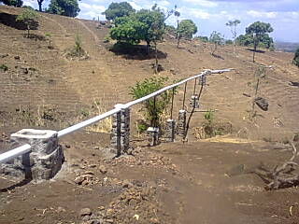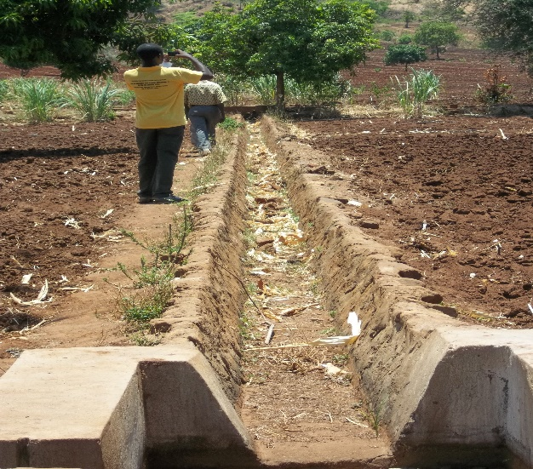
Part of Kamwaza scheme under construction

2.1. Marriage pattern
Just like in Chauluka, the discussion in Kamwaza also revealed that there are two marriage patterns that are followed in the community. These are also matrilocal and patrilocal. Lobola was also discussed in the area. Respondents said there are lobola cases in the area where a man brings a woman in after paying for the woman and the children to come. Once that is done, the woman and the children belong to the man’s family. These cases do not involve women from the area but those from outside the village. This pattern is different from the patrilocal one since, under this arrangement the children belong to the man. There are about 12 cases of lobola with 3 women from Likoma, 1 from Kasungu, 1 Rumphi, 1 Tanzania, 2 from Nsanje, 1 from Karonga, 1 from South Africa, 1 from Zimbabwe and 1 from Karonga, who is the village head’s wife. All these cases are of the village head’s clan men.
2.2. Land tenure
Just like the other village, land is inherited from parents “malo amachoka kumakolo”. The parents found land through the village head which passes through the children, generation by generation. Even when the parents die, land is still inherited by the children of both sexes. If any members wants more land, then they ask the village head who shares the reserved land called “Lizaya”.
2.3. Relationship between land tenure and marriage pattern
As land is passed from parents to children, marriage is one of the ways through which children get a share of their land from parents. In both settings, parents share land to their children. In the matrilineal where the man follows the wife to her home, the children are guaranteed security of their land. Explaining further, one of the male respondents stated that through marriages and inheritance land is sometimes recognized through a man and not a woman. The circumstance under which that happens is when cousins marry each other. In such a case, the woman’s uncle, who is mostly the head of the family land is the one that gets to be the father in law, the father of the woman’s husband. In this case land is recognized by the male side. He gave an example of this situation in Kamwaza royal family, saying the leadership goes through the man’s side.
In a lobola setting, when the woman is brought into the area, it means that she and her children are forever members of that community. In case the husband dies, they remain and cultivate in the area. One of the respondents interviewed was married through lobola. She is a Tonga originally from Likoma in northern Malawi but her husband passed away in 2000. She has lived in the area since 1973 and still lives there to date.
2.4. Divorce rate
There are cases of divorce happening in the area and these cases mostly involve younger couples aged between 17 to 35 years. One of the reasons given is that younger couples lack respect for each other. One woman said “anthu ali osainilana kwa mzake kuno, chikondi chinatha” to mean that both men and women do not listen to each other and there is no love between them and this results in divorce. Others argued that there is too much freedom these days and that some women have become rude to their husbands. To avoid going to the police in the name of gender violence men just prefer to leaving the women. On the same issue, one woman said “kusasamala kwa ife azimayi, mwamuna ali kuntchito kutenga mphongo kulowetsa nyumba” which means some women are careless, with the trend of men going to South Africa or work somewhere else, some women become loose and invite other men into their houses. This leads to breakup of their marriages.
Other respondents also blamed men for such unbecoming behaviour. One woman said “amuna atekeseka kudziwa azimayi ndiye akumawasiya azimayi, akadziwa nkufunsa, nkumati ndiwe wamwano kazipita” meaning that many young men are womanizing so that when a woman gets to ask they are labelled as rude and sent packing. In the discussion, it was noted that men are mostly the ones who decide to end the marriages, and when a man decides, a woman is supposed to listen. The other issue that came up concerns the use of the counsellors (ankhoswe). Much as it used to be effective in the past, men and women said that nowadays couples decide on their own what they want to do and by the time the issues get to the counselors, they would have already made their decision to separate or divorce.
There are issues of gender violence in the area and most women pointed out that it is due to the infidelity of men. If a woman hears something about her husband, she ends up being beaten; mostly it is men who beat their wives. Others said the issues of gender violence are not as many due to freedom that everyone seems to have. One man said that issues that were referred to as discipline are now referred to as violence thus many people are afraid of going to the police or to the village court, so they just let things be as they are or divorce.
2.5 Changes in the land tenure over time
Just like in the other area, people from Kamwaza also said they had seen a lot of changes on land tenure issues. The commonly held view is that there used to be more land in the past compared to the present. Of course this is inevitable because people are still being born and are using the same amount of land. One man said with confidence that in next year there will not be anyone farming a plot as big as 2 acres alone, since children are being born and land is being shared.
They also talked about people showing love through sharing land in the past which cannot happen now. Some talked about the idea of borrowed land, noting that people in the past could lend each other land for free and the person could use until when they were ready to give it back. Nowadays no one can be found doing this, it is either they are renting it to someone with money or labour. On access to land, one of the respondents gave the example of himself, saying he used to cultivate some “dimba” garden with his mother. He grew up cultivating that same “dimba” until it was taken away from him by the owners saying the land was just borrowed to the mother and not owned.
Another change concerns the idea of land ownership where people now make demarcations on land foe easy identification. One woman said in the past people would just move anyhow not worrying about where they would start from once they are back. They would find a place easily unlike nowadays when people mark land so that when they go elsewhere and come back they may not find their plots intact. Even a village head has no power over abandoned land as it used to be the case in the past, when the village head would give idle land to others with no land at all. For those with no land, the trend is still the same, they can approach the village head who gives them from the remaining communal land. If not enough, they can rent land from those willing and there is more of rented land than borrowed land in the area. The rates of the rented land ranges from K3,000 to K8,000 per acre according to the interests of the owner.
In relation to marriage patterns, some respondents said much as the land belongs to women or men, the power has moved from the family or the uncles to the father or parents, to mean if a father gets to leave a will before he dies, the law will follow what the will says. Nowadays most parents leave their land or houses to their children, and this has reduced cases of people sending women and children home in case the man dies. Women benefit from this new development because according to one respondent, “mayiwo katundu wake ndi anawo” meaning that the mother owns land and the children, so they are not homeless, and the same goes for men in the matrilineal setting. One woman said because of the new development, men are not afraid to build houses “aliyense ali paufulu kumanga maziko a ana ake” meaning, everyone is striving to build a foundation for their children unlike in the past when people were very concerned with tradition that children belong to a woman and that their wellbeing had to be in the hands of the mother.
2.6. Gendered division of livelihood
From the discussion it was indicated that both men and women share responsibilities when it comes to cropping tasks. Both sexes work together starting from clearing the land to harvesting. But most respondents said that everything to do with the granary is done by the women and men only help when constructing it. Women are the ones that enter the granary in line with the tradition that women are responsible for food security in the home. However an emergency like a wife being away or sick, then a man can enter the granary.
On domestic chores, men have been found to help out on some but with women taking most of responsibilities. For activities like cooking, cleaning the home, going to the maize mill, washing, taking care of children and fetching firewood, it is women who perform such tasks. Other activities like fetching firewood, both men and women can do and men are becoming more involved than they used to do in the past. With cooking, men do this during emergencies like women or female children not home but if all is fine it is the women’s task. For taking care of the children, it is now becoming both the woman’s and man’s task. For expenditure on clothes, fees or upkeep is done by the men as the head of the family. Respondents also said that men do not support their sister’s children although this was common in the past. The reason is that people have become more modern and believe in taking care of their children and men strive to provide for their own children. Roof making and house construction are usually done by men with women only helping out in passing the mud and the grass. The same goes with brick moulding where men do the moulding and women help in fetching water for the work. Water for domestic use is fetched by women and children.
2.7. Use of proceeds from farming
As it has been mentioned above, in the male headed families men are the ones that make decisions with sometimes in consultation with their wives since they do the farming together. It was found out that many also prioritize fertilizer for the next growing season, while the rest of the proceeds are used for consumption (food and clothes). Some women belong to village credit groups, so proceeds go there. In the female headed households, the woman is the one responsible for decision making and they use proceeds in similar wasys as above. It was also noted that many of the men in this area drink beer and that is one of the activities on which they use the money for.
2.8. Impacts of matrilineal or patrilineal land tenure on gendered investments in land-bound water infrastructures
2.8.1 Water investment infrastructures in the village
The village has only 1 borehole and an irrigation scheme. The borehole is recognized by the village head and it is public to be used by everyone. The borehole is said to have been installed around the 1970s, it was the first borehole to be installed in Kamwaza villageThe water is basically used for everything that needs water, starting with domestic tasks; drinking, cooking, washing, cleaning, and bathing. It is also used for tasks like moulding bricks, building houses and in some cases for irrigating home gardens. It was mentioned that the borehole was donated by Government through the village head to cater for the entire village; hence the siting was made in the middle of the village. There is a committee that runs the water facility which was chosen by the community with the support of the village head. In case the borehole develops faults, the committee was trained on how they can fix such problems and also how to keep it clean. The committee consists of both men and women and most of them are equipped with the skills but it is usually the men. For maintenance expenses, the men and women around contribute money with guidance from the committee. Everyone can access the water but it is mostly used by the women and children since they are usually the ones that do most of domestic chores.
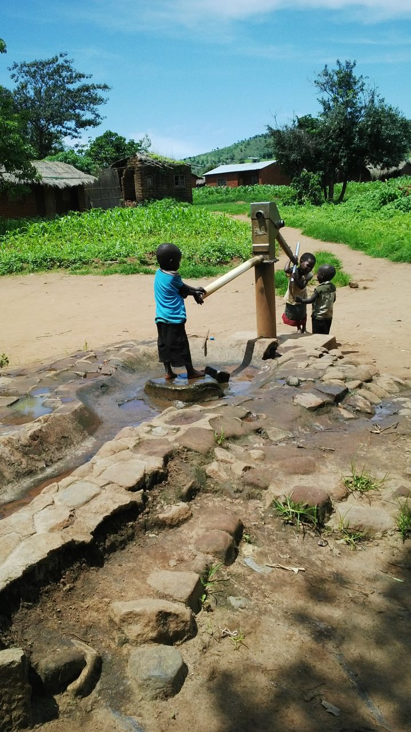
The irrigation scheme was initiated in 2006 after some members had left farming at Chauluka scheme. It started with 12 men and 1 woman. These 13 people were all from the ruling clan of Kamwaza. After noticing constant food shortages in the area, the 12 men decided to develop their own scheme using Mbiririmbite River. In this year, they were helped by ADMARC with 16 bags of fertilizer which was shared amongst the group. The woman’s task was to gather food from the men’s homes to use at the construction site. They worked for 12 days and the water got to the spot they targeted by the end of those 12 days. The site was chosen with some traditional knowledge about land and water. They chose this particular site because of the presence of “mkuwu” tree which traditionally they know that where such trees exist, the river does not run out of water. The spot has a lot of trees which meant that those trees keep water. After diverting the water, more people joined and now there are 53 with women outnumbering the men. There are 40 women and 13 men despite the fact that had been the initiators. Most of the respondents pointed out that this is due to the fact that women are found around their homes throughout the year than men. In addition, they said women also tend to welcome developments in the area better than men who are not usually home. The scheme is still under construction; all work is done by the members regardless of sex. Women and men are very much involved in gathering the sand and stones for construction works whilst most men do the building. Cooking is usually done by the women but everyone contributes the food. They have a committee of 10, comprising of 4 women and 6 men which were chosen by members of the scheme. They have recently been supported by CARE Malawi which provided equipment and training on administration and also maintenance and skills regarding irrigation farming. However in the process they experienced resistance from some land owners who did not want the pipes to pass through their farms and they had to settle the matter through the TAs intervention and in the end work continued. The committee is responsible for managing the scheme at all levels; it is also the one that communicates with the donors. Membership is free so long as one is part of Muwalo group village head. One expresses their need to join the scheme to the committee who lay down the rules under which their scheme operates like membership fee of K600, water fee of K500 and a yearly fee of K500, making a total of K1600. For the new members wishing to join, they have to a pay an extra fee that covers the work the rest of the group have done before. In their scheme, if a member misses a day, s/he is charged K200 a day. So when a member is re-joining, they do a calculation of those missed days, which they may pay by installments.
Much as the work has not fully started at the scheme, respondents claimed that there has been fair distribution of water at the site to both men and women. Water is shared in blocks where leaders help in the distribution of the water. However some complained that at times those with bigger plots do not want to share the water fairly. In terms of land some members who already have plots at the site ended up having bigger plots. Those that do not have the plots have to rent from those not using all their land or those in the scheme but with bigger plots. Due to the differences in plot sizes, there is night irrigation which is mostly done by men. There is no rule against women doing it but most respondents said women are just afraid to go to the site at night because the area is known to have hyenas. Every member is free to let the spouse work on their behalf if need be, they said this also goes beyond family members. One can use hired labour if need be, but they only need to inform the committee about this.
However, many respondents said that as soon as the growing season starts this year, they have been trained that land has to be shared equitably to every member to ensure that there is indeed fair distribution of water and also manageable to everyone. The plan is that the scheme will expand by getting more land from both members and non members, then they can share that land fairly with sizes of 20 by 50 metres for each member.
Table 5 below shows the names of the Kamwaza scheme initiators
Serial No | Name | Sex
1 | Peter Kalinde (deceased) | Male
2 | German Kamwaza | Male
3 | Lekison Rabson | Male
4 | Sitithanda Mpemba | Male
5 | Chikondi Mpemba | Male
6 | Jefrey Lekison | Male
7 | Lonard Chadilika | Male
8 | Kapasule Lekison | Male
9 | Wilson Kamwaza | Male
10 | William Kamwaza | Male
11 | Akimu Kanyemba | Male
12 | Tomasi Masauko | Male
13 | Catherine Chimsitsi | Female

Table 6: List of plot holders at
Kamwaza irrigation scheme
Serial No | Name | Sex
1 | Akimu Kanyenda | M
2 | Alesi Ketulo | F
3 | Ayiline Ketulo | F
4 | Belita Hesten | F
5 | Dorothy Robert | F
6 | Efilida Chinkanda | F
7 | Egileti Chinkanda | F
8 | Elena Lekisoni | F
9 | Elicy Westoni | F
10 | Elifa Masanjala | F
11 | Elina Tchester | F
12 | Enita Paulo | F
13 | Evelyn Westoni | F
14 | Flora Saidi | F
15 | German Kamwaza | M
16 | Gertrude Kachingwe | F
17 | Gilita Agisoni | F
18 | Jamson Viah | M
19 | Jeneti Duli | F
20 | Jephry Lekison | M
21 | Joyce Devi | F
22 | Josofina Majamanda | F
23 | Josse Nelson | F
24 | Judith Muwalo | F
25 | Kafeleni Chitsitsi | F
26 | Kafeleni Noah | F
27 | Lefita Listone | F
28 | Lekison Labson | M
29 | Linile Viga | F
30 | Liniya Siyaya | F
31 | Lones Manuel | F
32 | Lucy Christopher | F
33 | Luniya Jackson | F
34 | Luniya Siyaya | F
35 | Magi Njala | F
36 | Margaret Fulaitoni | F
37 | Margaret Maxwell | F
38 | Maleni Kandeu | F
39 | Mary Kamwaza | F
40 | Masauko Ngoma | M
41 | Mavesi Kamwaza | F
42 | Mphatso Kamwaza | M
43 | Olipa Kambenje | F
44 | Onex Masanjala | M
45 | Patricia Lonard | F
46 | Seveliya Libson | F
47 | Sinosi Kajawo | M
48 | Sitithana Mphemba | F
49 | Stadon Chilingulo | M
50 | Tikulirapati Amos | F
51 | Tomasi Masauko | M
52 | Willy Matchosi | M
53 | Nelson Jossey | M

Like Chauluka, residents of Kamwaza Village have clear gendered division of tasks. Women are responsible for all domestic tasks and on the farm, they also take a huge share.
Women and men in Kamwaza have very few options available to them and so they tend to engage in irrigation farming as a way of raising income to feed their children. They complained that there are no other income earning opportunities in the village. They mentioned the following challenges affecting their livelihoods:
- Some members do not own land at the scheme, instead they rely on rented land. This affects irrigation farming calendar since the tenant has to wait for the owner of the plot to harvest his or her regular rain fed crops before preparing for irrigation.
- There is lack of a reservoir to collect and keep water for irrigation. This makes it difficult to irrigate crops once water levels become low in the months of September and October. So instead of planting twice, the irrigation farmers plant only once.
- The scheme is undergoing construction with the help of Total Land Care but the organisation is phasing out of the area this year even before all works have been completed. Therefore the scheme needs more funds for completion.

The study has found that there is a direct link between gendered land tenure and investments in water infrastructure. Women who own and control land are taking an upper hand in the use of water through irrigation farming, allowing them to produce food for their families.
6.0 CONCLUSION
Findings from this study show a different trend in land tenure and water investments from elsewhere. As owners of the land, women who use water for domestic and productive activities are key in the promotion of water infrastructure development. Although men took the initiative to set up the irrigation scheme, women dominate in terms of numbers of plot users. The existing matrilineal land tenure allows women to invest and produce food for their families. This has been evidenced by the membership of the irrigation schemes. The study has also revealed that water use is gendered as it is mostly women that use it for productive and domestic activities.

BIBLIOGRAPHY
Amede T, Desta L, T, Harris D, Kizito F, Cal, Xuellang (2014) The Chinyanja triangle in the Zambezi River Basin, southern Africa: status of and prospects for agriculture, natural resources management and rural development (Unpublished report).
Andersson Djurfeldt, A. (2013). "African Re-agrarianization? Accumulation or Pro-poor Agricultural Growth?" World Development 41: 217-231.

Andersson Djurfeldt, A., G. Djurfeldt and J. Bergman Lodin (2013). "Geography of Gender Gaps: Regional Patterns of Income and Farm–Nonfarm Interaction Among Male-and Female-Headed Households in Eight African Countries." World Development 48: 32-47.

Andersson Djurfeldt, Agnes; Mulwafu, Wapulumuka; Mvula, Peter; Djurfeldt, Göran; Hillbom, Ellen, "’the family farms together, the decisions , however, are made by the man’ – Limits to women’s incomes and ‘bargaining power’ within matrilineal, uxorilocal land tenure systems in Malawi“ Journal of Agrarian Change forthcoming

Andersson, A. (2011). "Maize remittances, smallholder livelihoods and maize consumption in Malawi." Journal of Modern African Studies 49(1): 1-25.

Berge, E., D. Kambewa, A. Munthali and H. Wiig (2013). Lineage and Land Reforms in Malawi: Do Matrilineal and Patrilineal Landholding Systems Represent a Problem for Land Reforms in Malawi?, Centre for Land Tenure Studies, Norwegian University of Life Sciences.

Bhaumik, S. K., R. Dimova and I. N. Gang (2013). Is women's ownership of land a panacea in developing countries? Evidence from land-owning farm households in Malawi, William Davidson Institute at the University of Michigan.
Boserup, Esther (2005), The conditions of agricultural growth: the economics of agrarian change under population pressure. New Brunswick, New Jersey: Aldine Transaction.

Boserup, Esther (2007), Woman’s role in economic development. London Sterling, Virginia: Earthscan

Bryceson, D. F. (2006). "Ganyu casual labour, famine and HIV/AIDS in rural Malawi: causality and casualty." Journal of Modern African Studies 44(2): 173.
Chanock, M. (1985). "Law, custom and social order: The colonial experience in Malawi and Zambia."

Chileshe, Roy Alexander (2005) Land tenure and rural livelihood in Zambia: case studies of Kamena and St Joseph (Unpublished report).

Chirwa, E. and A. Dorward (2013). Agricultural Input Subsidies: The Recent Malawi Experience, Oxford University Press.

Chirwa, E. W., P. M. Mvula, A. Dorward and M. Matita (2011). "Gender and intra-household use of fertilizers in the Malawi Farm Input Subsidy Programme." Unpublished Report.

Chirwa, W.C. (2002) ‘Land Use and Extension Services at Wovwe Rice Scheme, Malawi’, Development Southern Africa, 19(2), 307-327.

Daley Elizabeth and Birgit Englet (2000).“Securing Land Rights for Women”. Journal of Eastern African Studies 4, No. 1.

Davison, Jean (1993). “Tenacious Women: Clinging to Banja Household Production in the Face of Changing Gender Relations in Malawi” JSAS 19, 3:405-21.
Djurfeldt, G., E. Aryeetey and A. Isinika (2011). African Smallholders - Food Crops, Markets and Policy. London, CAB International.

Djurfeldt, G., H. Holmén, M. Jirström and R. Larsson, Eds. (2005). The African Food Crisis - Lessons from the Asian Green Revolution. Wallingford, CABI Publishing.
Ferguson, A. E., and W. Mulwafu (2007) “If Government failed, how are we to succeed? The importance of History and Context in the present-day irrigation reform in Malawi” in Barbara van Koppen, Mark Giordano and John Butterworth’ (eds.) Community-based Water Law and Water Resources Management Reform in Developing Countries, CAB International.
Government of Malawi, “Malawi National Land Policy”, Ministry of Lands and Housing. Lilongwe, December 2001.

Hirschmann, D. and M. Vaughan (1984) Women Farmers in Malawi: Food Production in the Zomba District, Berkeley, CA: Institute of International Studies, University of California.
Holden, S. T. and R. W. Lunduka (2013). Who Benefit from Malawi's Targeted Farm Input Subsidy Program? Forum for Development Studies, Taylor & Francis.

Jul-Larsen, E. and P. Mvula (2009). "Security for Many or Surplus for the Few? Customary Tenure and Social Differentiation in Southern Malawi" Journal of Southern African Studies 35(1): 175-190.

Kaarhus, R. (2010). “Women’s Land Rights and Land Tenure Reforms in Malawi: What Difference Does Matriliny Make?” Forum for Development Studies, 37:2, 171-192.
Kennedy, E. and P. Peters (1992). "Household food security and child nutrition: the interaction of income and gender of household head." World Development 20(8): 1077-1085.
Kettlewell, R.W. (1965). Agricultural Change in Nyasaland, 1945-1960 (Stanford: Food Research Institute, 1965), Vol.5:229-285.

Kishindo, Paul (2004) “Customary land tenure and the new land policy in Malawi” Journal of Contemporary African Studies, Vol. 22(2), 213 -225.

Kishindo Paul (2006). “Customary Land Tenure: A Village Case Study”, in Tsutomu Takane (ed.), Current Issues of Rural Development in Malawi, Institute of Developing Economies.

Kishindo, P. (1996) “Farmer Turnover on Settlement Schemes: The Experience of Limphasa Irrigated Rice Scheme, Northern Malawi”, Nordic Journal of African Studies, 5(1), 1-10.

Makato, CJA (1984) “Smallholder Rice Irrigation in Malawi: The Role of the Farmer in Irrigated Rice” in Blaikie, M., (ed.) African Regional Symposium on Smallholder Irrigation. Harare: University of Zimbabwe, pp. 287-294.
Mead, Margaret (1976) “A Comment on the role of Women in Agriculture”, in Irene Tinker and Michele Bo Bramen (eds) Women and World Development: The Complexities of Change, Washington, D.C: The Overseas Development Council.

Meinzen Dick, Ruth and Margreet Zwarteveen, (1998) Gendered participation in water management issues and illustrations from water users’ association in South Asia:
Mitchell, J. C. (1956). The Yao Village: A Study in the Social Structure of a Nyasaland Tribe, Manchester University Press.

Moore H.L. and M. Vaughan (1994).Cutting Down Trees: Gender, Nutrition and Agricultural Change in the Northern Province of Zambia, 1890-1990. Portsmouth, N.H.: Heinemann.

Mulwafu, W.O and B. Nkhoma (2004). “The Experience of Irrigation Management Transfer in two Irrigation Schemes in Malawi, 1960-2002”, Journal of Physics and Chemistry of the Earth, (29), 1327-1333

Ng'ong'ola, C. (1982). "The design and implementation of customary land reforms in central Malawi." Journal of African Law 26(2): 115-132.
Njuki, Jeminah M., Mariam T Mapira, Shamie Zingore and Robert Delve “The dynamics of social capital in influencing use of soil management options in the Chinyanja Triangle of southern Africa” (Unpublished report).

Palmer, Robert and Neil Parsons, Eds, (1977). The Root of Rural Poverty in Central and Southern Africa. Berkeley and Los Angeles: University of California Press.

Peters Pauline, E. (2010). “Our daughters inherit our land, but our sons use their wives’ fields”, in Journal of Eastern Africa Studies Vol. 4, No. 1.
Peters, P. E. (1997). "Against the Odds Matriliny, land and gender in the Shire Highlands of Malawi." Critique of Anthropology 17(2): 189-210.

Peters, P. E. (2006). "Rural income and poverty in a time of radical change in Malawi." The Journal of Development Studies 42(2): 322-345.

Peters, P. E. (2010). "“Our daughters inherit our land, but our sons use their wives' fields”: matrilineal-matrilocal land tenure and the New Land Policy in Malawi." Journal of Eastern African Studies 4(1): 179-199.

Peters, P. E. (2013). "Land appropriation, surplus people and a battle over visions of agrarian futures in Africa." Journal of Peasant Studies 40(3): 537-562.

Peters, P. E. and D. Kambewa (2007). "Whose security? Deepening social conflict over ‘customary’ land in the shadow of land tenure reform in Malawi."
Takane, T. (2008). "Labour use in smallholder agriculture in Malawi: six village case studies." African Study Monographs 29(4): 183-200.
Vaughan, Megan (1987). The Story of an African Famine: Gender and Famine in Twentieth-Century Malawi. Cambridge: Cambridge University Press.

Veldwisch, G. Bolding, A. and Wester, P. (2009) “Sand in the Engine: The Travails of an Irrigated Rice Scheme in Bwanje Valley, Malawi”, Journal of Development Studies, 35(3), 197-226.

