


Evaluation of Bush and Climbing Beans under different Cropping Systems and Nutrient Management Regimes in Linthipe and Kandeu, Malawi
2014/15 season Annual Report for Africa RISING

Gift B Ndengu, Lulseged Tamene Desta, Powell Mponela, Barthlomew Chataika, Rowland Chirwa
International Centre for Tropical Agriculture, Malawi Office, Box 158, Lilongwe
Contact person: Lulseged Tamene Desta – lt.desta@cgiar.org
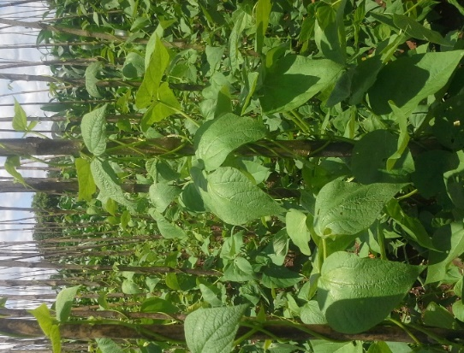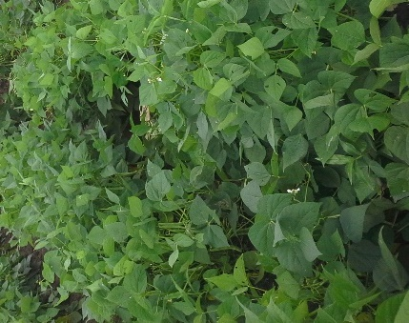

Contents
Executive summary 3
Acknowledgement: 4
Introduction 5
Methodology 6
Study Area 6
Study design and treatments 6
Data collection and statistical analysis 7
Outputs 8
Scale out new varieties through increased mother and baby trials 8
Reduction of bean yield gap by promoting use of best fit agronomic practice 9
Grain yield, podload, and seed-podratio 9
Effects of management (cropping system and soil amendments) and genotype (variety) on yield 11
used. 15
Effects of agro-ecological zones on the yield of beans 15
Land equivalent ratio (LER) 15
Conclusion 16
References: 5
Appendices 7

Executive summary
CIAT is undertaking action research based on mother-bay approach in Linthipe and Kandeu, in the Dedza and Ntcheu districts of Malawi, respectively. The overall aim is to improve bean production through introduction of improved bean genotypes and integrated soil fertility management (ISFM) technologies. Participatory approaches were adopted to enhance learning in farmers and provision of feedback to researchers. Trials were laid out in a split plot design, where varieties were whole plots while management option (eight treatments) were split plots.
We noted from levels of participation predominance of women members (82.8% of 209) and ownership of mother trials (91.4% of 12). The climbing bean varieties (DC86-263 and MBC33) were greatly affected by the dry spell that affected the region. Coincidentally, the bush beans varieties (SER45 and SER83), bred for drought tolerance were put under field test and had good performance. In climbers the terminal dry spell affected podding 4.2 - 8.6 (mean = 6.3), podfilling (low-pod ratio) 1.4 – 3.1 (mean= 2.2) and yield 0.2 – 0.5 Mgha⁻¹ (mean = 0.3 Mgha⁻¹), where as in bush beans higher podload of 14.2 – 18.9 (mean = 16.1), seed-pod ratio 2.7 – 4.1 (mean = 3.2) and yield 0.9 – 1.2 Mgha⁻¹ (mean =1.05 Mgha⁻¹) were realised. The poor performance of climbers during the season was in contrast with the one during previous normal season 2013- 14, where the yield range was 0.61 – 2.6 Mgha⁻¹ (mean = 1.5 Mgha⁻¹). Nevertheless, the success story of the bush bean varieties SER45 and SER83 in the 2014-2015 growing season, underlined their suitability for use in drought conditions.
The study found the interaction between genetic and environmental/management factors on bean productivity with significant differences in yield among cropping systems when either intercropped with maize or sole planted, application of chicken manure, NPS fertlisers, or manure + fertiliser (p< 0.05). SER45 and MBC33 responded well to manure only, while SER83 and DC86-263 required a combination of manure and fertilizer. This points to the need for matching genotypes to appropriate cropping system and fertility management. Across agro-ecologies, there were insignificant differences (p > 0.05) in bush bean productivity. On the other hand, climbers had significantly better performance in the rift valley escarpments (RVE) of the Kandeu site (0.51 ± 0.53 Mg ha⁻¹) compared to the Lilongwe plain (LLP) of the Linthipe site climbers with lower yields (0.27± 0.33 Mg ha⁻¹).
The land equivalent ratio (LER) for bean-maize intercrop in the trial was found to be 0.9. This implies that intercrop reduced land utilization for maize-bean cropping system by 10%. The low value was due to yield of beans which was significantly lower in intercrop than under sole. However, for maize intercropping with beans was advantageous giving higher combined yield under intercrop than as a sole crop. This indicates that a farmer would not require extra land to produce enough maize and bean would be an additional cropping the contrary, bean farmers would require more land when intercropped with maize to produce as much as it would do under sole cropping.

Acknowledgement:
This research work was undertaken under the CGIAR Dryland Systems, but was funded by the USAID through Michigan University, under the Africa RISING project.
We are very thankful to the Africa RISING project for funding the project. Gratitudes also go to the Department of Extension Services (DAES) in Ministry of Agriculture, Irrigation and Water Development for helping in the implementation. In Particular we are thankful to Mr. E. Mwazani and Mr. J. Phiri (Kandeu) and Ms. M. Mkandawire and Mr. H. Dambolachepa (Linthipe) for providing guidance to farmers in the trials and coordinating activities.

Introduction
Common beans are the cheapest source of proteins for the rural poor and are a readily available source of calcium, magnesium, vitamin B, iron and Zinc (TL II, 2013). In addition, they can also be sold to generate income to help farmers’ access essentials to improve their lives. However, several constraints including low soil fertility, unsuitable varieties, and adverse climatic conditions such as drought have resulted in yield being of as low as 381 kg ha⁻¹in Malawi against potential of 1500-5000 kg ha⁻¹ (Muthoni et al., 2007; TL II, 2013; Ramaekes et al., 2013). Similar constraints in production have been identified in other Sub-Saharan Africa (SSA) countries where productivity has been reported to be at about 470 kg ha⁻¹ (TL II, 2013). Yield gaps among farmers within same locations and with similar ecological conditions result from slow adoption as well as temporal differences in adoption rate of new bean production technologies for pest and diseases management as well as soil fertility management (Muthoni et al., 2007; TL II, 2013). Unlike most other leguminous crops, common beans are not very well adapted to extreme weather conditions, such as very low and high temperatures (Rao et al., 2013). Drought or moisture stress at critical times significantly affects bean yield, however, severity of effects due to moisture stress depends on the stage of development at which the bean is and the type of bean (i.e. whether climbers or bush beans) (Rao et al, 2013). Prolonged dry spells during the flowering stage result in yield reduction, caused by low production of pods, while dry spells at pod forming stage cause yield drops due to embryonic abortions (Emam et al., 2010). Such fragilities to climatic effects necessitate the use of the most suitable varieties for a particular agro-ecological zone to enhance productivity.
The Integrated Soil Fertility Management (ISFM) techniques where farmers combine use of drought resistant and high yielding varieties are being promoted to address these challenges and improve productivity of maize-bean farming system. In addition, farmers also need to be equipped with good agricultural practices including pest and disease identification and management, and timely and appropriate application of inputs, planting, weeding, and harvesting. However, there is still challenge as technology adoption by smallholder farmers in the region is still low (Ajayi and Oloruntoba, 2007). Mother- baby approach is being championed to effectively create a farmer- researcher interfacethat creates an environment conducive for knowledge and experience exchanges between farmers and researchers, for effective adaptation of site specific crop productivity technologies and their dissemination. This approach has been found effective for delivery and dissemination on promising technologies. The varieties understudy include SER45 and SER83 (bush bean), as well as DC86-263 and MBC33 (climbing bean) are promising for drought tolerance and adapting to bean growing areas of Malawi, respectively. On station and on farm trials conducted across the major bean growing agro-ecologies demonstrated high inherent potentials in yield, disease resistance, and drought resilience/tolerance, the selected varieties. SER45 and SER83 varieties were specifically bred for drought and aluminium toxicity tolerance, disease resistance, and high yield (CIAT, 2010). Both SER45 and SER83 are small seeded genotypes (varieties). Evaluation of the mid-altitude climbers by McKnight foundation and the National Bean Programme in Malawi identified MBC33 and DC 86-263 as promising climbers. Notably, MBC33 is a large seeded variety, while DC 86-263 is a small seeded.
In view of this, bean variety performance assessment trials were undertaken by CIAT for the above varieties in Kandeu and Linthipe Extension Planning Areas (EPAs), in Ntcheu and Dedza districts, respectively. The main goal of the trials was to improve bean production through introduction and dissemination of improved bean production technologies, based on use of improved varieties and integrated soil fertility management (ISFM) to bean farmers in the site. The approach was to be that of participatory approach. Specific objectives included to: (a) increase number of mother trials to accommodate a larger number of farmers for wider benefit; (b) study and demonstrate the effects of different management options (manure, fertiliser, intercropping) on yield of climbing and bush beans , in different soil health conditions; and (c) Reduce yield gap by use of improved agronomic and management practices.

Methodology

Study Area
The study was undertaken in Kandeu (Ntcheu) and Linthipe (Dedza) Extension Planning Areas (EPAs) in central Malawi (Fig. 1). Linthipe and Kandeu are both located in central Malawi at 14º 10’ south and 34º 10’ 6’’ east, and 14º 35’south and 34º 37’, respectively. The sites are renowned bean growing areas, providing good opportunity of comparing with existing varieties in determining the performance of the newly introduced varieties, as well as fertility management options. These sites were purposefully selected as they had contrasting agro-ecologies [Lilongwe plain (LLP) for Linthipe and the rift valley escarpments (RVE) for Kandeu) which can facilitate genetic x environment interaction comparisons. Linthipe is a medium - high altitude site (1200 – 1300masl), while Kandeu is a low- medium altitude site (900 – 950masl.
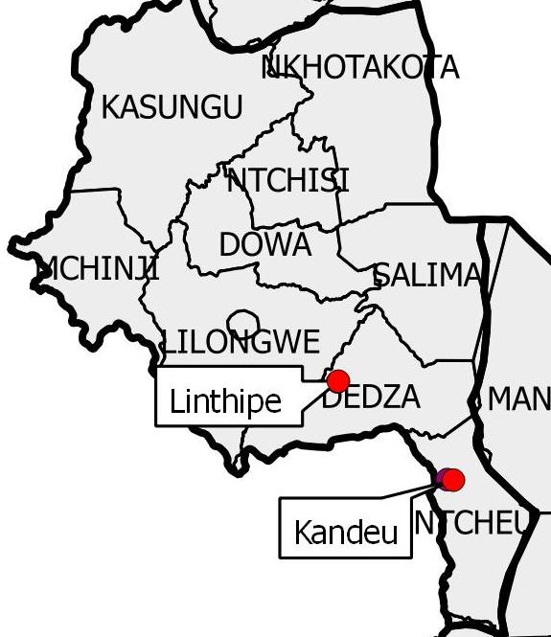
Figure 1: Map of central Malawi showing Africa Rising sites

Study design and treatments
In these trials different management practices were tested in a participatory manner under a mother- baby trial design. In this design, a mother trial is a ‘demonstration farm’ where different sets of technologies are assessed through participatory approaches, implemented by farmers and facilitated by extension and researchers (Badu-Aparaku et al., 2012; Snapp et al., 2002). Mother trials were laid out in split-plot design with two promising bean varieties (for either dwarf or climbing) as whole plots and farming system and inputs (manure and fertilizer) options designed as split plots (Appendices 1 and 2). Treatments (i.e. management options) were randomized in three replicates and ridges were made approximately 0.75 m and 4 m long. Each plot had 5 ridges and a dead row (not to be planted with anything) was left in between the plots to act as foot path.
The two climbing bean varieties understudy were MBC33 and DC86-263, whereas the bush bean varieties were SER45 and SER83. Maize (DK8033) was used as a secondary crop (auxiliary) while beans were the primary crop (main) in the intercrop of the two. Management options for the bush and climbing genotypes are shown in Table 1. In both maize and beans, manure was applied rate of 17.0 Mgha⁻¹ in bushbeans, 8.5 Mgha⁻¹ in climbers and 6.8 Mgha⁻¹ in sole maize treatments requiring manure. Planting bush beans was done on the same day maize was planted, while climbing beans were staggered by two weeks from the planting date of maize. This was done to allow the maize grow and provide a live stake to the climbing beans.
For climbers in bean-maize intercrop, both crops were planted on the same planting station at spacing of 25cm. In case of bush beans, a bean was planted on the same planting station with maize and in between maize plants. When grown as a sole crop, bush beans and climbing beans were planted 10 cm and 20cm apart, respectively. Basal dressing with 23:21:0 + 4 S fertiliser in the maize crop was done at the rate of 46 kg N ha⁻¹ and 42 kg P ha⁻¹ , just after emergence, while topdressing with Urea (46% N) was done twenty-one days after the maize planting date, at the rate 92 Kg N h⁻¹.
Table 1: Treatments in the trails of the 2014/15 season in Linthipe and Kandeu, central Malawi
Code | Treatment (s)
B | Bean
Bc | Bean + Manure
Bcf | Bean + Manure + Fertilizer
BM | Bean + Maize
BMc | Bean + maize + Manure
Mcf | Maize + Manure + Fertilizer
BMcf | Bean + Maize + Manure + Fertilizer
BMf | Bean + Maize + Fertilizer

Data collection and statistical analysis
To standardize collection of data, an agronomic field guide data book was developed (Appendix 3). This was used by extension officers and lead farmers. Farmers were then trained to inspect and take records throughout the phenological development as follows: emergence (3 leaves), 50% flowering for bean and tasseling for maize, 50% podding for beans and cobbing for maize, days to physiological maturity, harvesting data (Appendix 4). During harvesting, five bean plants were randomly harvested from the net plot by cutting at the base (Nami et al., 2012). Haulms and pods were separated and weighted. Pods were counted to determine podload and then shelled. Seeds and husks from the five plants were weighed separately. Seed from the five plants were counted to determine number of seeds per pod and a further 100 seeds weighed. Air-dried weights of the sampled haulms and husks were also collected. The pods were then shelled and seed and chaff weighed separately. Similarly, number of maize plants in the net harvest plot was counted and recoded. Five randomly selected maize plants were harvested, their cobs weighed and recorded. The resultant cobs were shelled, and the fresh weight of grains determined. Yield was determined on air-dried basis.
Data analysis involved the use of descriptive statistics and analysis of variance to assess the performance of the genotypes under different management options in the two sites. Factorial unbalanced ANOVA was used determine the main and interaction effects among genotype, cropping system, and soil fertility amendments.
The calculation of the land equivalent ratio (LER) was based on the formula shown below (Fairhurst, 2012).
$$LER=\sum{(\frac{Yi}{YM})}$$
Where LER is land equivalent ratio, Yi is yield of crops when grown as intercrops, and YM is the yield of crops when grown as monocrops. The LER calculated in this report applies for Linthipe only as no maize data was provided for Kandeu. LER was calculated to determine whether or not extra land would be required to produce as much yield of the crops under intercrop as they would do under sole cropping (Fairhurst, 2012).

Outputs

Scale out new varieties through increased mother and baby trials
When comparing the 2013/14 season with that of 2014/15, the number of mother trials increased from 5 to 12. This represented a 240% increase. Similarly, the number of participating farmers rose from 46 to 209 in the 2014-2015 season (354.3%) (Figure 2). Comparatively, Kandeu registered a higher increase (763.6%) than Linthipe (225.7%). This indicated that a greater proportion of participants in Kandeu got interested in the new bean varieties and agronomic practices after observing performances in the 2013-2014 season compared to Linthipe.
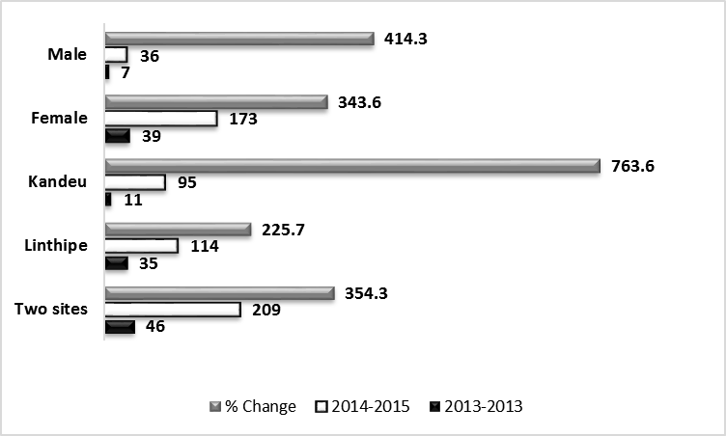
Figure 2: Mother trials and participating farmers during 2013-2014 season and 2014-2015 season in the study sites
Observation of results revealed that higher number of women participated in the trials for both seasons (2013/ 2014 and 2014/2015). Even though, a greater proportion of males joined in the season 2014/-2015 (414.3%) than females (343.6%), their number was still very low than that of women (Figure 2). In addition, both sites showed that ownership of mother trials was dominated by women (Figure 2). The dominance of women could be a result of continental wide crop alignment. Cropping beans for subsistence is in most societies considered a women activity. In the project of the 12 members that owned mother trials, one was a man, who was in Kandeu. The graph in Figure 3shows the proportion of a gender owning a mother trial based for the two sites combined (i.e. all the 209 farmers) and site based proportion as well. The only man owning the mother trial defeated the odds. Details on number of participating farmers aggregated by gender with the associated technologies used and land area covered is shown in Appendix 7. .
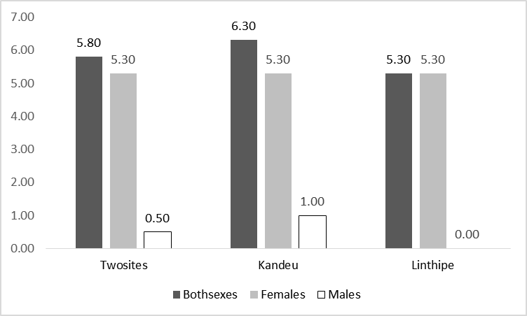
Figure 3: Ownership of mother trials in both sites in % of the total number of participants for the two sites combined and at site level for both sexes and gender aggregated

Reduction of bean yield gap by promoting use of best fit agronomic practice
The project stressed the use of best fit technologies for increased bean production based on use of integrated soil fertility management practices and high yielding as well as drought resistant varieties. These technologies were show-cased to both participating and nonparticipating farmers in the treatments (Figure 4), where farmers saw the roles of technologies in increasing yield and provision of resilience to drought. In addition hands-on training was given in crop management, pest and diseases prevention, identification and control. This was based on the fact that pest and disease infestation, as well as poor crop management were some of the critical factors stagnating the bean yield in the country (Appendices 5 and 6).
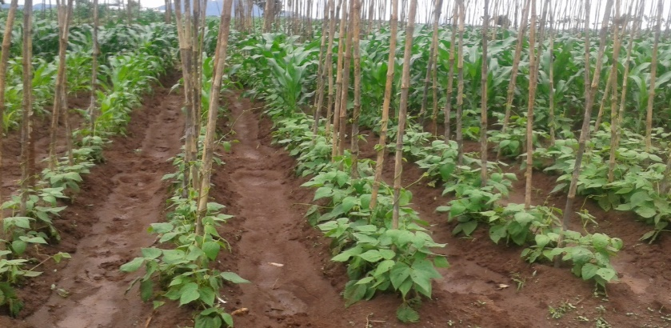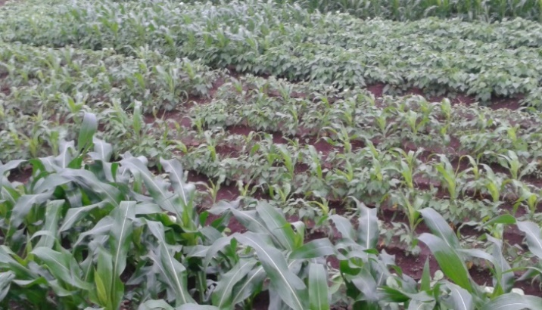Figure 4: Early performance of climbing and dwarf beans during 2014/2015 season clearly showing differences between treatments

Grain yield, podload, and seed-podratio
Results show that grain yield was the highest (1.05 Mgha⁻¹) in bush beans. Amidst drought, SER45 had higher yield of 1.1 Mgha⁻¹followed by SER83 (1.0 Mgha⁻¹). However, climbers were affected by terminal dry spell and had relatively lower yields, where the least was DC86-283 (0.2 Mgha⁻¹). Table 2 below shows grain yield, podload and seed-pod ratio. It is worth noting that climbing bean varieties have longer periods of growth and maturity (4 months) as compared to bush beans (3 months) (Ramaekes et al., 2013). Under normal circumstances, climbing beans have the potential of producing between 4 -5 tons ha⁻¹, as compared to a maximum of 3 tons ha⁻¹ for the bush beans (Ramaekes et al., 2013). Consequently climbing beans are highly sensitive to drought as opposed to bush beans (Ramaekes et al., 2013). This means that with relatively shorter duration and low amount of rains, bush beans would most likely do better than climbing beans.
Table 2: Grain yield, podload and seed-pod ratio of the bean in the trial sites of Linthipe and Kandeu
Variable | GH | Variety | N | Mean |  |  | Conf  -95% | Conf  95% | Max | CV | SE
Grain yield (Mg/ha) | Climber | DC86-263 | 73 | 0.2ª | ± | 0.3 | 0.2 | 0.3 | 1.2 | 112.5 | 0.0
Grain yield (Mg/ha) | Climber | MBC33 | 82 | 0.4^{b} | ± | 0.5 | 0.3 | 0.5 | 2.1 | 117.6 | 0.1
Grain yield (Mg/ha) | Dwarf | SER45 | 125 | 1.1 ^{c} | ± | 0.8 | 0.9 | 1.2 | 4.6 | 70.9 | 0.1
Grain yield (Mg/ha) | Dwarf | SER83 | 122 | 1.0^{c} | ± | 0.6 | 0.9 | 1.2 | 3.6 | 61.1 | 0.1
Podload
Podload | Climber | DC86-263 | 72 | 7.5ª | ± | 4.7 | 6.4 | 8.6 | 21.4 | 63.1 | 0.6
Podload | Climber | MBC33 | 81 | 5.0^{b} | ± | 3.7 | 4.2 | 5.8 | 23.6 | 74.2 | 0.4
Podload | Dwarf | SER45 | 125 | 16.5^{c} | ± | 8.3 | 15.0 | 18.0 | 42.8 | 50.4 | 0.7
Podload | Dwarf | SER83 | 120 | 15.6^{c} | ± | 7.7 | 14.2 | 17.0 | 40.2 | 49.4 | 0.7
Seeds-pod Ratio | Climber | DC86-263 | 73 | 2.8ª | ± | 1.1 | 2.5 | 3.1 | 6.3 | 40.6 | 0.1
Seeds-pod Ratio | Climber | MBC33 | 82 | 1.5ª | ± | 0.7 | 1.4 | 1.7 | 3.5 | 43.7 | 0.1
Seeds-pod Ratio | Dwarf | SER45 | 126 | 3.4^{b} | ± | 4.0 | 2.7 | 4.1 | 45.8 | 119.9 | 0.4
Seeds-pod Ratio | Dwarf | SER83 | 121 | 2.9^{b} | ± | 0.9 | 2.7 | 3.0 | 5.8 | 32.0 | 0.1

Note: Means which are within column and of the same variable are not significantly different (p>0.05), if have the same letter, while those with different letters are significant (p<0.05), GH = growth habit (i.e. being either a climber or bush)
Similarly, podload was the highest in SER45 (16.5 ± 8.3) followed by SER83 (15.6 ± 7.7), with the least being MBC33 (5.0 ± 3.7 Mgha⁻¹). It is important to note that though MBC33 had fewer seeds in their pods than DC86-263, the higher yield for MBC33 was because it is their large seeded nature. The low podload in the climbers, suggest low podfilling, as evidenced by the unusually low seed-pod ratio. The performance in climbers was in contrast with the performance of the climbers in the normal year of 2013- 14 (without drought), where the yield range was 0.61 – 2.6 Mgha⁻¹ (mean = 1.5 Mgha⁻¹). This indicated a problem in the podding and podfilling process. Podding and podfilling process requires good supply of soil moisture. However, the 2014/15 growing season was characterised by a prolonged dry spell towards the end of the rainy season. The timing for the dry spell was more disadvantageous to climbers than bush beans, as it came at a point when bush beans had gone beyond the critical stage, allowing them to continue their development with residual moisture, unlike the climbers which had just started flowering (Figure 5), and were a long way to physiological maturity.
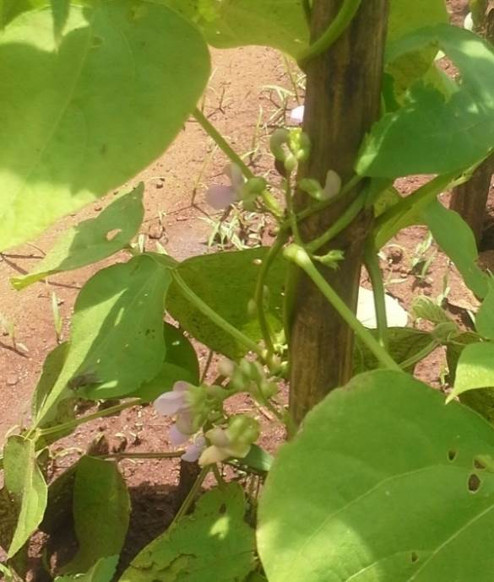
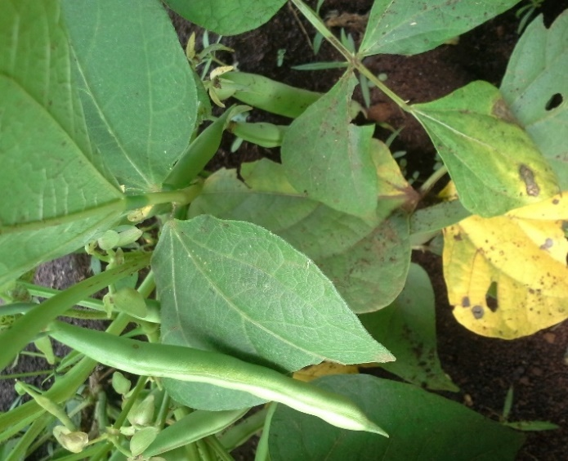
Part of the stake for climbers
Figure 5: Flowering climbing beans (left) and bushbeans with pods taken in Linthipe on 27/02/2015 when the drought had just started.

Effects of management (cropping system and soil amendments) and genotype (variety) on yield
Accounting for the effects of environment and management, factorial ANOVA results for genetic (variety) and management (treatment) (Table 3) showed that for both climbers and bush beans, treatments had significant effects on yield (p<0.05). However no significant differences were accounted for between the two bush bean varieties (p>0.05), but statistically significant in climbers (P<0.05). This indicated differences in yield performance between the two climbing bean genotypes. Holding variety constant, highest yields were obtained in treatments that had sole bean cropping system with both manure and fertilizer applied (Bcf), followed by treatments involving sole beans with manure only applied (BC).
Table 3: Effects of treatments on bean yield in both climbers and bush varieties
Effect | GH | SS | df | MS | F | P-value
Intercept | Bush | 263.3567 | 1 | 263.3567 | 669.0582 | 0.000000
Variety | Bush | 0.0974 | 1 | 0.0974 | 0.2475 | 0.619299
Treatment | Bush | 23.8448 | 6 | 3.9741 | 10.0963 | 0.000000
Variety*Treatment | Bush | 3.7582 | 6 | 0.6264 | 1.5913 | 0.150443
Error | Bush | 91.7142 | 233 | 0.3936
Intercept | Climber | 15.83411 | 1 | 15.83411 | 176.4084 | 0.000000
Variety | Climber | 0.92155 | 1 | 0.92155 | 10.2671 | 0.001675
Treatment | Climber | 9.71377 | 6 | 1.61896 | 18.0369 | 0.000000
Variety*Treatment | Climber | 1.39345 | 6 | 0.23224 | 2.5874 | 0.020777
Error | Climber | 12.65591 | 141 | 0.08976
Bolded effects are significant at p< 0.05
The yield difference between beans under Bcf and Bc treatments was insignificant (p >0.05) (Figure 6). This meant that use of manure only (Bc) is a cheaper option, as it, was as equally productive as the use of a combination of fertiliser and manure (Bcf). Chicken manure is rich in phosphorous and nitrogen (Alley and Vanlauwe, 2009), important macronutrients in bean growth, hence good bean performance in treatments with manure. Low bean yields were observed in treatments that involved beans without manure nor fertiliser, as well as those with beans-maize intercrops (Figure 6). In these treatments the lowest yield was encountered in a bean-maize intercrop where neither fertiliser nor manure was applied.
Figure 6: Mean bean yields in different treatments
The highest bean yield in bean-maize Intercrop was observed in the treatment that involved bean + maize applied with a combination of manure and fertiliser followed by the one involving bean + maize with manure only (Figure 6), however the difference between all maize-bean intercrops was not significant (p>0.05). Interactions between treatment and cropping system showed that bean yields under sole cropping responded much better to manure (Bc) and the combination of manure and fertiliser (Bcf) than under intercropping (Figure 6). When intercropped with maize (i.e. BM, BMc, BMcf, and BMf) bean yields were generally low (Figure 6) owing to interspecific competition, where maize outperformed beans on use of environmental resources for growth and development. AS such if the intention is to produce beans for commercial purposes, with yields > 1.0 Mgha⁻¹, then they must be grown as a sole crop, treated with manure (Bc) or a combination of manure and fertiliser (Bcf), but if beans are a secondary crop they can be intercropped with maize, where yield would barely go beyond 0.6 Mgha⁻¹ (Figure 6). In this cropping system (intercropping) as well as use of manure proved to be better (cheaper) options, as there were insignificant differences between Bc and Bcf treatments.
A look at specific varieties and treatments (i.e. cropping system, whether or not fertilizer or manure was applied) showed that cropping system, application of fertilizer, interaction between variety*cropping system as well as cropping system* fertilizer, had significant effects on bean yields (Table 4). The lack of significance in manure in Table 4 was unexpected. The positive response to yield after manure application (Bc) shown in Figure 6 and 7 (Bc), is a clear indication that it had significant effects on the yield of both bush and climbing beans. From Figure 7 it can be seen that the response of SER45 to manure application was highly positive as opposed to SER83. The difference between yield under manure for SER45 and SER83 was also significantly (p< 0.05) (Figure 7). For the other treatments, the differences were unfortunately insignificant (p>0.05). In addition, the graph in Figure 7 showed that when both manure and fertiliser were applied (Bcf), yield in SER83 was improved to the level of SER45.
Table 4: Effects of growth habit, variety, cropping system, fertiliser, and manure on bean yield (Mg ha⁻¹)
Source | Effect (F/R) | df Effect | MS Effect | df Error | MS Error | F | p
1[GH] | Fixed | 1 | 49.13207 | 373 | 0.279797 | 175.5987 | 0.000000
2[Variety] | Fixed | 2 | 0.53058 | 373 | 0.279797 | 1.8963 | 0.151568
3[cropping system] | Fixed | 1 | 17.47915 | 373 | 0.279797 | 62.4707 | 0.000000
4[inorganic fertiliser] | Fixed | 1 | 4.88741 | 373 | 0.279797 | 17.4677 | 0.000036
5[Fert] | Fixed | 3 | 2.80909 | 373 | 0.279797 | 10.0397 | 0.000002
6[Manure] | Fixed | 0 | 0
1*2 | Fixed | 0 | 0
1*3 | Fixed | 1 | 0.12449 | 373 | 0.279797 | 0.4449 | 0.505162
1*4 | Fixed | 1 | 0.10719 | 373 | 0.279797 | 0.3831 | 0.536326
1*5 | Fixed | 2 | 0.28679 | 373 | 0.279797 | 1.025 | 0.359803
1*6 | Fixed | 0 | 0
2*3 | Fixed | 2 | 1.05591 | 373 | 0.279797 | 3.7738 | 0.023846
2*4 | Fixed | 2 | 0.12664 | 373 | 0.279797 | 0.4526 | 0.636321
2*5 | Fixed | 4 | 0.23732 | 373 | 0.279797 | 0.8482 | 0.495349
2*6 | Fixed | 0 | 0
3*4 | Fixed | 1 | 0.78581 | 373 | 0.279797 | 2.8085 | 0.094603
3*5 | Fixed | 1 | 1.59432 | 373 | 0.279797 | 5.6981 | 0.017481

This further implies that interaction effects of manure and fertilizer were also significant, as can be evidenced from the yield response shown in Figure 6 and 7 for the treatment (Bcf). Consideration of variety response to different treatments revealed interesting results. Bean varieties displayed contrasting responses to use of manure (Bc). When both manure and fertiliser were applied (Bcf), there was positive response to yield by both of SER45 and SER83 and the yield difference between them was insignificant (p>0.05). These results were suggestive of the fact that for SER45 the use of manure (Bc) only is the cheapest option. In case of SER83 significant yield responses could only be obtained when both manure and fertiliser are applied (Bcf).
As for the climbers, there was a significant yield response MBC33 to manure application (Bc) under sole cropping system, as well as the combination of manure and fertiliser (Bcf), while the response of DC86-263 was moderate (Figure 7). Yield differences when either manure (Bc) or both manure and fertiliser (Bcf) were used were significant between the two varieties, and MBC33 was superior in both cases. Interestingly for climbers, only MBC33 under Bc and Bcf had yields significantly higher (p< 0.05) than the rest of the other treatments. Observations on the performance of the two climbing varieties when intercropped with maize, showed that yields were generally lower than 0.2 Mgha⁻¹ in such treatments, with insignificant differences between them (p >0.05). This observation implied that for MBC33, use of manure only (Bc) in sole cropping was as equally productive as the combination of fertlisers and manure (Bcf), since both significantly improved yield, unlike in DC86-263. Nevertheless, to maximize profitability, use of manure is recommended for MBC33 in sole cropping. However in the absence of manure P fertlisers could be

Figure 7: Interaction effects of variety and treatment on yield of SER45, SER83 (bush beans), DC86-263, and MBC33 (climbers)

used.

Effects of agro-ecological zones on the yield of beans
Bean yields in the two agro-ecological zones (rift valley escarpments and Lilongwe plain) were found to be significantly different (p <0.05). The rift valley escarpments (RVE) had a higher mean yield (0.96 Mgha⁻¹) than the Lilongwe plain (LLP) (0.65 Mgha⁻¹). Yield variability was higher in the RVE than in the LLP (Table 4). The cause of variability in yield in the RVE is most likely the variability in the terrain (which could affect fertility gradients) interacting with management, while LLP is almost homogenous. As such for the LLP variabilities were most likely emanating from variability in crop management rather than variability in terrain which could induce significant variabilities in fertility gradients.
Table 4: Yield of climbers and bush beans in the agro-ecological zones of Lilongwe plain and rift valley escarpments of Kandeu
Growth habit | Agro-ecological zone | N | Grain yield (Mg/ha) |  |  | Conf-95% | Conf 95%
All groups (Bush + climber) | Both (RVE & LLP) | 402 | 0.77ª | ± | 0.70 | 0.71 | 0.84
All groups (Bush + climber) | Rift valley escarpments | 163 | 0.96^{b} | ± | 0.57 | 0.87 | 1.05
All groups (Bush + climber) | Lilongwe plains | 239 | 0.65^{c} | ± | 0.77 | 0.55 | 0.74
Bush | Rift valley escarpments | 149 | 1.04ª | ± | 0.53 | 0.95 | 1.12
Bush | Lilongwe plains | 98 | 1.07ª | ± | 0.90 | 0.89 | 1.25
Climber | Rift valley escarpments | 42 | 0.51ª | ± | 0.53 | 0.35 | 0.68
Climber | Lilongwe plains | 113 | 0.27^{b} | ± | 0.33 | 0.21 | 0.33
Note: Means which are within column and of the same growth habit definition in the rows are not significantly different (p>0.05) if have the same letter, while those with different letters are significant (p<0.05)

When disaggregated by growth habit (i.e. bush or climbers), results indicate that climbing bean yield in RVE were higher than those of LLP (p<0.05) (Table 4). This was not expected as LLP has a higher altitude (>1000m asl) than RVE in Kandeu (<1000m asl) and that climbing beans generally do better in high altitude areas. On the other hand, the difference in yields of bush beans between the agro-ecological zones (AEZ) was found to be statistically insignificant (p>0.05), even though yield values were higher in LLP than in the RVE suggesting that the two agro-ecologies are equally productive for bush beans.

Land equivalent ratio (LER)
Maize yield under sole cropping with both manure and fertiliser applied (Mcf) was 5.9 Mgha⁻¹ (std = 2.7), while under similar soil fertility management conditions (Bcf), sole beans yielded 1.3 Mgha⁻¹ (std = 0.9). On the other hand, mean yield of bean in beans-maize intercrop with both manure and fertlisers applied (BMcf) was 0.6 Mgha⁻¹ (std = 0.5), and maize mean yield under the same cropping system (bean-maize intercrop) and fertility improvement conditions (BMcf) yielded a mean of 6.1 Mgha⁻¹ (std = 3.2). Calculation of the land equivalent ratio for beans intercropped with maize was found to be 0.9. This most probably implied no or little need for a larger land to produce the same yield as the crops would do under monocrops (Fairhurst, 2012). However, this was most likely true for maize and not for beans. This is because sole beans yielded less in intercrop (0.6 Mgha⁻¹) than in a monocrop (1.3 Mgha⁻¹), and the difference was statistically significant (p<0.05), unlike maize which yielded better in intercrop (6.1Mgha⁻¹)) than in monocrop (5.9Mgha⁻¹), though the difference was insignificant (p<0.05). The maximum yield in sole beans observed was 4.6Mgha⁻¹ (in treatment Bc), seconded by 3.9 Mgha⁻¹ in treatment (Bcf).

Conclusion
Results of this study revealed that participation in the bean integration program is highly dominated by women (82.8%). Women also owned the majority of the mother trials, where the share of women was 5.3% while that of men was 0.5%. Climbing bean (DC86-263 and MBC33) productivity was greatly affected by the dry spell that characterised the nation, but the effects were quite minimal on bush beans (SER45 and SER83). This has been seen in lowered podloads, seed-pod ratio and yield in climbers, while the values were relatively high in bush beans. Under normal situations climbers outperform bush beans in all respects of yield components and actual yield. This demonstrated the suitability of SER45 and 83 varieties in drought conditions.
The study has also shown that bean productivity was significantly affected by cropping system, application of manure, fertlisers or a combination of the two. Proper choice of cropping system and fertility management is therefore paramount in increasing its productivity and consequently reduce the yield gap. Response of yield to manure or combination of manure and fertlisers has been found to be variety specific. To significantly increase productivity, beans must be planted as a monocrop rather than an intercrop with maize, where either manure only or a combination of manure and fertlisers could be applied. From this study, it been also shown that use of manure only especially for SER45 and MBC33 is equally productivity as the use of the combination of the two (manure + fertiliser). Hence use of manure is a cheaper and more viable option for these varieties for those who can access it. Comparisons based on agro-ecological zones show insignificant differences in productivity between the zones for bush beans, however, a significant difference was revealed in the performance of climbers. In the Lilongwe plain (LLP) climbers had lower yields as opposed to those in the rift valley escarpments (RVE). Response of varieties to manure (Bc) and manure + fertiliser (Bcf), showed that the yield of SER45 positively responded to manure application, while the rest responded positively when a combination of the two was used (Bcf). The LER for bean-maize intercrop was found to be 0.9. However, the value favoured maize more than beans as bean yielded less in intercrops than in sole crops, while maize yielded more as an intercrop than as a sole crop. So no extra land is needed for maize when intercropped with beans to yield as much as it would do under sole cropping, while on the contrary, beans would require extra land when intercropped with maize to produce as much as it would do under sole cropping.

References:
Ajayi, M.T. and Oloruntoba, A. (2007). Assessment of factors effecting farmers’ adoption and utilization of major agriculture technologies developed by International Institute of Tropical Agriculture (IITA). Journal of Agriculture, Forestry, and social sciences, 5,
Alley, M.M. and Vanlauwe, B. (2009). The role of Fertlisers in Integrated plant Nutrient management. International Fertlisers industry Association, Paris, France. Tropical biology and Fertility Institute of the International Centre for Tropical Agriculture, UN Avenue, Gigiri, Nairobi, Kenya.
Badu-Aparaku, B., Fakorede, M.A.B., Menkir, A., and Sonogo, D., Editors (2012). Conduct and Management of Maize Filed Trials. IITA, Ibadan, Nigeria. 59 pp.
Emam, Y., Shekoofa, A., Salehi F. and Jalali A.H. (2010). Water Stress Effects on Two Common Bean Cultivars with Contrasting Growth Habits. American-Eurasian J. Agric. & Environ. Sci., 9, 5, 495-499
Fairhust, T. (2012). Handbook for Integrated Soil Fertility Management. The Africa Soil Health Consortium, CABI, ICRAF Complex, Nairobi< Kenya.
Muthoni, R., Barungi, M., Chirwa, R., Chianu, J., Birachi, E. (2007). Determining the Market Share of Improved Common bean varieties traded in selected markets in Malawi.
Nami, F., Shakiba, M.R. Mohammadi, S.A., and Ghanbari, A. (2012). Yield and Yield Components Affected by Leaf Water Status in Field-grown Common Bean Genotypes under Two Contrasting Irrigation Regimes. Intl J Agri Crop Sci. Vol., 4, 21, 1599-1606
Ramaekers, L., Micheni, A., Mbogo, P., Vanderleyden, J. and Maertens, M. (2013). Adoption of climbing beans in the central highlands of Kenya: An empirical analysis of farmers’ adoption decisions. African Journal of Agricultural Research, 8, 1, 1-19
Rao, I, Beebe, S., Polania, J., Ricaurte, J., Cajiao, C., Garcia, R., and Rivera, M. (2013). Can tepary bean be a model for improvement of drought resistance of drought resistance in common bean? African Crop Science Journal, 21, 4, 265 – 281.
Snapp, S., Kanyama-Phiri, G., Kamanga, B., Gilbert, R., and Wellard, K. (2002). Farmer and Researcher Partnership in Malawi: Developing Soil Fertility Technologies for Near-Term and Far-Term. Expl Agric, 2, 411 – 431
TL II (Tropical Legumes II) (2013). Bulletin of Tropical Legumes. The Tropical Legume Project.

Appendices
Appendix 1: Plot layout for climbers

Appendix 2: Plot layout for bushbeans (Dwarfs)

Appendix 3: Showing data record forms
Note: this appendix is showing the structured summary of the data record forms used, each original table had 48 rows.
PART 1: APPLICABLE TO TRIAL AND PLOT
Form A: Site information, management history and activity records

Trial/ClubName ................................
Site....................................................
Village................................................
Field ID.........................................................
GPS reading.......................................

Activity record form
Activity | Date
Planting
Germination
Stand count
Thinning/Supplying
First weeding
Second weeding
Third Weeding
Banking
50% flowering
Physiological maturity
Harvesting

PART 2: CROP DATA (maize and beans)

This section contains the design of forms that will be used in collection of the agronomic and yield data. They only contain the at most the first three rows of the full form contained in the data book.
Form B: Crop establishment/Plant Population
Site.......................................................: Recorded by: …………………………………..

Plot No | Variety | Rep | No of rows | No of planting stations | Plants per row | Row spacing | Plant spacing | Germination %
 |  | 1

Form C: Fertilizer, Manure and Pesticides Application (maize and beans)

Site.......................................................: Recorded by: …………………………………..

Plot No | Variety | Rep | Manure |  |  | Fertilizer |  |  | Pesticides
Plot No | Variety | Rep | Date | Type | Rate kg/ha | Date | Type | Rate kg/ha | Date | Type | Rate kg/ha

Form D: Nutrient deficiency or pest and diseases record form (maize and beans)
Site............................................ Recorded by: ………………………………
Date of observation | Variety | Rep | Trt No | Visual nutrient deficiency | Visual pest/disease
Form E: Phenology: Flowering, Podding and Growth habit (beans)
Site.......................................................: Recorded by: …………………………………..

Plot No | Bean Line | Rep | 50% Flowering | Flower colour | 50% Pod setting | Growth habit | Physiological maturity

Form F: Weeds (plot) and Pests (crop) Assessment

Site.......................................................: Recorded by: …………………………………..

Plot No | Variety | Rep | Weeds |  |  | Pests
Plot No | Variety | Rep | Date | Most common weeds | Cover rating | Date | Most predominant pests | Extent of damage

Form G: Bean disease assessment form

Site.......................................................: Recorded by: …………………………………..
Plot No | Bean Line | Rep | ALSFL | BCMNV | ANTFL | CBBFL | RUSTFL | Other.

Form H: Bean yield record form

Site............................................................ Recorded by: .............................................
Plot No | Bean Line | Rep | Date of harvest | Area net plot  (m²) | No. of plants in harvested plot | Pod load for 5 plants (pods/plant) | Number of pods per plant | Number of seeds per pod | Fresh weight of all pods in the net plot (kg) | Fresh weight of haulm in net plot (kg) | Fresh weight of sub-sample (take about 100 g) | Oven dry weight of grain from Sub-sample | Dry weight of husks of Sub-sample after removing grains | Fresh weight of sub-sample of haulms (g) | Dry weight of oven dried sub-sample haulms | Oven dry weight of 100 seeds

Form I: Phenology: Tasseling and Maturity (maize)
Site.......................................................: Recorded by: …………………………………..
Plot No | Maize Variety | Rep | 50% tasseling | Physiological maturity

Form J: Disease assessment form (maize)

Site.......................................................: Recorded by: …………………………………..
Plot No | Maize Variety | Rep | GLS | Maize streak | Leaf blight | Rust | Smut | Other:…..

Form K: Final yield record form (Maize)
Bock 1(V1): Site............................................................ Recorded by: .............................................
Plot No | Maize variety | Rep | Date of harvest | Area net plot  (m²) | No. of plants in harvested plot | Fresh wt of stover (kg) | Fresh weight of all cobs in the net plot (kg) | Fresh wt of 5cobs | Fresh wt of grains from 5cobs | Maize sheath fresh wt | Dry weight of sample of stover | Dry wt of sample of maize sheth | Dry weight of sample grain | Oven dry weight of 100 seeds

Appendix 4: Farmers undergoing training in harvesting: measuring, and recording yield components beans in Linthipe

Appendix 5: Farmers being trained on general crop management in Linthipe

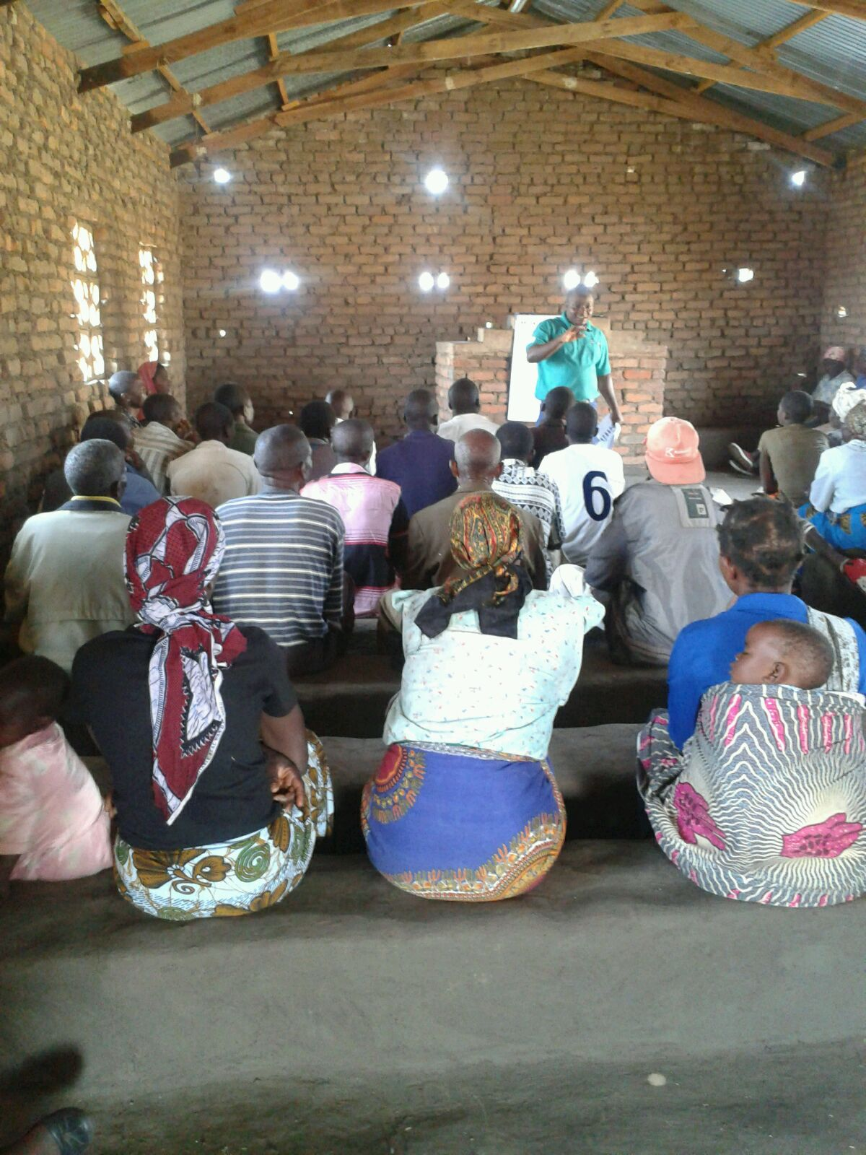

Appendix 6: Farmers discussing pests and diseases of beans based on bean disease leaflets during a training season
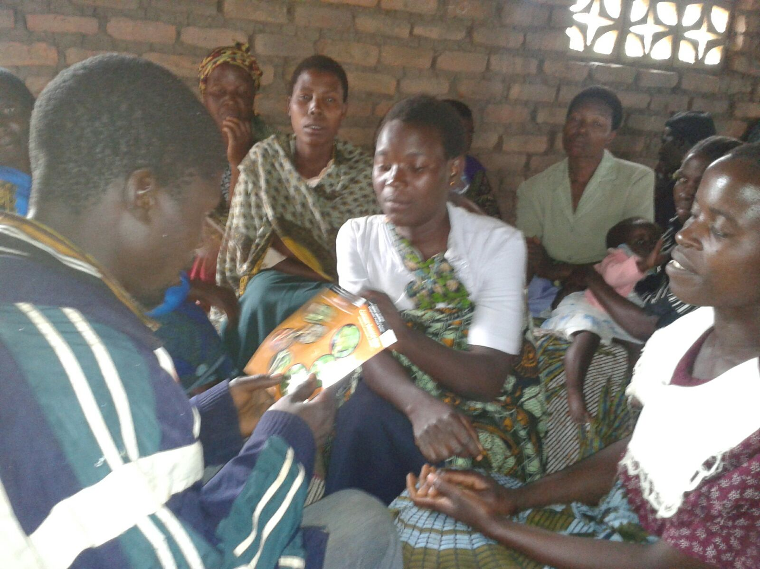
Appendix 7: Technologies used with information on land coverage and gender
Technology | Male | Female | Land (ha)
SER45 | 36 | 173 | 1.0
SER83 | 36 | 173 | 1.0
DC86-263 | 36 | 173 | 1.0
MBC33 | 36 | 173 | 1.0
Maize + manure + NPS | 36 | 173 | 0.3
Bean + maize | 36 | 173 | 1.2
Bean + Stickstakes (Bamboo) | 36 | 173 | 0.4
Bea + maize +manure + NPS | 36 | 173 | 0.3
Chicken manure | 36 | 173 | 0.6
Chicken manure + fertiliser(NPS) | 36 | 173 | 0.9
Fertlisers (NPS/23:21:0 +4S) | 36 | 173 | 0.2

