

PERFORMNACE OF SER 45 BUSHBEAN VARIETY UNDER DROUGHT
Ndengu G., Desta L.T., Mponela P., Chataika B. and Chirwa R.
SER45 is a small seeded bean variety, bred for tolerance to drought, just like SER83. High potentials have been shown by the variety in resistance to diseases and yield. The mean yield results from the current trials was 1.1 ± 0.8 Mgha⁻¹. Variabilities were high within the yield due to variabilities in treatments (Table 1).
Table 1: Yield of SER45 in the trial sites
SER45 | Mean (Mgha⁻¹) | 1.1
SER45 | Conf-95% | 0.9
SER45 | Conf 95% | 1.2
SER45 | Std | 0.8
SER45 | CV | 70.9
Based on the treatment, yield response for SER45 was the highest in treatment Bc (1.7 Mgha⁻¹) (beans in purestand applied with chicken manure) and Bcf (1.7 Mgha⁻¹) (pure stand bean with both manure and fertlisers applied) (Figure 1). The difference between the two was insignificant (p >0.05), suggesting that use of manure only in pure stand is the best and cheaper option in its production to increase yields (highest yields). Under bean-maize intercrop (i.e. BM, BMc and BMcf) SER45 had lower yields than those in purestand with similar treatments (i.e. B, Bc, and Bcf, respectively). This indicated that intercropping significantly reduced the yield of SER45, due to interspecific competition.
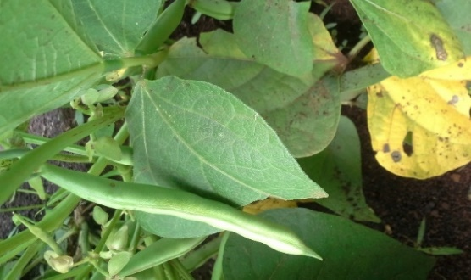
Figure 1: Effects of treatments n the yield of SER45 in the trial sites of Linthipe and Kandeu
Figure 2: SER45 podding in Linthipe at the peak of drought
The most interesting aspect of the study was that SER45 yielded better (yield > 1.0 Mgha⁻¹) despite the terminal drought in the background, indicating its potential suitability for drought conditions. In addition use of manure only gave the highest yield (Bc). Hence significantly reducing the cost of bean production on the part of farmers.

