


Annual Report (2015)

On

“Demonstration of promising barley and kabuli chickpea varieties/technologies to enhance coping mechanism and achieving food security”

Submitted by,

ICARDA, South Asia & China Regional Program,
New Delhi in partnership with CAZRI, Jodhpur-India


Full Title: Demonstration of promising barley and kabuli chickpea varieties/technologies to enhance coping mechanism and achieving food security

Activity Leader: Dr Ashutosh Sarker (a.sarker@cgiar.org); Other scientists (CG): Dr Atul Dogra (a.dogra@cgiar.org); Dr B. Dhehibi (B.Dhehibi@cgiar.org)

National Partner: CAZRI, Jodhpur; Other Scientists NARS: Dr Anurag Saxena drasaxena@gmail.com)
Locations: Rajasthan- Jodhpur (Gobindpura, Manasagar); Jaisalmer (Sankadia, Didu) and Bermer (Dhok)

Objectives:
i) To provide food and nutritional security at house-hold level through increased chickpea production
ii) To alleviate feed deficit and enhance livestock productivity through high yielding barley with enhanced biomass production
iii) To out-scale already proven improved varieties and best practices identified in 2013.
iv) To identify new varieties better than previously selected ones
v) To enhance capacity development of farmers and extension agents through farmers' field school, training, field days, etc.

Outputs: Demonstration of improved chickpea and barley varieties
Seed of two improved varieties of barley (RD 2786 and RD 2660) and four varieties of chickpea (CSJK 6, RSG 963, RSGK 6 and CSJK 21) were provided to farmers in a participatory mode. Farmers were also trained on the improved package & practices before the sowing of cops in their field. A total of 50 farmers were involved in improved production practices of barley and chickpea.
Table 1: List of the improved varieties
Sr. No. | Crop | Variety | Quantity
 | Barley | RD 2786 | 340 kg
 | Barley | RD 2660 | 850 kg
 | Chick pea | CSJK 6 | 260 kg
 | Chick pea | RSG 963 | 240 KG
 | Chick pea | RSGK 6 | 80 KG
 | Chick pea | CSJK 21 | 60 kg

The seeds and needed fertilizer were distributed to farmers of three arid district of western Rajasthan for testing the performance of different varieties of chick pea and barley. Two villages each of Jaisalmer (Deedhu and Sankdia) & Jodhpur (Mansagar and Govindpura) and a village in Barmer (Dhok) were selected and field trials were carried out at 24 and 34 locations, for chickpea and barley, respectively.
Chickpea:
Chickpea varieties were sown in 45 cm a part rows using 75 kg seed ha⁻¹ in the last week of November. Nitrogen (20 kg ha⁻¹) and phosphorus (50 kg ha⁻¹) through DAP was applied as basal dose. Total three irrigations were given to the crop through sprinkler irrigation method. The crop was harvested in the last week of March to first week of April. The economics was computed on the basis of prevailing market prices of different inputs and outputs.
Yield data revealed that all varieties (RSG 963, CSJK 6/ RSGK 6 and CSJK 21) produced higher pods/plant, seeds/pod and 1000 seed weight compared to local variety, which led to higher seed and straw yield (Table 2). The plant height was highest in RSG 963 compared to other varieties. Among all the varieties RSG 963 resulted in 13.5 and 24.1% higher seed yield over CSJK 21 and local variety, respectively. The net returns and benefit: cost ratio was also highest with CSJK 6 followed by RSG 963, CSJK 21 and local variety, respectively (Table 3).

Table 2: Effect of variety on the yield attributes and yields of chick pea
Variety | Plant height (cm) | Pods/plant | Seeds/Pod | 1000 seed weight (g) | seed yield  (kg/ha) | Straw yield (kg/ha)
CSJK 6/ RSGK 6 | 36.4 | 32.2 | 1.6 | 299 | 1320 | 2050
CSJK 21 | 33.1 | 30.4 | 1.7 | 236 | 1225 | 2015
RSG 963 | 42.3 | 52.4 | 1.5 | 171 | 1390 | 2240
Local | 39.4 | 27.9 | 1.5 | 232 | 1120 | 1995

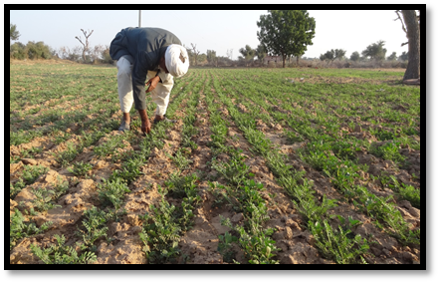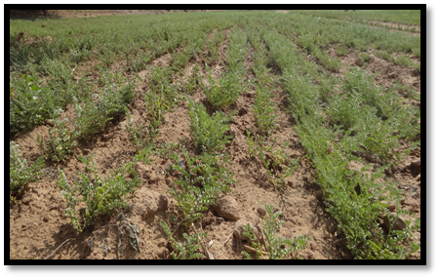

Plate 1: Variety CSJK 6 and CSJK 21 in farmers’ field

Table 3: Effect of varieties on the monetary returns in chick pea
Variety | Gross return  (Rs./ha) | Cost of cultivation  (Rs./ha) | Net return (Rs./ha) | Benefit: cost ratio
CSJK 6/ RSGK 6 | 78750.00 | 31290.00 | 54060.00 | 1.72
CSJK 21 | 73420.00 | 31290.00 | 48255.00 | 1.54
RSG 963 | 83170.00 | 31290.00 | 51880.00 | 1.65
Local | 67585.00 | 28980.00 | 38605.00 | 1.33
Price considered of chickpea @ Rs. 55/kg and straw @ Rs. 3.00/kg

- Barley
Two improved varieties of barley (RD 2786 and RD 2660) were sown during the last week of November at all the locations at 30 cm row to row spacing using 100 kg seed/ha. The recommended dose of fertilizers for barley (100 kg Nitrogen and 60 kg phosphorus/ha) was given through DAP and urea. Full dose of phosphorus and half of Nitrogen was applied as basal application; whereas, remaining half dose of N was applied in two equal splits i.e. at 25 and 45 days after sowing. The crop was raised under irrigated condition and five irrigations were given through sprinkler system. All other recommended package of practices was followed to raise the crop. Crop was harvested in the last week of March to first week of April. The economics was calculated on the basis of prevailing market prices of different inputs and output.
Plants of Variety RD 2786 were taller than variety RD 2660 (Table 4) and number of tillers/m, grains/ear and test weight were also recorded higher in RD 2786. However, other improved variety produced higher number of tillers/m, grains/ear and 1000 grain weight as compared to local variety. Variety RD 2786 produced higher grain (3790 kg/ha) and straw yield (4940 kg/ha). The lowest grain yield (3190 kg/ha) was obtained with local variety. The increase in the grain yield due to variety RD 2786 was 4.4 and 18.8% over RD 2660 and local variety, respectively. The net returns (Rs. 28855/ha) and benefit: cost ratio (1.02) were higher with RD 2786 followed by RD 2660 (Rs. 25795 and 0.91) and local variety (Rs. 20905 and 0.76), respectively (Table 5).
Table 4.Effect of varieties on the yield and yield attributes of barley
Variety | Plant height  (cm) | Tillers/m | Grains/ear | 1000 grain weight (g) | Grain yield  (kg/ha) | Straw yield (kg/ha)
RD 2786 | 88.3 | 95.4 | 21.8 | 44.9 | 3790 | 4940
RD 2660 | 80.2 | 87.6 | 20.8 | 44.1 | 3630 | 4410
Local | 85.4 | 75.2 | 18.6 | 40.2 | 3190 | 4265
Table 5.Effect of varieties on the in barley
Variety | Gross return  (Rs/ha) | Cost of cultivation (Rs/ha) | Net return(Rs/ha) | Benefit: cost ratio
RD 2786 | 57255 | 28400 | 28855 | 1.02
RD 2660 | 54195 | 28400 | 25795 | 0.91
Local | 48405 | 27500 | 20905 | 0.76
Price of barley grain @Rs.12.50/kg and straw @Rs.2.00/kg
Overall, improved varieties both in chickpea and barley showed promising results and farmers were keen to adopt these improved varieties in their cropping system. However, non-availability of seed of these varieties at appropriate time is one of the major reasons for non-adoption. Results of this season will help in choosing varieties and technologies for coming season. There was also involvement of women and in coming month they will be trained on post-harvest operations and on value-addition which will increase the income opportunities for farmers both for adopted and neighbouring farmers.
Similarly, in year 2015 (rabi season), 58 farmers has been covered for barley and chickpea demonstrations. Seeds have been distributed and sowing has been done, other parameters will be recorded from time to time. Two more villages have been covered this year for chickpea under khadins (Conserved moisture condition) in Jaisalmer (Damodara and Dedha).

Progress towards the achievement of research outcomes and IDOs (2 pages)
Summarise major successes in the progress towards research outcomes and IDOs. Refer to relevant indicators from Table 1, where relevant and to the indicators of progress towards the CRP’s IDOs .

Effect of improved variety and nutrient management on seed yield of barley
Barley, an important rabi cereal crop of Rajasthan, occupies about 3.07 lakh ha area, accounts for 9.10 per cent of the total rabi cereals area and 8.16 percent to total rabi cereals production of the state. But average productivity of barley is low (3111 kg ha⁻¹, 2012-13) compared to total rabi cereals productivity (3477kg ha⁻¹). Low productivity may be due to traditional methods of cultivation practices followed by the farmers but there is considerable scope of increasing barley productivity by using improved package and practices. Keeping this in view, in 34 field trials, improved barley varieties RD-2660 and RD-2786 were disseminated in two villages (Deedhu and Sankadia) of Jaisalmer and Govindpura and Mansagar villages of Jodhpur district along with application of RDF (100 kg N & 60 kg P₂O₅ ha⁻¹) and farmers’ practices. Full dose of phosphorus and half of Nitrogen was applied as basal application; whereas, remaining half dose of N was applied in two equal splits i.e. at 25 and 45 days after sowing. Improved variety RD 2786 produced higher grain (3790 kg ha⁻¹) and straw yield (4940 kg ha⁻¹). The lowest grain yield (3190 kg ha⁻¹) was with local variety. Variety RD 2786 gave 4.4 and 18.8% higher yield over RD 2660 and local variety, respectively. The net returns (Rs. 28855 ha⁻¹) and benefit: cost ratio (1.02) were higher with RD 2786 followed by RD 2660 (Rs. 25795 and 0.91) and local variety (Rs. 20905 and 0.76), respectively. All the farmers were trained with improved package and practices for barley and relevant literature in local language was also provided.

Effect of improved variety and nutrient management on seed yield of gram
Gram is an important rabi pulse crop of Rajasthan, occupies about 12.52 lakh ha area, which accounts for 38.60 percent of the total pulse area of the state and contributes 65.28 percent to total pulse production of the state. The average productivity of gram is 1019 kg/ha (2012-13) which is low as compared to its total rabi pulse (1023kg/ha). Low productivity may be because of traditional methods of cultivation practices by the farmers. There is a considerable scope for increasing the productivity of gram by using improved practices. Keeping this in view, 24 field trials of gram varieties CSJK-6, CSJK-21, RSG-963 and RSGK-6 were conducted at Govindpura and Mansagar villages of Jodhpur district, Dhok, of Barmer district and Deedhu and Sankadia villages of Jaisalmer district of Rajasthan to disseminate improved technology of gram. Crop was sown in 45 cm a part rows using 75 kg seed ha⁻¹ in the last week of November. Nitrogen (20 kg ha⁻¹) and phosphorus (50 kg ha⁻¹) was applied as basal dose. Total three irrigations were given to the crop through sprinkler irrigation method. The crop was harvested in the last week of March to first week of April. The mean seed yield of improved varieties RSG 963, CSJK 6, RSGK 6 and CSJK 21 was recorded 1390kg/ha,1320kg/ha and 1225kg/ha, respectively. This increased yield is due to improved practices as compared to farmers practices which was about 110 kg/ha. Among all the varieties RSG 963 resulted in 13.5 and 24.1% higher seed yield over CSJK 21 and local variety, respectively. The net returns and benefit: cost ratio was also realized highest with CSJK 6 followed by RSG 963, CSJK 21 and local variety, respectively. All the farmers were trained with improved package and practices for gram and relevant literature in local language was also provided.

Progress towards Impact (1/2 page)
If/when relevant major contributions towards understanding impact and impact per se should be summarized, with a web link to more detailed documents.
- Demonstration of promising barley and kabuli chickpea varieties/technologies were made to enhance coping mechanism through crop diversification and achieving food security in Rajasthan.

- Improved gram varieties resulted in 24.1% higher yield over local variety and net returns and benefit: cost ratio was highest with improved variety in comparison to local variety. Low productivity may be because of traditional methods of cultivation practices by farmers.

- Improved barley varieties gave 18.8% higher yield over local varieties. The net returns (Rs. 28855 ha⁻¹) and benefit: cost ratio (1.02) were higher with RD 2786 followed by RD 2660 (Rs. 25795 and 0.91) and local variety (Rs. 20905 and 0.76), respectively.

- Under Capacity development, both direct and indirect farmers were trained on improved package and practices for both barley and chickpea. Literature in local language was developed and distributed to farmers.

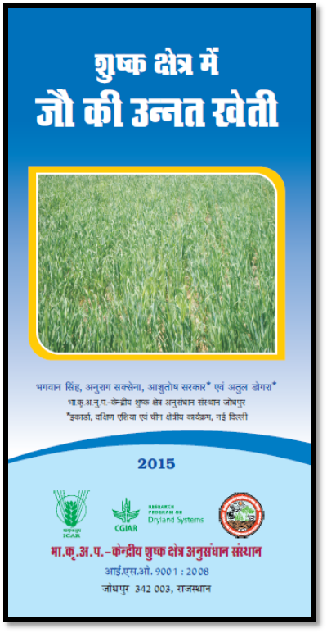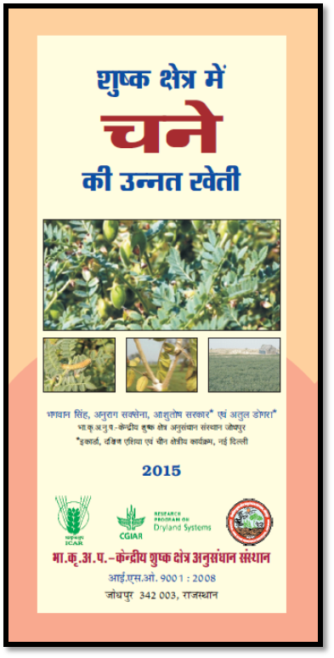
Plate 2: Improved Barley and Chickpea Cultivation in Dry Areas

Please list in alphabetical order, full citation, weblink and codes as applicable for all publications

A. Popular article/Leaflet developed for farmers:
- Singh, Baghwan., Saxena, Anurag., Sarker, Ashutosh and Atul Dogra. 2015. Improved Barley Cultivation in Dry Areas (Sushak kshetroan main barley ke kheti). CAZRI/ICARDA publication-in Hindi

- Singh, Baghwan., Saxena, Anurag., Sarker, Ashutosh and Atul Dogra. 2015. Improved Chickpea Cultivation in Dry Areas (Sushak kshetroan main channe ke kheti). CAZRI/ICARDA publication-in Hindi

B. Abstract Submitted/Presented:

- Saxena, Anurag; Singh, Bhagwan; Sarker, Ashutosh and Atul Dogra. Effect of improved variety and nutrient management on seed yield of barley. 2015. Abstract submitted for International Symposium on Biodiversity, Agriculture Environment & Forestry 11-12 Dec 2015, Ooty, Tamil Nadu, India

- Saxena, Anurag; Singh, Bhagwan; Sarker, Ashutosh and Atul Dogra. Effect of improved variety and nutrient management on seed yield of Chickpea. 2015. Abstract submitted for International Symposium on Biodiversity, Agriculture Environment & Forestry 11-12 Dec 2015, Ooty, Tamil Nadu, India

