Six Monthly Progress Report At a Glance
Soil and Water Conservation Research Institute (SAWCRI), Chakwal, Pakistan
(ICARDA-2). All data for model calibration and validation collected, model calibrated and validated for control and treatment (SLM practice) (1 dataset)
The following structures sites were selected for the collection of data to run the SWAT model in the meeting held on 22-02-2015:
- Rehna Sadat
- Kohkar Bala
- Khandoa
- Dhoke Mori
- Chak Khushi
A number of field visits were carried out for the collection of data by SAWCRI staff.
A special proforma for the collection of data with the help of Prof. Ghulam Nabi (Centre for Excellence in Water Resources Engineering- University of Engineering & Technology, Lahore, Pakistan) was developed so that needed information regarding installed structures could be collected and provided:
- Topographic surveys from year 2010-2014 of selected structures sites were provided. i.e., HA, HD, elevation and GPS points.
- Pictures and maps of selected structures sites, gully and structure number were provided to understand the locations of site with installation of structures and without structures
- Textural class analysis of the selected soil sites were also carried out and provided
- Rainfall data from year 2009-2014 were compiled and provided that was collected by SAWCRI Chakwal
- A meeting was conducted on 19-05-2015 between Prof. Ghulam Nabi at Centre for Excellence in Water Resources Engineering (CEWRE) in Lahore and concerned SAWCRI Chakwal staff to discuss the provided data and further data requirements to run the SWAT model

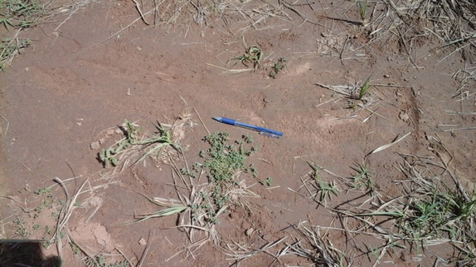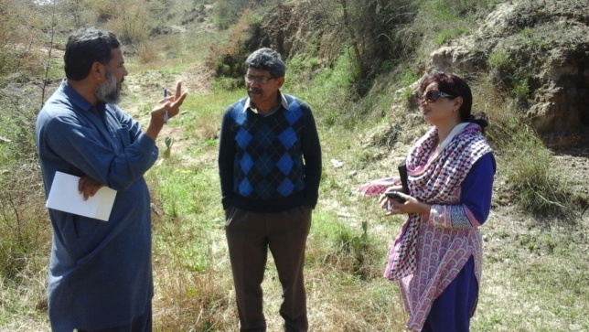
Visit to structure installed sites with Prof. Ghulam Nabi

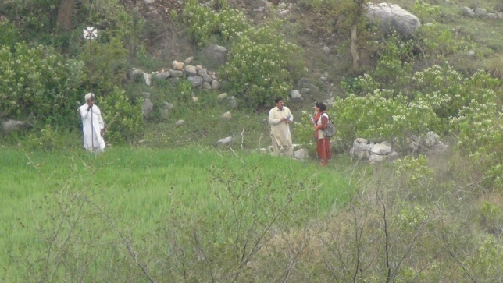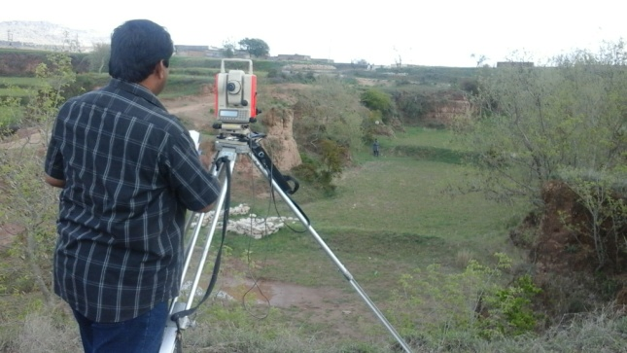
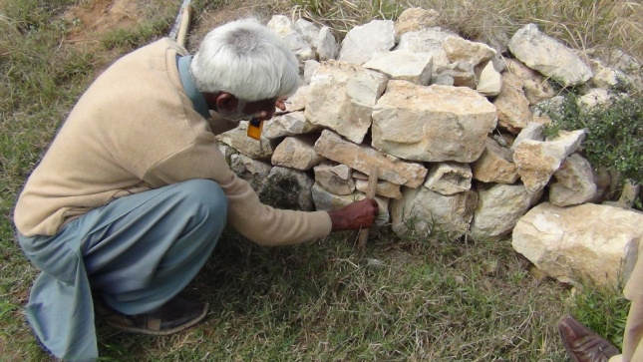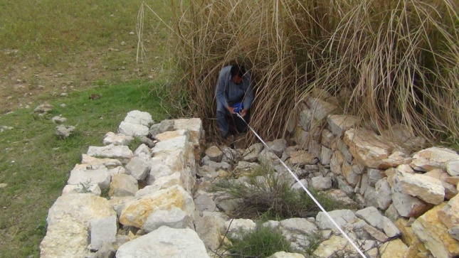
Activities and field visit for the collection of data
Activities carried out for SWAT Modeling
- Data screening is completed and the location of soil conservation structures was verified with field survey and Google Earth

- The Digital Elevation Model (DEM) development has been completed for the Rehna Sadat, Kohkar Bala, Khandoa, Chak Khushi, and Dhoke Mori area.

- Rainfall data has been analyzed as per model requirement

- Landsat data has been downloaded and land use-land cover (LULC) maps for Rehna Sadat, Kohkar Bala, Khandoa, Chak Khushi and Dhoke Mori are ready

- Soil Conservation data due to structures has been analyzed

- Input files for SWAT model calibration were completed up to mid of June, 2015

- Model has been completely calibrated during the last week of June, 2015
Complete timeline with milestones for project deliverables
 | Jan | Feb | Mar | Apr | May | Jun | Jul | Aug | Sep | Oct | Nov | Dec
Finalization of the methodology and digitization of existing data
Survey and data collection of selected sites and structures for SWAT modeling
Data set up for SWAT modeling
Data processing &Model calibration
Model validation and up- scaling for selected structures
Final results and report writing

Detailed Report
SWAT Modeling of Small Mountainous Catchments in Pothwar Area of Pakistan for Soil Erosion Estimation
EXECUTIVE SUMMARY
This study was undertaken to estimate soil erosion using semi-distributed basin-scale SWAT model in Dhrabi Watershed District in Chakwal, Pakistan. Four sub-catchments of Dhrabi Watershed were selected and model setting-up was done using the ArcSWAT interface for each sub-catchment separately. Soil erosion monitoring was set to collect sediment in a small pond and runoff was measured by automatic water level recorder.

SWAT Manual Calibration helper tool was used for to calibration the model parameters using time series (monthly) sediment load data of 2009 to 2010 and then validation of simulated sediment yield was done for the year 2011 for each sub-catchment separately. The performance of the model was evaluated using statistical and graphical methods to assess the capability of the model in simulating the sediment yield for the study area.

The correlation coefficient value was 0.78 between simulated and observed sediment yield data for combined sub-catchments and the coefficient of determination (R²) and NSE values was obtained above 0.80 and 0.70 respectively for the calibration period and 0.70 and 0.65 respectively for the validation period for each sub-catchments.

The sensitivity analysis on five sediment yield producing parameters was carried out and result showed that USLE_P is most sensitive parameter and its value used ranges from 0.11 to 0.89 and other parameters are SPEXP, SPCON, USLE_C, and USLE_K and value used ranges from 1.0 to 1.33, 0.0032 to 0.007, 0.164 to 0.192 and 0.211 to 0.2537 respectively and sensitivity of these used parameters decrease simultaneously and value of USLE_LS factor ranges from 2.36 to 2.46 combined for all four catchments.

Keywords: Sediment yield, SWAT, MUSLE, sensitivity analysis

Introduction
Water and soil are the most important and basic natural resources of agriculture and livestock production which plays a key role in economic growth of any region. Research studies showed that the agricultural soils developed from wind and water transported material comprising of alluvial deposits, mountain washed out and stream valley deposits etc. However, when this balance i.e. fertile soil formation is disturbed by anthropogenic activities then the sediment yield is dramatically increased at the expense of soil renewal and causes a serious threat to water resources development.

Globally, water resources is a growing concern and it was estimated that due to soil erosion the productivity loss in dry lands range from US$13 billion to US$28 billion per year (Scherr and Yadav, 1996).

Recently, using modern technologies such as soil erosion estimation can be done using different techniques such as empirical models, physical based models and conceptual models etc. at watershed level but empirical models like USLE are still used because of their ease of application and low data requirements but it is not able to simulate physical processes in a watershed. In contrast, physically-based models like WEPP provide detailed simulations of processes, but they require a large amount of data and are usually applied to small watersheds with areas ranging between 10 and 100 km² (Kliment et al. 2008).

Conceptual models like SWAT represent a compromise between these two model types by combining empirically-derived algorithms with physically-based ones (Borah and Bera 2003). So SWAT is more suitable as a tool for establishing sustainable water resources management in watersheds dominated by agriculture. urbanization, deforestation, overgrazing, improper tillage practices, leaving the land fallow and low organic matter are the major causes of soil erosion and produced the serious economy loss to the nation (Ashraf et al., 2002).

It was studied that the top soil is being lost at least 16 times faster than it can be replaced and this continuous and rapid loss of nutrient rich top soil eventually leads to desert-like situations by making conditions unsuitable for plant growth. Soil erosion causes not only onsite degradation of agricultural land, but also off-site problems such as the downstream deposition of sediment in fields, floodplains, and water bodies. Land degradation resulting from erosion is one of the most important issues in the rainfed areas and in order to access the magnitude of problems due to soil erosion it is necessary to keep track of quantitative data on the extent and actual soil erosion rate for better and reasonable solution of these problems. (IAEA, 2004).

Rainfall, land use, soil and topographic data along with other climatic and meteorological data are the key parameters for modelling the sediment yield of any catchment/watershed, but assessing and mitigating soil erosion at the watershed level is complex both spatially and temporally due to erratic and unpredicted pattern of rainfall, climatic changes, heterogeneities in topography, land cover and other catchment features for specified areas under study.

This study focuses on the Pothwar area (Dhrabi Watershed District Chakwal)) where high intensity rainfalls, steep slopes, and erodible soils without adequate protection have led to extensive soil erosion in this area and consequences are devastating. They include loss of fertile soil, loss of vegetation, reservoir depletion by sedimentation, and eutrophication and contamination of surface and groundwater and highest recorded rate of erosion is estimated to be 150-165 tons per hectare per year. (Ashraf et al., 2002). The texture mostly varies from sandy to silt loam and clay loam comprising from poor to fertile lands. The plateau has a flat to gently undulating surface broken by gullies and low hill ranges.

Due to climate change the rainfall pattern in this region is unpredicted with respect to time which causes severe erosion and its impact on surface water resources. The severe erosion produce high sediment yield causes loss of soil and water conservation structures such as small dams and water ponds. The management techniques practiced in this region to conserve soil and water are not only related to the conservation of natural resources but also to the sustainable development of the agricultural sector. In order to formulate management practices, soil erosion must be considered. Soil loss from a watershed can be estimated based on an understanding of the underlying hydrological process in a watershed, climatic conditions, landforms and soil factors.

High sediment yields are natural in upland Plateau of Pothwar area and balanced by the high rates of erosion and soil production. When this balance is disturbed by anthropogenic activities then the sediment yield is dramatically increased at the expense of soil renewal. This rise in soil erosion and sediment yield in Pothwar area has endangered soil and water conservation structures, reservoir projects and caused doubts about the viability of existing and future schemes. Untimely sedimentation may reduce the benefits and, if it is ignored, remedial measures may become prohibitively expensive. Keeping in view such problems estimation of sediment yield and evaluation of soil erosion parameters were done in Pothwar area on the Dhrabi watershed using semi distributed Soil and Water Assessment Tool (SWAT) tool.

SWAT Model Description
SWAT is a conceptual basin scale, semi-physical, semi-empirical continuous-event based, daily and hourly time step hydrologic semi distributed long term simulation model developed to predict the impact of land management practices on water, sediment, and agricultural chemical yields in large complex watersheds with varying soils, land use and management conditions over long periods of time (Arnold et al., 1998, 2000; Neitsch et al. 2001). It can also be used to simulate water and soil loss in agriculturally dominated small watersheds (Tripathi et al. 2003).

Watersheds are divided into sub-watersheds based upon drainage areas and each sub watershed is further divided into Hydrological Response Units (HRUs) based on land cover and soil type. Each HRU is assumed to be spatially uniform in land use, soil, topography, and climate. SWAT requires specific information about weather, soil properties and topography, vegetation, and land management practices occurring in the watershed. A full description of SWAT can be found in the theoretical documentation by Neitsch, et al.

Modelling Sediment Yield in SWAT
Erosion and sediment yield in SWAT are computed for each HRU with the Modified Universal Soil Loss Equation (MUSLE) (Williams and Berndt, 1977). MUSLE uses the amount of runoff to simulate erosion and sediment yield while the USLE uses rainfall as an indicator of erosive energy.

MUSLE is expressed in terms of runoff volume, peak flow, and Universal Soil Loss Equation (USLE) (Wischmeier and Smith, 1978) factors. The hydrology model supplies estimates of runoff volume and peak runoff rate, which, with the sub-basin area, are used to calculate the runoff erosive energy variable.

The modified universal soil loss equation adopted in SWAT is given out in the following mass balance equation:
$$S.Y=11.8 {\left(Q_{surf}×q_{peak}×{area}_{hru}\right)}^{0.56}.K_{USLE}.C_{USLE}.P_{USLE}.{LS}_{USLE}. CFRG$$

where S.Y is the sediment yield (tons/day), Q_{surf} is the surface runoff (mm/ha), q_{peak} is the peak runoff rate (m³/sec), area_{hru} is the area of hydrological response unit (ha), K_{USLE} is the soil erodibility factor, C_{USLE} is the management cover factor, P_{USLE} is the support practice factor, LS_{USLE} is the topographic factor and CFRG is the coarse fragment factor.
The most sensitive soil erosion evaluation parameters which are used in Arc SWAT are listed below.

Table 1: Soil Evaluation Parameter used in Arc SWAT
Parameter | Description
USLE_P | USLE practice factor
USLE_C | Cover and management factor in USLE
USLE_K | USLE Soil erodibility factor
SPCON | Linear parameter for calculating the maximum amount of sediment that cab be re-entrained during channel sediment routing
SPEXP | Exponent parameter for calculating sediment re-entrained in channel sediment routing
CH_EROD | Channel erodibility factor
CH_COV | Channel Cover factor

An iterative approach is usually used for manual calibration involving different steps as mentioned in Figure 1.

Yes
Calibration Complete
Sediment Yield Criteria
- d (%) ≤ 20
- R2 ≥ 0.6
- EN.S ≥ 0.5

No
Adjust
- USLE_P
- USLE_C
- SPCON
- SPEXP
- CH_EROD
- CH_COV

Run SWAT

Run SWAT using Default Parameters
(Sim1)
LEGEND
d: percent difference between measured and simulated average values
R²: Coefficient of determination
E_{N.S}: Nash-Sutcliffe efficiency coefficient
USLE_P: USLE practice factor
USLE_C: USLE Cover & Management factor
SPCON: Linear coefficient for with in channel sediment routing
SPEXP: Exponent coefficient for sediment re-entrained in channel sediment routing
CH_EROD: Channel erodibility factor
CH_COV: Channel cover factor

Figure 1: SWAT manual calibration flowchart for sediment yield (from Engel et al., 2007; adapted from Santhi et al., 2001)

Study Area Description
The study was conducted in the Dhrabi watershed an area of 196 km² which is located between latitudes 32°42ʹ36″N and 32°55ʹ48″N and longitudes 72°35ʹ24″E and 72°48ʹ36″E in District Chakwal, Pothwar Pakistan.

The watershed consists of low to medium hills between elevations of 445 to 898 meters above sea level. The source of elevation information was evaluated by Digital Elevation Models (DEMs). The topography varies from shallow to deep gullies, small to large terraces, and mounds to hillocks. The soil is predominantly of a sandy loam type and low in organic matter (less than 1%). The study was conducted from 2009 to 2011. The location map of the area is shown in Fig.2.
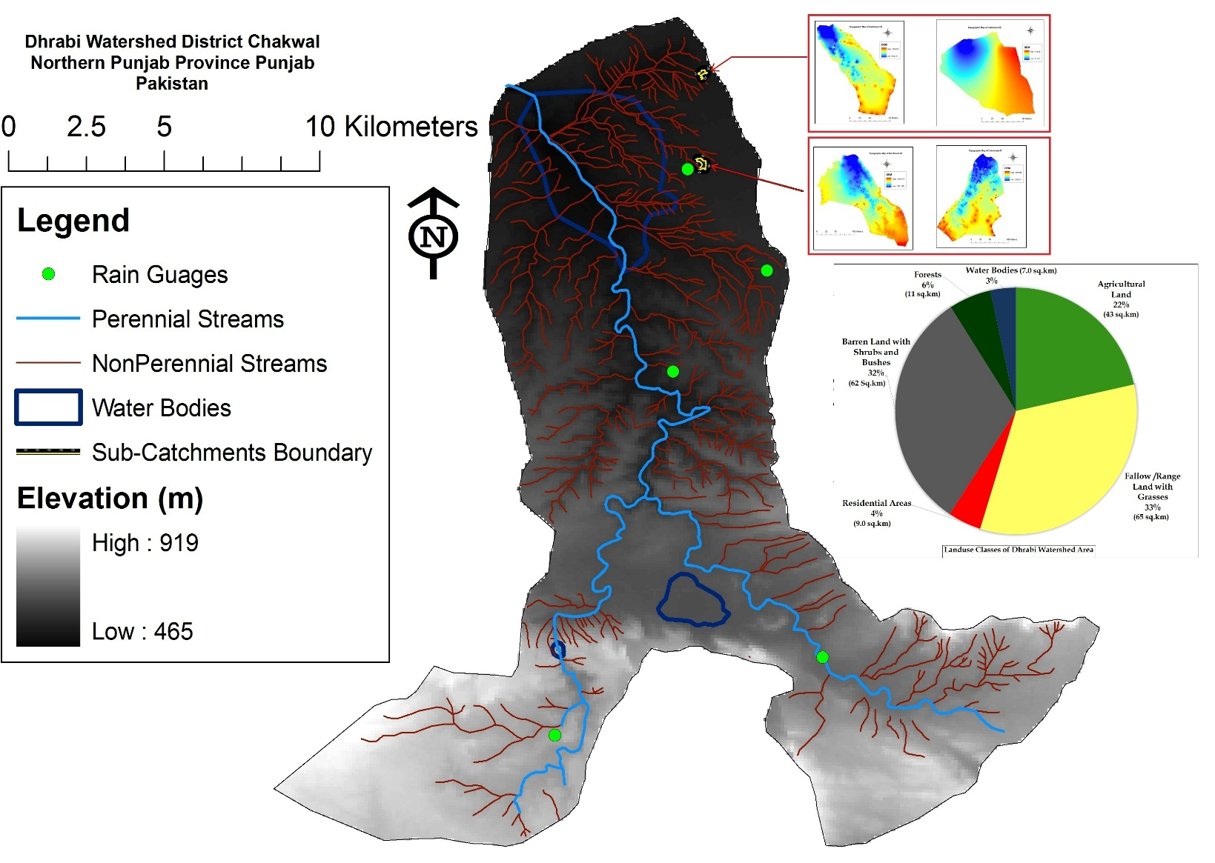
Figure 2: Location of study area in Dhrabi watershed of Pothwar Area
To determine the degree of soil erosion, sediment yield was measured from four sub-catchments in the watershed because catchments have well defined boundaries and fully representative of study area. These catchments consisted of gully and terraced land-use systems. The salient features of the catchments are given in Table 2 and topographic maps and Landuse maps are provided in Fig.4.

The soil texture class of these catchments is sandy loam and rainfall ranges from 450mm to 630 mm with high spatial and temporal variation. Over 60 % rainfall occur in June and September.

Table 2: Salient features of Sub-catchments
Catchment ID | Soil Type | Landuse Classification | Catchment area (ha)
25 | Sandy Loam | Trees, Grasses, Bushes, Shrubs, Pastures for Grazing, Winter wheat, Agricultural Land | 2.0
27 | Sandy Loam | Trees, Grasses, Bushes, Shrubs, Pastures for Grazing, Winter wheat, Agricultural Land | 3.0
31 | Sandy Loam | Trees, Grasses, Bushes, Shrubs, Pastures for Grazing, Winter wheat, Agricultural Land | 1.5
32 | Sandy Loam | Trees, Grasses, Bushes, Shrubs, Pastures for Grazing, Winter wheat. Agricultural Land | 3.3

Material and Methodology
The first step in setting up of SWAT model on any study area is the physiographic analysis based on catchment topography. The Arc SWAT automatically delineates a watershed into sub watersheds based on Digital Elevation Model (DEM) to account for catchment heterogeneities. For this study four sub catchments of similar characteristics were selected for the evaluation of sediment yield in Dhrabi watershed so physically topographical survey of these sub-catchments were taken using GPS and then DEM of these sub catchments were generated using point source elevation data as shown in Fig.4. DEM of each sub-catchment was supplied to the Arc SWAT for topographic analysis, delineation of sub-watershed and stream network generation.

In this case the whole sub catchment was divided into single sub basin. Successful execution of terrain processing module of Arc SWAT interface resulted in generation of appropriate database for the sub-basin parameters and a detailed topographic report of the watershed.

Land use and soil map along with their respective look up tables prepared earlier were supplied to the model for reclassification according to SWAT coding convention.
Further entire watershed was classified into three slope categories using the interface. All three maps were then overlaid to create HRU’s with unique land cover/soil and slope class. Subdividing the areas into hydrologic response units enables the model to reflect the evapotranspiration and other hydrologic conditions for different land cover/crops and soil.

Location table of Weather Data, Daily Precipitation Data Files, Maximum and Minimum Temperatures, Wind Speed, Relative Humidity, Solar Radiation data were loaded to link them up with the required files already created for the purpose. After loading all the input data and generating the required database files, SWAT model was initially run on monthly basis using default parameter values.

Table 3: Model input data source
Data Type | Source | Description
Topography (DEM) | Surveying Using GPS  (SAWCRI, Chakwal) | Digital Elevation Model (1m×1m) Resolution of Four sub-catchments
Soil Map | Soil Textural Analysis by SAWCRI, Chakwal | Physical properties of soil, i.e. sandy loam soil
Landuse Map | Google Earth | Classification based upon Google earth survey
Climate Data | Automatic weather station and water level recorder installed in different sub- catchments by SAWCRI Chakwal | Daily data of Precipitation, Temperature, Wind speed, Relative Humidity, Solar Radiation and Flow data
Sediment Data | An experimental setup for measurement of sediment load of each catchment by SAWCRI Chakwal Department. | Event based sediment data

A line diagram given in Fig.3 provides the procedure for simulation of sediment yield using Arc SWAT tool.
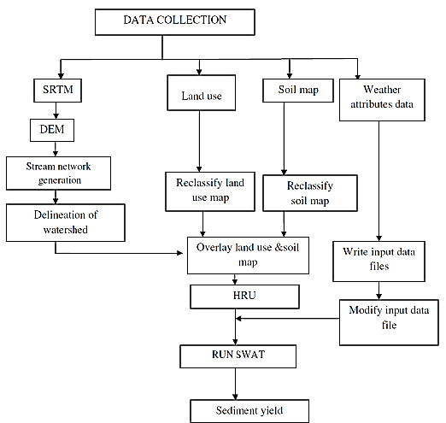
Figure 3: General Algorithm used for Sediment Yield Simulation in Arc SWAT

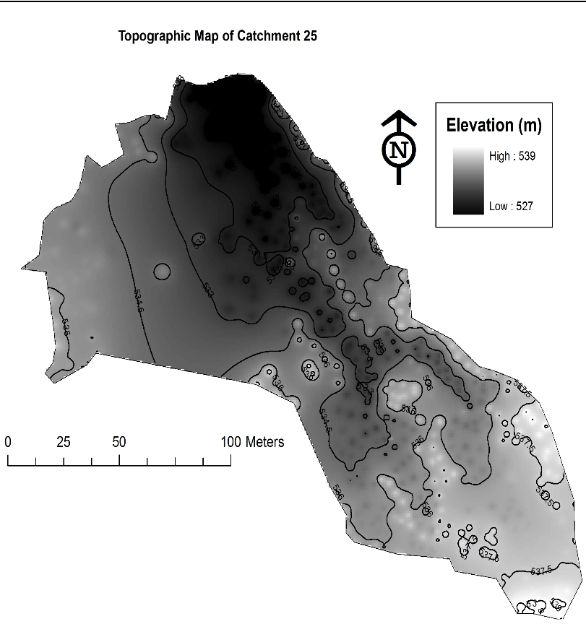 | 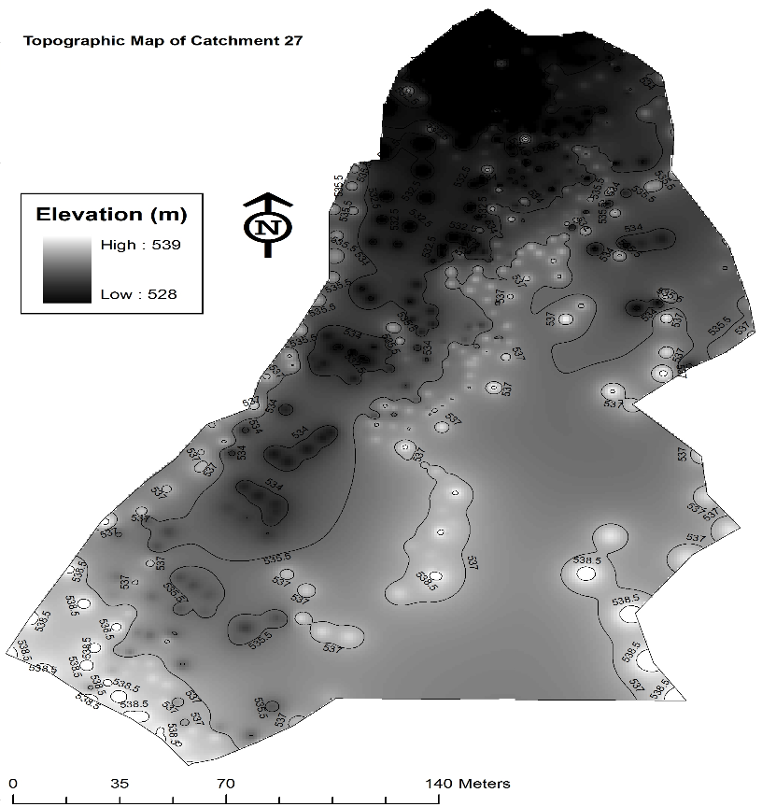
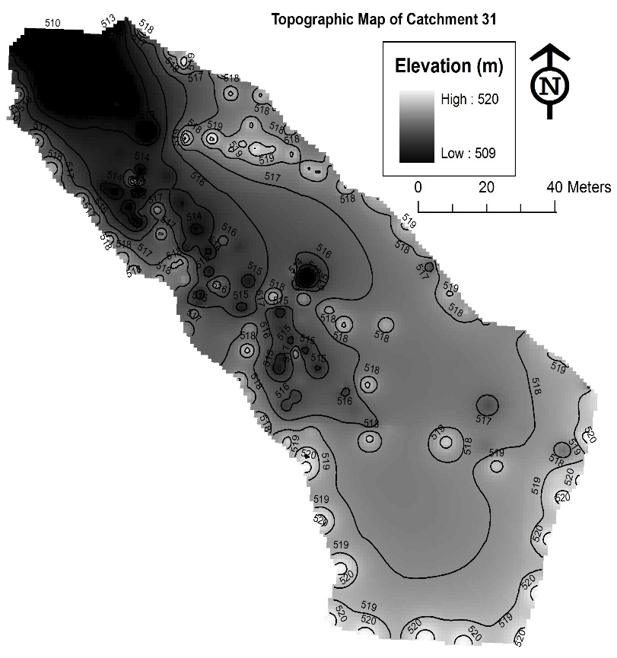 | 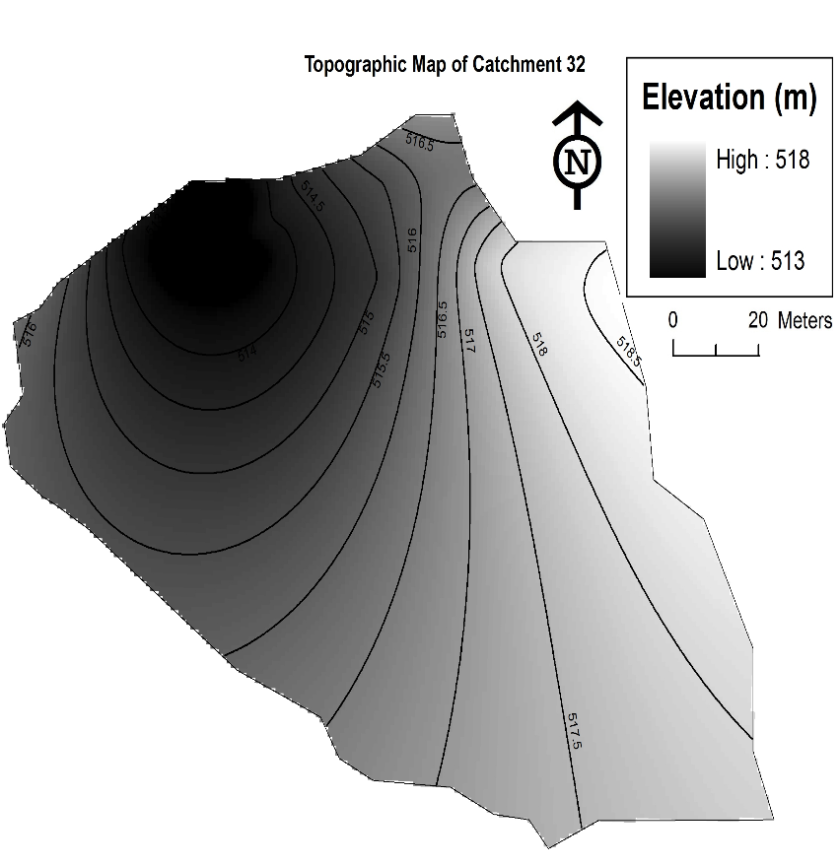

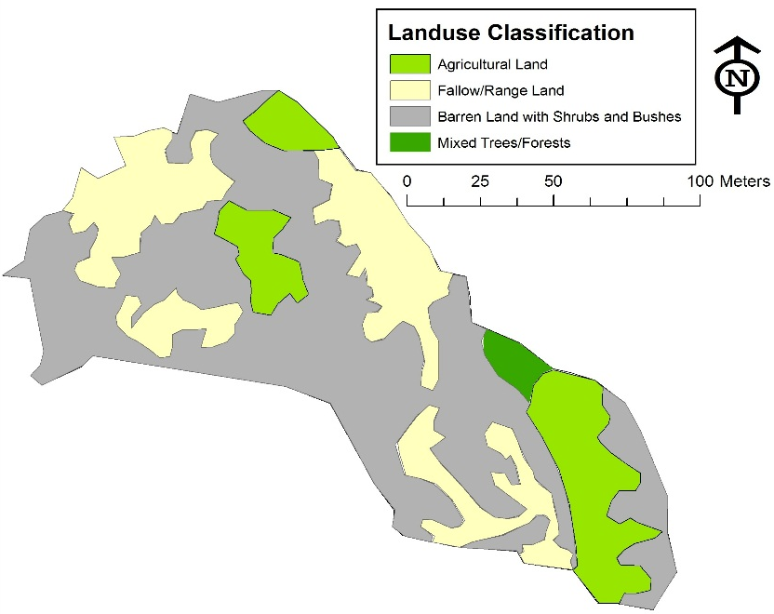 | 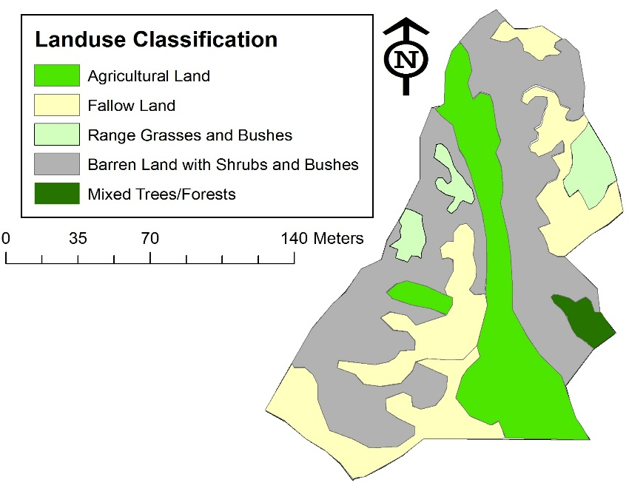
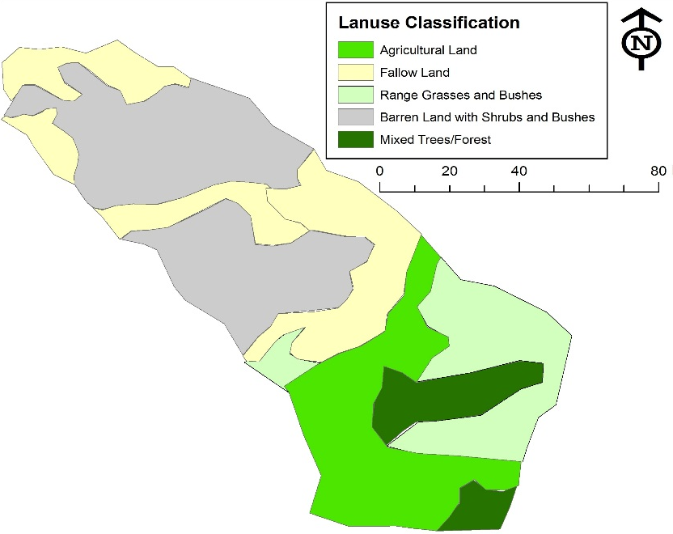 | 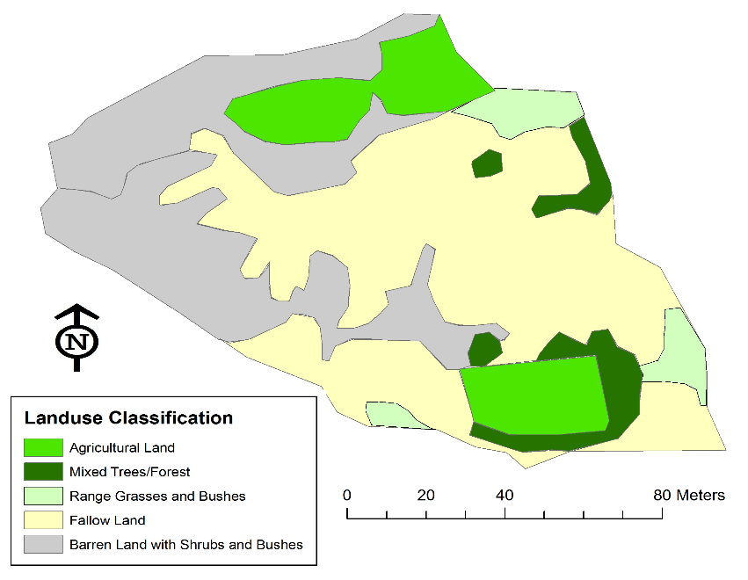

Table 4: Land use Classification of Sub-Catchments
Processed Land use | SWAT Class | Percentage of Catchment Area
Processed Land use | SWAT Class | Cat-25 | Cat-27 | Cat-31 | Cat-32
Agricultural Land | Agricultural Land Generic (AGRL) | 14.19 | 2.15 | 19.83 | 11.48
Fallow Land | Crop Land/Grass land Mosaic (CRGR) | 24.54 | 25.26 | 23.42 | 45.68
Mixed Trees/ Forest | Forest Mixed (FRST) | 1.49 | 1.75 | 7.66 | 5.04
Range Grasses and Bushes | Range Grasses (RNGE) | 0.00 | 5.20 | 15.41 | 9.39
Barren Land with Shrubs and Bushes | Mixed Grass Land/ Shrubs (MIGS) | 59.78 | 47.64 | 33.68 | 28.40

Model Performance Evaluation
Calibration and validation results were evaluated by graphical and statistical criteria such as, correlation coefficient, Nash Sutcliffe Efficiency (E_{N.S}), Coefficient of Determination (R²),

Nash-Sutcliffe Coefficient [NS]
Nash-Sutcliffe coefficient measures the efficiency of the model by relating the goodness-of-fit of the model to the variance of the measured data.
Nash-Sutcliffe efficiencies can range from 0 to 1. An efficiency of 1 corresponds to a perfect match of modelled discharge to the observed data. An efficiency of 0 indicates that the model predictions are as accurate as the mean of the observed data, whereas an efficiency less than zero (NS < 0) occurs when the observed mean is a better predictor than the model. Besides, due to frequent use of this coefficient, it is known that when values between 0.6 and 0.8 are generated, the model performs reasonably. A value between 0.8 and 0.9 tells that the model performs well and a value between 0.9 and 1 indicates that the model performs extremely well. The formula for Nash- Sutcliffe (NS) is:
$$E_{NS}=1- \frac{\sum_{i=1}^{n}{{\left(Q_{oi}-Q_{si}\right)}^{2}}}{\sum_{i=1}^{n}{{\sum{\left(Q_{oi}-{\overline{Q}}_{0}\right)}}^{2}}}$$
Where: E_{NS}: Nash-Sutcliffe coefficient, $Q_{oi}$: Observed sediment flow, $Q_{si}$: Simulated sediment flow and ${\overline{Q}}_{0}$: Average of observed sediment flow.

Coefficient of Determination [R²]
The coefficient of determination, denoted R², provides a measure of how well observed outcomes are replicated by the model. The range of R² lies between 0 and 1 which described how much of the observed desperation is explained by the prediction. A value of zero means no correlation at all; whereas one means that the desperation of the prediction is equal to that of the observation.
$$R^{2}=\frac{{\left[\sum_{i=1}^{n}{\left(Q_{si}-{\overline{Q}}_{s}\right)} \left(Q_{oi}-{\overline{Q}}_{o}\right)\right]}^{2}}{\sum_{i=1}^{n}{{\left(Q_{si}-{\overline{Q}}_{s}\right)}^{2}\sum_{i=1}^{n}{{\left(Q_{oi}-{\overline{Q}}_{o}\right)}^{2}}}}$$

Results and Discussion

Model Calibration, Validation and Application
Maximizing the model efficiency calibration and validation of soil erosion parameters were done using manual calibration procedure (trial-and-error method) based on the literature references and calibration technique described in SWAT user manual. Calibration of the model is setting or correcting output value of the model by changing values of input parameters in an attempt to match these with field conditions or observed values within some acceptable criteria and model validation is the process of performing model simulation with a different dataset from the calibration dataset, keeping the calibrated parameters constant, which is used to test whether the calibrated parameters were appropriate for the study basin.
General procedure which was adopted for manual calibration of soil erosion parameters in manual calibration helper tool of Arc SWAT as given in Fig.1
The calibration and validation was performed using observed data of sediment (ton/ha) for the year 2009 and 2010 respectively which was measured at plastic collecting tank i.e. the experimental setup of Soil and Water Conservation Research Institute (SAWCRI) Chakwal in each sub-catchments. The validated model was then used for application using sediment data of year 2011.
The time-series plots of measured and simulated data of each sub-catchment after calibration were drawn as given in Fig.6 and then two statistical indicators, Nash and Sutcliffe coefficient of efficiency (E_{N.S}) and coefficient of determination (R²) were used to evaluate the performance of model for each sub-catchment as given in table5.
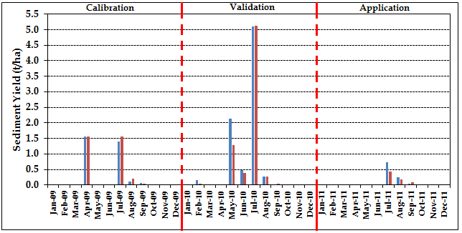
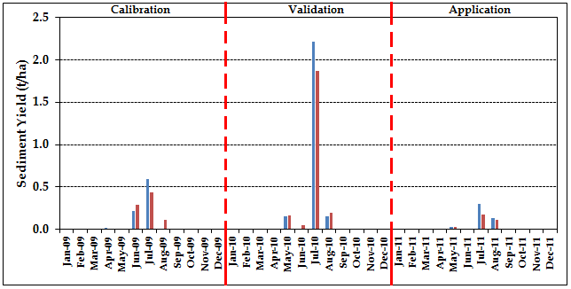
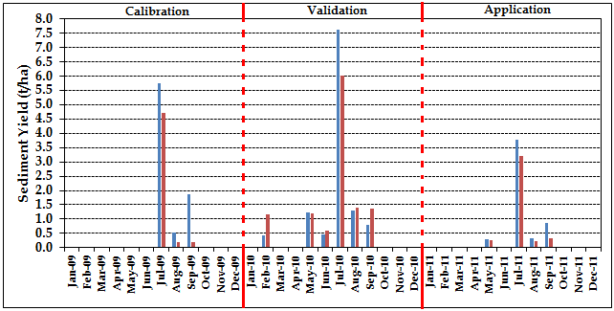
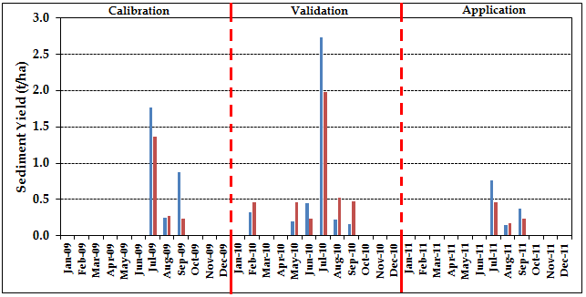

Comparison between observed and simulated sediment yield for all events in 2009 and 2010 are given in above table and graphical display of this data for all four sub-catchments is shown in Fig.

This revealed that there is a good relationship between measured and simulated sediment yield because the value of correlation coefficient is 0.78.
The model performance coefficients values for calibrated and validated data are given below.
Model Calibration
Parameter | Catchment 25 | Catchment 27 | Catchment 31 | Catchment 32
R² | 0.89 | 0.87 | 0.80 | 0.88
E_{N.S} | 0.86 | 0.81 | 0.77 | 0.80
Model Validation
R² | 0.83 | 0.86 | 0.83 | 0.87
E_{N.S} | 0.76 | 0.71 | 0.79 | 0.86
Model Application
R² | 0.79 | 0.78 | 0.74 | 0.76
E_{N.S} | 0.74 | 0.72 | 0.78 | 0.87

Parameter Sensitivity Analysis
The first step in the calibration and validation process in SWAT is the determination of the most sensitive parameters for a given watershed. The user determines which variables to adjust based on expert judgment or on sensitivity analysis. Sensitivity analysis is the process of determining the rate of change in model output value with respect to changes in model inputs (parameters). It is necessary to identify key parameters and the parameter precision required for calibration (Ma et al., 2000).
Sensitivity analysis was performed with One –Factor-At-a- Time (OAT) approach for sediment yield calibration using six parameters and list of parameter ranking was found in sensout.out file which is given in below table with default and value used for sediment yield calibration.
Parameter Ranking | Default Value | Values Used
Parameter Ranking | Default Value | Cat-25 | Cat-27 | Cat-31 | Cat-32
USLE_P | 0 to 1 | 0.11 | 0.89 | 0.13 | 0.32
SPEXP | 1.0 to 2.0 | 1.0 | 1.33 | 1.099 | 1.13
SPCON | 0.0001 to 0.01 | 0.0032 | 0.0032 | 0.006 | 0.007
USLE_C | 0.001 to 0.5 | 0.182 | 0.164 | 0.179 | 0.192
USLE_K | 0 to 0.65 | 0.246 | 0.211 | 0.2537 | 0.252

Summary and Conclusions
In this research study, SWAT 2009, a process based partially distributed hydrological model having an interface with ArcGIS software was used for modelling sediment yield for Dhrabi watershed in Chakwal. Four sub-catchments of similar characteristics of Dhrabi watershed were selected.
After preparing all required thematic maps and database as per the format of Arc SWAT model for all sub-catchments, model was setup and calibrated for monthly sediment yield using the observed data of 2009 to 2010 separately for each catchment named as Cat-25, Cat-27, Cat-31 and Cat-32. The model validation was carried out for a data set of one year 2011. The performance of the model for calibration and validation was evaluated using graphical and statistical methods. For the calibration and validation period, in graphical approach the correlation coefficient between observed and simulated data was 0.78 for combined sub-catchments. The values of coefficient of determination R² and NS coefficient for the sediment yield using manual calibration approach for calibration and validation period was given in above table. The model performance evaluation coefficients shown in this study can be considered reasonably satisfactory and the SWAT model is capable of predicting sediment yields for Dhrabi watershed with limited data availability.
The statistical results of the model’s performance in sediment yield prediction during calibration and validation periods with sensitivity analysis showed that the high E_{NS} and R² values above 0.7 and 0.8 respectively for calibration of four sub-catchments and for validation period E_{NS} and R² values were above 0.65 and 0.65 indicate that the model preformed fairly well for sediment yield during calibration and validation periods and the results were satisfactory.

REFERENCES
J. E. Nash and J. V. Sutcliffe, “River Flow Forecasting through Conceptual Models, Part I—A Discussion of Principles,” Journal of Hydrology, Vol. 10, No. 3, 1970, pp.
282-290. http://dx.doi.org/10.1016/0022-1694 (70)90255-6
Ashraf, M., F.U. Hassan, A. Saleem, and M. Iqbal M. 2002. Soil conservation and management: a prerequisite for sustainable agriculture in Pothwar. Science, Technology and Development 21(1): 25-31.
International Atomic Energy Authority (IAEA). 2004. Measuring soil erosion/ sedimentation and associated pesticide contamination. IAEA/RTC Regional Training Course project for East Asia and the Pacific. Restoration of soil fertility and sustenance of agricultural productivity, Malaysia.
Arnold, J. G., R. Srinivasan, R.S. Muttiah, and J.R. Williams. 1998. Large-area hydrologic modeling and assessment: Part I. Model development. J. Amer. Water Res. Assoc. 34(1): 73-89.
Neitsch JG, Arnold JG, Kiniry JR, Williams JR, (2001), „Soil and Water Assessment Tool, Theoretical Documentation - Version 2000‟ Blackland Research Center – Texas.
Tripathi, M.P., R.K. Panda, and N.S. Raghuwanshi. 2003. Identification and Prioritisation of Critical Subwatersheds for Soil Conservation Management using the SWAT Model. Biosystems Engineering (2003) 85(3):365-379, doi:10.1016/S1537-5110(03)00066-7.
Williams and Berndt, 1977 J.R. Williams and H.D. Berndt, Sediment yield prediction based on watershed hydrology, Trans. ASAE (1977), pp. 1100–1104
Wischmeier, W.H., Smith, D.D., (1978). Predicting Rainfall Erosion Losses A Guide to Conservation, Agricultural Handbook 537. Planning, Science and Education Administration. US Department of Agriculture, Washington, DC, 58 pp.
www.met-office.gov.uk/research/hadleycentre/pubs/brochures/B1999/imp_water_res.html
Engel, B., D. Storm, M. White, J. Arnold, and M. Arabi. 2007. A hydrologic/water quality model application protocol.J. American Water Resour. Assoc.43 (5): 1223-1236.
Santhi, C., J. G. Arnold, J. R. Williams, W. A. Dugas, R. Srinivasan, and L. M. Hauck. 2001. Validation of the SWAT model on a large river basin with point and nonpoint sources. J. American Water Resour. Assoc.37 (5): 1169-1188.
Kliment, Z., J. Kadlec and J. Langhammer. 2008. Evaluation of suspended load changes using AnnAGNPS and SWAT semi-empirical erosion models. Catena 73: 286–299.
Borah, D.K. and M. Bera. 2003. Watershed-Scale Hydrologic and Nonpoint-Source Pollution Models: Review of Mathematical Bases. Trans. ASAE 46(6): 1553–1566.

