CRP: Dryland Systems
Center: ICARDA
Flagship: South Asia
Action Site: Chakwal (Pakistan)
Activity title: Evaluation, demonstration and dissemination of fodder and feed intervention.
Short Title: Evaluation, demonstration and dissemination of fodder and feed intervention
Activity leader: Dr. Abdul Majid
Key partner(s): Fodder Program CSI, NARC, Islamabad, Pakistan
Progress report: 12 months (July-December, 2015)

Objective: Validate promising fodder varieties and silage making; develop informal seed enterprise (Oat)

Outputs Report IV.
One improved variety of maize, guar, and millet evaluated at 4 farmers’ fields

Introduction/Importance of Maize (Zea mays)
There are various ways to overcome fodder shortage. One of them is growing maize as forage crop, which is the third important cereal after wheat and rice. Maize crop has a variety of uses. Basically it is grown for grains and fodder for livestock. Maize is a rich source of starch, protein and edible oil. Similarly, dry matter production is 14 percent at early stage and at full bloom stage increases to 20 percent at milk formation and 29 percent at maturity. Selection of a good variety of seed is also important for producing better yield. Forage seed is widely available in local markets but its quality is usually mediocre and low in yield. Many farmers produce their own seed and may sell what they do not need. There is a need to supply pure and quality seed to ensure forage of high yield and nutritive value. The existing maize varieties of fodder crops in targeted areas are low yielding. Therefore, high fodder yielding variety “S-2002” was evaluated with local variety for green fodder and dry matter yield in two villages (Latifal and Saghar) at Chakwal district.
Methodology
Improved maize variety S-2002 was evaluated with local maize variety for green fodder and dry matter yields at farmers field at Latifal and Saghar (Table 1) during summer 2015. Maize plantation was carried out at 1st week of July 2015. All practices were kept same for both treatments such as plot size, planting method, seed rate, and fertilizer dose. The crop was harvested at 50% heading stage for measuring green fodder and dry matter yield. Green fodder yield data was recorded by harvesting one square meter plot randomly from three places. Each sample was weighed and averaged to calculate green fodder yield. For the determination of dry matter yield one kilogram green fodder sample was collected and oven dried at 60ºC and weighed again to calculate the dry matter yield.
Results:
At Latifal site, improved variety of maize (S-2002) produced 39.75 t ha⁻¹ green fodder and 8.42 t ha⁻¹ dry matter yields. Local variety gave 26.50 t ha⁻¹ and 5.32 t ha⁻¹ green fodder and dry matter yields respectively (Fig 1 and 2). The improved variety gave 33% and 37% more green fodder and dry matter yield than farmers’ variety (Figure 3).
At Saghar site, S-2002 maize variety produced 47.50 t ha⁻¹ and 9.02 t ha⁻¹ green fodder and dry matter yields, respectively. Local variety 30.67 t ha⁻¹ green fodder and 5.97 t ha⁻¹ dry matter yields were obtained (Figure 1 and 2). Improved practices at Saghar produced 35.4% higher green fodder yield and 33.8 % greater dry matter yield vs. local variety (Fig-3).

Introduction/Importance Millet
Millet (Pennisetum americanum) is an important grain and fodder summer season crop in Pothwar region. It is mainly cultivated due to its palatable and nutritious fodder for livestock. Improved millet varieties have the potential of producing high fodder yield even under moisture stress conditions compared to local varieties. The existing millet varieties of fodder crops in targeted areas are low yielding; thus, do not adequately cover fodder scarcity periods. Therefore, high fodder yielding variety “Millet No.8781” was evaluated with local millet variety for green fodder and dry matter yield in two villages of Chakwal district.
Methodology
Two validation plots in each village (Table 1) of improved variety of millet (No. 8781) versus local variety was conducted at farmers during summer, 2015. Millet was planted at 1st week of July 2015. All practices were kept same for the both treatments such as plot size, planting method, seed rate, and fertilizer dose. Green fodder and dry matter yields data was recorded at 50% heading stage by harvesting one square meter plot randomly from three places. Each sample was weighed and averaged to calculate green fodder yield. Dry matter yield was determined by collecting one kilogram green fodder sample and oven dried at 60ºC and weighed again to calculate the dry matter yield.
Results
At Latifal site, improved variety of millet No. 8781 produced 37.83 t ha⁻¹ green fodder and 7.19 t ha⁻¹ dry matter yields. Local variety gave 30.08 t ha⁻¹ and 5.14 t ha⁻¹ green fodder and dry matter yields respectively (Fig-1 and 2). The improved variety gave 21% and 29.88% more green fodder yield and dry matter yield compared with local variety (Fig-3).
At Saghar site, Millet No.8781 produced 39.08 t ha⁻¹ and 7.04 t ha⁻¹ green fodder and dry matter yields, respectively. Local millet variety produced 28.50 t ha⁻¹ green fodder and 5.20 t ha⁻¹ dry matter yields (Fig-1 and 2). Improved variety at Latifal gave 28% higher green fodder yield and produced 26 % more dry matter yield vs. local variety (Fig-3).

Introduction/Importance of Guar
Guar (Cyamopsis tetragonoloba) is perfect for cattle, sheep, goat, dairy and other ruminant livestock operations as a highly digestible, cheap and effective protein source through hay or fodder production. Guar is a fast growing fodder crop, that allows to produce large volumes of high quality protein fodder for livestock enterprise. It is extremely drought resistant, being able to absorb efficiently all ground water. It grows easily in those semiarid regions where less hardy crops perish. The existing guar varieties of fodder crops in targeted areas are low in yield. Therefore, high fodder yielding variety “BR-99” was evaluated with local guar variety for green fodder and dry matter yield in two villages (Latifal and Saghar) at Chakwal district.
Methodology
Two validation plots in each location (Table 1) of improved guar variety (BR-99) versus local variety were planted at Latifal and Saghar villages at 1st week of July 2015. All the agronomic practices were kept the same, such as plot size (0.3 acre), seed rate (50 kg ha⁻¹), and fertilizer dose (75kg N and 57kg P). Green fodder and dry matter yields was recorded at 10-50% heading stage by harvesting one square meter plot randomly from three places. Each sample was weighed and averaged to calculate green fodder yield. Dry matter yield was determined by collecting one kilogram green fodder sample and oven dried at 60ºC and weighed again to calculate the dry matter yield.

Results:
At Latifal site, improved variety of guar (Br-99) produced 23.35 t ha⁻¹ green fodder and 4.83 t ha⁻¹ dry matter yields. Guar local variety gave 15.75 t ha⁻¹ and 2.64 t ha⁻¹ green fodder and dry matter yields, respectively (Fig-1 and 2). The improved variety gave 33% and 45% more green fodder and dry matter yield than farmers/local variety (Fig-3).
At Saghar site, Br- 99 produced 26.67 t ha⁻¹ and 5.92 t ha⁻¹ green fodder and dry matter yields, respectively. Local variety produced 20.50 t ha⁻¹ green fodder and 3.63 t ha⁻¹ dry matter yields (Fig-1 and 2). Cultivation of improved variety at Latifal produced 23% higher green fodder yield and 39 % greater dry matter yield vs. local variety (Fig-3).

Overall
The average data of maize, millet and guar of green fodder and dry matter yield presented in figure 1 and 2 shows that, improved variety of maize, millet and guar gave better results compared with locally cultivated varieties at both villages.

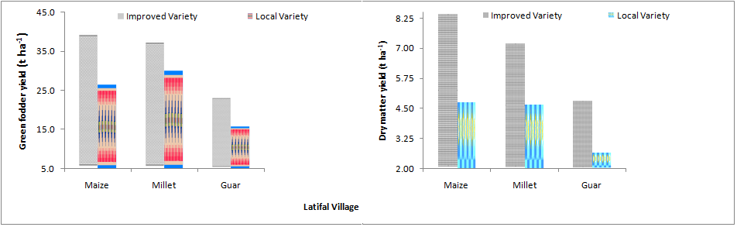
Fig-07: Average green fodder and dry matter yields of improved vs. local maize, millet and guar varieties evaluated at Latifal village.

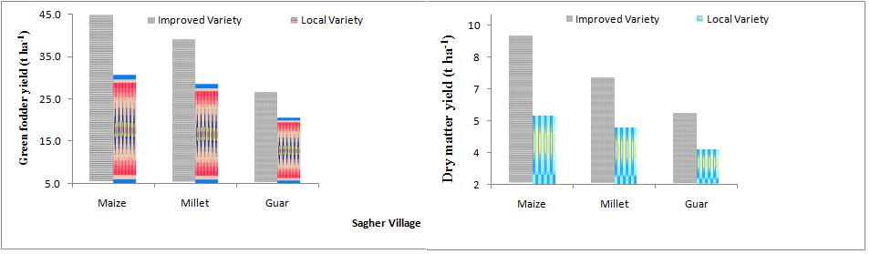
Fig-08: Average green fodder and dry matter yields of improved vs. local maize, millet and guar varieties evaluated at Saghar village.

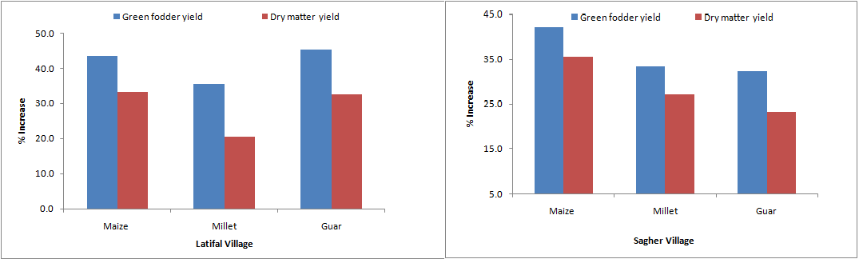
Fig-09: Percentage increase in green fodder and dry matter yields of improved maize, millet and guar over local varieties at Latifal and Saghar villages.

Table 2.List of farmers engaged in the maize, millet and guar evaluation in two villages
S No | Farmer Name | Village | Crop planted
1 | KhadimHussain S/o Fateh Khan | Saghar | Maize | Millet | Guar
2 | Qasim Shah S/O Muhammad Shah | Saghar | Maize | Millet | Guar
3 | Muhammad Iqbal S/O M. Nawaz | Latifal | Maize | Millet | Guar
4 | Fakhar-ul-Hassan S/O SahibzadaMahboobAlam | Latifal | Maize | Millet | Guar

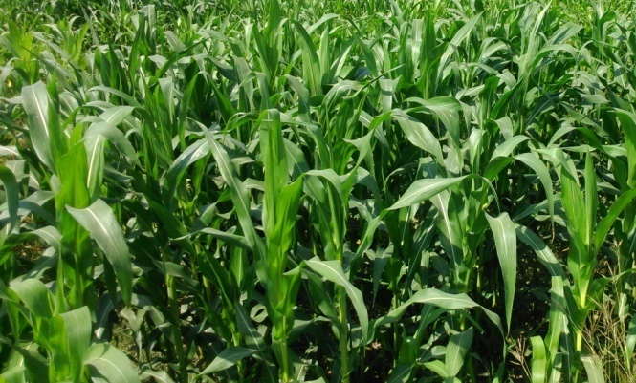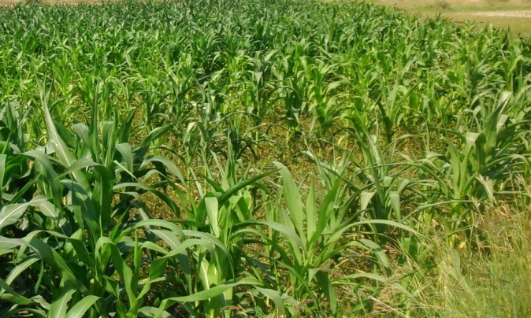
Pic-1: Improved maize variety S-2002 vs. Local maize variety at Latifal village

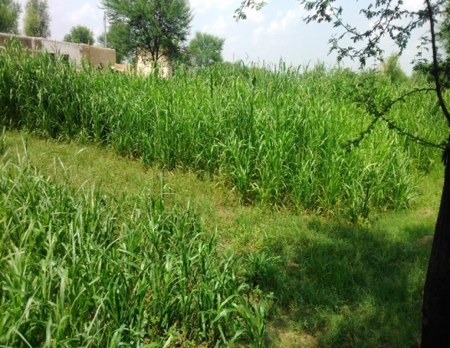  Pic-2: Improved Millet No. 8781 vs. local variety at Saghar village | 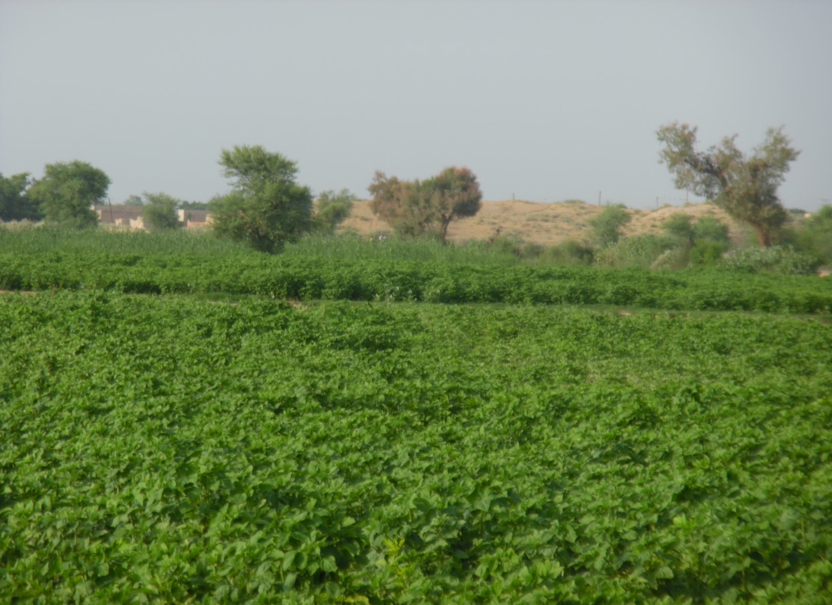  Pic-3: Improved BR-99 vs. local guar variety at Saghar village.

