CRP 1.1. “Dryland Systems in Central Asia” Program

Period of January – June, 2015

Studies on improving water use efficiency of dryland systems with potential for intensification
Submitted by International Water Management Institute

(Fergana Action Site)

Tashkent, Uzbekistan
July, 2015

Modeling of water use efficiency of winter wheat

- Introduction

For the last 20 years river flow available for irrigation of crops in Central Asia is reduced from 90% to 83%. Growing demand from non-agricultural water uses is the main challenge creating pressure on water available for agriculture. Since 1992, increased demand for energy and the shift of the upstream reservoir in the Syrdarya River from irrigation to hydropower generation mode caused reduction of water available for irrigation in average by 2 km³/year. The similar risk exist in the Amudarya River basin. Climate change may also effect on future water availability for agriculture. Central Asia is referred to be highly vulnerable to climate change and adaptation programs under development (World Bank, 2009). Over the last 70 years, the air temperature in the Central Asia has increased by 0.029 ºC per year while precipitation exhibited high multi-annual and multi-decadal fluctuations. It is already caused reduction of the volume of glaciers by third in the upstream of the Syrdarya River and Amudarya River. Water and energy nexus could be mitigated by reducing energy intensity and improving water and energy productivity in agriculture, consuming main part of available water.
The agriculture of Uzbekistan is heavily dependent on energy inputs mainly from fossil fuels. The agricultural production system is characterized by the intensive use of inorganic fertilizers, pesticides and energy consumption for water pumping. These inputs are heavily dependent on fossil fuels. With increasing population needs for energy in Uzbekistan will grow. A study was undertaken on winter wheat, one of two of the important crops in Uzbekistan. Most of the previous studies were limited on estimation of the crop energy or water requirements. In this study it was hypothesized that there is high interrelation between water productivity and energy productivity – better understanding this linkage will promote further improvement of irrigation water management.
This study applied the experimental field scale approach focused on improving water use efficiency by introducing new varieties of winter wheat and improved irrigation technology. Winter wheat is the most important cereal grown in Central Asia. Whereas worldwide about 65% of the produced wheat originates from irrigated agriculture, in Uzbekistan virtually all winter wheat is cultivated on irrigated land (FAO and WFP 2000). Proper cultivation practices by farmers of Uzbekistan can support meeting quality standards for wheat flour. During the past 22 years, the area under irrigated cereals increased more than seven times from 221,000 ha to about 1.6 million ha, and gross yields rose from 1.54 in 1991 to 4.46 t/ha in 2012 (Statistical collection 2013). Winter wheat length of growing period is from October to mid-June around 255-265 days and 3000 ºC heat units required for growth stages. The harvesting period of winter wheat is in summer characterized by the maximum temperatures exceeding 40ºC causing high evaporation rates. After winter wheat harvesting there are still about 100-110 days and 2600 ºC heat units are remaining till October which is very suitable for the second crop production to convert evaporation loss into useful crop transpiration which will lead to improved water use efficiency, enhanced food security and increase income of farmers in Central Asia. This half year report presents results on evaluating water and energy productivity for winter wheat, only.
This study used the HYDRUS-1D (Šimůnek et al., 2008a) software to simulate crop transpiration and evaporation from winter wheat/fallow fields. We analyze three alternative water management regimes: full irrigation (FI), high deficit irrigation (HDI), and low deficit irrigation (LDI), all under deep and shallow water table conditions in the Fergana Valley.

2. Methods and Data
2.1. Study Area

Monitoring activities with winter wheat crop were conducted in the Odiljon Farrukhbek Sakhovati farm, Komiljon Umarov Mirob Water Users Association, Toshloq district, Ferghana province in 2014-2015 years on silt loam soils where the depth of groundwater table is 1.5-2.0 meters. Field experiments are still being carried on. The farm is located in Fergana valley at latitude of 40º31’59.9’’N, longitude of 71º47’4.1’’E and elevation of 461 m (figure-1). The farmer has 43.8 ha land and specialized to grow mainly cotton (23 ha), winter wheat (20.8 ha) and vegetables as a second crop after winter wheat if irrigation water is available. The farm is located in K.Umarov WUA where the main sources of irrigation are canal and groundwater. The area is water-short because is located in the tail ends of the Southern Fergana Canal (SFC), however there is available low saline groundwater from the depths of 1.5-2 m.
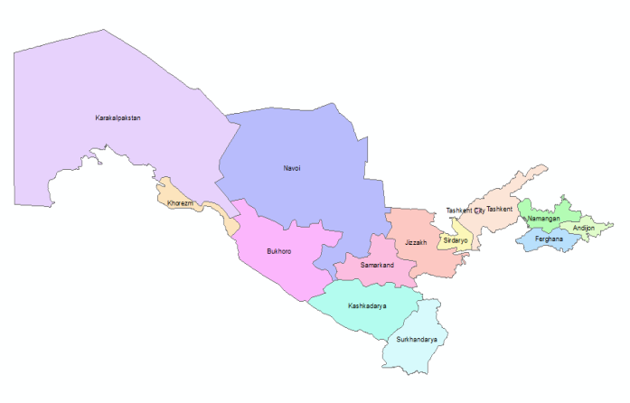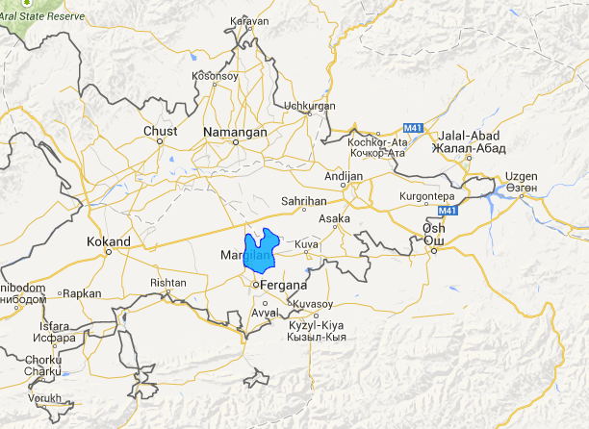
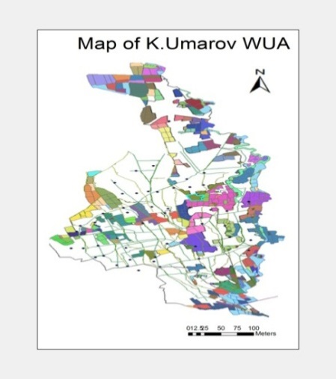
Fig 1. Location of the study area

2.2. Climate

Climate in study area is arid continental (Jenniver Sehring, Ernst Giese 2011). According to the available long term climate data, the average temperature during six summer months, from April to October, air temperature is varying from 26-30ºС and the maximum temperature raises up to 47ºC in summer whereas the minimum temperature declines as low as -4ºС in winter. Long-term annual precipitation ranges from 50 to 150 mm, with 90% occurring from October through May (figure-2). Soil bulk density is 1.47±0.02 Mg m⁻³ in the top, increasing to 1.51±0.03 Mg m⁻³at the soil layer of 0-50 and 50-100 cm (Table 2).

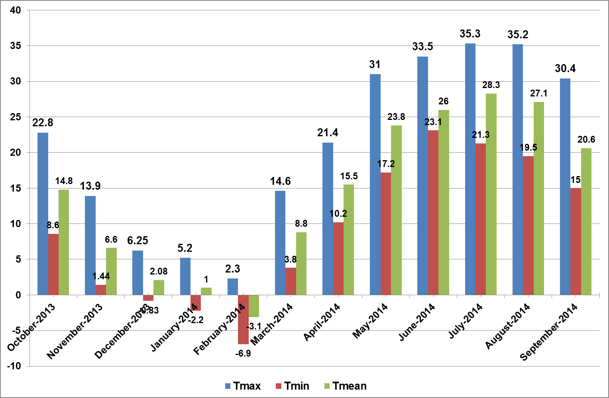
Fig. 2. Monthly average temperature of Fergana province, 2013-2014 (Source: Fergana meteorological station).

Table 2. Physical properties of the soil at the Odiljon Farrukhbek Sakhovati farm
Soil layer | Texture |  |  | FC | SBD | Porosity
Soil layer | Sand | Silt | Clay | FC | SBD | Porosity
cm | % | % | % | % of weight | g/cm³ | %
0-30 | 36.8 | 47.4 | 15.8 | 19.3 | 1.47 | 45.6
30-50 | 35.6 | 48.1 | 16.1 | 21.7 | 1.49 | 44.8
50-100 | 34.8 | 48.3 | 16.9 | 18.9 | 1.51 | 44.1

- MATERIALS AND METHODS
  - Methods and Data
The research has been started with monitoring farming practices along with the winter wheat variety “Tanya”, irrigation applications, soil moisture before and after each irrigation. The width between furrows was 60 cm. Composite soil samples were collected from the field at the following depths: 0-0.15, 0.15-0.30, 0.30-0.50, 0.50-0.75, 0.75-1.0 m. Sampling was undertaken prior to the irrigation season and after the irrigation season. The collected samples were air dried and processed. The soil physical attributes consisted of particle-size analysis, field capacity, infiltration rate, saturated hydraulic conductivity, bulk density, and moisture content. Particle-size analysis was determined on randomly selected samples from 0-0.15, 0.15-0.30, 0.30-0.50, 0.50-0.75, 0.75-1 m depths at five locations in each field by the sedimentation method using sodium hexametaphosphate as a dispersing agent. Field capacity was determined from one randomly selected location (2 m × 2 m) in each field by flooding, covering of flooded area with polyethylene sheet, and determining soil moisture in the following days over a period of 3-5 days until stabilization was achieved at all the soil depths. Soil moisture content was determined by the gravimetric method. Soil bulk density was determined on undistributed soil samples collected from each soil depth using the core method. Operation of the well, supplying water for irrigation and water distribution between the fields were also monitored. Soil chemical analyses of humus, nitrogen, phosphorus and potassium analysis were done before the planting and after harvesting period.
  - Phonological observations
Phonological observations are being studied with response of different irrigation technologies. Crop parameters observed were as follows: crop height (cm), crop soil cover, yield. In experiment year the density of plants are done two times after germination and before harvesting period in each variant and replications by counting all the plants in control furrows. Crop soil cover is identified by using 1m x 1m special wooden board with 10cm x 10cm grids. Photos are taken and processed by using ArcGIS tools to calculate the area of covered in percentage.

2.3. Research Method
HYDRUS 1D, a variably-saturated water flow model (Šimůnek et al., 2008), was used to examine the effects of policy/crop changes on potential water savings and to estimate crop transpiration and evaporation. The HYDRUS-1D software package is a finite-element numerical model, which simulates the one-dimensional movement of water, heat and multiple solutes in variably-saturated porous media (Šimůnek et al., 2008a). The model has been previously used and verified in a number of studies (e.g., Hernandez, 2001; Sanchez et al., 2003; Šimůnek et al., 2008a, 2008b, 2008c). For instance, Forkutsa et al. (2009) used the HYDRUS-1D model to simulate irrigated cotton with shallow groundwater on loam and sandy loam soils of the Khorezm region located in the Amudarya River downstream. Shouse et al. (2011) used the model to simulate root water uptake from a shallow saline groundwater. Since the system modeled in our study is similar to these studies, hence HYDRUS-1D is a robust choice for our analysis.
The HYDRUS-1D model simulates variably-saturated water flow by solving the Richards equation, written as:
(1)
where θ is the volumetric water content (cm³/cm³), t represents time (day), z is the vertical coordinate (positive upward), h denotes the pressure head (cm), K is the unsaturated hydraulic conductivity [cm/day], and S is the soil water extraction rate by plant roots (cm³/cm³/day).
The model estimates the potential crop evapotranspiration using the Penman-Montheith equation (Allen et al., 1998). Details of the numerical approach used in the model are given by Šimůnek et al. (2008a). Based on the result of numerical simulations, the yield and water productivity of alternative cropping systems were estimated. The yield of crops was found using the FAO’s expression of the yield response to ET (Steduto et al., 2009):

(2)
where Y_{x} and Y_{a} are the maximum and actual yields, ET_{x} and ET_{a} are the maximum and actual evapotranspiration, and k_{y} is a yield responses factor, representing the effect of a reduction in evapotranspiration on yield losses. For the evaluation of yield estimates, the biomass yield of crops was also calculated using the relationship recommended by Steduto et al. (2012) and applied in Aquacrop:
(3)
where T is the crop transpiration (in mm) and WP is the water productivity parameter (kg of biomass per m² and per mm of cumulated water transpired over the time period, in which the biomass is produced). The relationship between the yield and transpiration for winter wheat is taken from a study of Sommer et al. (2013), who using the field data for the study area, proposed the following relationship:
(4)
This relationship was used to verify the winter wheat yield estimated using the expression (2). Yield and transpiration relations for green gram were taken from studies by Webber (2008) and for alfalfa by Smeal et al. (1991).
The root mean square error (RMSE) of yield estimates was calculated
(5)
where n is the total number of situations.
The upper boundary condition was defined in HYDRUS-1D using the atmospheric boundary condition with a surface layer. The meteorological conditions were measured at the Fergana weather stations, located at a longitude of 71.75º, a latitude of 40.38º, and an elevation of 547 m asl. They included daily maximum and minimum air temperatures (ºC), relative humidity (%), sunshine hours, rainfall (mm), and wind speed (km/day). The lower boundary condition was set to a variable daily pressure head. The solute stress was not considered in the paper.
For the purpose of numerical modeling, the soil profile was divided into six numerical layers and grouped into four soil materials, determined by a soil description. The canopy ground cover was used to calculate the potential evapotranspiration, and to separate from it soil evaporation and transpiration. The water uptake method proposed by Feddes et al. (1978) and modified by van Genuchten (1980) was used to describe water stress conditions. The water stress reduction term was parameterized using the function proposed by Feddes et al. (1978), and using parameter values from the HYDRUS database (Šejna et al., 2012) for winter wheat (Table 3).
Table 3. Root water uptake – water stress reduction parameters (Feddes et al., 1978; Šejna et al., 2012) used in the HYDRUS model
Root water uptake parameters | Unit | Winter wheat
PO | [cm] | 0
POpt | [cm] | -1
P2H | [cm] | -500
P2L | [cm] | -900
P3 | [cm] | -16000
r2H | [cm/day] | 0.5
r2L | [cm/day] | 0.1

The crop development is given in the model using a daily crop height, a root depth, a soil cover fraction (Table 4).
Table 4. Main crop parameters for winter wheat*
Crop parameters | Unit | Winter wheat
Crop height, max | Cm | 100
Root depth, max | Cm | 100
LAI/Crop cover, max |  | -/0.98
Crop vegetation season |  | 4/10- 10/06
Crop harvesting |  | 10/06
Yield, max | t/ha | 6
*Data compiled from Edgorov et al., 2006; Sumochkina et al., 1977; Webber, 2008; Allen et al., 1998, 2005; Sommer et al., 2012.

These crop parameters were assumed to be conservative and applicable for a wide range of conditions simulated by the model.
The van Genuchten-Mualem model (van Genuchten, 1980) with an air-entry value of -2 cm was selected to obtain a predictive equation for the unsaturated hydraulic conductivity function. The van Genucthen-Mualem parameters describing the soil hydraulic properties of each layer (Table 5) are determined using the inverse solution (Karimov, 2013).
In Table 5, Q_{res} is the residual soil water content, Q_{sat} is the saturated soil water content, a and n are shape parameters, K_{s} is the saturated soil hydraulic conductivity, and l is the pore-connectivity parameter.
Table 5 Van Genuchten-Mualem parameters to describe soil hydraulic properties
Soil layer, cm | 0-60 | 60-120 | 120-180 | 180-300
Soil type/Parameters | Silt loam | Silt loam | Silt loam | Silt loam
Q_{res} [cm³/cm³] | 0.038 | 0.0010 | 0.0012 | 0.0010
Qs_{at}[cm³/cm³] | 0.407 | 0.250 | 0.301 | 0.336
a [-] | 0.024 | 0.0001 | 0.0016 | 0.0157
N [-] | 1.43 | 5.16 | 1.65 | 1.73
K_{s} [cm/d] | 11.4 | 1.08 | 27.6 | 4.48
I [-] | 0.00055 | 0.054 | 0.0098 | 0.0065

Using these parameters, simulations were carried out for a period of 365 days.

- Results and Discussion

3.1. Water use of the winter wheat/fallow system

The modeling results for the winter wheat/fallow cropping system are shown in Table 6. The RMSE between yields estimated using equations (2) and (4) was 0.1367.
Table 6. Water use of the winter wheat/fallow system as affected by irrigation applications and shallow groundwater
Scenario | I+P | GWL | Y_{a} | Y_{b} | ET_{a} | T/ET_{a} | E/ET_{a}
 | mm | m | t/ha | t/ha | mm | [-] | [-]
Full irrigation | 609 | 3.0 | 5.98 | 5.69 | 568 | 0.59 | 0.41
 | 579 | 2.5 | 6.03 | 5.74 | 585 | 0.58 | 0.42
 | 494 | 2.0 | 5.84 | 5.71 | 585 | 0.57 | 0.43
 | 419 | 1.5 | 5.70 | 5.76 | 616 | 0.55 | 0.45
Low deficit irrigation | 524 | 3.0 | 5.67 | 5.64 | 520 | 0.64 | 0.36
 | 504 | 2.5 | 5.68 | 5.53 | 549 | 0.59 | 0.41
 | 430 | 2.0 | 5.37 | 5.35 | 539 | 0.59 | 0.41
 | 349 | 1.5 | 5.70 | 5.76 | 616 | 0.55 | 0.45
High deficit irrigation | 434 | 3.0 | 5.32 | 5.18 | 489 | 0.63 | 0.37
 | 415 | 2.5 | 5.49 | 5.36 | 525 | 0.60 | 0.40
 | 350 | 2.0 | 5.37 | 5.35 | 539 | 0.59 | 0.41
 | 265 | 1.5 | 5.39 | 5.34 | 591 | 0.53 | 0.47
Rainfed winter wheat | 185 | 3.0 | 3.72 | 3.30 | 363 | 0.56 | 0.44
 | 185 | 2.5 | 4.28 | 3.99 | 427 | 0.57 | 0.43
 | 184 | 2.0 | 4.75 | 4.61 | 486 | 0.57 | 0.43
 | 185 | 1.5 | 5.38 | 5.33 | 591 | 0.53 | 0.47

Over all, the data given in Table 5 show that the yield of winter wheat was in the range of 5.7-6 t/ha under full irrigation, 5.4-5.7 t/ha under LDI, 5.3-5.5 t/ha under HDI, and 3.7-5.4 t/ha under rainfed conditions.
The grain yield was higher for deep groundwater as compared to shallow groundwater conditions under full irrigation. The grain yield was higher for shallow groundwater as compared to deep groundwater conditions for rainfed conditions, implying that the groundwater depth should be considered as an input in irrigation applications. There was no significant difference in yield under shallow and deep groundwater conditions for LDI and HDI, implying that shallow groundwater contributes to addressing the irrigation water deficit. These estimates did not account for the effects of soil and groundwater salinity, which may affect the yield of winter wheat.
Although the highest T/ET_{a} ratio was estimated for LDI with deep groundwater, followed by HDI with deep groundwater, average values of yield were lower for HDI as compared to low deficit irrigation. Under all irrigation scenarios, the T/ET_{a} ratio was estimated to be higher under deep groundwater conditions, as compared to shallow groundwater.

3.2. Water use efficiency of winter wheat/fallow system

Estimates of water productivity is given in Table 7.
Table 7. Water productivity of winter wheat/fallow (WW-F) system
Irrigation scenario | Groundwater depth | Cost of production | Water use efficiency
 | m | US$/ha | US$/m³
FI | 3.0 | 2561 | 0.45
 | 2.5 | 2585 | 0.44
 | 2.0 | 2502 | 0.43
 | 1.5 | 2443 | 0.4
LDI | 3.0 | 2431 | 0.47
 | 2.5 | 2436 | 0.44
 | 2.0 | 2300 | 0.43
 | 1.5 | 2443 | 0.4
HDI | 3.0 | 2280 | 0.47
 | 2.5 | 2354 | 0.45
 | 2.0 | 2300 | 0.43
 | 1.5 | 2311 | 0.39
RF | 3.0 | 1594 | 0.44
 | 2.5 | 1835 | 0.43
 | 2.0 | 2036 | 0.42
 | 1.5 | 2306 | 0.39

Conclusions

The preliminary results obtained indicate high correlation between water use efficiency, irrigation regime and groundwater depths; however, these results have to be verified based on the data recently obtained at K. Umarov WUA. Further analyses required to compare winter wheat/fallow system with winter wheat/legume crop system. Data collection is going on from mung bean plantations established at the farm. More in depth socio-economic analyses are required.

