CRP: Dryland Systems (DS)

Center: ICARDA

Flagship: South Asia
Action site: Chakwal (Pakistan)

Activity title: Identification, demonstration and validation of promising technologies and diversification options for enhanced productivity & livelihood security.

Sub activity: Introduction of Cactus (Opuntia ficus-indica) as a multi-purpose crop under intensive production system

Activity leader: Mounir Louhaichi

Key national partner: NARC

Objective: Increase resilience and improve use of marginal lands of agropastoral production systems while enhancing capacity development of farmers and extension agents through training, field days, etc.

Target audience: Agro pastoralists

A Prickly Cactus Journey: From Hellish Plant to Farmers' Darling
Submitted by Dryland Systems on July 5, 2015

Farmers in Pakistan are now embracing cactus as a multipurpose, income-generating crop to reduce risks associated with climate change
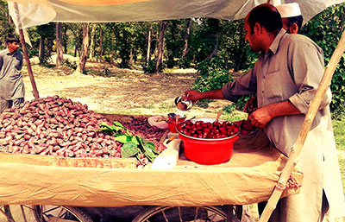
Pakistani farmer harvesting cactus pear fruit, Photo: ICARDA

The cactus pear (known by its scientific name as Opuntia ficus-indica) was not always accepted in Pakistan as a source of food for animals, much less as a fruit fit for human consumption. It was commonly believed to be the plant from hellfire; it suffered this unfortunate reputation by association with the upright prickly pear (known by the scientific name as Opuntia stricta), its close “cactus cousin.”
Unlike the cactus pear, the upright prickly pear is an invasive weed with large thorns, which animals do not like to eat and farmers do not like to pick or see in their farmlands. Pakistani farmers were not very familiar with the cactus pear being a succulent, thorn-free type of cactus suitable as green forage for feeding livestock. They were simply reluctant about the idea of cactus in general being a suitable crop to meet their needs for livestock feed, let alone other uses.
Today, the reality is very different. Farmers have not only changed their mind and beliefs about the cactus pear; they have actually increased their demand for its production.
Adapted to extreme conditions, the cactus pear can grow and survive in severely degraded soils and areas, where not much of anything else will grow. Given its high water efficiency and content, the cactus pear can sustain livestock through the driest of seasons. Compared to many other common crops and fodder, the cactus pear is easy to establish, maintain, and utilize. Its well-developed root system, which avoids wind and rain erosions, makes it an ideal feed crop in the face of climate change conditions.
Since the 1980s, scientists at the International Center for Agricultural Research in the Dry Areas (ICARDA) in collaboration with a host of partners and stakeholders have been documenting lost knowledge of how indigenous communities used cacti in the past, and identifying the potential uses of cacti, such as:
- Forage for livestock and animals;
- Fruit and vegetable where young cladodes are consumed fresh or cooked;
- Source of natural red dye accepted by health authorities worldwide;
- Processed foods where a potential market for cacti-based concentrated juices, liquors, semi-processed and food supplements is viable;
- Cosmetics industry, which might be a significant source of income;
- Medicinal applications: promising results for the treatment of gastritis, diabetes, hypercholesterolemia, and for obesity.
ICARDA and ILRI scientists, in collaboration with the Pakistan Agricultural Research Council and the National Agricultural Research Center of Pakistan, supported by the CGIAR Research Program Dryland Systems and the USAID-funded Agriculture Innovation Program for Pakistan have been conducting a series of on-farm demonstrations and farmer field days in the Chakwal research action site in Punjab Province to showcase the multiple uses of the cacti crop, including feeding livestock on chopped cactus pads.
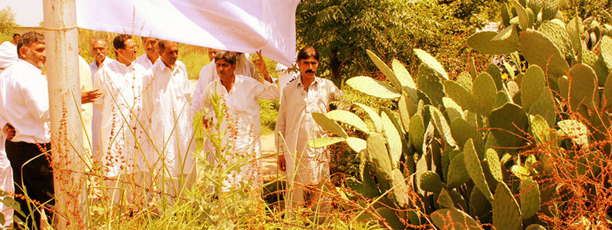Farmers Day at cactus field managed by the National Agricultural Research Center of Pakistan, Photo: ICARDA
It did not take long before farmers started to ask cactus pads to be planted in their fields. The farmers' change of heart towards the cactus pear has generated a new problem. There is not enough supply to meet the demand.
The cactus pear was introduced to Pakistan in recent years through Cactusnet, an international technical network on cactus established back in 1993 through an initiative led by FAO and ICARDA. Network members from several countries shipped cactus cladodes to first to India, where different cultivars are being evaluated against criteria of suitability and adaptation to local conditions. Based on preliminary findings, the most prominent varieties are being identified and then shared with farmers in both India and Pakistan.
Many varieties of offspring cactus cladodes have been already produced and shared amongst local dryland farming communities. The farmers are now focusing on letting their cactus plants grow larger so that more cacti crop can be harvested annually.
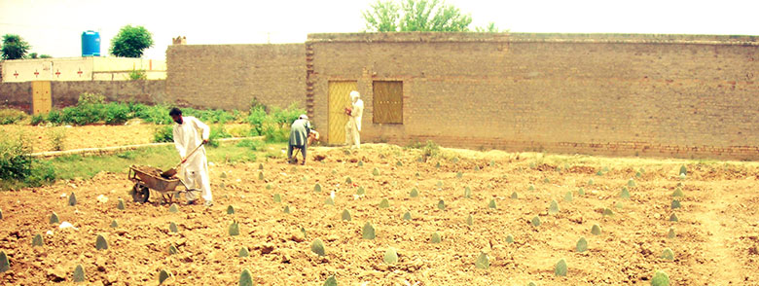Farmer’s cactus pear plot near dwelling, Photo: ICARDA
It is hoped that in time, the cactus pear crop will be utilized as green forage to reduce the feed gap during the driest part of the year, when other crops fail to survive, and livestock mortality is the highest. The use of these high-energy, nutrient-rich cacti plants is not only helping to reduce risks associated with extreme climate variability and depleted natural resources; it is also providing farmers with an alternative source of income through the sale of cacti fruit and cacti seed oil to cosmetic companies. Cooked cladodes are also appropriate from human consumption, therefore contributing to increased food security for Pakistan’s dryland communities. As knowledge of the benefits of the cactus pear spreads from one community to another, scientists are helping farmers refine the cultivation, harvesting, and processing practices for this game-changing crop that has been resurrected from a mythical hellfire.
This research is being conducted in the framework of the CGIAR Research Program on Dryland Systems under the South Asia Flagship and supported by the CGIAR Fund Donors.
For more information, please contact:
Mounir Louhaichi, Senior Rangeland Scientist, International Center for Agricultural Research in Dry Areas and ICARDA Focal Point for the FAO-ICARDA Cactusnet at m.louhaichi@cgiar.org

About the authors
Kathryn Clifton is a Post-Doctoral Fellow in Landscape Ecology at the International Center of Agricultural Research in the Dry Areas in Amman, Jordan.
Mounir Louhaichi is a Senior Rangeland Scientist at the International Center for Agricultural Research in Dry Areas in Amman, Jordan.
Muhammad Islam, Small Ruminant Production Scientist at the International Center for Agricultural Research in Dry Areas in Islamabad, Pakistan.
About the editor
Tana Lala-Pritchard is the global Communications Program Coordinator for the CGIAR Research Program on Dryland Systems.
References
Ben Salem, H. and M. Louhaichi. 2014. Promoting Cactus as an alternative and sustainable livestock feed. ICARDA’s publication (Factsheet)
Nefzaoui, A., M. Louhaichi and H. Ben Salem. 2013. Cactus as a tool to mitigate drought and to combat desertification. Journal of Arid land studies, 24 (1): 121-124
Nefzaoui, A., and M. El Mourid. 2009. Cacti: A key-stone crop for the development of marginal lands and to combat desertification. Acta Horticulturae, 811: 365-372
Ben Salem, H., Nefzaoui, A., and L. Ben Salem. 2004. Spineless cactus (Opuntia ficus indica f. inermis) and oldman saltbush (Atriplex nummularia L.) as alternative supplements for growing Barbarine lambs given straw-based diets. Small Ruminant Research, 51: 65-73

Related Content
- How Much Cactus is in Your Lipstick
- Cactus: an unlikely fodder solution
- Cactus: A Sustainable And Versatile Plant For The Dry Areas
- Factsheets on Uses of Cactus

Tags:
- Pakistan
- South Asia
- climate change
- cactus production
- drylands
- adaptation
- resilience
- water conservation
- animal feeding

Flagship:
- South Asia
- See more at: http://drylandsystems.cgiar.org/news-opinions/prickly-cactus-journey-hellish-plant-farmer%E2%80%99s-darling

