Product Line 5: Insect-smart chickpea, cowpea, and pigeonpea production systems

Activity 1: Screening cowpea germplasm (cultivated and wild relatives) for aphid resistance (Ousmane Boukar)

- Objective of activity and intended output
The objective of this activity is to evaluate various cowpea germplasm accessions for resistance to aphid (Aphis craccivora). The envisioned activity output is identification of resistant lines.

- Materials and methods
A total set of 376 entries including 374 mini-core accessions, 1 resistant check (TVu801) and 1 susceptible check (TVx 3236) were evaluated in screening cages at Kano and screen house at Cotonou for resistance to cowpea aphid (Aphis craccivora). The box-screening technique described by Souleymane et al. (2013) was used. The main traits recorded were the score of aphid damage, aphid population per plant and the number of plants that recovered following aphid attack.

- Results and interpretation
A score of 1 (resistant) to 5 (susceptible) was used to assess aphid damage (Jackai and Singh, 1988). Data analysis revealed highly significant differences in aphid damage scores on the tested accessions at 21 days after infestation. In Kano the average damage score ranged from 2.6 (TVu15315) to 5.0 (TVu10362) while in Cotonou the average score it ranged from 1.0 (TVu3043) to 5.0 (TVu1037). Across the two locations, 104 accessions showed similar or better tolerance to aphid attack than the resistant check TVu801. Among these, TVu1583, TV3043, TVu467, TVu6464, TVu972, TVu1637, TVu6837 and TVu84 showed good tolerance in both Kano and Cotonou (Fig. 1). However, no significant difference was noted in number of aphids per plant between the accessions,.

Fig.1: Aphid damage scores on the best 10 and worst 10 lines in Kano (black) and Cotonou (red).

Plant recovery was estimated 30 days after aphid infestation by counting the number of plants that survived and computer percentage survival based on number of seedlings infested (Table 1). Some lines showed good capacity to recover following aphid infestation. Despites the loss of their leaves, their stems stayed green. The lines listed in Table 1 have good capacity to recover from Aphid damage. Such lines might not be significantly affected under field conditions where the pest population density is low (Table1 & Fig.2).

Table 1: List of lines with good recovery capacity
Varieties | Number of emerged seedlings | Number of dead plants | Number of seedlings that survived | Survival rates 30 days after aphid infestation (%)
TVu9866 | 4 | 0 | 4 | 100
TVu12746 | 4 | 1 | 3 | 75
TVu9651 | 4 | 2 | 2 | 50
TVu9820 | 4 | 0 | 4 | 100
TVu14290 | 4 | 0 | 4 | 100
TVu14321 | 4 | 1 | 3 | 75
TVu6464 | 4 | 0 | 4 | 100
TVu6947 | 4 | 0 | 4 | 100
TVu1583 | 4 | 0 | 4 | 100
TVu3043 | 4 | 1 | 3 | 75
TVu15694 | 4 | 1 | 3 | 75
TVu15742 | 4 | 2 | 2 | 50
TVu1637 | 4 | 0 | 4 | 100
TVu15610 | 4 | 0 | 4 | 100
TVu14992 | 4 | 1 | 3 | 75
TVu6837 | 4 | 1 | 3 | 75
TVu10754 | 4 | 2 | 2 | 50
TVu647 | 4 | 1 | 3 | 75
TVu972 | 4 | 0 | 4 | 100
TVu15391 | 4 | 1 | 3 | 75
TVu15445 | 4 | 0 | 4 | 100
TVu14539 | 4 | 0 | 4 | 100
TVu14393 | 4 | 1 | 3 | 75
TVu84 | 4 | 2 | 2 | 50

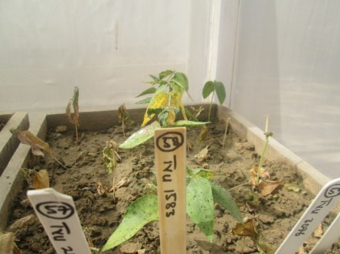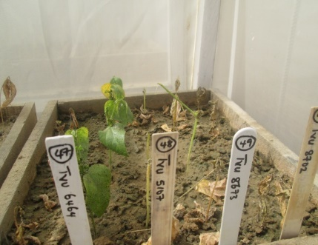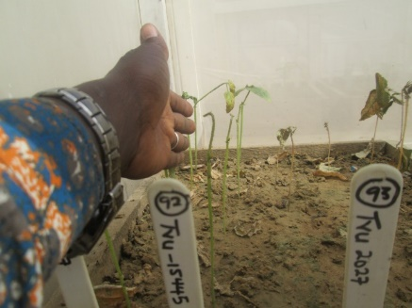
Fig.2: Varieties staying green

- Next steps
Resistance in identified lines will be confirmed in Kano and genetic studies initiated to determine if there is allelism with earlier reported resistant lines.
Data generated on the cowpea mini-core lines would be used in Genome wide association studies to identify QTLs associated with aphid resistance.

