Activity 4 - Conduct adaptive trials in target sites (locations) in collaboration with NARS

Objective: To support the variety release pipelines with groundnut breeding lines with key traits.

Materials and methods: Best lines identified at ICRISAT are multiplied and shared with NARS for conducting adaptive trials.

Results and interpretation: Fifty-seven introgression lines (ILs) that combine early maturity with foliar fungal disease resistance were shared with six national partners, and multi-location evaluation of these ILs in disease hotspots recorded significant pod and haulm yield increase over the recurrent parents (Janila et al. 2016, Plant Breeding. Doi: 10.1111/pbr.12358.). At Dharwad-Karnataka, a foliar fungal disease hot spot location in India, introgression lines recorded higher pod yield over the state check varieties, GPBD 4 and G 2-52 under both, irrigated and rainfed conditions. Selected introgression lines recorded up to 6.8 t ha pod yield, 26% higher than GPBD 4 (5.4 t ha) and 46% over G 2-52 (4.8 t ha) under irrigated conditions, and up to 5.8 t ha pod yield, which is 29% higher than GPBD 4 (4.1 t ha) and 40% over G 2-52 (3.6 t ha) under rainfed conditions (Fig. 3 & 4).

Sixty-five high oleic lines were shared for multi-location testing in India, the lines had oleic acid content varying from 75 to 82%. In 2016, international nurseries were shared with six countries to conduct adaptive trials. 128 advanced breeding lines for the key traits, drought tolerant, short-duration and foliar diseases resistant were shared with ICRISAT-Kano and ICRISAT-Bamako, and with collaborators in Myanmar and Bangladesh. Twenty high oleic lines were shared with our collaborator in Uganda. Seed increase of 200 lines to enable seed supply in 2017.

Fig. 3. Pod yield (PY) of groundnut introgression lines compared to recurrent parents at Dharwad location.

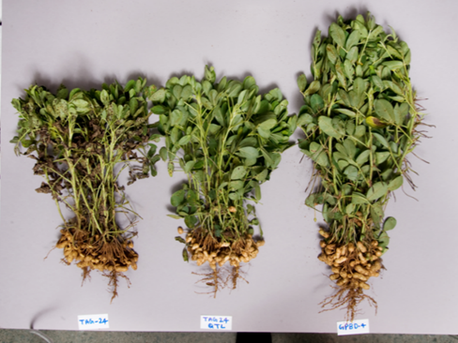
Fig. 4. Introgression line in the genetic background of TAG 24 (left), recurrent parent, TAG 24 (middle) and disease resistance donor, GPBD 4 (right) at 75 days after planting in disease nursery at ICRISAT-Patancheru.

Next steps: Seed increase and sharing of new high oleic lines and the lines that combine early maturity with foliar fungal disease resistance. Develop International Nurseries for high oleic, high oil, and fresh seed-dormancy and share them with partners.

