Integrated Crop-Livestock Conservation Agriculture
For Sustainable Intensification of
Cereal-based Systems
In North Africa and Central Asia
(January 2013-January 2016)

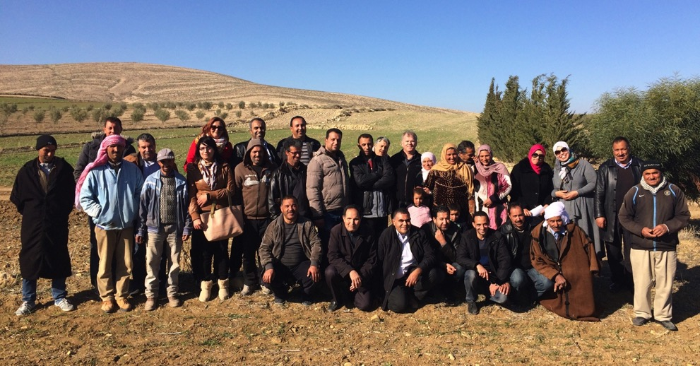

Grant Number: IFAD GRANT # I-R-1393-ICARDA
Project Completion Review Mission
Mission Report
January 2016



PREPARED BY:
Dr Jay Cummins

INTERNATIONAL AGRICULTURE FOR DEVELOPMENT
PO Box 380
BRIGHTON
SOUTH AUSTRALIA 5048
AUSTRALIA

Email: jay@iafd.org
Phone: +61 418 818 995
Web: www.iafd.org

JANUARY 2016

Acknowledgements
Thank you to all of the CLCA project team members from ICARDA, Tajikistan, Algeria and Tunisia who provided so much enthusiasm and commitment during the Review Mission visits.

Front Cover Photo:
Farming families and project team members attending a field day conducted as part of the Mission activities in the Silana District, Tunisia. Photo J. Cummins

Page 3 Photo:
The Algerian CLCA team pictured with local farmers from the Ain El Khadra community near M’Sila demonstrate the valuable networks that they have established (and credibility amongst the local farmers). Photo: J. Cummins

Integrated Crop-Livestock Conservation Agriculture
For Sustainable Intensification of Cereal-based Systems
In North Africa and Central Asia
(January 2013-January 2016)

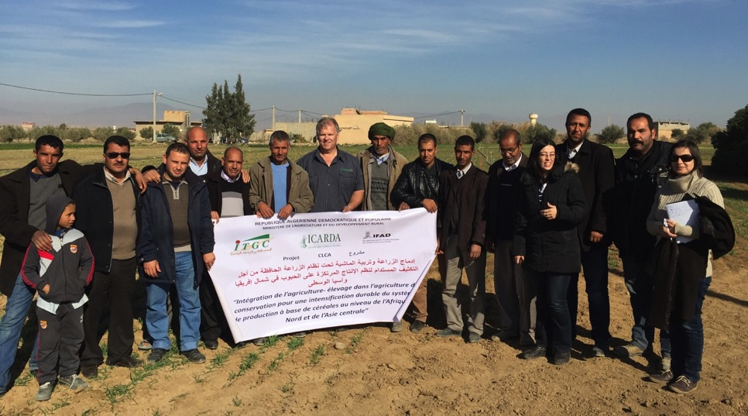

Grant Number: IFAD GRANT # I-R-1393-ICARDA
Project Completion Review Mission
Mission Report
January 2016

ABBREVIATIONS

ACIAR Australian Centre for International Agricultural Research
ADOPT Adoption and Diffusion Outcome Prediction Tool
BMP Best Management Practice
CA Conservation Agriculture
CANA Conservation Agriculture for North Africa
CBA Cost Benefit Analysis
CIMMYT International Maize and Wheat Improvement Centre
CLCA Conservation Livestock Conservation Agriculture
CRDA Commissariat Regional au Developpement Agricole
CS Conventional Sowing
CT Conventional Tillage
CWANA Central and West Asia and North Africa
DG Director General
DSE Dry Sheep Equivalent
GIS Geographical Information System
GM Gross Margin
GPS Global Positioning System
Ha hectare
IAfD International Agriculture for Development
ICARDA International Centre for Agricultural Research in Dry Areas
IFAD International Fund for Agricultural Development
INAT Institut National Agronomique de Tunisie
INGC Institut National des Grandes Cultures/ National Institute for Field Crops
ITGC Institut Technique des Grandes Cultures
INRAT Institut National de la Recherche Agronomique de Tunisie
IRESA Institution de la Recherche et de l’Enseignement Superieur Agricoles
IRR Internal Rate of Return
KASA Knowledge Attitudes Skills Aspirations
Kg kilogram
M&E Monitoring and Evaluation
mm millimetre
NARS National Agricultural Research Systems
NRM Natural Resources Management
OEP Office de l’Elevage et des Paturages
OM Organic Matter
R & D Research and Development
R, D & E Research Development and Extension
TAAS Tajikistan Academy of Agricultural Sciences
USD United States Dollars
WB World Bank
WUE Water Use Efficiency
ZT Zero Tillage

Table of Contents
ABBREVIATIONS 4
1. CONCLUSIONS 7
2. KEY PROJECT ACHIEVEMENTS AND DISCOVERIES 9
3. AN APPRAISAL OF PROJECT SUCCESS 11
4. OPPORTUNITIES FOR BUILDING ON PROJECT ACHIEVEMENTS TO DATE 12
4.1 Development of Low-cost ZT Seed Drills 12
4.2 Technical Capacity and Capability 12
4.2.1 Development of Integrated Crop Protection Systems 13
4.2.2 Development of Crop Monitoring Systems 13
4.2.3 Improved Skills in Conducting On-farm Trials and Demonstrations 13
4.3 Development of High-performing Intensive Livestock Production Enterprises 13
4.4 Adopting a Market Chain Approach to Decision-making 14
4.5 Formation of Farmer CLCA Discussion Groups 14
4.6 Achieving Significant Reductions in Irrigated Crop Water Use 15
4.7 Addressing Crop Water Use Efficiency and Crop Yield Potential (Rain-fed Crops) 15
4.8 Monitoring the Long-term Impact and Benefits of CLCA 15
4.9 The Importance of Measuring Change in Knowledge, Attitudes, Skills, Aspirations and Practice Change (KASAP) 16
4.10 Further Analysis of the Socio-economic Research (Ex-ante survey) 16
4.11 Market Responsive Supply Chains for Agricultural Inputs 17
5. INTRODUCTION 18
6. PROJECT COMPLETION REVIEW MISSION AND TOUR 19
6.1 Mission Tasks 19
6.2 Project Goal 20
6.3 Target Groups and Benefits 20
6.5 Target Groups and Areas 21
7. PROJECT REVIEW AND ASSESSMENT 24
7.1 Work Plan Review of Activities 24
7.2 Discussion of Outputs 27
7.2.1 The Ex-ante Evaluation of CA Based Technologies 27
7.2.2 Enhanced Crop-Livestock Integration in CA 27
7.2.3 Site Specific CLCA Technology Packages 29
7.3. Scientific Quality and Field Implementation Activities 33
7.4. Analysis of Outcomes and Impacts at the Farmer Level 35
7.5 Farmer’s Perceptions of Technologies and Adoption 38
7.6 Assessment of Dissemination Methodologies and Scaling Up 41
7.7 Success of Capacity Development Activities 45
7.8. Identification of Critical Research Gaps 46
7.9 Perceptions of Project Achievements and Impacts amongst Stakeholders 49
7.10 Project Exit Strategy Approach and Sustainability 51
7.11 Links to other IFAD Projects In-country 52
8. IDENTIFYING OPPORTUNITIES FOR A PHASE II PROJECT 56
8.1 Development of Low-cost ZT Seed drills 56
8.2 Achieving Significant Reductions in Irrigated Crop Water Use 56
8.3 Technical Capacity and Capability 58
8.4 Addressing Crop Water Use Efficiency and Crop Yield Potential (Rain-fed Crops) 58
8.5 Development of Integrated Crop Protection Systems 60
8.6 Improved Skills in Conducting On-farm Trials and Demos (Adaptive Research Outputs) 60
8.7 Supporting Change at the Farmer Level 61
8.8 Formation of Farmer CLCA Discussion Groups 61
8.9 Development of Crop Monitoring Systems 62
8.10 Development of High-performing Intensive Livestock Production Enterprises 63
8.11 Adopting a Market Chain Approach to Decision making 63
8.12 Improving Farmer Decision-making for Livestock Grazing and Management 63
8.13 Monitoring the Long-term Impact and Benefits of CLCA 64
8.14 Building Human Capacity and Capability 65
8.15 Quantifying the Impact of Project Outcomes 65
8.16 The Importance of Measuring Change in Knowledge, Attitudes, Skills, Aspirations and Practice Change (KASAP) 65
8.17 Further Analysis of the Socio-economic Research (Ex-ante survey) 66
8.18 Market Responsive Supply Chains for Agricultural Inputs 67
APPENDICES 69
APPENDIX I: Program for Review Mission Undertaken by Dr Jay Cummins 69
APPENDIX II: Examples of Simple Tools that can be Integrated into CLCA packages for farmers 73

1. CONCLUSIONS

The Project “Integrated Crop-Livestock Conservation Agriculture for Sustainable Intensification of Cereal-based Systems in North Africa and Central Asia (January 2013-January 2016)” has in its’ short period of operation (only two full cropping seasons) proven to have made a significant impact towards the development of integrated Conservation Livestock-Conservation Agriculture (CLCA) systems for farmers across the CWANA region.
It is strongly recommended that consideration be given to the provision of resourcing for a Phase II extension to the project, for a minimum period of 5 years. This is supported through the need to address the following challenges and opportunities:
- The significant challenges that small landholder farmers face across the CWANA region; in terms of the need to develop sustainable, productive and profitable farming systems to help alleviate rural poverty in a fragile environment of climate change, climate variability and political instability.
- The opportunity to significantly increase economic production for small holder farmers across the region through the development and implementation of CLCA systems, including the transformation of relatively unproductive weedy fallows into productive forage producing pastures (thereby significantly increasing livestock productivity and livestock numbers under semi-intensive feedlot activities and overall farm profitability).
- The natural resource management benefits associated with reducing soil erosion, enhancing soil fertility/structure, and reducing water applied to irrigated crops (water security) under systems that are built upon the core elements of CLCA, including ZT sown crops, strategic grazing of stubble residues.
- The opportunity for increasing crop yields (that are sustainable and profitable) in the long term through introducing an integrated CLCA system (thereby enhancing regional food security) over a sensible time frame that will allow the long-term benefits of the system to be monitored, demonstrated and the full benefits realised.
- Enhancing the capacity and capability and resilience of farmers, rural communities and NARS project staff through providing a key focal point for developing an integrated CLCA system that serves as a catalyst for extending the system to other regions outside of the immediate project focus areas of participant countries.
- The need to undertake ‘adaptive research activities’ aimed at developing key ‘best management practices’ that can be readily adopted by farmers, and importantly capable of achieving high impact particularly during the early stages of farmer adaptation and adoption of CLCA practices. This provides the opportunity to develop ‘research based evidence’ that provides the validation and credibility associated with on-farm research and demonstrations, and sees the project evolve from a research and development focused project (Phase I) to an adaptive research, development and participatory extension driven project (Phase II).
- The underlying commitment, motivation and recognition of the importance of this project and its potential benefits to regional food and water security that is recognised at the highest level of Government amongst all current project partners.
- The leadership provided by ICARDA in developing cohesive partnerships and underpinning professional R&D across the CWANA region, and ability to influence Government policy and recommendations in relation to supporting the adoption of CLCA practices by the rural poor.
- There remains a significant yield gap across the CWANA region, based upon current yields achieved and the potential yields possible (based upon crop water use efficiency models). The opportunity to develop highly productive and profitable CLCA farming systems underpinned by an integrated crop and livestock production practices remains a real opportunity. Increasing crop water use efficiency/yield potential by up to 50% or more across the CWANA is a realistic target to aim for, and needs to be demonstrated in Phase II of the project.
This Mission Report provides a number of key recommendations that should be taken into consideration when developing the Phase II project description and methodology.

2. KEY PROJECT ACHIEVEMENTS AND DISCOVERIES

The project has also been successful from a number of aspects:

- There is a strong sense of commitment across all project teams to develop CLCA systems for the betterment of food security and sustainable agricultural development across the regions.
- The level of capacity development amongst participants involved in the project has been quite significant, and the targeted activities have assisted in providing project teams with important skills necessary to deliver key project activities and outcomes.
- Many of the technical staff involved in the project has largely been early career agricultural professionals. Developing their skills and capabilities through the project will provide long-term benefits to all organisations, and the young professionals themselves.
- The level of support and commitment exhibited by project partners and participating organisations at the highest level has been clearly demonstrated, with a long-term view for providing in-kind support clearly demonstrated.
- The most important benefactors from the project, namely farmers and their families whom have been exposed to the CLCA system are extremely interested and prepared to adopt the CLCA systems provided it can be demonstrated that such systems can be successful within their own local farming systems.
- Project delivery teams were able to clearly demonstrate their high level of enthusiasm and commitment to undertaking the project activities, across all organisations that were visited as part of the project review in Tajikistan, Algeria and Tunisia.
- The project has been able to engage with young professionals from project teams and NARS; and importantly enhance their skills and capabilities through a range of capacity building and training experiences. Participation of post-graduate students (Masters and PhD) has been invaluable, and will contribute significantly to the long-term capability of participant countries.
- Coordination of the project has been well managed, both at the national level and also the overarching responsibility and leadership as provided by ICARDA.

There have been some significant advances in the development of the integrated CLCA systems as a result of the project activities such as:

- The successful demonstration of ZT seeding systems across all three countries (across diverse production environments), whereby crops have achieved equivalent yields to those of conventionally sown crops. The ZT system has demonstrated that crops can be successfully sown without the need for cultivation, using the John Shearer provided seed drills.
- The ex-ante baseline adoption survey has collected a significant amount of socio-economic information that has proved invaluable in terms of describing the key characteristics and attributes of the targeted farming population, local farming systems and adoption characteristics of the research audience.
- The opportunity to reduce significantly the amount of irrigated water applied to crops produced under a ZT seeding system without any yield penalties in Algeria when compared to conventionally sown crops presents a significant benefit to farmers and the environment.
- The benefits associated with inclusion of oat-vetch sown fodder crops, including the potential to increase soil fertility (in the longer term) and the significant opportunity to increase livestock production (that are fed the fodder) from extensive research and demonstrations conducted in Tunisia. The opportunity to replace unproductive ‘fallow practices’ through sown oat-vetch fodder crops offers the opportunity to significantly increase whole farm production and profitability, largely through increased livestock production.
- Across all three countries (Tajikistan, Algeria and Tunisia) there is the opportunity to introduce ZT seeding system that achieves equal yields to conventionally sown crops and offers a range of additional benefits to farmers (timely sowing, reduced fuel and labour input costs).
- Development of innovative approaches to creating awareness and sharing technical information related to CLCA systems through the use of social media featuring farmer case studies, best management practice technologies and professionally edited videography.

One of the greatest challenges faced by the project was the delayed commencement date of January 2013. This date, mid-way through the 2012-13 cropping season, in effect meant that there could only be two years of cropping season-based activities and field demonstration and trial results. Further complications including the delayed arrival of the ZT seeding equipment to Tajikistan (due to procurement, freight and logistics issues) further hampered the ability to sow any ZT trials in year one of the project, even late in the growing season.

Despite these hurdles, during year 2 of the project substantial effort was made to overcome the delays from Year 1, with exceptional efforts being put in by project field staff across the three countries. In an attempt to further amend the reduction in the effective lifespan of the project, all project partners have agreed to following through the results of research and demonstrations associated with the 2015-16 season (whereby results from activities will be collected following harvest in June 2016), thus providing three years of results for the project.

From an analysis of the annual and final reports, it is evident that an overwhelming majority of planned activities and outcomes have been successfully completed. Further to this, there is a significant opportunity for a second phase of the project to act as a catalyst to address the real opportunities across the CWANA region of significantly increasing both crop and livestock production through the development and introduction of an integrated CLCA system.

The first phase of the project has highlighted the gains to be made through increased crop WUE through enhanced crop management practices (adopting the complete CA system as part of an integrated agronomic package), increased fodder production for livestock (replacing largely unproductive weedy fallows), in addition to conserving soil and limited groundwater reserves.

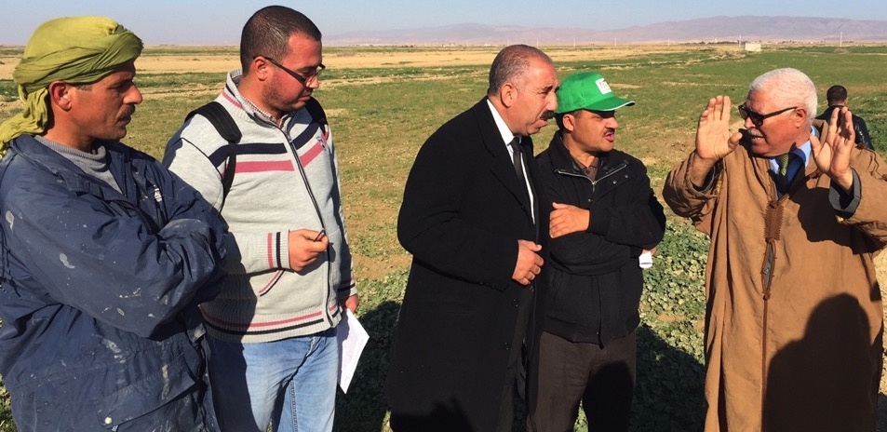
FIGURE 1: Farmer group interaction with technical experts provides the ideal environment to discuss crop and livestock management decisions, as demonstrated with a farmer group at M’Sil, Algeria. Photo J. Cummins

3. AN APPRAISAL OF PROJECT SUCCESS
PROJECT SCORECARD

 |  | 
Effectiveness | - The majority of objectives have been achieved, with a significant number of discoveries to date providing an extremely strong case for the support of a phase 2 project. These include:  - the development of ZT seeding systems  - demonstrated increases in fodder production (converting to increased opportunities for livestock production)  - potential water savings under irrigated crop production systems  - improved understanding of grazing behavior and requirements of livestock | - The overall effectiveness of the project is yet to be realized, due to the short period of operation of the Phase 1 project.  - This will only improve over time, as the momentum and synergy builds around the development and adoption of a truly integrated CLCA system.  - There is a need for an extension strategy framework to be developed by each country proponent by their respective NARS, that provides a roadmap for initiating large-scale adoption strategies relating to CLCA systems amongst resource poor farmers.
Impact | - Innovative approaches to working with farmers have resulted in the development of affordable and adaptable CLCA technologies  - The adoption of CLCA systems will take place over an extended period of time, given the complexity of the system, and the need to develop regional ‘best management practices’ and benchmarks. | - The full impact of the project is yet to be realized, given the complexity of the CLCA system and the need to adapt and developed improved management systems.  - A focus on building R, D & E capacity across all three countries (and in particular Tajikistan) will further enhance impact and project success into the future.
Relevance | - The project has identified and addressed the needs of the targeted audience (small landholders), based on highly detailed ex ante farm household socio-economic analysis.  - Strong farmer engagement and an exhaustive number of on-farm demonstrations, coupled to regular farmer consultation and feedback has helped to ensure strong project relevance.  - The project addresses three critical elements; water and food security, and maximizing farm profitability; whereby farmers can implement practical changes having lasting benefits to all in the community. | - Alley farming systems are appropriate for landscapes characterized by high soil erosion potential, and/or where subsoil constraints such as salinity limit high crop productivity.  - The development of low-cost, locally manufactured seed drills will help to ensure that the adoption of CLCA systems are within the financial resources of small, resource-poor landholders.  - There is the need in a future project to ensure that a training needs analysis amongst all NARS project participants is conducted, and in particular capacity building in participatory extension systems is provided.
Sustainability | - The project is built on a strong foundation of capacity building, both at the farmer level and also project teams comprising research and extension outreach personnel.  - The CLCA system presents a truly integrated production system that is based upon long term agricultural sustainability.  - Farmer interest and motivation is growing considerably, and present an ideal model for long term practice change. | - The phase 1 project has run for two growing seasons. A long-term investment is warranted (5 years +) to properly develop and adapt CLCA systems in a practical and applicable manner at the farmer level.  - Further farmer engagement, largely through forming, supporting and empowering farmer groups will provide a sustainable model for the achievement of enduring impacts.
Efficiency | - The work programs and activity outputs have been extensive across all three countries.  - The in-kind co-contribution of NARS has been significantly under-estimated, resulting in a significant amplification of project outputs and potential impacts. | - A delayed commencement date for the project, and project payments to NARS resulted in the inability to deliver on all scheduled activities.  - Delays in the shipment and commissioning of the ZT seed drills provided additional challenges to project teams.

Table 1: Summary of both the success factors and areas for improvement associated with the project.

4. OPPORTUNITIES FOR BUILDING ON PROJECT ACHIEVEMENTS TO DATE
There are a number of opportunities for enhancing project outcomes, particularly if a second phase of the project is to be explored. These include the following:

4.1 Development of Low-cost ZT Seed Drills
There was an overwhelming response from farmers in relation to their need to be able to access low cost ZT seed drills if they were to be able to adopt ZT seeding systems. Whilst the benefits of the ZT seeding systems have been clearly demonstrated to farmers who have been involved in the on-farm demonstrations or who had attended farmer field days, affordability of such equipment was considered to be potentially a major barrier to adoption. Whilst the use of the imported John Shearer seed drills had provided outstanding results, few if any of the targeted farmers were in a position to purchase such drills due to the relatively high cost of the machinery and the relatively small scale of operation of the farmers.

There is the need to encourage and support the local development and manufacturing of seed drills, that achieve the same level of results as the imported seed drills, and which are affordable to the small landholders. Prototype seed drills are reportedly undergoing field evaluation assessments in Tunisia, Algeria and Tajikistan’s neighbor Uzbekistan, and further initiatives need to be encouraged.

There are also a range of other approaches to enhancing farmer access to affordable machinery that needs to be explored, this includes group ownership (at a local rural community level), and the encouragement of local contractors to provide services to smaller farmers in terms of a crop sowing service using the ZT seed drills. These initiatives would assist in the uptake of the CLCA system, provided that there continues to be local and regional support provided by NARS to assist in the adaptation and adoption of the CLCA practices (including addressing local technical constraints that may be encountered).

There is the opportunity to further develop the skills and capabilities of technical teams involved in the use of the seed drills, as well as provide further technical support and assistance in the design and development locally made ZT seed drills. As this is a highly specialized field, it is recommended to consider accessing the skills of internationally recognised ZT Seed Drill Design Engineer Dr Jacky Desbiolles (who provided highly specialised training and prototype development advice in the CANA project).

4.2 Technical Capacity and Capability
The level of technical capacity and capability of participants across participating countries varies considerably, and is a reflection on both past experience and familiarity with the CLCA related technologies.

Tajikistan would benefit greatly from a more focused level of capacity building training, due to the relatively recent introduction of CLCA systems to this country. It is evident that both Algeria and Tunisia have excellent technical capabilities. CLCA systems appear to be further advanced in Tunisia as a result of ZT seeding systems research having been introduced a number of years earlier than that of Algeria.

All three countries expressed the need to be provided with further technical training, and in a future project it is recommended to undertake a skills assessment and training needs analysis amongst project and support teams. Further to this, formalising a system of ‘train the trainer’ activities, where those trained in the program are able to conduct further training amongst staff from their respective organisations would further magnify the impact and benefits from such initiatives. This would assist in maximizing the impact from project investments, and importantly help in achieving the need to reach out to as many small landholders as possible.
Further to this, there are a number of specific areas of training and capacity building identified during the Review process, and these are elaborated in further detail:

4.2.1 Development of Integrated Crop Protection Systems
The development of CA systems increasingly rely on the use of herbicides and insecticides to effectively control a range of crop pest and weed populations across the various crop rotation phases. In order to reduce the on-set of herbicide resistance for example, it is important that an integrated approach to weed management is developed and adopted in the CLCA system. Therefore, it is important that adaptive research takes place both at the farmer field level, and on research stations, where weed control techniques can be developed, that are appropriate to local agro-ecological conditions. There is only a basic level of understanding of plant protection amongst many of the technical field staff, therefore it is a priority to further develop and enhance such skills.

4.2.2 Development of Crop Monitoring Systems
The introduction of crop monitoring systems to farmers, as a participatory driven activity provides enormous potential to assist farmers in adopting an integrated CLCA system. Making the best management decisions throughout the crop growing season will largely draw on a farmers experience and intuition that contributes to the ‘art’ of farming. Good decisions, however they are made, can only come from having good information.

‘Hands on’ training in crop monitoring, crop diagnosis and introducing new technologies and practices can be well supported through the group-based environment. Farmers and CLCA project staff and other extension personnel together will develop skills and learn from one another, as part of the participatory driven approach.

The training needs to be practically orientated. Field diagnosis skills, developing practical analysis of field symptoms, and problem solving techniques are all ‘applied skills’ that need to be integrated into targeted capacity building of project team members. The training needs to be provided by professionals with practical field experience, who have worked in providing agronomic services and training to farmers. This training will ideally be supported through the development of a range of field identification guides and tools that can be used by both farmers and field staff.

4.2.3 Improved Skills in Conducting On-farm Trials and Demonstrations
Whilst it is evident that the organisations engaged in conducting on-farm demonstrations had an extremely strong commitment and enthusiasm, there is the need to provide some training in relation to on-farm demonstration methodologies and protocols. By involving farmers in conducting on-farm demonstrations and trials, there are a number of significant benefits. Farmers need to feel confident that the new technology or practice will work, provide a specific advantage (or benefit), and will not expose them to unnecessary risk. Similarly it is important that project teams have the right skills and knowledge to properly conduct and manage on farm trials and demonstrations, and training in this area would be of significant benefit. This work is largely adaptive research, and is evidence based.

4.3 Development of High-performing Intensive Livestock Production Enterprises
Phase 1 of the project has identified the opportunity to increase feed availability of livestock, primarily through sown fodder (such as oats and vetch). This presents significant opportunities to increase the carrying capacity of livestock. Rather than animals wasting energy through the open grazing of pastures (under a labour intensive shepherding system), the further development and promotion of small-scale farm feedlots needs to be examined. Under this system, livestock are predominantly fed conserved fodder (such as the high quality oats-vetch mix), whilst periodic grazing occurs at strategic periods (such as strip grazing of sown oat-vetch pastures during the early to mid-growth stages of fodder crops, and for short intensive periods in stubbles following the cereal harvest).

There are opportunities to utilise a range of decision making programs associated with calculating livestock feed requirements (across a calendar year), as well as tools for estimating feed on offer, and estimate the carrying capacity of specific pastures and stubbles based upon an assessment of biomass and the specific livestock requirements.

An integrated approach to livestock ‘best practice management’ is required as part of maximizing the productivity and economic efficiencies from the integrated CLCA system, hence it is important to develop and address appropriate animal health and management needs of livestock. The ‘Lifetime Ewe Management Training Program’, as provided to Australian farmers (www.lifetimewool.com.au) provides an ideal livestock management framework that should be considered as part of training and capacity building initiatives. The program addresses the broader issues of managing breeding ewes, animal health, nutrition and feeding regimes and managing lambs. The development of a similar program that captures the key elements of the Lifetime Ewe Management Program, adapted for CWANA livestock production systems should be pursued.

Consideration needs to be given to addressing all of the major production constraints in an integrated crop-livestock production system, as part of developing ‘best practice’ recommendations for famers in relation to the management of both livestock and crop production enterprises.

4.4 Adopting a Market Chain Approach to Decision-making
Responding to market opportunities, and specifically targeting periods of the year where there are price premiums in the market place is critical to maximising profitability. Farmer experience in Tunisia for example has found that prices received for lambs during the Eid period can be up to 100% higher than for other periods of the year, hence the need to maximize such market opportunities and gear the livestock production systems accordingly.

There is the opportunity to undertake adaptive research activities that can develop a production breeding and feeding model that can maximize the financial returns from market price premiums, for example utilising sown forage from the improved CLCA system (which through farmer experience to date has demonstrated superior growth rates of young lambs).

4.5 Formation of Farmer CLCA Discussion Groups
The importance of local farmer discussion groups is critical to the successful adoption of new technologies and innovations (as illustrated in Figure 1). Supporting the development of farmer groups during their formative stages is critical to ensuring that the groups are well managed and locally governed. It is crucial to understand their local needs, specific levels of capability, and explore different models of support necessary to increase their own skills and capabilities both from a technical and farm business management perspective. It is important that there are appropriate M&E systems in place, in order to determine the level of practice change that takes place amongst group members. It is evident that there have been some highly effective farmer groups formed to date in the existing CLCA project, and these achievements need to be expanded considerably.

Soundly functioning groups will prove invaluable contributions towards increasing the adoption of CLCA practices. The groups when properly functioning will assist in the extension outreach of CLCA technologies to the broader community, through providing mentoring support to a wider audience of farmers that otherwise could not be accessed under resource constrained extension systems. This will allow scarce NARS resources to be used efficiently, and offer the potential to achieve much greater impact in an expansive phase of the project.

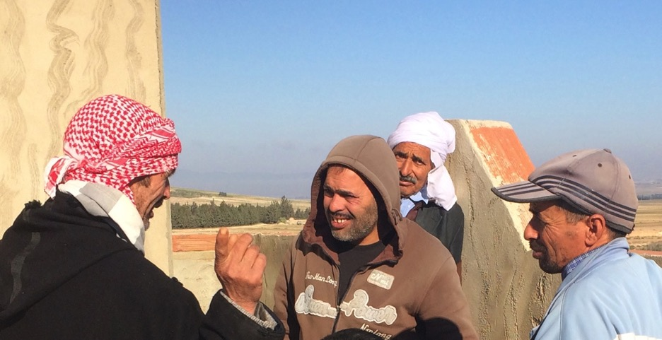FIGURE 2: Farmer interaction and discussions in relation to the development of CLCA systems is an essential element of ensuring that new practices are practical, relevant and importantly pose minimal risk to farm businesses. Photo J. Cummins

4.6 Achieving Significant Reductions in Irrigated Crop Water Use
Initial evidence from the field demonstration activities and initial farmer experience associated with the trialing of the ZT seeding systems (under irrigated crop production systems) in Algeria have indicated reduced water volumes applied to cereal crops; between 30 and 40% when compared with conventionally sown crops. Further field assessments are warranted to validate farmer observations and experience. Consideration to incorporating soil profile moisture-monitoring tools, such as the G Dot and Full Stop tools as part of practical field investigation and validation activities should be considered. This opportunity to drastically reduce irrigation water volumes under a ZT seeding system represents a significant opportunity to develop an integrated CLCA system that extends the benefits to preserving the natural resource base to also include scarce water resources.

4.7 Addressing Crop Water Use Efficiency and Crop Yield Potential (Rain-fed Crops)
Crop WUE is best described as a measure of the forage (biomass) or grain yield produced for each millimetre of water used (i.e. transpired) by a pasture or crop during the growing season. Crop yield potential refers to the percentage of the maximum crop water use efficiency that is achieved. The difference between the potential yield, and the achieved yield is referred to as the ‘Yield Gap’. It is important that a future project utilises the Crop Yield Potential model, and sets about providing targets for farmers to maximise both maximum economic yield and crop water use efficiency. By exploring these relationships, and establishing what is possible, then long term targets can be set for achieving sustainable crop yield increases, and in turn meeting regional Food and Water security needs.

4.8 Monitoring the Long-term Impact and Benefits of CLCA
There is the need to establish long-term demonstration trials that identify long-term benefits and potential threats associated with CLCA systems. International experience has identified that the full benefits of a CLCA system are not immediately apparent, since for example physical soil improvements may take 5 to 10 years. Monitoring the long-term benefits associated with the new production systems will assist in quantifying the net benefits associated with a range of factors such as soil improvements under a ZT CA system (physical characteristics, soil fertility), assimilated grazing management of stubbles (retaining different quantities of plant and stubble residues), as well as the long-term profitability of the different production systems, for both crop and livestock production enterprises (including crop rotation practices and sequencing).

There is the need to develop alternative crop rotations to the current mono-culture practices that focus entirely on cereal production, and so the continued exploration of alternative crop rotation options such as grain legume crops and fodder, and oilseeds such as canola need to be explored further. Included in future adaptive research and demonstration activities are the need to explore rotational benefits associated with soil structure and soil quality, soil pathogens and crop diseases and soil nutrition (particularly nitrogen).

4.9 The Importance of Measuring Change in Knowledge, Attitudes, Skills, Aspirations and Practice Change (KASAP)
There is the need to examine how future extension and development outreach activities associated with a future CLCA program can be best designed and the impact assessed in terms of actual practice change. A useful approach worth considering in future M&E exercises is Bennett’s Hierarchy (that focuses on measuring changes in Knowledge Attitudes, Skills, Aspirations and Practice change). It is essential that the impact of the capacity building activities are identified and documented as part of an appropriate M&E framework. Adopting the KASAP approach, through identifying changes in Knowledge, Attitudes, Skills and Aspirations and Practice change it will be possible to quantify changes that take place as a result of the project activities.

4.10 Further Analysis of the Socio-economic Research (Ex-ante survey)
The depth and validity of the survey data arising from the ex-ante survey work can’t be under-estimated. It is important to continue to utilise this data set, and importantly obtain follow up data in order to assess the impact and change in farmer behavior and farm business economic performance. Additional information, and further interpretation needs to be supplemented with focus discussion groups amongst farmers in the targeted project areas across the three countries. Areas of opportunity in the further analysis of available data are highlighted:

- The establishment of business management, production economics and technical (agronomic, grazing and livestock) indicators is an important cornerstone in developing benchmarks that can be used to demonstrate and assist in the widespread popularisation of CLCA practices across the targeted areas.
- It is important to undertake a detailed assessment of the trade-offs between changes in the core enterprise elements of the system (crop versus livestock versus fully integrated production systems), in addition to the implications of systems changes on farm business cash flow and enterprise profitability.
- The extensive database of information lends itself to undertaking market segmentation analysis to assist in identifying and describing specific characteristics of the farming population whom are more likely to adopt CLCA systems. This may offer the potential to then target specific audiences of the farming population based upon these characteristics, and then in turn lead to more rapid uptake and/or higher rates of adoption.
- The management of risk on-farm by farmers similarly needs to be analysed through utilising farm group focus discussions, and a range of risk management frameworks developed with farmers to address the economic, production, marketing and climatic risks. This needs to be developed in a context where farmers are able to manage their farming operations in a ‘whole of production systems’ context.

4.11 Market Responsive Supply Chains for Agricultural Inputs
There is the need to assist in facilitating the development of market responsive supply chains for agricultural inputs needed for the implementation of CLCA system systems at the farm level. Given the opportunity to expand the area under a CLCA system considerably, it is likely that there will be significantly higher demands for seeds (in particular forage species such as vetch), fertilisers, herbicides and ZT seed drills (as discussed in section 4.1).

It is important that the agronomic and livestock management systems are fine-tuned, and best practice recommendations identify specifically the choice of options for forage and other crop species, fertiliser products, herbicides as well as animal health products that are needed to maximise production and profitability. This will require the examination and analysis of agri-input supply chains.

The increased farmer adoption of sown forage legume (primarily vetch) has increased the demand for vetch seed. Most of this seed has been sourced from outside of the CWANA region. There is the opportunity for this seed to be produced locally. The production of locally sourced seed should be encouraged, allowing entrepreneurial orientated farmers to capitalise upon this market opportunity, and assist in providing reliable supply chains. There was some evidence from Tunisia where farmers were starting to produce seed locally, and this should be expanded further through NARS encouragement.

At the government level the need to encourage competition amongst the input supply sector needs to be facilitated. Access to competitively priced inputs is critical to maximising the full economic benefits of the CLCA system. It appears at this stage the supply of agri-inputs is highly inefficient (particularly in terms of price competitiveness and farmer buying power). It appears that the full economic benefits through increased management efficiencies are not capitalised due to a poor market supply chains existing for agri-inputs. The formation of local farmer discussion groups provides the opportunity for farmers to form local ‘buying groups,’ where as a result of economies of scale they may be able to barter for lower prices for agri-inputs from suppliers due to their united ‘buying power’.

In relation to fertilisers, it is important that the CLCA system identifies the specific crop nutritional requirements and addresses a range of crop management and production decisions. These include:
- How much phosphorus and nitrogen based on the crop requirements?
- How much of these elements will be removed in grain and straw?
- What impact will the incorporation of plant residues (stubble) have on N availability to the crop, and how much additional N needs to be applied to overcome this?
- What is the optimum P and N mix for the crop?
- What combination of product should be applied at sowing?
- How much N should be applied post-seeding?

In developing efficient supply chains for crop inputs, it is important to work with the suppliers of such products, and develop market responsive supply chains for agricultural inputs.

5. INTRODUCTION

Food and water security in the CWANA region continues to be challenged as the population in the project’s targeted countries has grown by 15 to 30% over the past 25 years. Further to this, environmental threats such as climate change, increased water scarcity, and unsustainable farming practices continue to generate significant challenges for the rural poor. This in turn threatens the ability of this region to meet the future food security needs of the rural poor, whilst unsustainable farming practices threaten the region’s fragile and limited natural resource base (soil and water).

Across the CWANA regions, the tell-tale signs of unsustainable farming practices are evident, and include declining water resources, wind and water generated soil erosion, declining soil fertility, monoculture agriculture, low crop water use efficiency (including significant ‘yield gaps’ between ‘what is produced and what is possible’), and rural poverty; particularly amongst small landholder farming families and communities.

CA has been introduced with relative success in countries such as Australia, USA and Canada, largely through adopting a ‘farming systems approach’ through utilising participatory based research, development and extension approaches on-farm. Whilst it has taken more than 25 years to develop, this system continues to evolve, and as such the development of any CA system occurs as part of a continuous improvement cycle.

The benefits of introducing a CLCA system are well documented. Recent ICARDA experience under dryland farming systems in Syria and Iraq has clearly demonstrated the benefits and farmer interest in successfully developing CLCA systems focused on ZT seeding operations and improved grazing management of crop and pasture residues. This project; “Integrated Crop-Livestock Conservation Agriculture for Sustainable Intensification of Cereal-based Systems in North Africa and Central Asia” targets three countries in the CWANA region, namely Tajikistan, Algeria and Tunisia. The local NARS experience in relation to the development of CLCA across this region varies considerably.

The concept of sowing crops without tilling the soil is a relatively recent phenomenon for Tajikistan, whilst in the case of Algeria CA was first experimented with in 2004-5 and for Tunisia CA was first introduced in the late 1990’s. Across all three regions, the inclusion of a conservation livestock based system into a CA system has previously been unheard of, hence this project provides a significant opportunity to develop a fully integrated CLCA system.

Despite CA systems first being introduced to NA some 10 to 25 years ago, the adoption of such practices (primarily ZT seeding systems) has been limited to farmers having large landholdings where they have been able to afford to purchase expensive CA seed drills that have been sourced from countries such as Australia and Brazil. The adoption of CA has been reported to have stagnated, and despite the demonstrated efficiency gains through reduced seeding costs and yield responses, remains out of reach for the majority of small farmers (having <20 hectares of land) who are responsible for more than 80% of the farmed areas across this region.

In Tajikistan, there have been some elements of CA systems that have been experimented with amongst farmers through past projects supported by ICARDA, such as the direct seeding of wheat into standing cotton, with the wheat stubble only to be deep ploughed following harvest. Therefore, the development of a CA system in this region remains a true challenge, particularly across region of the country where an integrated crop-livestock production system predominates. It is therefore evident that the development of a CLCA system has enormous potential across the CWANA region, with the opportunity of advancing the development of an integrated crop-livestock system targeting the needs of the small farmer providing a significant challenge that may provide a key role in alleviating rural poverty and contributing positively to regional food and water security.

6. PROJECT COMPLETION REVIEW MISSION AND TOUR

On November 19th, 2015 Dr Jay Cummins was notified by ICARDA of his appointment to undertake a Completion Review for the project “Integrated Crop-Livestock Conservation Agriculture for Sustainable Intensification of Cereal-based Systems in North Africa and Central Asia”. The review, comprising 15 days of field mission visits and 5 days allocation for report writing and review (20 days in total) involved an initial briefing at ICARDA’s operational headquarters in Amman, Jordan, and was then preceded by field tours to Tajikistan, Algeria and Tunisia.

6.1 Mission Tasks
The mission was composed of one reviewer who was appointed to undertake a Completion Review of the project from its inception until now. The review focused on the assessment of the realisation of the project objectives as per the project document in the countries involved. The assessment was based on both quantitative and qualitative measures of results.

The main tasks of the mission were to:
- Review Work plan activities; review the consistency and alignment of activities carried-out by the project partners (NARS and ICARDA) on the basis of the approved work plans with the outputs and activities proposed in the original project document Log Frame.
- Scientific quality of field implementation activities; assessment of the scientific quality and magnitude of the field implementation and its coherence and compliance with the work plans approved by the Steering Committee of the project.
- Analysis of outcomes and impacts at the farmer level; analysis of the outcomes and impacts of the technologies promoted by the project on target farmers in the selected sites.
- Farmer’s perception of technologies and adoption; analysis of the farmers’ perceptions of the introduced technologies and assess their ability to adopt these practices.
- Assessment of dissemination methodologies and scaling up; make a qualitative and quantitative assessment of the on-station and on-farm research dissemination methodologies used by the project and the technology innovations tested and their potential for scaling-up.
- Success of capacity development activities; review and assess the capacity development activities, their relevance and their targeting to the beneficiaries and stakeholders.
- Identification of critical research gaps; identify critical research gaps that need to be addressed in a second phase of this project (if any) to better consolidate, validate and disseminate the results of the project.
- Perceptions of project achievement and impacts amongst stakeholders; make field visits to the selected project sites as well as meeting and discussing with farmers, policy makers, NARS and other relevant stakeholders when appropriate to assess their perceptions on the project’s achievements and impact.
- Project exit strategy approach and sustainability; elaborate on the project exit strategy and sustainability after its completion.
- Links to other IFAD projects in-country; determine the extent to which the project was able to link to, and influence, IFAD investment projects in each Country.
- Gender balance and engagement; determine to what extent was the project able to work with women and men farmers in each country.
- Mission report; submit a mission report.

The specific issues addressed by the mission were agreed to by the ICARDA Focal Point (Dr Hichem Ben Salam) and scientists in charge of the grant management and implementation, and the National Coordinator in each of the involved countries. The mission reviewed the project in terms of the following factors;
- Effectiveness: Has the intervention achieved its objectives or will it be able to do so in the future?
- Impact: What are the overall effects of the intervention, intended and unintended, long term and short term, positive and negative?
- Relevance: Is the intervention consistent with the needs and priorities of its target group and the policies of the partner countries and donor agencies?
- Sustainability: Will the benefits produced by the intervention be maintained after the cessation of external support?
- Efficiency: Are the costs of the intervention justified by the results?

In order to prepare the Mission Report, it is important not only to address and consider the Mission Review Terms of Reference and Tasks, but also the project goal, target groups and benefits in order to ensure that the Mission Report is able to assess the full impact and achievements to date (and provide guidance towards a future Phase II of the project should the opportunity arise).

It should also be noted that the annual progress and completion reports as prepared by the respective country project teams (and coordinated through ICARDA) provide a much higher level of detailed reporting and analysis of project outcomes and achievements. These should be read in conjunction with this report.

6.2 Project Goal
Enhanced sustainability of natural resource use, increased farm profitability, and improved livelihoods of resource-poor farmers through large-scale adoption of conservation agriculture (CA) technologies capitalising on the system synergies of crops, livestock and soils in the drylands of Central and West Asia and North Africa (CWANA). This project will support directly two of the main development objectives of IFAD’s strategic framework, Objective 1 for Strengthened NR and Economic base; i.e. resilience to CC, environmental degradation, market transformation and Objective 2 (Poor rural women and men and their organizations able to manage profitable, sustainable and resilient farm and non-farm enterprises or take advantage of decent work opportunities). In addition, the project will make a significant contribution in five of the eight themes of the IFAD Strategic Framework.

6.3 Target Groups and Benefits
- Resource poor farmers whose livelihoods depend on mixed livestock / cropping systems in the target low rainfall regions will be direct beneficiaries. Productivity is expected to increase by 10%. A total of at least 1000 households targeted in selected countries; a total of 10,000 thousand family members including women in target communities will benefit from the proposed project activities. Ultimately, other rural communities in similar agro-ecologies across WANA will benefit from the improved options identified and promoted by the project.

- NARES R&D partners will have access to new and innovative information which will be disseminated. Extension agents will be direct beneficiaries with a needs assessment and targeted capacity building being carried out for their improved dissemination of the new technology packages.

- Policy makers will be exposed to the new Integrated CLCA technologies at both district and national levels, which will improve the resilience and adaptation of rural families to climate change and improve their living standard.

6.4 Project Components and Activities
The project consists of two main components targeting four (4) expected outputs:

1. Understanding and responding to the trade-offs, constraints and opportunities for the adoption of the crop-livestock CA systems in project areas of CWANA,
- Ex-ante evaluation for CA based technologies in CWANA, proposed activities and milestones.
- Enhanced crop-livestock integration in CA through optimized stubble grazing strategies and increased fodder availability from forages or fodder shrubs.
- Site-specific conservation agriculture technology packages fine-tuned and disseminated for enhanced farm productivity, resource use efficiency and profitability.

2. Knowledge management and dissemination of the CLCA in CWANA region.
- Capacity development, co-learning, knowledge and information dissemination in the target areas and across the CWANA region.

* Source: Integrated Crop-Livestock Conservation Agriculture for Sustainable Intensification of Cereal-based Systems in North Africa and Central Asia (IFAD CLCA Proposal 20 June 2012).

6.5 Target Groups and Areas

Target Groups
- Resource poor farmers whose livelihoods depend on mixed livestock / cropping systems in the target low rainfall regions will be direct beneficiaries. A total of at least 1000 households will be targeted in selected countries; a total of 10,000 thousand family members including women in the target communities will benefit from the proposed project activities.
- NARES R&D partners will have access to new and innovative information which will be disseminated. Extension agents will be direct beneficiaries with a need assessment and targeted capacity building being carried out for their improved dissemination of the new technology packages.
- Policy makers will be exposed to the new Integrated Crop-Livestock Conservation Agriculture (CLCA) technologies at both district and national levels, which will improve the resilience and adaptation of rural families to climate change and improve their living standard.

Target Areas

Tajikistan
1. The Gissar Valley (Experimental Farm of the Tajik Research Institute of Farming comprising 669 ha of irrigated and dryland) located in the Sharora settlement, in the Gissar district, 18 km from the City of Dushanbe.
2. Fergana Valley: located 350 km from the city of Dushanbe and sharing a common border with the Tashkent province of Uzbekistan, in the north. The target region comprises 1549 ha irrigated land, 212 ha rainfed and 2,891 ha rangelands and having an annual rainfall of 300-400 mm.
3. Rasht Valley is located 193 km north of Dushanbe. The total area of the village is 58,229 ha, with 4.6% of land area arable (2700 ha) and the remainder (95.4%) rangelands. The majority of livestock is reared in small and medium-sized farms. The average annual precipitation, which is concentrated in the winter and spring, ranges from 575 to 600 mm, with a winter snow cover of 50 to 100 cm.

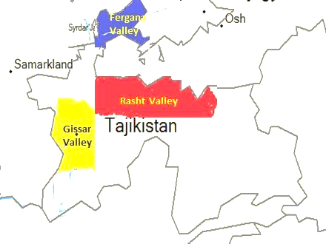

FIGURE 3: Study Area in Tajikistan (Source: ICARDA)

Algeria
M’Sila location is in the high plateaus and in the center east of Algeria. It is the administrative center of the Wilaya that is located at 248 km southeast from the capital, Algiers. It covers an area of 18,175 km, has 15 districts, 47 municipalities (of which 16 are rural), and has 148,037 households. The poverty level of this region is ranked ‘very precarious’. The predominant production system is a cereal - livestock system (with a cereal-fallow rotation) and extends over a wide area. M’Sila location has a cereal-based system associated with sheep pastoralism (agro pastoral systems). Setif location was selected for on-station grazing research.

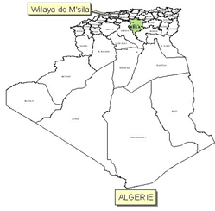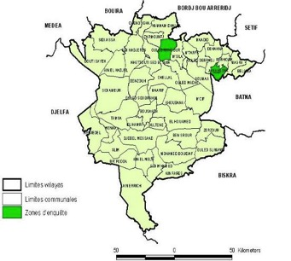

FIGURE 4: Study Area in Algeria (Source: ICARDA)

Tunisia
The Governorate of Siliana, the target location of the project in Tunisia has a semi-arid climate, with rainfall 300-450 mm, and an average temperature of 18 °C. The topography is a mix of plains and hilly areas, and the soils are light textured and low in organic matter. The farming system is an integrated cereal (durum wheat and barley) and livestock (sheep and goat) system. Within Siliana, the districts of Krib, Aroussa, and Chouarnia were selected as main activity sites.

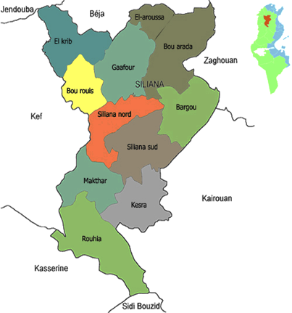

FIGURE 5: Study Area in Tunisia (Source: ICARDA)

7. PROJECT REVIEW AND ASSESSMENT

7.1 Work Plan Review of Activities

Activities undertaken by the project team members overwhelmingly satisfied the majority of outputs as described in the Project Log Frame reporting. In terms of an analysis of the outputs Table 2 (below) provides a summary of the degree to which specific project outputs and activities have been completed (as of December 2015). To assist in the visual interpretation of the specific level of achievement by participating countries, Table 2 contains a simple colour shading system that provides a simple overview of the relative level of completion of the specific outputs and activities, and are supported by additional comments.

Description of the Intervention including verifiable indicators | % Completion  By Country |  |  | Comments
 | Taj | Alg | Tun | Comments
A. OUTPUTS
- Ex-ante evaluation of CA based technologies in CWANA.  - Strategies for promoting uptake and out-scaling of CA practices by month 36 |  |  |  | 100% completed for Tajikistan, Algeria and Tunisia
- Enhanced crop-livestock integration in CA through optimized stubble grazing strategies and increased fodder availability from forages or fodder shrubs.  - First report on grazing strategy available by 12th month, validated by month 24 (2nd report). |  |  |  | - A stubble management tool was developed in Tunisia after year 1, was further refined after year 2 and awaits validation after the current 3rd year on station and on farm trials. Also, in order to evaluate and to complete the model with regard to meeting the ewe’s nutritional requirements, intake measurements were carried out on station (Achieved 75%)  - A similar tool is being developed for Algeria (Achieved 75%)
- Site-specific conservation agriculture technology packages fine-tuned and disseminated for enhanced farm productivity, resource use efficiency and profitability.  - Detailed reports on CA adaptive trials available by months 12, 24, and 36.  - Recommendations on crop management practices available by month 30. |  |  |  | CA adaptive trials for rotations, weed management, variety selection and irrigation were tested in all locations and recommendations are being packaged (Achieved 75%)
2.1. Capacity development, co-learning, knowledge and information  dissemination in the target areas and across the CWANA region.  - At least 15 NARES representatives and 60 farmers (10-30/ country) trained in workshops, with 500 trained through field days  - Three Masters Students |  |  |  | At completion of year 2, 280 NARES trained in workshops and 357 trained through field days  (Achieved 75%)
 |  |  |  | Students’ involvement in the project activities exceeded target. Figures at end of year 2 are: 5 undergraduate students; 4 Master students and 5 PhD students (Achieved 100%)
B. ACTIVITIES
- Development of baseline data on farming and tillage practices, crop choices, and farmer perceptions, in the target regions. New farm surveys will be conducted using a representative random sample of the farming community including data on crop residue management, feeding strategies, resource flow maps for ex-ante analysis.  - Base line data collected by month 6 |  |  |  | 100% completed for the three platforms: Survey implemented, data collected and analyzed and reports delivered
- Expert estimates of the agronomic benefits of CA options will be systematically solicited from researchers and extension staff where on-farm data is not available  - Ex-ante economic analyses of CA technologies completed by month 18. |  |  |  | 100% completed for the Tunisian and Algerian platforms (reports delivered) and 100% completed for the Tajik platform
- An economic evaluation, including a financial risk assessment, will be made of the CA technologies and trade-offs that farmers face |  |  |  | 100% completed (for the economic evaluation) for the Tunisian and Algerian platforms (reports delivered) and 100% completed for the Tajik platform
1.1.4 Optimal livestock production and conservation agriculture  cropping systems will be determined for different farming  systems under different costs and price scenarios.  - Optimal production under different scenarios developed and shared with stakeholders. |  |  |  | 80% completed
1.1.5 Monitor the adoption of CA technologies with follow up surveys  and identify constraints and determinants of adoption.  - The diffusion of CA documented |  |  |  | 100% completed for the three platforms (repots for the cropping season 2014-2015 are ongoing)
1.1.6. Identify gendered limitations and advantages that can promote  adoption of conservation agriculture and determine if CA will  increase labour burden on women.  - The impact of CA on women documented. |  |  |  | 100% completed for the Tunisian and Algerian platforms (sections included in the baseline reports delivered)
1.2.1. In the on-station (years 1 and 2 at Setif) and the 30 on-farm  stubble grazing experiments (multi-year, 15 initiated in Year two  and an additional 15 initiated in Year 3), crop residue off-take  through different grazing strategies will be measured.  - Grazing strategies presenting different levels of residue retention, and proportions of energy and protein intake by grazing sheep described. First estimates by month 18.  - Trade-off between biomass intake (lost residue retention) and direct manuring assessed by month 30.  - On-station experiments at Setif, Algeria and in Tajikistan (if possible). At least 15 multi-year on-farm trials initiated in years two and three. |  |  |  | First estimates were obtained in Tunisia by 18 months, and then confirmed in Tunisia and Algeria by month 24 and full report will be available by month 36  (Achieved 75%)  In addition to Setif, the number of on-farm trials in Algeria reached 27 in year 3 (90%), 18 in Tunisia and 10 in Tajikistan
 |  |  |  | In addition to Setif, the number of on-farm trials in Algeria reached 27 in year 3 (90%), 18 in Tunisia and 10 in Tajikistan
1.2.2. Grazing strategies will be evaluated with regard to meeting the  ewe’s nutritional requirements.  - Fast growing and high nutritive value fodder species identified for alley cropping by month 24 and confirmed by month 36. |  |  |  | For low and medium rainfall areas in each target country, potential forage crops (forage pea and vetch) grown in association with shrubs in alley cropping system demonstrated. (Achieved 100%)
1.2.3. The effect of nutrient recycling (urine and fecal excretion) on soil  fertility will be assessed considering the differences between  daytime grazing only and day and night time grazing.  - Forage crops and suitable crop establishment options identified in first crop season and validated both on-station and on-farm after the second season. |  |  |  | At laboratory conditions, urine and fecal excretion amount (8 sheep for 4 weeks) were evaluated and converted to C and N basis to estimate soil inputs coming from sheep flock.  Forage legumes and cereals were tested under CA for their productivity in crop rotation (Achieved 100%)
1.2.4. Fast growing high biomass and quality fodder species will be  tested on-station and on-farm for compatibility with annual  crops. Already identified germplasm will be grown in year 1.  Plant cover (establishment, vigor, and growth over time) of crop  and fodder resources will be monitored under CA in conjunction  with Output 1.3.  - Alley cropping technology has been adopted to improve integrated crop livestock feeding options and evaluated on at least three sites in Algeria and will be integrated into Activity 1.3.3. |  |  |  | Different shrub species were tested in all 3 countries and the best species were identified. Data related to shrubs establishment, vigor and growth have been collected and being analyzed (Achieved 100%)
1.2.5. Appropriate feeding strategies will be developed for utilising these  species in fodder for improving livestock productivity.  - Particulate Organic Matter and soil water infiltration capacity increased in response to improved grazing management. |  |  |  | Data is available from Algeria particularly and will be analyzed after completion of data collection and lab analysis following this year trials (Achieved 50%)
- Large sets of diverse germplasm for each of wheat, barley, and lentil, along with sets of triticale, oat, vetch, forage pea, and other potential fodder crops will be tested on-station in Algeria and Tajikistan, in conjunction with Output 1.2 to identify the genetic variation in crop response to CA (ZT), compared to conventional (tillage) methods.  - Suitable genotypes selected for CA trials by month 24 (2 seasons)  - One location in Tajikistan and one location at Setif in Algeria in combination with 1.2.4.  - Crop rotations tested by month 18 (second season). |  |  |  | In Tajikistan efforts focused on wheat, where it was difficult to obtain large sets of germplasm for the different tested crops (Achieved 20 %). In Algeria and Tunisia, it was possible to access sets of diverse germplasm for each of wheat, barley, and lentil, along with sets of triticale, oat, vetch, forage pea, and other potential fodder crops
 |  |  |  | Three locations both on-station and on-farm trials, several crop rotations are being compared. Results were available by month 24 (Achieved 100%)
- Selected promising lines will be analyzed for feed quality as a fodder / grain crop and validated in on-farm variety trials with participating farmers. |  |  |  | Selected forage species were analyzed for feed quality and validated using FEAST tool in Tunisia and Algeria (Achieved 75%)
- Conduct adaptive trials integrating CA technologies (ZT, crop  rotations, and stubble management) with weed and nutrient management, and the integration of fodder/grain species in at least 45 on-farm trials (multi-year, 15 initiated in Yr 1 and an additional 15 initiated each in years 2 and 3), spread across the three target countries (Tajikistan, Tunisia, and Algeria).  - Site-specific crop management recommendations ready by month 18 |  |  |  | CA adaptive trials for rotations, weed management, variety selection and irrigation were tested in all locations and recommendations are being packaged (Achieved 75%)
- These activities will be conducted with farmers groups and local farmer organization will be the key vehicle that will uses as means to involve large number of farmers and that promote farmer-to-farmer learning & communications  - A total of at least 15-new multi-year on-farm trials initiated/yr conducted across the target sites and will integrate activities 1.2.4 (alley/relay cropping), 1.3.1 crops, and CA (1.3.3 tillage).  - Technology guidelines & extension material ready by month 24. |  |  |  | This occurred in Algeria (100%) and partly in Tunisia (50%)  Extension material developed in Tunisia and Tajikistan (Achieved 75%)
2.1.1. Develop and enhance farmer-participatory capacity through  the creation innovation platforms (training courses, materials)  for delivering adapted CLCA technologies.  - At least 60 farmers and service providers trained during each cropping season.  - Field days (1/region, 1-3 regions per country) will be conducted each year to disseminate information to NARES and farmers policy makers and the private sector. |  |  |  | 100%
2.1.2. Advanced training of farmers, extension agents and service  providers in using CLCA technologies for improving crop and  livestock productivity to facilitate adoption of CLCA based  technologies in the target regions.  - At least 15 Extension agents trained at ICARDA during first two cropping seasons. |  |  |  | Over 15 extension agents trained at ICARDA for statistical analysis, crop-livestock integration, use of FEAST, weed management, ZT seeders (>100%)
2.1.3. Organize degree and non-degree trainings for NARES and lead  farmers in CLCA at ICARDA to facilitate technology transfer to  other staff and farmers.  - Three NARS researchers trained for MSc degree during project implementation in respective countries/ ICARDA.  - At least 4 field days are conducted during each cropping season. |  |  |  | 100% completed In addition, 1 PhD student is preparing his thesis on this project
2.1.4. Involve policy makers in the project initiation workshops, in field  visits and in the innovation platforms to ensure buy-in and support  to the enabling environment to CA adoption (involvement of  of extension agents and farmer organistions, subsidy policies,  regulatory issues, etc)  - Policy makers and private sector invited and attending the initiation workshop, annual planning workshops, field visits and final workshop |  |  |  | 100%

TABLE 2: Summary of the review of the detailed work plans, including the level of completion of outputs and activities (as of December 2015).

Interpretation Key:

Colour Shading | General level of achievement (%)
 | Excellent to Outstanding achievement >85%
 | Moderate to High achievement (40 to 80%)
 | Low to Moderate achievement (< 40%)
 | Not applicable or specified as a country specific activity

7.2 Discussion of Outputs

7.2.1 The Ex-ante Evaluation of CA Based Technologies
The ex-ante evaluation of CA based technologies in CWANA was achieved to a very high standard, with a high level of detail and interpretation provided on a country by country basis, as well as an overall assessment as provided by ICARDA. Across the three countries, a total of 1164 surveys were conducted at the farm household level. Data entry and data cleaning activities were undertaken in order to ensure that the database developed was consistent and accurate in terms of providing reliable and validated information.

It is evident that there is a relative high level of achievement obtained, with ICARDA providing excellent leadership and technical input into this activity. This included the development of the survey questionnaire instrument, and training provided to each of the participating countries in relation to survey data collection techniques, analysis and interpretation, thus ensuring a high level of capability and capacity amongst the national data collecting teams.

Key outputs from this activity included the following:
- General socio-economic information relating to farmers, farm family business operations.
- Adoption behaviour amongst farmers, including level of adoption of different practices.
- Farm physical characteristics (area, soil types, landscapes).
- Farmer knowledge about livestock, crop and fodder production, CA principles.
- Perceived constraints to the adoption of CLCA.

The depth of information will serve as a useful baseline of socio-economic and adoption characteristics associated with the targeted participants in each of the three countries. Future follow up survey work as part of a longitudinal assessment of practice change and adoption behaviour is highly recommended, particularly during the closing stages of a Phase II project should it proceed.

Further interrogation of the extensive database of information is recommended, particularly from the perspective of segmenting the market based on adoptive characteristics. Identifying the general profile of prospective adopters will serve as a useful means of targeting specific profiles of farmers that are most likely to adopt CLCA technologies, allowing maximum impact to be achieved from limited project and NARS resources.

7.2.2 Enhanced Crop-Livestock Integration in CA
Enhancing crop-livestock integration in CA, through optimising stubble grazing strategies, and increased fodder availability from forages or fodder shrubs was partially achieved in both Algeria and Tunisia. There were a range of setbacks primarily in the area of the establishment of fodder shrubs in alley farming systems that were largely out of the control of project teams. In a number of circumstances unseasonal cold frosty conditions and damage caused by an infestation of slugs (that were later treated) resulted in an unexpected high level of seedling mortality. In some instances uncontrolled grazing at farmer demonstration sites resulted in less than optimal establishment. In situation where it has been possible to better manage livestock grazing, satisfactory establishment is expected – within a 3 to 5 year time frame (which is not an unrealistic expectation).

The introduction of sown oat-vetch crops (as illustrated in Figure 6), for the purposes of providing fodder crops for livestock, and largely replacing weed fallows in Algeria and Tunisia has proven to provide extremely encouraging results to date. The further development of this system, and in particular increased monitoring and analysis of the benefits to livestock production, subsequent crops (and overall farm profitability) is highly recommended, in addition to exploring opportunities with other fodder crops such as alfalfa. Further to this, exploring alternative grazing systems, including ‘cut and carry’ fodder conservation and the integration of small scale feedlot activities on-farm may well offer opportunities for developing a truly integrated CLCA system with positive economic benefits for small scale farmers.

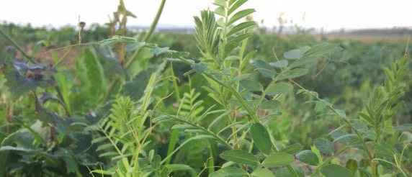
FIGURE 6: It is evident that the sown vetch-oats mix is providing farmers with an extremely productive option for meeting critical livestock nutritional needs. Photo J. Cummins

In Tajikistan, there was limited scope and opportunity to achieve specified outputs, with efforts limited to initially establishing locally desirable fodder species in the context of an alley farming system. Unfortunately the core output of optimising stubble grazing strategies will not be achieved for Tajikistan, as efforts were concentrated on developing the CA efforts associated with the development of ZT seeding systems.

There is the opportunity to strengthen this output in a Phase II project activity, and in particular to link with other IFAD project investments in Tajikistan where there is a strong emphasis on the development of improved fodder production and grazing systems for livestock particularly in the rangeland regions. Further to this, the opportunity to undertake a concerted effort for the introduction of fodder crops as part of the crop rotation needs to be explored, such as sowing cereal-vetch pasture mixes as well as alfalfa. Such fodder crops need to be carefully managed, and monitored, both from agronomic management and grazing perspectives.

The project placed a high priority upon the development of an enhanced and integrated conservation agriculture based livestock-crop production system, comprising optimised stubble grazing strategies, integrated fodder supply systems from either forages or fodder shrubs. It is anticipated that such outcomes will only be partially achieved, given the relative complexity and the need to develop the system over a number of seasons (5 years as a minimum). Whilst there has been a concentrated effort to research and establish such systems principles in quite a detailed manner (particularly through the efforts conducted in Tunisia), it is recommended to explore similar research and models that have been developed in similar agro-ecological environments (such as the Mediterranean environment of southern Australia), where there are a range of benchmarks and recommended practices that should be explored and adapted for the north African context.

In a similar approach, work conducted by ACIAR in the high altitude mixed farming environment of the Tibet Autonomous Region of the People’s Republic of China may provide some useful guidance in relation to integrated conservation farming systems development research (including livestock feed modelling) that has focused on livestock, fodder and crop production improvements (Integrated Crop and Dairy Systems in Tibet Autonomous Region, PR China, Project 2006/119). References include:
http://ageconsearch.umn.edu/bitstream/100729/2/Waldron.pdf
http://www.uq.edu.au/agriculture/docs/CAEG/CAEGTibetanual01-01-12.pdf
http://www.crawfordfund.org/wp-content/uploads/2014/10/Crawford-Fund-SA-Forum-Ann-McNeill.pdf

7.2.3 Site Specific CLCA Technology Packages
Across all three countries, the development of site specific CLCA packages made good progress. The main limitation in general related to the fact that at the official conclusion of the project, there had only been two full crop seasons for results; hence it is not always possible to provide conclusive recommendations.

Further to this, the development of CLCA packages are relatively complex, and need to take into consideration a wide range of intervening factors, such as best practice agronomic and livestock management, integrated pest, weed and disease management (across a cropping rotation extending for a number of years), risk management and decision support frameworks for farmers (including simple but realistic detailed economic analysis, minimising production risk, providing clear market signals from a market chain approach), as well as adapting and modifying CA practices according to local physical, social and economic constraints.

The development of CLCA packages take place over time, hence after a two year period of field trials and demonstrations, there is still a large amount of validation work as well as technical capacity building of project staff. Further to this, the engagement of farmers in the development of CLCA technology packages remains a crucial component. Through practical farmer experiences, (factoring in their attitudes to risk and adoption behaviour characteristics), the development of CLCA packages will be both practical and relevant to local agro-ecological environments, and importantly presented in the right context to optimise adoption.

Across the three countries, there has been a different emphasis placed upon the key aspects of the CLCA packages. In Tajikistan the principal emphasis has been placed upon tillage and crop rotations, in Algeria weed control, crop rotation and livestock management, and in Tunisia tillage, crop rotation and grazing management. Whilst these specific elements of emphasis have tended to reflect the research capability in the respective countries, there is the need to consider all elements in an integrated CLCA package for farmers. As mentioned previously, this can only be achieved after a considerable experience has been gained from a number of years of research and demonstration related activities, and assumes that all such relevant research capability is available in each of the participating countries.
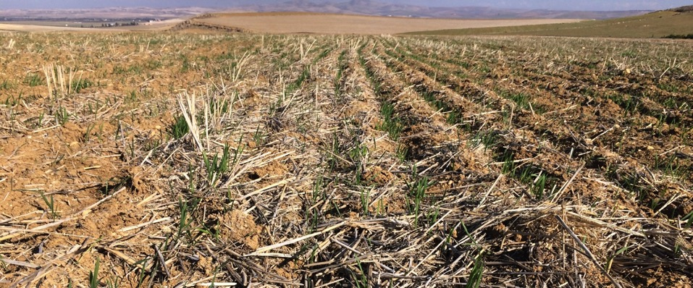
FIGURE 7: On-farm demonstrations in the CLCA project are successfully demonstrating the benefits associated with ZT. In this instance (Siliana, Tunisia), the wheat crop is successfully germinating through a high level of retained wheat stubble, reflecting an integrated approach to managing livestock grazing. Photo J Cummins

The development of CLCA packages needs to source information and knowledge from a range of sources and experiences that needs to be defendable. It may not always be possible to conduct local research to validate some information or concepts due to limitations in available resources, time and effort. This is where the application of scientific and practical farmer experiences are important in developing ‘best management practices’, and applying them as part of structured farmer group based learning experiences. Through adopting core principles such as ‘action research’, participatory based development and extension (engaging farmers as the ‘central stakeholders’) it is possible to create ‘innovative platforms’ that can enhance and develop new ideas and support farmers in the change process associated with developing, adapting and introducing CLCA systems.
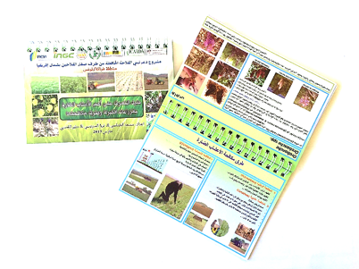
FIGURE 8: An excellent example of developing a valuable resource tool for farmers and extension officers has been provided through the CANA project. This field guide assists in the identification and management of a range of common crop weeds across North Africa. Photo: J. Cummins

From the Australian experiences, there are some excellent examples of some basic CLCA principles that can easily be adapted to farming systems associated with the CWANA region. These principles can be utilised in the development of CLCA information packages for farmers. If required some simple local demonstrations and trials can assist in providing local validation of the core principles and specific benchmarks (refer to Appendix II; Examples of tools suitable for CLCA packages for farmers).

7.2.4 Capacity Development, Co-learning and Information Dissemination across Target Areas and the CWANA Region.

It is evident that the project was able to achieve a high level of activity in the areas of capacity development, with ICARDA providing a lead role in the facilitation and delivery of training, and is clearly demonstrated in the activity summary in the Table 3.

Topic | Location | Number of participants | Female
Focus group to assess adoption of CA using ADOPT | Algeria | 62 | 1
Socio-economic rapid rural survey | Algeria | 23 | 5
Machinery and ZT technologies | Algeria | 20 | 0
Data management and data analysis using SPSS and ADOPT (Algerian NARS participants) | Algeria | 10 | 7
Socio-economic trainings | Jordan | 3 | 2
Data management and data analysis using SPSS (Tajik NARS partners) | Jordan | 2 | 1
Focus group to assess adoption of CA using ADOPT | Tajikistan | 45 | 14
Socio-economic rapid rural survey | Tajikistan | 25 | 10
Focus group to assess adoption of CA using ADOPT | Tunisia | 19 | 2
Socio-economic rapid rural survey | Tunisia | 19 | 2
Methods for conducing survey/questionnaire | Tunisia | 4 | 0
Forage production | Algeria | 30 | 16
New techniques for sustainable sheep and goat production | Jordan | 16 | 3
Agro-ecological monitoring | Jordan | 5 | 3
Alley cropping | Jordan | 5 | 3
Principals and applications of effective rangeland management | Jordan | 1 | 1
Feed Assessment Tool FEAST (conducted by national team) | Tunisia | 40 | 0
Feed Assessment Tool FEAST | Tunisia | 21 | 14
Weed management | Algeria | 4 | 4
Weed management, no-till equipment and forage production | Tajikistan | 26 | 0
Soil and irrigation | Algeria | 30 | 14
Machinery modification to test two trailed John Shearer seeders | Algeria | 10 | 0
Crop production under CA | Tajikistan | 17 | 3
Crop rotation | Tunisia | 20 | 0
Proposal, management and reporting of research projects | Jordan | 1 | 0
Designing experimental protocols | Tunisia | 10 | 0
Scientific writing | Tunisia | 1 | 1
Advanced MS Office Excel | Tunisia | 1 | 1
Awareness training Meteorological Data | Tunisia | 1 | 1
Methods of experimental design under CA with specific reference to forages. | Tajikistan | 34 | 10
TOTAL |  | 505 | 118

TABLE 3: Summary of Training activities undertaken by ICARDA (Credit ICARDA)

There is however a continued demand (and need) to further expand the training opportunities, as has been demonstrated from a number of discussions with project teams undertaken during the Mission Study, and this needs to be addressed in a Phase II operation of the project.

It is important to recognise that there is a degree of variability in terms of the level of skills and capabilities of project participants between the participating countries. This is largely a reflection of past experience and familiarity in relation to the development of CLCA systems, and professional contact with research and development expertise specifically aligned to CLCA and participatory development and extension approaches.

There is significant opportunity for further building the capacity of project staff and NARS stakeholders across all three countries, noting that by far the greatest needs are in Tajikistan. In recent years, there has been a concerted effort to recruit agricultural science graduates in both Algeria and Tunisia to undertake on-farm applied research and extension activities. Such initiatives are to be commended, however these young professionals will benefit considerably through further training and development, and importantly flexible mentoring programs provided by practically focused internationally recognised technical and participatory extension experts.

The project has achieved an excellent level of participation of post-graduate students in the project activities, particularly in Tunisia and Algeria. In the case of Tajikistan, it is important to encourage and foster future post-graduate engagement of English speaking students, with a preference to identify post-graduate research activities in English speaking countries (that are also considered leaders in the development of CLCA systems) as part of a sandwich research program. This will broaden the horizons of the students, and assist in overcoming past isolation.

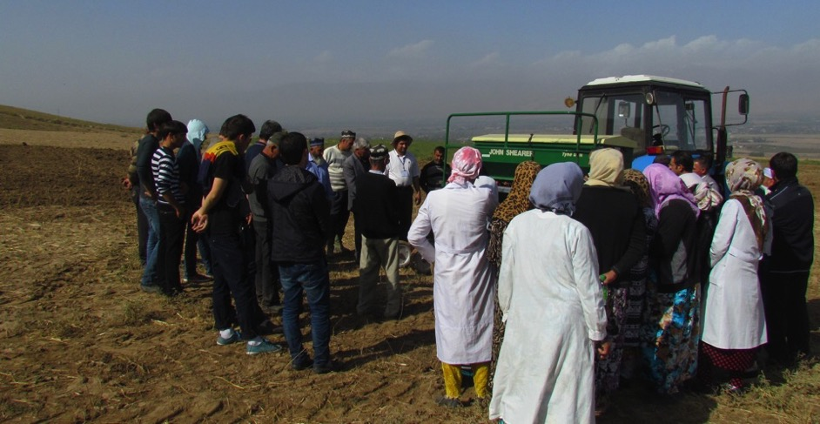
FIGURE 9: An example of ICARDA provided training in relation to the ZT Seed Drill calibration and operation. Photo: Credit Harun Cicek ICARDA

7.3. Scientific Quality and Field Implementation Activities

Activities conducted at the farmer field sites were orientated towards demonstrating CLCA practices, and had a strong ‘developmental theme’ associated with them. Complementing these activities were the on-station research trials, which served as a principal focus for undertaking the applied research activities associated with the project activities. It is important to note that many of these activities commenced before specific budgets became available to the project partners, and so there was a deep level of commitment from the NARS partners to commence the project before all formalities had been completed.

Overall, there was a satisfactory level of ‘scientific quality’ was associated with the implementation of the field-based activities. These were aligned to the specific work plans that were approved by the Project Steering Committee. Through their project leadership role, senior ICARDA scientists provided much needed guidance and assistance to staff, with frequent field visits conducted in all three countries in an effort to provide formal training and capacity building activities as well as peer mentoring. There is however a number of recommendations that if implemented will greatly assist in enhancing the quality of the scientific outputs, and these have been integrated into this Mission Report.

Tajikistan
Of the field trials observed, the Tajikistan team was able to provide satisfactory research and demonstration trials with consistency. Whilst only a small number of sites were inspected (due to seasonal snow falls access to remote sites became difficult), the sites were useful in demonstrating key outputs to farmers associated with the adaptation and development of ZT seeding systems using the John Shearer seed drills. The team would benefit from further training and capacity building activities. Given the greater depth of practical experience evident in Algeria, Tunisia and the ICARDA team, the Tajikistan team members would benefit enormously from having practical placements with these other technical teams, and should be strongly encouraged in any future program.

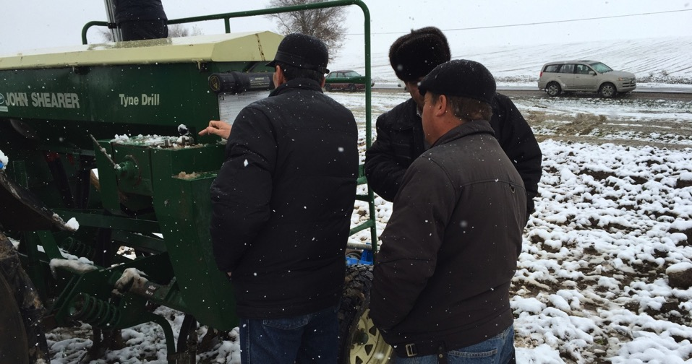
FIGURE 10: Significant farmer interest was generated during a field demonstration and workshop on ZT seeding systems held in the Dangara District. Photo: J. Cummins

Algeria
It is evident that the ITGC team was able to maintain a high level of scientific quality associated with the field trials, and that activities were aligned to the requirements as specified by the Project Steering Committee.

Given the large distances required to travel to the field demonstration sites, there has been a lot of effort put in by the team to ensure consistency across the sites. Variability in some of the demonstration sites was evident, in terms of undulating land resulting in variability in the delivery of irrigated water through flood irrigation. This is more of a common characteristic of the farmland, where there has been limited leveling of land to improve irrigated water distribution. All demonstration sites visited were easily accessible for the purposes of managing the sites, as well as hosting farmer field day related events. Research Station trial sites were well managed and laid out. The sites selected were consistent in terms of topography and soil type, thus providing a high degree of confidence in of the consistency of trial results.

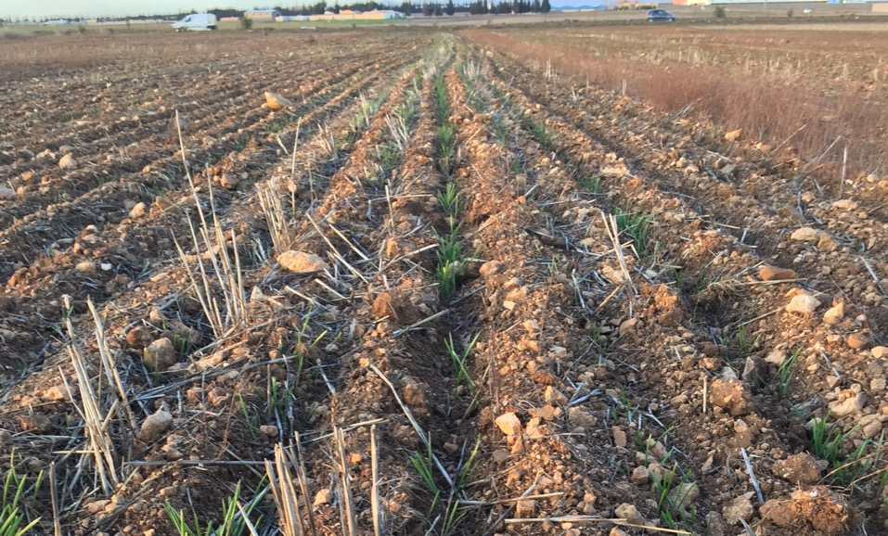
FIGURE 11: Field trials sown on the Setif Research Station were well designed and managed, reflecting the high level of technical capability amongst the project team. Photo: J. Cummins

Tunisia
Visits to the field trial and on-farm demonstration sites illustrated that there is an extremely high level of scientific integrity associated with the research activities. Pleasingly, it was apparent that there is a good level of cooperation amongst the research and development teams, which involved engaging multiple organisations and associations. The research team in particular had an excellent understanding of the need to develop integrated crop-livestock production systems that were underpinned by conservation agriculture principles.

The efforts of the Tunisian team in establishing a local farmer association called the ET Taaoun group (described as a ‘Mutual Agricultural Services Society) are to be commended. The key purpose of the association is the establishment of formal links between farmers and R, D & E professionals (NARS teams) for the purpose of undertaking on-farm demonstrations relating to CLCA, assisting in the local promotion of CLCA amongst farmers throughout the local community, and to explore new opportunities in particular with ZT seeding systems, development of forage crops and the integration of crops and livestock.

It is evident that in all three countries, there is a high level of commitment and dedication shown by the project teams. This undoubtedly has been a critical success factor in ensuring that the project outputs have been delivered to the best ability of all team members and contributing NARS organisations.

7.4. Analysis of Outcomes and Impacts at the Farmer Level

Tajikistan
Research activities conducted in Tajikistan were able to generate high levels of awareness of CA systems, and in particular the development of ZT seeding systems. As the promotion of CA systems is a recent phenomenon in Tajikistan, the first step of promoting awareness was one of the key activities undertaken. Availability of suitable ZT seed drills for research and demonstration purposes was made available through the project; these being amongst the first specialized CA equipment to ever be used in Tajikistan.

Farmer awareness of CA based cropping systems is evident in the districts where project activities have been conducted. Indeed for those farmers who have used the seed drills (provided through the project) on their own farms had resulted in an extremely positive response. Importantly wider interest amongst other farmers within their respective communities had been generated, with interest expressed by these farmers who wanted to experiment with the new John Shearer ZT seed drills on their own properties.

In Tajikistan, there was a reduced emphasis in relation to the livestock component of the research work, with significant effort being concentrated towards the development of the conservation cropping aspects of the project, primarily through activities associated with the ZT seeding systems. As time progresses, it is expected that the key elements associated with the ZT seed system will be perfected, since the principles of ZT seeding systems (primarily sowing crops without the need to cultivate) is a recent phenomenon to Tajikistan.

Efforts to develop the livestock component of the CLCA system associated with the project received a secondary priority, given the availability of resources and personal having the capability to investigate this area of the project further. Some elements however were addressed in the project, such as the development of the alley farming principles utilizing local tree/fodder species. The successful establishment of the alley farming demonstration trials will provide the opportunity in future project work to assess the benefits of alley farming systems from an integrated crop-livestock production system perspective.

Algeria
It is evident that there was an excellent awareness of the technologies that are being promoted amongst targeted farmers. Farmers attending the field visits (as part of the mission) were extremely well engaged and aware of the details associated with the specific demonstrations. There was often lively discussion amongst the farmers and the project staff, with good working relationships and trust clearly established.

The project team had through the demonstration sites and related field day activities created a high level of awareness amongst farmers, to the point where many of the farmers are enthusiastic about having the opportunity to adopt both the conservation agriculture and conservation livestock practices on their farm. Should farmers have access to affordable ZT machinery, either purchased outright or hired through local contractors, it is likely that there will be high levels of adoption. The project team had well established networks and other partners involved in the project. This is particularly important in terms of raising a wider awareness of the project and related activities, thus creating wider interest and awareness of the new integrated crop-livestock management systems.

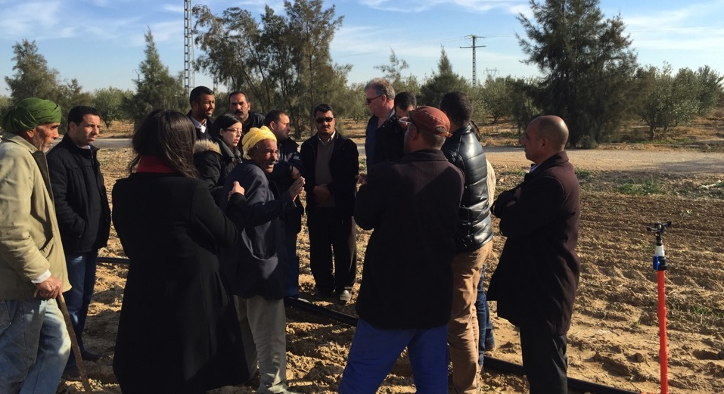FIGURE 12: Strong farmer interaction illustrates the high level of engagement that the Algerian CLCA team have achieved with farmers engaged in demonstration trials from the Ain El Khadra community near M’Sila. Photo: J. Cummins

Tunisia
It is evident from the field visits and discussions conducted that there is increasing interest in the development of CLCA systems in Tunisia. Of significance was the emergence of a wide range of impacts that were now being experienced by farmers at the demonstration sites. Farmers attending a briefing session associated with the project review tour were extremely perceptive in terms of the initial favourable impacts that the CLCA systems were having at the farm level. Of equal significance to farmers were:

- The advantages associated with the introduction of ZT seeding systems, in terms of timely seeding, reduced fuel costs, reduced soil disturbance and potential for soil erosion.
- The introduction of sown oat-vetch fodder crops, which had significantly increased the production of high quality fodder hay for livestock, with antidotal evidence from farmer experience clearly demonstrating increased fertility of breeding ewes (and subsequent lambing percentages), superior growth rates of lambs (350 grams per day not being uncommon) and a price premium in the market place for quality and attractive looking lambs.

The sown oat-vetch fodder mix also offered additional benefits, including increased contributions of available nitrogen to the soil (of benefit to the following cereal crop in the rotation), and in one situation a farmer identifying the opportunity for local apiarists to place their bee hives in proximity to the flowering vetch crop.

The excellent demonstration work conducted by the project partners at the farmer level had also led to increased local social cohesion by farmers in the targeted village community, to the point where they had recently formed a local association. The objectives of the association were to improve on-farm production and to share knowledge and experiences relating to CLCA within the local farming community. The farmer association had also taken on the important role of coordinating local demonstrations of the ZT seeding system, having the benefit of the John Shearer seed drill being based within their local community.

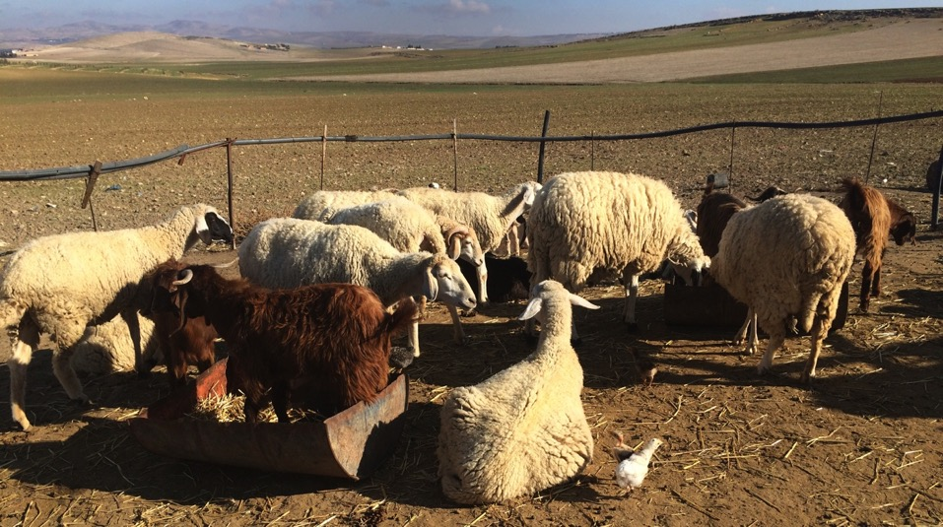
FIGURE 13: Animals confined to this household feedlot in Tunisia demonstrate the opportunity that is available to increase livestock numbers. Reducing open grazing by animals, and providing them with harvested oat-vetch hay illustrate the application of an integrated CLCA system. Photo: J. Cummins

Whilst it is still too early to clearly predict and quantify the long term impacts of the CLCA system, it is likely that in the future farmers will have the opportunity to adopt an integrated package of technologies that will lead to increased production, profitability and sustainability of both crop and livestock production. Increased high quality and nutritionally rich fodder is likely to increase the opportunity to carry more livestock on-farm (expanding opportunities for small household based animal feedlots), with increased growth rates and price premiums.

It needs to be recognised that more work needs to be done to develop ‘best management agronomic practices’ associated with the ZT seeding system. Of high priority are the development of integrated weed management systems, alternative crop rotations (to the mono-cultural practices of cereal production) and the development of agronomic benchmarks (seeding rates, time of seeding, fertiliser management (rates and timing)) for the range of agro-ecological zones.

As with the other countries engaged in the CLCA project, the issue of machinery availability at affordable prices remains the most significant barrier to the uptake of the ZT seeding system amongst Tunisian farmers. It was reported that through the CANA project, the INGC team were coming close to developing a local prototype machine with a local Tunisian manufacturer. It is critical that this outcome remains a priority to follow through to the point of large scale manufacturing of such equipment. Developing a range of models for machinery ownership, syndication and contracting services for small-scale farmers needs to be developed in an effort to ensure wide scale adoption.

7.5 Farmer’s Perceptions of Technologies and Adoption

Tajikistan
Tajikistani farmers associated with the demonstration sites are extremely curious and interested in the new CA systems being demonstrated using the ZT seed drills. There is however some apprehension, primarily due to perceived risks in adopting a seeding system that does not involve traditional farming practices underpinned by deep tillage (i.e. the perceived need to till the soil, prepare a seed bed, provide a fine soil tilth).

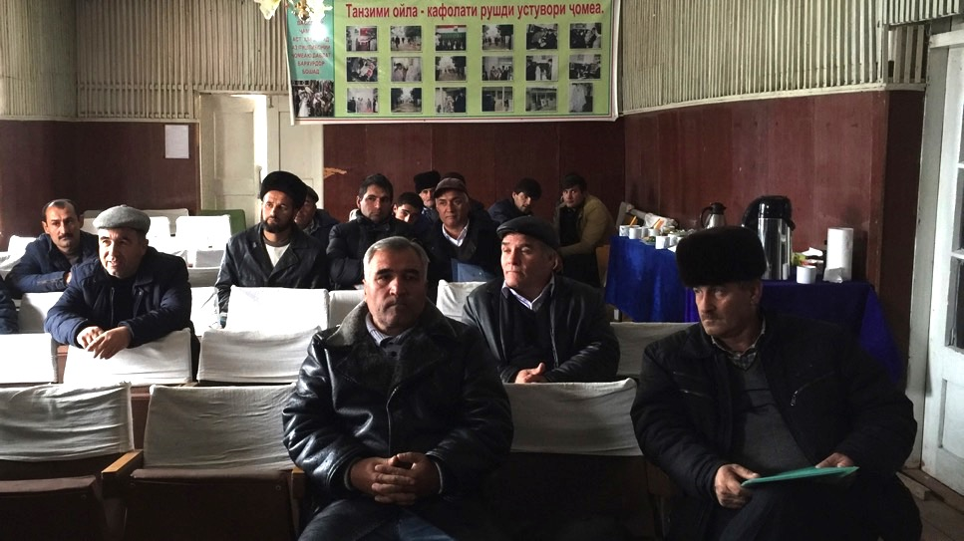
FIGURE 14: Farmers were interested to learn more about ZT seeding systems, and crop rotation options during a workshop conducted in the Dangara District. Photo: J. Cummins

Demonstrations provided the opportunity for farmers to experience first-hand the ZT seeding system and assess the benefits themselves. The efforts of the Tajikistani researchers in clearly identifying the benefits of the CA ZT system are commendable, and in turn will assist in providing a convincing reason for farmers to consider the benefits

Algeria
Farmers consulted during the field visits associated with the mission indicated that:
- They are very interested in the technologies, and are aware of the associated benefits
- It is important to see the demonstration trials preferably over a 3-year period, so that they could confirm the consistency of results.
- Farmers recognised the importance to have all elements of the improved systems addressed, in order to maximize adoption success and financial returns.
- The main limitation mentioned by all farmers in relation to the new system is the availability of low cost ZT machinery. Without this, there will be simply limited adoption of the CLCA system, and the opportunity will be lost.
Whilst there were no specific issues in relation to the capability of farmers to adopt the improved systems, there is the issue of capacity. To elaborate on this further, farmers do not necessarily have the financial capacity to purchase the specialized ZT seed drills themselves outright, given the high cost of currently imported equipment. Should locally available (manufactured) drills be available, farmers indicated that they would be prepared to pay in the order of $6-12,000 US for such equipment.

Within the groups of farmers questioned, it is evident that there are varying degrees of farmer capability (in terms of technical agronomic and livestock management), and so some farmers may need more support than others. Ideally, through adopting a farmer participatory approach and supporting farmer group networks/discussion groups, there is the opportunity for the more progressive and technically capable farmers to support other in the adaptation and development of improved CLCA systems.

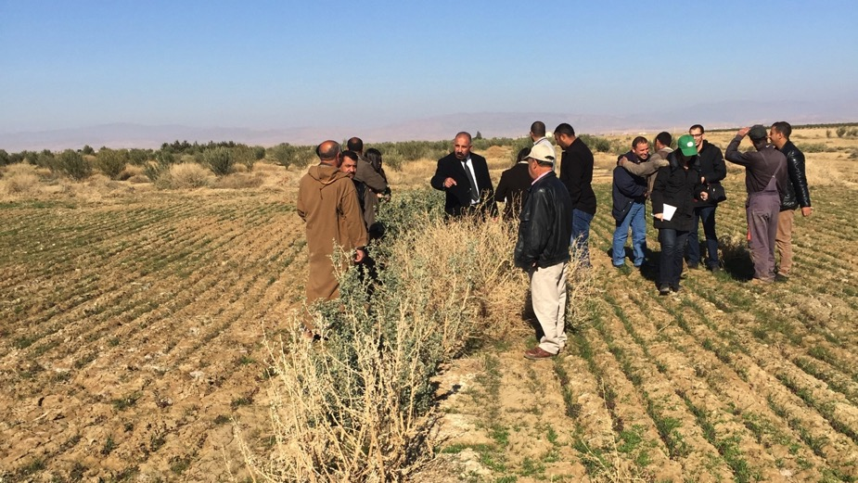
FIGURE 15: Alley farming demonstration in the M’Sila district. Saline affected soil at this site was providing additional challenges to both the sown fodder crop and ZT sown cereal crop. Photo: J. Cummins

In terms of adapting the conservation livestock system, there is interest amongst farmers in the practice of sowing fodder crops (that have been demonstrated as part of the field demonstration activities). It is important that additional applied research and development work be conducted in order to develop improved livestock feed management systems across the full season (12 month period), that brings together a range of strategies including strip grazing of sown fodder crops, hay conservation and feeding to livestock in contained feedlot areas, and reduced grazing of stubbles.

In relation to the concepts of the alley farming, there were some mixed opinions in relation to the overall versatility of the system. Whilst farmers recognised the benefits of having additional perennial based fodder available (and the potential opportunity to reduce wind and water erosion), they did identify a number of barriers associated with the uptake of the technology. These included the loss of highly productive land for crop production, difficulty in operating machinery of varying widths between the rows (different width equipment would result in operational inefficiencies), preferential grazing of stubbles by livestock to that of the sown fodder species. Further to this, the competition of the perennial plant species for soil moisture during dry periods may adversely impact on crop yield.

An alternative option may be the establishment of dedicated ‘blocks’ of sown perennial fodder species, particularly on land less suitable to crop and/or annual fodder production (such as steep slopes, saline or salt affected soils). Under these situations it is likely that returns from cropping will be less, grazing can be better controlled (than compared with alley farming) particularly if these ‘blocks’ are fenced off).

Tunisia
Tunisian farmers considered that the development of the CLCA systems in Tunisia offered significant advantages in relation to increasing on-farm production of both livestock and crop production systems. Whilst initially the concept of sowing a crop without the need for cultivation had met some hesitation, after the first year of demonstrations farmer participants soon became convinced that such a seeding system offered potential advantages over their current conventional seeding methods. Importantly the fact that an integrated crop-livestock CA system was being developed was of significant appeal to farmers, in that the demonstrations also addressed the opportunity for increased fodder production for livestock.

The farmers that participated in the field tour activity were clearly driven by the need to maximize on-farm profitability through introducing new technologies and practices. As a group they indicated that they kept records their own farming operations, and regularly undertook gross margin analysis as a planning tool to determine optimum enterprise mixes capable of providing highest returns.

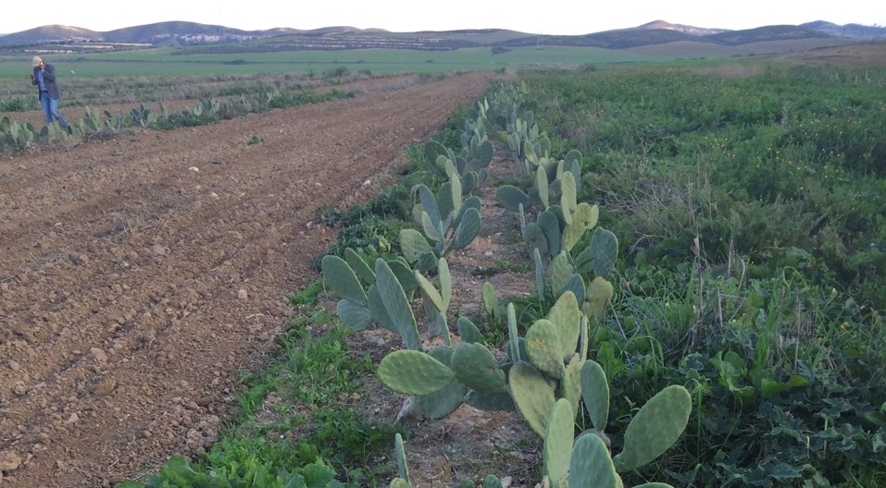
FIGURE 16: Alley farming demonstration utilizing spineless cactus at the Bourbia Research Station of INRA Tunisia. Establishment was gradually progressing despite some early plant losses (due to frost and slug infestations). Photo: J. Cummins.

For adoption to take place, there are two elements that need to be addressed; farmer capability and farmer capacity. Capability describes that farmer’s intellectual ability and understanding of the key scientific principles associated with the technology. Farmer capacity refers to their ability to afford the technology or practice.

It is evident that the farmer group visited had significant capability to adopt the CLCA system. The concept of ‘farmers learning together’ is extremely important, as are the resultant benefits of farmer led on farm participatory research, development and extension. The visit to this village community has provided confidence in this approach. The importance of providing technical support to such farmer groups cannot be over emphasised, so therefore it is important that support continues to be provided by project staff (whilst at the same time the technical staff can learn greatly from the farmer’s experience and observations).

In terms of capacity, the current high cost of imported machinery such as the John Shearer seed drill is an issue, and as indicated the availability of relatively low cost and affordable machinery needs to be within the financial capacity of farmers to adopt. Once low cost locally manufactured ZT seed drills are available, a significant barrier to wide-scale adoption would have been addressed.

7.6 Assessment of Dissemination Methodologies and Scaling Up

Tajikistan
Research dissemination methodologies utilized were simple; invite farmers to field days and workshops and present to them the basic theoretical principles of the CA systems being demonstrated. There have also been some on-line video productions that have been produced in order to assist in raising the awareness of such technologies amongst farmers and the wider industry.

The principle technology innovations tested related to the sowing of a range of crops under a ZT seeding system, a key element of a CA system. Few other CA elements were addressed, with limited focus on livestock grazing management. The demonstration trials have also focused on sowing a range of crop types, with the aim of introducing farmers to a range of different crops including food legumes and oilseeds, in addition to different forage species. This has been undertaken specifically to assist farmers in diversifying crop type and crop rotation in an effort to improve overall crop production profitability.

In terms of the potential for scaling up of the CA ZT seeding system, there is an enormous potential to scale up the technology amongst Tajikistan farmers. For those farmers that are aware of the technology (through either their direct engagement with on-farm demonstrations) or attendance at a field day, there is significant interest.

Algeria
There was a wide range of methodologies and associated activities that are utilized through the project to disseminate of information to farmer groups. Field demonstration sites were by far perhaps the most valuable means of demonstrating the new technologies to farmers. It is evident that the Field Station trials also provided a useful focal point for farmers to come and view the different aspects of the system during the Station’s Open Days.

Identifying farmers who were willing to provide some of their land as part of the demonstration trials in the first year of the project often proved challenging to the team, since farmers were largely unaware of the technology. After the first year however, with promising results now illustrating the potential benefits of the improved systems becoming apparent, additional farmers were far more willing to participate in the field demonstration program in the second and third years.

The project team was able to successfully integrate the key elements of an integrated crop-livestock production system based on key conservation agriculture principles. Both the ZT seeding system and fodder production demonstrations were often conducted in close proximity to one another. Discussions with farmers through field day activities involved both elements of the demonstrations, and importantly the implications of developing an integrated crop livestock production system discussed in detail. Livestock production is recognised as an important element in the management of risk and the opportunity to maintain consistent income even in years of poor rainfall by farmers, hence the importance of promoting a fully integrated system.

Field day activities linked to the field demonstrations provided the opportunity for the Algerian team to address a wider group of local farmers about the demonstrations, as well as to gain initial feedback from farmers in relation to the new practices. With increased farmer awareness and interest, and through both informal and formal extension activities, there is tremendous opportunity to scale up the technologies. It is important however that the conservation cropping and livestock systems that are developed work well, in terms of achieving equal if not greater production, and importantly increased economic returns.

ITGC have been active in producing videos highlighting the key technical aspects and farmer experiences associated with the project, which have been promoted through a YouTube Channel and Facebook page for the ITGC Field Station at Setif. Many of the videos produced have (and will continue) to serve as excellent training materials for farmers, and in many cases feature ‘farmer case studies’, with farmers themselves sharing their own personal experiences and opinions in relation to the suitability of CLCA practices.

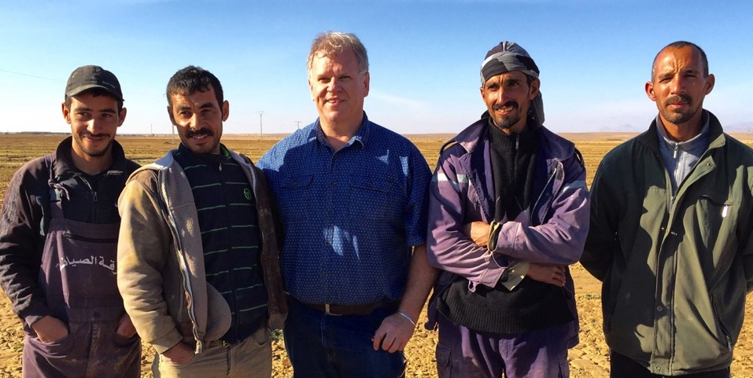
FIGURE 17: Algerian farmers from the M’Sila district pictured with Dr Jay Cummins (centre) were enthusiastic to discuss the benefits of the CLCA system, and in particular the benefits gained through introducing ZT sown crops, such as reductions in the number of irrigation practices, more timely sowing and reduced operational costs (primarily achieved through fuel savings). Photo: J. Cummins

The opportunity for ‘up-scaling’ an integrated livestock crop production system (based on conservation agriculture principles’) is extremely significant to say the least. Evidence to date from the field station and on-farm demonstration sites are providing convincing evidence to farmers in relation to the benefits of ZT (earlier seeding, reduced time, fuel, seed and irrigated water savings). Further quantification of the benefits of such a system (including total on-farm profitability) is recommended, in order to factor in the full benefits of the system. It is worth noting that one farmer visited operated a small-scale beef cattle feedlot and dairy operation. He had alfalfa incorporated into his cropping rotation (cut and carry/cut hay operation), which when combined with utilization of barley produced on-farm represented an additional income earning stream. This operation seemed to be well managed, from the perspective of the visual condition of cattle present, and the calving percentage achieved for this season.

The opportunity to adopt a similar model for sheep production warrants further investigation from the perspective of increasing animal numbers significantly to capitalize upon increased fodder production (as sown fodder is increased in the crop rotation to largely replace weedy fallows).

Tunisia
On-station research activities conducted aimed to address key research questions in relation to the development of an integrated crop-livestock CA based system. The project team considered it important to address the practical elements of an integrated system, and therefore was focused on achieving practical research outcomes that could then be transferred to local farming communities (as part of an adaptation process).

It was considered by researchers that there had been very few studies (if any) conducted in Tunisia in relation to the grazing management of cereal stubbles and livestock performance. As a result research was conducted in order to determine how best cereal stubbles could be grazed in a CA system, addressing perspectives such as the intensity of, and level of grazing to maintain a balanced return of cereal stubble so the soil and adequate soil cover to prevent erosion risks, as well as the performance of livestock themselves under cereal stubble grazing systems (maintaining livestock weight versus weight gain priorities).
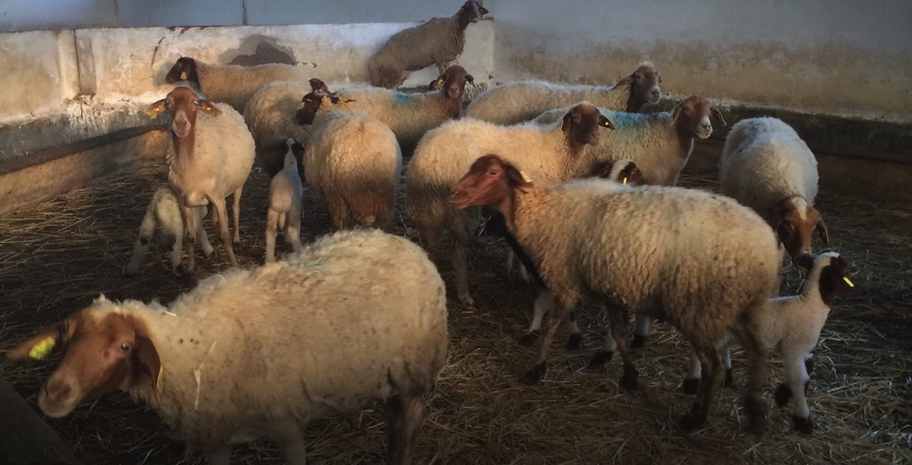
FIGURE 18: Barbarine sheep flock from the Bourbia Research Station, which was used in an extensive number of feeding trials.
Having addressed these practical adaptation research needs, the research team considered that they had been successful in developing ‘practical solutions’ that would be capable of having an immediate impact at the farmer level.

The project team in Tunisia exemplified a sound working relationship between INRAT (research focused) and INGC (extension outreach – farmer adoption focused). As a result, the working relationships provided a relatively seamless process in terms of adapting research discoveries to practical on-farm adoption opportunities. This successful model illustrates a successful partnership that should be encouraged to continue in future project activities. There are opportunities for INGC to play a greater role as the focus of the project moves to one of on-farm development and participatory driven extension outreach focused activities (whilst still recognising the importance of, and the need for adaptive research activities).

In terms of the specific dissemination methodologies adopted, the principle approaches adopted in the project included farmer participatory development and extension (through on-farm demonstrations), farmer engagement at open days and field days at the research station sites, and farmers themselves utilising the seed drills to sow their own crops under a ZT seeding system.

A number of extension publications and information sheets were produced through the project to serve as useful extension materials for use by farmers and other extension staff. These resources assisted in providing an awareness and background information relating to CLCA systems.

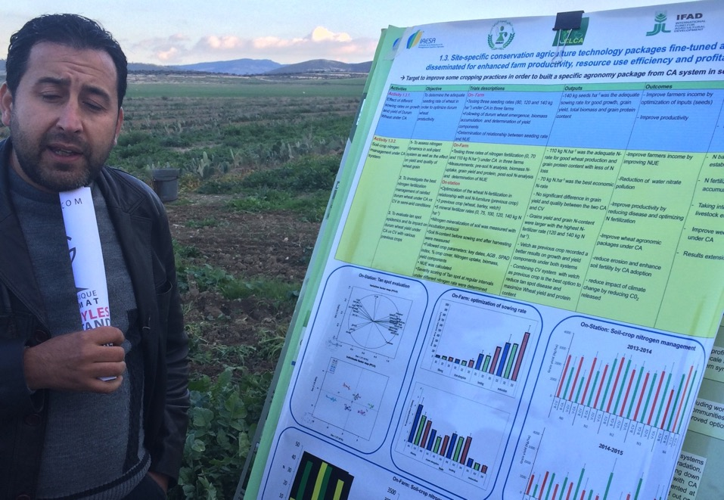
FIGURE 19: A significant effort in developing integrated CLCA packages has been undertaken by the CLCA project team in Tunisia, in an effort to develop and promote a truly integrated crop-livestock production system as demonstrated by team members during a visit to the Bourbia Research Station.
Many of the Tunisian project team members were also involved in the Conservation Agriculture for North Africa (CANA) project, an Australian Government funded program focused on developing ZT seeding systems for small landholders. This provided additional benefits to project team members, in terms of training and capacity building, as well as access to Australian expertise in agronomy, crop protection and agricultural machinery design specifically for ZT seeding systems.

7.7 Success of Capacity Development Activities

Tajikistan
The capacity development activities implemented were primarily targeted towards agricultural research officers and technicians. There were basically two categories of activities those delivered by expertise originating from outside of Tajikistan (as part of the overarching capacity building initiatives administered by ICARDA), and locally delivered training activities delivered by local expertise.

The capacity development activities were aimed to provide training participants with the necessary skills and capability to deliver a range of elements and outputs associated with the project, such as undertaking farmer adoption studies, conducting on farm experimentation, principles of CA systems (ZT seeding systems, integration of livestock grazing and management).

It is evident that these activities contributed significantly to the success of the project, and importantly has assisted in building the local capacity of research and development experts. The full impact of benefits associated with the training is yet to be realized, since there has been only a modest level of research and dissemination activities undertaken through the project (and primarily focused on the conservation agriculture aspects of the project).

It is worth noting that as the concept of CA, and in particular ZT seeding systems is relatively new to Tajikistan, the research officers themselves had to be convinced of the potential benefits of the new systems. Just as farmers were unsure of the ability to sow crops without tillage and gain comparable yields without deep tillage, so too were the research officers. As a result of the training, there has been a positive attitude swing amongst research officers.

Algeria
Capacity development activities addressed the needs of the project staff engaged in undertaking the field research and demonstration trials. It is evident that these activities were largely successful in providing valuable skills to the project team. Project team members felt that there should have been additional training opportunities provided, since many in the team were relatively young and inexperienced.

As the Algerian project team were relative early career professionals, it is evident that they will benefit strongly from further capacity building activities focused on both the technical and social rural development and extension aspects.

The nature of the project, integrating livestock and crop production within a conservation agriculture framework is relatively complex, with a wide range of intervening variables. Hence it is important to provide a broader level of training so that staff can feel technically competent across the range of disciplines and subject matters.

There has been no training in participatory extension, farmer group facilitation and agricultural change management. Certainly these will be key priority areas in future project work where there will be a need to shift to broader scale promotion and facilitation of adoption.

Tunisia
It was considered that there could have been more capacity building activities conducted amongst the project team in order to raise their skills and capabilities. As for the Algerian team, the Tunisian team were relatively young and early career professionals, hence the provision of targeted technical training on key areas of skill development was considered to be an important priority.

General Comments and Recommendations

It is recommended that in a future Phase II project it would be beneficial to conduct a training needs analysis amongst the project team staff. This should be based on identifying and determining the level of a range of core competencies and skills required to adequately perform the professional job roles of project team members and associated project objectives.

In relation to the training programs, there are a number of additional principles that need to apply. Specific learning outcomes and the acquisition of specific skills and capabilities acquired through the training should be clearly demonstrated amongst participants. It is therefore recommended that appropriate M&E takes place, and in particular exit surveys of participants following the training, in order to determine the specific learning outcomes achieved.

7.8. Identification of Critical Research Gaps

Tajikistan
CA systems, including ZT seeding, integrated livestock management (strategic grazing of stubbles, fodder production) is a recent concept introduced to Tajikistan. As a result, the development and adoption of such systems is in its’ infancy. Whilst the first phase of the project has been successful in terms of creating awareness and interest amongst farmers in the pilot demonstration sites, there is much more work that needs to be done if the system is to be properly adapted and developed for Tajikistan’s unique farming systems.

There is the need to further trial the ZT seeding system, so as to ensure that consistent results are achieved under a range of farming systems; be it rainfed or under irrigated production systems. It is important to adopt a ‘whole of systems’ approach, primarily targeting an integrated agronomic and livestock management system. As an example, there is limited experience relating to integrated weed management, and so this can be described as a specific ‘research gap’ that requires further field research, and in particular ‘capacity building’ for the research staff engaged. Similarly, the role of livestock in the grazing of harvested stubble residues needs to be verified, particularly in terms of grazing thresholds required to maintain optimal stubble ground cover and density.

Whilst a new centre for agricultural machinery research has been established, there are few resources and limited expertise available to undertake applied field research work. To adequately establish the research unit, it will be important to ensure that there is an adequate level of financial resources to be provided, in addition to capacity building of staff (such as principles of conservation agriculture and machinery design, proper field trial research protocol, and agronomic assessments).

In the case of Tajikistan, it is evident that much work needs to be done in terms of building research skills and capability, so that ‘adaptive research’ relating to the development of conservation agriculture systems can be undertaken. It is recognised that additional work is required to properly develop suitable CLCA systems under irrigated crop production systems, in order to significantly increase production across a system that is less impacted upon by rainfall variability.

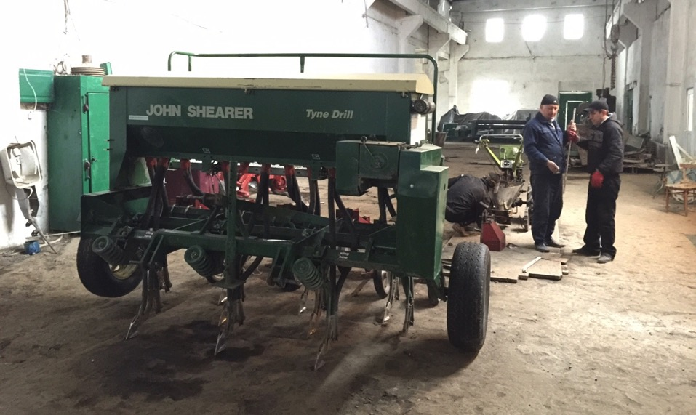
FIGURE 20: The workshop of the recently established TAAS Agricultural Machinery Research Unit, featuring the John Shearer ZT seed drill. Photo J. Cummins

Further on-farm field trial focused research (adaptive in nature) will assist in developing CA systems that can be validated through on-farm demonstrations and in turn dissemination of results that will ultimately lead to increased adoption if done correctly. These elements will form a key focus of a second phase project. Importantly, engagement of the Tajikistan project teams with the experienced North African teams will assist in building local Tajikistan capacity and appreciation of developing and conducting on-farm participatory based demonstration trials.

Algeria
The development of a truly integrated crop-livestock conservation agricultural system requires significant skill and understanding of all of the intervening variables and their association with one another. It is evident that there are a number of areas of the development of the system that warrant further adaptive research. This relates to:

- Integrated weed management, including herbicide management and weed control.
- Crop rotation management; there are many ranges of crops that have not been fully explored and that offer much potential to farmers to increase overall crop production (oilseeds, food pulses).
- Irrigation and water management, from the perspective of increasing crop water use efficiency, conserving water through irrigation timing, soil moisture monitoring, farmer decision making in relation to irrigation timing.
- Economic Decision support, identifying the most profitable combinations of crop and livestock production from a farm business management perspective (that is linked to the development of decision support tools and packages for farmers).

Tunisia
Whilst there has overall been a high level of attention devoted to the development of a truly integrated crop-livestock production system based upon conservation agriculture principles, there are however a number of ‘research gaps’ that need to be addressed in order to develop a truly robust and sustainable CLCA system. It is important that the research gaps are addressed, so that farmers are able to develop and apply an integrated approach to managing the production system, in terms of crop and livestock production, sustainable soil and land management practices.

For the crop and fodder production system, specific research needs include:
- The development of integrated weed management strategies that explore the use of herbicides and cultural techniques (grazing management, cutting hay to achieve seed set control) for adequate weed control (including seed bank dynamics and impact of management on seed reserves.
- Crop rotation and sequencing (in terms of identifying the most profitable rotations that maximize economic crop yield and meet the nutritional needs and demands for livestock).
- Nitrogen management, timing and applications to achieve maximum economic yield, in addition to the rotational benefits of legume based crops and fodder crops on soil nitrate levels.
- Development of specific agronomic benchmarks, including seeding rate and timing.
- Development of decision support tools for farmers – to make better farming practice decisions, including adaptation of the APSIM model, animal feed demand calendars (and associated feed budgeting), gross margin planning and analysis.
- There is the opportunity to utilize farmer production and data records in order to develop ‘whole farm profitability analysis’, so that valid comparisons can be made between a range of management systems for both crop and livestock production.

Livestock research needs include:
- Examination of other forages that may be of value to farmers for livestock production (for example the native legume Sula, and a greater use of Opuntia species may offer opportunities for providing more available fodder to livestock).
- The nutritional value of shrubs (and how best they can be integrated into the farming landscape without adversely affecting crop production).
- The feeding calendar for livestock, so that the specific fodder production and feed needs of livestock can be identified (and management adjusted accordingly to fully capitalise on available production and avoid periods of the season when available feed may be in deficit).

General comments
The development of any integrated production system is complex and evolves over a period of time. Often specific characteristics of the system alter over time that may influence the productivity and sustainability of the system since we are dealing with complex biophysical relationships. It is not possible to predict all of the likely changes within the system, hence there is the need to continue to maintain a research focused monitoring role that is responsive.

The limitation of being able to undertake a detailed analysis of the financial impacts (and subsequent economic decision support) associated with a range of indicators (financial and technical related) after only two effective cropping seasons represents another research gap. There is a need to identify the most profitable combinations of crop and livestock production from a farm business management perspective and in particular address the management of risk as part of this decision support. The level of socio-economic analysis and skills across the project teams and in particular the leadership provided by ICARDA in this regard is highly commendable and needs to be capitalized in future project initiatives.

7.9 Perceptions of Project Achievements and Impacts amongst Stakeholders

Tajikistan
It is evident that there is a strong interest and commitment in relation to the development of CLCA systems in Tajikistan amongst all organisations that were visited during the project review exercise. The government of Tajikistan strongly supports the project, since it offers the potential to provide valuable outcomes, such as national and regional food security, building of agricultural technical and educational capacity building and improved livelihoods for the country’s citizens who rely on agriculture as their principal source of employment, income and livelihoods.

Farmers:
There is a high level of interest in relation to the ZT seeding systems aspects of the project, since this is the main element that is being promoted to farmers. Farmers are naturally curious about the potential benefits that are on offer, in terms of the ability to direct seed crops without the need for cultivation.

Policy Makers:
There is an extremely strong underlying commitment at the most senior level of government in relation to the development of CLCA systems in Tajikistan. This is driven through the need to achieve food security for the country, both in terms of both grain and livestock production. This is reflected through conversations conducted during the review with representatives from The President’s Office.

NARS:
The NARS network in Tajikistan is extremely positive towards the development of CLCA systems, and in facto serve as one of the central pillars of achieving positive contributions towards project outputs. The research specialists are extremely motivated towards being active partners in the project.

Others:
The Local Government authorities are responsible for the delivery of extension outcomes on a local district basis. From general discussions, it is evident that there is a much lower level of capability and capacity at the district level, in terms of farmers having access to well qualified and experienced extension personnel. Whilst at a regional management level perspective the local authorities welcome the opportunity to be associated with such projects, the level of impact and contributions per se may be a limiting factor.

Algeria
There is a high level of enthusiasm amongst the project team staff and partners whom were visited during the review period. This comes from the highest level of the NARS organisations, with a consistent level of support enduring through to the field operational level. The level of motivation amongst the younger project staff is to be commended, and this in itself is considered to be a critical success factor in the project to date.

Farmers:
Farmers consulted were extremely enthusiastic, interested and motivated in relation to the prospects of adopting the improved CLCA systems, notably the ZT seeding system. The adoption of conservation livestock systems will require additional effort, since farmers are very focused on their current methods adopted in livestock management and grazing. Communal grazing is deeply rooted into Algerian agrarian systems, and any change in attitude and practice is likely to take many years, if not a gradual generational shift. Farmers are excited about the additional benefits that ZT sown crops appear to be providing under irrigated crop production systems – where significant water savings are clearly evident.

Policy Makers:
There is the need to address production shortfall in terms of the ability to satisfy a higher level of food security for Algeria. There is a sound understanding of the project objectives and anticipated outcomes from the current project, with full support from the Government evident. The Government is committed to supporting the development of CLCA systems, and there are negotiations being undertaken at present in relation to the provision of generous interest rate subsidies for the purchase of ZT seeding equipment by farmers at minimal interest rates.

NARS:
NARS provide significant support and contribution to the project activities and outcomes, and are fully supportive of all initiatives. The project teams are extremely motivated, and it is obvious that they are also well supported by their respective managers. The NARS value the professional linkages and capacity training activities that are provided through the project. Since many of the staff are generally early career professionals, they have much to gain through the range of training and development activities provided through the project.

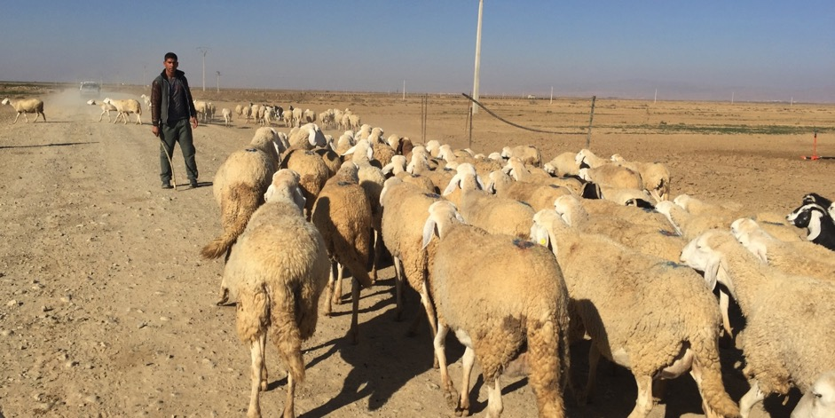
FIGURE 21: The challenge of managing communal grazing of available cereal stubble residues represents a major challenge to the development of an integrated CLCA system across the CWANA region. Photo taken in Algeria by J. Cummins.

Tunisia
It was evident that there is a strong underlying commitment to the CLCA project amongst all stakeholders that were consulted during the mission visit. Whilst there has been a considerable level of experience in adapting and developing CA systems in Tunisia in recent years, this project offered the opportunity to integrate CA across both crop and livestock production systems. This opportunity (and challenge) was being actively pursued by NARS and famers engaged in the project actively, and there had been to date a strong sense of achievement.

Farmers:
There are over 500,000 farmers in Tunisia who are involved in agricultural production. The majority are small landholders, who struggle to maintain their livelihoods through mainly crop and livestock production activities. It is evident from the field activities and related visits to farmers, that they are extremely motivated and appreciative of the on-farm demonstrations and trials that have been conducted through the project. Interest in forming local discussion groups amongst those farmers who have been involved in the on-farm demonstrations will see the formation of a number of groups in Tunisia.

Policy Makers:
It is evident from discussions at senior levels that the Tunisian government recognise the need to increased agricultural production (both crop and livestock production) in order to address food security needs and concerns in both Tunisia and the wider region. The importance of developing sustainable production systems that are based upon conservation agriculture principles in order to conserve natural resources such as Tunisian’s fragile soils remains a high priority.

NARS:
The regional development and extension services recognize the need to improve farming practices that are underpinned by sustainable farming practices. There is concern in regional areas in relation to the level of soil erosion associated with conventional farming practices. There is a positive acceptance of the benefits associated CLCA system amongst the local agencies, and as such there is full support of activities that take place at the farmer level. The engagement of both national and regionally based extension professionals will be critical in the expanded roll out of the CLCA system, and as such it is important that these stakeholders continue to be involved in project related capacity building and training activities.

7.10 Project Exit Strategy Approach and Sustainability

Tajikistan
The project is in a relatively early infancy period, having achieved an awareness of the ZT seeding technology primarily through the program of field demonstration trials and research activities conducted at NARS facilities.

It is difficult to assess the success of a potential exit strategy, given the early stages of the development of the technologies. Therefore a significant amount of local resourcing would be required to continue with demonstration related activities, in addition to addressing the capacity building needs of current staff involved in the program. Only after such a system has been developed and extended can a properly thought out exit strategy be formulated and instigated.

Algeria
The availability of cost effective ZT seed drills will help to ensure that there will be some opportunity for adoption of the practices to take place. Whilst there is a local prototype being developed, this machine is still early in its’ early stages of development, full commercial production may be several years away.

There is some interest amongst farmers in forming discussion groups specifically focused on the conservation agriculture project outcomes. This is a positive indication of the strong farmer interest, however there also needs to be a commitment from NARS to support this engagement, and in particular continue on with the demonstration site activities should there be limited opportunities to secure additional project funding.

In time a properly planned exit strategy will see a far greater level of responsibility being transferred to special interest CLCA farmer groups to assist in the widespread adoption of CLCA systems. An appropriate exit strategy would therefore need to factor in an on-going maintenance level of support to such farmer groups. This would need to be resourced through NARS.

Tunisia
It is evident that there has been a large amount of experience and capability generated in Tunisia, in relation to the development of ZT CA based systems for crop production. What is new and innovative is the integration of both CA based livestock and crop production systems, rather than the two enterprises working in isolation.

The Tunisian platform provided the opportunity to focus on the identification of a range of key sustainability indicators associated with the development an integrated CLCA system. The identification of these indicators reflect a significant project milestone outcome, and provides the opportunity to be developed as an extension outreach package/tool for farmers across all of the countries engaged in the project (as part of an exit strategy).

The development of a ‘sustainability index tool’ would provide the opportunity to compare the sustainability of different farming practices (in relation to long term soil fertility, soil health, crop rotation gross margins) whilst also providing the opportunity to benchmarking ‘best management practice’ associated with crop and livestock production.

Whilst there is still a significant amount of work yet to be done in relation to developing a fully integrated system, there is the need to now direct effort at developing appropriate strategies for supporting the wide spread adoption of the integrated CA system.

Appropriate exit strategies in turn will be characterised by:
- Farmer community based groups playing a greater role in developing and adapting the principles of CA systems to their local agro-ecological environments. The importance of building local capacity in this arena should be a key priority.
- NARS playing more of a supportive and facilitating role than they have done so in the past, particularly at the regional governorate level.
- Supporting farmer decision making in relation to the adaptation and adoption of CLCA systems will remain an important priority, whereby NARS will have an on-going role to develop resources and tools to aid farmer decision making, and providing a longer term systems research and monitoring role.

7.11 Links to other IFAD Projects In-country

Tajikistan
The main IFAD funded projects identified (during the planning phases of the CLCA project) in Tajikistan for which the CLCA project could link with were “Khatlon Livelihoods Support Project” and the “Improving Livelihoods of Small Farmers and Rural Women through Value-Added Processing and Export of Cashmere, Wool and Mohair” project (which has since been completed).

Of the two projects, outcomes from the Khaton Livelihoods project offers a focus on livestock production in the rangeland region in Khaton, and covers five districts, namely Dangara, Temurmalik, Baldzhuvan, Muminabad and Shurobod. This project has developed strong capability in fodder production and grazing management; these experiences and capability promises much benefit for integrating this expertise into the second phase of the current CLCA project.

The CLCA project activities to date have tended to focus on the conservation agriculture cropping elements, hence there is the need to further strengthen the conservation livestock components, and through forming closer working relationships with the IFAD Khaton project significant benefits are possible in terms of utilising the technical expertise and experience in the areas of livestock grazing management and fodder production

To date efforts for the different IFAD projects to work closely together have been relatively passive with limited contact between the respective project teams. It is therefore hoped that there will be increased working cooperation between the IFAD projects, now that an initial working relationship has been established (through this CLCA project review process).

Given the significant potential that a fully integrated CLCA project has to offer Tajikistan agriculture (in terms of raising the profitability of Tajikistan’s small farmers through closing the crop yield-livestock productivity gap), it is hoped that outcomes from the CLCA project will assist in shaping IFAD’s investment in Tajikistan.

Algeria
The CLCA project in Algeria was aligned to the IFAD project “Development Project in the Mountain Regions (PDRMM: Project développement rural des zones montagneuses du nord de la Wilaya de M’Sila)”, coordinated by the General Direction of Forestry. Following discussion held with the CLCA project team, in addition to the IFAD Mountain Regions project team representative, it became evident that there has been a good level of cooperation between project staff, with the Mountain region project at times providing support to the CLCA project, and field staff from both projects visiting each other’s respective sites.

ITGC is a partner in both projects, and so there was good liaison and connections between these projects. It is expected that the Mountain Ranges project will be able to influence the CLCA project, such as encouraging the adoption of sprinkler irrigation, providing input into fodder species selections and recommendations. The Mountain Forestry project concludes December 2015. Note whilst IFAD originally funded this project the Algerian Government repaid IFAD the cost of this project (with the project being loan based as opposed to a grant), however the project continued along the original terms of reference.

IFAD visited the Ministry Agriculture earlier in January 2015. It appears that there is interest in pursuing further project opportunities (that involve other partnering countries) as part of a donor based funding for future development activities focusing on integrated crop-livestock production. It is generally agreed that further support is needed in order to develop agriculture and rural livelihoods in Algeria.

Tunisia
Discussions with the Tunisian project team indicated that there is a high level of project integration and cooperation at the field level with the IFAD project “Integrated Agricultural Development Project in the Governate of Siliana (Phase II)”. This provided a positive impact, particularly in the coordination of on-farm demonstrations and field days through the sharing of knowledge, information and experience between the projects.

As a result, both IFAD projects would have benefited from such a strong association with one another. In terms of the ability for the projects to influence IFAD project investments into the future, such a strong working relationship would be beneficial in terms of identifying the most important needs of resource poor farmers, and in turn providing well informed recommendations and reporting functions to IFAD.

7.12 Gender Balance and Engagement

Tajikistan
In Tajikistan male farmer participants dominated participation in the activities. As a result, the ability to achieve gender balance was limited. This outcome is a reflection of the realities of the social and cultural nature of agriculture in Tajikistan, and as such these deep-rooted social norms are largely difficult to break down. This situation similarly is reflected in the male dominance of research and extension staff engaged in the project per se, with limited female engagement in these organisations.
Key findings from the ex-ante survey indicated that:
- There are very few female heads of the farm in all regions surveyed in Tajikistan.
- The low representation of females is the result of conservative traditional views about the appropriate roles for male and female in the society.
- About 50% of surveyed farmers are involved in occasional/seasonal employment in the cities
- High unemployment rates have led to males seeking seasonal and long term employment opportunities outside of their respective farming districts, whilst women have remained at home to take care of all farming activities in addition to household needs.
- Women undertake part-time work and are paid either in cash or by agricultural products.

Algeria
The project engaged only with male farmers, and is considered to be a reflection of the deep social traditions that result in the exclusion of women from engaging in agricultural related activities outside of their immediate homes. The Algerian project team however included a number of female extension officers that was encouraging. Key findings from the ex-ante survey indicate that:
- In Algeria, rural women play a significant role in economic and social development associated with the family unit and the farm operations.
- Due to the socially recluse nature of farming women, it had been difficult to conduct focus group sessions with women and therefore difficult to establish their specific contributions.
- Based on an assessment of the seasonal calendar of farming operations, it is considered that the introduction of CLCA systems was unlikely to generate additional workload burdens on farming women.

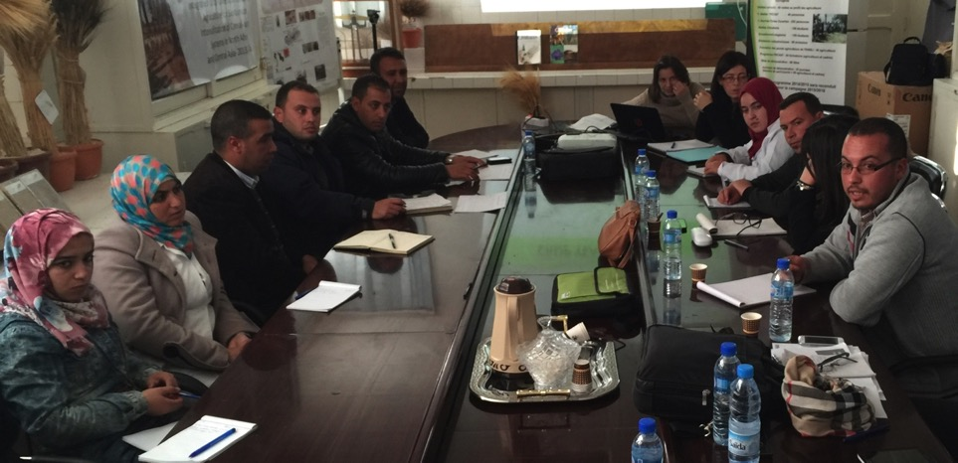
FIGURE 22: Members of the Algerian CLCA Project team and supporting extension officers at the Setif Research Station, Algeria. Photo J. Cummins
Tunisia
Whilst attendance at field days and training related activities were dominated by males, there are some occasions when women are involved in attending field day activities. The role of women in undertaking agricultural related work roles is recognised. Whilst many of these activities are labour-related, the women do play a significant role in feeding and managing the livestock enterprises, be it poultry, sheep goats or cows. Key findings from the ex-ante survey indicate that:
- Tunisian women participate in all agricultural activities associated with the farming operation.
- More than 70% of survey respondents indicated that the contribution of women in agricultural activities is equal or more than 50%.
- The relationship of women and men in the farming operations follows one of a ‘collaborative model’, whereby:
  - activities in general are not clearly defined and divided between males and females
  - household tasks however are mainly undertaken by women
  - there tends to be a male dominance over farm related decision making.

8. IDENTIFYING OPPORTUNITIES FOR A PHASE II PROJECT

8.1 Development of Low-cost ZT Seed drills
There was an overwhelming response from farmers in relation to their need to be able to access low cost ZT seed drills if they were to be able to adopt ZT seeding systems. The benefits of the ZT seeding systems have been clearly demonstrated to farmers involved in the on-farm demonstrations or who had attended farmer field days, affordability of such equipment was considered to be potentially a major barrier to adoption. Whilst the use of the imported John Shearer seed drills had provided outstanding results, few if any of the targeted farmers were in a position to purchase such drills.

Whilst some other project have encouraged the local development and manufacturing of suitable seed drills (such as through the ACIAR funded CANA project that has now been completed), there is the need to follow through earlier initiatives, and to provide technical support and encouragement to local manufacturers. Several prototypes have been developed in Tunisia, Algeria, and Tajikistan’s nearby neighbor Uzbekistan. Critical to the success of the widespread adoption of ZT seeding systems in the ICARDA CA project conducted in Syria and northern Iraq were the development of locally manufactured seed drills; a similar approach is warranted in the CWANA region. There are a range of other approaches to enhancing farmer access to affordable machinery that needs to be explored, including local community group ownership and the encouragement of local contractors to provide ZT sowing services to smaller farmers.

8.2 Achieving Significant Reductions in Irrigated Crop Water Use
Initial evidence from the field demonstration activities and initial farmer experience associated with the trialing of the ZT seeding systems in Algeria have indicated reduced water volumes applied to cereal crops; between 30 and 40% when compared with conventionally sown crops.
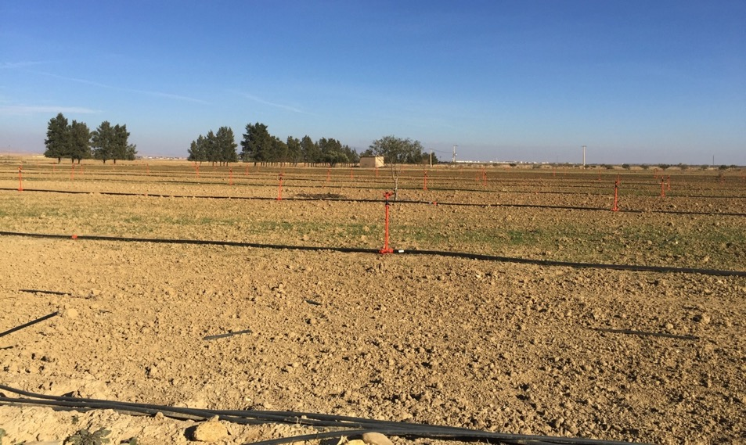
FIGURE 23: Improved irrigation practices achieved through the introduction of sprinklers and ZT seeding systems present enormous opportunities for the M’Sila district in Algeria. Further investigative work is required to quantify the efficiency gains possible. Photo J. Cummins

Farmer observations indicate that the time taken (under flood irrigation) for water to travel the distance of the irrigation bays is reduced by as much as 50% for the first initial irrigation (reflecting a net decrease in total volume of water pumped onto the crop) under ZT than when compared to conventionally sown (and cultivated crops). Further to this, under the ZT system, the frequency of irrigation can often be reduced by 20 to 30% across the growing season. If such reductions in water applications can be achieved consistently under flood irrigation, this would have significant benefits in terms of a major reduction on the draw-down of scarce aquifer resources (on systems that are being significantly exploited), in addition to reduced input costs for farmers (reduced electricity costs for pumping, less labour input associated with irrigating crops).

On-farm research focusing on irrigation and water management is required as a matter of high priority, in order to adapt the key principles of developing a sustainable and profitable CLCA system.

Such practically focused on-farm research provides the opportunity for achieving significant and immediate impact at the farm level. It is critical to develop a better understanding of how and why crops are able to maintain yields under the ZT seeding system with significant reductions in applied water:
- Impact of physical soil characteristics and water distribution and movement down the soil profile, including the root growth zone.
- Identify physical characteristics that contribute to water savings (benefit of additional plant material (mulch) being returned to the soil under CA, hard pans created by cultivation that reduce water penetration, percolation rates of water into different soil types).
- Quantify what water savings can be achieved under improved irrigation practices (leveled flood irrigation bays, sprinkler irrigation), and ZT seeding systems.
- Monitoring of water movement down the soil profile (and water quality) through using a range of simple monitoring tools such as the G-dot and Full Stop tools (to provide an objective means for farmers to determine when the crops require irrigation).

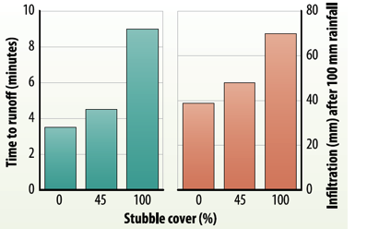
FIGURE 24: Specific water savings under irrigated production systems associated with ZT requires quantification. The diagram illustrates the benefits of retaining stubble on improvements in water. Farmer experience in Algeria requires some basic validation through on farm comparisons. Source: http://www.soilquality.org.au/factsheets/benefits-of-retaining-stubble-in-qld

8.3 Technical Capacity and Capability
There is some variability in the level of technical capacity and capability of participating countries, and is a reflection on both past experience and familiarity with the CLCA related technologies. Tajikistan would benefit greatly from a more focused level of capacity building training, due to the relatively recent introduction of CLCA systems to this country. It is evident that both Algeria and Tunisia have a sound base of technical capability, however CLCA systems appear to be further advanced in Tunisia as a result of such work having been instigated a number of years earlier than that of Algeria. All three countries expressed the need to be provided with further training, and a number of these needs were identified through this project review.

8.4 Addressing Crop Water Use Efficiency and Crop Yield Potential (Rain-fed Crops)
The indicator Crop Water Use Efficiency (WUE) is commonly used by Australia farmers to identify how efficient they are as producers of crops. WUE is best described as a measure of the forage (biomass) or grain yield produced for each millimetre of water used (i.e. transpired) by a pasture or crop.

Interest in the crop WUE model in Australia was generated through the work of South Australian researchers Reg French and Jeff Schultz during the 1980’s on water use efficiency for grain production by wheat. French and Schultz estimated growing season water use as equal to in-crop rainfall (sowing to harvest), plus any soil moisture at sowing, minus any unused water at harvest. Crop water use therefore was calculated by the rainfall received from shortly before sowing to harvest.

This growing season water was used by crop transpiration or evaporation losses from the soil surface. French and Schultz estimated that 110 mm of water was lost by evaporation from the soil surface, and that grain yield was potentially 20 kg/ha/mm of water transpired (that is, growing season water use – 110 mm for evaporation allowances). Similar estimates have been made for pasture production, where it has been estimated that annual pastures should yield 30 kg/ha/mm of dry matter after deducting 30 mm of water use.

Poor WUE can indicate management problems or constraints imposed by soil, nutrition, pests or disease. WUE can be improved by identifying and correcting limitations to crop growth, such as nutrient deficiencies, diseases and weeds, soil constraints and poor agronomy such as variety choice and delayed sowing. The water use efficiency concept is easiest to use in a Mediterranean climate. This is because the summers are dry, and April–October rainfall alone is a good estimate of water supply to crops in the southern hemisphere. In the case of North Africa, the Growing Season Rainfall (GSR) would most likely to be the period September to March.

The Crop Yield Potential is simply a measurement of the percentage of yield potential achieved. As an example, for a farmer is growing wheat, the GSR is 310 mm, then Crop Yield potential is calculated as:
310 (GSR) – 110 (evaporation losses) X 20 kg/mm rainfall = 4,000 kg/ha = 4.0 t/ha.
If the farmer achieves 2.0 t/ha, then he is achieving 50% of yield potential.
Yield Potential % = (yield obtained/ yield potential X 100).

This model offers tremendous opportunity to determine what the potential gains can be through farmers maximising crop yield potential across a regions and countries. These principles have been applied to a Mapping tool developed by the CSIRO, and is available on the website www.yieldgapaustralia.com.au There are four maps that illustrate for a given region:
- The potential Yield
- The potential yield achieved
- The actual wheat yield achieved, and
- The yield gap (difference between actual and potentially achieving full crop yield potential)

An example (Figures 25 (a-d) for southern Australia covering these four key elements is provided.
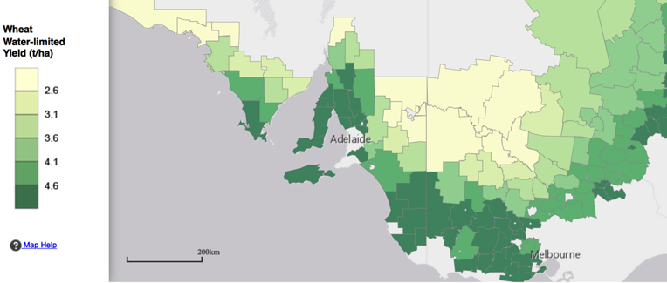

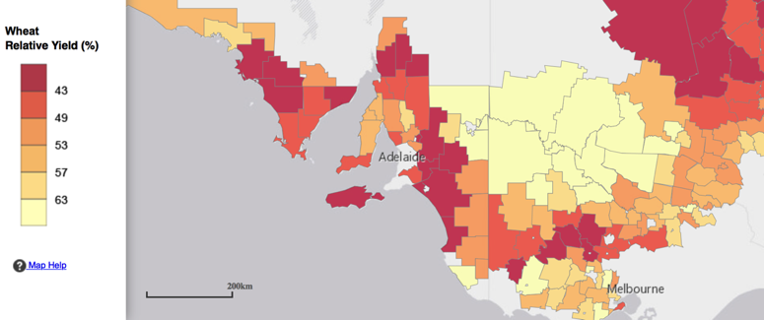

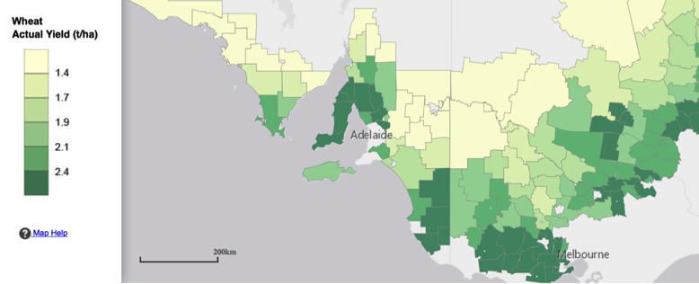

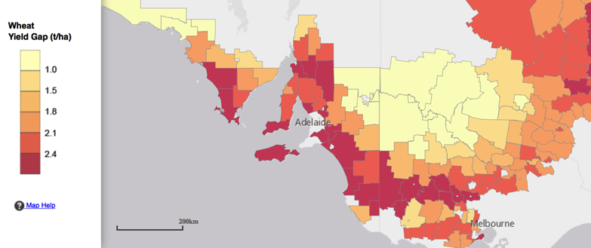

FIGURE 25 (a, b c d): Adaptation of the Crop WUE and Yield Potential models to identify ‘yield gaps’ and potential to increase overall productivity (and in turn regional food security). This specific example is taken from the Mediterranean climatic region of southern Australia.

8.5 Development of Integrated Crop Protection Systems
The development of CLCA systems increasingly rely on the use of pesticides and herbicides to effectively control a range of crop pest and weed populations across the various crop rotation phases. In order to reduce the on-set of herbicide resistance for example, it is important that an integrated approach to weed management is developed and adopted in the CLCA system.

Therefore it is important that adaptive research takes place both at the farmer field level, and on research stations, where weed control techniques can be developed that are appropriate to local agro-ecological conditions. Further to this, the skills and capabilities of both the research and extension staff, and farmers themselves needs to be enhanced, so that weeds are effectively controlled and managed optimally, from both economic and agronomic perspectives.

It is evident that project staff and farmers who were consulted as part of the project review would benefit from training in a range of crop protection disciplines, such as integrated weed, insect and disease management.

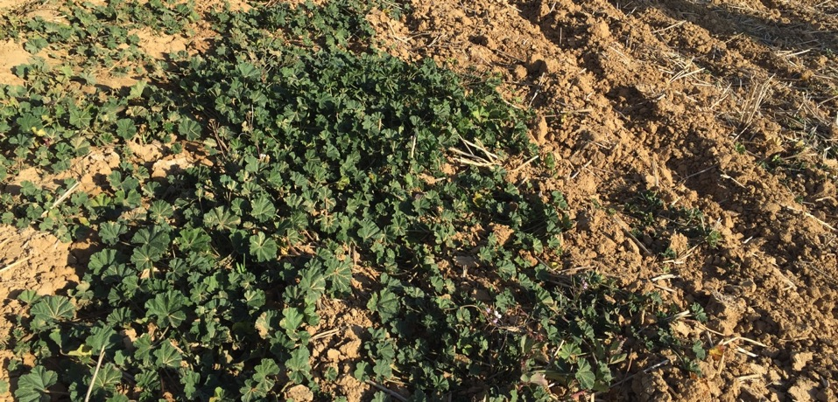
FIGURE 26: This Mallow weed infested cereal crop demonstrate the need to adopt an integrated approach to weed management. Importantly such weeds can be controlled through using a number of alternative herbicide product mixes (currently not practiced across north Africa), and applying herbicides to non-stressed weeds (in this instance an irrigation prior to crop sowing and herbicide treatment would freshen up the weeds and improve herbicide efficacy). Photo: J. Cummins.

8.6 Improved Skills in Conducting On-farm Trials and Demos (Adaptive Research Outputs)
Whilst it is evident that the organisations engaged in conducting on-farm demonstrations had an extremely strong commitment and enthusiasm, there is the need to provide some training in relation to on-farm demonstration methodologies and protocols.

By involving farmers in conducting on-farm demonstrations and trials, there are a number of significant benefits. Farmers make decisions by sourcing available information from a range of sources. Farmers need to test out any new farming practice, technology or crop variety on their own farms before adopting them. Farmers need to feel confident that the new technology or practice will work, provide a specific advantage (or benefit), and will not expose them to unnecessary risk.

It is important to adopt a ‘keep it simple’ approach when conducting on-farm demonstrations, some additional efforts can be made which can add a higher level of validity and quantification in relation to comparing different practices and treatments. These include side-by-side comparisons between treatments, the inclusion of replications (for a small number of treatments), site selection protocols (specifically what variables should be monitored and compared), analysis and interpretation of results.

The level of sophistication of the demonstration trial methodology (including the specific trial/demonstration layout including treatments) will influence the degree of confidence in the validation of the findings obtained from the field. Specific guidelines are available which provide an overview of these principles (refer to the “Test as you Grow Manual”):
http://www.gga.org.au/files/files/1041_Test_as_you_grow_manual.pdf

NARS Field staff would benefit considerably from a training program focused on the establishment and management of on-farm trials and demonstrations, with the view of addressing research protocols, field layout and design and managing farmer participation and support.

8.7 Supporting Change at the Farmer Level
It is important to recognise the process that farmers undertake in making the decision to trial a new technology, innovation or farming practice. It is important that the decision-making processes that farmers undergo is clearly understood, and is supported by NARS.

The decisions that farmers make in relation to the adoption of a new technology or farming practice involves a number of key steps;

- Initial process of awareness,
- Consideration and willingness to trial the technology
- Evaluation of the appropriateness and suitability of the technology
- Adaptation and refinement (this may involve multiple repeats of this process)
- Assessment of the benefits, the relative risk of the technology
- Decision to adopt, dis-adopt, or continue to appraise the technology

Depending upon the relative complexity of the technology, it may take several years of ‘trial and error’ experiences for farmers to fully assess and reach a decision as to whether or not they will adopt the specific technology. Certainly in the case of a CLCA system, it is a relatively complex system and involves a wide range of intervening factors. Hence it is important that farmers are well supported during this complex process. Farmers ‘learning together’ in groups supported by R, D & E professionals will assist in this process.

8.8 Formation of Farmer CLCA Discussion Groups
The importance of local farmer discussion groups is critical to the successful adoption of new technologies and innovations. It is important to support the formation and development of such groups, and it is evident that there is already some excellent progress in the formation of such groups in Algeria and Tunisia.

It is important that such groups are well supported, particularly during their formative stages. It is crucial to understand their local needs, specific levels of capability, and explore different models of support necessary to increase their own skills and capabilities, not only technical, but also monitoring and evaluation, project development and management, as well as other overall agricultural management aspects relating to conducting on farm research and farmer participatory activities.

It is important to consider how farmers make decisions, and identify the tactical decision making processes that they perform. Through working with farmers, having an understanding of their behaviour, and factors influencing their decision making and overall behaviour we can develop appropriate systems to support adoption and change at the farmer level.

There are tremendous capacity building opportunities for younger emerging NARS professional staff to work with local farmer groups and associations, in order to understand and develop their own professional and technical skills. Working on-farm alongside farmers provides the opportunity for such staff to gain knowledge and practical skills from farmers, relating to production and management issues, adaptation and adoption of CLCA related farming systems technologies.

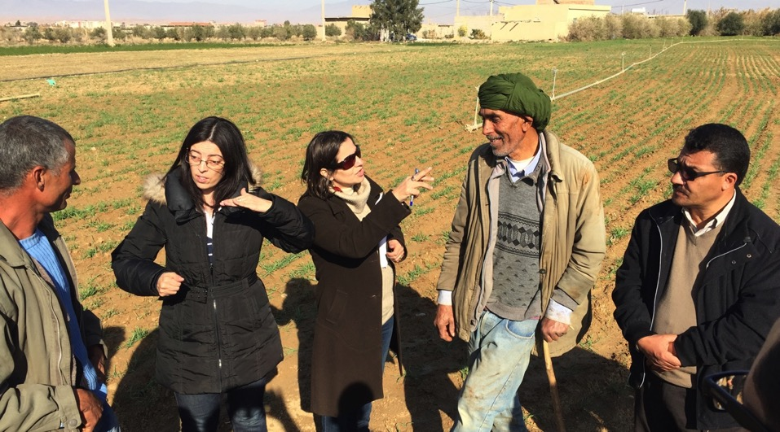
FIGURE 27: Members of the Algerian CLCA team achieved good interaction with local farmers from the Ain El Khadra community near M’Sila in relation to the introduction of CLCA systems into their local farming district, highlighting the importance and benefits of adopting a farmer participatory development and extension approach. Photo: J. Cummins

8.9 Development of Crop Monitoring Systems
The introduction of crop monitoring systems to farmers, as a participatory driven activity provides enormous potential to assist farmers in adopting an integrated CLCA system.

Making the best management decisions throughout the crop growing season will largely draw on a farmers experience and intuition that contributes to the ‘art’ of farming. Good decisions, however they are made, can only come from having good information.

Through accurate assessment of crop growth and productivity, farmers can evaluate changes that are made in their cropping management and to their CLCA system in order to determine the suitability of new technology and to modify existing farming practices. Any experimentation with a change in practice no matter how small, or the adoption of new methodology or introduction of a new CLCA system, must include proper assessment to be able to adequately determine whether the change has been for the better and by how much.

Crop performance can also be measured against established and recognised benchmarks for crop growth and productivity. This allows growers to compare their crop’s performance with others in their own and other districts, which will indicate opportunities and potential for improvement. Benchmarks provide guidance and highlight the critical success factors in maximizing economic yield.

By identifying limitations to crop growth, action can then be taken to address these critical factors before significant losses occur, thereby increasing crop production and profitability. Accurate assessment and monitoring of the crop to assess the ongoing performance of the crop allows farmers to be pro-active, rather than reactive, to factors affecting crop performance.

An important part of developing crop monitoring activities for farmers are the group based activities. Farmers learning together with NARS field staff are key benefits associated with the participatory driven approaches.

Group discussion sessions can be held on an informal basis as part of the program. They can be held at any time of the year, and may involve the following examples:

- Pre-cropping discussions (such as cropping intentions, fertiliser programs, soil fertility, grazing management of stubble residues, erosion potential).
- Review activities undertaken throughout the year (addressing issues like weed control and management, effectiveness of seeding operations, pests and diseases
- Following harvest — discussion and interpretation of yield results, crop WUE, review of the success of the CLCA technologies and practices.

8.10 Development of High-performing Intensive Livestock Production Enterprises
Phase 1 of the project has identified the opportunity to increase feed availability of livestock, primarily through sown fodder (such as oats and vetch). This presents significant opportunities to increase the carrying capacity of livestock. Rather than animals wasting energy through the open grazing of pastures (under a labour intensive shepherding system), the further development and promotion of small scale farm feedlots needs to be examined.

Under this system, livestock are predominantly fed conserved fodder (such as the high quality oats-vetch mix), whilst periodic grazing occurs at strategic periods (such as strip grazing of sown oat-vetch pastures during the early to mid-growth stages of fodder crops, and for short intensive periods in stubbles following the cereal harvest).

8.11 Adopting a Market Chain Approach to Decision making
Responding to market opportunities, and specifically targeting periods of the year where there are price premiums in the market place is critical to maximizing profitability. Famer experience in Tunisia for example has found that prices received for lambs during the Eid period can be up to 100% higher than for other periods of the year, hence the need to maximize such market opportunities and gear the livestock production systems accordingly.

There is the opportunity to undertake some adaptive research activities that can develop a production breeding and feeding model that can maximize the financial returns from the market price premium periods, utilizing sown forage from the improved CLCA system (which through farmer experience has demonstrated superior growth rates of young lambs).

8.12 Improving Farmer Decision-making for Livestock Grazing and Management
There are opportunities to utilize a range of decision making programs associated with calculating livestock feed requirements (across a calendar year), as well as tools for estimating feed on offer, and estimate the carrying capacity of specific pastures and stubbles based upon an assessment of biomass and the specific livestock requirements.

Meat and Livestock Australia, for example have developed a Feed Demand Calculator, which allows farmers to balance the available feed on offer through the growing season (including pastures, crop grazing opportunities, conserved fodder and hay) with the specific nutritional requirements associated with their specific flock structure. The calculator is available from the following link: http://www.mla.com.au/Extension-training-and-tools/Tools-calculators/Feed-demand-calculator

A stocking rate calculator is also available from their web site, which is a useful tool in terms of determining how many livestock can be placed within a certain field area:
http://www.mla.com.au/Extension-and-training/Tools-and-calculators/Stocking-rate-calculator

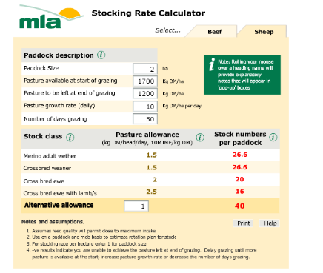
FIGURE 28: An integrated approach to livestock ‘best practice management’ is required as part of maximizing the productivity and economic efficiencies from the integrated CLCA system, hence it is important to develop and address appropriate animal health and management needs of livestock.

8.13 Monitoring the Long-term Impact and Benefits of CLCA
There is the need to establish long-term demonstration trials that identify long-term benefits and potential threats associated with CLCA systems. International experience has identified that the full benefits of a CLCA system are not immediately apparent, since for example physical soil improvements may take 5 to 10 years or even longer.

Monitoring the long-term benefits associated with the new production systems will assist in quantifying the net benefits associated with a range of factors such as:
- Soil improvements under a ZT CA system (physical characteristics, soil fertility).
- Assimilated grazing management of stubbles (retaining different quantities of plant and stubble residues).
- The long-term profitability of the different production systems, for both crop and livestock production enterprises.

There is the need to identify particular risks to the production system and to be ‘one step ahead’ of potential threats that may impact on the long-term sustainability of the CLCA system, such as:
- Impact on weed seed bank dynamics, potential threat of herbicide resistance.
- Likely incidence of crop diseases (leaf and root) through monitoring of soil pathogens and physical incidence of damage to crops.
- Identification of optimal crop rotation practices (in terms of agronomic management and profitability), including the need to manage production risk and shift from a monoculture based cropping system that has a complete reliance on cereal production.

Long-term demonstration trials require a relatively high degree of management and monitoring, and are best suited to being undertaken controlled conditions, such as research stations. Demonstration trials on-farm are also possible, however require a higher level of farmer commitment in the long-term.

8.14 Building Human Capacity and Capability
It is important that the capacity of project participants is improved through the course of the project. There are two main audiences concerned, these being those professionals involved directly in project delivery activities, and farmers themselves. The need to properly assess current skill levels, identify those skills and capabilities required to perform specific project delivery activities (amongst project staff) or to lead on-farm experimentation and adoption of appropriate technologies (amongst farmer audiences) is critically important. Training and capacity building activities can then be formulated on a needs basis, linked to the specific outputs and project delivery requirements.

In order to achieve impact in a future Phase II program, it is likely that there will be an increased emphasis on delivering participatory extension based activities, with famers taking the central role in on-farm activities. Skills to support professionals engaged in facilitating this process will be crucial to project success.

8.15 Quantifying the Impact of Project Outcomes
It is important to quantify the impact and benefits associated with the introduction of new technologies and innovations associated with the project outputs. Given the opportunity to significantly influence farmer practice over substantial areas of agricultural lands, appropriate monitoring and evaluation frameworks need to be established, that are capable of measuring the net contributions to increased agricultural production and profitability, at a farm, district, regional and national level. Identifying these key performance indicators, and monitoring these over an extended period of time will help to ensure that impacts are properly quantified.

8.16 The Importance of Measuring Change in Knowledge, Attitudes, Skills, Aspirations and Practice Change (KASAP)

The ex-ante evaluation of the CA based technologies has been an extremely useful research tool in terms of its ability to help identify baseline adoption characteristics associated with CLCA practices (including farmer perceptions of the benefits and barriers to adoption).

There is the need to look more deeply at how specifically the development and extension outreach of future elements of a CLCA program can be best designed, and importantly the impact assessed in terms of actual practice change. A useful approach worth considering in future M&E exercises is Bennett’s Hierarchy (that focuses on measuring changes in Knowledge Attitudes, Skills, Aspirations and Practice change). It is essential that the impact of the capacity building activities are identified and documented as part of an appropriate M&E framework. Adopting the KASAP approach, through identifying changes in Knowledge, Attitudes, Skills and Aspirations and Practice change it will be possible to quantify changes that take place as a result of the project activities.
Determining the change in farmer KASAP relating to CLCA over time is an important tool to assess the success of the project. Through survey questionnaires the elements of KASAP can be measured, whether the surveys are longitudinal in nature, or if such elements are measured before and after specific capacity building activities. Examples of specific activities may relate to formal training programs, or a composition of activities undertaken over a growing season (for example farmer participation in a series of field demonstrations and related activities over a growing season).

FIGURE 29: Overview of the Bennett’s Hierarchy, as it applies to KASAP

There are some simple attitudinal questionnaires that can provide a useful indication of the attitudes and aspirations of a particular audience of farmers. Using a Likert scale, survey respondents indicate their level of agreement to a range of specific statements (i.e. strongly disagree, disagree, neither agree nor disagree, agree or strongly agree). Statements can be presented in either a positive or negative manner. Examples include the following:

- It is not possible to sow a crop on my farm without first cultivating the soil.
- Retaining cereal stubbles is good for the soil
- Weeds in crops provide good feed for livestock after harvest.
- Conservation Agriculture systems are not profitable on my farm

Useful references include the following:
http://www.robertsevaluation.com.au/images/pdfs/bennett_how_to_use.pdf
http://www.agrisk.umn.edu/conference/uploads/ghachfeld0356_05.pdf

8.17 Further Analysis of the Socio-economic Research (Ex-ante survey)
The depth and validity of the survey data arising from the ex-ante survey work can’t be under-estimated. It is important to continue to utilize this data set, given the significant number of farm households that have been surveyed across the three countries.

It is important to obtain follow up data in order to assess the impact and change in farmer behavior and farm business economic performance, and this can be done as part of a longitudinal survey exercise towards the concluding moments of the second project phase. This will allow a full assessment of the impact of the project, over a longer period of time where it can be expected that there would have been a far greater period of time for change to be implemented on-farm, and the full benefits of the CLCA system would have become apparent. Additional information and further interpretation needs to be supplemented with focus discussion groups amongst farmers in the targeted project areas across the three countries.

The establishment of both key economic (business management and production economics) and technical (agronomic, grazing and livestock) lead indicators is an important cornerstone in developing benchmarks that can be used to demonstrate and assist in the widespread popularization of CLCA practices across the targeted areas. This needs to be conducted in conjunction with the respective project teams across the three countries. It is important that many of these indicators are derived from either an existing pool of knowledge and experience (for example basic agronomic best practice for crop production, utilizing specific grazing and carrying capacity tools for livestock, established benchmarks for recommended plant residue cover to prevent soil and wind erosion).

It is important to undertake a detailed assessment of the trade-offs between changes in the core enterprise elements of the system (crop versus livestock versus fully integrated production systems), in addition to the implications of systems changes on farm business cash flow and enterprise profitability. In particular, the use of Gross Margin Analysis is an excellent tool in terms of comparing the relative profitability and likely cash returns to farmers. Comparisons can be made between different crop rotations and enterprise mixes (adjusting the amount of area of farms under crop, forage production, supplementing weedy fallow for sown forage crops (and increased livestock numbers) will provide clear economic results for farmers, who are quite advanced in their thinking in relation to the need to maximize farm business profitability across the CWANA region.

The management of risk on-farm by farmers similarly needs to be analysed through utilizing farm group focus discussions, and a range of risk management frameworks developed with farmers to address the economic, production, marketing and climatic risks, and how farmers can best manage this in a ‘whole of production systems’ context. It is the management of risk that drives the farm business, and farmer willingness to adopt new technologies, innovations and business models.

8.18 Market Responsive Supply Chains for Agricultural Inputs
There is the need to assist in facilitating the development of market responsive supply chains for agricultural inputs needed for the implementation of CLCA system systems at the farm, regional and national levels. Given the opportunity to significantly expand the area under a CLCA system, there will be significantly higher demands for seeds (particularly for forage production), fertilisers, herbicides and ZT seed drills. The development of locally manufactured seed drills needs to be encouraged and supported in the respective countries.

It is important that the agronomic and livestock management systems are fine-tuned, and best practice recommendations identify specifically the choice of options for fertiliser products, herbicides as well as animal health products that are needed to maximize production and profitability. This will require the examination and analysis of agri-input supply chains, and at the government level the need to encourage competition amongst the input supply sector needs to be facilitated. It is important to involve and engage with the agribusiness sector, and to identify and overcome their specific constraints in relation to making them aware of the emerging changes in the adoption of CLCA systems, and future farmer requirements in relation to inputs.

Locally produced forage seed production needs to be encouraged, and presents a potentially profitable enterprise for entrepreneurial farmers and/or farmer groups to pursue. Currently the sourcing of vetch seed for Tunisian farmers is from outside of the country (largely from Europe). Given the enormous potential economic benefits associated with sown forage crops and pastures (in place of weedy fallows) for farmers, it appears on the outset that there will be significant farmer demand for seed, and opportunity to establish a profitable local production and supply chains across all three participating countries.

Access to competitively prices inputs is critical to maximizing the full economic benefits of the CLCA system. It appears at this stage this is currently highly inefficient, with the full economic benefits through increased management efficiencies not being realised due to a poor market supply chains existing for agri-inputs. This can be easily assessed in relation to the relative prices paid for some common inputs such as glyphosate (sued in the control of weeds prior to sowing the ZT crops).
In relation to fertiliser practices, it is important that the CLCA system identifies specifically the specific crop nutritional requirements and addresses a range of crop management and production decisions. These include:
- How much phosphorus and nitrogen based on the crop requirements?
- How much of these elements will be removed in grain and straw?
- What impact will the incorporation of plant residues (stubble) have on N availability to the crop, and how much additional N needs to be applied to overcome this?
- What is the optimum P and N mix for the crop?
- What combination of product should be applied at sowing
- How much N should be applied post-seeding?

Many of these issues are technically related, hence the need to undertake and determine sound agronomic practices that importantly provide economic and profitable increases for farmers. The development of ‘independently verified’ recommendations likewise is crucial to ensuring that farmers are able to manage both financial and production risks. In developing efficient supply chains for crop inputs (that are economically responsive), it is therefore important to work with the suppliers of such products, and develop market responsive supply chains for agricultural inputs.

APPENDICES

APPENDIX I: Program for Review Mission Undertaken by Dr Jay Cummins
Location | Representative | Position | Organisation
4th – 5th December Travel from Australia to Amman, Jordan
6th December
Amman, Jordan | Hichem Ben Salem | Project Coordinator CLCA  (Animal Nutrition Specialist) | ICARDA
Amman, Jordan | Andrew Noble | DDG- Research | ICARDA
Amman, Jordan | Aymen Frija | CLCA Project Team, Economist | ICARDA
Amman, Jordan | Boubaker Dhehibi | CLCA Project Team, Economit | ICARDA
Amman, Jordan | Mourad Rekik | CLCA Project Team, Animal Production Specialist | ICARDA
Amman, Jordan | Harun Cicek | Former CLCA Project Team member, Agronomy-CA Specialist | Formally ICARDA
Amman, Jordan | Serkan Ates | CLCA Project Team member,  Forage production Specialist | ICARDA
 | Mounir Louhaichi | CLCA project Team member,  Rangeland Specialist | ICARDA
7th December
Amman, Jordan | Enrico Bonaiuti | CRP Dryland Systems-Research Management Unit Coordinator | ICARDA
Amman, Jordan | Charles Kleinermann | Head of Capacity Development Unit | ICARDA
Amman, Jordan | Rajitta (on behalf of Andrea Gros) | Head of Communications & Information Services Unit | ICARDA
Amman, Jordan | Hichem Ben Salem | Project Coordinator CLCA | ICARDA
8th December 2015 Travel from Amman to Tajikistan
9th December 2015
Dushanbe, Tajikistan | Academician Sattory | President | Tajik Academy of Agricultural Science (TAAS)
 | Dr. Aziz Nurbekov | Agronomist | ICARDA-CAC
 | Prof. Saidjamol Saidov | Deputy President | TAAS
 | Dr. Kamoliddin Kurbonov | Head Department of International Relations | TAAS
 | Prof. Nurali Asoev | Director | Tajik Research Institute of Farming TAAS
Gissar District, Tajikistan | Deputy Governor | Deputy Governor | Gissar District
Gissar District, Tajikistan | Various farmers | Farmers associated with project demonstration sites | Gissar District farmers
10th December 2015
Dangara, Tajikistan | Various farmers Dangara District | Discussions with farmers, attend field day and workshop
11th December 2015
Dushanbe, Tajikistan | Sadi Karimov | General Manager, IFAD project | IFAD Project Office, Ministry of Agriculture
Dushanbe, Tajikistan | Dr. Sherali Safarov | Head of Crop Production | Ministry of Agriculture
Dushanbe, Tajikistan | Dr. Fazliddin Ikramov | Head of Livestock Production | Ministry of Agriculture
Dushanbe, Tajikistan | Prof Tolibek Bukhoriev | MP Agrarian Party, Leader Agrarian Block | Tajikistan Parliament
Dushanbe, Tajikistan | Prof. Jalil Pirzoda | Head of Environmental and Agricultural Department, President’s Office | Tajikistan Presidential Office
12th December 2015 Travel from Tajikistan to Algiers.
13th December
Algiers, Algeria | Dr Omar Zaghouane | Director General of ITGC | ITGC, Algeria
Setif, Algeria | ITGC Project Team | Setif Research Station | ITGC, Setif
14th December
Setif, Algeria | Agricultural Services Team representatives | Setif Research Station | Setif
M’Sila Communities, Algeria | M’Sila /communities of Ouled Mansour Farmer cooperators | Belbey Aissa, Arouia Bachir, Kerfa Rabeh, Benyettou Lamri, Benyettou Abelkader, Dif Ammar, Dif Abdellah, Ghyat Mohamed | M’Sila /communities of Ouled Mansour
15th December 2015
M’Sila Communities, Algeria | M’Sila Communities of Ain El Khadra | Farmer cooperators  Mebarki Ammar, Drissi Abdelhak, Zahem Abdelmajid, Bouguerra Ali, Ramli Hafid, Hajaj Mohamed, Adjlane Abdelha | M’Sila Communities of Ain El Khadra
Setif, Algeria | Research Station | Inspect Research field Trials | Setif
Discussions during the field tour with the following participants
 | Djellakh Faiza | CLCA project Coordinator | ITGC
 | Project Team members | Ghalem Zahra, Benlakhal Zohra, Sersoub Djamel, Louadi Nasser eddine, Bendada Hocine, Belguet Harun | Algerian team project of CLCA in ITGC
 | Benmakhlouf Hamza | Project Officer | Livestock Research Institute
 | Zehaf Ammar | Project Officer | General Management of Forests
 | Khechna Abderrazek | Director, Project Management Unit | General Management of Forests
 | Taibi Abdelouahab | Project Officer, High Commission to the development of the steppe | Haut commissariat au développement de la steppe in M’Sila
 | Zaghlach Ahmed | Representative | The Direction of the Agricultural Services of M’Sila
 | Chaaraoui Abdelkrim | Representative | Direction of Agricultural Services of M’Sila
16th December Travel from Algeria to Tunisia
17th December, Tunis
Tunis, Tunisia | Dr Ali Rhouma | Research Director at IRESA, representative of IRESA President | IRESA
Tunis, Tunisia | Prof. Mohamed Ben Hammouda | Director General | INRAT
Tunis, Tunisia | Mr Houcine Angar | Director General representative | INGC
Tunis, Tunisia | Mr Hichem Lakdhar | Siliana CRCA Director General rep. | CRCA
Tunis, Tunisia | Miss Lamia Ben Salem | OEP Director General rep. | OEP
Tunis, Tunisia | Prof. Narjess Lassoued | Director of the forage and livestock laboratory at INRAT | INRAT
Tunis, Tunisia | Prof. Mohamed Chakroun | CLCA project coordinator | INRAT
Tunis, Tunisia | Ayoub Fouzai | Socio-economic Scientist | INRAT
Bourbia, Tunisia  (INRAT Research Station) | Presentations from CLCA project team, and inspection of trial sites | Hechmi Ferchichi, Mohamed Chakroun, Salah Ben Youssef, Sourour Labidi, Mohamed Annabi, Hatem Cheik Mhamed, Noura Omri Ben Youssef,  Nizar Moujahed, Cyrine Darraj; Hajer Guesmi Ayoub Fouzai
18th December
Field Tour to Silana District | Mr Mohamed Labidi | Director General | CRDA
Field Tour to Silana District | Mr Fathi El Hichri | Director of Crop Production | CRDA
Field Tour to Silana District | Mr Ayman Boussifi | Head of Regional Office | OEP
Field Tour to Silana District | Hichem Lakdhar | Associate Director | PDAI
Field Tour to Silana District | Farmer group members | Taoufik Ben Ameur, Mohamed El Arbi Ben Ameur, Jamel Sahli, Nabil Sahli, Mohamed El Hédi Awaissi, Hmid Ben Mohamed, Mourad Ben Mehrez, Moez Ben Ammar, Abdel Kader El Mekki, Habib Kharrouba | Mutual Agricultural Services Society (Et Taaoun Village)
19th December
Tunis, Tunisia |  | Meeting with CLCA INRAT Project Team
20th December departure from Tunisia

APPENDIX II: Examples of Simple Tools that can be Integrated into CLCA packages for farmers

Feed Budgeting

Feed budgeting involves assessing the pastures and livestock. A feed budget can be completed on a whole farm basis or individual field basis.

A feed budget can be used to plan grazing programs for an entire season or assist with short term grazing management decisions such as rationing out dry feed over summer. The following information is required to be able to complete a feed budget.

It is important to determine the total grazing area, the budget period (for raising the livestock to market requirements) and identify the target markets.

Livestock – What do your stock require?
Livestock pasture intake and nutritional requirements
Monitor livestock condition score and know target score
How many Dry Sheep Equivalents (DSE) you have

Pastures – How much feed do you have?
Average pasture on offer at start of the period (kg/ ha Dry Matter - DM)
Target feed on offer at the end of period
Pasture quality
Pasture growth rate (kg/ha/day)
Pasture wastage
Plant species
Ground cover targets

Determine how much feed is on offer

Pastures – Use a 0.1 m² quadrate.
Cut 10 x 0.1m² quadrants across the field to ground level.
Weigh the material from each quadrant and average the weights.
Weigh a sub sample and dry in an oven to work out dry matter (DM) percentage.

Dry Matter Percent = dry weight / wet weight x 100
e.g. 15 gm / 100 g x 100 = 15% dry matter
Dry matter production kg/ha = average weight in a 0.1 m² x 100

Cereals – Use a 1 m ruler (stick) placed along the row.
Cut 10 x 1 m rows at ground level and weigh each sample.
Average the undried weights.
Weigh a sub sample and dry in an oven to work out dry matter (DM) percentage.

Dry matter production tonnes/ha = average wet weight 1m row x 100 / row spacing (cm) x 10 x dry matter %

Getting Started
A simple method of feed budgeting is the DSE method.

Intake – Allow: - 1kg DM/DSE/day for green feed
- 1.5 kg DM/DSE/day for dry feed that allows for poorer quality and wastage

Dry Sheep Equivalents
One DSE is the amount of energy required to feed a 50kg wether in fat score 2

Example 1 Feed Budget
Calculate stocking density (number of sheep required)
The farmer wants to know how many 60kg lambing ewes he can put on a 4 hectare field. Currently it contains 600kg of DM/ha.
The farmer wants the field to last the 42 days of lambing and maintain 500 kg of DM per ha in order to limit the potential for soil erosion.

 | Field / Date | Example
A | Feed On Offer (kg DM/ha)
B | DM after grazing (kg DM/ha)
C | Crop growth rate (kg/ha/day)
D | Days of grazing
E = (A-B)+(CxD) | Total feed available (kg DM/ha)
F | Stock class & DSE rating
G = 1 kg x F x D | Total Feed intake (kg DM /head)
E÷G | Stocking Density (animals /ha)

Example 2: Feed budget
Calculate available grazing period
The farmer has 12 ewes in late pregnancy and a 3 ha field.
How many days grazing will the farmer get?

 | Field | Example
A | Food on offer - start of grazing (kg DM/ha)
B | DM after grazing (kg DM/ha)
C = A-B | Total Feed available (kg DM/ha)
D | Stock class and DSE rating
E | Stocking density (animals /ha)
F= 1 kg x D x E | Daily feed intake (kg DM/ha/day)
G | Crop growth rate (kg DM /ha/day)

Working out Grazing Days

It is helpful to work out the grazing potential or stocking rate based on how much stubble is available after harvest.

See the table below for an indication of crop yields and the estimate of grazing days, or use the following calculations.

Number of grazing days (DSE/ha) = (stubble level (kg/ha) – critical level (kg/ha)) ÷ (removal rate (2kg/ha/day) x stocking rate (DSE/ha)
Or stocking rate (DSE/ha) = (stubble level (kg/ha) – critical level (kg/ha)) ÷ (removal rate (2kg/ha/day) x no. of days required)
Critical levels: 750kg cereal stubble /ha

DSE = dry sheep equivalent

These levels take no account of the nutritional requirement of the livestock. Hand feed as required.

A range of crop yields and after-harvest stubble yields, with estimates of grazing days to the point of critical ground cover

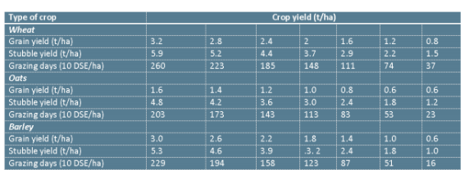

Source: http://www.nspnr.com.au/WP_Media_Grounds_Cover_Article.pdf

DSE Dry Sheep Equivalents

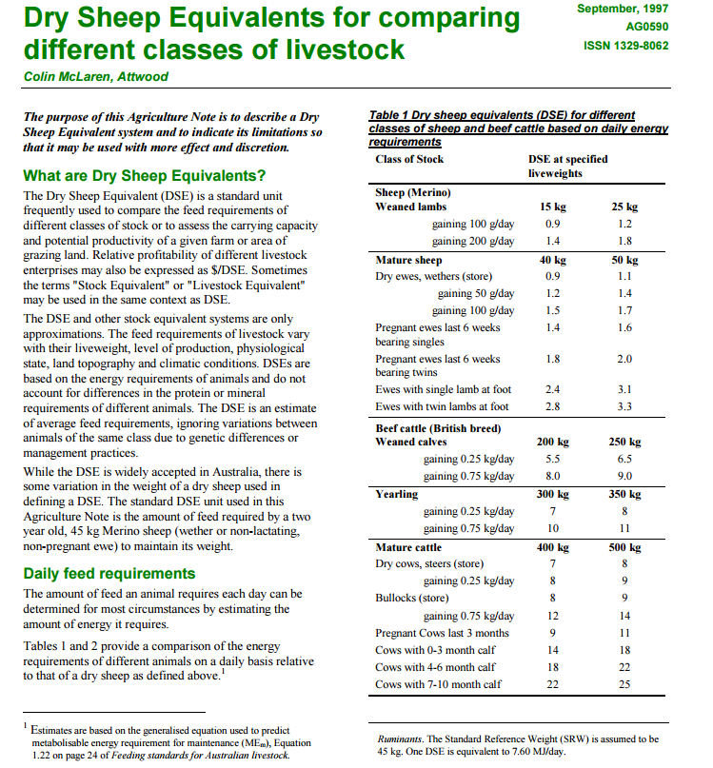
A full version is available from: http://www.agronomy.com.au/download/dseratings.pdf

Photo standards for levels of cereal stubble retained (based on % groundcover) Source: http://msfp.org.au/wp-content/uploads/2013/06/GEE-A5-Stubble-Guide-low_res.pdf
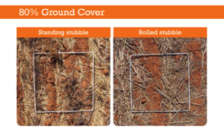
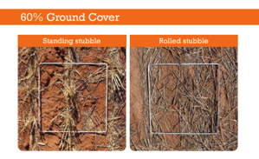
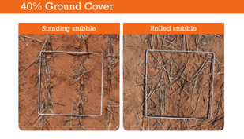
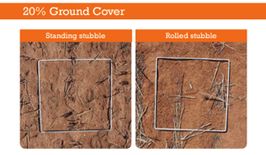
Crop Water Use Efficiency

French and Schultz established a relationship between wheat yield and water use in Mediterranean environments of South Australia; they suggested that the relationship could be of value for developing crop growth models, predicting yields and providing guidelines for cropping strategies. Their work was based on 61 field experiments conducted in South Australia between 1964 and 1975 using predominantly the variety Halberd. They measured rainfall and evaporation, soil water at sowing and harvest, and crop growth and yield. Importantly, they selected sites with minimal risk of runoff or deep drainage allowing them to estimate the water used by the crops from the change in soil water content between sowing and maturity plus the rainfall over the same period.

They also found that for sites that received low to moderate rainfall and had no accumulation of moisture from long fallow, growing season rainfall could be used to approximate water use. They noted that, when defined in this way, ‘water use’ is the sum of the water transpired (i.e. productively used by the crop), and the ‘unproductive’ direct evaporation from the surface of the soil and crop.

The separation of these two components is the core of the French and Schultz approach. Figure (i), from the publication, is a plot of grain yield and water use in the 61 experiments. Conventionally, a regression line would be fitted, but as French and Schultz commented, it would be of poor fit and do nothing to explain the complex effect of weather on growth and yield. Instead, they attempted to explain the results by separating the two components of water use.

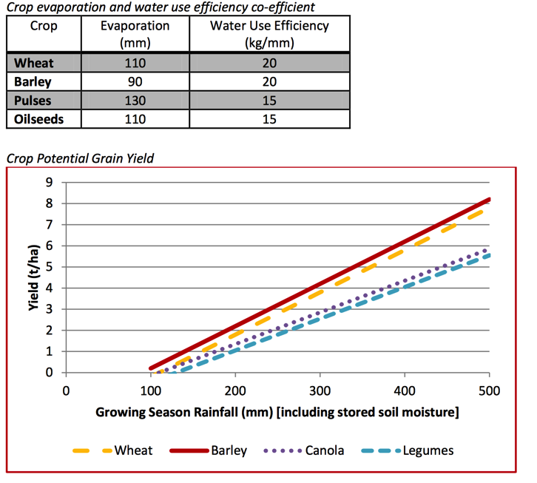
Credit: Birchip Cropping Group
http://www.bcg.org.au/cb_pages/files/Explination%20N%20Budgeting.pdf

Conceptually, the water lost by evaporation can be obtained from the intercept on the water use axis of the linear relationship between yield and water use. For the most efficient crops this line has a slope of 20kg/ha/mm of water use, and intersects the axis at 110mm.

It is from this graph that the widely used French & Schultz benchmark is derived: Attainable yield = (Water use - 110) x 20 French and Schultz showed that their interpretation of their data was in substantial agreement with many other Australian and international studies of water use carried out between 1960 and 1984.

French & Schultz speculated on whether the parameters 110 mm of evaporation and 20 kg/ha/mm applied beyond the South Australian environments used in their studies. They were able to demonstrate that for evaporation, the figure was highly variable, from 30 mm where crops used predominantly stored soil water (for example northern NSW and Queensland), to 170 mm - this figure they attributed to poor infiltration, surface ponding, and surface runoff on poorly structured soils. For attainable yield per unit water use, French & Schultz recognised that as the drying power of the atmosphere rose, this benchmark would be lower - and that this would apply through the growing season at a given site, and also between geographic locations.

The main limitations to the practical application of the French & Schultz approach are how to accommodate the agronomic and climatic influences that influence both parameters, soil evaporation and attainable yield per unit water use. In this chapter, we present approaches that aim at these limitations while conserving the simplicity of the original method.

Source: Water use efficiency of grain crops in Australia: principles, benchmarks and management Victor Sadras and Glenn McDonald, Grains Research and Development Corporation, Australia.
And Birchip Cropping Group www.bcg.org.au

