Technical Report PK-CRP DS/SSRI-07/2015

Assessment of Participatory Varietal Selection of wheat activity Under CRP1.1 Dryland system

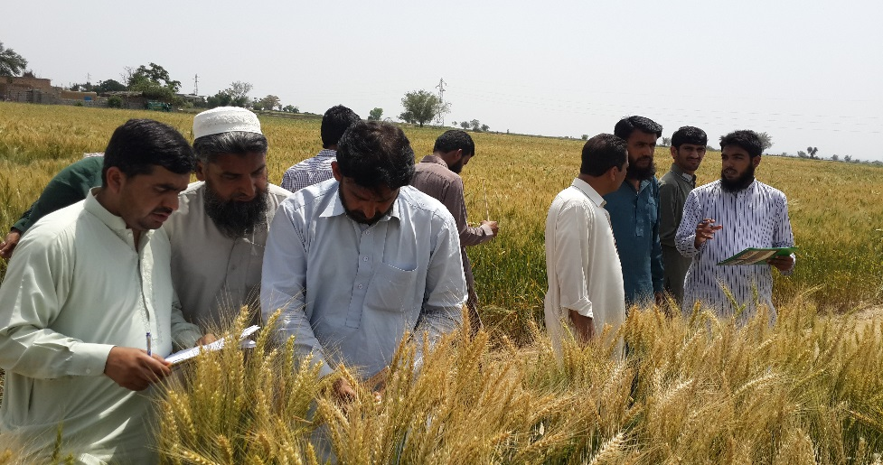

By

Hassnain Shah, Waqas Farooq and Ramzan Anser
Social Science Research Institute - National Agriculture Research Centre
Islamabad - Pakistan

&

Boubaker Dhehibi
Social, Economic and Policy Research Program (SEPRP)
International Center for Agricultural Research in the Dry Areas (ICARDA)
Amman - Jordan

July, 2015

Table of Contents

Table of Contents 2
Summary 4
1. Introduction 5
1.1 Objectives 6
2. Methodology and Process followed 6
3. Results and Discussion 10
3.1 FFD Activity 10
Suggestion and Recommendation 14
Reference 15

Summary
Wheat is the staple crop of Pakistan being consumed and grown all over the Pakistan in all cropping systems. National and international breeding programs are continuously developing the new varieties. There is some success in disseminating modern varieties based on high yield potential through seed companies and extension system with certain level of adoption lag. In the varietal development, seed production and distribution system farmers’ participation is minimal. Farmer participation in breeding programs or varietal selection was negligible in Pakistan. Under, CRP dry land system a demonstration trial at farmer field in order to select the best variety by the farmers was established. The present study is based on Participatory varietal selection carried out at two activity cluster at Chakwal site. Participatory selection process was initiated from the vegetative stage to maturity on field demonstration trials managed by farmers. The social sciences team collected data and documented feedback from the farmer both at initial and maturity stages. At the final stage a Farmer Field Day was arranged for participatory varietal selection (PVS). The purpose of PVS farmer field days was to give awareness to the farmer about the new crop verities and management practices package in addition to evaluate the varieties. Another objective was to involve farmers and ensure their participation from start till the end i.e., harvesting so that the farmer can see, observe and evaluate the varieties. For this purpose a FFD was organized on the same field at vegetative stage and then at maturity stage. Farmers were distributed in groups and then taken to field where crops were shown to them. Farmers evaluated the varieties on the different agronomic parameters that include plant height, disease infestation, no of tillers, stem length, spike length, number of grains, grain size, and expected yield in mounds/acre. Among wheat varieties AAS-2011 was top ranked at resilience cluster as well as at the intensification cluster while Dhurabi was ranked second. Among lentil varieties at resilience locations, Masoor 2002 was ranked first and Markaz 09 second. The consumer preferences by women for wheat flour, preparation of loaves and bread revealed that Dhurabi was the best wheat variety in terms of taste and preferences for preparation of bread.

Introduction
The participatory research approach involves the collaboration of farmers and scientists in agricultural research and development (Bentley, 1994). There is a need for on-farm verification of appropriate varieties adapted to dry ecology of the rainfed areas. In addition, the introduction and adoption of the improved technology to popularize it among the farmers through on-farm demonstrations and verifications may serve as catalyst to increase the productivity as has been proved in many other cases (Tabo et al., 1999 a,b). In this process farmers, researchers and extension workers collaborate and work in a group. Many released varieties are tested on research stations without including farmers in the decision-making process. Therefore, farmers choices for selection and adoption of these varieties may vary. Furthermore, inclusion of farmers in the process may also help to reduce adoption lag of improved varieties. Therefore, participatory varietal selection has proved successful to identify appropriate varieties and increase variety adoption rates particularly in area where choices are limited (Witcombe et al., 1996 & 1999).
PVS activity was included in CRP 1.1 for wheat, lentil and gram. The BARI as NARS partner conducted trails at two activities clusters. The sowing of trials was done in November, 2014. To integrate the concerned stakeholders in the process right from the beginning two field days were organized at trial locations at the early stage. The assessment report on the earlier FFD on PVS organized in December 2014 is submitted last year (Technical Report CRP DS-SSRI 06/2014). The role of social science component is aimed to elicit farmers’ selection criteria and their reactions and also asses what could be done for better involvement of farmer at each level (Paris et al., 2001).
At the later stages gram was totally wiped out due to heavy rainfall which provided conducive conditions for disease (blight) attack, at both location. The lentil was also destroyed at the intensification cluster. Wheat and lentil sustained at resilience cluster. At the maturity stage FFDs were again organized at both locations. These were targeted at participatory evaluation and selection by the farmers along with representatives from extension department.
The social sciences team also participated and supported the technical team in implementing this process through developing some formats for recording the participants’ observation to rank the varieties. In addition to this the feedback and evaluation process is documented with following objectives.

1.1 Objectives
The specific objectives of this supporting research activity were to:
- To elicit farmers’ selection criteria for varietal choices
- To document the process and feedback of the participants
- To provide feedback to the IRT for considering farmers’ choices and priorities in future activities at the project site
- Methodology and Process followed
Looking at the reality that Participatory varietal selection is premised on the basis that only a small percentage of varieties developed by plant breeders are eventually utilized because farmers are left out of the selection process (Olaoye et al., 2009). The PVS activity under CRP DS at chakwal site was included as part of the work plan for 2014-15. The major objectives of the PVS activity were:
- On-farm participatory Evaluation and identification of promising wheat, and Lentil varieties developed by NARS by farmers (Wheat and Lentil at Resilience as well as at intensification cluster ).

- Capacity building of farmers and stakeholders in participatory varietal selection:
The activities was planned to achieve the following Specific targets
  - Create awareness among rural farming communities about latest crop varieties developed by NARS.
  - Involve rural communities in participatory varietal selection process from vegetative stage till maturity.
  - Provide an opportunity to rural communities identify high yielding crop varieties for their ecologies to facilitate adoption and subsequent enhancement of land productivity and profitability.
  - Involve extension agents in the process to facilitate future up-scaling of the selected promising varieties for rainfed areas.
  - Transfer of production technology knowledge of respective crops to the rural communities and other stakeholders.

Social Sciences Research Institute (SSRI) being partner of the project which is supposed to facilitate the project partners in improving the activities and targeting the desired outcomes. With special focus to the PVS activity under CRP Social Sciences followed the following process to develop mechanism for targeting inclusiveness of all stakeholders.
- Consultation with implementing technical partners. Discussion on the proposed mechanism were held with the scientists involved in on farm PVS. Consensus was developed before organizing the Farmer Field Days (FFD).
- Developed activity plan to conduct the field day. The important activities to be conducted in a step wise fashion were as follows:
  - Social Sciences team participated as team member and supported in conduct of the FFD activity
  - Invite local field staff from extension department and service provider in the FFD
  - Share with participant the background of the activity and overall CRP field activities by the technical experts from BARI
  - Encourage the participants to be part of the activity throughout season and regularly visits the field plots during crop season
  - Social sciences team prepared a Performa with some indicators in consultation with BARI team for evaluation of the interventions
  - Sharing the process and developing consensus on the indicators for evaluation by the participants
  - Group formation and facilitation in evaluation by the participants on agreed criteria.
  - Getting feedback in groups and individual participants about the activity and suggestion for improvement
First of all consultation was carried out with the technical partner to develop a joint methodology for successful and smooth activity of FFD. SSRI team after consultation with technical partners developed a Performa for the group activity to evaluate the varieties on following parameters.
- Plant Height
- Disease infestation (Percentage)
- No of Tillers
- Stem Length (Inches)
- Spike Length (Inches)
- Grains (Number)
- Grain Size (1=small ,2=Ave, 3=Bold)
- Expected yield Mounds/acre

There were two crops available which were demonstrated for PVS at maturity stage namely, Wheat and Lentil. Five varieties of each wheat and lentil were demonstrated. Wheat and lentil were demonstrated at both the sites.
List of Varieties planted for PVS
Wheat | Lentil
- AAS-2011  - Chakwal-50  - 3NARC-2009  - Pakistan-2013  - Dharabi-2011 | - Masoor-2006  - Masoor-2002  - Chakwal Masoor  - Markaz-09  - Punjab Masoor

Varieties of Lentil and Wheat were sown on separate fields. Purpose of farmer field days was to give awareness to the farmer about the new crop verities and management practices package and evaluate the varieties. The purpose of the FFD was to involve farmers and ensure their participation throughout the crop season so that farmer can see, observe and evaluate the varieties.
After introduction and sharing the purpose of the FFD and conducting the trail the farmers were distributed in groups. Three groups were made and were taken in the trial field. In each plot the five varieties were tagged from A to E. that the names of the varieties were not displayed to avoid any biasness as per pre-information or experience of the farmers. Social sciences team along with the implementing IRT team from BARI facilitated each group to rank the varieties by asking different parameters. Beside these parameters farmers also used their own evaluation criteria and preferences like physical appearance etc.

Table 1. Number of farmers’ interviewed and their farm category
Category | No
Small | 10
Medium | 8
Large | 7
Total | 25

This was second FFD and many of the participants were well aware about the on-going activity in the area. he exercise in the early stage of the target crops has helped to sensitize about the process and agitated the minds for critical thinking.
In addition to the facilitation in implementation of the activity following other aspects are targeted by the socioeconomic team.
- Documented the process followed
- Record the feedback of the farmers and extension professionals
- Provide input for further improvement of process
In this context two Farmer field days were organized by Barani Agriculture Research Institute Chakwal (BARI) scientists. The first field day was organized on 17-04-2015at Resilience activity cluster and the second on 20-04-2015 at intensification activity clusters within Chakwal site.

Results and Discussion

3.1 FFD Activity
The FFD was successful in involving three main stakeholders, the farmers, researchers and extension workers for evaluating and selecting the best suited varieties. This would help to formalize the process and would help to disseminate the best suited variety of each crop. The FFD was well organized in terms of number of farmers' participation and diversity of farmers regarding age (very young to old), farm size- small, medium and large farmer and education level. Farmer filed day was organized on 17-04-2015 at resilience activity cluster where around 50 farmers participated in FFD. The second field day was conducted at Intensification activity cluster on 20-04-2015 where 55-60 farmers participated. Officials and field staff of Agriculture Extension Department also participated in both FFDs. All participating farmers had sown the target crop demonstrated under CRP for PVS.
Farmer Field Day Saghar (Resilence Cluster) held on 17-April -2015
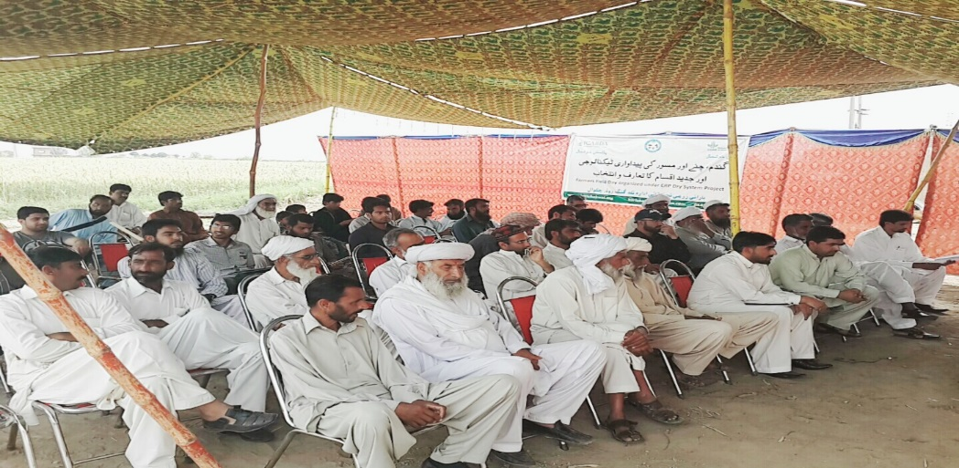

Farmer Field Day at Latifal (Intensification Cluster) held on 20-April -2015
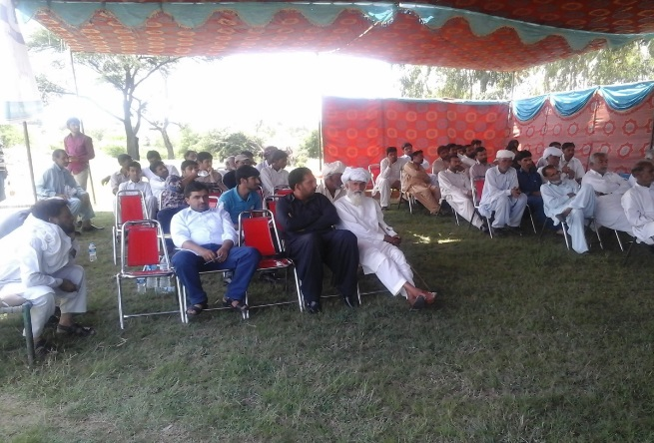

The program activities included the introductory session that included the welcome address followed by a brief discussion on varieties and objective of FFD. Awareness was given about the importance of new crop varieties and management practices. Famers were found keen and interested in the activity and different varieties under the trail. 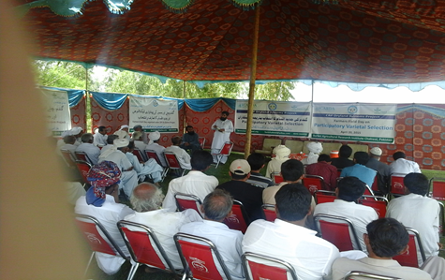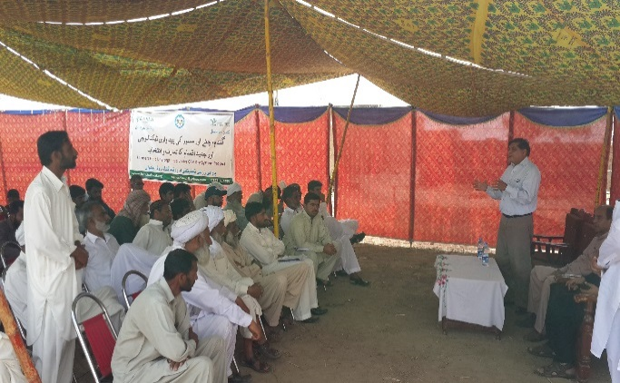
After presenting the lecture, an elaborative discussion was carried out in which farmers asked the questions. Farmers had detailed discussion on the techniques; they discussed the issues, availability of seed and required technical support. Besides this most of farmers have shared their own problems regarding the agriculture in that area. Presence of other line departments and technical partners and international organization (ICARDA) country head helped to develop confidence, trust and interaction of farmers. After discussing the issues farmers were taken to field and they saw the crops by themselves and evaluated the different varieties on the set indicators.
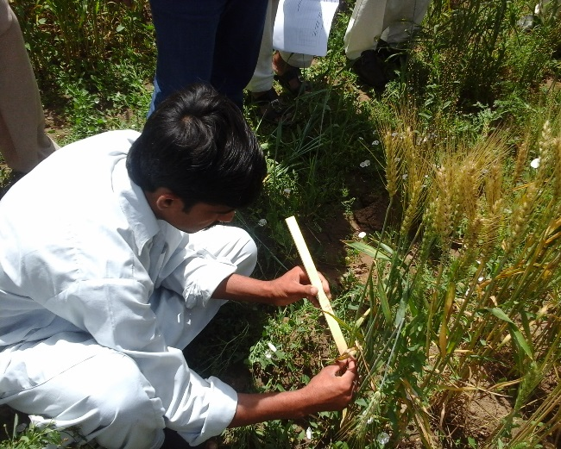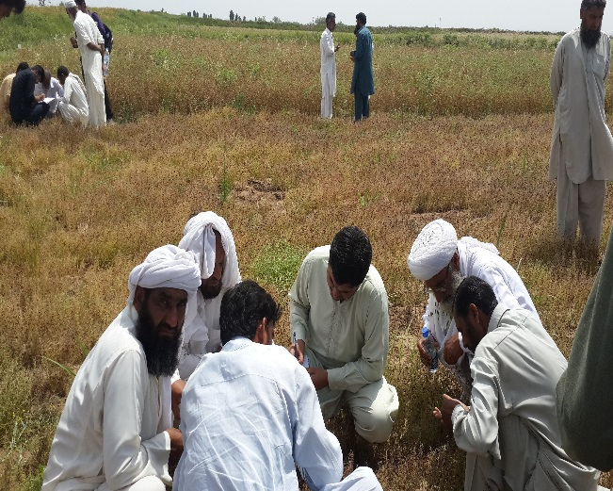
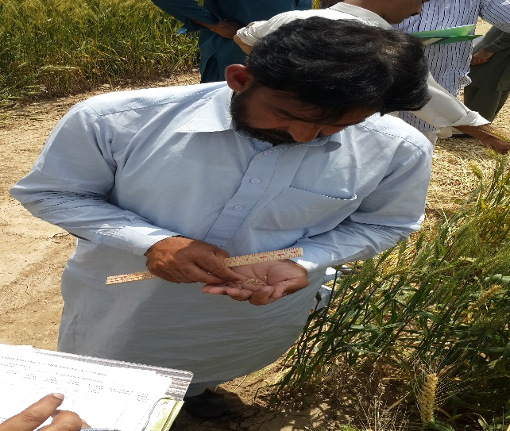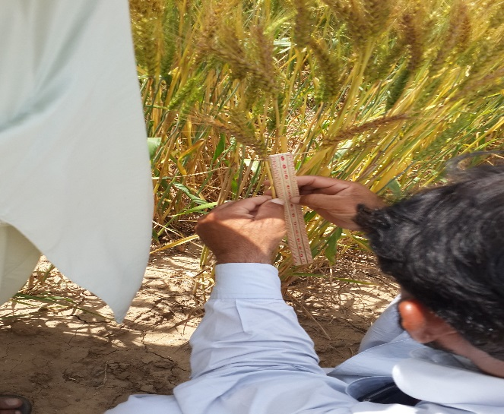
3.2 Selection Process
Varieties selection process involved following steps.

Farmers were given awareness about the new crop varieties. Information about the seed and production technologies was also shared. Lastly they observed the crops in fields and evaluated. All this helped to develop a scientific thinking for evaluation and participatory thinking through discussions. Farmers were taken to field and they observed different parameters like plant height, crop condition, disease infestation, tillers no, length, grain size and number of grains. Farmers observed all the aspects critically and evaluated the varieties namely AAS-2011, Chakwal-50,NARC-2009, Pakistan-2013, Dharabi-2011. Results of three groups were presented by the farmer group leader. All the three groups result was average out and presented in Table 2. Out of three groups two groups ranked AAS-2011 as First and Dharabi 2011 as second while third group ranked Dharabi-2011 the first and AAS -2011 second. Therefore among wheat varieties AAS-2011 was top ranked at intensification site.

Table .2.Varieties evaluation of Wheat at Intensification
Variety | Plant-height (Inch) | Crop Condition in terms of Lodging  (Percent) | Disease infestation  (Percent) | Tillers  (Nos)  Per feet | Stem Length (Inches) | Spike Length (Inches) | Grains (Number) | Grain Size (1=small 2=ave. 3=Bold | Expected yield Mounds/acre | Var. Ranking 1=top 5 lowest
AAS-2011 | 41 | 5 | 0 | 44 | 34 | 6 | 60 | 3 | 60 | 1
Chakwal-50 | 36 | 5 | 0 | 34 | 31 | 5 | 50 | 2 | 50 | 5
NARC-2009 | 34 | 10 | 0 | 39 | 29 | 5 | 45 | 2 | 50 | 3
Pakistan-2013, | 37 | 10 | 15 | 43 | 30 | 5 | 55 | 2 | 55 | 4
Dharabi-2011 | 40 | 5 | 0 | 40 | 35 | 5 | 55 | 3 | 55 | 2

At resilience site three groups were made they evaluated the varieties on the same parameters. At resilience site there were two crops namely wheat and lentil. The groups first evaluated the lentil and then wheat. Among wheat AAS-2011 and Dharabi-2011 were selected by the farmers as first and second important varieties. Farmers were in the view that Chakwal-50 is best variety and adopted in area but at participatory trial AAS-2011 was considered top .

Table 3.Varieties evaluation of Wheat at Resilience
Variety | Plant-height (Inch) | Crop Condition in terms of Lodging  (Percent) | Disease infestation  (Percent) | Tillers  (Nos)  Per feet | Stem Length (Inches) | Spike Length (Inches) | Grains (Number) | Grain Size (1=small 2=ave. 3=Bold | Expected yield Mounds/acre | Var. Ranking 1=top 5 lowest
AAS-2011 | 39 | 0 | 0 | 43 | 33 | 6 | 60 | 3 | 60 | 1
Chakwal-50 | 35 | 5 | 0 | 35 | 30 | 5 | 50 | 2 | 50 | 5
NARC-2009 | 37 | 0 | 0 | 36 | 30 | 5 | 45 | 2 | 50 | 3
Pakistan-2013 | 34 | 0 | 5 | 35 | 28 | 5 | 55 | 2 | 55 | 4
Dharabi-2011 | 40 | 5 | 0 | 42 | 35 | 5 | 55 | 3 | 58 | 2

Table 4.Varieties evaluation of Lentil at Resilience
Variety | Plant-height (Inch) | Crop Condition in terms of Lodging  (Percent) | Disease infestation  (Percent) | Tillers  (Nos)  Per feet | Stem Length (Inches) | Spike Length (Inches) | Grains (Number) | Grain Size (1=small 2=ave. 3=Bold | Expected yield Mounds/acre | Var. Ranking 1=top 5 lowest
Masoor-2006 | 7-8 | 10 | 0 | 28 | 4 | 5 | 9 | 2 | 3 | 3
Masoor-2002 | 10 | 5-10 | 0 | 28 | 5 | 6 | 10 | 2 | 4 | 1
Chakwal Masoor | 10.5 | > 5 | 0 | 29 | 4.5 | 5 | 8 | 1 | 3 | 4
Markaz-09 | 9.5 | > 5 | 0 | 30 | 4 | 5 | 8 | 2 | 3.5 | 2
Punjab Masoor | 10 | 5 | 0 | 30 | 4 | 5 | 8 | 1 | 3.5 | 5

The evaluation results for lentil were quite varying. Two farmer groups reported Masoor 2002 as top good variety and Markaz-09 was ranked as second.

Consumer Preferences about the Wheat Varieties

The additional part included at later stage was the consumer preferences about different wheat varieties.

Table 5. Consumer Preferences about the Wheat Varieties
Variety | General Appearance | Quality in doughing (Flour mixing with water) | Quality at preparing loaves | Taste in eating | Shelf life of wet floor to be used for more than a day | Self-life of loaves after some time | Ranking
AAS-2011 | Medium | Better | Better | Better | Better | Medium | 2
Chakwal-50 | Medium | Better | Better | Medium | Medium | Better | 3
NARC-2009 | Better | Better | Medium | Medium | Medium | Better | 4
Pakistan-2013, | Poor | Better | Poor | Poor | Medium | Poor | 5
Dharabi-2011 | Better | Better | Better | Better | Better | Better | 1

Consumer preferences were checked by making different groups of women who have participated in value addition training in June 2015 at BARI. Flour of all the varieties were given to them without mentioning the name of variety. Women carried out all the process like doughing (flour mixing with water) , Making loaves and cooking the loaves . They observed the each variety its appearance, it quality, its taste and shelf life and evaluated the varieties according to their own preferences. The results of all the varieties are shown in above mentioned table. Women ranked Dharabi 2011 as first and AAS-2011 on second. More or less same results were drawn from the PVS at farm level in terms of yield. Suggestion and Recommendations
- Participation of farmer and other line department was highly encouraging. Farmers were of the view that such type of activities were done first time in their area. The officials from extension department along with scientists participated in FFD and interacted with farmers. This would be helpful in increasing integration and coordination at local level. High participation rate shows the interest and confidence of farmer on project team. Some of the earlier suggestions based on observation, discussions and feedback still needs to be considered. These area given as under:
- Charts containing the complete production technological packages could be displayed for better understanding and knowledge dissemination.
- Single crop targeted FFD could help to improve understanding and targeted participation of farmers with respect to crop choices as interest of the participating farmer varied by site and by crops.
- Progressive farmers and informal seed grower should be invited to share their experiences to increase trust and interest of the farmers through equal to equal sharing of knowledge.
- Some arrangements for distribution of seed of best varieties from the trails could be made for promotion and adoption of the best varieties.

Reference
Bentley, J.W.1994. Facts, Fantasies, and Failures of Farmer Participatory Research. Agriculture and Human Values 1: 140150
Olaoye, G. S.O. Ajala, and S.A. Adedeji (2009). Participatory selection of a maize (Zea mays L.) variety for the control of stem borers in a southeastern Nigeria location. Journal of Food, Agriculture & Environment Vol.7 (2), April 2009: 508-512. http://world-food.net/download/journals/2009-issue_3_4/56.pdf
Paris, T. R., Singh, A. and Luis, J. (2001). Listening to male and female farmers in rice varietal selection: a case in eastern India. In An Exchange of Experiences from South and Southeast Asia. Proceedings of the International Symposium on Participatory Plant Breeding and Participatory Plant Genetic Resource Enhancement, Pokhara, Nepal, 1–5 May 2000. Cali, Columbia: CIAT.
Tabo, R., A.O. Ogungbile, S.C. Gupta, and D. Ajayi. 1999. Participatory Evaluation of Sorghum cultivars in Northern Nigeria. Intl. Sorghum Millet Newslet 40: 36-38.
Tabo, R., A.O. Ogungbile, S.C. Gupta, and D. Ajayi. 1999. Participatory Evaluation of Pearl Millet cultivars in Northern Nigeria. Intl. Sorghum Millet Newslet 40: 53-55.
Witcombe, J.R., Joshi A., Joshi, K.D. and Sthapit, B.R. 1996. Farmer participatory crop improvement. I. Varietal selection and breeding methods and their impact on biodiversity. Expt. Agric. 32:445-460.
Witcombe, J.R., Peter, R., Jones, S. and Joshi, A. 1999. Farmer participatory crop improvement: IV. The spread and impact of a rice variety identified by participatory varietal selection. Expt. Agric. 35:471-487.

