Final Report BMZ Small Grants

General Information

Implementing Organisation and Contracting Partner | Deutsche Gesellschaft für Internationale  Zusammenarbeit (GIZ) GmbH  Friedrich-Ebert-Allee 40  53113 Bonn  Tel. +49-(0) 228-44600  Internet: www.giz.de
Contact for project reports | Advisory Service on Agricultural Research  for Development (BEAF)  Stefanie Zeiss  Tel. +49-(0) 228-4460-3883
Closing date | 30/11/2017
Reporting period | From 01/08/2016 to 28/02/2018
Submit by e-mail to | stefanie.zeiss@giz.de

Basic data

1. The IARC applicant | ICARDA
2. Project title | Impact evaluation of SLM options to achieve land degradation neutrality
3. Funding type,  GIZ Project Number and Contract Number | Small Grant  GIZ Project number: 14.1432.5-001.00  Contract number: 81204252
4. Reporting Period | From 01/08/2016 to 28/02/2018
5. Project Coordinator and Project Scientists | Richard Thomas (project coordinator)  Address: Yousef El Sukkar Street, Bld no. 8, Amman 11195, Jordan | P.O.Box 950764  Phone number: +962-6-5903120 / +1 289-888-1400  e-mail address: r.thomas@cgiar.org  Quang Bao Le (Scientist)  Address: Yousef El Sukkar Street, Bld no. 8, Amman 11195, Jordan | P.O.Box 950764  Phone number: +962-6-5903120  e-mail address: Q.Le@cgiar.org  Enrico Bonaiuti (Scientist)  Address: Yousef El Sukkar Street, Bld no. 8, Amman 11195, Jordan | P.O.Box 950764  Phone number: +962-6-5903120  e-mail address: E.Bonaiuti@cgiar.org  Chandrashekhar Biradar (Scientist)  Phone number: +962-6-5903120  e-mail address: C.Biradar@cgiar.org  Fajr Fradi (Junior Project Officer/Scientist)  Phone number: +962-6-5903120  e-mail address: fajr.fradi@cgmel.org
6. Project Partners | iMMAP  Badabate Diwediga, Jim Jaspe, Bashar Ayyash  Codeobia  Moayyad AlNajdawi  Institut National de Génie Rural, Eaux et Forêts  Taoufik Hermassi  Institut des Régions Arides (IRA)  Mohamed Ouessar

Final Technical Report

7. State of Project Implementation
The aim of the project was to develop and implement a web-based GIS tool for defining sustainable land management (SLM) options by social-ecological context at global scale. This Global Geo-informatics Options by Context (GeOC) tool aims to support the implementation of SLM practices by the international community. The GeOC is designed to provide stakeholders/projects and programmes with plausible, robust extrapolation domains for guiding decisions on SLM options, and an open platform for docking different disciplinary projects into integrative/holistic, converging actions for SLM. The status of achievement of the planned outputs is shown in Table 1.

Output 1 was completed by the development of a web-based GIS tool for defining sustainable land management (SLM) options by social-ecological context. The alpha version of the tool was developed within 6 months of the project’s initiation and was tested with partners from March to October 2017 via training events and a workshop to achieve Output 2, a country-specific knowledge base of standardized geo-referenced SLM options by context compendium. The tool is available online and is supported by presentations, videos and a user manual.

The project team, including Tunisian country scientists, was able to develop a knowledge base of projects and practices (Output 3) that includes detailed mapping of any selected areas of the country (Output 4).

A total of 47 participants attended two training workshops including 12 farmers and 30 scientists from national institutions. In addition, presentations of the tool were given at the WOCAT International Symposium in Cali, Colombia, June 2017 and at two learning and exchange sessions during the UNCCD COP13 held in Ordos China September, 2017.

Table 1. Status of achievement of the planned project outputs

Output | Status of achievement
- User-friendly, interoperable online tool to enable stakeholders to query SLM options in different context in order to assess potential impact for applying options in time and space | Completed
- The first country-specific, yet an accessible knowledge base of standardized, geo-referenced SLM options-by-context and impact assessment of the tested SLMs that is embedded in the GeOC (Global Geoinformatics Options by Context) being developed by CRP 1.1 and ICARDA. | Completed
- Accessible knowledge base of projects in target country. | Combined with Output 2 (*)
- Detail mapping of at least 10% of completed interventions sub-sets (pilots) | Completed.

(*) Justifications: 1. The knowledge base contains the data and the references of SLM information gathered for Output 2. These references were also recorded in the SLM data forms (both online and off-line). 2. The building of SLM database in Output 2 was based on not only information from the CGIAR‘s Dryland Systems Program CRP and relevant ICARDA projects, but also from other published projects/programs.

8. Major research findings
8.1 The GeOC tool is a new system framework (Deliverable of Output 1) that enables stakeholders to query SLM options in different contexts in order to assess potential impact for applying options in time and space.

8.1.1 The criteria and features of the development of GeOC included:

- A basis on a systems framework that is scientifically-sound and able to cope sufficiently with the diversity of social-ecological contexts
- improved linkages among different scales (from global to regional and local landscape) and between pixelized codes and descriptive/profile data (e.g. GIS rasters of socio-biophysical data and standardized profiles of SLM data),
- Multiple entry points for diverse needs and preferences of users
- Common use functions, yet easy-to-use
- Open for improvements and customizations (version-by-version).

Our review of contemporary systems frameworks pointed out three main gaps.
Firstly, some frameworks commonly used in SLM analysis and assessment (e.g. Driver – Pressure – State – Impact – Response (DPSIR)) generally overlook the contextual diversity that would shape SLM outcomes.
Secondly, many current studies use typologies as strata to aggregate/design management options without testing whether the types do actually shape SLM outcomes.
Thirdly there is a lack of spatially explicit tools capable of generalizing regional/global patterns from place-based findings.

The crux of the conceptual framework for GeOC that helps address these gaps is a systems-based clarification of the relationship between context (including drivers) and management options as the basis for data integration, selection of objective-oriented indicators and analysis/assessment of the diversity of land use systems and related contexts over space (see Annex 1).

8.1.2 Structure of GeOC database

The database structure of GeOC includes three domains and influencing linkages (Figure 1). The contextual data include not only the social, economic and biophysical drivers of land management, but also the identities of the land use system itself and land users’ needs/preferences. The SLM data is a portfolio of technical and institution options that is kept open for continuous addition by stakeholders in the course of learning and development.
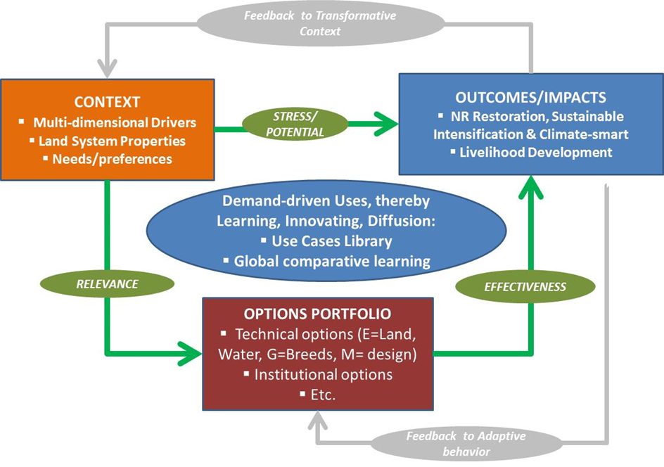
Figure 1: Data domains and influencing linkages in GeOC.

8.1.3 GeOC’s use functions:

GeOC has a web-based GIS Graphic User Interface (GUI) and integrated databases that allow users to start from the entry points they prefer. The tool will allow querying the different SLM measures from around the world to search ‘similar’ environments based on their geographical, biophysical and socioeconomic context and to search ‘similar’ SLM measures or SLM types or SLM techniques with the same goals. By showing all the options for a certain context, the platform facilitates the dissemination of SLM techniques to researchers, policy decision-makers, land manager (including farmers). The main functions of the GeOC are expressed in Figure 2.
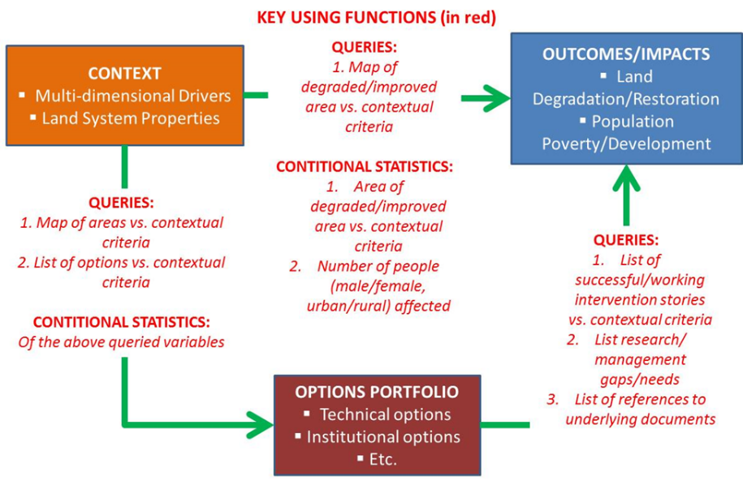
Figure 2: Key functions (expressed by the red texts in linking with three data domains) of the GeOC

Further details on GeOC’s concept, framework and design are shown in an open-access working paper (Le, Thomas and Bonaiuti 2017).

8.2 GeOC as a user-friendly, interoperable online tool (Deliverable of Output 1)

As a web-based integrative tool, GeOC has two components:
1. The web-based geographic information system (called WebGIS sub-tool). This component includes a web-based GIS interface with key functions (filtering/querying, zonal statistics, spatial similarity analysis), and GIS database of drivers and performance/impact indicators of SLM.
2. The Sustainable Land Management component (called SLM sub-tool). This component includes the web-based form for importing standardized and completed SLM options by context, and the SLM database. The two components are matched and synchronized (Figure 3).
Figure 3: GeOC tool synchronizes two web-based sub-tools: WebGIS and SLM.

8.2.1 WebGIS sub-tool of the GeOC:

The internet page of WebGIS sub-tool (https://mel.cgiar.org/slm/visualization) is available for users. A user will need to register an account to start with. A short video clip that introduces the WebGIS and demonstrates some functions has been posted on Youtube (video clip on WebGIS). In summary, the WebGIS was designed to offer a user-friendly graphic interface, including three main parts:

- Filter Options: This feature provides users with multiple drop-down menus that allow them to select contextual criteria and/or performance/impact indicators (in GIS format) for options-by-context analysis (see Figure 4). The design offers users different entry points to define a context relevant to their needs. For example, a user can identify a specific location by selecting from the given lists a region/sub-region/country/national administrative unit(s) under which the location of interest falls (Annex 2), then select concrete contextual criteria (from given lists, including bio-physical, assessibility, demographic and economic conditions) and/or performance/impact indicators (Annex 3) and based on these to select the value ranges of the parameters.
- Mapping Tool: This part is a vertical bar of buttons that allows access to performance functions of basic GIS (e.g. extent zooming, drawing areas of interest), contextual similarity analysis (e.g. delineate similar socio-ecological context over a large area), show SLM implementation sites, and download selected GIS data (see Figure 4, Annex 4). The steps for defining an area of interest with specific contextual criteria using the Filter Options and Mapping Tool of WebGIS are shown in Annex 5.
- Statistical summaries of contextual conditions and SLM performance/impacts: Details of these are shown in Annexes 6 and 7.

Figure 4: A screenshot of a part of Graphic User Interface (GUI) of the WebGIS sub-tool of the GeOC, showing Filter Option (the dark area with drop-down menu on the left side) and Mapping Tool (the vertile tool bar on the left of map window)

8.2.2 Online SLM form synchronized with the WebGIS:

The internet page of SLM data form (https://mel.cgiar.org/slm) is available for users. A user will need to register an account to start with. A short video clip that introduces the online SLM data form and demonstrates some functions has been posted on Youtube (video clip on SLM data form). In summary, the online SLM submission form is composed of 6 sections, each of which focuses on one particular aspect of the SLM technology: 1. Name and sources of the SLM technology; 2. Description of the SLM technology; 3. SLM purpose and classification; 4. Geographic locations, extents and socio-ecological context/environment; 5. Technical specifications, inputs and costs, 6. Impacts and influencing factors. An explanation on details of these sections can be found in a presentation of the online SLM data form. An example screen shot of the forms is shown in Figure 5.

Figure 5. Screenshots of the web-based SLM form. A: with standardized information fields, B-C: different functions for mapping SLM sites, including link to the Mapping Tool in WebGIS, and retrieval of GIS data, D-E: interfaces allow users to manage their submitted SLM (D) and for the platform administators to manage the peer-reviewed approval process (E).

8.2.3 Off-line SLM form:

An off-line Excel template for “Standardized Description of Sustainable Land Management (SLM) Technologies with a Focus on Field-Landscape Level” was produced. This off-line SLM template matches exactly (field-to-field) with the web-based SLM data form, thus allows users to upload the off-line data to the web-based GeOC.

8.2.4 Innovative aspects of the developed SLM sub-tool:

The innovation introduced by the tool is the development of the functional context socio-ecological type (fCSET) approach to overcome the challenges of socio-ecological context diversity in the adoption of SLM practices. The fCSET approach groups common biophysical, economic and social drivers of land use adoption and change into distinct context types that shape SLM adoption and productivity and efficiencies of the use of resources (e.g. rain water and mineral nutrients). The drivers selected for analyses were based on a literature review. We identified and mapped context types using spatial cluster analysis with global data retrieved from different sources (such as USGS, FAO-IIASA, UNEP, IUCN and CIESIN-CIAT). The functionality of the derived context types was evaluated by unbalanced ANOVA that measured and tested the differences in primary productivity and rain use efficiency among the context types. Our initial result demonstrates the potential of the fCSET approach to further our understanding of the role of socio-ecological contexts in SLM, and management of the contextual diversity. The results can be used by SLM-oriented projects/programs and citizen scientists to improve targeting of SLM options. For example given limited resource and aims, we can know approximately where efforts should be focused by managing, or coping with what drivers. The result can also be used as an extrapolation domain: given SLM outcomes in a number of project sites, we can identify where similar intervention options have a potential of success based on contextual similarity. Further details of these innovations are provided in Annexe 9.

Additional innovative aspects of the tool are:

- The data available to users derives from a multi-variate database rather than static factsheet (PDF or document file): This feature allows user-defined queries in response to SLM’s attributes selected (e.g. type, environmental and socio-economic characteristics), or exportation to spread-sheet formats for further multi-variate analyses
- Provides different options for mapping SLM - including selection of relevant administration units, ability to draw one’s own boundaries, and importing prepared GIS maps: Allows multiple entry points to be chosen determined by the users’ preferences and resource availabilities.
- Synchronized with the GIS database and tool (WebGIS) to retrieve - hence relate with – spatial data on contextual /driver and impact variables over larger scales: Allows spatially explicit analysis/assessment in comparison with baseline data in land degradation/improvement to define best SLM practices for a given context. If trade-offs among aspects of impacts are too complex to measure and/or cope with, the tool will inform stakeholders of a portfolio of SLM options with quantified pros and cons for multi-stakeholder discourses that help achieve social consensus.
- Data entry forms both off-line and web-based form for standardized description of SLM (adapted from WOCAT): Allows either on- or off-line inputs and aligning each other (online with off-line); Matches to a certain extent with the WOCAT questionnaire, thus creating opportunities for communication and automatic contribution to the WOCAT global database once technological links between the two databases are achieved. Owners of SLM data in GeOC also have an option to submit and publish their data in the well-known WOCAT global database (with some minimal adaptation to the current WOCAT standard).

8.3 GIS database embedded in GeOC (Deliverable of Output 2)

There are 35 variables in the format of GIS rasters that were embedded in the WebGIS sub-tool. The categories of these GIS variables are shown in Figure 6. Brief definitions of the GIS variables are shown in Annex 8. The global data are collected and resampled (up- or down-scaled to 1 km resolution) from different sources (such as USGS, FAO-IIASA, UNEP, IUCN, CIESIN-CIAT, CGIAR-CSI). Important data such as inter-annual trends of rainfall, social-ecological contextual types are driven from the analyses of CRP-Dryland Systems data on integrated systems work. Agricultural resource poverty, proximities to roads, towns and water bodies were calculated by ICARDA Geoinformatics Unit (http://geoagro.icarda.org/en/). The innovation introduced by the tool is the initiation of the functional context socio-ecological type (fCSET) approach to overcome these challenges of socio-ecological context diversity. Details of this approach are included in Annex 9.
Figure 6. Diagram show categories of GIS database embedded in the WebGIS sub-tool.

8.4 Geo-referenced SLM database embedded in GeOC (Deliverables of Outputs 2 and 4)

In the national context of Tunisia, we define a SLM option-by-context (SLM OxC) as the nesting of three elements: SLM technology type (SLM type), Socio-Agro-Ecological Zone (SAEZ) and Aggregated Land Use System (ALUS).

SLM OxC = SLM type x SAEZ x ALUS

where SLM type donates a so-called “SLM option” and the SAEZ x ALUS represents the socio-ecological context. The detailed classifications of SAEZ and ASUS are given in Annex 10.

Zaghaoun and Medenine are the two Tunisian governorates that were selected as the pilot study regions. There is a high diversity of SLM practices and socio-ecological contexts in the study regions, even though the study was not exhaustive in identifying and mapping all the SLM practices. Twenty nine (29) SLM technology types are identified and mapped for the two regions (11 in Zaghouan and 18 in Medenine). These SLM types matched with SAEZ and ALUS units found in the regions, resulting in 51 SLM OxC (29 in Zaghouan and 22 in Medenine) (see Table 2).

Table 2. The numbers of SLM types and SLM OxC database generated in the two study regions.

 | Governorate |  |  |  | Total database
 | Zaghouan |  | Medenine
 | SLM type | SLM OxC | SLM type | SLM OxC | SLM type | SLM OxC
Number | 11 | 22 | 18 | 29 | 29 | 51

The summary of these 51 SLM OxC data are given in Annex 11. One SLM OxC includes two components:
- Filled SLM data form: 6 sections; both online (SLM web) and off-line (Excel) formats.
- GIS map of the SLM areas: polygon rather than point; both online (WebGIS) and off-line (ESRI shape or Google Earth KML) formats

8.5 Development of common use cases (Deliverables of Outputs 1, 2)

A common challenge in this type of work deals with the absence of sufficient guidance to utilize complex data resources for diverse users' contexts, including user-specific purpose, objective, application scales, institute's or group's capacity and many other factors. Today, system informatics deals with this complex challenge by following a ”use case approach“. A typical use-case is a sequence of limited steps that describes the interactions between a typical user (or users group) and the information system to accomplish a typical goal. To cope with the diverse uses needed, the approach aims at establishing a use cases library that consists of as many as possible typical use cases. Given a use case library, a specific user can find a typical use case that is similar to his/her need for rapid application with low cost. Recognized strengths of the approach are: (1) strong analytical perspective and complete analysis assurance, (2) simple and easy to understand and adopt, (3) widely recognised market standard, (4) encourage join work between users and system designers to develop typical use case library.

We developed the two typical use cases in line with common entry points, with the following hyperlinks to demonstrating video clips:
- Context-based analysis: searching implemented SLM options with a context defined by the user.
- Mapping extrapolation dommain relevant to given SLM site(s): searching similar socio-ecological context(s)given considered SLM option(s).

9. Assessment of research findings
The GeOC tool can be used by land users and managers including farmers and foresters, land use planners and government ministries that deal with land related issues and SDG reporting. The tool can also help all CGIAR centers involved in land management and can be combined with other monitoring and evaluation systems for projects and programmes via the Dryland System-CRP developed Monitoring and Evaluation System or MEL (https://mel.cgiar.org). The tool is being used already within the project “Restoration of Degraded Lands for Food Security and Poverty Reduction in East Africa and the Sahel – Taking Successes in Land Restoration to Scale“, that runs into 2019 and is managed by the World Agroforestry Center (ICRAF), International Fund for Agricultural Development (IFAD), International Crops Research Institute for the Semi-Arid Tropics (ICRISAT), International Livestock Research Institute (ILRI), International Center for Agricultural Research in Dry Areas (ICARDA) and the CGIAR Research Program on Forests, Trees and Agroforestry (CRP-FTA).

10. Know-how transfer
The former research team from CRP-Dryland Systems, currently at ICARDA has begun discussions with the WOCAT group at the University of Berne, Switzerland, and has developed a concept note that will ensure interoperability between the GoOC and the WOCAT database. The latter is the UNCCD recommended database for SLM options. Thus if implemented the tool can potentially reach all 100+ countries that have signed up to the achievement of LDN and that are currently developing their LDN targets. Discussions are also underway with the UNCCD Global Mechanism on the potential of including the tool in their efforts to help countries achieve LDN via the new LDN Fund.

11.T raining
A listing of training events and external presentations is included below:

Dates | Title of event and venue | Number of participants
March 13-14 2017 | National Face to face Workshop Training on Systems Tool-aided Participatory Development of Sustainable Land Management Scenarios, Zaghouan, Tunisia | Male:19, Female:3
March 16-17 2017 | National Face-to-face Workshop Training on Training on the job for NARS, research institutes and policy makers, Zaghouan, Tunisia | 35 participants including 10 farmers and 21 scientists from national institutions
June 13-16, 2017 | Selected presentation of GeOC tool at WOCAT International Symposium, co-organized by WOCAT Secretariat, CIAT, and FAO, in Cali, Colombia | 52 participants from 25 countries and diverse institutions ranging from Governments, international organizations, non-governmental organizations, to academia
September 4-5, 2017 | Presentations & training at Soil Leadership Academy capacity building and knowledge exchange event at the UNCCD COP-13, Ordos China | About 20 COP participants over 2 days
October 24, 2017 | Participatory technology transfer & cooperative capacity building, Tunis, Tunisia | 12 participants including 2 farmers & 9 scientists from national institutions

12. Lessons learned
Suggestions for improvements of the tool were obtained from a survey of the trainings in Tunisia. Participants opined that more field visits and training on the tools are required. Others wished to see the tool related to an actual land planning case study. The selection of participants for the training could be better focused to ensure that the relevant staff are trained. This implies closer collaboration with the relevant institutes add government ministries within the countries targeted.

13. Future research needs
The tool can be refined iteratively by undertaking more case studies in land degradation ‘hot spots’. Thus research should be done ‘in development’ ie., closely linked to larger development projects that are determined and designed by national institutes and government ministries.

Further work is needed on defining the architypes or socio-ecological patterns of vulnerability to, and recovery from, land degradation and how these link to SLM options in terms of feasibility of implementation.

Greater emphasis needs to be given to understanding the economics of land degradation and in particular better information on the cost-benefit analysis of SLM option is needed.

14. Summary
The alpha version of the GeOC tool has been developed and data domains on the contexts and SLM options have been established using global data from widely available databases that combine biophysical and socio-economic data (compared to the more usual dependency on just one data source). A library of use case studies is being established for widespread dissemination of targeted SLM option. The GIS Web-based tool has entry points for pre-defined contextual types, user defined contextual criteria, pre-defined option types, and a search facility for users. Further work is needed on the outcome-impact data related to the application of SLM options.

The tool can contribute to countries‘ nationally determined contributions to various land-related SDGs and especially to SDG 15 with its focus on achieving land degradation neutrality (LDN). The tool can contribute to this as the achievement of LDN requires the implementation of sustainable land management options and the measurement of the impact of such interventions.

Discussions are on going with both the World Overview of Conservation Approaches and Technologies (WOCAT) and the UNCCD as to how the tool can be used to achieve and monitor LDN which is seen as a central core of SDG 15. The tool has been introduced into a EU-IFAD project on the restoration of degraded land for food security and poverty reduction in East Africa and the Sahel via a collaboration with the World Agroforestry Centre (ICRAF) (ICARDA, 2018).

15. Publications, papers and results
Websites of the project information:

https://mel.cgiar.org/projects/geoxc

https://mel.cgiar.org/projects/geoxc/52/impact-evaluation-of-sustainable-land-management-slm-in-tunisia

Website of the GeOC tool (new user needs to register an account to log in):

Home page: https://geoc.mel.cgiar.org

WebGIS sub-tool (for users): https://mel.cgiar.org/slm/visualization

SLM data form sub-tool (for users): https://mel.cgiar.org/slm/

SLM review-approval (for admin): https://mel.cgiar.org/slm/approval

Donor Report (1):

Richard Thomas, Quang Bao Le, Enrico Bonnaiuti (2017). Impact evaluation of SLM options to achieve land degradation neutrality – ICARDA Interim Report submitted to GIZ. http://dx.doi.org/20.500.11766/6822

Technical Reports and Working Papers (5):

Quang Bao Le, Richard Thomas, Enrico Bonaiuti (2017). Global Geo-informatics Options by Context (GeOC) Tool for Supporting Better Targeting and Scaling-out of Sustainable Land Management: Designing the System and Use Cases. Amman, Jordan: The International Center for Agriculture Research in the Dry Areas (ICARDA). http://dx.doi.org/20.500.11766/7358
Jim Jaspe (2017). Impact evaluation of SLM options to achieveland degradation neutrality: ICARDA-iMMAP report. http://dx.doi.org/20.500.11766/7826
Badabate Diwediga. (2017). Impact evaluation of SLM options to achieve land degradation neutrality in Tunisia: consultant monthly report (March 2017). http://dx.doi.org/20.500.11766/7826
Badabate Diwediga (2017). Land cover changes in Tunisia using MODerate Resolution Imaging Spectroradiometer (MODIS) MCD12Q1 yearly products. http://dx.doi.org/20.500.11766/7833
Badabate Diwediga, Fajr Fradi (8/11/2017). Creating Spatial Data on Sustainable Land Management Practices in two Pilot Sites in Tunisia (Northern Africa). http://dx.doi.org/20.500.11766/7824

Manuals and Training Materials (16):

Fajr Fradi, Jim Jaspe, Bashar Ayyash, Quang Bao Le, Enrico Bonaiuti, Megi Cullhaj, Federico Lettieri, Valerio Graziano (2017). GeOC User Guide. Amman, Jordan: The International Center for Agriculture Research in the Dry Areas (ICARDA). http://dx.doi.org/20.500.11766/7065
Jim Jaspe, Bashar Ayyash, Badabate Diwediga, Mahdi Hamdan, Fajr Fradi, Valerio Graziano, Khaled El-Shamaa, Jalal Omari, Quang Bao Le, Enrico Bonaiuti, Chandrashekhar Biradar. (25/10/2017). GeOC Installation Guide. Amman, Jordan: iMMAP. http://dx.doi.org/20.500.11766/7490
Quang Bao Le (2016). Overview analysis work after the first workshop by core team (English version). Amman, Jordan: CRP on Dryland Systems (DS). http://dx.doi.org/20.500.11766/7055
Quang Bao Le (2016) Overview analysis work after the first WS by core team (French version). Amman, Jordan: ICARDA. http://dx.doi.org/20.500.11766/7056
Quang Bao Le (2017). Evaluations de l’érosion du sol et de l’impact des pratiques de CES dans le contexte actuel, First session overview (English version). Amman, Jordan: CRP on Dryland Systems (DS). http://dx.doi.org/20.500.11766/7057
Evaluations de l’érosion du sol et de l’impact des pratiques de CES dans le contexte actuel, First session overview (French version). Amman, Jordan: CRP on Dryland Systems (DS). http://dx.doi.org/20.500.11766/7058
Quang Bao Le (2017). Participatory grid-based erosion evaluation (English version). Amman, Jordan: ICARDA. http://dx.doi.org/20.500.11766/7059
Quang Bao Le, Badabate Diwediga (2017). Results of Participatory grid-based erosion transferred to GIS (French version). http://dx.doi.org/20.500.11766/7060
Taoufik Hermassi (2017). Classification and cost of SWC done in 1st WS (French version). Amman, Jordan: University of Carthage. http://dx.doi.org/20.500.11766/7061
Quang Bao Le (2017). Presentation of the LAMPT tool. Amman, Jordan: ICARDA. http://dx.doi.org/20.500.11766/7062
Quang Bao Le (2017). Introduction of the training program “Sustainable Land Management Options by Context: Approach and Geospatial tool to support Achieving Land Degradation Neutrality”. Amman, Jordan: ICARDA. http://dx.doi.org/20.500.11766/7049
Richard Thomas (2017). Concept of land degradation neutrality. Amman, Jordan: ICARDA. http://dx.doi.org/20.500.11766/7050
Quang Bao Le, Richard Thomas, Enrico Bonaiuti (2017). Concept and design of GeOC tool. Amman, Jordan: CRP on Dryland Systems (DS). http://dx.doi.org/20.500.11766/7048
Quang Bao Le (2017). A first (beta) version of the web-based SLM form. Amman, Jordan: ICARDA. http://dx.doi.org/20.500.11766/7051
Quang Bao Le (2017) Data domains of the GeOC Tool. Amman, Jordan: ICARDA. http://dx.doi.org/20.500.11766/7052
Badabate Diwediga, Quang Bao Le (2017). Multi-temporal and multi-scale assessment of landscape pattern dynamics in Tunisia using MODIS and Landsat data (French version). http://dx.doi.org/20.500.11766/7857

Template (1):

Quang Bao Le (2017). Template for Standardized Description of Sustainable Land Management (SLM) Technologies with a Focus on Field-Landscape Level. http://dx.doi.org/20.500.11766/7820

Videos and Images (11):

Fajr Fradi, Quang Bao Le, Enrico Bonaiuti, Tana Lala-Pritchard, Richard Thomas, Holly Anne Holmes. (1/8/2017). Introduction of the GeOC. Amman, Jordan: The International Center for Agriculture Research in the Dry Areas (ICARDA) (ICARDA as the Executive Producer). http://dx.doi.org/20.500.11766/7471
Fajr Fradi, Quang Bao Le, Enrico Bonaiuti, Richard Thomas, Tana Lala-Pritchard, Holly Anne Holmes. (1/8/2017). Overview of the WEB-GIS interface. Amman, Jordan: The International Center for Agriculture Research in the Dry Areas (ICARDA) (ICARDA as the Executive Producer). http://dx.doi.org/20.500.11766/7472
Fajr Fradi, Quang Bao Le, Enrico Bonaiuti, Richard Thomas, Tana Lala-Pritchard, Holly Anne Holmes. (1/8/2017). Definition and visualization of the context socio-ecological type (CSET). Amman, Jordan: The International Center for Agriculture Research in the Dry Areas (ICARDA) (ICARDA as the Executive Producer). http://dx.doi.org/20.500.11766/7474
Fajr Fradi, Quang Bao Le, Enrico Bonaiuti, Richard Thomas, Tana Lala-Pritchard, Holly Anne Holmes. (1/8/2017). Mapping of the context socio-ecological type (CSET). Amman, Jordan: The International Center for Agriculture Research in the Dry Areas (ICARDA) (Executive Producer). http://dx.doi.org/20.500.11766/7473
Fajr Fradi, Badabate Diwediga, Quang Bao Le, Enrico Bonaiuti, Tana Lala-Pritchard, Richard Thomas, Charlotte Hemingway. (23/11/2017). Composantes de l\'outil GeOC. Amman, Jordan: International Center for Agricultural Research in the Dry Areas (ICARDA) (ICARDA as the Executive Producer). http://dx.doi.org/20.500.11766/7834
Fajr Fradi, Badabate Diwediga, Quang Bao Le, Enrico Bonaiuti, Tana Lala-Pritchard, Richard Thomas, Charlotte Hemingway. (23/11/2017). Cartographie du type du contexte socio-ecologique. Amman, Jordan: International Center for Agricultural Research in the Dry Areas (ICARDA) (ICARDA as the Executive Producer). http://dx.doi.org/20.500.11766/7835
Fajr Fradi, Badabate Diwediga, Quang Bao Le, Enrico Bonaiuti, Tana Lala-Pritchard, Richard Thomas, Charlotte Hemingway. (23/11/2017). Aperçu de l\'interface de l\'outil de gestion durable des terres (GDT). Amman, Jordan: International Center for Agricultural Research in the Dry Areas (ICARDA) (ICARDA as the Executive Producer). http://dx.doi.org/20.500.11766/7836
Fajr Fradi, Quang Bao Le, Enrico Bonaiuti, Tana Lala-Pritchard, Richard Thomas, Holly Anne Holmes. (23/11/2017). Overview of interface of the sustainable land management (SLM) tool. Amman, Jordan: International Center for Agricultural Research in the Dry Areas (ICARDA) (ICARDA as the Executive Producer). http://dx.doi.org/20.500.11766/7819
Fajr Fradi, Badabate Diwediga, Quang Bao Le, Enrico Bonaiuti, Tana Lala-Pritchard, Charlotte Hemingway. (23/11/2017). Définition et visualisation du type du contexte socio-écologique (CSET). Amman, Jordan: International Center for Agricultural Research in the Dry Areas (ICARDA) (ICARDA as the Executive Producer). http://dx.doi.org/20.500.11766/7837
Fajr Fradi, Badabate Diwediga, Quang Bao Le, Enrico Bonaiuti, Tana Lala-Pritchard, Richard Thomas, Charlotte Hemingway. (23/11/2017). Aperçu de l\'interface Web-GIS. Amman, Jordan: International Center for Agricultural Research in the Dry Areas (ICARDA) (ICARDA as the Executive Producer). http://dx.doi.org/20.500.11766/7838
Fajr Fradi, Badabate Diwediga, Quang Bao Le, Tana Lala-Pritchard, Richard Thomas, Charlotte Hemingway. (23/11/2017). Introduction de l\'outil GeOC. Jordan: ICARDA (ICARDA as the Executive Producer). http://dx.doi.org/20.500.11766/7839

