GL-FP4.2.6.7 Facilitate seed production of early maturing chickpea cultivars and enhance adoption of these cultivars by farmers in SA
1. Objective of activity and intended output (1-2 sentences)
Facilitate seed production of early maturing chickpea cultivars and enhance adoption of these cultivars by farmers in SA

2. Materials and methods (very brief and succinct, 3 sentences at the most)
- Quality seed of chickpea varieties were procured from research stations and also from National Seed Corporation in India for promoting the seed system in Odisha state, India. Cluster of villages were selected in each district based on the soil type and interest of the farmers to grow chickpea.
- Rice-follow areas were targeted for promoting early maturing varieties such as JAKI 9218, NBeG 3, NBeG 47, Ujjawal, Vihar and JG 14. Dibbling method of sowing was demonstrated for sowing the seed. Seed priming was practiced for ensuring maximum germination and plant stand. Regular training programs were organized to farmers on crop production and crop protection technologies during planting, pod filling and at maturity stages.

3. Results and interpretation (again succinct, maximum of 250 words). Include data in the form of graphs, tables or pictures.
- In an effort to make farmers self-sufficient in quality seed for sowing purposes, farmers in Odisha state, India were encouraged to take up seed production in Keonjhar, Mayurbhanj and Sundargarh. The farmers (581) were supplied with 19,455 kg seed of NBeG 3, JAKI 9218 and Ujjawal varieties for cultivation on 264.68 ha area, and produced 39,889 kg foundation seed and 1,37,535 kg certified seed.
- Quality seed from farmers was procured for the purpose of sowing in the next season. A total of 41,691 kg seed (18,220.5 kg from Keonjhar, 21,200 kg from Mayurbhanj, and 2,270 from Sundargarh) of four desi varieties (JAKI 9218, NBeG 3, NBeG 47 and JG 14) and two kabuli varieties (Vihar and Ujjawal) was procured from the farmers of three districts. The seed was certified by state seed certification agency (OSSOPCA) and channeled to seed chain
- Similarly, under IFAD project, 9,150 kg and 1,920 kg of breeder and TL seed of chickpea was produced at research station in Madhya Pradesh, India, respectively. 300 kg foundation seed was produced by partners in Nepal.

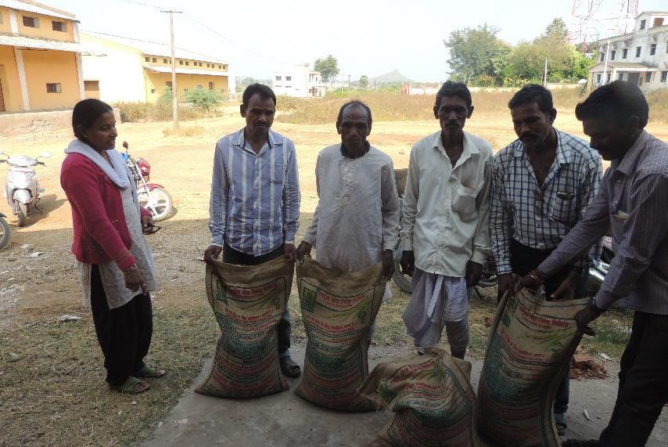

Fig 1. Seed distribution to farmers in Odisha

4. Next steps (1-2 sentences)

Efforts of quality seed production, FPVS trials and awareness programs will be continued to strengthen the seed systems in South Asia.

