Development of GxExM specific, economically most viable options for rabi-sorghum belt agroecologies. Ultimate target will include evaluation of grain&stover - quantity&quality improvement possible with stay-green technology in the field trials. These observations will be projected into the modelling outputs and used for the stay-green technology trade-off&risk analysis (if possible in "on-farm" scale).

Scientists: JKholova, VVadez, S. Dattamazumdar, K. Chadavalada, G. Fox, A. Borrell. M. Blummel, Ratnavathi, Talwar, Swarna (&teams)
Region(s): SA
Country(ies): India

Rationale: Environmental constrains has been characterized (Kholova et al. 2013, attached) and the lucrative adaptive traits (stay-green) under the current management in given agro-ecologies identified (Kholova et al. 2014). The missing piece is to explore the best management options in combination with given physiological mechanism to maximize the sorghum economic gains in target regions (rabi-sorghum belt). To deliver the maximum impact of the stay-green sorghum technology we need to understand the sorghum quality parameters which largely determine an acceptability of the product, economic value and the end-uses for the crop.

Methodology: This rabi season (2016-17) we are evaluating the ICRISAT sorghum elite breeding material (50 lines, hybrids, OPVs, B-&R-lines) under the non-limiting N- and water-availability and in farmers-like situation (limited N supply and terminal drought, high plant density). We aim to analyze the existing ICRISAT elites for quantitative&qualitative traits and understand which plant processes determine the plant fitness and acceptability in the target agro-ecologies (relevant quantitative&qualitative traits).
The modelling framework to analyze GxExM is being used from previous studies (Kholova et al 2013&2014)

Results and discussion:
- The data from previous trials (2011-2013) is being summarized into the publication (Kholova et al. “Effects of water-use mechanisms underlying expression of stay-green phenotype on the dynamics of the production and production trade-offs in sorghum”). This paper will focus on the analysis of GxE interactions and interplay of water use trait with N-acquisition linked traits is under preparation.
- Another MS are being developed to describe the baseline processes which affect the grain&stover quality parameters (Chandavalada et al, in prep).
- A diligent trainee from IIMR (Swarna P.) is being trained to model the effect of various management interventions (N application, plant population) in sorghum agro-ecologies in India (Fig 5).

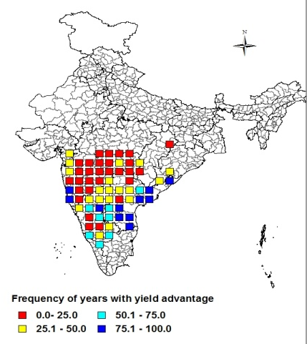
Fig 5. The color-coding reflects the likelihood of the locations to experience the sorghum grain yield increase due to increased nitrogen application (equivalent of on-station trials).

Conclusions: The precise knowledge and deciphering the basis of GxExM should help to refine breeding methodology/targets and maximize the sorghum production&quality in low-input environments (i.e. rabi-sorghum cultivation). Currently, it appears that technologies developed in our team (stay-green sorghum) have double-sided effect on improvement of grain&stover quality&quantity. Apart of the progress in GxExM modelling, we are trying to link the generated information to socioeconomic modelling to evaluate putative on-farm benefits of stay-green technology (with M. Blummel, Surjit).

