Activity 10: Train extension staff, agro dealers and farmers in GAPs, evaluation of PVS trials and selection of appropriate technologies
Objective and intended output: Build the capacity of the stakeholders along the finger millet value chain (extension staff, farmers, agro dealers) to increase production and productivity. Output is Number of stakeholders trained.
Materials and methods: Short training courses for extension staff were organized to train extension staff on GAPs and evaluation of trials, these they then passed on to the farmers. During field days demonstrations were done on the best varieties, agronomic practices like quality seed, water management practices, proper post-harvest techniques (use of tarpaulins and threshers, proper storage) and value addition.
Results and interpretation: 6258 extension staff, agro dealers, processors and farmers were trained in GAPs like proper timely planting, seedbed preparation, correct plant populations, correct weeding regimes, pest and disease control, proper harvesting and post-harvest techniques. During feed days farmers, extension staff and other stakeholders were trained on how to identify the best technologies.

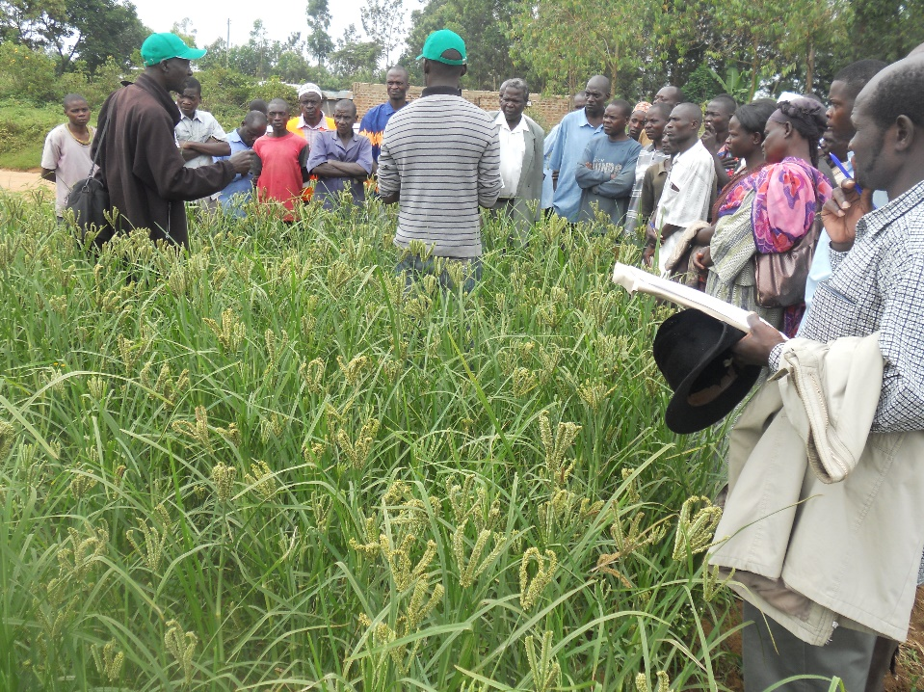
Farmers being trained on Finger millet Good Agronomic Practices (GAP)

Next steps: Train more stakeholders. Avail the different technologies to the farmers through PVS and demonstrations for them to select

