
Confined field evaluation of GE Potato for resistance to potato blight disease caused by Phytophthora infestans and developing Ugandan adapted varieties

28/11/2019

To : Chairperson
National Biosafety Committee
UNSCT,
Kampala

FIELD AND SCREEN HOUSE PLANTING REPORT FOR MULTI-LOCATIONALCONFINED FIELD TRIAL-3 AT KACHWEKANO ZARDI, RWEBITABA ZARDI AND BUGINYANYA ZARDI

Preparation of tuber seeds for the ML-CFT-3
Potato tubers (Transgenic Victoria (Vic.172 [820046.172], Vic.39 [820046.39], and Vic.179 [820046.179]) and non-transgenic Victoria for planting were raised from KaZARDI screen house facility located within the confined field trail. The production of seed tubers from Vic.39 and Vic.179 were meant to test their field resistance to Phytophthora infestans whereas the production of seed tubers from Vic.172 is meant for regulatory trials which will generate data and samples for the risk assessment studies.
Transportation GE tubers to other sites
The UNCST and NBC approval (No objection PROG 21/6, and decision NBC 01/2017) documents provide authorization to plant ML-CFT-3 with Vic.172, Vic.39 for confined field evaluation in Uganda. The Vic.179 seed tubers were not considered for planting because they were not ready at the time for planting. For each trial, the exact number of transgenic and non-transgenic seed tubers were separated in individual bags and then moved to the other locations, Rwebitaba and Buginyanya ZARDI, by NARO trial manager and CIP staff and were escorted throughout in transit by a designated Agricultural Inspector from Ministry of Agricultural Animal industry and fisheries (MAAIF) Mr Asiimwe Ronald. Upon arrival at theplanting sites, the package was inspected in presence of the trial manager, CIP staff, UNSCT Biosafety officer (Musa Kwehangana) and NBC chairperson (Dr Charles Mugoya). The correct number of tubers was always confirmed before planting.
Planting
Planting of ML-CFT-3 was done on14th-octomber at Kachwekano ZARDI, 15th Oct 2019 at Rwebitaba ZARDI, and 17th Oct 2019 at Buginyanya ZARDI. At Kachwekano site, two transgenic events (Vic. 172 and Vic. 39) were planted in the field while at the two other sites (Rwebitaba and Buginyanya) only the transgenic event Vic.172 was planted. At each site, uniform size tubers (300 for experimental test material and 450 for the control materials were used. The tubers that remained following field planting were planted for seed production in the screen house on 28th/11/2019 at Kachwekano ZARDI.
Field design and Planting
Using a randomized complete block design (RCBD) with 3 replications, 18 plots of 3m X 3 m were made within the CFT field at Kachwekano while 15 plots of the same dimension were made at Rwebitaba and Buginyanya. Each plot consisted of 5 rows separated from each other by 1 m. The spacing of 75 cm between row X 30 cm within the rows was used. 50 tubers of transgenic Victoria (Vic.172), Vict.39 and non-transgenic Victoria were planted per replicate. During planting, straight line trenches of about 10 cm deep were dug and 120 kg/acre of NPK 17:17:17 fertilizer was applied using hands and then sprouted tubers were placed into the trenches with sprouts facing upwards and then covered making a mound on the tubers. All the planted fields were labeled according to the field layout map of the plots. The planting was witnessed by National Biosafety Committee members and Inspectors from Ministry of Agriculture and CIP scientists.

Field layout of ML-CFT at Kachwekano
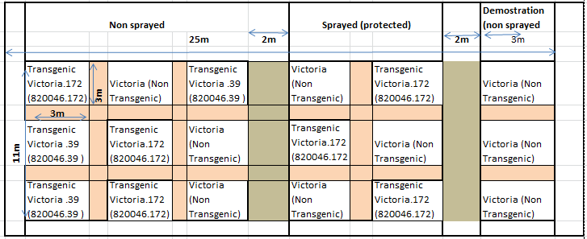

Field layout of ML-CFT at Rwebitaba and Buginyanya
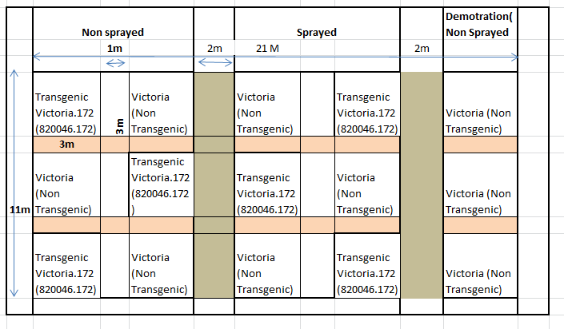

Following planting, the entire team that was involved in the exercise cleaned up themselves and was thoroughly checked on their way out to avoid any escape of the test material from site. The use of bags with the exact number of tubers needed and the verification of the presence of the 10 seed tubers in each row make very difficult to have any tuber loss.

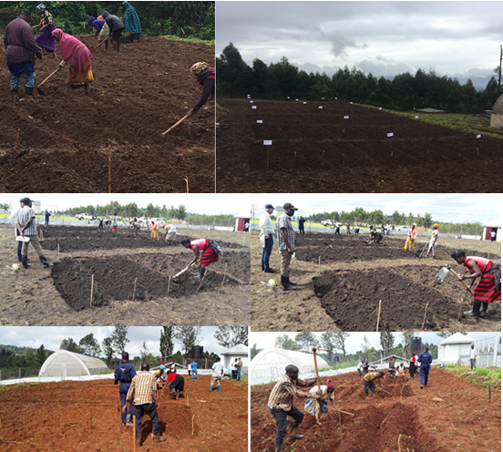

Figure 1. Planting of ML-CFT at Kachwekano, Rwebitaba and Buginyanya

Planting of Transgenic tubers in the Screen house for seed production
The tubers that remained following the ML-CFT-3 field planting were kept and then planted on 28/11/2019 in the screen house for generation of seeds to be used in the multi-location trials planned for March 2020. The planting was supervised by designated biosafety Inspector (Mr Ronald Asiimwe). Two tubers were planted per planting bucket on raised tables
Table 1: Number of tubers planted in the Screen house for seed production
Event | Quantity
Vic. 172 | 200
Vic. 39 | 20
Vic. 179 | 208
Non transgenic Victoria | 72
Total | 500
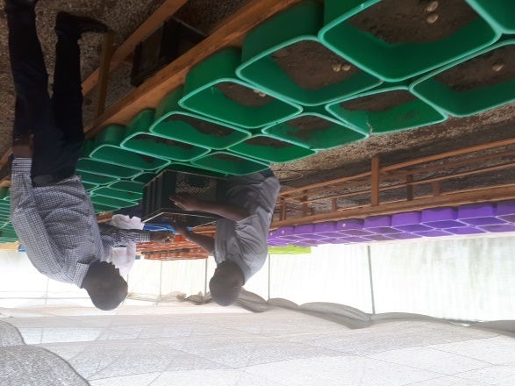
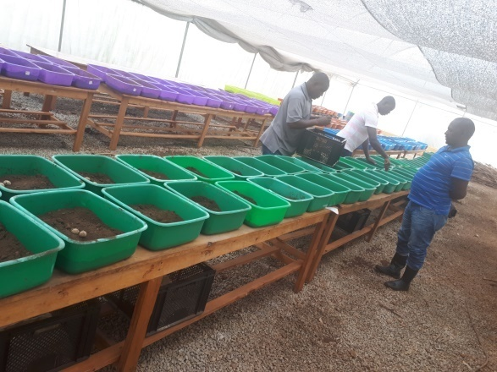

Figure 2. Planting of GE tubers for seed production at Kachwekano,

Annex 1: PLANTING OF CONFINED TRIAL FORM
PLANTING OF CONFINED TRIAL
TRIAL: Confined field evaluation of GM Potato for resistance to potato blight disease caused by Phytophthora infestans and developing Ugandan adapted varieties |  |  |  | SITE: Kachwekano ZARDI
Authorization Code Number: A567 |  |  |  | Planting Date: 14/10/2019
Instructions: Record the information requested below. Use additional pages if needed to recordany notes or details. Excess planting material should be stored or disposed of by [approvedmethod], or according to specific instructions.
Line Number | Amount Planted | No retained
820046.172 | 300
820046. 179
820046. 39 | 300
Victoria Non Transgenic | 450
Total | 1050
 | 1050 tubers
Comments on Planting:
Planting was well done according to the protocol
Intended Purpose of Retained Plant Material:
N/A (all materials were utilized in the field and in screen house), however, there was temporary storage of 500 tubers (Victoria 172 (200 tubers), Victoria 39 (20 tubers), Victoria 172 (208 tubers) and non transgenic Victoria (72 tubers), in the screen house after field planting and these were reserved for seed multiplication in the screen house and were planted on 28/11/2019
Storage Location:  Storage area within the CFT facility |  |  | Storage Location Secure: Yes No
Comments on why store:
For generation of seed for multi-location trials.
Shipping Containers Sterilized/Inspected/Destroyed by (Circle All That Apply):
Bleach Solution / Burned / Other (describe)
No shipping was done
Treated/Disposed of by (Initials) |  |  | Date  N/A
Total Genetically  Modified Planted |  |  | Plots  18 |  | Ha  0.00243
Total Area, Including  Non-GM Plants and Plots |  | Length (m)  25 | Width (m)  11 |  | Ha  0.00275
Reminder: Include a verified, signed and dated plot map in the study file. Plant [approved
borders] according to the approved plot diagram. Complete and submit Planting Report with final

plot map within five (5) days of completing planting.

Checked for Accuracy and Completeness by Trial Manager
Signature: Date: 14/10/2019

PLANTING OF CONFINED TRIAL
TRIAL: Confined field evaluation of GM Potato for resistance to potato blight disease caused by Phytophthora infestans and developing Ugandan adapted varieties |  |  |  | SITE:RWEBITABA ZARDI
Authorization Code Number: A567 |  |  |  | Planting Date: 15/10/2019
Instructions: Record the information requested below. Use additional pages if needed to record any notes or details. Excess planting material should be stored or disposed of by [approved method], or according to specific instructions.
Line Number | Amount Planted | No retained
820046.172 | 300
820046. 179
820046. 39
Victoria Non Transgenic | 450
Total | 750
 | 750 tubers
Comments on Planting:
Planting was well done according to the protocol
Intended Purpose of Retained Plant Material:
For generation of seed for multi-location trials
Storage Location:  Storage area within the CFT facility |  |  | Storage Location Secure: Yes No
Comments on why store:
For generation of seed for multi-location trials.
Shipping Containers Sterilized/Inspected/Destroyed by (Circle All That Apply):
Bleach Solution / Burned / Other (describe)
No shipping was done
Treated/Disposed of by (Initials) |  |  | Date  N/A
Total Genetically  Modified Planted |  |  | Plots  18 |  | Ha  0.0054
Total Area, Including  Non-GM Plants and Plots |  | Length (m)  21 | Width (m)  11 |  | Ha  0.00231
Reminder: Include a verified, signed and dated plot map in the study file. Plant [approved
borders] according to the approved plot diagram. Complete and submit Planting Report with final

plot map within five (5) days of completing planting.
Checked for Accuracy and Completeness by Trial Manager
Signature: Date: 15/10/2019

PLANTING OF CONFINED TRIAL
TRIAL: Confined field evaluation of GM Potato for resistance to potato blight disease caused by Phytophthora infestans and developing Ugandan adapted varieties |  |  |  | SITE: BUGINYANYA ZARDI
Authorization Code Number: A567 |  |  |  | Planting Date: 17/10/2019
Instructions: Record the information requested below. Use additional pages if needed to record any notes or details. Excess planting material should be stored or disposed of by [approved method], or according to specific instructions
Line Number | Amount Planted | No retained
820046.172 | 300
820046. 179
820046. 39
Victoria Non Transgenic | 450
Total | 750
 | 750 tubers
Comments on Planting:
Planting was well done according to the protocol
Intended Purpose of Retained Plant Material:
For generation of seed for multi-location trials
Storage Location:  Storage area within the CFT facility |  |  | Storage Location Secure: Yes No
Comments on why store:
For generation of seed for multi-location trials.
Shipping Containers Sterilized/Inspected/Destroyed by (Circle All That Apply):
Bleach Solution / Burned / Other (describe)
No shipping was done
Treated/Disposed of by (Initials) |  |  | Date  N/A
Total Genetically  Modified Planted |  |  | Plots  15 |  | Ha  0.0054
Total Area, Including  Non-GM Plants and Plots |  | Length (m)  21 | Width (m)  11 |  | Ha  0.00231
Reminder: Include a verified, signed and dated plot map in the study file. Plant [approved
borders] according to the approved plot diagram. Complete and submit Planting Report with final

plot map within five (5) days of completing planting.
Checked for Accuracy and Completeness by Trial Manager
Signature: Date: 17/10/2019

