Activity 5 - Support the release of resilient groundnut varieties in target regions in collaboration with NARS

Objective: To collaborate with NARS to conduct variety release trials and prepare release proposals.

Materials and methods: To provide superior varieties into variety release pipeline. Advanced breeding lines for release trials are shared, and data and pedigree information with NARS to enable compilation of release proposals, and facilitate availability of Breeder Seed required at the time of release.

Results and interpretation: In collaboration with NARS prepared release proposal for ICGV 02266 a farmer preferred variety identified in Odisha for state release. ICGV 02266 is a high pod yielding, drought tolerant variety, having medium-bold kernels, and good haulm-quality. It recorded over 25% higher pod yield over the popular variety Smruti in on-farm trials conducted in Baragada, Jajpur and Dhenkanal districts in Odisha during 2011-14 under TL II project supported by Bill & Melinda Gates Foundation.

Following national testing under AICRP-G, identified ICGV 03043, a high oil yielding line for national release for Zone V in India and other lines are in different states of testing for release (Table 1 and Fig. 5). Indian national program in looking forward to replace the Zonal Check, R 2001-2 as it has poor pod features despite being a prolific pod yielding variety. In 2016, ICGV 03043 recorded superior yield over R 2001-2 and will possible replace R 2001-2 as Zonal Check. ICGV 07222, a drought tolerant high oil yielding line was identified as adapted line for Tamil Nadu state in India, and ICGV 05155 is an adapted line for cultivation in Gujarat. Farmer participatory varietal selection trials were conducted in Odisha state (Fig. 6), and in collaboration with NARS, supplied 3500 kg of seeds of new High oil’ varieties to conduct Pilot demonstrations in 17 ha during rainy 2016.

Table 1. Performance of new high oil lines in AICRP-G testing in India.
Entry | Mean pod yield (Kg/ha) over seven locations of Zone V in India | % increase over the best check R 2001-2
R 2001-2 (Zonal check) | 2861
GPBD 4 (Zonal check) | 2085
VG 9816 (Zonal Check) | 2493
R 2001-3 (Zonal Check) | 2731
ICGV 05155 | 2958 | 3.4
ICGV 03043 | 3028 | 5.9
ICGV 06420 | 2638
ICGV 03042 | 2947 | 3.0
Source: Annual workshop report of AICRP-G; Data from Advanced varietal trials during rainy 2015 season at seven locations of agro ecological zone V of India.

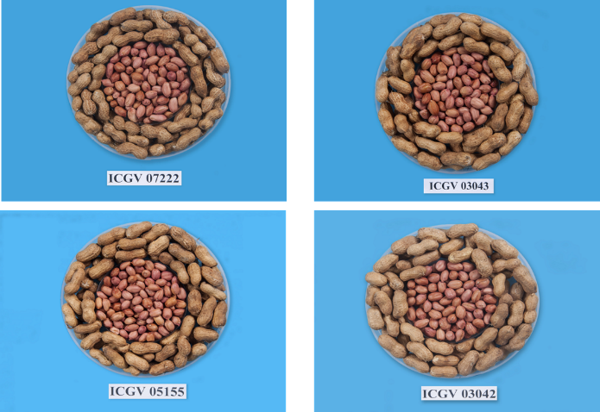
Fig. 5. New high oil lines identified for release (ICGV 03043) in India at national level for Zone V, and other lines in advance stages of testing for release.
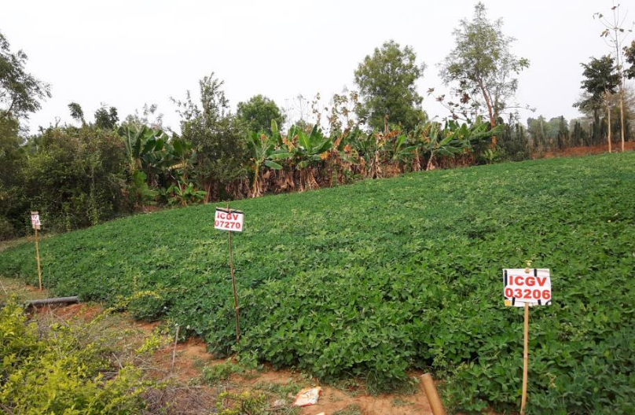
Fig. 6. Farmer Participator Varietal Selection trial conducted in farmers’ field in Bolangir district of Odisha state during post-rainy 2015-16 season.

Next steps: Fast-tracking release of high oleic lines and feed new lines with improved trait and their combinations into variety release pipelines.

