SARD – SC WHEAT PROJECT NIGERIA
GIANT STRIDES IN RURAL WOMEN DEVELOPMENT
Celebrating the Contributions of Women to Wheat Production and Processing
Today is Rural Women’s Day. On this day, the project celebrates the contributions of women to agricultural development. Wheat is one of the most important staple crops in Nigeria at an annual demand of 4.1 million metric tons. The Support to Agricultural Research for Development of Strategic Crops (SARD – SC) Wheat Component project supports women along the whole wheat value chain, in wheat production, processing and marketing. Lake Chad Research Institute Maiduguri has the national mandate for the genetic improvement of wheat, and implements the SARD – SC wheat project in Nigeria.
Women are increasingly contributing to wheat-related activities through this project along with broader government support aimed at increasing national production of wheat in the country. The project interventions target gender - specific obstacles for strengthening the participation of women in wheat processing and production. These are related to difficulties in meeting the labour requirements, financial difficulties in purchasing inputs for farming wheat, by-products quality, limited representation in leadership roles, and limited access to markets.
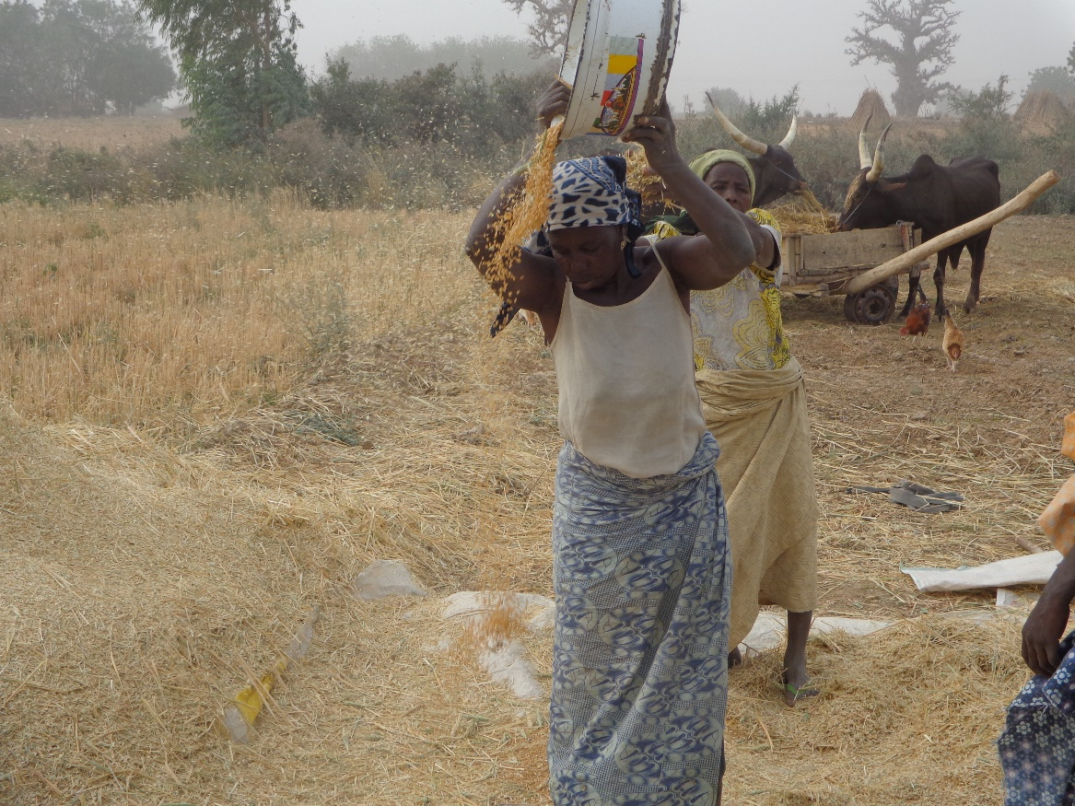
Some Nigeria rural women winnowing wheat after harvest. Pic credit: LCRI
Since its inception, the project continues to offer trainings to women in value addition which has improved by - products quality. According to women who have participated in the trainings, this led to increased sales of wheat by - products (up to double in some cases) thereby contributing significantly to poverty alleviation amongst rural women. With regards to production, the project continues to offer women farmers opportunities to participate in On – Farm and Off – Farm Trainings such as Farmer Field Schools, Field days, and pre-season trainings which cover the entire production cycle of wheat and the recommended agronomic practices. This resulted in increase in yield obtained on women’s farms as well as men’s. The project assisted in organizing the rural women as well as men into Innovation Platforms and links them to the Wheat Farmers Association which provides farmers with all inputs such as fertilizer, herbicides, pesticides and small cash loans to cover labor and fuel for irrigation purposes, then farmers repay their loans with wheat product.
Additionally, the project offers women opportunities to strengthen their leadership roles through public speeches and presentations whereby women interact with government officials at a high level and are provided with opportunities to voice their concerns. For example, in a field day in Kadawa area, a woman leader from the Wheat Farmers Association of Kano State requested from the Governor of Kano State, land for landless women and the youth. As a result 250 youth and women were granted with land of 1 ha each. The Wheat Farmer Association, supported by the project, encourages women to take on leadership roles. The Chairperson Wheat Farmer Association in Bauchi State, for example, is a woman who cultivates 100ha. The project has registered numerous other women in all the 13 major wheat growing states and the 4 Innovation Platforms of the project in Nigeria. It continues to support the involvement of women in production, processing, value addition and reduction of drudgery through mechanization. However, mechanization will also lead to job losses for women, such as in winnowing. As such, the project will train women and provide them with a thresher to generate alternative income.
Cultural barriers such as segregation of gender are addressed through the appointment of women extension agents in training women on agronomic practices in wheat production and linking them with respective institutions.
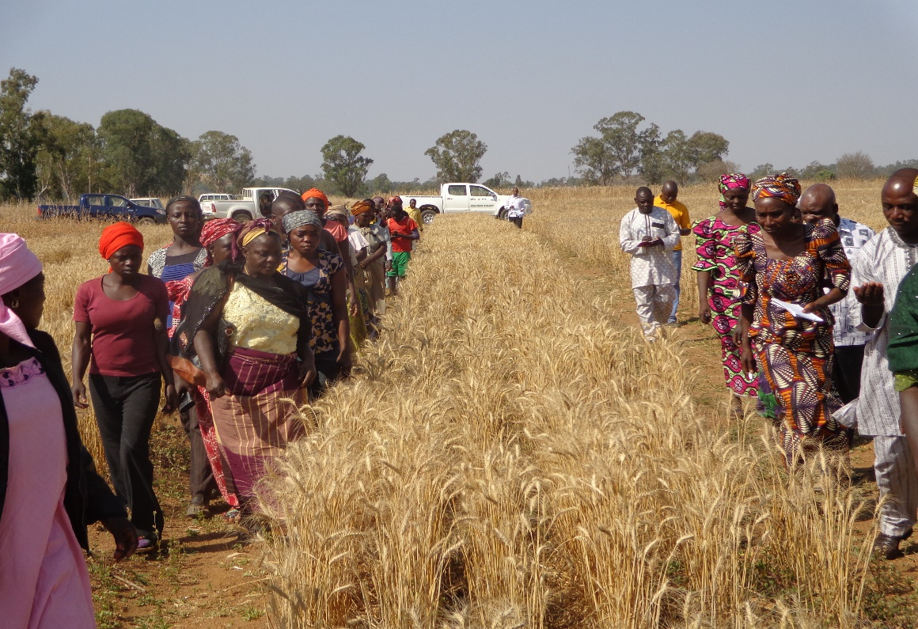
Women involved in Rainfed wheat varietal selection on the Jos plateau. Pic. Credit LCRI
Taken together, the project addresses practical and strategic gender gaps to overcome obstacles for women in wheat production and processing. The project is scaling this approach through linking up with policy makers and gender-progressive institutions. The number of women beneficiaries is on the rise. For example, in Kano State 2500 women have so far registered in an on-going exercise for accessing inputs and loans.
Women in the rural areas are now particularly more involved in wheat production, processing and marketing than ever before due to the SARD–SC wheat intervention. Some explaining that this is the first project to target women in the wheat crop. The pre – season trainings, field days, fields schools and demonstrations being conducted by the Lake Chad Research Institute in collaboration with the SARD – SC Wheat project and the support of the Federal Ministry of Agriculture and Rural Development in various states in Nigeria provided new knowledge, thinking and confidence in wheat production, processing and utilization for women thereby significantly contributing to poverty alleviation amongst the rural women. Today, we celebrate with the Nigerian rural women, the strengthening of their roles in wheat production and processing.
An article written by:: SARD - SC Gender team, Nigeria and Dina Najjar, Social and Gender Specialist, ICARDA Edited by: Mohammed Abba Sadiq, Communication specialist – SARD – SC Wheat project Nigeria

