4.1.1.1. Market adaptability and nutritional quality of beans. Precooked beans are accepted
Developing new bean products in Kenya, Uganda and Rwanda through private sector collaborations
Preecooked Beans and snacks
Objective and intended output: It can be argued that the common bean is under-utilized in the diets of many communities due to limited knowledge and skills on its culinary preparation. This activity has the objective of opening new markets for common beans with products that are convenient for urban and rural housewives.
Materials and methods: One of the initiatives targeted “dry” precooked beans and the other “wet” precooked beans. The “dry” precooked bean is dehydrated after processing but retains the main character of the dry beans (colour, storage under normal room temperatures but can be cooked within 10-15 mins to make a meal (trading under Sisi products). New processing methods available to the private sector can be harnessed to enhance the nutritional quality, palatability, nutrient digestibility and iron bioavailability of beans. Extrusion is a popular method in food processing that is being promoted for bean-based products development in Uganda.
Results and interpretation: A number of initiatives targeting value addition for beans started to bear fruits: two of them involved development of new bean products called precooked beans. And another precooked bean snack that is ready to eat -0 minutes to cook (Figure 1). The wet precooked bean in Rwanda was launched in the market in the second quarter of 2016 under the trade name Farm Fresh precooked beans (Figure 2).PABRA and NARS have been heavily involved in the collaborative efforts from product development to ensuring supply of grain to the processing firms. 23,875 farmers (11,447 men and 12,428 Women) are engaged in seed and grain production.
The three products developed through extrusion include: a) BeaNut butter - a bean and peanut mix butter that is used in making soups, sauces, and added to vegetables; b) Instant bean flour - a flour that can be incorporated into baking recipes and porridges; c) Bean pellets - bean cubes that resemble beef cubes and can be cooked in sauces.
Next steps: Trade and consumer launch of precooked beans and start commercial production for the market are expected from end of quarter 1 of 2017. In addition, there will be study of demand of precooked bean during and after launch to understand market dynamics for these new products
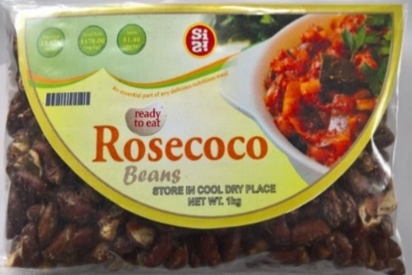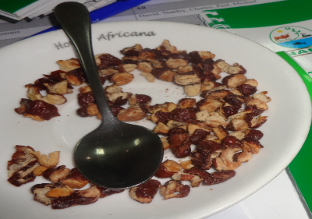
Figure 1. Bean snack

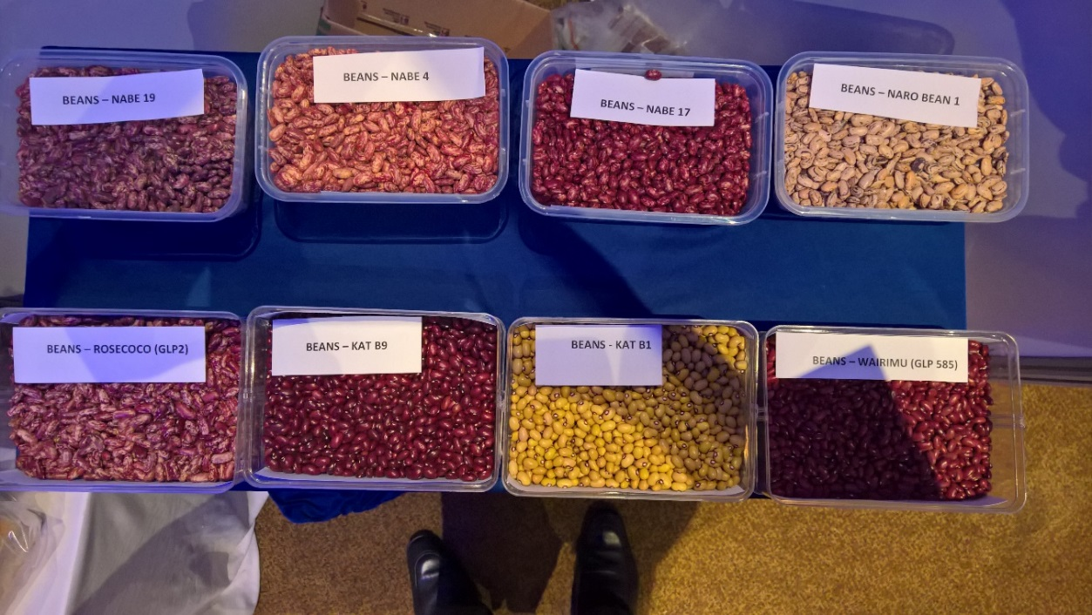
Figure 2. Some of the varieties selected for precooked bean production in Kenya and Uganda

Developing bean commodity corridors in PABRA member countries
Objective and intended output: PABRA is using a commodity corridor approach to develop production and marketing of beans in the countries. The approach focuses on intensification of bean production and marketing and in close collaboration with the private sector lead firms.
Materials and methods: Bean production hubs as well as market/consumption hubs have been mapped out in Africa and a number of them in Kenya and Uganda as well as Ethiopia are already applying the approach to promote production of market demanded varieties.

Results and interpretation: A report on the corridor concept and implementation approach will be available end of the first quarter of 2017. The precooked bean products are being promoted under the corridor approach in Kenya and Uganda. In Kenya the corridor is in the Lake basin bean corridor while in Uganda, it targets the central Uganda bean corridor.
Next steps: Partners will be consulted to share this vision and develop work plans that are integrated around corridors.
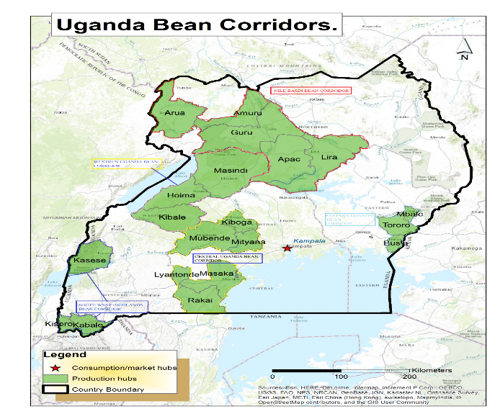
Figure 3: An example of bean corridor in Uganda

Engaging the private sector for nutrition - Kenya, Uganda
Objective and intended output: Engagement of the private sector, in both Kenya and Uganda, was aimed at promoting cost-effective production and consumption of nutrient dense and safe bean-based products.

Materials and methods Azuri Health (Kenya) and Nutreal Limited (Uganda) were facilitated to generate a strategic plan, assess market opportunities, and conduct product definition workshops for a bean based porridge targeting the Base of Pyramid (BOP) consumers.

Results and interpretation: The outputs of this engagement were: (i) strategic plans on product development, targeted consumers, and promotion mechanism; (ii) market reports detailing the opportunities available for the companies to enter the proposed market in their respective countries; and (iii) a product definition document to guide the product development teams when choosing ingredients, processing methods, packaging materials, and marketing strategy.

Next steps: These efforts need to be scaled out to other countries with a budding food processing industry.

