2.3.1.1. Identification of genes and genetic mechanisms contributing to improved crop performance in low fertility soils, especially under water constraint. Common bean lines identified as resistant to soil pathogens to serve as sources for Andean beans.

Objective and intended outputs: This research is aimed, first, to establish a reliable methodology to screen Phaseolus against resistance to the root rot pathogen Pythium myriotylum and to waterlogging, and second, to evaluate wild relatives of common bean for pathogen resistance and and also tolerance to heat and to waterlogging, as these environmental parameters often accompany the pathogen.

Materials and methods: Greenhouse infrastructure was adapted to control and monitor constantly soil moisture through the installation of an automatic watering system that included pipes, sensors, and data loggers (Figure 1). We are reporting the results obtained from phenotyping a set of accessions corresponding to 100 from Phaseolus vulgaris, 40 from Phaseolus coccineus, 10 from Phaseolus dumosus, 15 from Phaseolus costaricensis and 1 from Phaseolus albescens, evaluated under two challenging conditions: waterlogging and waterlogging plus P. myriotylum infection. Experimental data was registered from 10 seeds per accession at 7, 14, 21 and 28 days after sowing. The experiment was repeated twice. Another group of breeding lines called RRA (Root Rot Andean) that has been developed by bean breeding program, was evaluated to find resistance to Pythium and Sclerotium. This population was originated from interspecific crosses (P. vulgaris x [P. vulgaris x P. coccineus]) and was evaluated after several selection cycles in the field.

Results and interpretation: More than 150 accessions were identified as promising for waterlogging and/or P. myriotylum including wild P. vulgaris, P. coccineus, and P. dumosus (Table 1). It is essential to consider these traits together as Pythium species typically occur in conditions of excess moisture. As this was our first experience with waterlogging we did not know what to expect, but were surprised that so many accessions survived the waterlogging treatment. However, very few expressed a capacity to extend roots into a saturated soil, but maintained a very shallow root system. Parallel to these evaluations, accessions were analyzed for heat tolerance, which is relevant to this complex since the Pythium species is prevalent in warm climates. Among the RRA lines, 100 lines that are resistant to both pathogens were identified (Table 2).

Next steps: This activity was carried out under a project financed by the Global Crop Diversity Trust, in which the next steps will be to initiate crosses in a pre-breeding program. Accessions with a degree of tolerance will be favored in making crosses. The RRA lines have been shared with colleagues in Africa for testing with local isolates.

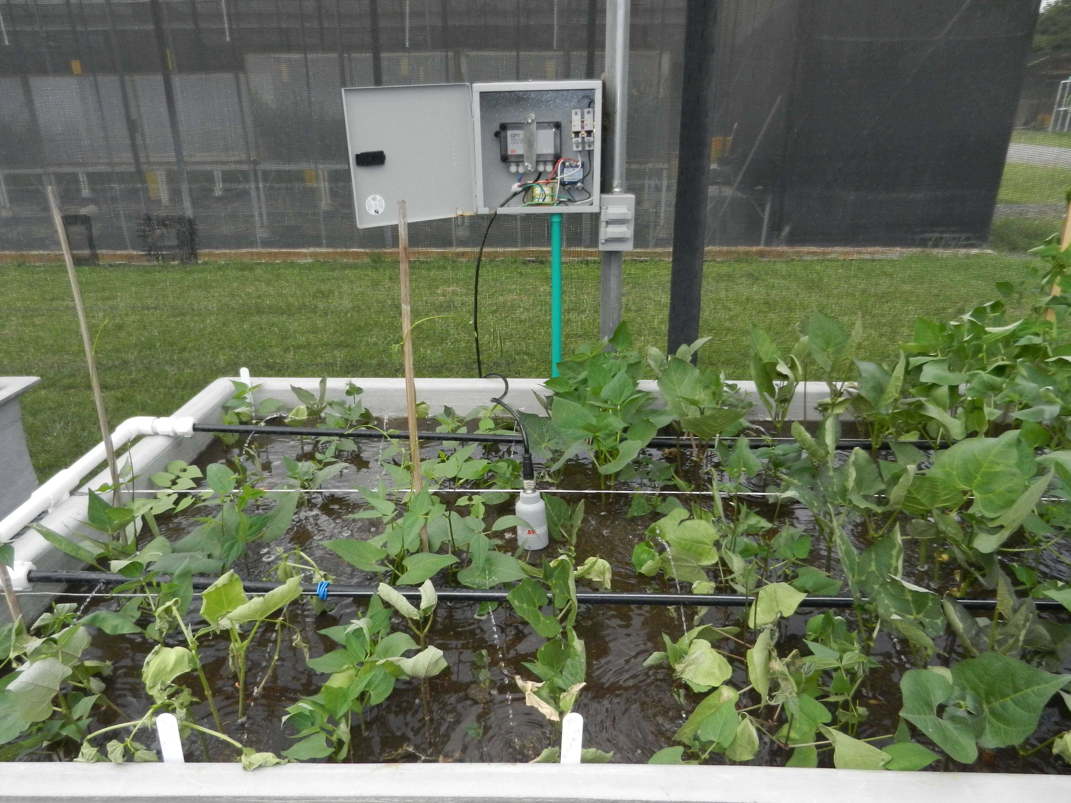

Figure 1: Adaptations to greenhouse soil trays for screening Phaseolus to waterlogging and Pythium disease, with SM150 Delta-T® sensors to monitor and control soil moisture, and dataloggers GP1 Delta-T® to store the data obtained during the experiments.

Table 1: Results obtained from testing accessions against waterlogging and waterlogging plus P. myriotylum. Only accessions showing tolerance to waterlogging (T), and resistance (R) and intermediate resistance (I) to waterlogging plus pathogen are shown.

Identification | species | Phenotype
Identification | species | Waterlogging + Pythium | Waterlogging
G2771 | Phaseolus vulgaris | R | T
G10000 | Phaseolus vulgaris | R | T
G19895 | Phaseolus vulgaris | R | T
G21117 | Phaseolus vulgaris | R | T
G21245 | Phaseolus vulgaris | R | T
G23432 | Phaseolus vulgaris | R | T
G35263 | Phaseolus dumosus | R | T
G35346 | Phaseolus coccineus | R | T
G35999 | Phaseolus coccineus | R | T
G40877 | Phaseolus costaricensis | R | T
G12889 | Phaseolus vulgaris | R | T
G21197 | Phaseolus vulgaris | R | T
G10022 | Phaseolus vulgaris | R | T
G12949 | Phaseolus vulgaris | R | T
G23438 | Phaseolus vulgaris | R | T
G11054 | Phaseolus vulgaris | R | T
G23435 | Phaseolus vulgaris | R | T
G19901 | Phaseolus vulgaris | R | T
G23421 | Phaseolus vulgaris | R | T
G35382 | Phaseolus coccineus | R | T
G11053 | Phaseolus vulgaris | R | T
G23416 | Phaseolus vulgaris | R | T
G12879 | Phaseolus vulgaris | R | T
G19906 | Phaseolus vulgaris | R | T
G24412 | Phaseolus vulgaris | R | T
G35066 | Phaseolus coccineus | R | T
G35837A | Phaseolus coccineus | R | T
G23511A | Phaseolus vulgaris | R | T
G50075 | Phaseolus vulgaris | R | T
G10023 | Phaseolus vulgaris | R | T
G23429 | Phaseolus vulgaris | R | T
G19026C | Phaseolus vulgaris | R | T
G40897 | Phaseolus albescens | R | T
G11050 | Phaseolus vulgaris | R | T
G12875 | Phaseolus vulgaris | R | T
G12879A | Phaseolus vulgaris | R | T
G23434A | Phaseolus vulgaris | R | T
G35877 | Phaseolus dumosus | R | T
G40604 | Phaseolus costaricensis | R | T
G12869 | Phaseolus vulgaris | R | T
G24576 | Phaseolus vulgaris | R | T
G12851 | Phaseolus vulgaris | R | T
G23440 | Phaseolus vulgaris | R | T
G24391 | Phaseolus vulgaris | R | T
G10019A | Phaseolus vulgaris | R | T
G40804 | Phaseolus costaricensis | R | T
G23552 | Phaseolus vulgaris | R | T
G19026 | Phaseolus vulgaris | R | T
G35266 | Phaseolus coccineus | R | T
G40892 | Phaseolus costaricensis | R | T
G12947 | Phaseolus vulgaris | R | T
G19897 | Phaseolus vulgaris | R | T
G23434B | Phaseolus vulgaris | R | T
G40806 | Phaseolus costaricensis | R | T
G40811 | Phaseolus costaricensis | R | T
G12865 | Phaseolus vulgaris | R | T
G40811B | Phaseolus costaricensis | R | T
G23419A | Phaseolus vulgaris | R | T
G23441 | Phaseolus vulgaris | R | T
G23583 | Phaseolus vulgaris | R | T
G35006 | Phaseolus coccineus | R | T
G13021 | Phaseolus vulgaris | R | T
G10019 | Phaseolus vulgaris | R | T
G22303 | Phaseolus vulgaris | R | T
G24758 | Phaseolus vulgaris | R | T
G19908 | Phaseolus vulgaris | R | T
G22837 | Phaseolus vulgaris | R | T
G23586 | Phaseolus vulgaris | R | T
G23589 | Phaseolus vulgaris | R | T
G23592 | Phaseolus vulgaris | R | T
G35103 | Phaseolus coccineus | R | T
G35500 | Phaseolus coccineus | R | T
G35506 | Phaseolus coccineus | R | T
G35856 | Phaseolus coccineus | R | T
G35871 | Phaseolus coccineus | R | T
G12871 | Phaseolus vulgaris | R | T
G23582 | Phaseolus vulgaris | R | T
G23723 | Phaseolus vulgaris | R | T
G23426 | Phaseolus vulgaris | R | T
G23426A | Phaseolus vulgaris | R | T
G10002 | Phaseolus vulgaris | R | T
G11034 | Phaseolus vulgaris | R | T
G23439 | Phaseolus vulgaris | R | T
G35177 | Phaseolus coccineus | R | T
G35453 | Phaseolus dumosus | R | T
G35476 | Phaseolus coccineus | R | T
G23725 | Phaseolus vulgaris | R | T
G24404 | Phaseolus vulgaris | R | T
G35851 | Phaseolus coccineus | R | T
G40878 | Phaseolus costaricensis | R | T
G23431 | Phaseolus vulgaris | R | T
G11051 | Phaseolus vulgaris | R | T
G19890 | Phaseolus vulgaris | R | T
G23470 | Phaseolus vulgaris | R | T
G23526 | Phaseolus vulgaris | R | T
G35846 | Phaseolus coccineus | R | T
G40896 | Phaseolus costaricensis | R | T
G35485 | Phaseolus coccineus | R | T
G35838 | Phaseolus coccineus | R | T
G23545 | Phaseolus vulgaris | R | T
G12867 | Phaseolus vulgaris | R | T
G23556 | Phaseolus vulgaris | R | T
G23459 | Phaseolus vulgaris | R | T
G23579 | Phaseolus vulgaris | R | T
G24345 | Phaseolus vulgaris | R | T
G35313 | Phaseolus coccineus | R | T
G35358 | Phaseolus coccineus | R | T
G19909 | Phaseolus vulgaris | R | T
G23585 | Phaseolus vulgaris | R | T
G24423 | Phaseolus vulgaris | R | T
G35509 | Phaseolus coccineus | R | T
G35599 | Phaseolus coccineus | R | T
G23464 | Phaseolus vulgaris | I | T
G12852 | Phaseolus vulgaris | I | T
G35007 | Phaseolus coccineus | I | T
G35353 | Phaseolus coccineus | I | T
G35454 | Phaseolus coccineus | I | T
G35758 | Phaseolus dumosus | I | T
G12856 | Phaseolus vulgaris | I | T
G23569 | Phaseolus vulgaris | I | T
G23445 | Phaseolus vulgaris | I | T
G23580A | Phaseolus vulgaris | I | T
G24665 | Phaseolus vulgaris | I | T
G24408 | Phaseolus vulgaris | I | T
G19893 | Phaseolus vulgaris | I | T
G35759 | Phaseolus coccineus | I | T
G35086 | Phaseolus coccineus | I | T
G35597 | Phaseolus coccineus | I | T
G19892 | Phaseolus vulgaris | I | T
G23462 | Phaseolus vulgaris | I | T
G12893 | Phaseolus vulgaris | I | T
G35845 | Phaseolus coccineus | I | T
G23576 | Phaseolus vulgaris | I | T
G12922 | Phaseolus vulgaris | I | T
G12922A | Phaseolus vulgaris | I | T
G35369 | Phaseolus coccineus | I | T
G35995 | Phaseolus dumosus | I | T
G19889 | Phaseolus vulgaris | I | T
G24605 | Phaseolus vulgaris | I | T
G35573 | Phaseolus dumosus | I | T
G40805 | Phaseolus costaricensis | I | T
G24416 | Phaseolus vulgaris | I | T
G35464 | Phaseolus vulgaris | I | T
G35471 | Phaseolus vulgaris | I | T
G35359 | Phaseolus dumosus | I | T
G23678 | Phaseolus vulgaris | I | T
G23442 | Phaseolus vulgaris | I | T
G35757 | Phaseolus coccineus | I | T
G35837 | Phaseolus coccineus | I | T
G23454E | Phaseolus vulgaris | I | T
G35099 | Phaseolus dumosus | I | T
G24318 | Phaseolus vulgaris | I | T

Table 2: Interspecific lines between Andean beans and Phaseolus coccineus that were resistant to two soil pathogens in a greenhouse test.

Genotype Designation
RRA190
RRA186
RRA184
RRA182
RRA181
RRA179
RRA178
RRA176
RRA175
RRA173
RRA172
RRA171
RRA170
RRA169
RRA168
RRA167
RRA164
RRA162
RRA161
RRA160
RRA159
RRA158
RRA157
RRA156
RRA155
RRA150
RRA149
RRA147
RRA146
RRA145
RRA143
RRA141
RRA139
RRA138
RRA137
RRA136
RRA135
RRA134
RRA133
RRA132
RRA131
RRA129
RRA127
RRA126
RRA125
RRA124
RRA122
RRA121
RRA120
RRA119
RRA113
RRA110
RRA107
RRA104
RRA103
RRA102
RRA101
RRA100
RRA99
RRA94
RRA93
RRA92
RRA91
RRA90
RRA86
RRA81
RRA80
RRA79
RRA78
RRA77
RRA76
RRA75
RRA74
RRA72
RRA71
RRA70
RRA62
RRA59
RRA57
RRA50
RRA48
RRA46
RRA43
RRA41
RRA39
RRA38
RRA36
RRA32
RRA31
RRA30
RRA29
RRA26
RRA17
RRA16
RRA15
RRA14
RRA13
RRA12
RRA9
RRA4

