
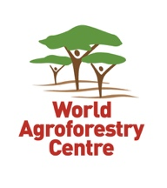

DRYLAND SYSTEM 2016 REPORT:

Atlas of Land Restoration Options in East Africa and the Sahel

Leigh Winowiecki, with contributions from Anne Kuria, Yvonne Agoya and Harry Wells, December 2016

World Agroforestry Centre (ICRAF), Nairobi, Kenya

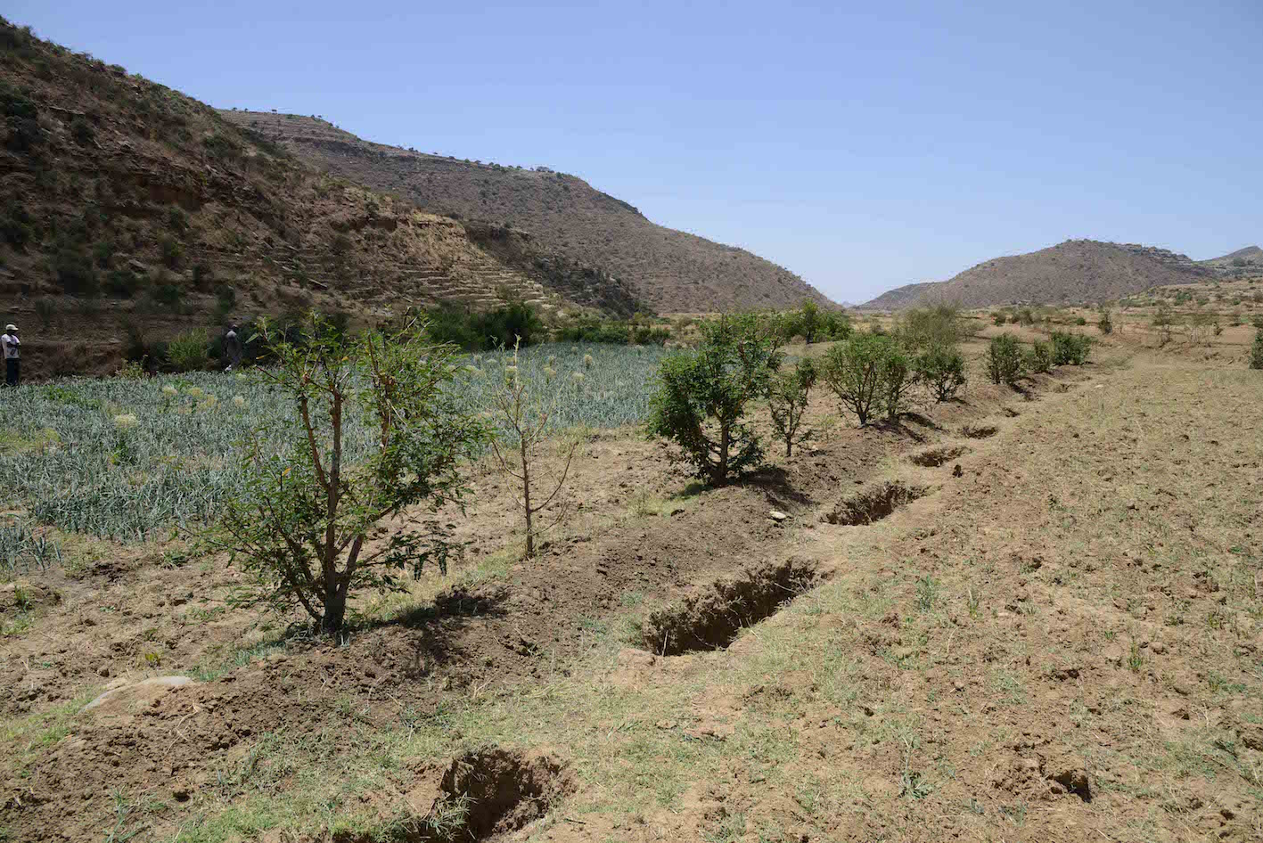

Photo of land restoration technologies in Samre woreda, Ethiopia.

Table of Contents

I. Introduction 2
II. Methods 2
III. Results 3
a. A DETAILED OVERVIEW OF LAND RESTORATION INTERVENTIONS IN FOUR WATERSHEDS IN SAMRE WOREDA, TIGRAY by Anne Kuria 3
b. STUDY SITES 5
c. MAYTEKLI WATERSHED 6
d. WAZA WATERSHED 11
e. DEKERA WATERSHED 17
f. AMDI WOYALE WATERSHED 20
g. Matrix of Restoration Options in East Africa and the Sahel 22
i. Restoration Options in Kenya 22
ii. Restoration Options in Ethiopia 26
iii. Restoration Options in Tanzania 28
iv. Restoration Options in Niger and Burkina Faso 36
IV. Discussion 44

Introduction
Land degradation has become increasingly prevalent in many parts of sub-Saharan Africa (SSA) during the last five to six decades, mainly due to explosive population growth, coupled with erratic and unreliable climatic patterns, unsustainable land management practices and often non-existent policies for land management. Often, droughts and famines in SSA are manifestations of more profound problems of soil- and land degradation. For example, in semi-arid environments, such as the in the highlands of Ethiopia, land degradation dates back many decades. As land degradation, food security and human well-being are inextricably linked, restoration has become a key priority in many African countries as well as through global initiatives.
A number of international initiatives, including the United Nations Convention to Combat Desertification (UNCCD) and the UN Environment Programme (UNEP), recognize the severity of land degradation globally and recently launched the ‘2030 Agenda for Sustainable Development’. For example, goal 15 in the Sustainable Development Goals (SDGs) aims to "protect, restore and promote sustainable use of terrestrial ecosystems, sustainably manage forests, combat desertification, and halt and reverse land degradation and halt biodiversity loss". At the Land Degradation Neutrality (LDN) project inception meeting in Bonn, January 2015, agreement was reached for a monitoring framework towards achieving national level land degradation neutrality targets (UNCCD 2015). Indicators include trends in land use/cover, land productivity and soil organic carbon stocks. In order to support this agenda, methods and approaches that are scientifically rigorous and applicable to a range of different ecosystems globally at multiple scales must be implemented to assess and monitor land degradation. To aid country practitioners in carrying out restoration activities, IUCN and WRI created a guide to assess opportunities for forest landscape restoration, where they highlight the need for spatial data for assessing restoration potential (IUCN and WRI, 2014). However, major gaps still exist in methods to assess land degradation, particularly for spatially explicit assessments at scales necessary for targeting interventions (Davies et al., 2012; Lal, 2004; Mortimore, 2009) as well as out-scaling of key restoration activities and technologies.

Methods

Literature Review
A detailed literature review was conducted and focused on documenting and quantifying successes and failures of large and small scale restoration projects. Coordinated by ICRAF, each country review was led by a CGIAR center: ILRI in Ethiopia; ICRAF in Tanzania and Kenya; ICRISAT in Niger and Burkina Faso. These reviews are available on the mel.cgiar.org. The lessons learned were used to inform project activities, identify key restoration activities in each country, as well key actors implementing restoration activities. In addition, the review documented if baseline assessments were conducted, interventions implemented, and the indicators used to evaluate success of the restoration interventions. For this report we systematically went through the reviews and created a matrix of restoration options for each country, including potential benefits of the technologies and possible constraints.

Local Knowledge Field Study
A study aimed at eliciting farmers’ local knowledge to identify gaps and opportunities for taking land restoration to scale in dry-land systems was carried out in Samre, Tigray between October and November, 2016. To achieve this, the study first identified key on-going restoration activities. This including field visits across the landscape, with key stakeholders as well as farmers. The key lessons learnt from this study will be critical in informing future scaling activities for the IFAD’s land restoration project.

Results

A DETAILED OVERVIEW OF LAND RESTORATION INTERVENTIONS IN FOUR WATERSHEDS IN SAMRE WOREDA, TIGRAY by Anne Kuria

This report presents an initial overview of land restoration interventions in four watersheds in Samre woreda, Tigray, Ethiopia. There are three main land use categories in Samre woreda: cropland, exclosures and communal grazing land. Land restoration activities are being implemented on two land uses (cropland or exclosures) and depend on the level of land degradation.

Exclosures: This involves setting aside the severely degraded areas where soil has been lost, with the aim of reversing land degradation through employing various land restoration interventions. This is achieved through:
> Controlling soil loss and restoring soil and land to its productive use and increasing soil fertility through reducing surface run-off and enhancing sediment trapping at all slope locations (upslope, midslope and downslope)
> Enhancing ground water recharge and soil moisture retention- which is then utilized for irritating crops, watering livestock and home consumption
> Enhancing vegetation regeneration (natural and planted), thereby also increasing ecological resilience (soil stabilization) and also increasing the provisioning ecosystem services such as fuelwood, fodder, bee forage.
Exclosures are managed by the watershed committees comprising of 12 to 60 members, and governed through by-laws such as farmers practice cut and carry system of livestock management
Cropland: This is established on areas that are relatively less degraded and which has arable soils to support crop production.
Restoration interventions within the cropland are managed by the farmers, but with technical support from the implementing and the watershed committee
Land restoration interventions are selected based on the context of the landscape namely: intended land use, slope gradient, and soil type and status.

Table 1: Contextual Conditions that influence Land Restoration Interventions
RESTORATION INTERVENTION | CONTEXT |  |  | FUNCTION
RESTORATION INTERVENTION | LANDUSE | SOIL | SLOPE | FUNCTION
Hillside bench terraces with stones | Cropland &  Exclosures | Areas with soil | >50%  Upslope | To stabilize soil and convert steep slopes into arable flat bench land to enable crop cultivation.
Hillside stone bunds | Exclosures | Rocks or areas with no or minimal soil | >50%  Upslope | Constructed horizontally across the slope contour, the main aim is to slow the speed of rain surface runoff downslope and intercept small amounts of soil and enable gradual soil formation and regeneration
Deep trenches | Cropland  & Exclosures | Deep soil | Midslope and downslope | To trap sediments and retain moisture. Smaller sized cropland trenches measuring (2x0.5x0.5)m compared to exclosures (4 or 3 or 2 x 1x1)m in order preserve more cropland for production
Percolation channels | Exclosures | Deep soil | Upslope | Ground water recharge. They feed into percolation ponds which are larger in size. They are arranged horizontally and are 1m apart in order to intersept more water  Size- 6x3x1.5m
Percolation ponds | Exclosures | Deep soil | Upslope | They are huge and aimed at ground water recharge. They are built upslope to intercept water from a larger upper surface area, including the mouth of vertical gullies due to the large amount of surface runoff
Large half moon basins | Exclosures | Shallow soil | < 15% slope  Downslope edge | Soil interception and conservation of surface run off. Trees are then planted
Eye brow basins | Exclosures | Shallow to deep soil | 35%- 50% slope  Up/midslope | Soil interception and conservation of surface run off
Micro basins | Exclosures | Shallow soil | 15%- 50% slope  Midslope | Soil interception and conservation of surface run off
Loose stone and rock-filled gabions checkdams | Exclosures | No soil, shallow or deep soil | Upstream and midstream | Reduce the speed of surface run-off, enhance sediment deposition to create conditions for gully healing including supporting vegetation regeneration
Water harvesting check dam | Exclosures | No, shallow or deep | Downstream | Built downstream across the gully to store rainwater and also ground water recharged through other structures such as percolation ponds
Biological gully bank stabilization | Exclosures | No, shallow or deep | Along the gully | Reclamation, reshaping and stabilization of gully banks through planting or regenerating natural vegetation

STUDY SITES
The study areas are shown in the map below. Waza has the oldest land restoration interventions in one of its four sub-catchment which was implemented by the Productive SafetyNet Programme in 2012. The Drylands Development (DryDev) project has implemented interventions in 2016 in three watersheds (Waza, Maytekli and Dekera); Amdi-woyale watershed has no interventions (Figure 1).

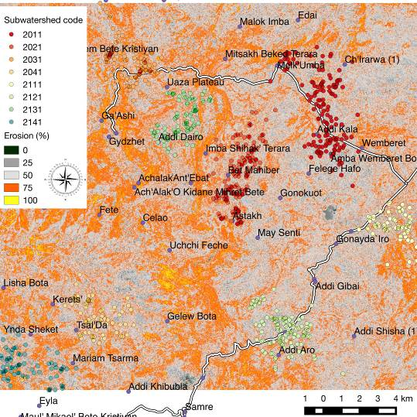
Maytekli
Waza
Amdi Woyale
Dekera

Figure 1: Erosion prevalence map of the four watersheds in Samre woreda. Source: Vågen et al 2016.

MAYTEKLI WATERSHED
Main crops in the Maytekli watershed include wheat, barley, teff. Soil is sandy silt with rocks. Dominant tree species: Euphorbia candleabrum, Acacia melanoxylon, Cordia africana, Juniperus procera, Croton macrostachyus, Acacia spp (Siraw), and some bee forage shrubs (tebeb, Grbia, shbukarni). Table 2 highlights the interventions.

Table 2: List of land restoration interventions in Maytekli watershed.
Land use | Period of Intervention | Implemented by | Slope Conditions | Restoration Intervention
Rehabilitated crop land converted from communal grazing land | 2015 | Productive Safety Net Programme | Steep slope | Bench terraces with stone on steep slopes. Converted land has been distributed to 25 landless farmers.  Farmers are planting mangoes and avocadoes and irrigated vegetables
Rehabilitated cropland | 2016 | DryDev | Flat downslopes | FMNR (Acacia), Agroforestry species- Sesbania, Leucaena, Acacia albida
Exclosures and catchment treatment. It was a communal grazing land | 2016 | DryDev | Steep slopes | Hillside bench terraces, Percolation channels, Percolation ponds, Half-moon microbasins, Eye brow micro basin, Deep trenches,  Water harvesting checkdam ponds, Loose stone checkdam, rock-filled dam
Gulley reclamation | 2016 | DryDev | Up and downstream | 3.75km of gully rehabilitated
Communal land with No intervention ‘Control’ site | - | - | Steep slopes | Highly degraded with recent land slides which occurred in August, 2016  It is adjacent to the reclaimed cropland under the SafetyNet programme

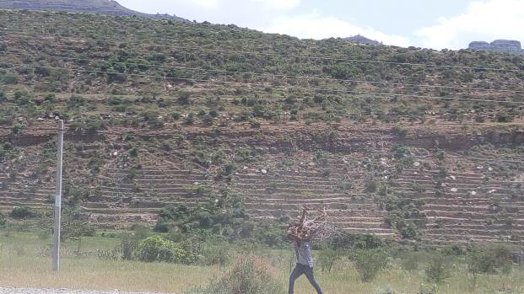
Rehabilitated farmland that was distributed to 25 farmers

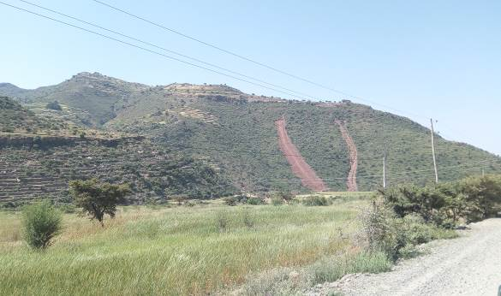
Recent landslide (August, 2016) from the ‘control’ non-intervention area

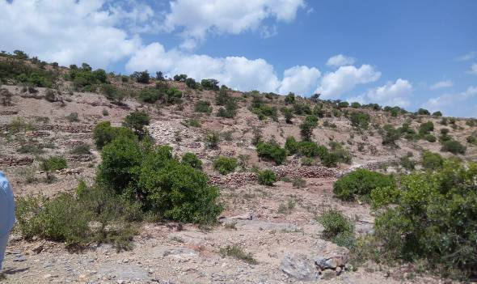
A recently rehabilitated exclosure with various soil and water conservation structures by DryDev

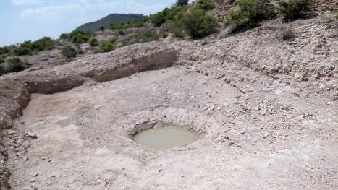
Percolation pond
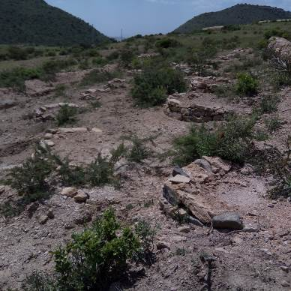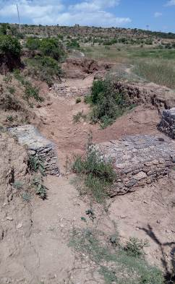
Large half moon basins planted with Grevillea robusta, Eucalyptus, Acacia melanoxylon; and loose stone gabions

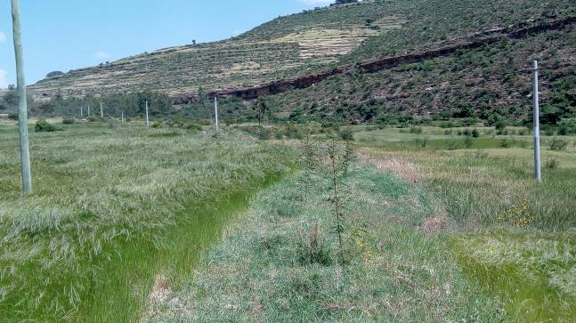
Downslope cropland management with FMNR and agroforestry species such as Sesbania sesban
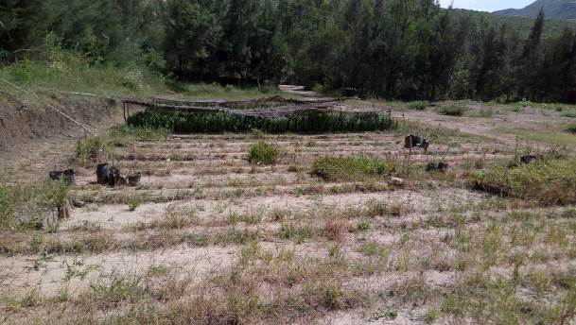
Tree Nursery operated by Restoration of Tigray Society (REST)

Seedlings being raised in the nursery include: Rhamnus prinoides, Acacia melanoxylon, Moringa oleifera, Coffea arabica, Juniperus procera, Olea africana, Casuarina spp. Grafted mangoes and avocado.

WAZA WATERSHED
Waza watershed has 4 sub-catchments of which 2 are already under restoration (Endejewergesi and Endamariam) while two are highly degraded with no interventions (Abehtsebo and Abemetae).

Table 3: List of land restoration interventions in Waza watershed.
Sub-catchment | Land use | Period of Intervention | Implemented by | Restoration Interventions
Endejewergesi | Rehabilitated Cropland | 2016 | DryDev | Upslope steep slopes- Stone hillside bench terraces, FMNR, Sesbania sesban and Leucaena leucocephala  Slope bottoms- deep trenches.  Also, farmers have established micro-gardens and are irrigating grafted mangoes and avocadoes and onions and tomatoes using water from the check dam
 | Exclosures | 2016 | DryDev | Steep mid catchment - Percolation channels, Percolation ponds,  Half-moon microbasins- planted with Acacia melanoxylon, Eucalyptus and Grevillea robusta, Eye brow micro basins, Deep trenches. Acacia has 100% survival rate and fast growth.  Apiculture for landless youths  Slope bottom have deep trenches
 | Gully rehabilitation and water harvesting through checkdam | 2016 | DryDev | 1.25 km gully area already reclaimed.  Upstream- loose stone and rock-filled gabions  Reshaping of the gulley bank by biological treatment through planting Vertiver grass, Arundo donax, elephant grass, Sesbania sesban, Acacia melanoxylon, Aloe vera and natural vegetation regeneration.  Downstream -water harvesting checkdam ponds
Endamariam | Rehabilitated cropland | 2012 | Productive SafetyNet Programme (PSNP) | Through FMNR and agroforestry species mainly Sesbania sesban
Endamariam | Exclosures | 2012 | (PSNP) | Soil erosion completely controlled from 56tonnes/ha of soil loss in 2013 to nil  On steep slopes stabilized with bench terraces  Downslope natural regeneration mainly with Acacia spp.
Endamariam | Gully reclamation | 2012 | (PSNP) | 3.75 km gully fully reclaimed through gabions and stabilized by Acacia regeneration and planting of Arundo donax (bamboo), Sesbania and vertiver grass
Abemetae | - | - | - | No intervention.
Abehtsebo | - | - | - | No intervention

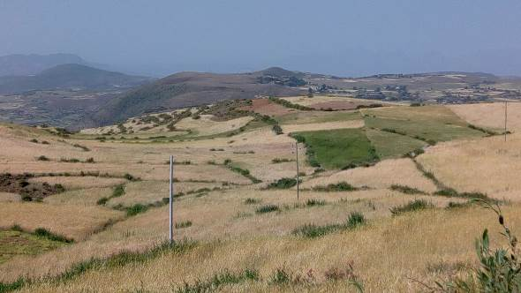
FMNR in Endejewergesi sub catchment of Waza watershed

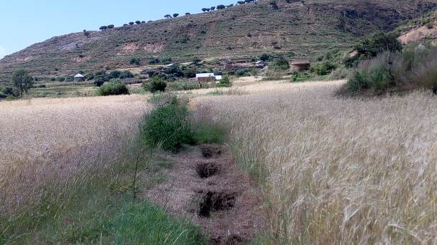
Deep trenches and Sesbania sesban in cropland of Endejewergesi sub-catchment

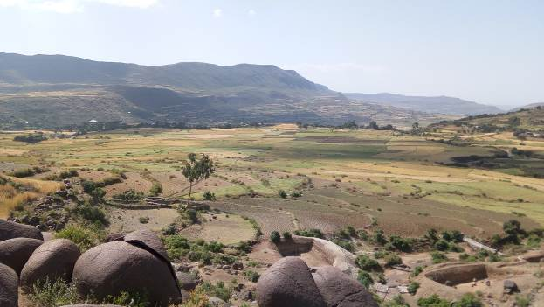
Endejewergesi landscape

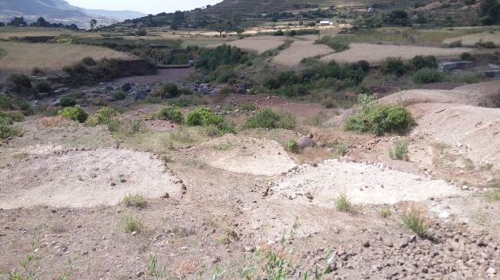
Half moon basins and percolation ponds in Endejewergesi.

Apiculture has also been initiated in Endejewergesi for the landless youths using naturally occurring shrubs
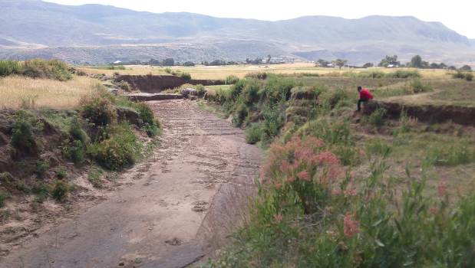
Gully rehabilitation using loose stone gabions and vegetation

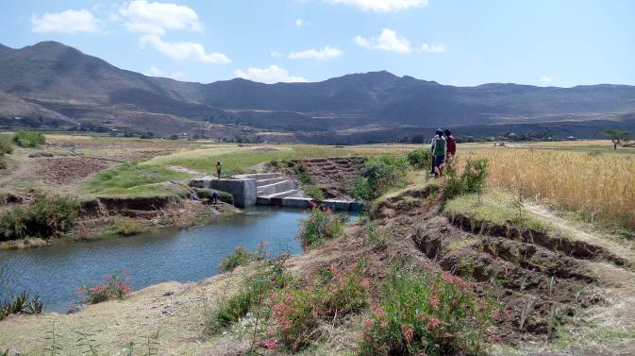
Checkdam constructed by DryDev- which has transformed livelihoods through increasing production and enhancing climate-resilient production through providing water for irrigation of vegetables and fruits
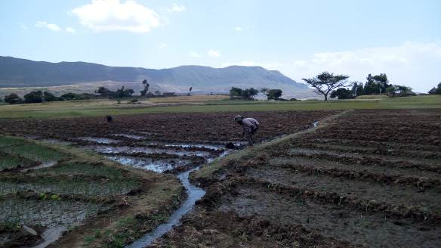
A farmer irrigating onions on his farm in Endejewergesi.

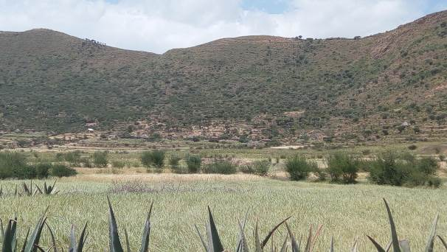
Treated exclosures (upslope) in Endamariam sub-catchment by PSNP

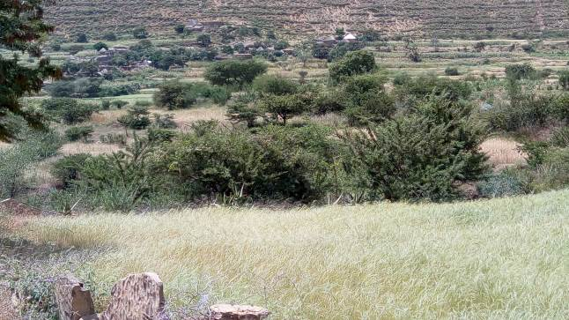
FMNR in Endamariam sub-catchment

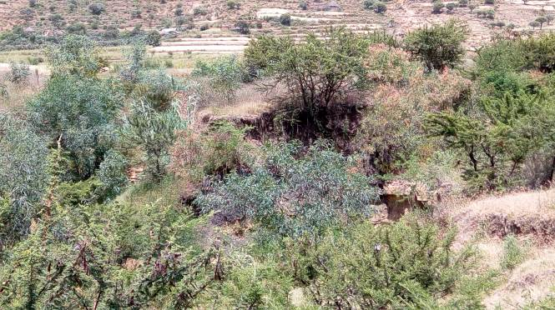
A rehabilitated gully in exclosures in Endamariam sub-catchment

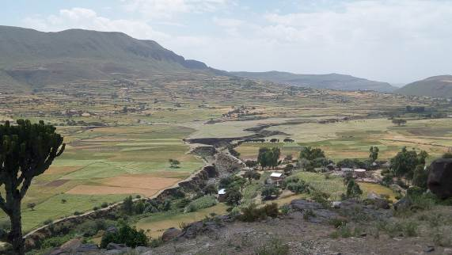
Untreated gulley in Abehtsebo sub-catchment, and overlooking a non-restored Abemetae sub-catchment

DEKERA WATERSHED
The landscape is characterized by rocky upslopes due to severe soil loss. Main crops grown include teff, sorghum, maize, sunflower.

Table 4: List of land restoration interventions in Dekera watershed.
LAND USE | Age of Intervention | PROJECT | SLOPE CONDITIONS | RESTORATION INTERVENTION
Cropland | 2016 | DryDev | Relatively flat downslopes | Deep moisture retention trenches since it is a drier lowland area.
Exclosures | 2016 | DryDev | Rocky upslope | Stone bunds. Regeneration of shrubs such as ‘kankeb, kuliow,tahses’
Exclosures | 2016 | DryDev | Midslope | Percolation channels, percolation ponds, deep trenches  Half moon micro basins to conserve water for planted trees ie Moringa oleifera, Grevillea robusta, Acacia melanoxylon and Sesbania sesban

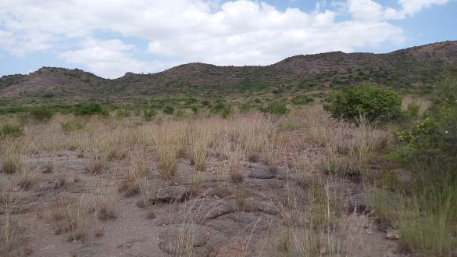
Regenerating natural vegetation on rocky upslope land of the recent exclosure in Dekera

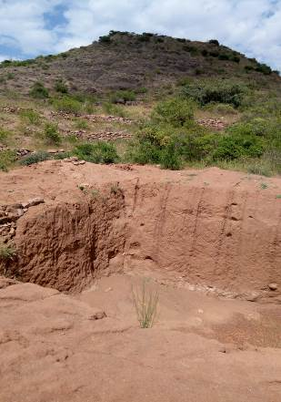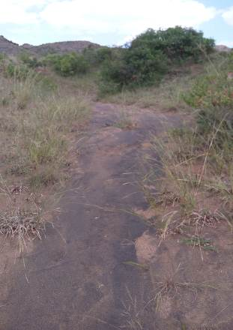
A series of stone bunds across a gully that feed into a percolation ponds; Recent silt trapping through the regenerating vegetation in exclosures in Dekera watershed

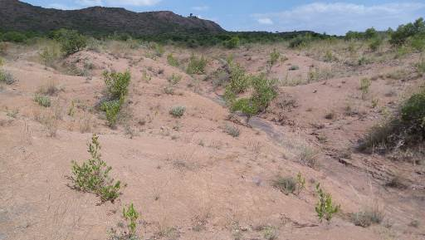
Regeneration of vegetation

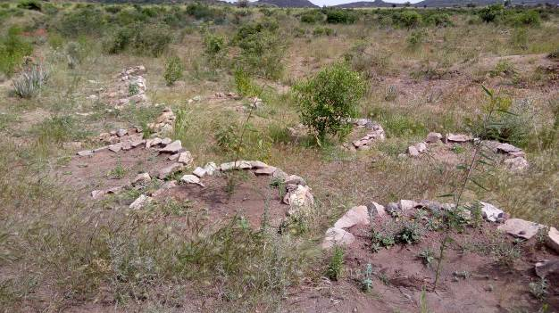
Sesbania sesban planted along the Half moon microbasins

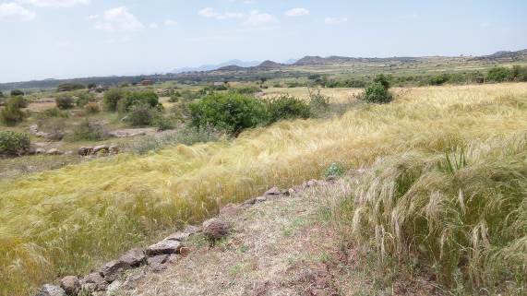
Rehabilitated cropland with stone bunds and deep trenches in the downslopes of Dekera

AMDI WOYALE WATERSHED
This watershed is severely degraded and has no land restoration interventions. Main crops include maize, beans, wheat, barley, teff, sorghum.
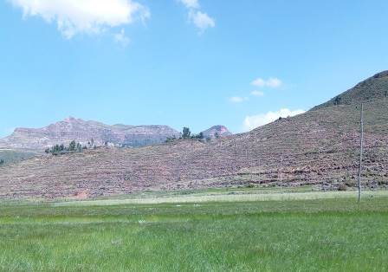
A bare landscape in Amdi-woyale watershed
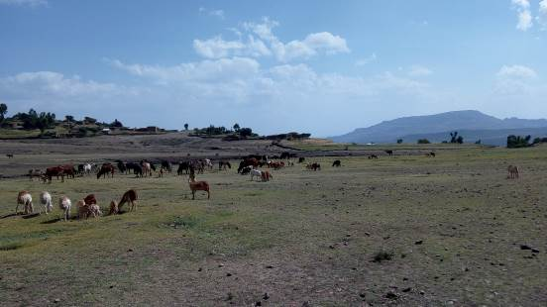
Free-grazing livestock on the downslopes of Amdi-woyale watershed

Matrix of Restoration Options in East Africa and the Sahel

Restoration Options in Kenya

Country | Restoration Technology | Description | Benefits | Barriers to Adoption | Adoption
Kenya | Enclosures | Areas closed off from human and domestic animal interference for a specified duration of time in order to promote the natural regeneration of plants and reduce degradation on formerly degraded communal grazing land. | - Increased biodiversity  - Increased ground vegetation cover | - Technical/biophysical:  When the top soil is severely degraded then, restoration of enclosed areas is largely dependent on reseeding and tree planting, rather than natural regeneration Cross-cutting issues:  -Gender roles and responsibilities  -Increased yield stability amongst private owners  -Rehabilitation of rangelands is largely dependent on reseeding and tree planting rather than natural regeneration  -Building on existing knowledge systems is the basis for land restoration  - Perceptions:  -Male perspective: Increase in male responsibilities (fencing needs and their regular maintenance)  -Female perspective:  Reduction in herding needs as animals graze in paddocks with little to no herding | Medium
Kenya | Agroforestry | The integration of high value trees and shrubs with crops and livestock. | - Increased soil fertility  - Increased soil moisture  - Diversified income sources  - Improved nutrition | - Long-term benefits | Medium
Kenya | Farmer Managed Natural Regeneration (FMNR) | A low-cost, sustainable land restoration technique used by subsistence farmers to enhance tree growth for improved food security and climate change resilience. | - Acceptance among different stakeholders, and local/county government  - Ease of collaboration among stakeholders and partners  - Low-cost approach and requires less labor  - Compatibility and complementarity: Easy to integrate with other alternative livelihood options such as livestock keeping, bee keeping, tree nurseries  - Enhanced sense of community empowerment  - Improved household income  - Improved household food security, for both humans and livestock  - Reduction of soil erosion within farms  - Increased interaction among community members and community with the county government | - Land and tree tenure systems: FMNR can only be adopted by farmers who have private land ownership  - Charcoal burning/lack of alternative energy sources, leading to cutting down of the regenerated trees.  - Bush burning  - Increased brick burning  - Conflicts between pastoralists/crop growing farmers  - Limited capacity/knowledge on tree management practices suitable for the different trees species  - Existence of policies/ by-laws that do not support the adoption of FMNR among community members  - Existence of poor enforcement mechanisms of the existing by-laws | Medium
Kenya | Improved Fallow | This is a rotational system that uses preferred tree species as the fallow species (as opposed to colonization by natural vegetation), in rotation with cultivated crops as in traditional shifting cultivation. | - Production/ economic benefits:  -Suppression of weeds  -Increased crop yields  -Increased quantity of biomass  -Source of fodder  -Firewood  - Ecological benefits:  -Soil physical properties  -Carbon sequestration  -Nitrogen recycling  -Control of soil erosion | - Lack/slow acceptance of the practices by farmers  - Land tenure: Most of improved fallows are adopted on privately owned lands | Medium
Kenya | Alley cropping | A production system in which trees and shrubs are established in hedgerows on arable crop land, with food crops, cultivated in the alleys between the hedgerows | - Production / economic benefits:  -Provision of livestock fodder  -Provision of fuelwood  - Improved crop yield  - Biomass production  - Ecological benefits:  -Control of soil erosion  -Nitrogen Content  Nitrogen recycling  -C sequestration  -Weed control  - Improved levels of soil organic matter;  - Supply of mulch for protecting the soil and regulating water infiltration  - Supply of stakes and ligneous materials that can be put to industrial use. | - Lack/slow acceptance of the practices by farmers  - Land tenure: Most of the alley cropping practices are adopted on privately owned lands | High
Kenya | Soil and water conservation practices | Water conservation structures play a key role in conserving soils by reducing the runoff of soil and the nutrients | - Improved crop yields  - Improved livestock production, due to increased fodder for livestock  - Improved tree growth, as a result of increased water availability  - Improved micro-climate  - Reduced incidences of land degradation | - Lack/slow acceptance of the practices by farmers  - Land tenure: Most of the SWC practices are practiced on privately owned lands  - Low adoption among farmers | Low

Restoration Options in Ethiopia

Country | Restoration Technology | Description | Benefits | Barriers to Adoption | Adoption
Ethiopia | Grazing exclosures | Grazing exclosures are created to improve year-round availability of forage, as well as to protect degraded communal lands from grazing-induced soil erosion and compaction. | - Improved production of forage and wood  - Soil conservation Improved soil fertility  - C sequestration  - Improved hydrological flows.  - Reduce soil erosion and flood intensity  - Increase downstream water yield  - Revive springs in some cases  - Increase the ground water table | - Increased soil C, sequestering  - Local by-laws  - Rainy season grazing restrictions  - Existence and design of local by-laws and institutional mechanisms for enforcement  - Level of intensification of cropping and farming systems  - Participation of exclosure users  - Climate and soils | Medium - High
Ethiopia | Integrated Watershed Management (IWSM) | It consists of a variety of soil and water conservation measures, often implemented in combination with one another under the guidance of local participatory watershed planning. | - Increase in crop yields  - Reduction in drought vulnerability  - Increase crop production and incomes  - Crop intensification  - Restoration of rainfed areas through improved collective action | - Inadequate participation in planning  - Inequitable access to irrigation  - Labor costs  - Assets  - Using crop residues as mulch in croplands reduces dry season fodder availability  - Land and tree tenure  - Government taxes  - Farmer participation | High
Ethiopia | Participatory Rangeland Management (PRM) | The practice of community-based natural resource management in pastoral areas. | - Establishment of conducive land tenure security  - Control of invasive species (e.g., Prosopis) and bush encroachment  - Greater emphasis on camel and goat herding  - Re-seeding, maintaining mobility  - greater emphasis on camel and goat herding, re-seeding  - Maintaining mobility and restricting fragmentation  - Locating new water access points where they complement rather than conflict with grazing management systems | - Strength of local institutions  - Legitimacy of communal ownership  - Inclusion of customary institutions and herders from across all wealth strata as key stakeholders  - Poorly suited climate or institutions | Medium

Restoration Options in Tanzania

Country | Restoration Technology | Description | Benefits | Barriers to Adoption | Adoption
Tanzania | Contour bunds/ridges or Fanya chini | Trench/terrace where excavated soil is dumped down-slope to form earth bunds along contours; widely advocated for slopes up to 5 % | - Reduced soil erosion  - Reduced soil loss  - Increased water infiltration | - Land tenure/ownership  - Labor constraints | Medium
Tanzania | Fanya juu (Swahili for ‘throw up’) | Trench/terrace where excavated soil it dumped up-slope to form earth bunds along contours
Tanzania | Stone bunding | Linear stone barriers to slow runoff and accumulate soil
Tanzania | Kainam terrace | Technique indigenous to the hills southwest of Lake Manyara, Tanzania, involving terraces protected by storm drains; ridges along contour are then planted with careful mulching
Tanzania | Cut-off drains or trenches | Ditches dug to intercept fast-flowing water to avoid excess runoff in fields on sloping land and prevent gullying
Tanzania | Grass strip | Vegetative structural barrier composed of grass densely sown in 0.5-1 m wide strips along contours (spaced as terraces) to reduce runoff, soil erosion and provide forage or mulch
Tanzania | Mgeta system | Laying down grass and weeds along contours to counter sheet wash.
Tanzania | Trash lines | Buffer strips of crop residues along contours
Tanzania | Ladder/step terraces | Strips of organic waste (for soil fertility) covered with soil from above to form ladder-shaped terraces
 | Bench terrace | Terraces with vertical intervals ranging from 1.2-1.8 m; usually for high-value crops for which the slope is too steep
 | Tied ridges | Smaller sub-ridges/cross-ties built within main contour ridges to create micro-basins for in-situ rainwater harvesting
 | Miraba (Swahili word for ‘squares’) | Rectangular grass-bound strips that may or may not follow contours.
 | Minimum tillage | Soil not turned and aims to minimize soil manipulation.
 | Zero tillage | Extreme form of minimum tillage without pits/furrows
 | Conservation tillage | Breaking up compacted soil and facilitating in-situ rainwater harvesting.
 | Strip catchment tillage | Strips of crops alternating with strips of grass/cover crops; usually used on gentle slopes in semi-arid areas
 | Ngoro/Ngolo (or Matengo/Ingolu) pitting | Technique unique to the Wamatengo people of Matengo highlands (Mbinga District, Tanzania), which combines pits and ridges with yield-dependent fallow and crop-rotation; practiced on slopes of 35-60 % steepness
 | Chololo pits (named after the village in Dodoma Region where it was developed) | A modification of zai pits from the Sahel involving holes ~22 cm diameter, ~30 cm deep and ~60 cm apart. Excavated soil is used to make small bunds around the holes, into which manure, crop residues and ash (to expel termites) and soil are added. 1-2 seeds of maize/millet are sowed per hole.
 | Semi-circular bunds | Crescent-shaped bunds to harvest runoff, particularly when planting tree seedlings in semi-arid areas
 | Meskat system or ‘Negarim’ technique | Basin system in which each micro-catchment feeds runoff to a single cropping basin (typically 10-100 m²) surrounded by an earth bund (~30-40 cm high)
 | Majaluba/  Majaruba | Cross-slope earthen barriers and basins to intercept and store hillslope runoff, typically for lowland rice. Similar to other basin micro-catchments but with larger external catchment
 | Ephemeral stream diversion | Divert water from ephemeral streams into cascades of open bunds (Caag system) or closed basins with small spillways
 | Charco dams’ | Excavated pits/ponds on relatively flat ground to store runoff; often used to water livestock
 | Ndiva or Ndiwa | ‘Indigenous’ irrigation dams often fed by springs
 | Stream bed flood water harvesting | Diverting floodwater from the stream bed onto adjacent plains to cultivate crops
 | Vinyungu | Camber-bed type cultivation typically practiced clay-heavy soils in wet valley bottoms or other low-lying areas
 | T-basins | Series of basins connected to external catchments (e.g. roads/footpaths); crops are planted on the T-shaped earth between basins, in which trees can be planted
 | Compost (Mboji in Kiswahili) | Crop residues, household waste, manure, grass, branches piled or in pits |  | - Quantity and quality of available manure and/or compost  - Labor constraints to application | Medium
 | Manure | Organic matter from animals (typically faeces) or plants (green manure) to improve soil fertility
 | Mulching (e.g. Tughutu) | Living or dead plant biomass (or stones) to reduce evaporation and improve soil fertility (if organic matter)
 | Trash heaping | Organic waste accumulated on flat land (e.g. between trash lines) mainly for soil fertility improvement but also for SWC
 | Burying trash and weeds | Organic matter from waste/weeds buried mainly to improve soil fertility but also to control weeds
 | Plowing in crop residues | Crop residues are plowed into the soil prior to planting to improve soil fertility
 | Trench farming | Planting in trenches into which large amounts of organic matter are added to improve soil fertility (also improves infiltration and moisture storage)

Restoration Options in Niger and Burkina Faso

Countries | Restoration Technology | Description | Benefits | Barriers to Adoption | Adoption
Niger and Burkina Faso | Vallerani system | This is a new system of water harvesting where a special tractor-pulled plough is used to automatically construct water-harvesting catchments. | - Rapid growth of trees  - Herbaceous cover improves in quality and quantity which results in:  - Providing 20-30 times more livestock fodder  - Helps conserve the soil
Niger and Burkina Faso | Planting trenches | The main purpose of this technique is to restore tree cover and prevent soil erosion on the slopes by reducing water flow that threatens the land in the downstream. | - Reduce gully erosion and sedimentation of areas with a fragile soil structure  - Permits the reintroduction of trees on degraded, unfertile land and contributes to dissipating the force of runoff and increases infiltration  - Groundwater recharge
Niger and Burkina Faso | Contour ridges/tied ridges | This is a microcatchment technique. Ridges follow the contour at a spacing of usually 1 to 2 m. Runoff collects and is stored in the furrow between ridges. Crops are typically planted on the ridge tops. | - Preventing water from accumulating in low spots and potentially breaching ridges on slopes.  - Useful on undulating terrain, or in situations where precise contouring is not possible.  - Simple to construct and amenable to use with animal traction or tractors  - Yield of runoff from very short catchment lengths is extremely efficient  - Even crop growth
Niger and Burkina Faso | Contour bunds | As the name indicates, the bunds are established following the contour, at close spacing. With the optional inclusion of small earth “ties,” formed laterally between the bunds, the system can be divided into individual micro catchments | - Suitability to crop cultivation between the bunds  - The yield of runoff is high  - When designed correctly, there is no loss of runoff out of the system
Niger and Burkina Faso | Contour stone bunds | Contour stone bunds are used to slow down and filter runoff, thereby increasing infiltration and capturing sediment. | - Improved crop performance  - Well suited for small-scale application on farmer’s fields  - Can be implemented quickly and cheaply over large areas.  - No need for spillways  - Less maintenance is required | - Unavailability of stones in some places such as in regions with sandy soil. | High
Niger and Burkina Faso | Contour line cultivation | This is a holistic landscape approach to manage water and capture rainfall on a watershed scale. | - To capture and retrain rainfall in treated fields  - Assist evacuation of excessive rainfall and destructive surface flow that may run onto fields during heavy storm events.
Niger and Burkina Faso | Vegetative strips | Vegetative strips, either naturally occurring or planted, are traditionally used to demarcate and protect fields by farmers in various parts of Africa. | - Controls soil erosion and prevents loss (through surface runoff) of fertilizers applied to the crop.  - Can reduce runoff and soil erosion  - Increase in crop yields  - Provide fodder for livestock and material for various domestic needs  - It is simple, cheaper and therefore accessible to poor farmers
Niger and Burkina Faso | Mulching | It is a traditional technique that usually involves leaving millet and sorghum stalks in the field after harvest. In cases where a relay crop has been planted, such as watermelon, the stalks serve to reduce the evaporation of remaining moisture from the soil and acts as a barrier and prevents wind erosion, helping trap the thin rich dust carried by the harmattan wind. | - Feed and bedding for livestock  - Effective for restoring infertile patches of cropland | - The growing demand for biomass for household and livestock
Niger and Burkina Faso | Sand Dune Stabilization | Stabilization of active sand dunes is achieved through a combination of mechanical measures (such as palisades) and biological measures (such as live fences and sowing grass) | - Stop sand encroachment and stabilize sand dunes on-site  - moderating temperatures  - mitigating the impact of wind  - Increase in:  - Soil cover  - Biomass/above ground carbon sequestration and storage  - Animal carrying capacity and  - Soil fertility, leading to more production of wood and fodder | As establishment of these systems requires high labor inputs, it makes them unattractive to farmers in Sahel, outside of donor financed projects
 | Farmer Managed Natural Regeneration | It is a practice which involves identifying and protecting the wildlings of trees and shrubs on farmland. FMNR is a systematic regeneration of living stumps and emergent seedling of indigenous trees, which previously had been slashed and burned in field preparation. | - Simple, low-cost method of re-vegetation  - Accessible to all farmers and adapted keeping in mind the needs of smallholders.  - Reduces dependency on external inputs  - It is easy to practice and provides multiple benefits to people, livestock, crops and the environment. | - Improved soil fertility  - Increased supply of food, fodder and firewood | High
 | Stone bunds - farmer natural regeneration | This innovative experience combines the stone bunds with FMNR. | The stone bunds could help improving the regeneration of trees. |  | Low
 | Zaï technique | Traditionally, planting pits were used on a small-scale to rehabilitate barren land (zipélé in Burkina) and hardpan areas where rainfall could no longer infiltrate. The promotion of Zaï became popular in the early 1980s in various location in WAS. They are dug by hand, with the excavated earth formed into a small ridge downslope of the pit for maximum capture of rainfall runoff. | - The improved infiltration and increased nutrient availability brings degraded land into cultivation.  - The technology is easily adopted.  - Enhance water infiltration  - Reduce soil erosion and siltation of the pits.  - Grass growing between the stones helps increase infiltration further and accelerates the accumulation of fertile sediment  - Increase crop yields | The labor needed to dig the holes. This operation is time consuming. | High
 | Zaï-Stone bunds | It is a combination of the two techniques: Zaï and Stone bunds. | - Protection of soil against erosion  - Rain water harvesting  - Exploiting all advantages of zaï technologies in terms of better use of rain water and soil fertility improvement Better management of the cropping system.
 | Zaï-Stone bunds-Farmer Managed Natural Regeneration | This innovative experience adds framer assisted natural regeneration (FMNR)
 | Semicircular bunds | They are earth embankments shaped in as a semi-circle, with the tips of the bunds facing uphill and aligned to the contour (Ray and Simpson 2014; Hien et al., 2015). The Semicircular bunds were initially developed to harvest the runoff water for growing crops. | - Quick and easy method of tree establishment and rangeland improvement in the semi-arid areas.  - Increase crop yields
 | Agroforestry-Semicircular bunds | As for the Zaï system, semicircular bands can be used to grow trees in the system. The improvement of humidity and soil fertility (manure or compost application) in the structure of SCB involves the germination of tree seedlings that coming from manure, compost or from winds. | - Contributes to reforestation.
 | Bio-reclamation of degraded lands | The bio-reclamation of degraded land (BDL) system has been developed by ICRISAT. It is an integrated system of RDL with different components, the semicircular bund (SCB) and Zaï structures, for food and vegetables crops and trees. | - Provides solutions to a range of critical constraints affecting the livelihood of the rural population of the Sudano Sahel. |  | High
 | Agroforestry parkland systems | The APS is more a sustainable management practice developed by farmers over years than a typical RDL technique. APS are cropland areas interspersed with self-generating, indigenous tree species.

Discussion
A critical issue in taking land restoration to scale is that ecological, economic and institutional context varies at fine scale. As this report showcases, there are a variety of restoration options available and also currently in use in the five action countries. However, each of these has specific benefits and corresponding barriers and constraints to adoption. This points out the need to adopt an options by context approach. In other words, this means that generic approaches to restoration require local adaptation to fit sites and farmer circumstances. Since options include technology, market and delivery mechanism, and policy interventions, a multi-scale approach is required to initiate and sustain restoration. Further research, including the monitoring the success (and failure) of these restoration approaches is needed to understand what works where and for whom.

