Activity 3: Expression profiling from different tissues and developmental stages to define gene atlas

- Objective of activity and intended output (1-2 sentences)
To define a gene expression atlas in pigeonpea. This would serve as an important resource for functional genomics and gene discovery studies in pigeonpea and related legumes.
- Materials and methods (very brief and succinct, 3 sentences at the most)
Thirty seven different samples representing 19 aerial, seven underground, two germinal and nine seed development related tissues from five different developmental stages have been targeted. The five developmental stages included germinal, seedling, vegetative, reproductive and senescence were used for sample collection. Total RNA was isolated from each of these 37 tissues and subjected to sequencing using Illumina HiSeq platform to generate the expression profile of the genes involved in the development from germinal to senescence stage in major tissues of ICPL 87119 (Asha) genotype.
- Results and interpretation (again succinct, maximum of 250 words).
RNA-Seq data has been generated using Illumina HiSeq platform from 37 tissues/ libraries. The dataset has been analyzed in two sets consisting of 590.84 for the development of a gene expression atlas (CcGEA; Figure 2) and 342 million paired-end reads for studying the transcriptional programming during pod and seed development in pigeonpea (Figure 3 and 4), respectively. Genes with differential, specific, spatio-temporal and constitutive expression during the course of development in different tissues have been studied. The comprehensive gene expression study of the whole plant development as well as exclusively in pod and seed development would be crucial in identifying candidate genes involved in important agronomic traits such as seed related traits. The usefulness of these resources have been demonstrated by identifying a highly co-expressed and co-regulated gene network crucial for normal pollen and seed development. Gene expression atlas of Cajanus cajan (CcGEA) developed has been accepted for publication in the Journal of Experimental Botany, while study on transcriptional programming in pod and seed development in pigeonpea has already been published in PLoS One, 2016, Vol. 11, e0164959.
Figure 1: Expression studies of DCL, AGO and RDR genes in response to SMD in pigeonpea

Figure 2: Summary of the tissues used and sequencing data generated for the development of gene expression atlas (CcGEA)
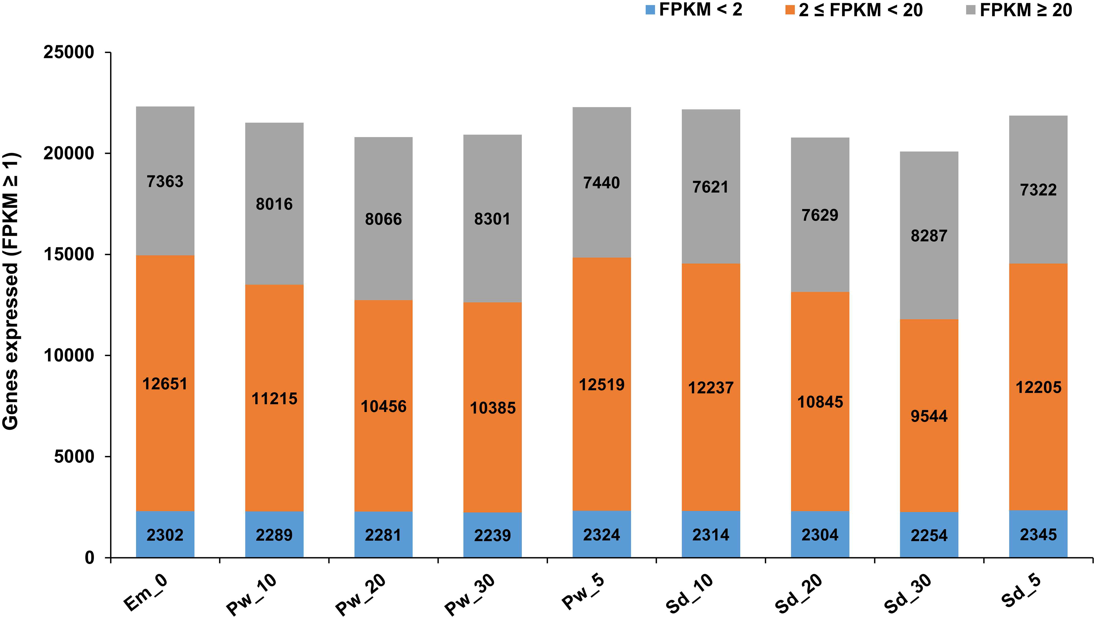
Figure 3: Genes categorized based on expression level (FPKM<2, 2 ≤ FPKM < 20 and FPKM ≥20) in each of the samples for studying pod and seed development.

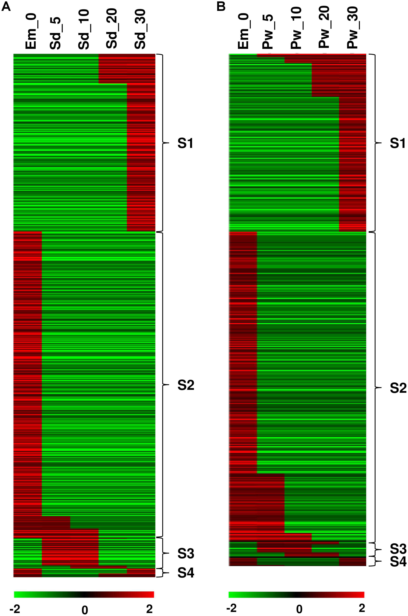
Figure 4: Temporal expression pattern of genes identified in (A) developing seed from Em_0 to Sd_30 and in (B) developing pod wall from Em_0 to Pw_30.

