Activity : Evaluation plant water budget of orphan grain legume species in lysimeters and of traits related to plant water budget in the LeasyScan facility

Objective of activity and intended output – The project aims at benchmarking the crop water budget in five orphan legume crops, using a lysimeter system consisting of long and large PVC tubes and from which assessments of crop cycle water usage, transpiration efficiency, and water extraction capacity can be rigorously measured (in addition to agronomic parameters allowing comparisons).

Materials and Methods: For the first three experiments in lysimeter the genetic material consisted of 22 genotypes, 13 of lablab, horsegram, moth bean, rice bean and cowpea, which were benchmarked to 9 genotypes across mungbean, soybean, peanut and bean. For the remaining experiment, 90 genotypes were used (lablab-23, horsegram-22 moth bean-9, rice bean-10, cowpea-15, which were benchmarked to 9 genotypes across mungbean (2), soybean, peanut and bean (3 each). Plants were grown in 1.2m PVC tubes, 20 cm in diameter, filled with Vertisol from the ICRISAT farm, fertilized with single super phosphate and muriate of potash, both at a rate of 200mg kg⁻¹ soil.

Results and interpretation:
Water extraction – Among the most interesting was the high extraction capacity of rice bean and also all of the four horsegram genotypes. This was a confirmation of the previous trial where high extraction capacity in these two species was noted. Here also one of the dolichos extracted an important quantity of water from the soil profile.
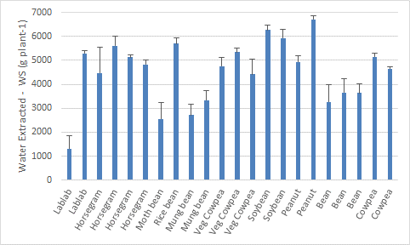 | Figure 1 – Water extracted (g plant⁻¹) from the soil profile under terminal water stress in 22 genotypes across 9 legume species (Exp. 2). Data are means of four replicated plants (± SE).

Total plant water use under WW conditions – Similar to the previous trial, one of the lablab and all of the bean lines had low water usage, which was related to earliness in the case of beans.
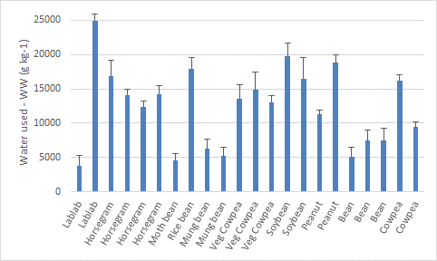 | Figure 2 – Water used to support transpiration under WW conditions (g plant⁻¹) from the soil profile under terminal water stress in 22 genotypes across 9 legume species (Exp. 2). Data are means of four replicated plants (± SE).
For lablab the low water use of one genotype was related to its low vigor of one of the genotypes. The horsegram genotypes had a moderate water use, lower than the soybean or one of the peanut lines, but similar to the vegetable cowpea and more than the mungbean lines.
In the trial with 90 genotypes across the 9 species the dolichos, peanut and soybean were by far the largest water users, in part because of a longer crop duration. However this was not the only reason since peanut had a water use similar to soybean although its duration was about 15 days longer. Horsegram, rice bean and cowpea, together with moth bean and mung bean were low water users.
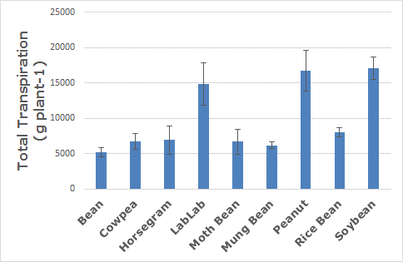 | Figure 3 – Water used to support transpiration under WW conditions (g plant⁻¹) from the soil profile under terminal water stress in 90 genotypes across 9 legume species (Exp. 4). Data are means of eight replicated plants (± SD).

Transpiration efficiency –Overall the bean lines had high TE under both treatment, while the mungbean had relatively low TE. However the range of variation under WW conditions was relatively low (1.5-2.5 gkg-1). The horsegram lines had among the highest TE under WW conditions, at par with bean and cowpea lines.

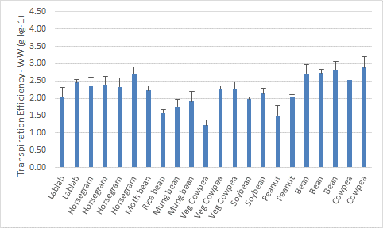 | 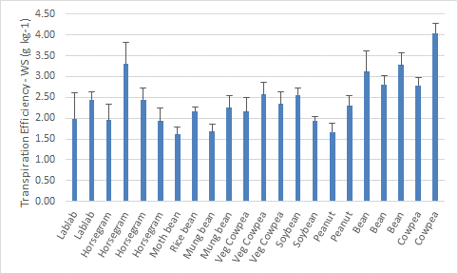
Figure 4 – Transpiration efficiency (g biomass kg⁻¹ water) under WW (left pane) and WS (right pane) conditions in 22 genotypes across 9 legume species (Exp. 2). Data are means of four replicated plants (± SE).

In Exp.4, transpiration efficiency was measured in a larger range of germplasm in the orphan legume species. The horsegram germplasm confirmed its high TE potential as a specie, at a similar level than cowpeas. The standard deviation for TE in the horsegram group suggested that some entries were particularly high. Among these, horsegram entry PGH3-1-1 is to be mentioned among the toppers with a TE of 4.73 g kg⁻¹. By contrast, none of the cowpea entries had TE above 4.00.
In Exp.4, transpiration efficiency was also calculated from the standpoint of the quantity of grain produced per unit of water transpired (“TE-grain”). Again, the horsegram and cowpeas reached high TE-grain values but were topped up by the rice beans.
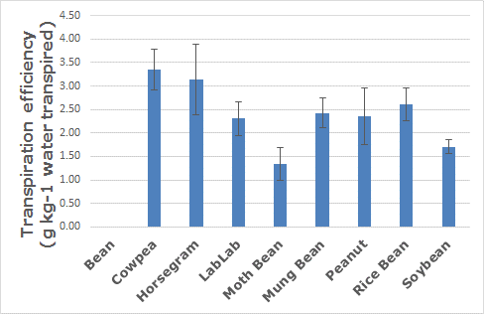 | 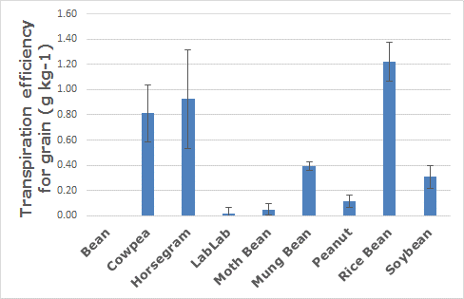
Figure 5 – Transpiration efficiency (g biomass kg⁻¹ water) under WW (left pane) and transpiration efficiency of grain production (g seed weight kg⁻¹ water) (right pane) conditions in 90 genotypes across 9 legume species (Exp. 4). Data are means of four replicated plants (± SD).

Next steps: The results from Exp.2 confirmed those of the previous trial. In terms of water extraction capacity the horsegram and the rice bean appear to be promising. There was no large TE differences in this trial (Exp.2) while there were in the previous trial (Exp.2). The larger Exp.4 confirmed that horsegram had a high TE as a specie, on par with cowpeas, and with a few lines being superior for TE, like entry PHG 3-1-1, or PHG 3-26-1. A very interesting analysis came from measuring a TE-grain index, translating the conversion of water into grain, where rice bean topped the 9 legume species, being 50% higher in that index than cowpeas. TE-grain was also very high in horsegram and cowpea and here also with one line of horsegram, Phule Sakas, having the highest TE-grain of 1.51 g kg⁻¹, above the highest TE-grain for rice bean. The orphan legumes confirmed their late duration phenology, except the moth bean, and showed limited photoperiodic effects, except for the rice beans and one of the horsegram – this will need to be assessed in more details with a larger range of genetic material in each specie. The horsegram was the specie with the largest variation in maturity.

