Activity: 100 FPVS and 200 field demonstrations conducted with best-bet varieties in Asia.
- Objective of activity and intended output:
To realize the full potential of the high yielding cultivars there is a need to demonstrate the full package of practices for the respective agro ecologies.
- Materials and methods:
Integrated Crop management (ICM) technologies will be implemented in conducting Farm Participatory Varietal selection (FPVS) trials and OFTS (On Farm Demonstrations)
- Results and interpretation:
In 2016, 1500 on farm demonstrations and 13 FPVS trails are in progress in diffenrt states of India. Holistic interventions such as soil test based fertilizer application, dibbling method of sowing, treatment of bio fertilizers, broad bed/ridge and furrow method of sowing, need based pesticide application were adopted. The early maturing varieties and hybrids were harvested and medium duration varieties and hybrids are in maturity.

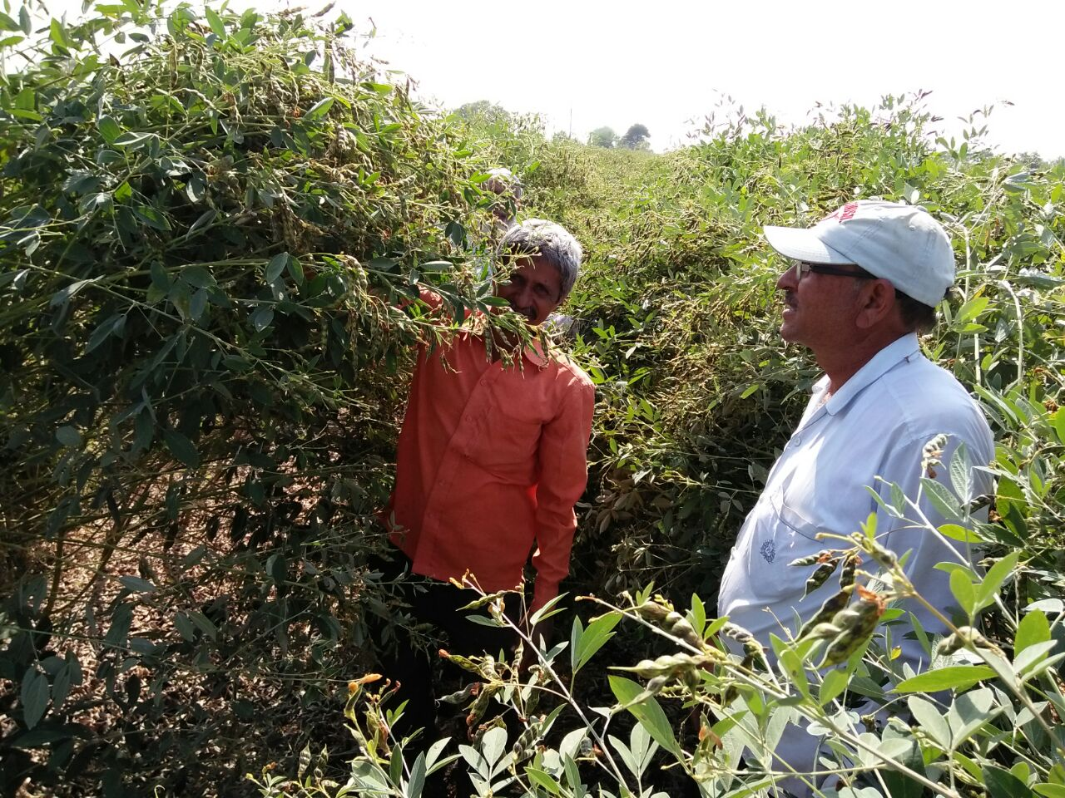

Mr Vijay Tatte, farmer from Lehgao village of Amravati district, Maharashtra, India hybrid pigeonpea ICPH 2740 field at podding stage.

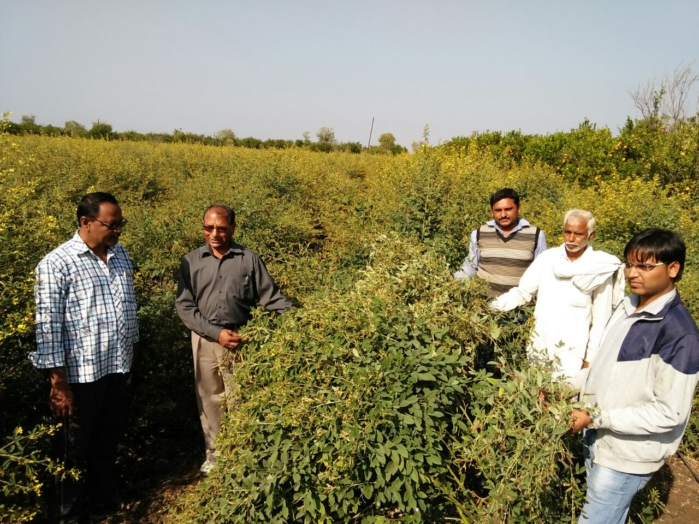

Mr. O.L Shekhawat, Agronomist, KVK, Durgapur, Amravati during monitoring in field of Mr. Dipak Hadoke, Daryapur Taluka, Amravati district, Maharashtra, India with hybrid pigeonpea ICPH 2740 at podding stage
- Next steps:
There is a need to scale up on farm demonstrations with elite cultivars to reach more number of farmers.

