Activity 2 - Develop MAGIC and biparental populations following SSD (2) Phenotyping of populations for target traits.

Objective: To identify QTLs and develop markers for key target traits.

Materials and methods: Single seed descent method is used to develop multi-parent and bi-parental populations and advance generation (F6 and above) are screened for target traits in replicated trials.

Results and interpretation: Seed increase is in progress of 3000 F₆ generation MAGIC lines derived from the crosses involving the parents, ICGV 91114, ICGV 06040, 55-437, ICGV 00440, ICGV 00308, GPBD 4, ICGV 05155 and ICGV 88145. RIL population derived from the cross, ICGV 07368 X ICGV 06420 is phenotyped for kernel oil content, and another RIL derived from the cross, ICGV 03057 X CS 19 was phenotyped for stem rot resistance (Fig. 1). CS 19 is an interspecific derivative from the cross, TMV 2 X Arachis diogoi (ICG-4983) developed at Directorate of Groundnut Research, India (SK Bera, Personnel communication). Two-season phenotyping of RIL population for resistance to PBND (peanut bud necrosis disease) at disease hot spot location (Raichur, Karnataka, India) derived from the cross, TAG 24 X ICGV 86031 is completed. Two bi-parental RIL populations were shared with NARS for phenotyping for kernel features and stem rot disease. RIL population derived from the cross, ICGV 06040 X ICGV 87141 is phenotyped for kernel iron and zinc concentration.

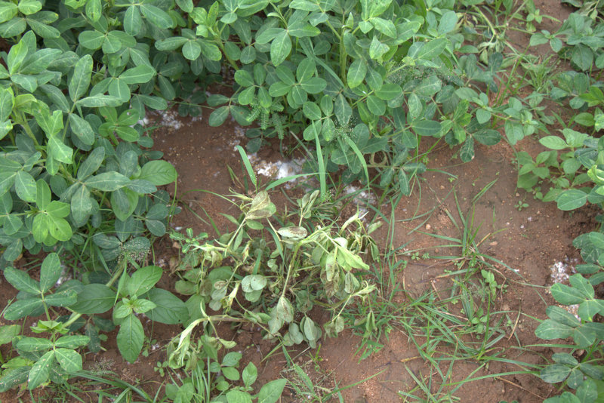
Fig. 1. Phenotyping of a RIL population from the cross, ICGV 03075 X CS 19 for stem rot resistance in sick plot at ICRISAT-Patancheru in Rainy 2016.

Next steps: Phenotyping of MAGIC lines and sharing of these lines with NARS partners. Development of NAM population.

